Indexing Views, Temp and Variable Tables

**USF_ID:U72254994(Venkata Satya Sai Lakshmi Lavanya)**

**Subject_ID:ISM6218(Advanced Database Management System)**

**Procedure creation with recompile and without recompile option**

View with Index

Temp Table with index

Table Variable with index

Query results with execution plans for the same query against all 3

(Temp_table, variable table ,view &the production table)

Query Results and Execution Plan of the query on Production table(with primary_key/clustered index)

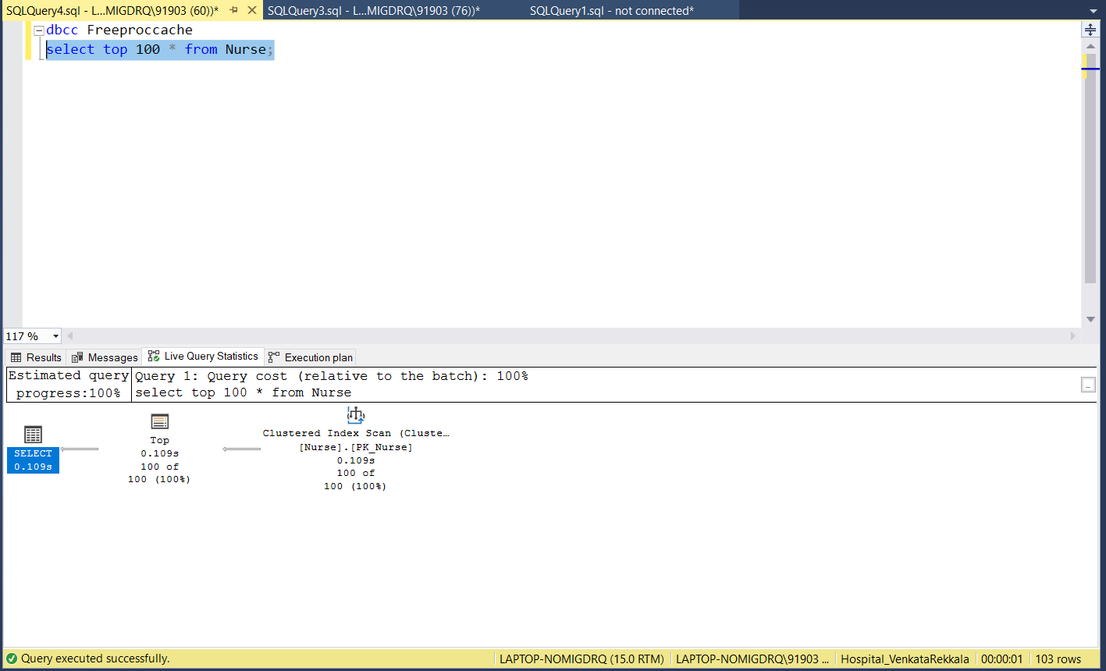

Query Results and Execution Plan of the query using View(Having Index)

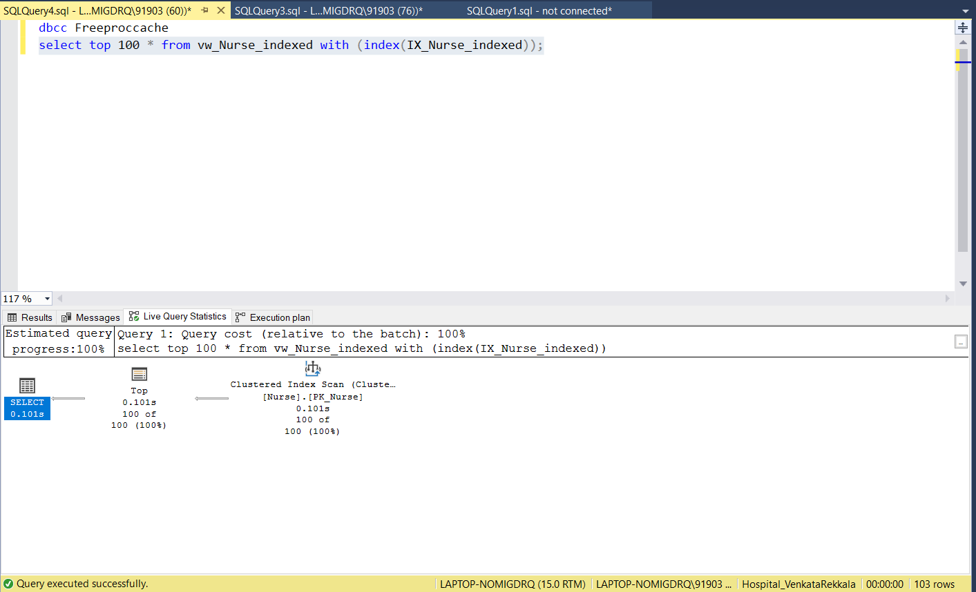

Query Results and Execution Plan of the query using Temp Table(Having Index)

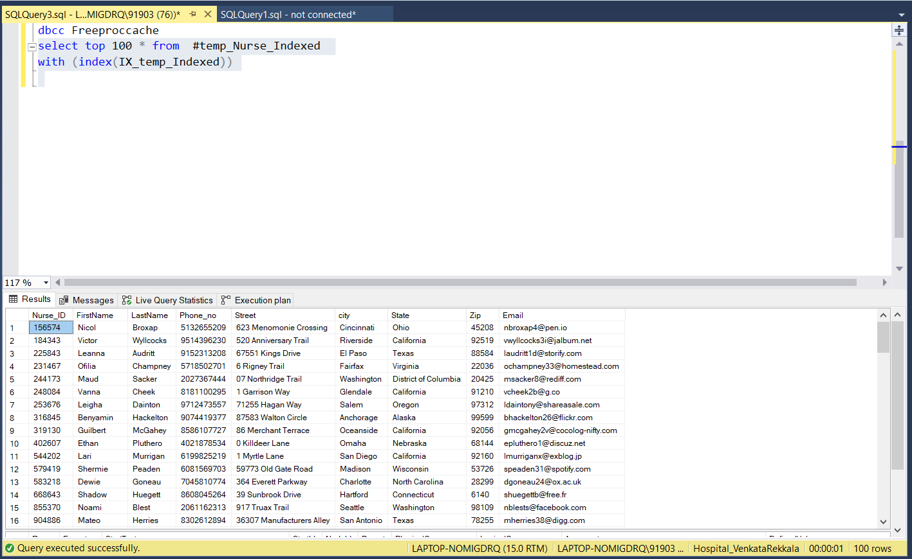

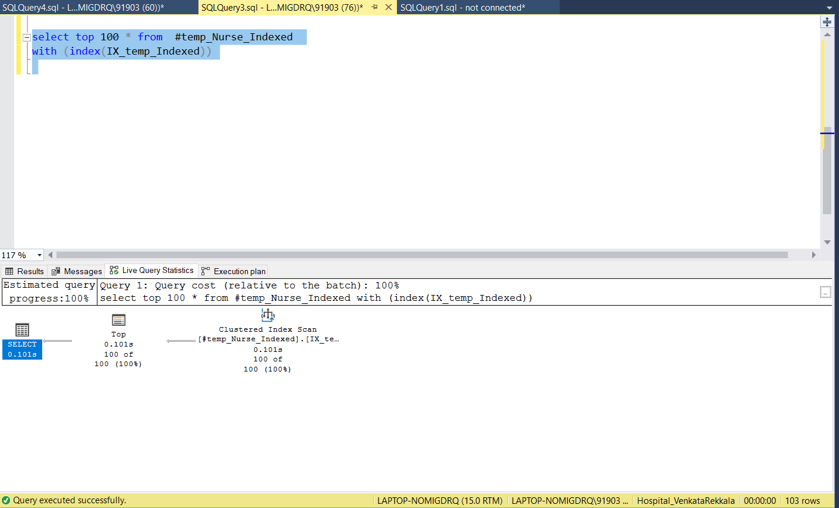

Query Results and Execution Plan of the query using Table Variable(Having Index)

