Smote percentage (200)(501 negative , 416 positive )(55, 45) – full datatset: slightly imbalanced:

Two class boosted decision tree:

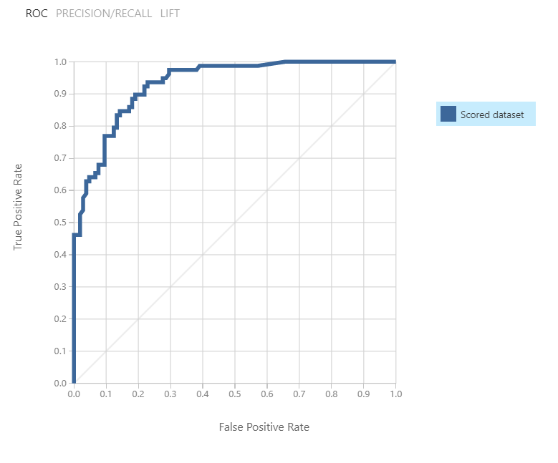

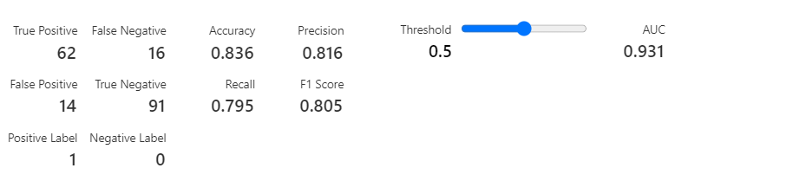

Two class neural network:

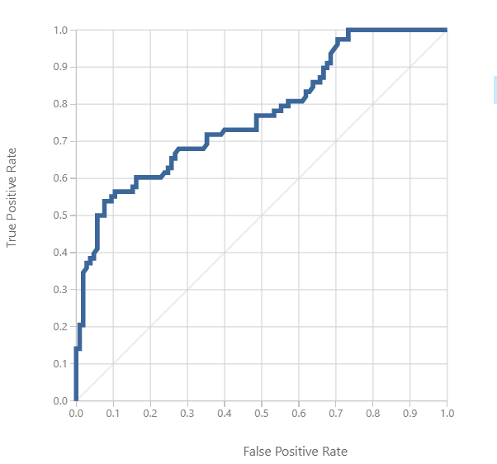

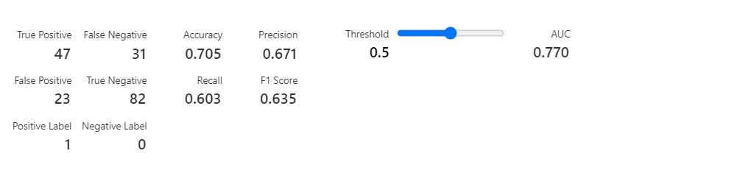

Two class decision forest:

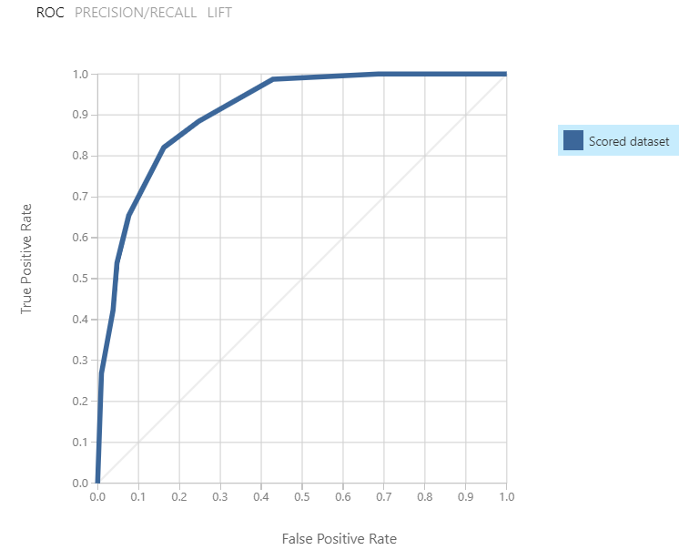

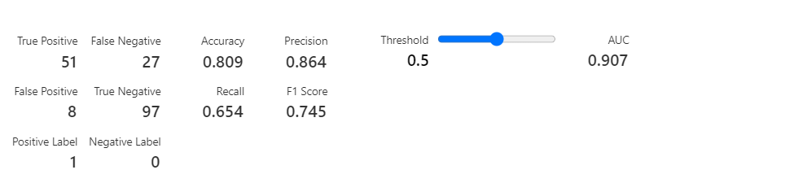

Smote percentage -150 (417 negative, 416 positive)

Two lass boosted decision tree:

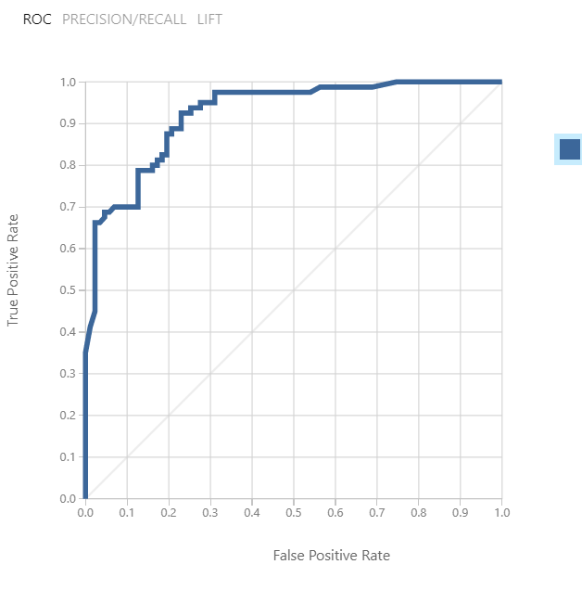

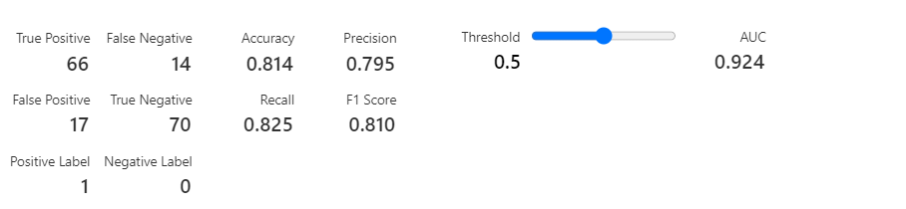

Two class neural network:

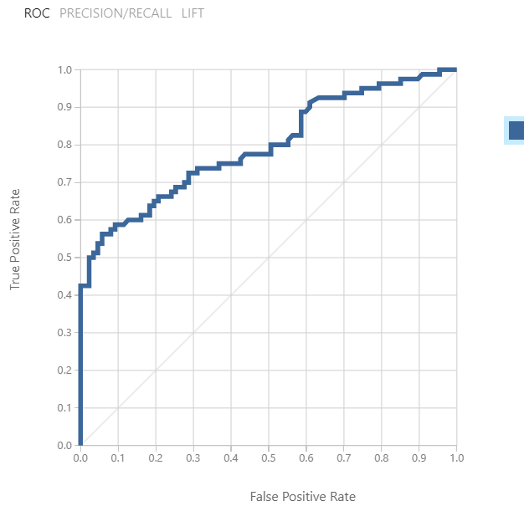

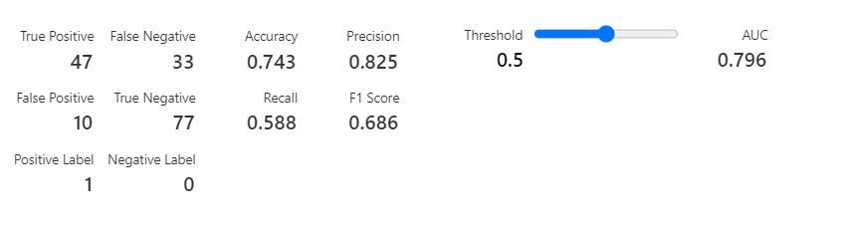

Two class decision forest :

