**ASSIGNMENT - 4**

Name : Sai Leela Otikundala

Student id : 700747149

Git Hub Link : https://github.com/SaiLeelaOtikundala/Neural-assignmnet-4.git

In class Programming:

1. Add one more hidden layer to auto encoder

Output 1:

1. Do the prediction on the test data and then visualize one of the reconstructed version of that test data. Also, visualize the same test data before reconstruction using Matplotlib

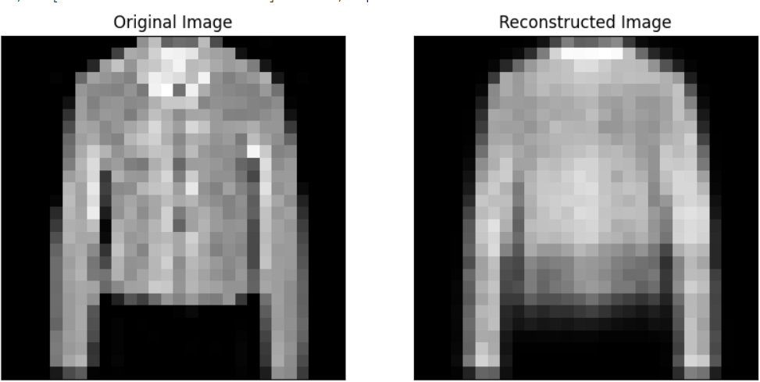

1. Repeat the question 2 on the denoisening autoencoder

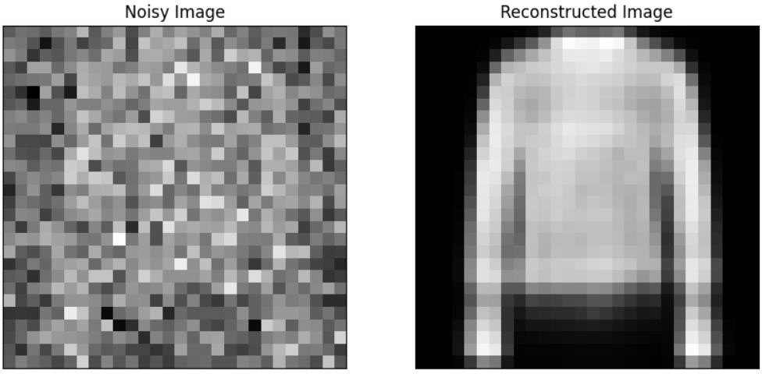

1. plot loss and accuracy using the history object

