**A COMPARATIVE STUDY OF MACHINE LEARNING AND DEEP LEARNING TECHNIQUES FOR FAKE REVIEW DETECTION**

**OBJECTIVE:**

The primary goal of this project is to determine the a comparative study of machine learning and deep learning techniques for fake review detection Based on Machine-Learning with Early Classification Based Approach for Fault Classification in whether the result is it’s a bad Review are its Genuine Review this we used Stochastic logistic regression (LR), support vector machines (SVM), decision tree (DT), naive Bayes (NB), random forest (RF), XGBoost (XGB) and an ensemblelearning method of such algorithms, (2) advanced ML algorithms such as convolutional neuralnetworks (CNNs), bidirectional long short-term memory (BiLSTM), bidirectional gated recurrentunits (BiGRU), ANN, CNN-BiLSTM, CNN-BiGRU and of such transformer-based models such as BERT,

**ABSTRACT**

With the continual evolution , online evaluations are increasingly seen as a critical aspect in establishing and keeping a positive reputation. Furthermore, they play an important part in the decision-making process for end consumers. A good review for a specific object typically draws more consumers and leads to a significant rise in sales. Deceptive or phoney evaluations are now purposefully generated in order to develop a virtual reputation and attract potential clients. As a result, detecting false reviews is an active and ongoing research topic. Identifying phoney reviews is dependent not only on the essential elements of the reviews, but also on the reviewers' behaviour. This research provides a machine learning method for detecting false reviews. In addition to the review features extraction approach, this research employs different features engineering techniques to extract diverse reviewer behaviours. The study examines the performance of machine learning classifiers; Decision Tree, Random Forest, SVC, CNN, Naïve Bias, Logistic Regression, XGBoost, ANN, LSTM, BERT. The results demonstrate that the algorithm is better at determining whether a review is bad or genuine.

**Keywords:** Decision Tree, Random Forest, SVC, CNN, Naïve Bias, Logistic Regression, XGBoost, ANN, LSTM, BERT

**EXISTING METHOD**

The increasing growth of machine learning, computer techniques divided into traditional methods and machine learning methods. This section describes the related works of classification of a comparative study of machine learning and deep learning techniques for fake review detection Using Machine Learning Model Detection and how machine learning methods are better than traditional methods. The existing method in this project have a certain flow is used for model development Decision Tree are used algorithms in existing system. But it requires large memory and result is not accurate.

**Disadvantages:**

1. Accuracy low

2. Requires more time

3. Difficult to handle

**PROPOSED SYSTEM**

Many machine learning algorithms are available for prediction and diagnosis a comparative study of machine learning and deep learning techniques for fake review detection Some of the machine learning algorithm are Decision Tree, Random Forest, SVC, CNN, Naïve Bias, Logistic Regression, XGBoost, ANN, LSTM, BERT .and We used proposed Ensemble Voting method and compute best method for diagnosis a comparative study of machine learning and deep learning techniques for fake review detection In this stage we have first implement Decision Tree Classifier algorithm on these dataset and the implement algorithm individual then we are implement Voting Ensemble algorithm for combine these results and an compute the final accuracy.

**Advantages:**

1. Requires less time

2. Good Accuracy

3. Easy to handle

**Block Diagram:**

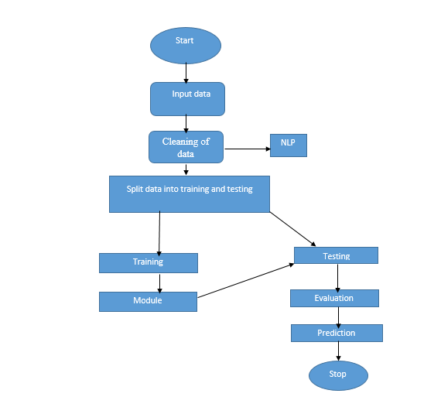

**Fig 1. Block Diagram of Proposed System**

**HARDAWARE AND SOFTWARE REQUERMENTS**

**H/W Configuration:**

• Processor - I3/Intel Processor

• Hard Disk -160 GB

• RAM - 8 GB

**S/W Configuration:**

• Operating System : Windows 7/8/10 .

• Server side Script : HTML, CSS & JS.

• IDE : Pycharm.

• Libraries Used : Numpy, IO, OS, Django, keras.

• Technology : Python 3.6+.

**LEARNING OUTCOMES:**

* About Classification in machine learning
* About Preprocessing Techniques
* About Decision Tree
* About Random Forest
* About SVC,
* About ANN,
* About CNN
* About Naïve Bias,
* About Logistic Regression
* About XGBoost,
* About LSTM,
* About BERT
* Knowledge on PyCharm Editor