IOT BASED HOME AUTOMATION USING ETHERNET

A Project Report

Submitted in partial fulfilment of the requirements for the award of the degree of

BACHELOR OF TECHNOLOGY

In

ELECTRONICS AND COMMUNICATION ENGINEERING

Submitted by

K.SAI LIKHITH | 13KA1A0443
M.CHANDRAKALA | 13KA1A0418
K. PRAKASH BABU | 13KA1A0434
M.SREEKANTH NAIK | 13KA1A0451
G.PRAVEEN | 13KA1A0447

Under the guidance of
Mrs.M.REVATHI, (M.Tech)
Lecturer,

JNTUACEK, KALIKIRI

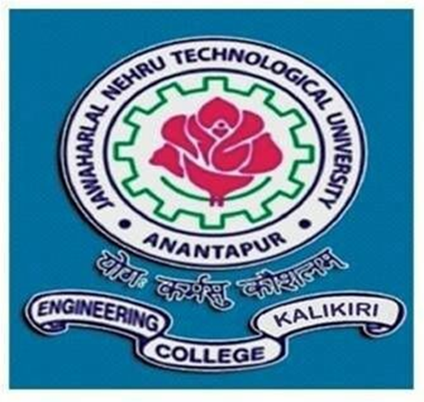
DEPARTMENT OF ELECTRONICS & COMMUNICATION ENGINEERING

JAWAHARLAL NEHRU TECHNOLOGICAL UNIVERSITY ANANTAPUR

COLLEGE OF ENGINEERING: KALIKIRI

CHITTOOR (Dist.), ANDHRA PRADESH – 517234

2013-2017
JAWAHARLAL NEHRU TECHNOLOGICAL UNIVERSITY ANANTAPUR

COLLEGE OF ENGINEERING: KALIKIRI

DEPARTMENT OF ELECTRONICS AND COMMUNICATION ENGINEERING

CERTIFICATE

This is to certify that the project report entitled
“IOT BASED HOME AUTOMATION USING ETHERNET”

that is submitted by

K.SAI LIKHITH | 13KA1A0443
M.CHANDRAKALA | 13KA1A0418
K.PRAKASH BABU | 13KA1A0434
M.SREEKANTH NAIK | 13KA1A0451
G.PRAVEEN | 13KA1A0447

in partial fulfilment of the requirements for the award of the Bachelor of Technology (B.Tech) in Electronics and Communication Engineering (ECE) from Jawaharlal Nehru
Technological University Anantapur College of Engineering, Kalikiri during the academic year 2013-2017.

Project Guide Head of the Department

Mrs. M.REVATHI Dr. D.VISHNU VARDHAN

Lecturer, Assistant Professor,

Department of ECE, Department of ECE,

JNTUACE, KALIKIRI JNTUACE, KALIKIRI

Internal Examiner External Examiner

ACKNOWLEDGEMENT

An endeavour over a long period can be successful only with a device and support of many well-wishers. The task would be incomplete without mentioning the people who have made it possible, because is the epitome of hard work. So with the gratitude, we acknowledge all those whose guidance and encouragement owned our efforts with success.

We wish to express grateful acknowledgement to our guide Mrs .M.REVATHI , M.Tech Lecturer, JNTUACEK, Kalikiri, for her inspiration guidance and continuous encouragement throughout the project.

We are thankful to Dr. D.VISHNU VARDHAN, Head of the Department, our project guide, for his valuable guidance, efforts, his constant source of inspiration and motivation throughout the project.

Our special thanks to Prof. Dr.D.ESWARA REDDY, Principal of JNTUA College of Engineering Kalikiri who provided us all the required facilities and helped in accomplishing the project within time.

Finally, we would like to extend our deep sense of gratitude to all the staff members, friends and last but not least we are greatly indebted to our parents who inspired us at all circumstances.

