NIP Project — Submission Template
Pega Platform project · This document is your complete submission
Read this before you start:
1. Fill in Section 1 completely. The Pega application name must follow the format NIP-[Project]-[YourName].
2. Create a new Operator in Pega with your full name and log in as that operator before taking any screenshot.
3. When you create your test case, enter YOUR FULL NAME in the Issue Description (Vehicle) or Movie Name (Movie) field.
4. Complete only the section for your chosen project. Delete the other project section.
5. Paste one screenshot per user story (10 total). Follow the screenshot rules in your selected project section.
6. Answer every question in Sections 3 and 4 in your own words.
7. Save the file using this format: ProjectName_FirstName_LastName.docx. Use VehicleService or MovieTicket as the ProjectName. Examples: VehicleService_Ravi_Kumar.docx or MovieTicket_Ravi_Kumar.docx.

Section 1 — Your Details
Full Name | BOTU SAI MAHESH
Email ID (registered on NIP) | saimaheshbotu2006@gmail.com
Phone Number | 9666731182
College Name | Aditya College Of Engineering and Technology
Course (e.g. IT, CS) | B.tech(CSE)
State | Andhra Pradesh
Project Chosen (Vehicle Service OR Movie Ticket Booking) | Movie Ticket Booking
Pega Application Name (e.g. NIP-VehicleService-YourName) | NIP-Movie Ticket Booking-SaiMahesh
Case Type Name (exact) | Movie Ticket Booking
Pega Instance URL | https://nguil1rq.pegacea.net/prweb/app/fraud-investigation/ai2rRSYKJFcQR6ODxs26Rv4aBkqwV-K5*/!STANDARD
Operator Name (created in Pega with your full name) | author@uplus

Section 2B — Movie Ticket Booking Management Application
Complete this section only if you selected this project. Delete the other project section before submitting.

Screenshot rules — IMPORTANT before you start:
1. Name your Pega application as: NIP-VehicleService-YourName OR NIP-MovieTicket-YourName
2. Create a new Operator in Pega with your full name (Security → Operators) and log in as that operator.
3. When you create your test case, enter YOUR FULL NAME in the Issue Description (Vehicle) or Movie Name (Movie) field.
4. The logged-in operator name must be visible in every screenshot wherever the Pega interface displays it.
5. The student's full name must be visible in all running-case screenshots.
6. Configuration screenshots must clearly show the relevant application or rule name.
Screenshots that do not show these will not be accepted.

US-001 — Submit Movie Ticket Request
What is expected:
Case created, customer submits Movie Name, Show Date, Show Time, Number of Tickets. Validation applied.
Screenshot — paste your screenshot below this line:
[ Paste screensho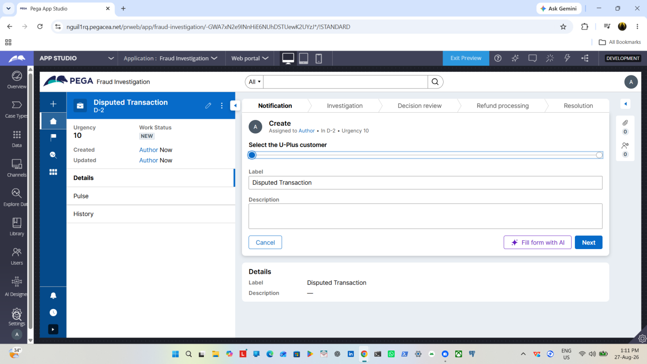t here - follow the screenshot rules above ]

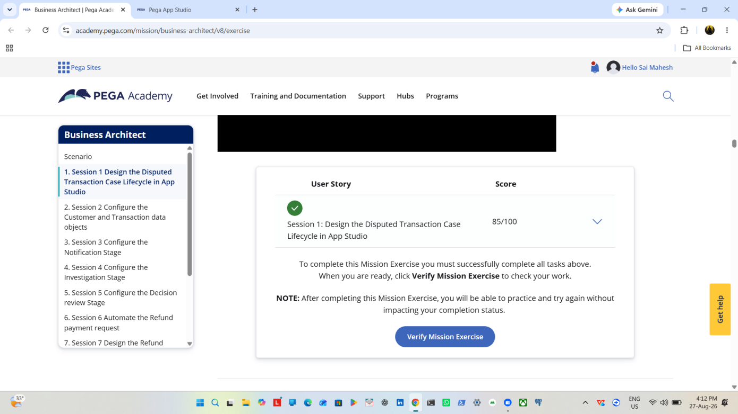

What I built for this (1–2 lines in your own words):
Created and done 1st task and result shown in screenshot

US-002 — Check Show Availability
What is expected:
Availability stage. Seat Availability Status and Available Seats Count captured. Booking proceeds only if available.
Screenshot — paste your screenshot below this line:
[ Paste screenshot here - follow the screenshot rules above ]
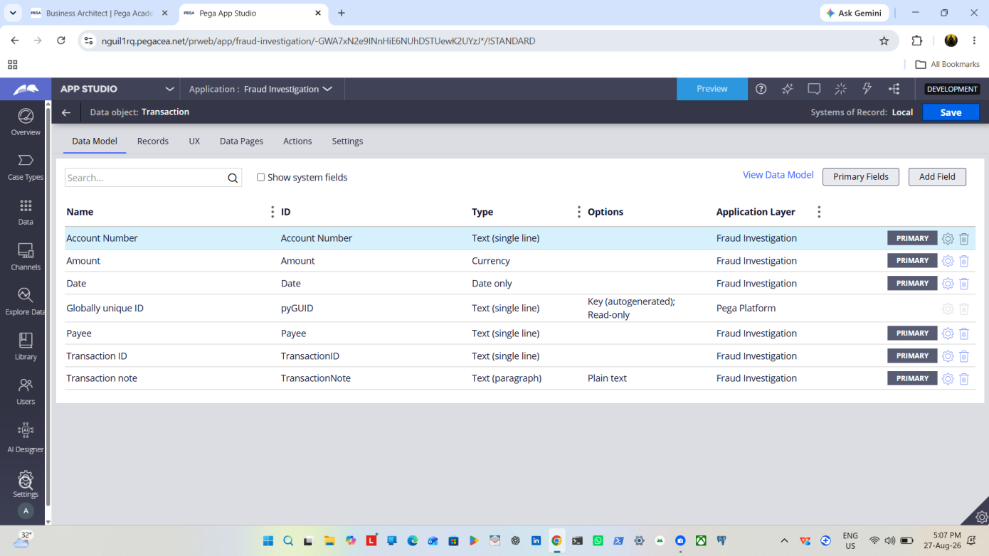

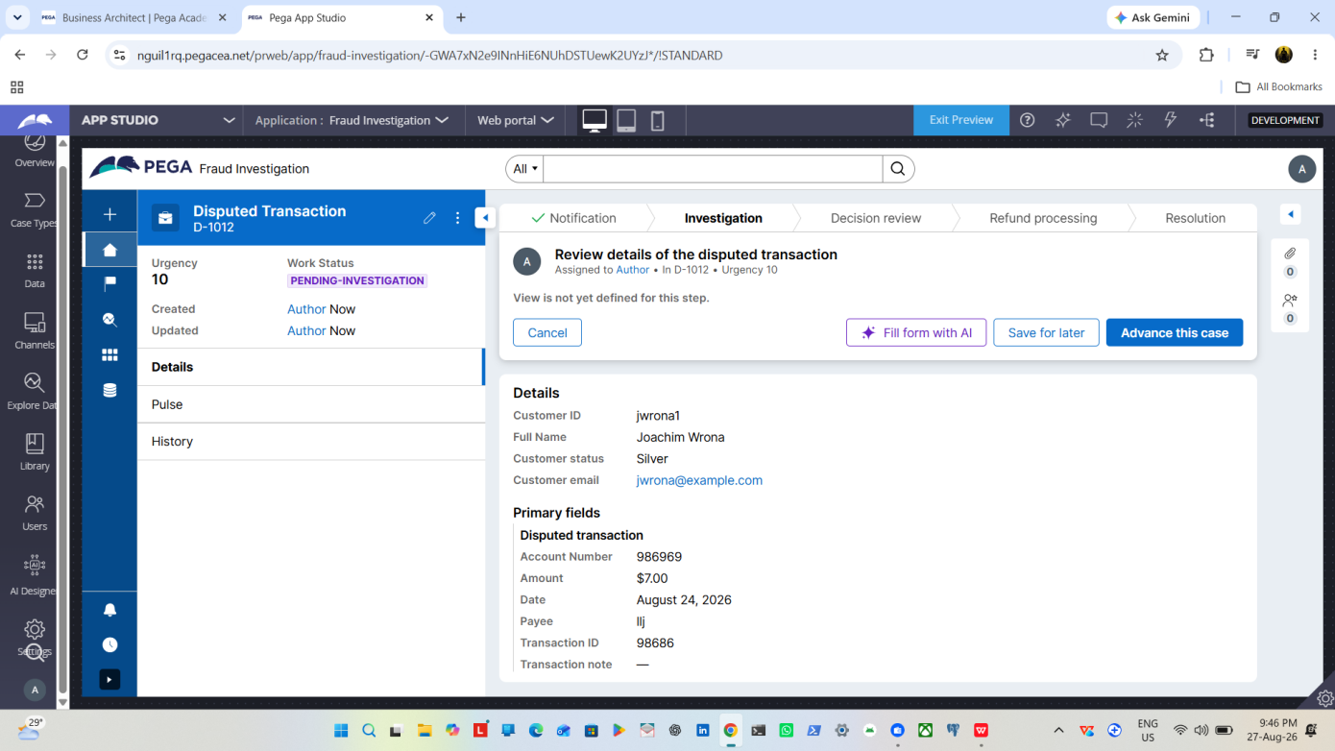

What I built for this (1–2 lines in your own words):
[ Type here ]
Result shown in screenshot above added the properties

US-003 — Calculate Booking Cost
What is expected:
Total Cost calculated automatically from Ticket Price and Number of Tickets using a business rule.
Screenshot — paste your screenshot below this line:
[ Paste screenshot here - follow the screenshot rules above ]

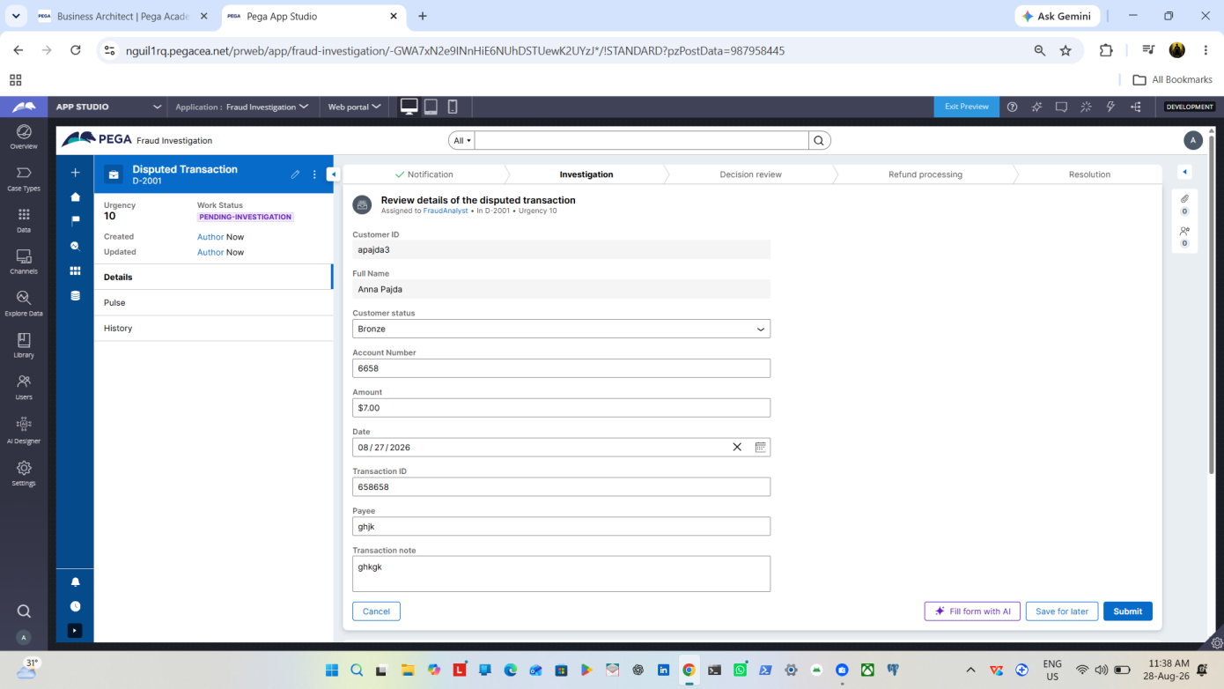

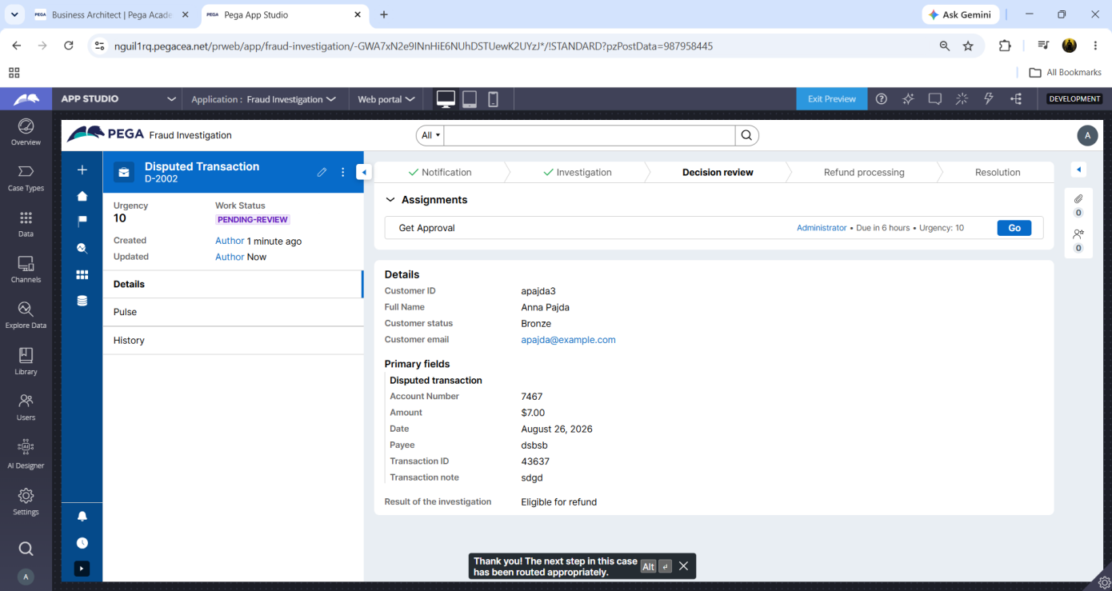

What I built for this (1–2 lines in your own words):
[ Type here ]
Result shown in screenshots

US-004 — Confirm Booking Request
What is expected:
Approval stage assigned to Customer. Booking Status captured. Flow branches on confirm/cancel.
Screenshot — paste your screenshot below this line:
[ Paste screenshot here - follow the screenshot rules above ]
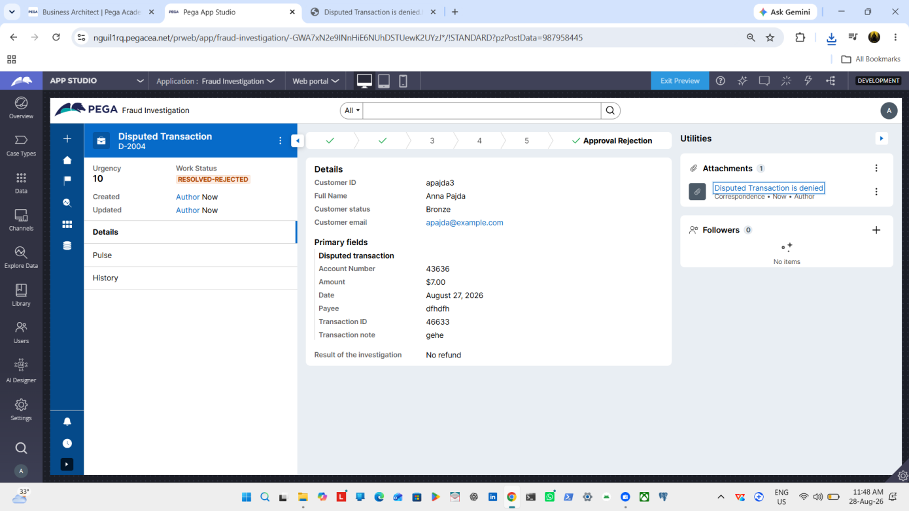

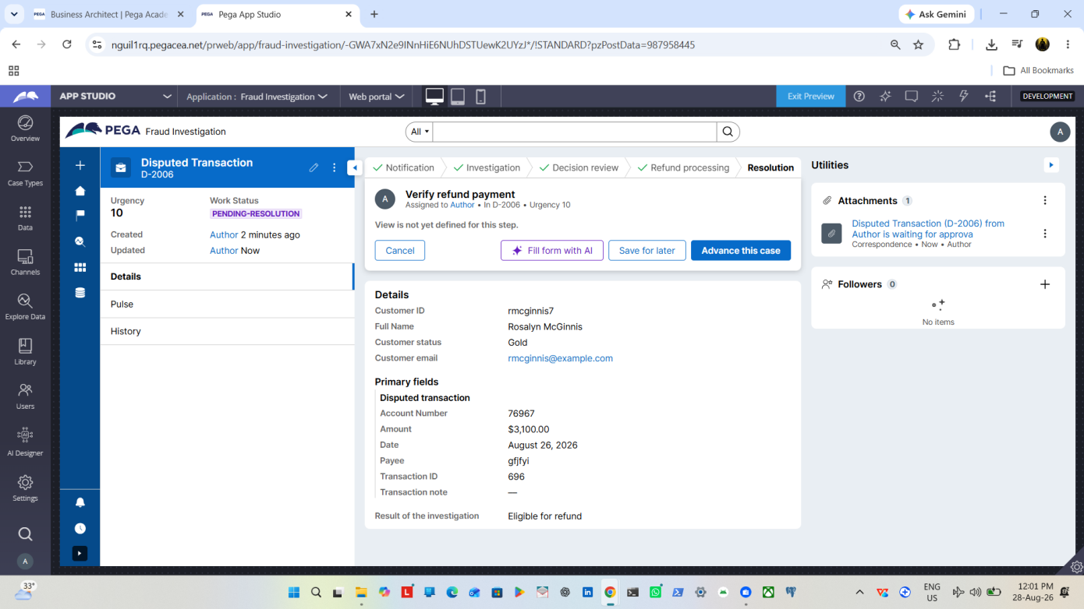

What I built for this (1–2 lines in your own words):
[ Type here ]
Result shown above screenshot

US-005 — Maintain Movie and Show Data
What is expected:
Reusable Movie and Show data objects created with Movie Name, Genre, Show Date, Show Time, Seat Capacity — linked to case.
Screenshot — paste your screenshot below this line:
[ Paste screenshot here - follow the screenshot rules above ]

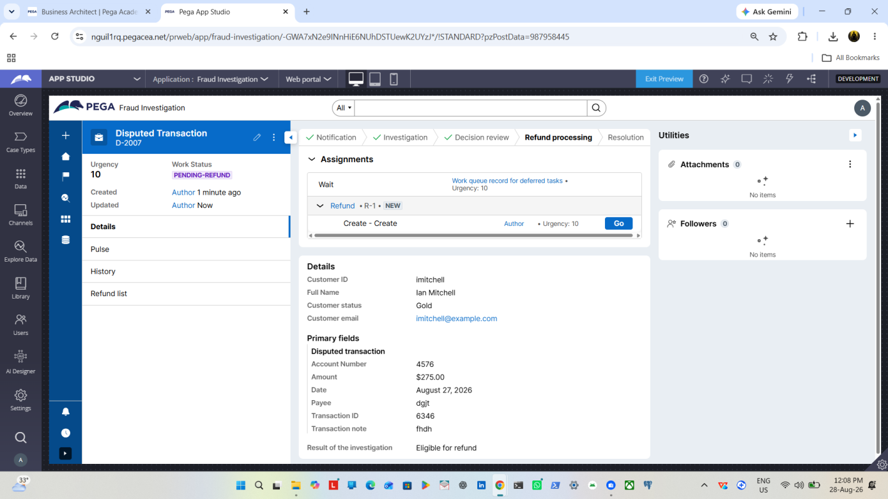

What I built for this (1–2 lines in your own words):
[ Type here ]
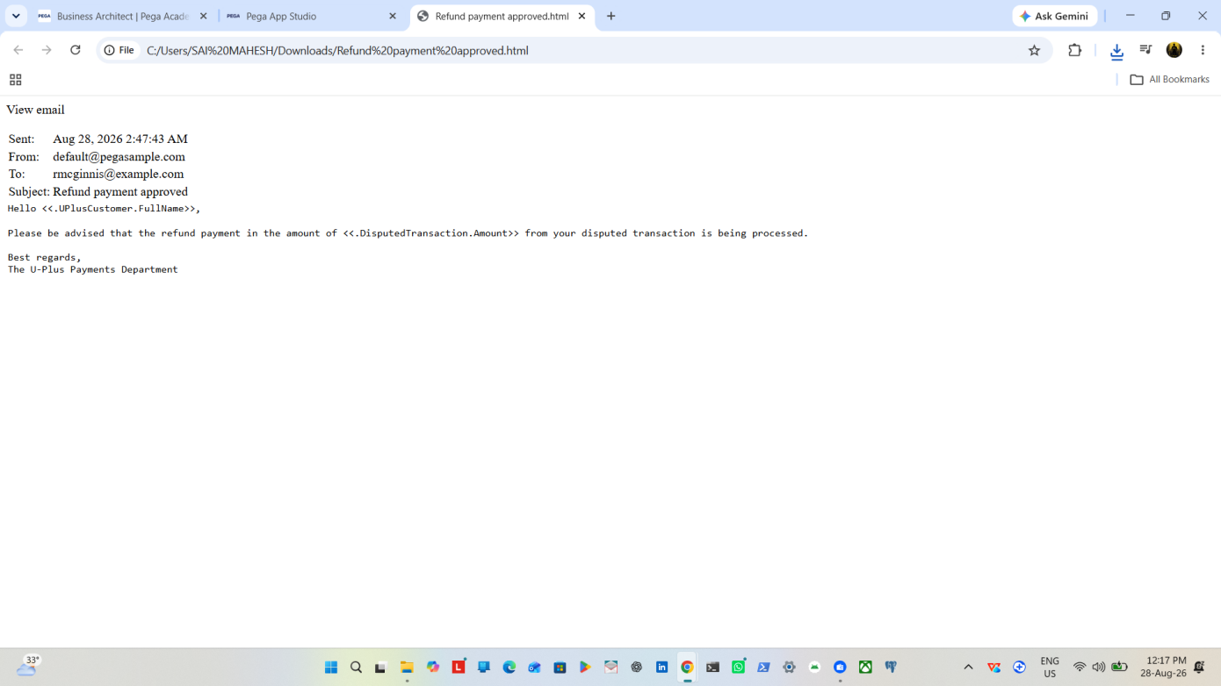

US-006 — Review Booking Details
What is expected:
Confirmation screen shows Movie Name, Show Timing, Number of Tickets and Total Cost clearly.
Screenshot — paste your screenshot below this line:
[ Paste screenshot here - follow the screenshot rules above ]
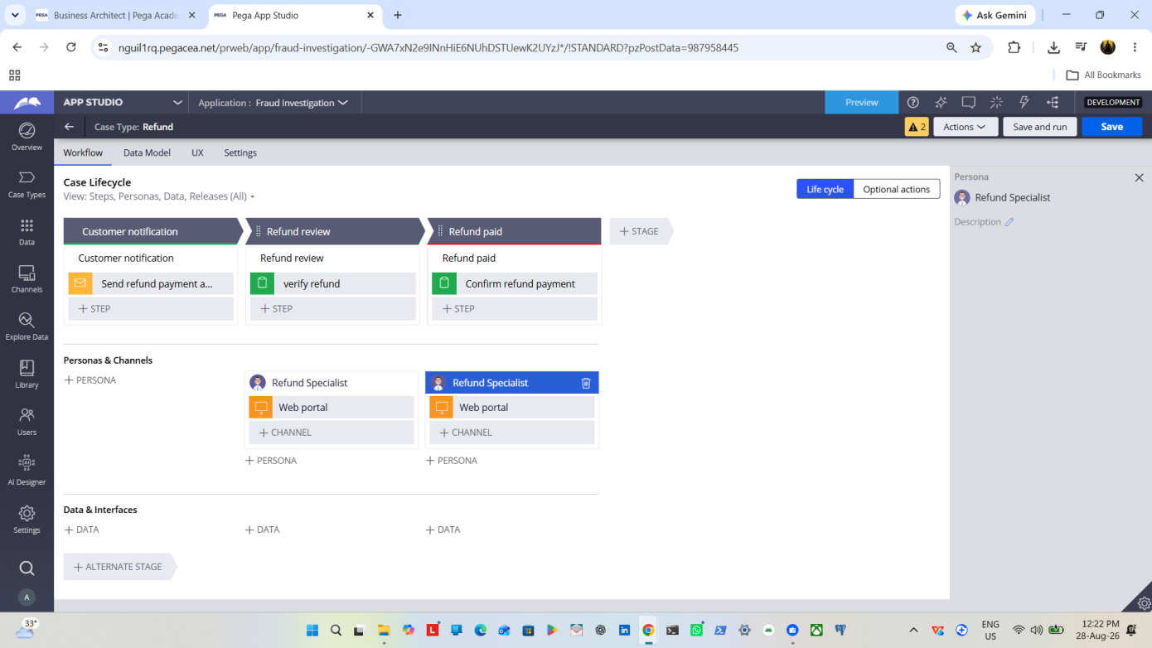

What I built for this (1–2 lines in your own words):
[ Type here ]
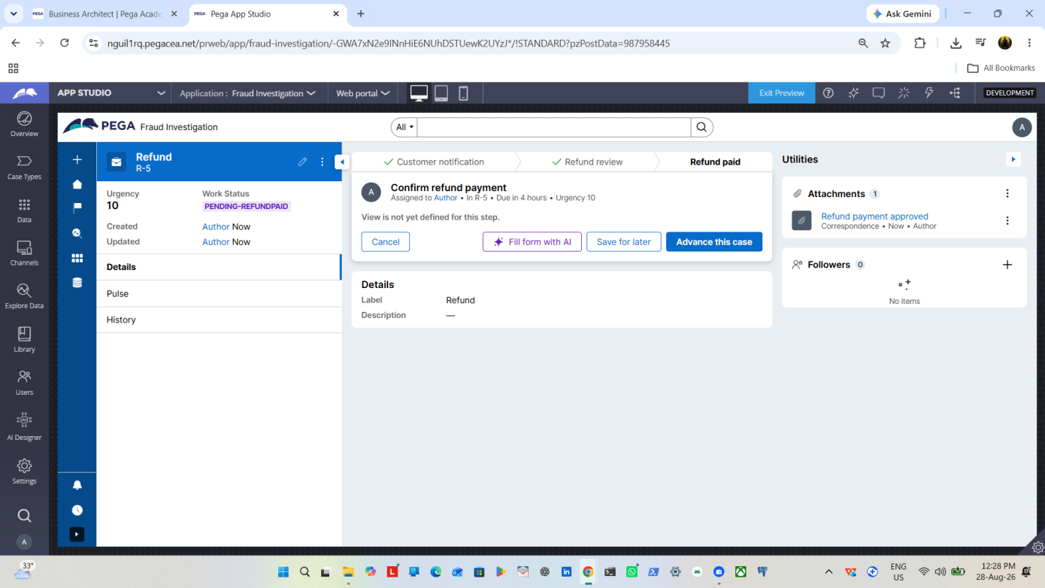

US-007 — Process Ticket Booking
What is expected:
Booking Execution stage. Seat Numbers, Ticket ID and Booking Confirmation Status maintained.
Screenshot — paste your screenshot below this line:
[ Paste screenshot here - follow the screenshot rules above ]
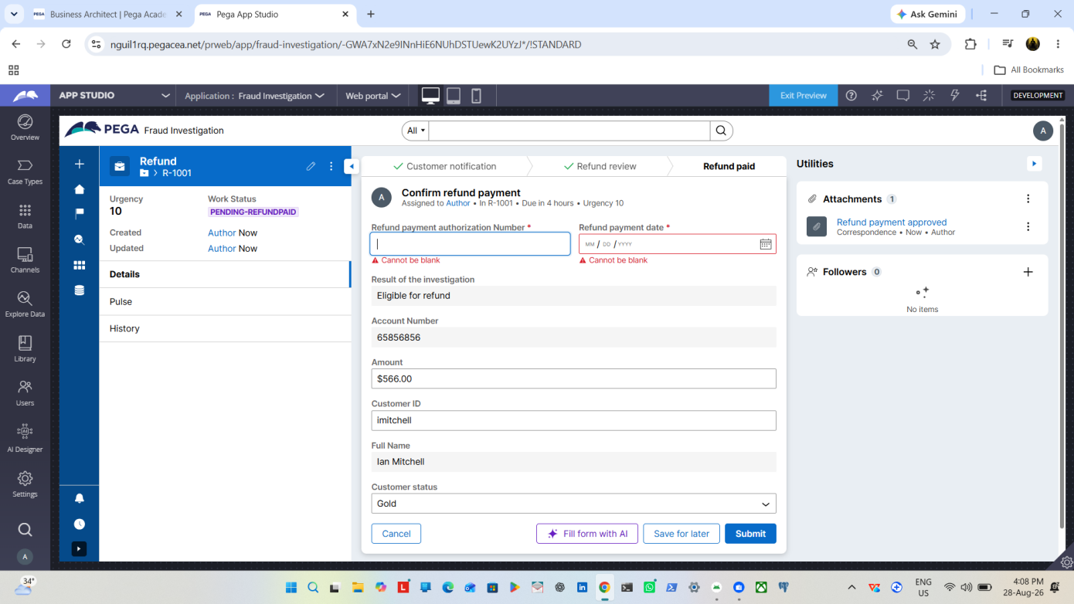

What I built for this (1–2 lines in your own words):
[ Type here ]
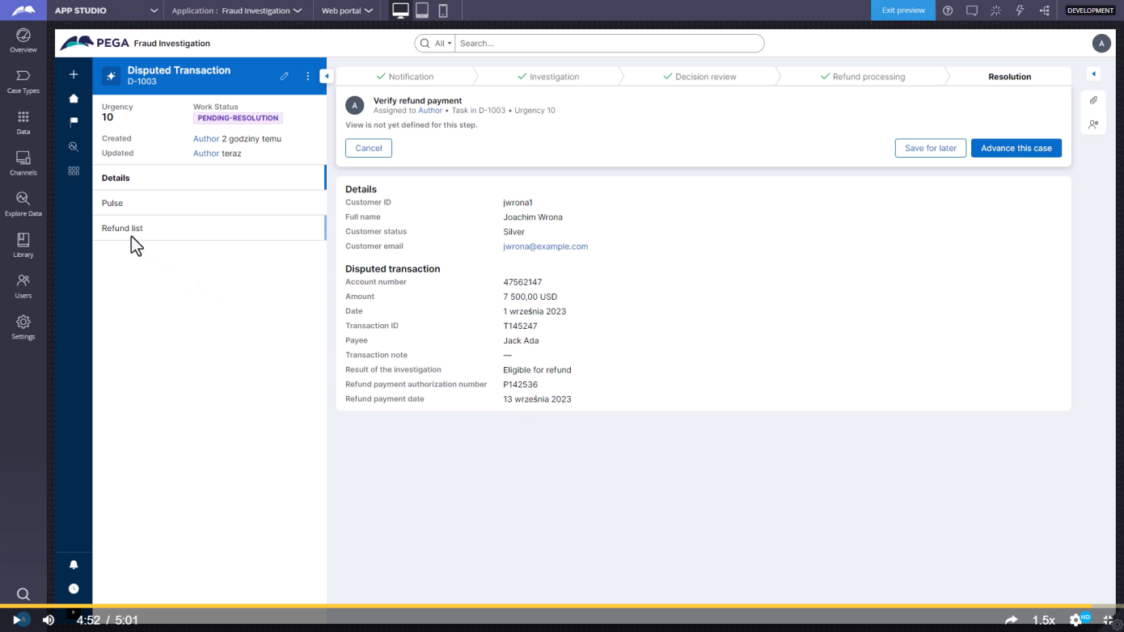

US-008 — Notify Booking Confirmation
What is expected:
Correspondence rule triggered on case resolution. Email includes movie, show, seat and cost details.
Screenshot — paste your screenshot below this line:
[ Paste screenshot here - follow the screenshot rules above ]

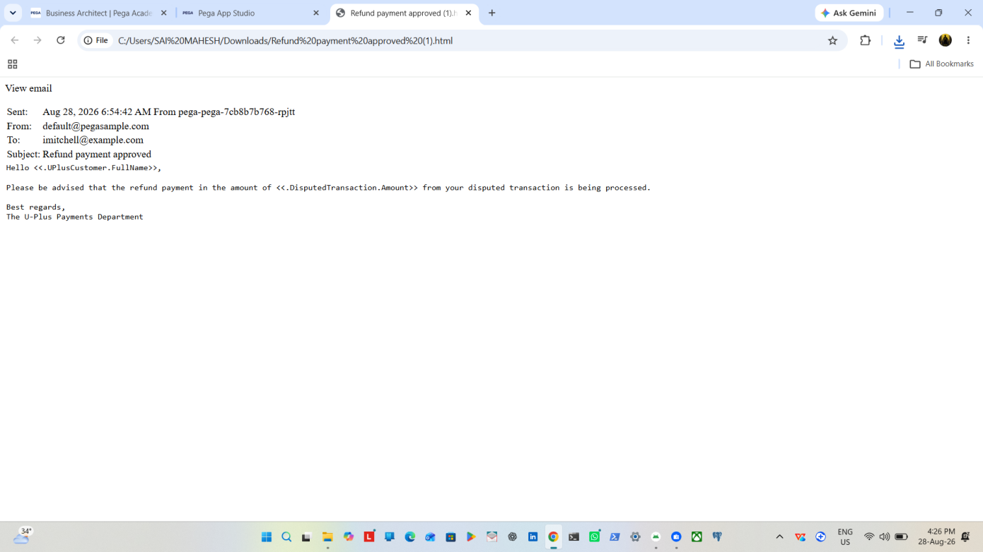

What I built for this (1–2 lines in your own words):
[ Type here ]
Booking shown in mail

US-009 — Define Booking SLA
What is expected:
SLA configured on the case type. Goal: 1 day. Deadline: 2 days. Priority increases on breach.
Screenshot — paste your screenshot below this line:
[ Paste screenshot here - follow the screenshot rules above ]

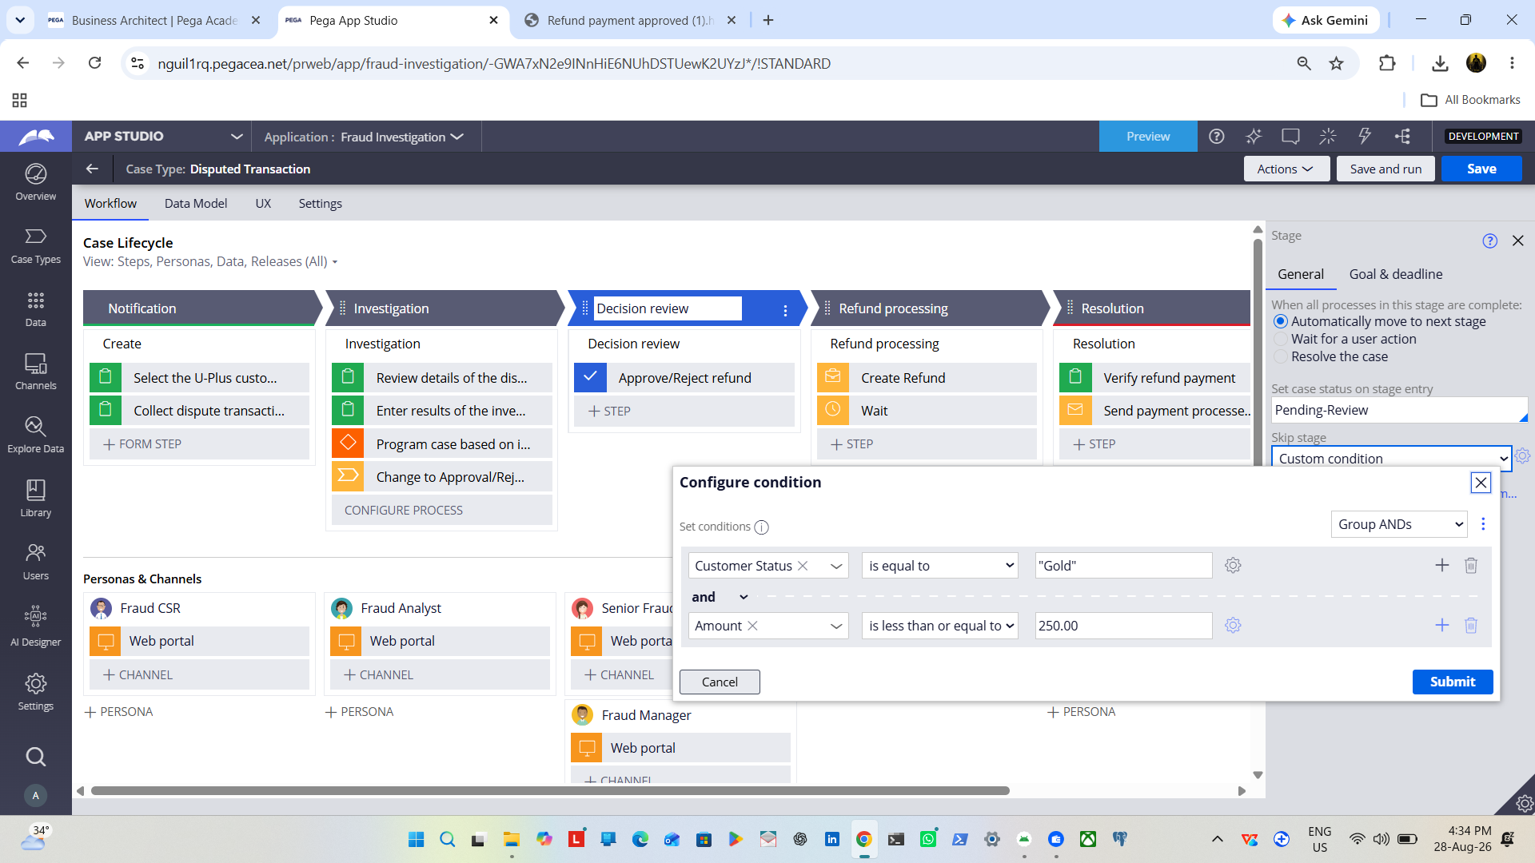

What I built for this (1–2 lines in your own words):
[ Type here ]
Confirm status

US-010 — Route by Show Type
What is expected:
Routing rule or Decision Table routes to PremiumShowQueue or StandardShowQueue based on Show Type property.
Screenshot — paste your screenshot below this line:
[ Paste screenshot here - follow the screenshot rules above ]

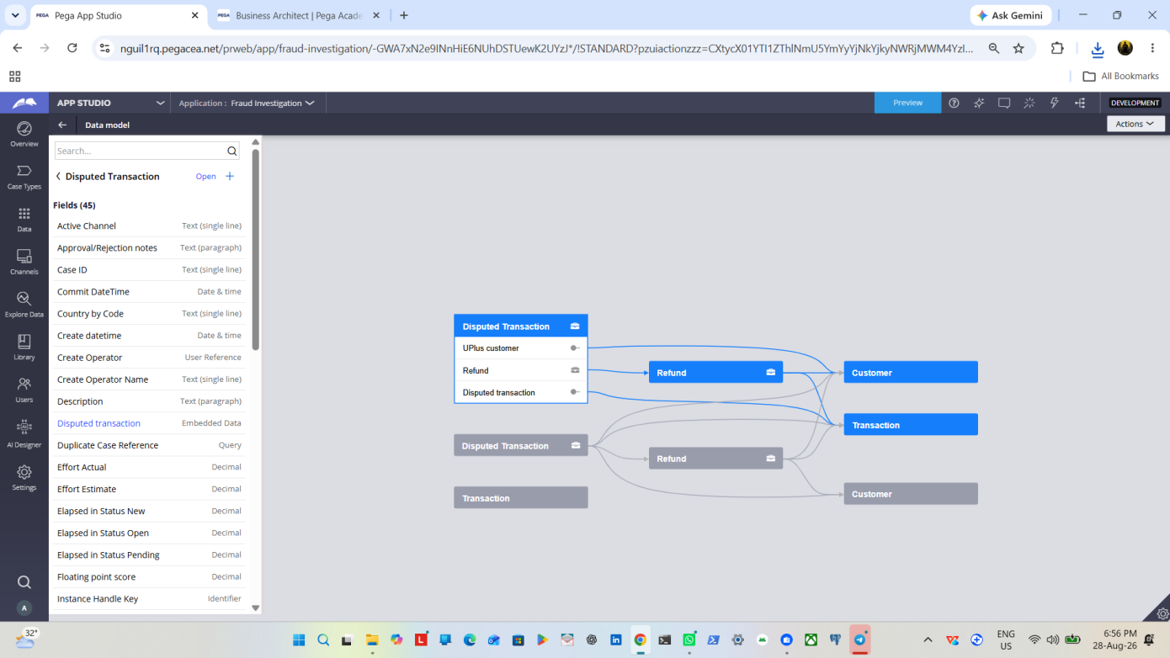

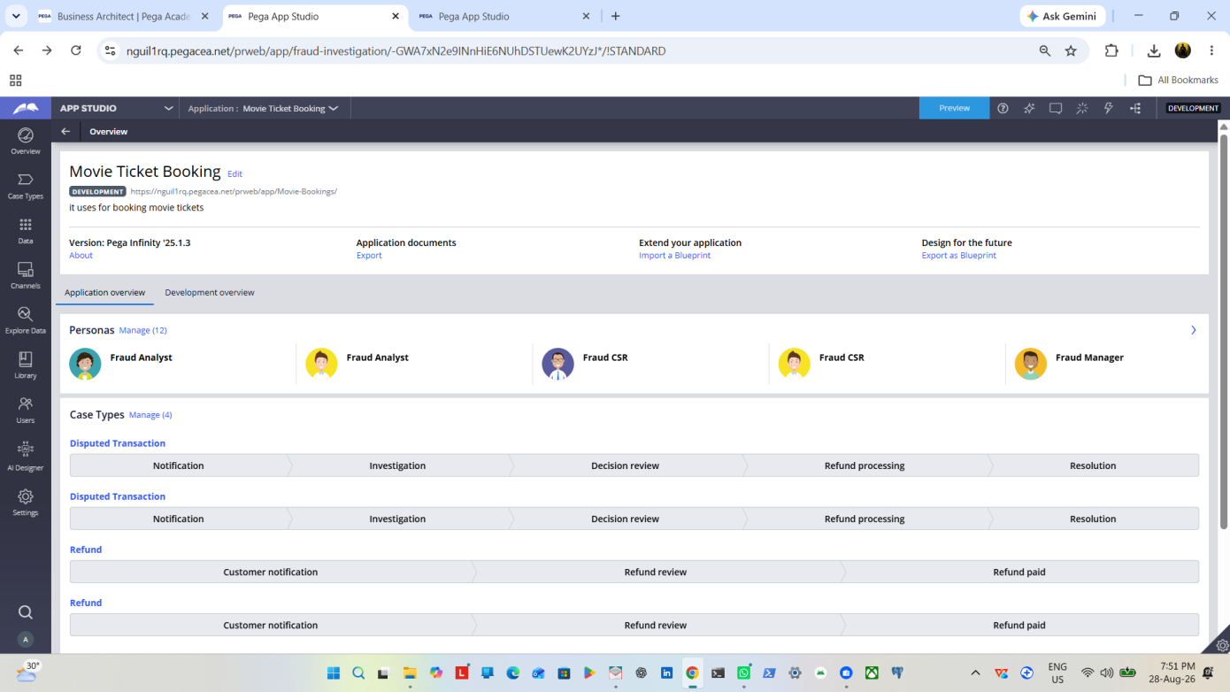

What I built for this (1–2 lines in your own words):
[ Type here ]
Final overview shown

Section 3 — About Your Application
These answers are checked against your screenshots. Write exactly what is in your application.

Q1. List your stages in the order they appear in your case lifecycle.
Stage names in order, separated by commas.
[ Type here ]
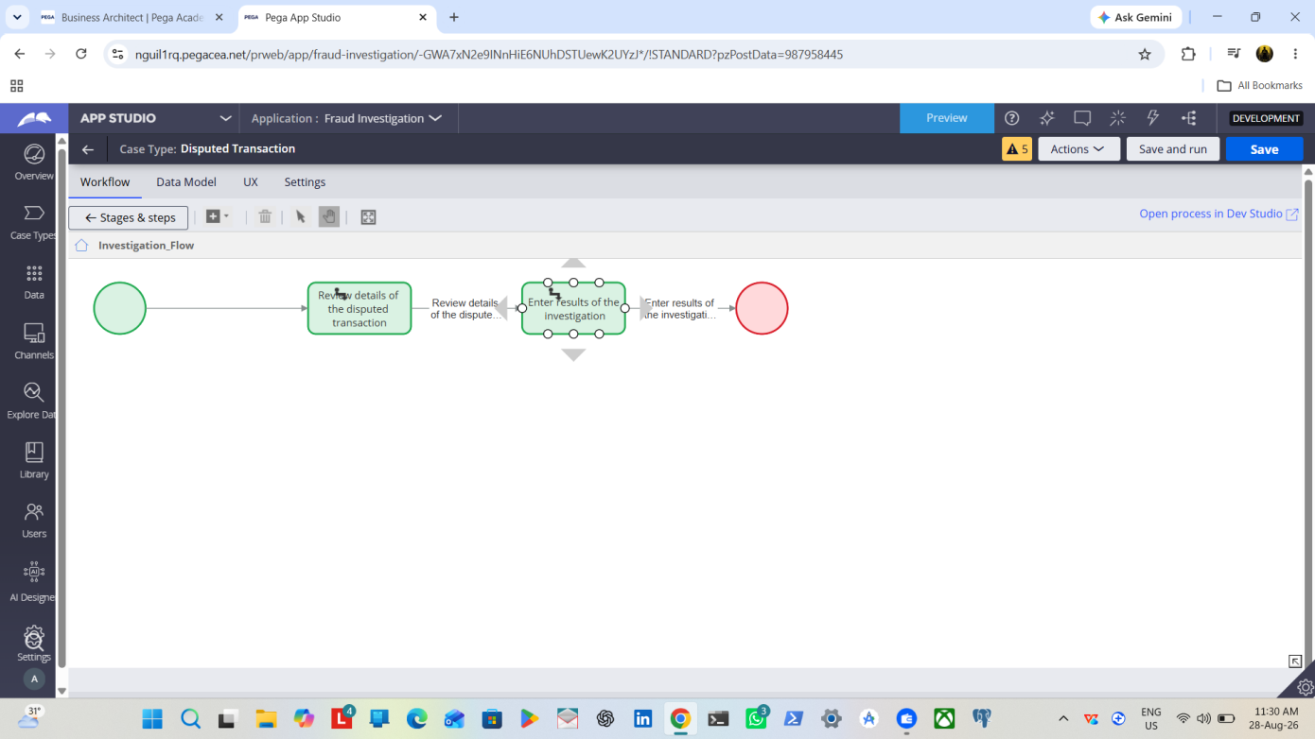

Q2. Name the data object(s) you created and the properties inside them.
Data object name and its properties.
[ Type here ]


Q3. What is the exact name and type of the rule you used to calculate Total Cost?
Provide:
• Rule Name
• Rule Type
• Properties used in the calculation
• Formula used
[ Type here ]
Total cost will be shown from total bookings*cost per ticket

Section 4 — Your Understanding
Short, honest and specific answers score well.

Q4. What did Blueprint generate for you, and what did you add or change yourself afterwards?
Be specific about what was already there and what you built or modified on top.
[ Type here ]
Blueprint generates the overall document of application

Q5. Was there anything Blueprint created that you had to correct or configure further? Describe one example.
A real example from your own work.
[ Type here ]

Booking Tickets

Q6. Explain your case flow from creation to resolution, in order.
What happens first, who does what, when the case closes.
[ Type here ]

Firstly created data objects and assigned different functions for project

Q7. Pick two design choices you made in your application and explain why you made them.
For each design choice, provide:
• What you implemented
• Why you chose that approach
• What benefit it provides to the application
[ Type here ]
Bookings done
Refund Money

Q8. What was the hardest part, and how exactly did you fix it?
Specific and honest. A real challenge scores much better than a generic answer.
[ Type here ]
Developing the Properties for data objects have and crosschecked verify actually what originally want to be and fixed it.

Q9. If the approval step was only needed when Total Cost is above a certain amount, what would you change in your application?
Explain what you would change and where. You do not need to build this.
[ Type here ]
Chabge according to application condition given

Q10. List three exact rule names from your application that you personally created or modified.
Include the rule name and rule type for each one (for example: CalculateTotalCost - Declare Expression).
[ Type here ]

Refund
Booking status
Available tickets in across shows

Q11. List all personas used in your application.
List the persona names exactly as they appear in your application.
[ Type here ]


Q12. List all work queues used in your application and explain when each one is used.
For each work queue, provide its exact name and the condition or type of work routed to it.
[ Type here ]
Refund Specialist-For refund Queries
Senior Fraud Analyst-For fraud activity queries

Before You Submit — Check These
Read through once before uploading.
1. Section 1 filled in. Application named as NIP-[Project]-[YourName]. Names match the actual application.
2. New Operator created in Pega with my full name. I logged in as that operator for all screenshots.
3. Only my chosen project section remains — the other project section is deleted.
4. All 10 user story screenshots are pasted and follow the operator, running-case, application, and rule-name evidence requirements.
5. Every question in Sections 3 and 4, including Q10, Q11, and Q12, is answered in my own words.
6. This file is named using the required format: ProjectName_FirstName_LastName.docx (for example, VehicleService_Ravi_Kumar.docx or MovieTicket_Ravi_Kumar.docx) and uploaded as required.

