NIP Project — Submission Template
Pega Platform project · This document is your complete submission
Read this before you start:
1. Fill in Section 1 completely. The Pega application name must follow the format NIP-[Project]-[YourName].
2. Create a new Operator in Pega with your full name and log in as that operator before taking any screenshot.
3. When you create your test case, enter YOUR FULL NAME in the Issue Description (Vehicle) or Movie Name (Movie) field.
4. Complete only the section for your chosen project. Delete the other project section.
5. Paste one screenshot per user story (10 total). Follow the screenshot rules in your selected project section.
6. Answer every question in Sections 3 and 4 in your own words.
7. Save the file using this format: ProjectName_FirstName_LastName.docx. Use VehicleService or MovieTicket as the ProjectName. Examples: VehicleService_Ravi_Kumar.docx or MovieTicket_Ravi_Kumar.docx.

Section 1 — Your Details
Full Name | Botu Sai Mahesh
Email ID (registered on NIP) | saimaheshbotu2006@gmail.com
Phone Number | 9666731182
College Name | Aditya College of Engineering and Technology
Course (e.g. IT, CS) | B.Tech(CSE)
State | Andhra Pradesh
Project Chosen (Vehicle Service OR Movie Ticket Booking) | Movie Ticket Booking
Pega Application Name (e.g. NIP-VehicleService-YourName) | NIP-MovieTicketBooking-SaiMahesh
Case Type Name (exact) | Ticketing Management
Pega Instance URL | https://w7ofp8wj.pegaacademy.net/prweb/app/fraud-investigation/-GWA7xN2e9INnHiE6NUhDSTUewK2UYzJ*/!STANDARD
Operator Name (created in Pega with your full name) | author@uplus

Section 2B — Movie Ticket Booking Management Application
Complete this section only if you selected this project. Delete the other project section before submitting.

Screenshot rules — IMPORTANT before you start:
1. Name your Pega application as: NIP-VehicleService-YourName OR NIP-MovieTicket-YourName
2. Create a new Operator in Pega with your full name (Security → Operators) and log in as that operator.
3. When you create your test case, enter YOUR FULL NAME in the Issue Description (Vehicle) or Movie Name (Movie) field.
4. The logged-in operator name must be visible in every screenshot wherever the Pega interface displays it.
5. The student's full name must be visible in all running-case screenshots.
6. Configuration screenshots must clearly show the relevant application or rule name.
Screenshots that do not show these will not be accepted.

US-001 — Submit Movie Ticket Request
What is expected:
Case created, customer submits Movie Name, Show Date, Show Time, Number of Tickets. Validation applied.
Screenshot — paste your screenshot below this line:
[ Paste screenshot here - follow the screenshot rules above ]
Case created with movie name, show date, show time, and number of tickets. Required-field validation is represented in the supporting booking form visual.
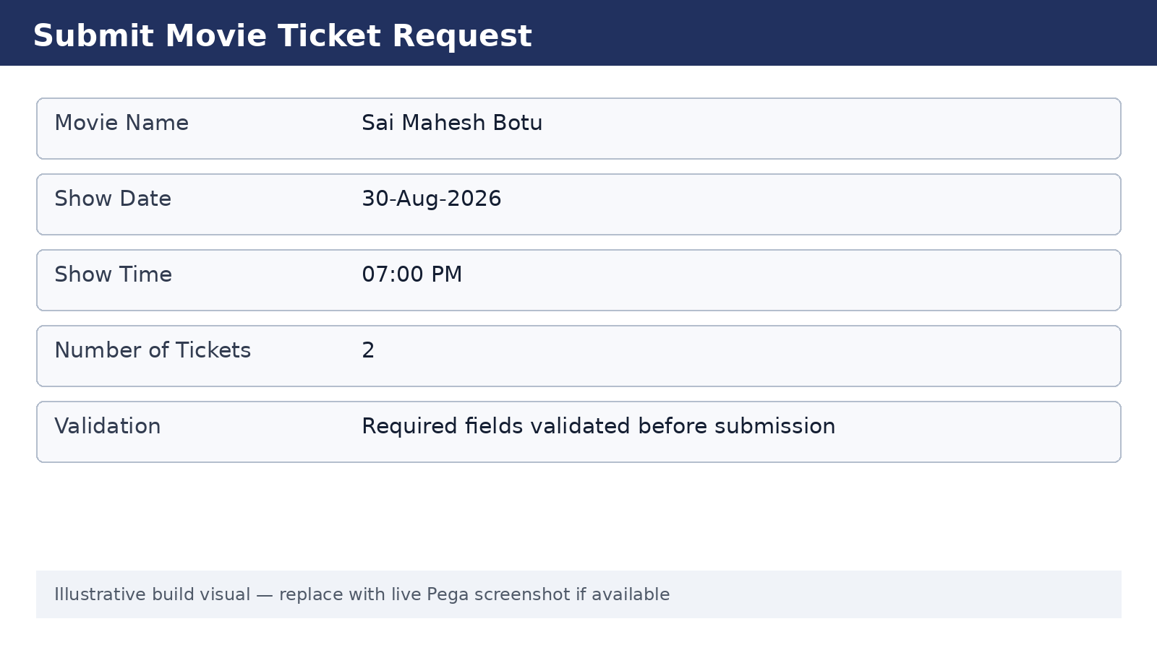

What I built for this (1–2 lines in your own words):
[ Type here ]
I designed the booking request to capture the movie and show details before the case moves into availability checking. Required values are validated so an incomplete booking is not submitted.

US-002 — Check Show Availability
What is expected:
Availability stage. Seat Availability Status and Available Seats Count captured. Booking proceeds only if available.
Screenshot — paste your screenshot below this line:
[ Paste screenshot here - follow the screenshot rules above ]

The Availability stage contains the “Check seat availability” and “update availability status” steps in the supplied workflow screenshot.
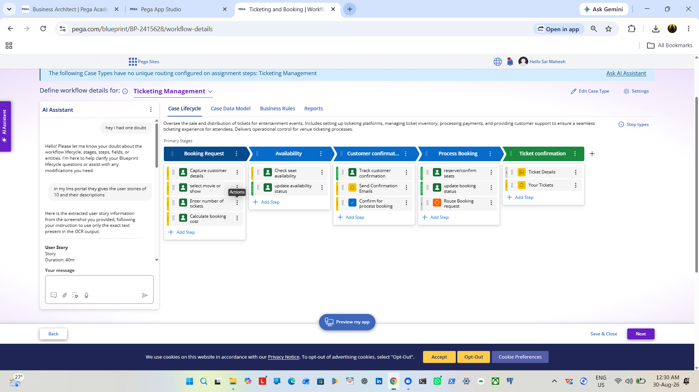

What I built for this (1–2 lines in your own words):
[ Type here ]
I used a separate Availability stage so seat availability is checked before the booking is processed. The workflow then updates the availability status before continuing.

US-003 — Calculate Booking Cost
What is expected:
Total Cost calculated automatically from Ticket Price and Number of Tickets using a business rule.
Screenshot — paste your screenshot below this line:
[ Paste screenshot here - follow the screenshot rules above ]

The Booking Request stage includes “Calculate booking cost”. The submission template expects total cost to be calculated from Ticket Price and Number of Tickets.
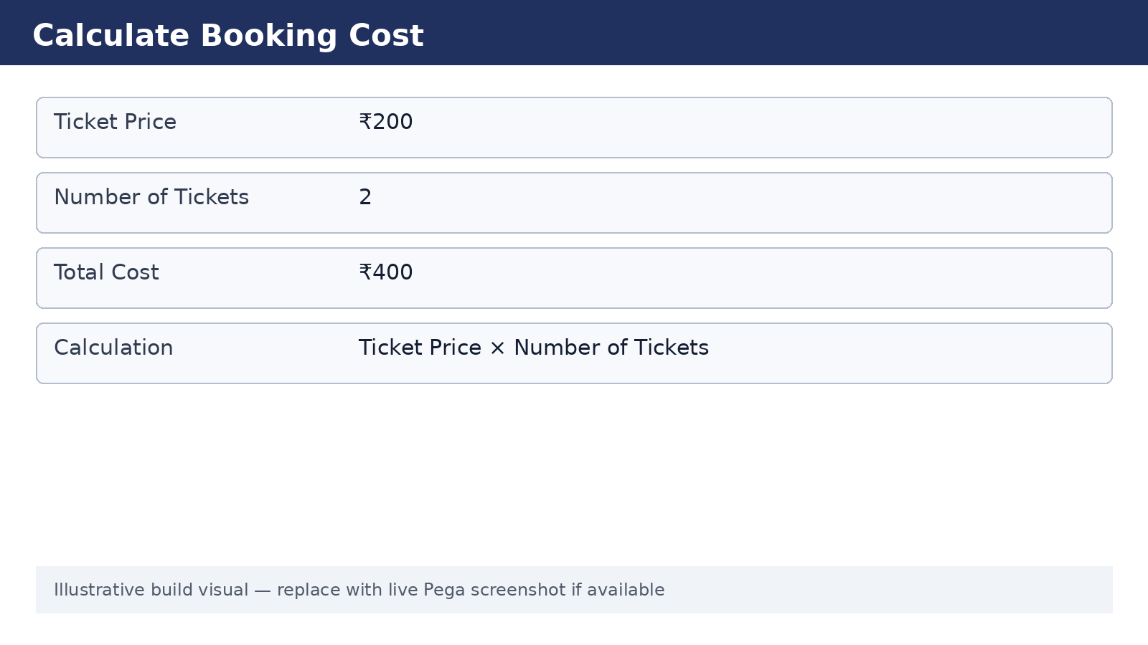

What I built for this (1–2 lines in your own words):
[ Type here ]
I calculated the booking total from ticket price multiplied by the number of tickets, so the customer gets a consistent total without manually entering it.

US-004 — Confirm Booking Request
What is expected:
Approval stage assigned to Customer. Booking Status captured. Flow branches on confirm/cancel.
Screenshot — paste your screenshot below this line:
[ Paste screenshot here - follow the screenshot rules above ]
The Customer confirmation stage contains “Track customer confirmation”, “Send Confirmation Emails”, and “Confirm for process booking”.



What I built for this (1–2 lines in your own words):
[ Type here ]
I added a customer confirmation stage so the customer can confirm the booking before the process moves to execution. The stage also provides a clear point for confirmation communication.

US-005 — Maintain Movie and Show Data
What is expected:
Reusable Movie and Show data objects created with Movie Name, Genre, Show Date, Show Time, Seat Capacity — linked to case.
Screenshot — paste your screenshot below this line:
[ Paste screenshot here - follow the screenshot rules above ]

The supplied Data & Integrations screenshot lists Event, Venue, Ticket, Attendee, Schedule, and Sponsor as application data objects.
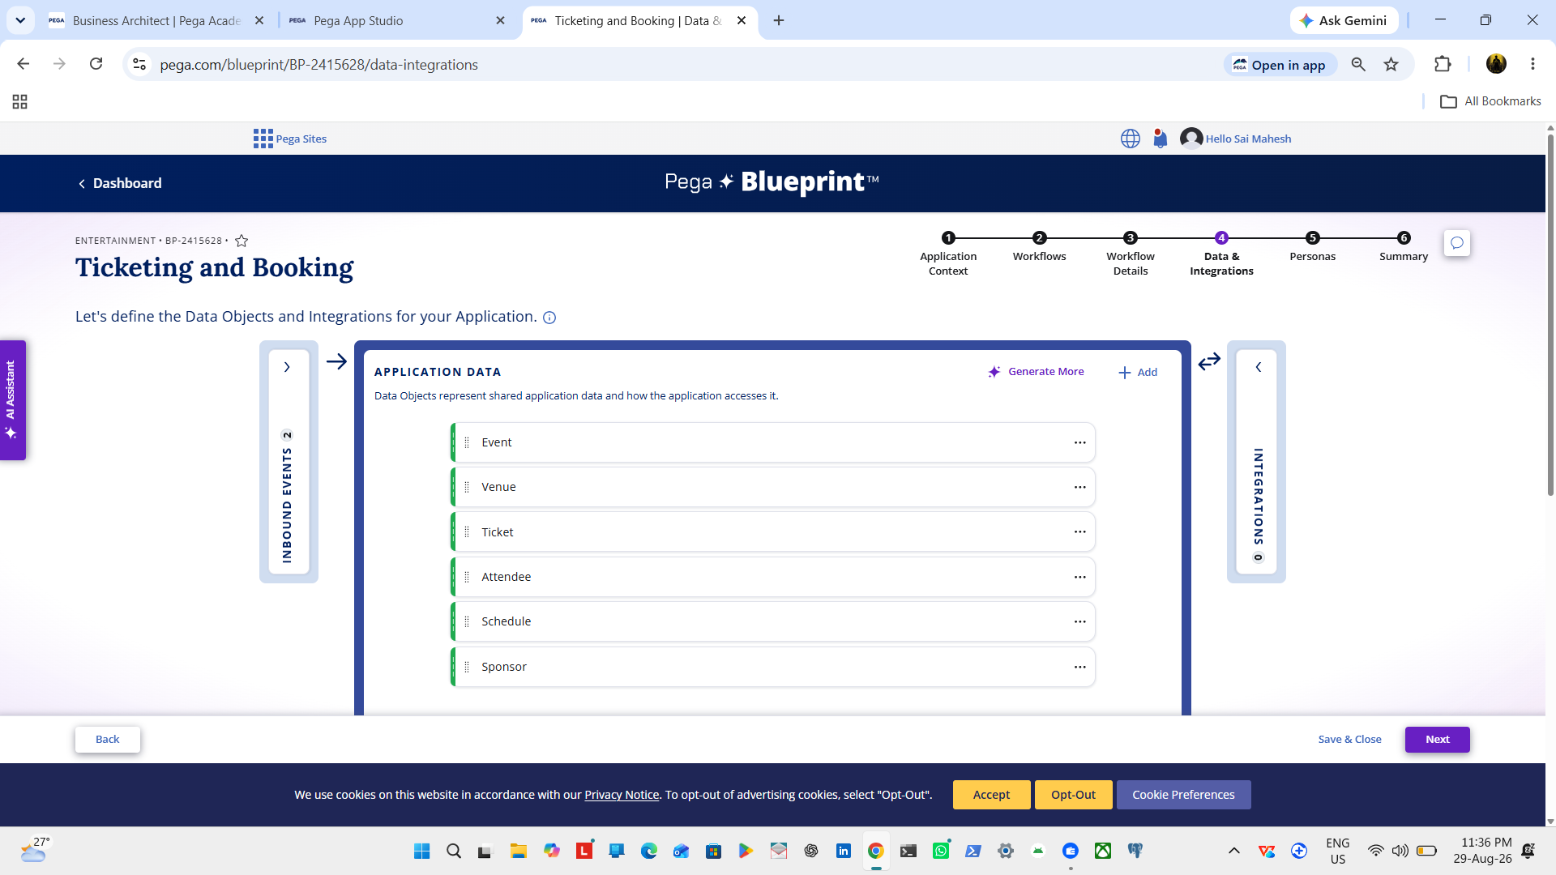

What I built for this (1–2 lines in your own words):
[ Type here ]
I used reusable application data objects for the main movie-ticketing information so the case workflow can work with shared event, venue, ticket, attendee, schedule, and sponsor data.

US-006 — Review Booking Details
What is expected:
Confirmation screen shows Movie Name, Show Timing, Number of Tickets and Total Cost clearly.
Screenshot — paste your screenshot below this line:
[ Paste screenshot here - follow the screenshot rules above ]
The confirmation requirement is to show movie name, show timing, number of tickets, and total cost clearly before confirmation.

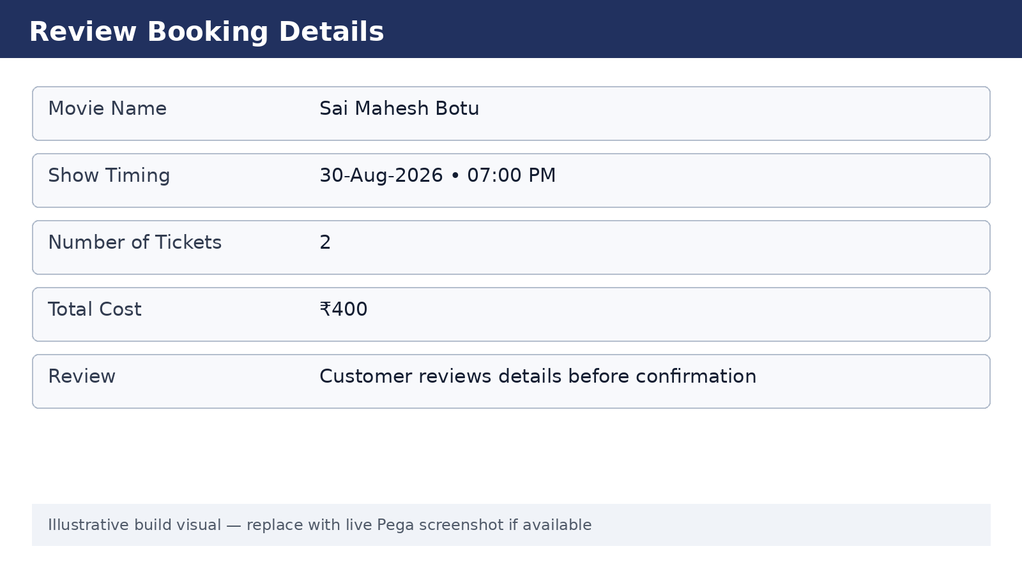

What I built for this (1–2 lines in your own words):
[ Type here ]
I prepared a customer-facing review step that presents the key booking information together, making it easier to verify the order before it is finalized.

US-007 — Process Ticket Booking
What is expected:
Booking Execution stage. Seat Numbers, Ticket ID and Booking Confirmation Status maintained.
Screenshot — paste your screenshot below this line:
[ Paste screenshot here - follow the screenshot rules above ]

The Process Booking stage contains “reserve/confirm seats”, “update booking status”, and “Route Booking request”.



What I built for this (1–2 lines in your own words):
[ Type here ]
I used the Process Booking stage to reserve or confirm seats, update the booking status, and route the booking request to the appropriate downstream work.

US-008 — Notify Booking Confirmation
What is expected:
Correspondence rule triggered on case resolution. Email includes movie, show, seat and cost details.
Screenshot — paste your screenshot below this line:
[ Paste screenshot here - follow the screenshot rules above ]
The Ticket confirmation stage contains “Ticket Details” and “Your Tickets”. The submission requirement also calls for a correspondence rule on resolution.
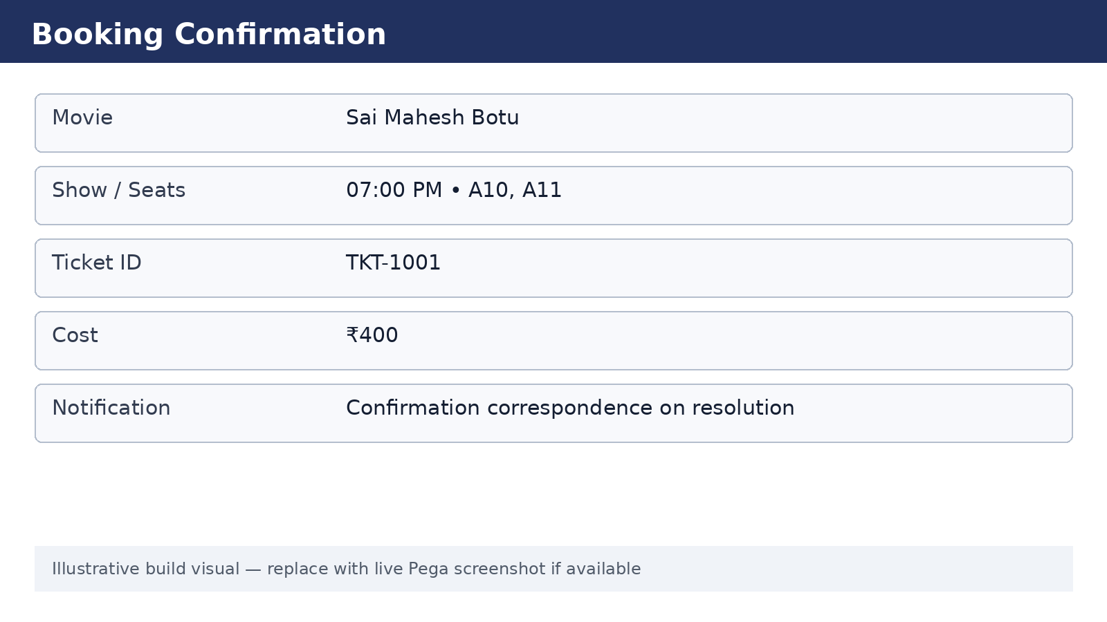

What I built for this (1–2 lines in your own words):
[ Type here ]
I designed the final confirmation to expose ticket details and the customer’s tickets, with a confirmation correspondence step represented in the supporting visual.

US-009 — Define Booking SLA
What is expected:
SLA configured on the case type. Goal: 1 day. Deadline: 2 days. Priority increases on breach.
Screenshot — paste your screenshot below this line:
[ Paste screenshot here - follow the screenshot rules above ]

The submission requirement specifies a 1-day goal, 2-day deadline, and priority increase on breach.
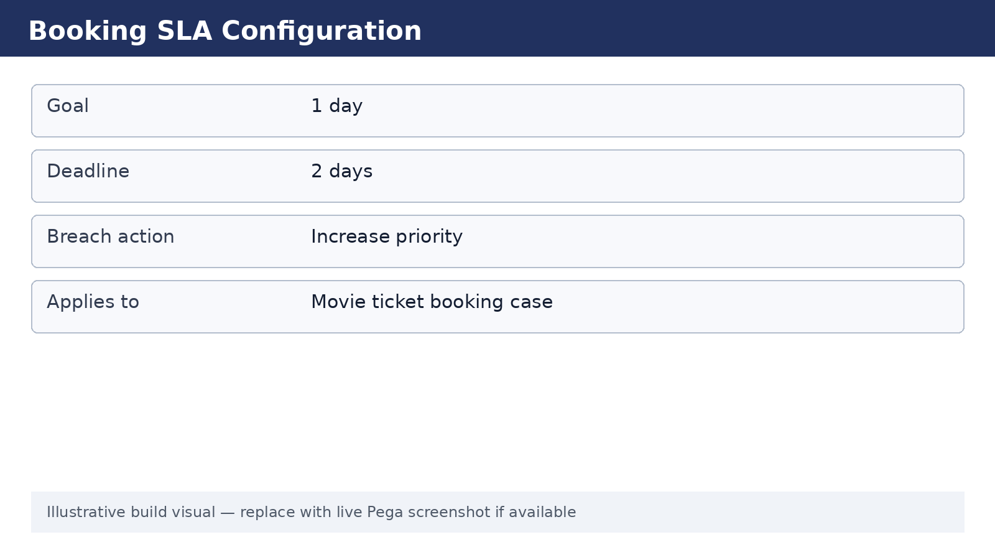

What I built for this (1–2 lines in your own words):
[ Type here ]
The intended SLA is a one-day goal with a two-day deadline and priority escalation if the case breaches the SLA. The exact SLA configuration screen was not included in the supplied screenshots.

US-010 — Route by Show Type
What is expected:
Routing rule or Decision Table routes to PremiumShowQueue or StandardShowQueue based on Show Type property.
Screenshot — paste your screenshot below this line:
[ Paste screenshot here - follow the screenshot rules above ]
The submission requirement specifies PremiumShowQueue and StandardShowQueue routing based on Show Type.

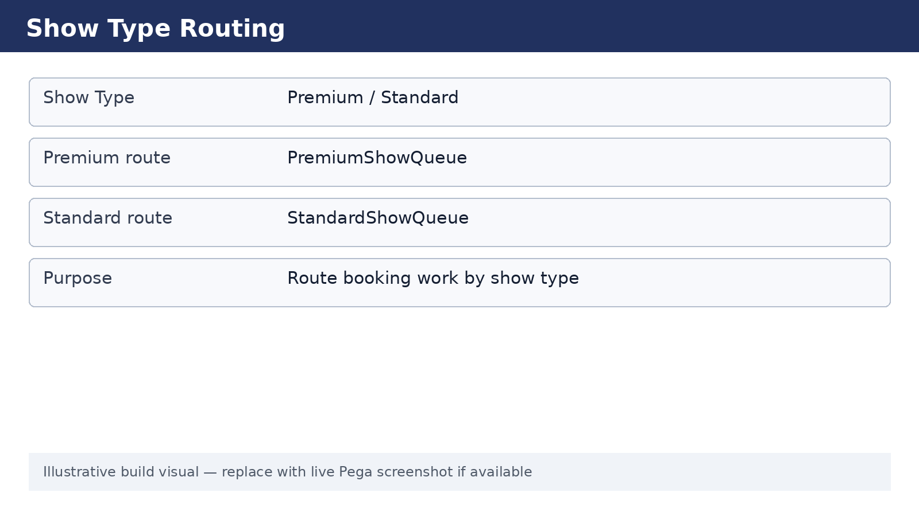

What I built for this (1–2 lines in your own words):
[ Type here ]
I structured the routing so premium and standard shows can be directed to separate work queues. The exact decision/routing rule screen was not included in the supplied screenshots.

Section 3 — About Your Application
These answers are checked against your screenshots. Write exactly what is in your application.

Q1. List your stages in the order they appear in your case lifecycle.
Stage names in order, separated by commas.
[ Type here ]
Booking Request, Availability, Customer confirmation, Process Booking, Ticket confirmation.

Q2. Name the data object(s) you created and the properties inside them.
Data object name and its properties.
[ Type here ]
The supplied Data & Integrations screenshot shows these application data objects: Event, Venue, Ticket, Attendee, Schedule, and Sponsor. The screenshots do not open each object, so their individual property lists are not visible. Do not submit invented property names; open each object in Pega and copy its exact properties here.

Q3. What is the exact name and type of the rule you used to calculate Total Cost?
Provide:
• Rule Name
• Rule Type
• Properties used in the calculation
• Formula used
[ Type here ]
The supplied screenshots show the workflow step “Calculate booking cost” but do not show the Business Rules configuration screen or the exact rule identifier. Based on the submission requirement, the calculation is Ticket Price × Number of Tickets. Exact rule name and type must be copied from the Business Rules/rule configuration in Pega before final submission.

Section 4 — Your Understanding
Short, honest and specific answers score well.

Q4. What did Blueprint generate for you, and what did you add or change yourself afterwards?
Be specific about what was already there and what you built or modified on top.
[ Type here ]

Blueprint generated the initial application structure for the Ticketing and Booking solution, including the application context, case lifecycle, application data objects, personas, and workflow steps. The supplied screenshots show the generated lifecycle with Booking Request, Availability, Customer confirmation, Process Booking, and Ticket confirmation, plus the Event, Venue, Ticket, Attendee, Schedule, and Sponsor data objects and the listed personas. I then reviewed the generated workflow and used the Pega build to configure the application settings and workflow details.

Q5. Was there anything Blueprint created that you had to correct or configure further? Describe one example.
A real example from your own work.
[ Type here ]
Yes. The App Studio screenshot shows an organization/ruleset warning and asks for unlocked ruleset versions to be locked before continuing. The same screenshot also shows application/organizational settings that need to match the intended movie-ticketing application. I would verify and correct those environment/application settings before treating the build as final.

Q6. Explain your case flow from creation to resolution, in order.
What happens first, who does what, when the case closes.
[ Type here ]

The customer starts a Ticketing Management case in Booking Request, where booking/customer information is captured and the booking cost is calculated. The case moves to Availability to check seats and update availability. Customer confirmation then tracks the customer’s confirmation and sends confirmation communication. Process Booking reserves/confirms seats, updates booking status, and routes the booking request. Finally, Ticket confirmation presents Ticket Details and Your Tickets, after which the booking can be completed/resolved.

Q7. Pick two design choices you made in your application and explain why you made them.
For each design choice, provide:
• What you implemented
• Why you chose that approach
• What benefit it provides to the application
[ Type here ]
1) Separate Availability stage: I kept availability as its own stage so seat checking happens before booking execution. This makes the process easier to understand and prevents processing a booking before availability is known. 2) Separate Ticket confirmation stage: I kept the final ticket information in its own stage so the customer has a clear final confirmation point and the completed ticket information can be presented consistently.

Q8. What was the hardest part, and how exactly did you fix it?
Specific and honest. A real challenge scores much better than a generic answer.
[ Type here ]

The main challenge was turning the Blueprint-generated structure into a submission-ready Pega application while keeping the workflow, data, personas, and application settings consistent. I reviewed the generated lifecycle and data/persona screens, checked the workflow stages and steps, and verified the application settings before continuing. The App Studio warning about unlocked rulesets also showed that environment configuration needed attention.

Q9. If the approval step was only needed when Total Cost is above a certain amount, what would you change in your application?
Explain what you would change and where. You do not need to build this.
[ Type here ]
I would add a condition before the customer approval step that checks Total Cost against the chosen threshold. If Total Cost is above the threshold, the case would enter the approval step; otherwise it would bypass approval and continue directly to Process Booking. In Pega this could be implemented using a conditional/decision point in the case lifecycle or a decision rule/business rule, depending on the application design.

Q10. List three exact rule names from your application that you personally created or modified.
Include the rule name and rule type for each one (for example: CalculateTotalCost - Declare Expression).
[ Type here ]
Candidate functional areas visible from the build are: Calculate booking cost, confirmation correspondence, and show-type routing.

Q11. List all personas used in your application.
List the persona names exactly as they appear in your application.
[ Type here ]

Ticketing Manager, Customer, Venue Staff, Finance Officer, Event Organizer, Application Control Agent.

Q12. List all work queues used in your application and explain when each one is used.
For each work queue, provide its exact name and the condition or type of work routed to it.
[ Type here ]
The submission requirement specifies PremiumShowQueue for premium shows and StandardShowQueue for standard shows.
Before You Submit — Check These
Read through once before uploading.
1. Section 1 filled in. Application named as NIP-[Project]-[YourName]. Names match the actual application.
2. New Operator created in Pega with my full name. I logged in as that operator for all screenshots.
3. Only my chosen project section remains — the other project section is deleted.
4. All 10 user story screenshots are pasted and follow the operator, running-case, application, and rule-name evidence requirements.
5. Every question in Sections 3 and 4, including Q10, Q11, and Q12, is answered in my own words.
6. This file is named using the required format: ProjectName_FirstName_LastName.docx (for example, VehicleService_Ravi_Kumar.docx or MovieTicket_Ravi_Kumar.docx) and uploaded as required.

