*Wavelet based Image fusion for Kidney Stone Detection*

Chekkala Saimanideep  
*School of Electronics Engineering*  
*Vellore Institute of Technology*Vellore, India  
chekkalasai.manideep2019@vitstudent.ac.in

Thanikaiselvan V  
*School of Electronics Engineering*  
*Vellore Institute of Technology*Vellore, India  
thanikaiselvan@vit.ac.in

*Abstract*— Image fusion is a process of integrating two or more images into a single image with more details and information. The high pass sub-bands in the 2-D DWT domain provide important features for image fusion algorithm. The Wavelet used here is Haar Wavelet. Kidney stones occur due to an excess of wastes in the blood. We use Morphological Analysis detection of kidney stone from the ultrasound images of kidney. The suggested approach locates stones using location coordinates. To remove the noises, median filtering is used. The filtered image is taken as input for morphological segmentation process. This will help to detect the stone in kidney

Keywords—2-D Discrete Wavelet Transform, Haar Wavelet, CT and MRI images, Morphological Operation, Ultrasound images

# Introduction

Image fusion is the process of combining information from multiple images of different modality, focus, view, sensors and time into a single image with complementary information and without redundant information. The fused image gives a better description than the source images and also it has better quality in the aspects of contrast, edge, texture and information. The kidney is a vital organ in the human body. Kidney stones have been a widespread problem in recent years. Kidney stones are solid pieces of material that form as a result of minerals in the urine. If the stone is not identified early on, the situation might get serious, and surgery may be required to remove the stone. With the help of Ultrasound images, we will identify the stones formed in kidneys

# Objective

Study of Wavelet Image fusion Technique and obtain a fused image of CT and MRI images. Image fusion involves two or more images to attain the most useful features for some specific applications. Kidney-stones can be a life-threatening situation. Therefore, timely diagnosis is very essential. To ensure the efficacy of surgical operations, it is necessary to precisely diagnose kidney stones. Detection of Stones formed in kidneys by using Ultra Sound Images. We aim to detect kidney stone by using of CT images.

# LITERATURE REVIEW

Yong Yang, Dong sun park, Nini Rao [1] In this modal a novel wavelet-based approach for medical image fusion is presented, which is developed by taking into not only account the characteristics of human visual system (HVS) but also the physical meaning of the wavelet coefficients. After the medical images to be fused are decomposed by the wavelet transform, different-fusion schemes for combining the coefficients are proposed coefficients in low-frequency band are selected with a visibility-based scheme, and coefficients in high-frequency bands are selected with a variance based method. S M Mahbubur Rahman, M Omair Ahmad, M.N.s. Swamy [2] proposed a novel contrast-based image fusion algorithm in the wavelet domain for noisy source images. The discrete wavelet transform has been significantly successful in the development of fusion algorithms for noise-free images as well as in image denoising algorithms. Experiments are carried out on a number of commonly-used greyscale and colour test images to evaluate the performance of the proposed method. Mahesh K. Jat ,Pradeep Kumar Garg, Susheela Dahiya [3] discussed the use of high-resolution images for identification of urban features through pixel-based image fusion techniques. Fusion techniques are used to merge high spatial resolution panchromatic image with low spatial resolution multispectral image to enhance the visual quality/appearance of some of the urban features present in the image. The fused images are interpreted on the basis of visual comparison, correlation coefficients and histogram statistics. All fusion techniques result in a change of the statistical parameters of the original images.

Wenlong Zhang, Xiaolin Liu, Wuchao Wang, Yujun Zeng [4] proposes a novel wavelet-based algorithm for the fusion of multi-exposed images. The luminance inversion is suppressed and the contrast of the fused image is enhanced, by introducing the brightness of input images into the well-exposedness weight. A novel enhancement function was proposed to enhance the details of the fused image. The proposed multi-exposure fusion scheme consists of three steps, transforming the input images into YUV space and fusing the color-difference components U and V according to the saturation weight, transforming the luminance component Y into the wavelet domain and fusing the corresponding approximate sub-bands and detail sub-bands by the well-exposedness weight and adjusted contrast weight, respectively, and transforming the fused image back into RGB space to obtain the final result. Michel Roux, M. He , X. Li [5] Image fusion is a process of integrating complementary information from multiple images of the same scene such that the resultant image contains a more accurate description of the scene than any of the individual source images. A method for fusion of multifocus images is presented. It combines the traditional pixel-level fusion with some aspects of feature-level fusion. First, multifocus images are decomposed using a redundant wavelet transform. Then the edge features are extracted to guide coefficient combination. Finally, the fused image is reconstructed by performing the inverse RWT. Min Fen Shen, Zhi Fei Su, Jin Yao Yang, Li Sha Sun [6] proposed a multi-focus image fusion algorithm based on redundant wavelet transform. For different frequency domain of redundant wavelet decomposition, the selection principle of high-frequency coefficients and low-frequency coefficients is respectively discussed. The fusion rule is that,the selection of low frequency coefficient is based on the local area energy, and the high frequency coefficient is based on local variance combining with matching threshold.

Saurabh Prasad, Wei Li, James Edwin Fowler, Lori Bruce [7] Hyperspectral imagery comprises high-dimensional reflectance vectors representing the spectral response over a wide range of wavelengths per pixel in the image. The resulting high-dimensional feature spaces often result in statistically ill-conditioned class-conditional distributions. Conventional methods for alleviating this problem typically employ dimensionality reduction such as linear discriminant analysis along with single-classifier systems, yet these methods are suboptimal and lack noise robustness. In contrast, a divide-and-conquer approach is proposed to address the high dimensionality of hyperspectral data for effective and noise-robust classification. Michele Griffa, Rolf Kaufmann, Andreas Maier, Christian Riess [8] presents a proof-of-concept study for differentiating kidney stones using X-ray dark-field tomography. Imaging techniques that are commonly used for the detection of kidney stones, such as X-ray CT and ultrasound, are insufficient to differentiate the types of kidney stones. The most important advantage of this method is its ability to image non-homogeneous kidney stones, i.e., to localize and identify the individual components of mixed-material kidney stones. They use a weighted total-variation regularized reconstruction method to compute the ratio of dark-field over absorption signal from noisy projections.

Viswanath Kala, Dr.Gunasundari R [9] The abnormalities of the kidney can be identified by ultrasound imaging. The kidney may have structural abnormalities like kidney swelling, change in its position and appearance. Kidney abnormality may also arise due to the formation of stones, cysts, cancerous cells, congenital anomalies, blockage of urine etc. The ultrasound images are of low contrast and contain speckle noise. This makes the detection of kidney abnormalities rather challenging task. Thus preprocessing of ultrasound images is carried out to remove speckle noise.

Kalannagari Viswanath, Dr.Gunasundari R [10] The detection of kidney stones using ultrasound imaging is a highly challenging task as they are of low contrast and contain speckle noise. This challenge is overcome by employing suitable image processing techniques. The ultrasound image is first preprocessed to get rid of speckle noise using the image restoration process. The restored image is smoothened using Gabor filter and the subsequent image is enhanced by histogram equalization. The preprocessed image is achieved with level set segmentation to detect the stone region. They are trained by multilayer perceptron and back propagation ANN to classify and its type of stone with an accuracy of 98.8%.

X. Li, S.-Y. Qin [11] proposed a novel method to fuse infrared and visible images based on compressive sensing theory. The method combined Contourlet Transform with Wavelet Transform to increase the sparsity of transformed coefficients and also to improve sample patterns and fusion rules. Firstly, the original images were decomposed in a Contourlet domain, and orthogonal wavelet transform was applied to the high level decomposed coefficients. Then, the composite double radially sampling mode with different sampling rates in each decomposition level was used to perform the linear measurements of coefficients and to fuse the measurement values using different rules in each level. Finally, the fused image was reconstructed by using nonlinear conjugate-gradient solution.

Anjan Gudigar , Raghavendra U, Jyothi Samanth, U Rajendra Acharya [12] Chronic Kidney disease is a progressive disease affecting more than twenty million individuals in the United States. Disease progression is often characterized by complications such as cardiovascular diseases, anemia, hyperlipidemia and metabolic bone diseases etc., Based on estimated GFR values, the disease is categorized in 5 stages which significantly influence patient outcome. As the CKD pathology directly impacts cardiovascular disease, the US imaging shows structural and hemodynamic adaptation. Hence, the development of a computer-aided diagnosis (CAD) model to predict CKD would be desirable, and can potentially improve treatment.

Wang Xin, Wei You-Li, Liu fu [13] proposed a new fusion method of infrared and visible video sequence based on the shift-invariant discrete wavelet transformation. Firstly the approximate target regions of each single-frame infrared image are detected by weighted information entropy. Secondly the new fusion algorithm based on SIDWT is proposed to fuse the target regions of the registered infrared and visible images. Lastly the fused target regions are fused with the background regions of visible sequences.

Annameti Rohith [14] The accuracy and sensitivity of median filter (n=114) was compared with rank filter (n=114). The median filter is used to detect the kidney stone in ultrasound images. 114 is the sample size taken with the p-value 0.8 and has been used to improve detection rate of kidney stones in terms of accuracy and sensitivity using Matlab simulation tool. (PDF) Detection of Kidney Stones in Ultrasound Images Using Median Filter Compared with Rank Filter.

Y.-R. Zhou, A.-H. Geng, Q. Zhang [15] proposed a novel method to fuse infrared and visible images based on compressive sensing theory. The method combined Contourlet Transform (CT) with Wavelet Transform (WT) to increase the sparsity of transformed coefficients and also to improve sample patterns and fusion rules. Firstly, the original images were decomposed in a Contourlet domain, and orthogonal wavelet transform was applied to the high level decomposed coefficients. Then, the composite double radially sampling mode with different sampling rates in each decomposition level was used to perform the linear measurements of coefficients and to fuse the measurement values using different rules in each level. Finally, the fused image was reconstructed by using nonlinear conjugate-gradient solution.

# FUSION RULES

## Activity Level Achivement

The process of measuring an activity level (quality of a pixel in an image) can be categorized into three methods as Coefficient based, Window based and Region based measures. Coefficient Based Activity (CBA)- In CBA, the activity level is measured as given in Eq. 1,

$(P) = |(p)| or AI (p) = |DI(p)|2$



Where, AI(p) - the activity level of a pixel at position p. Window Based Activity (WBA)-The WBA employ a small (typically 3 × 3 or 5 ×5) window centred at the current coefficient position. Thus, the activity level AI(p) is determined by the coefficients surrounding p using a small window.

## Coefficient combining methods

Coefficient combining is the process of combining low-frequency and high-frequency coefficients from the source images. Selection- The simplest selection method is choose-max (CM) as given in Eq. 2,

$Dz \left(p\right)=\left\{\begin{aligned}Dx\left(p\right), if Ax\left(p\right)≥ Ay\left(p\right) \\ \left(p\right), if(p)≤ Ay(p)\end{aligned}\right.$



In the high-frequency bands, the larger DWT coefficient corresponds to sharpness, brightness changes and thus leads to the salient features in the image such as edges, lines, and region boundaries. Therefore, the CM method is useful in the collection of detailed information. Weighted average (WA) - For each p, the composite DZ is obtained using Eq. 3,

$Dz (p) = Wx(p)Dx(p) + Wy(p) Dy(p)$



# 2D DISCRETE WAVELET TRANSFORM

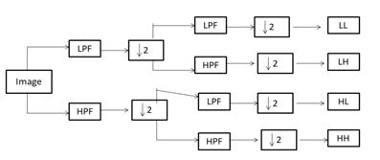

Fig. 1 One stage of 2-D Discrete Wavelet Transform multi resolution image decomposition

*Step 1*:- The images to be fused must be registered to assure that the corresponding pixels are aligned.

*Step 2*:- These images are decomposed into wavelet transformed images, respectively, based on wavelet transformation. The transformed images with K-level decomposition will include one low-frequency portion (low-low band) and 3K high-frequency portions (low-high bands, high-low bands, and high-high bands).

*Step 3*:- The transform coefficients of different portions or bands are performed with a certain fusion rule.

*Step 4*:- The fused image is constructed by performing an inverse wavelet transform based on the combined transform coefficients from Step 3.

The discrete wavelet transform (DWT) is an implementation of the wavelet transform using a discrete set of the wavelet scales and translations obeying some defined rules. In other words, this transform decomposes the signal into mutually orthogonal set of wavelets, which is the main difference from the continuous wavelet transform (CWT), or its implementation for the discrete time series sometimes called discrete-time continuous wavelet transform (DT-CWT).

The discrete wavelet transform (DWT), which applies a two- channel filter bank (with down sampling) iteratively to the low pass band (initially the original signal). The wavelet representation then consists of the low-pass band at the lowest resolution and the high-pass bands obtained at each step. This transform is invertible and non redundant.

# LOW FREQUENCY BAND FUSION

Low-Frequency Band Fusion, to simplify the description of the different alternatives available in forming a fusion rule, as in [5, 24] we also consider only two source images, X and Y, and the fused image Z. The fusion rule first calculates the window-based visibility of all coefficients in the low-frequency band. The visibility of wavelet coefficients is defined as given in Eq. 4-6,

$VI(p) = \frac{1}{W^{2}} \sum_{\left(i,j\right)∈Bw}{ Λ}(\overline{D}(p)) . \frac{|D\left(m+i, n+j,k,l\right)-D^{'}\left(p\right)|}{(\overline{D}(p)) }$

$\overline{D}(p)= \frac{1}{W^{2}} \sum_{\left(i,j\right)∈Bw}{D\left(m+i, n+j,k,l\right) }$

$Λ(\overline{D}(p)) = {(\frac{1}{\overline{D}(p) })}^{α}$







In Eq. 4 Bw is a w × w block, VI(p) denote the visibility in the block and in Eq. 6 Λ(D'(p)) is the weighting factor, α is a visual constant obtained by perceptual experiment.

# HIGH FREQUENCY BAND FUSION

Since the purpose of image fusion requires that the fused image must not discard any useful information contained in the source images and effectively preserve the details of input images such as edges, lines, and region boundaries. It is generally believed that the details of an image are mainly included in the high-frequency of the image.

$σ_{1}(p) = \frac{1}{(S×T)} \sum_{–s/2}^{s/2}{\sum_{-T/2}^{T/2}{(DI(m+s,n+t,k,l)}} -mean1(p) )2$

$Mean,(p) = \frac{1}{(S×T)} \sum_{–s/2}^{s/2}{\sum_{-T/2}^{T/2}{(DI(m+s,n+t,k,l)}})$





Where S × T is the neighboring size, and mean(p), σ1(p) denote the mean value and variance value of the coefficients centered at (m, n) in the window of S×T, respectively. The fusion scheme used for the high-frequency bands can be illustrated as in Eq. 9. Schematic diagram of the proposed fusion rule is given in Fig. 2.

$Dz \left(p\right)=\left\{\begin{aligned}Dx\left(p\right), if σx\left(p\right)≥ σy\left(p\right) \\ D\left(p\right), if σx(p)≤ σy(p)\end{aligned}\right.$



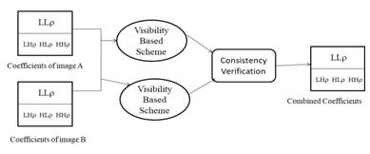

Fig. 2 Schematic diagram of the proposed fusion rule.

# HAAR WAVELET TRANSFORM

The Haar wavelet transform (HWT) has gained widespread acceptance in signal processing and image compression. Because of their inherent multi-resolution nature, wavelet-coding schemes are especially suitable for applications where scalability and tolerable degradation are important. Haar wavelets are the fastest to compute and simplest to implement. Other types of wavelets might give better results but at a higher cost. Perform a standard 2D Haar wavelet decomposition of every image in the database.

# KIDNEY STONE DETECTION USING ULTRASOUND IMAGES

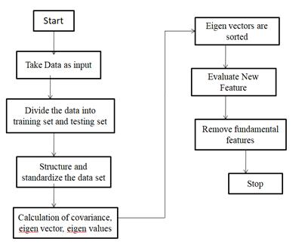

Fig. 3 Steps of PCA-based feature extraction

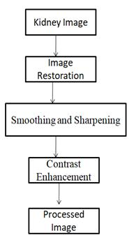

Fig. 4 Pre Processing of kidney Image

# MORPHOLOGICAL ANALYSIS

Morphological analysis is the process of examining possible resolutions to unquantifiable, complex problems involving many factors. Morphological analysis takes a problem with many known solutions and breaks them down into their most basic elements, or forms, in order to more completely understand them. For general problem solving, morphological analysis provides a formalized structure to help examine the problem and possible solutions. The elements of a problem and its solutions are arranged in a matrix to help eliminate illogical solutions.

## Applications

* Dilation adds pixels to boundary of an object. Dilation makes objects more visible and fills in small holes in the object.
* Erosion removes pixels from the boundary of an object. Erosion removes islands and small objects so that only substantive objects remain.
* You can use morphological opening to remove small objects from an image while preserving the shape and size of larger objects in the image.
* A flood fill operation assigns a uniform pixel value to connected pixels, stopping at object boundaries.
* You can use neighborhood processing to find global and regional minima and maxima in images.

## Discription of Proposed scheme

* The proposed image processing model first takes a fresh RGB image as an input which is collected from clinical laboratory.
* Thereafter, we convert the image from RGB to Gray and keep pixel values greater than 20 (threshold value) in order to binarized the gray scale image.
* We observed that the process of binarization provides better result for the pixels greater than 20. Now if there exist holes at the background then we need to fill those holes as a part of morphological operation.
* Then removes all connected components that have fewer than 1000 pixels. In this experiment, a rectangular polygon is considered as a region of interest.

# PERFORMANCE MEASURES

## Standard Deviation

The standard deviation of an image with size of M * N is defined in Eq. 10. Where f (m, n) is the pixel value of the fused image at the position (m, n), μ is the mean value of the image.

$\hat{} = (\frac{1}{M × N} \sum_{m=1}^{M}{\sum_{n=1}^{N}{{(f\left(m,n\right)-\hat{µ})^2)}^{1/2}}}$



## Average Gradiant

The average gradient of an image with size of M * N is defined in Eq. 11. Where f (m, n) is the same meaning as in the standard deviation. The average gradient reflects the clarity of the fused image.

$Avg = \frac{1}{\left(M-1\right)×(N-1)} \sum_{m=1}^{M-1}{\sum_{n=1}^{N-1}{\sqrt{\frac{[{\left(\frac{∂f\left(m,n\right)}{∂m}\right)}^{2}+ {\left(\frac{∂f\left(m,n\right)}{∂n}\right)}^{2}]}{2}}}}$



## Information Entropy

The formulation of the classical information entropy of an image is defined in Eq. 12. Where L is the number of gray level, and Pl equals the ratio between the number of pixels whose gray value is l (0 ≤ l ≤ L−1) and the total pixel number contained in the image.

$H= -{}_{l=0}^{L-1}P_{i}\log_{2}P_{i}$



## Cross Entropy

The cross entropy is used to measure the difference between the source images and the fused image. Small value corresponds to good fusion result obtained in Eq. 13. Where Pl and Ql denote the gray level histogram of the source image and fused image, respectively.

$CE={}_{l=0}^{L-1}P_{i}\log_{2}\frac{P_{l}}{Q_{l}}$

      

# RESULTS

## Wavelet Based Fused Image

*Fig 5 :- CT Image Fig 6 :- MRI Image Fig 7:- Fused Image*

*Fig 8 :- Fusion results of the CT and MR images*

## Kidney Stone Detection for Ultrasound Images

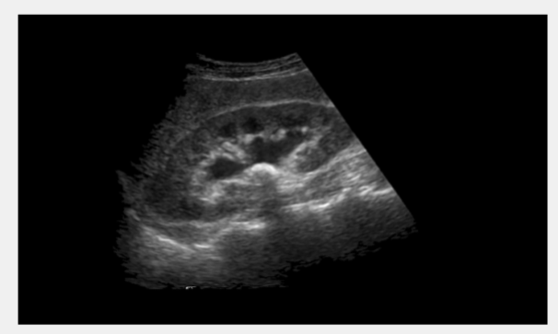

*Fig 9:- Input Image*

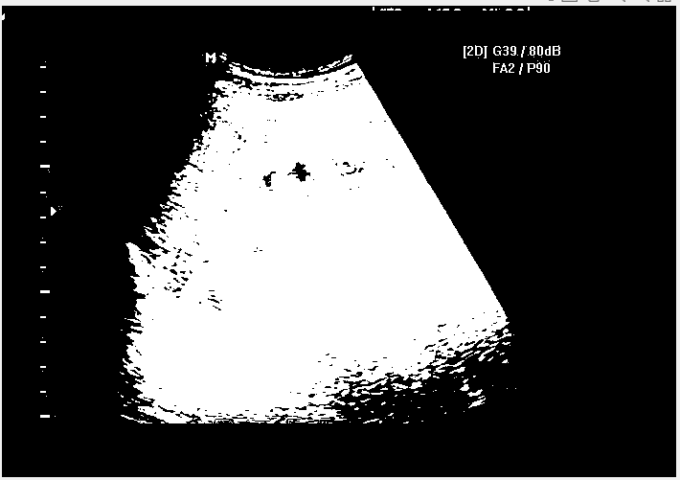

*Fig 10 :- Grey Image*

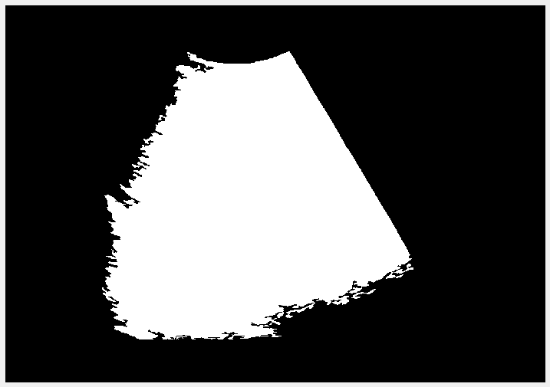

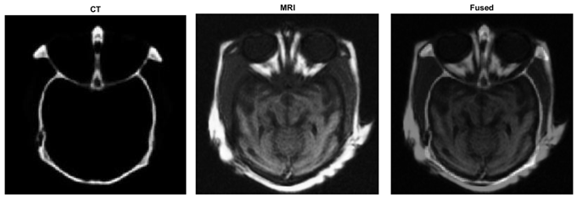

*Fig 11 :- Region of interest*

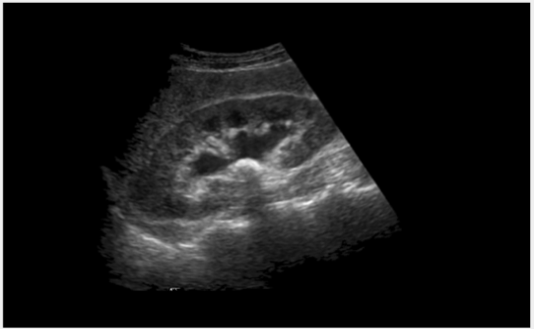

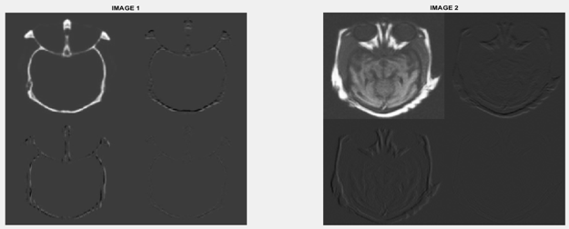

*Fig 12:- Preprocessed Image*

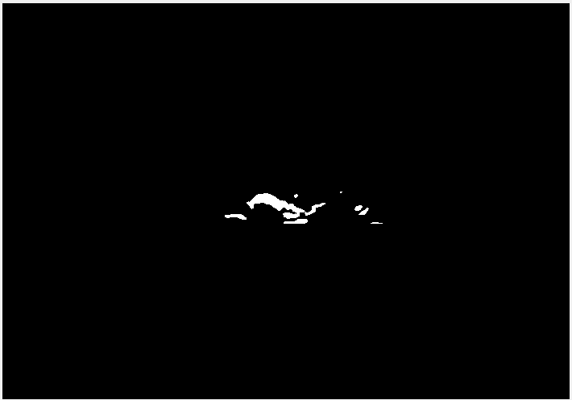

*Fig 13 :- Stone Detected*

For the Above input image the stone is detected

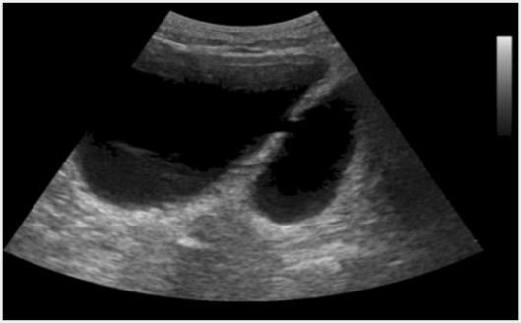

*Fig 14:- Input Image*

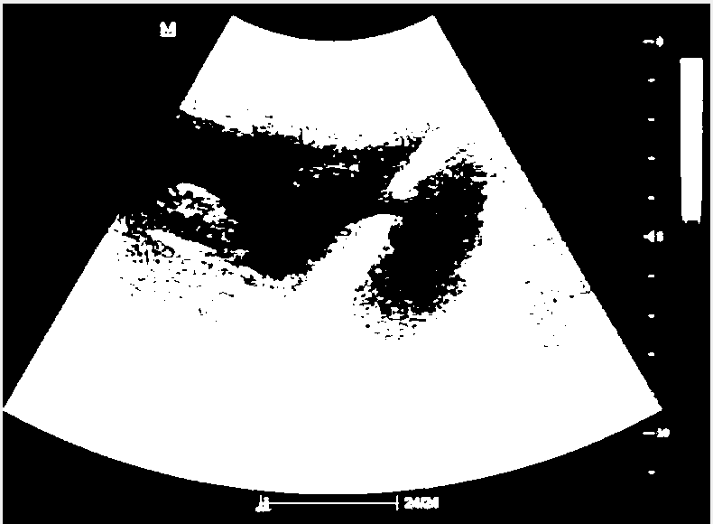

*Fig 15 :- Grey Image*

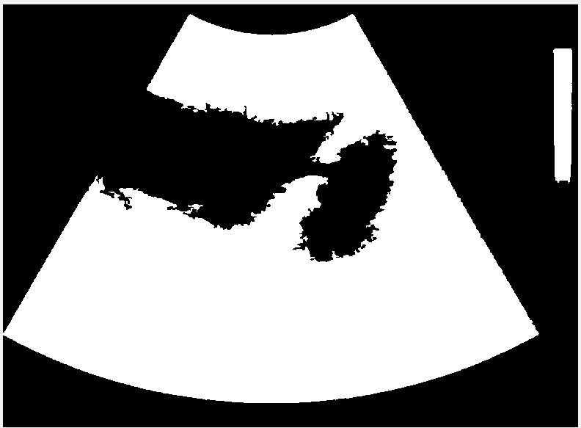

*Fig 16 :- Region of interest*

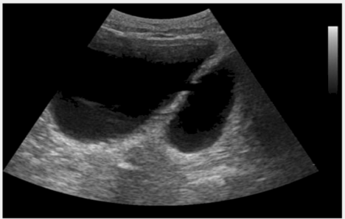

*Fig 17:- Preprocessed Image*



*Fig 18 :- Stone not Detected Image*

For the Above Image the stone is not detected

## Kidney Stone Detection in CT Images

# 

*Fig 19 :- Input Image*

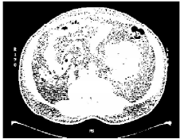

*Fig 20 :- Grey Image*

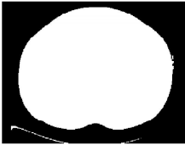

*Fig 21 :- Region of Interest*

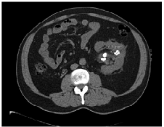

*Fig 22 :- Preprocessed Image*

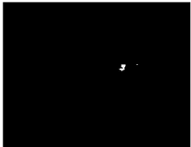

Fig 23 :- Stone Detected

For the Above input image the stone is detected

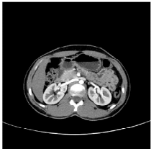

*Fig 24:- Input Image*

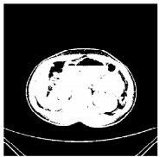

*Fig 25 :- Grey Image*



*Fig 26:- Region of Interest*

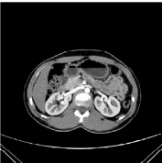

*Fig 27 :- Pre Processed Image*



*Fig 28 :- Stone not Detected Image*

For the Above Image the stone is not detected

We combined wavelet transform and various fusion rules to fuse CT and MRI images. Using this method we fused other head and abdomen images. The images used here are grayscale CT and MRI images. The image fusion process is defined as gathering all the important information from multiple images, and their inclusion into fewer images, usually a single one. This single image is more informative and accurate than any single source image, and it consists of all the necessary information.

Pre-processing, fragmentation and feature extraction on the input image are the basic and crucial functions of our proposed scheme for detecting the presence of kidney stones. A feature extraction procedure was used to measure the exact coordinates of the stone and the overall appearance of the stones created from the image. The accuracy of this method is 96.82%.

# Tabulation

In this table, we have calculated the standard deviation, Average Gradient, Information and Cross entropies for the following DWT fusion method

|  |  |  |  |  |
| --- | --- | --- | --- | --- |
| Fusion Method | Standard Deviation | Average Gradiant | Information entrophy | Cross Entrophy |
| DWT | 41.152 | 6.734 | 6.178 | 1.9428 |

Table 1

# Conclusion

##### The fusion of two modality images such as CT/MRI is combining the complimentary and redundant information both image in one, which increases the ease of perception, less time, and reduced storage space. The Image fusion helps us to visualize the structure of the body that includes water and fat modules. Image Fusion is a technique for taking very clear and detailed pictures of tissues and internal organs using high frequency radio waves delivered in pulses and a strong magnetic field. It is used to identify inflammation or infection in an organ, degenerative diseases, strokes, musculoskeletal disorders, tumors and other irregularities that exist in tissue or organs in their body.

First examines images of ultrasound and CT scans of patients with stones on the MATLAB platform. Next, we create the organizing component before moving on to the rest of the process. This method can be extended by identifying the area of ​​the kidney stone and estimating the size of the stone. It can be used to make the accurate position of the stone. The abnormalities of the kidney can be identified by ultrasound imaging. The kidney may have structural abnormalities like kidney swelling, change in its position and appearance. By using this morphological analysis we can able to identify stones formed in the kidneys.

# References

[1] Prema T. Akkasaligar, Sunanda Biradar, Veena Kumbar, Kidney stone detection in computed tomography images, 2017 International Conference On Smart Technologies For Smart Nation

[2] P. Mirajkar Pradnya, D. Ruikar Sachin, Wavelet based image fusion techniques, 2013 International Conference on Intelligent Systems and Signal Processing DOI: 10.1109/ISSP21356.2013 1-2 March 2013

[3] Yujie Xu, Huabin Wang, Xiumei Yin, Liang Tao, MRI and PET/SPECT Image Fusion Based on Adaptive Weighted Guided Image Filtering, 2020 IEEE 5th International Conference on Signal and Image Processing (ICSIP) DOI: 10.1109/ICSIP49896.2020 23-25 Oct. 2020

[4] Xuan Yang, Qingchao Zeng, Xun Liu, Qingliang Jiao, Ming Liu , CT and MRI image fusion based on weight difference between L1 and L2 norm, 2021 IEEE 2nd International Conference on Big Data, Artificial Intelligence and Internet of Things Engineering (ICBAIE) DOI: 10.1109/ICBAIE52039.2021 26-28 March 2021

[5] V. Amala Rani, S. Lalithakumari, A Hybrid Fusion Model for Brain Tumor Images of MRI and CT, 2020 International Conference on Communication and Signal Processing (ICCSP) DOI: 10.1109/ICCSP48568.2020 28-30 July 2020

[6] Akanksha Soni, Avinash Rai, Kidney Stone Recognition and Extraction using Directional Emboss & SVM from Computed Tomography Images, 2020 Third International Conference on Multimedia Processing, Communication & Information Technology (MPCIT) DOI: 10.1109/MPCIT51588.2020 11-12 Dec. 2020

[7] Siddharth Rajput, Abhilasha Singh, Ritu Gupta, Automated Kidney Stone Detection Using Image Processing Techniques, 2021 9th International Conference on Reliability, Infocom Technologies and Optimization (Trends and Future Directions) (ICRITO) DOI: 10.1109/ICRITO51393.2021 3-4 Sept. 2021

[8] Wan Mahani Hafizah, Eko Supriyanto, Jasmy Yunus, Feature Extraction of Kidney Ultrasound Images Based on Intensity Histogram and Gray Level Co-occurrence Matrix, 2012 Sixth Asia Modelling Symposium DOI: 10.1109/AMS20807.2012 29-31 May 2012

[9] Praveen R Mirajkar, Kishan Ashok Bhagwat, ArunVikas Singh, Ashalatha M E, Acute ischemic stroke detection using wavelet based fusion of CT and MRI images, 2015 International Conference on Advances in Computing, Communications and Informatics (ICACCI) DOI: 10.1109/ICACCI35697.2015 10-13 Aug. 2015

[10] Jionghua Teng, Xue Wang, Jingzhou Zhang, Suhuan Wang, Wavelet-based texture fusion of CT/MRI images, 2010 3rd International Congress on Image and Signal Processing DOI: 10.1109/CISP16830.2010 16-18 Oct. 2010