VISVESVARAYA TECHNOLOGICAL UNIVERSITY
Belagavi, Karnataka – 590018
BALLARI INSTITUTE OF TECHNOLOGY AND MANAGEMENT
Department of Computer Science and Engineering
Python Programming
MICRO PROJECT REPORT
TO-DO LIST APPLICATION
A Python-based Graphical Task Management System
Submitted in partial fulfilment of the requirements for the Micro Project
5th Semester, B.E. — Computer Science and Engineering (CSE), VTU
Submitted by:
Sai Meghana R
USN: 3BR24CS141
Under the Guidance of
Ms. Mayuri
Academic Year 2026 – 2027

TO-DO LIST APPLICATION
CERTIFICATE
This is to certify that the Micro Project entitled “To-Do List Application — A Python-based Graphical Task Management System” is a bonafide work carried out by [STUDENT NAME] [USN / REGISTER NUMBER], a student of the 5th Semester, B.E. in Computer Science and Engineering, Ballari Institute of Technology and Management, in partial fulfilment of the requirements prescribed by the Visvesvaraya Technological University (VTU) for the said course, during the academic year 2026 – 2027.
The Micro Project report has been approved as it satisfies the academic requirements with respect to the project work prescribed for the course.

____________________________ _____________________ Signature of Guide Signature of HOD
Ms. Mayuri Dr. R N Kulkarni
DECLARATION
I, , Sai Meghana R [3BR24CS141], a student of the 5th Semester, B.E. in Computer Science and Engineering at Ballari Institute of Technology and Management, hereby declare that the Micro Project entitled “To-Do List Application — A Python-based Graphical Task Management System” has been independently carried out by me under the guidance of Ms. Mayuri, and submitted in partial fulfilment of the requirements for the award of the said course as prescribed by the Visvesvaraya Technological University (VTU).
I further declare that this report is a record of genuine work done by me and has not been submitted, either in part or in full, for the award of any other degree or diploma of this or any other institution.

Date: ______________________________
Sai Meghana R
3BR24CS141
ACKNOWLEDGEMENT
I would like to express my sincere gratitude to my guide, Ms. Mayuri, for the valuable guidance, encouragement, and support extended throughout the course of this Micro Project.
I am also thankful to the Head of the Department, Department of Computer Science and Engineering, and to the faculty members of Ballari Institute of Technology and Management (BITM) for providing the necessary resources and a conducive learning environment.
Finally, I extend my heartfelt thanks to my family and friends for their constant motivation and support during the completion of this project.

TO-DO LIST APPLICATION
TABLE OF CONTENTS
Section | Page
1. Project Title | 6
2. Problem Statement | 7
3. Objective | 8
4. Skills Required | 9
5. Software Requirements | 10
6. Functional Requirements | 11
7. Algorithm / Flowchart | 12
8. Data Structures and Algorithms Used | 13
9. Python Implementation | 14–18
10. Sample Input and Output | 19–22
11. Exception Handling | 23
12. File Handling | 24
13. Testing | 25
14. Future Enhancements | 26
15. Conclusion | 27
Appendix A — Complete Python Source Code | 28 onward

1. Project Title
The To-Do List Application is a Python desktop application developed using Tkinter. It provides a graphical interface for creating, viewing, updating, deleting, searching, completing, and saving tasks.
The application includes login authentication, dashboard statistics, due-date reminders, priority handling, completion progress, and local JSON-based persistence.
- Task attributes are stored as name, priority, due date, and status.
- Dashboard cards show total, pending, completed, and overdue counts.
- View Tasks supports filtering and priority sorting.
- Search Task performs keyword-based sequential search.
- JSON persistence stores selected tasks locally.

2. Problem Statement
Managing assignments, project work, study activities, and personal reminders can become difficult when tasks are maintained only in notebooks or scattered notes. A user needs a simple application where tasks can be entered once, reviewed later, updated when requirements change, and marked as completed after finishing.
The project addresses the need for an offline desktop task management system with a clear graphical interface. It organizes tasks using a structured collection, calculates dashboard statistics, identifies overdue tasks from due dates, and provides search and filtering facilities.
A further requirement is persistence. Tasks saved by the user should remain available when the application is opened again. Therefore, JSON file handling is used for local storage.
The project demonstrates Data Structures and Algorithms through list-based storage, sequential search, filtering, priority-based sorting, counting, and date comparison.

3. Objective
The main objective is to develop a user-friendly Python GUI application that simplifies task organization while demonstrating core programming and DSA concepts.
- Develop an interactive Tkinter desktop GUI.
- Provide login authentication.
- Add tasks with priority and due date.
- Display total, pending, completed, and overdue statistics.
- Support viewing, filtering, sorting, searching, updating, deleting, and completing tasks.
- Persist selected tasks using JSON.
- Validate task names, dates, and task numbers.
- Display completion progress and due-date reminders.

4. Skills Required
- Python programming: functions, loops, conditions, lists, dictionaries, modules, and exceptions.
- Tkinter GUI engineering: frames, labels, buttons, entries, comboboxes, Treeview, Toplevel windows, and event handling.
- Data structures: list of task dictionaries.
- Searching: sequential search and duplicate detection.
- Sorting/filtering: priority mapping, status filtering, and list sorting.
- File handling: JSON reading and writing.
- Date processing: datetime.strptime() and date comparison.
- Error handling: try-except and messagebox feedback.
The application is modular, with separate functions for adding, viewing, deleting, updating, completing, searching, saving, clearing, and dashboard updates.

5. Software Requirements
Category | Requirement
Operating System | Windows 10 / Windows 11 recommended
Programming Language | Python 3.8 or higher
GUI | Tkinter / ttk
Storage | tasks.json
IDE | Visual Studio Code / PyCharm / IDLE
Modules | tkinter, ttk, messagebox, json, os, datetime
Hardware | Dual-core processor, 4 GB RAM or higher
No third-party package is required for the submitted implementation.

6. Functional Requirements
Module / Feature | Functionality
Login | Validates username and password before opening the dashboard.
Dashboard | Displays total, pending, completed, overdue and progress.
Add Task | Creates a task with name, priority, due date and Pending status.
View Tasks | Displays tasks and supports filtering and priority sorting.
Delete Task | Deletes a selected task and removes its saved copy.
Update Task | Changes task name, priority and due date.
Mark Completed | Changes a selected task to Completed.
Search Task | Searches task names using a keyword.
Save Tasks | Saves only the selected task to tasks.json.
Clear Saved Tasks | Clears saved tasks after confirmation.
Reminder | Shows tasks due today and overdue pending tasks.
Exit | Closes the application.

7. Algorithm / Flowchart
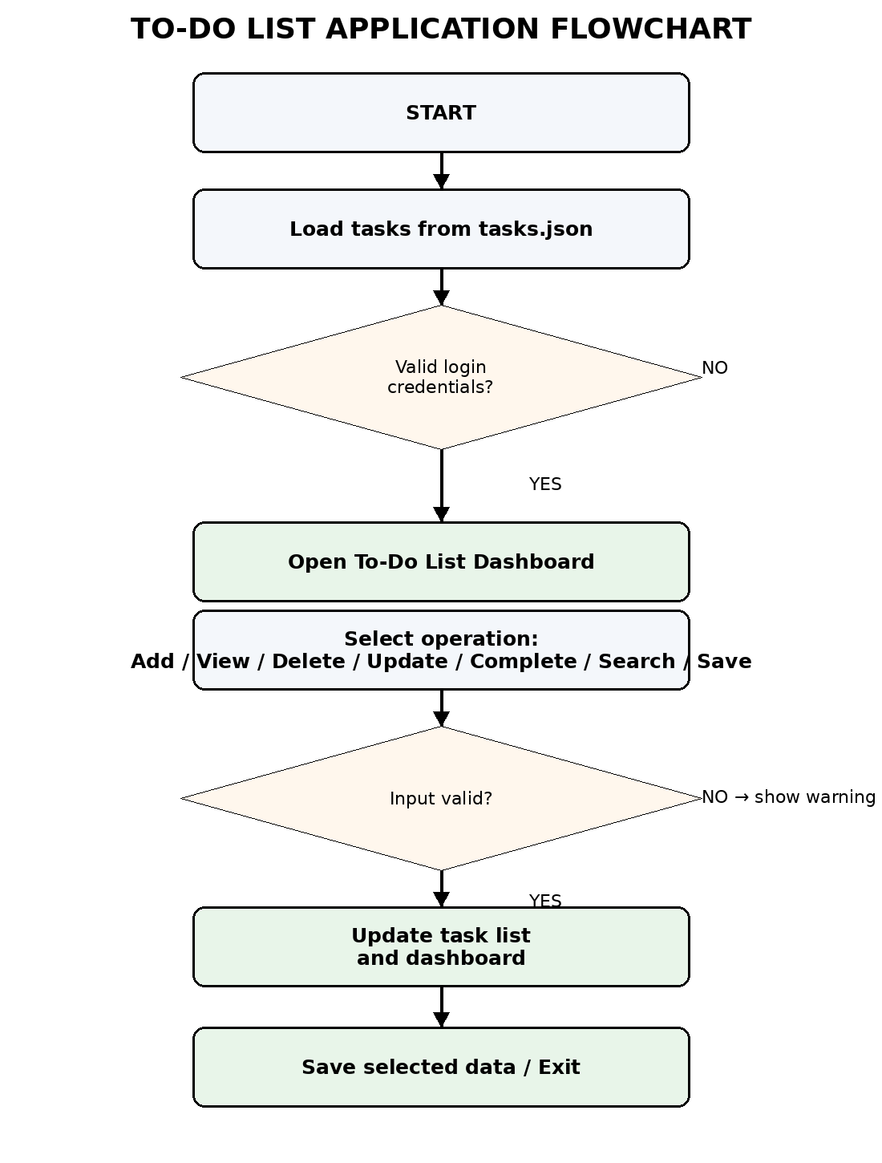
Figure 1: Algorithm / Flowchart of the To-Do List Application
- Start and load saved tasks from tasks.json.
- Display login and validate credentials.
- Open the dashboard when login is successful.
- Calculate dashboard counts and completion percentage.
- Wait for the selected task-management operation.
- Validate the required input.
- Update the task collection and dashboard.
- Save selected task data when requested.
- Check due-date reminders.
- Exit the application.

8. Data Structures and Algorithms Used
Concept | Use
List | Stores the current task collection.
Dictionary | Represents each task record.
Sequential Search | Searches task names and checks duplicates.
Filtering | Selects Pending, Completed, High, Medium, or Low tasks.
Sorting | Orders tasks High → Medium → Low.
Counting | Counts completed and overdue tasks.
Date Comparison | Compares due dates with today's date.
JSON Serialization | Persists Python task data locally.
The list-of-dictionaries representation is appropriate for a small offline application because records can be appended, indexed, updated, removed, filtered, and traversed directly.

9. Python Implementation — Data and Login
The program imports Tkinter, ttk, messagebox, json, os, and datetime. The global tasks list stores the current task collection and FILE_PATH points to tasks.json.
tasks = []

FILE_PATH = os.path.join(
os.path.dirname(os.path.abspath(__file__)),
"tasks.json"
)

def read_saved_tasks():
if not os.path.exists(FILE_PATH):
return []
try:
with open(FILE_PATH, "r") as file:
data = json.load(file)
if isinstance(data, list):
return data
return []
except:
return []
The login() function compares the entered username and password with the configured credentials. A valid login opens the dashboard; invalid credentials produce an error message.

9.1. Python Implementation — Dashboard and Statistics
The dashboard creates four statistic cards: TOTAL TASKS, PENDING, COMPLETED, and OVERDUE. Completion progress is calculated from the completed-to-total ratio.
def update_dashboard():
total = len(tasks)
completed = 0

for task in tasks:
if task["status"] == "Completed":
completed += 1

pending = total - completed
overdue = get_overdue_count()

if total > 0:
progress = (completed / total) * 100
else:
progress = 0
The dashboard also schedules check_reminders(), which identifies tasks due today and pending tasks whose due dates have passed.

9.2. Python Implementation — Add Task and View Tasks
add_task() opens a Toplevel form. The task name, priority and due date are collected and validated. Duplicate names are rejected.
new_task = {
"name": name,
"priority": priority,
"due_date": due_date,
"status": "Pending"
}

tasks.append(new_task)
update_dashboard()
window.destroy()
show_message("Task added! Use Save Tasks to save it.")
view_tasks() uses ttk.Treeview and supports All, Pending, Completed, High, Medium and Low filters. Priority sorting uses a mapping where High=1, Medium=2 and Low=3.

9.3. Python Implementation — Delete, Update and Completion
delete_task() validates the task number, removes the selected dictionary from the list, removes its saved copy, and refreshes the dashboard.
update_task() changes the selected task's name, priority and due date after validation.
tasks[number - 1]["status"] = "Completed"
update_saved_task(tasks[number - 1])
update_dashboard()
window.destroy()
show_message("Task marked as completed!")
mark_completed() changes the selected task status to Completed and updates its saved version.

9.4. Python Implementation — Search and Save
search_task() performs a sequential scan through the tasks list. The keyword and task names are converted to lowercase before comparison, making the search case-insensitive.
save_tasks() saves only the selected task. Before writing, it checks whether a task with the same name already exists in the JSON file. write_saved_tasks() uses json.dump(..., indent=4).
clear_saved_tasks() asks for confirmation and then writes an empty saved-task list.

10. Sample Input and Output
[
{
"name": "Complete DSA Assignment",
"priority": "High",
"due_date": "15-08-2026",
"status": "Pending"
},
{
"name": "Prepare Python Report",
"priority": "Medium",
"due_date": "18-08-2026",
"status": "Pending"
},
{
"name": "Submit Project",
"priority": "High",
"due_date": "10-08-2026",
"status": "Completed"
},
{
"name": "Review Notes",
"priority": "Low",
"due_date": "20-08-2026",
"status": "Pending"
}
]
For this demonstration dataset, the dashboard shows Total Tasks = 4, Pending = 3, Completed = 1, Overdue = 0 and Completion Progress = 25%.

10.1. Sample Input and Output — Login
The application begins with a login screen. The screenshot below is the actual output supplied with the project.
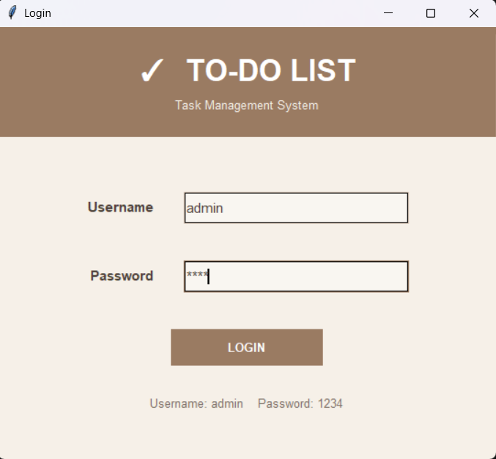
Figure 2: Login screen of the To-Do List Application
Sample input: Username = admin and Password = 1234. The login() function validates these values before opening the dashboard.

10.2. Sample Input and Output — Dashboard
After successful login, the dashboard displays the application title, statistics, progress bar and menu.
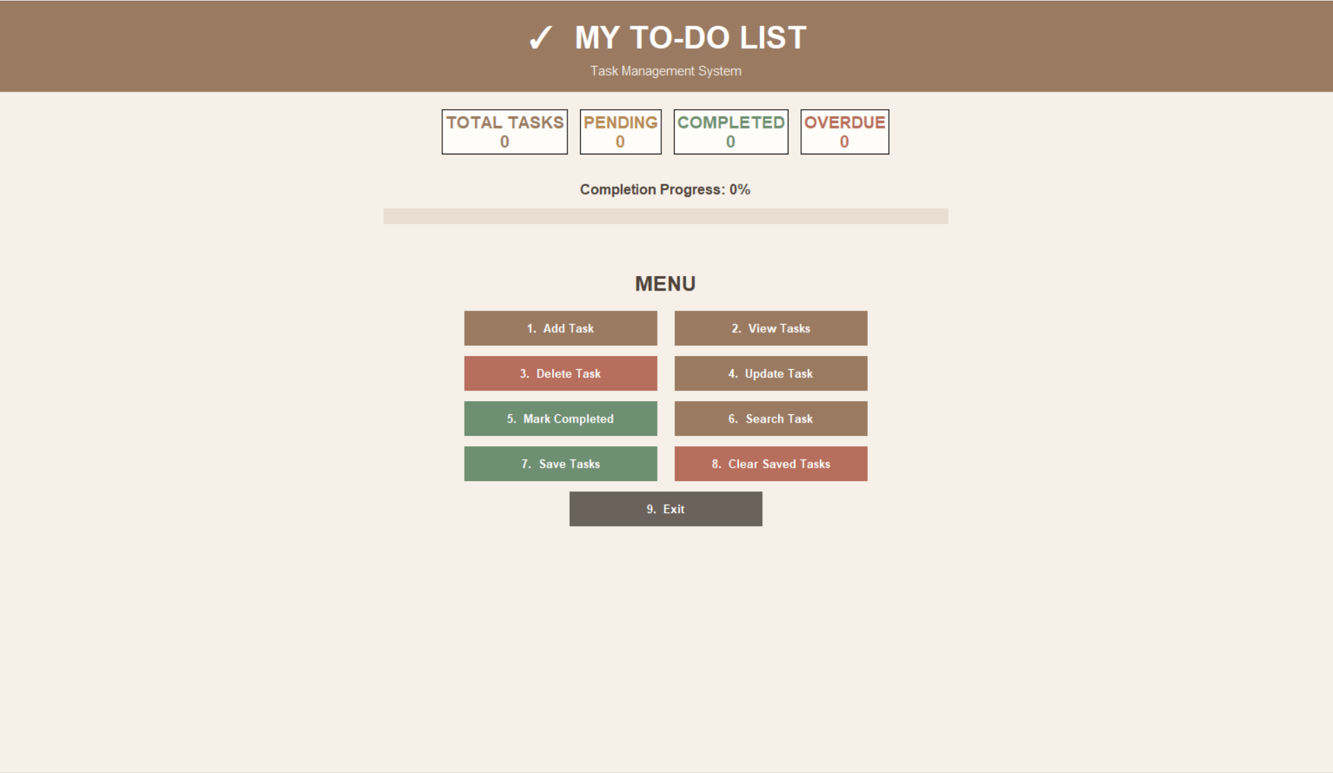
Figure 3: Dashboard output supplied with the project
The menu provides Add Task, View Tasks, Delete Task, Update Task, Mark Completed, Search Task, Save Tasks, Clear Saved Tasks and Exit.

10.3. Sample Input and Output — Task Operations
The following additional screenshots were captured from the submitted program using the same task structure. They demonstrate viewing tasks with priority sorting and searching for a keyword.
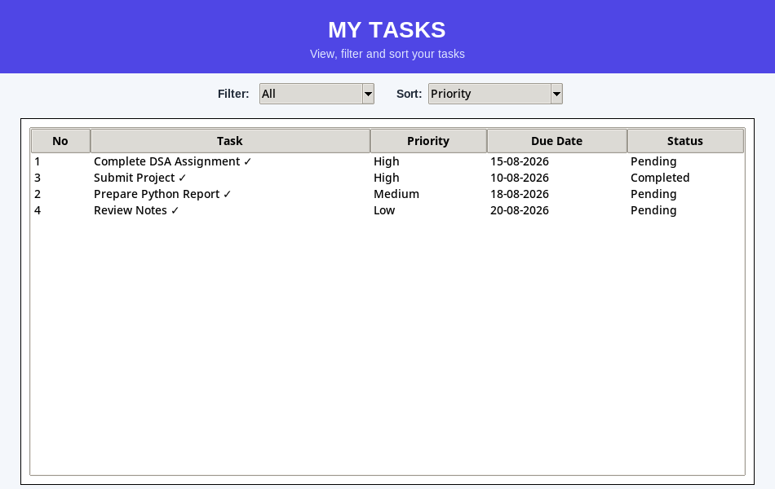
Figure 4: View Tasks screen

10.3. Sample Input and Output — Search Task

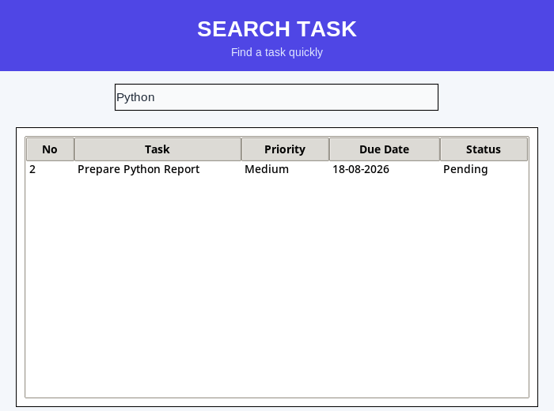
Figure 5: Search Task screen

11. Exception Handling
Exception handling is used throughout the application to handle invalid input and local file problems without crashing the GUI.
Situation | Handling
Missing tasks.json | Returns an empty task list.
Invalid/corrupted JSON | Exception is caught and an empty list is returned.
Empty task name | Warning is displayed.
Empty/invalid due date | Warning is displayed and the task is not added.
Duplicate task name | Warning prevents duplicate insertion.
Invalid task number | ValueError/range checks display a warning.
Save failure | Error message is displayed.
This defensive approach improves stability and user experience.

12. File Handling
The application uses local JSON persistence through tasks.json. os.path.exists() checks for the file, json.load() reads it, and json.dump(..., indent=4) writes the saved list.
- read_saved_tasks() reads existing JSON data.
- write_saved_tasks() writes selected saved tasks.
- load_tasks() initializes the global tasks list.
- update_saved_task() replaces a saved task.
- remove_from_saved() removes a deleted task from saved data.
- clear_saved_tasks() writes an empty list after confirmation.
The file is stored locally, so the project does not require an internet connection or external database.

13. Testing
ID | Feature | Test Scenario | Expected Result | Status
TC-01 | Login | Valid username/password | Dashboard opens | PASS
TC-02 | Login validation | Invalid credentials | Error message | PASS
TC-03 | Add Task | Valid task/date | Task added | PASS
TC-04 | Duplicate | Existing task name | Warning displayed | PASS
TC-05 | View Tasks | Open view window | Table displayed | PASS
TC-06 | Filter/Sort | Choose Pending/Priority | Filtered/sorted tasks | PASS
TC-07 | Search | Enter Python | Matching task shown | PASS
TC-08 | Complete | Select task number | Status becomes Completed | PASS
TC-09 | Update/Delete | Valid task number | Task changed/removed | PASS
TC-10 | Persistence | Save and reload | Saved task remains | PASS
TC-11 | Invalid date | Wrong date format | Warning displayed | PASS
TC-12 | Clear saved | Confirm clear | Saved list cleared | PASS

14. Future Enhancements
- Multiple user accounts instead of fixed demo credentials.
- Calendar-based date selection and recurring tasks.
- Task categories/tags for subjects and projects.
- Drag-and-drop ordering.
- More detailed reminder scheduling.
- CSV/PDF export.
- SQLite database for larger task collections.
- Backup and restore of task data.
- Task notes and attachments.
- Improved user profile and dashboard customization.
These enhancements can be added while retaining the current list-and-dictionary design.

15. Conclusion
The To-Do List Application successfully demonstrates how Python can be used to build a practical graphical task management system while applying fundamental Data Structures and Algorithms concepts. The project uses a list of dictionaries to represent tasks and applies searching, filtering, sorting, counting, date comparison and JSON serialization.
The application combines Tkinter GUI development with authentication, dashboard statistics, priority management, due-date reminders, task operations, search and local persistence. The supplied screenshots and additional program outputs demonstrate the main stages of execution.
Overall, the project provides a clear practical example of event-driven GUI programming, list/dictionary data structures, sequential search, priority sorting, exception handling and file management in Python.

Appendix A — Complete Python Source Code
The complete source code used for the To-Do List Application is reproduced below so that the report remains directly traceable to the submitted implementation.
import tkinter as tk
from tkinter import ttk, messagebox
import json
import os
from datetime import datetime

# =========================================================
# DESIGN COLORS
# =========================================================

BG = "#F4F7FB"
CARD = "#FFFFFF"
PRIMARY = "#4F46E5"
PRIMARY_DARK = "#3730A3"
TEXT = "#1F2937"
MUTED = "#6B7280"
SUCCESS = "#16A34A"
WARNING = "#F59E0B"
DANGER = "#DC2626"
BORDER = "#E5E7EB"

# =========================================================
# DATA
# =========================================================

tasks = []

FILE_PATH = os.path.join(
os.path.dirname(os.path.abspath(__file__)),
"tasks.json"
)

# =========================================================
# BASIC FILE FUNCTIONS
# =========================================================

def read_saved_tasks():
if not os.path.exists(FILE_PATH):
return []

try:
with open(FILE_PATH, "r") as file:
data = json.load(file)

if isinstance(data, list):
return data

return []

except:
return []

def write_saved_tasks(saved_tasks):
try:
with open(FILE_PATH, "w") as file:
json.dump(saved_tasks, file, indent=4)

return True

except Exception as e:
print("Error:", e)
return False

# =========================================================
# LOAD TASKS
# =========================================================

def load_tasks():
global tasks
tasks = read_saved_tasks()

# =========================================================
# DATE FUNCTIONS
# =========================================================

def get_task_date(task):
try:
return datetime.strptime(
task["due_date"],
"%d-%m-%Y"
).date()

except:
return None

def get_overdue_count():
today = datetime.today().date()
count = 0

for task in tasks:
due = get_task_date(task)

if due is not None:
if due < today and task["status"] != "Completed":
count += 1

return count

def get_today_tasks():
today = datetime.today().date()
today_tasks = []

for i, task in enumerate(tasks):
due = get_task_date(task)

if due == today and task["status"] != "Completed":
today_tasks.append((i, task))

return today_tasks

# =========================================================
# CHECK IF TASK IS SAVED
# =========================================================

def task_is_saved(task):
saved_tasks = read_saved_tasks()

for saved_task in saved_tasks:
if saved_task.get("name", "").lower() == task["name"].lower():
return True

return False

# =========================================================
# UPDATE SAVED VERSION OF A TASK
# =========================================================

def update_saved_task(task):
saved_tasks = read_saved_tasks()

for i, saved_task in enumerate(saved_tasks):
if saved_task.get("name", "").lower() == task["name"].lower():
saved_tasks[i] = task
write_saved_tasks(saved_tasks)
return True

return False

# =========================================================
# REMOVE TASK FROM SAVED FILE
# =========================================================

def remove_from_saved(task):
saved_tasks = read_saved_tasks()
new_saved_tasks = []

for saved_task in saved_tasks:
if saved_task.get("name", "").lower() != task["name"].lower():
new_saved_tasks.append(saved_task)

write_saved_tasks(new_saved_tasks)

# =========================================================
# DUE DATE REMINDER
# =========================================================

def check_reminders():
today_tasks = get_today_tasks()
overdue = get_overdue_count()
message = ""

if today_tasks:
message += "Tasks due today:\n\n"

for index, task in today_tasks:
message += (
str(index + 1)
+ ". "
+ task["name"]
+ " ("
+ task["priority"]
+ ")\n"
)

if overdue > 0:
if message != "":
message += "\n"

message += (
"You have "
+ str(overdue)
+ " overdue task(s)."
)

if message != "":
messagebox.showwarning(
"Task Reminder",
message
)

# =========================================================
# DASHBOARD MESSAGE
# =========================================================

def show_message(text):
message_label.config(
text=text,
fg=SUCCESS
)

root.after(
3000,
lambda: message_label.config(text="")
)

# =========================================================
# UPDATE DASHBOARD
# =========================================================

def update_dashboard():
total = len(tasks)
completed = 0

for task in tasks:
if task["status"] == "Completed":
completed += 1

pending = total - completed
overdue = get_overdue_count()

total_label.config(text="TOTAL TASKS\n" + str(total))
pending_label.config(text="PENDING\n" + str(pending))
completed_label.config(text="COMPLETED\n" + str(completed))
overdue_label.config(text="OVERDUE\n" + str(overdue))

if total > 0:
progress = (completed / total) * 100
else:
progress = 0

progress_bar["value"] = progress

progress_text.config(
text="Completion Progress: "
+ str(int(progress))
+ "%"
)

# =========================================================
# POPUP DESIGN HELPERS
# =========================================================

def popup_header(window, title, subtitle=None):
header = tk.Frame(
window,
bg=PRIMARY,
height=90
)
header.pack(fill="x")
header.pack_propagate(False)

tk.Label(
header,
text=title,
bg=PRIMARY,
fg="white",
font=("Arial", 20, "bold")
).pack(pady=(18, 2))

if subtitle:
tk.Label(
header,
text=subtitle,
bg=PRIMARY,
fg="#E0E7FF",
font=("Arial", 10)
).pack()

def style_entry(entry):
entry.config(
bg="#F9FAFB",
fg=TEXT,
relief="solid",
bd=1,
highlightthickness=1,
highlightbackground=BORDER,
highlightcolor=PRIMARY
)

def make_action_button(parent, text, command, color=PRIMARY, width=20):
return tk.Button(
parent,
text=text,
command=command,
width=width,
height=2,
bg=color,
fg="white",
activebackground=PRIMARY_DARK if color == PRIMARY else color,
activeforeground="white",
font=("Arial", 10, "bold"),
relief="flat",
bd=0,
cursor="hand2"
)

# =========================================================
# ADD TASK
# =========================================================

def add_task():
window = tk.Toplevel(root)
window.title("Add Task")
window.geometry("450x470")
window.resizable(False, False)
window.configure(bg=BG)

popup_header(
window,
"ADD NEW TASK",
"Create a new task"
)

body = tk.Frame(window, bg=BG)
body.pack(fill="both", expand=True, padx=35, pady=20)

tk.Label(
body,
text="Task Name",
bg=BG,
fg=TEXT,
font=("Arial", 10, "bold")
).pack(anchor="w")

task_entry = tk.Entry(
body,
width=40,
font=("Arial", 11)
)
style_entry(task_entry)
task_entry.pack(pady=(5, 14), ipady=6)

tk.Label(
body,
text="Priority",
bg=BG,
fg=TEXT,
font=("Arial", 10, "bold")
).pack(anchor="w")

priority_box = ttk.Combobox(
body,
values=["High", "Medium", "Low"],
state="readonly",
width=37
)
priority_box.pack(pady=(5, 14), ipady=4)
priority_box.set("Medium")

tk.Label(
body,
text="Due Date (DD-MM-YYYY)",
bg=BG,
fg=TEXT,
font=("Arial", 10, "bold")
).pack(anchor="w")

date_entry = tk.Entry(
body,
width=40,
font=("Arial", 11)
)
style_entry(date_entry)
date_entry.pack(pady=(5, 18), ipady=6)

def add():
name = task_entry.get().strip()
priority = priority_box.get()
due_date = date_entry.get().strip()

if name == "":
messagebox.showwarning(
"Warning",
"Please enter a task."
)
return

if due_date == "":
messagebox.showwarning(
"Warning",
"Please enter due date."
)
return

try:
datetime.strptime(due_date, "%d-%m-%Y")
except:
messagebox.showwarning(
"Warning",
"Use DD-MM-YYYY format."
)
return

for task in tasks:
if task["name"].lower() == name.lower():
messagebox.showwarning(
"Warning",
"This task already exists."
)
return

new_task = {
"name": name,
"priority": priority,
"due_date": due_date,
"status": "Pending"
}

tasks.append(new_task)

update_dashboard()
window.destroy()

show_message(
"Task added! Use Save Tasks to save it."
)

make_action_button(
body,
"✓ ADD TASK",
add
).pack(pady=5)

# =========================================================
# VIEW TASKS
# =========================================================

def view_tasks():
window = tk.Toplevel(root)
window.title("View Tasks")
window.geometry("950x600")
window.configure(bg=BG)

popup_header(
window,
"MY TASKS",
"View, filter and sort your tasks"
)

filter_frame = tk.Frame(window, bg=BG)
filter_frame.pack(pady=12)

tk.Label(
filter_frame,
text="Filter:",
bg=BG,
fg=TEXT,
font=("Arial", 10, "bold")
).pack(side="left", padx=5)

filter_box = ttk.Combobox(
filter_frame,
values=[
"All",
"Pending",
"Completed",
"High",
"Medium",
"Low"
],
state="readonly",
width=15
)
filter_box.pack(side="left", padx=5)
filter_box.set("All")

tk.Label(
filter_frame,
text="Sort:",
bg=BG,
fg=TEXT,
font=("Arial", 10, "bold")
).pack(side="left", padx=(20, 5))

sort_box = ttk.Combobox(
filter_frame,
values=[
"Priority",
"Original Order"
],
state="readonly",
width=18
)
sort_box.pack(side="left")
sort_box.set("Priority")

table_frame = tk.Frame(
window,
bg=CARD,
bd=1,
relief="solid"
)
table_frame.pack(
padx=25,
pady=5,
fill="both",
expand=True
)

columns = (
"No",
"Task",
"Priority",
"Due Date",
"Status"
)

table = ttk.Treeview(
table_frame,
columns=columns,
show="headings",
height=18
)

for column in columns:
table.heading(column, text=column)

table.column("No", width=60)
table.column("Task", width=330)
table.column("Priority", width=130)
table.column("Due Date", width=160)
table.column("Status", width=130)

table.pack(
padx=10,
pady=10,
fill="both",
expand=True
)

def display_tasks():
for item in table.get_children():
table.delete(item)

selected_filter = filter_box.get()
selected_sort = sort_box.get()
filtered_tasks = []

for index, task in enumerate(tasks):
if selected_filter == "All":
filtered_tasks.append((index, task))

elif selected_filter == "Pending":
if task["status"] == "Pending":
filtered_tasks.append((index, task))

elif selected_filter == "Completed":
if task["status"] == "Completed":
filtered_tasks.append((index, task))

elif selected_filter in ["High", "Medium", "Low"]:
if task["priority"] == selected_filter:
filtered_tasks.append((index, task))

if selected_sort == "Priority":
priority_order = {
"High": 1,
"Medium": 2,
"Low": 3
}

filtered_tasks.sort(
key=lambda x: priority_order.get(
x[1]["priority"],
4
)
)

for index, task in filtered_tasks:
saved_text = ""

if task_is_saved(task):
saved_text = " ✓"

table.insert(
"",
"end",
values=(
index + 1,
task["name"] + saved_text,
task["priority"],
task["due_date"],
task["status"]
)
)

if len(filtered_tasks) == 0:
table.insert(
"",
"end",
values=(
"",
"No tasks found",
"",
"",
""
)
)

filter_box.bind(
"<<ComboboxSelected>>",
lambda event: display_tasks()
)

sort_box.bind(
"<<ComboboxSelected>>",
lambda event: display_tasks()
)

display_tasks()

# =========================================================
# DELETE TASK
# =========================================================

def delete_task():
if len(tasks) == 0:
messagebox.showinfo(
"Delete Task",
"No tasks available."
)
return

window = tk.Toplevel(root)
window.title("Delete Task")
window.geometry("400x320")
window.resizable(False, False)
window.configure(bg=BG)

popup_header(
window,
"DELETE TASK",
"Remove a task from your list"
)

body = tk.Frame(window, bg=BG)
body.pack(fill="both", expand=True, padx=35, pady=25)

tk.Label(
body,
text="Enter task number:",
bg=BG,
fg=TEXT,
font=("Arial", 10, "bold")
).pack()

number_entry = tk.Entry(
body,
width=20,
font=("Arial", 11)
)
style_entry(number_entry)
number_entry.pack(pady=12, ipady=6)

def delete():
try:
number = int(number_entry.get())

if number < 1 or number > len(tasks):
messagebox.showwarning(
"Warning",
"Invalid task number."
)
return

deleted_task = tasks[number - 1]
del tasks[number - 1]

remove_from_saved(deleted_task)
update_dashboard()

window.destroy()

show_message(
"Task deleted successfully!"
)

except ValueError:
messagebox.showwarning(
"Warning",
"Enter a valid number."
)

make_action_button(
body,
"🗑 DELETE",
delete,
DANGER
).pack(pady=10)

# =========================================================
# UPDATE TASK
# =========================================================

def update_task():
if len(tasks) == 0:
messagebox.showinfo(
"Update Task",
"No tasks available."
)
return

window = tk.Toplevel(root)
window.title("Update Task")
window.geometry("450x500")
window.resizable(False, False)
window.configure(bg=BG)

popup_header(
window,
"UPDATE TASK",
"Edit your selected task"
)

body = tk.Frame(window, bg=BG)
body.pack(fill="both", expand=True, padx=35, pady=15)

tk.Label(
body,
text="Enter task number",
bg=BG,
fg=TEXT,
font=("Arial", 10, "bold")
).pack(anchor="w")

number_entry = tk.Entry(
body,
width=20,
font=("Arial", 11)
)
style_entry(number_entry)
number_entry.pack(pady=(5, 10), ipady=5)

tk.Label(
body,
text="New Task Name",
bg=BG,
fg=TEXT,
font=("Arial", 10, "bold")
).pack(anchor="w")

name_entry = tk.Entry(
body,
width=35,
font=("Arial", 11)
)
style_entry(name_entry)
name_entry.pack(pady=(5, 10), ipady=5)

tk.Label(
body,
text="New Priority",
bg=BG,
fg=TEXT,
font=("Arial", 10, "bold")
).pack(anchor="w")

priority_box = ttk.Combobox(
body,
values=["High", "Medium", "Low"],
state="readonly",
width=32
)
priority_box.pack(pady=(5, 10), ipady=3)
priority_box.set("Medium")

tk.Label(
body,
text="New Due Date",
bg=BG,
fg=TEXT,
font=("Arial", 10, "bold")
).pack(anchor="w")

date_entry = tk.Entry(
body,
width=35,
font=("Arial", 11)
)
style_entry(date_entry)
date_entry.pack(pady=(5, 15), ipady=5)

def update():
try:
number = int(number_entry.get())

if number < 1 or number > len(tasks):
messagebox.showwarning(
"Warning",
"Invalid task number."
)
return

old_task_name = tasks[number - 1]["name"]
name = name_entry.get().strip()
priority = priority_box.get()
due_date = date_entry.get().strip()

if name == "":
messagebox.showwarning(
"Warning",
"Enter task name."
)
return

if due_date == "":
messagebox.showwarning(
"Warning",
"Enter due date."
)
return

try:
datetime.strptime(
due_date,
"%d-%m-%Y"
)
except:
messagebox.showwarning(
"Warning",
"Use DD-MM-YYYY format."
)
return

tasks[number - 1]["name"] = name
tasks[number - 1]["priority"] = priority
tasks[number - 1]["due_date"] = due_date

saved_tasks = read_saved_tasks()

for i, saved_task in enumerate(saved_tasks):
if saved_task.get(
"name",
""
).lower() == old_task_name.lower():

saved_tasks[i] = tasks[number - 1]

write_saved_tasks(
saved_tasks
)
break

update_dashboard()
window.destroy()

show_message(
"Task updated successfully!"
)

except ValueError:
messagebox.showwarning(
"Warning",
"Enter a valid task number."
)

make_action_button(
body,
"✎ UPDATE",
update
).pack(pady=5)

# =========================================================
# MARK COMPLETED
# =========================================================

def mark_completed():
if len(tasks) == 0:
messagebox.showinfo(
"Completed",
"No tasks available."
)
return

window = tk.Toplevel(root)
window.title("Mark Completed")
window.geometry("400x320")
window.resizable(False, False)
window.configure(bg=BG)

popup_header(
window,
"MARK COMPLETED",
"Complete a task"
)

body = tk.Frame(window, bg=BG)
body.pack(fill="both", expand=True, padx=35, pady=25)

tk.Label(
body,
text="Enter task number:",
bg=BG,
fg=TEXT,
font=("Arial", 10, "bold")
).pack()

number_entry = tk.Entry(
body,
width=20,
font=("Arial", 11)
)
style_entry(number_entry)
number_entry.pack(pady=12, ipady=6)

def complete():
try:
number = int(number_entry.get())

if number < 1 or number > len(tasks):
messagebox.showwarning(
"Warning",
"Invalid task number."
)
return

tasks[number - 1]["status"] = "Completed"

update_saved_task(
tasks[number - 1]
)

update_dashboard()
window.destroy()

show_message(
"Task marked as completed!"
)

except ValueError:
messagebox.showwarning(
"Warning",
"Enter a valid number."
)

make_action_button(
body,
"✓ MARK COMPLETED",
complete,
SUCCESS
).pack(pady=10)

# =========================================================
# SEARCH TASK
# =========================================================

def search_task():
window = tk.Toplevel(root)
window.title("Search Task")
window.geometry("700x520")
window.configure(bg=BG)

popup_header(
window,
"SEARCH TASK",
"Find a task quickly"
)

search_entry = tk.Entry(
window,
width=45,
font=("Arial", 11)
)
style_entry(search_entry)
search_entry.pack(pady=15, ipady=6)

columns = (
"No",
"Task",
"Priority",
"Due Date",
"Status"
)

table_frame = tk.Frame(
window,
bg=CARD,
bd=1,
relief="solid"
)
table_frame.pack(
padx=20,
pady=5,
fill="both",
expand=True
)

table = ttk.Treeview(
table_frame,
columns=columns,
show="headings",
height=15
)

for column in columns:
table.heading(
column,
text=column
)

table.column("No", width=50)
table.column("Task", width=200)
table.column("Priority", width=100)
table.column("Due Date", width=130)
table.column("Status", width=100)

table.pack(
padx=10,
pady=10,
fill="both",
expand=True
)

def search():
for item in table.get_children():
table.delete(item)

keyword = search_entry.get().lower().strip()

for i, task in enumerate(tasks):
if keyword in task["name"].lower():
table.insert(
"",
"end",
values=(
i + 1,
task["name"],
task["priority"],
task["due_date"],
task["status"]
)
)

make_action_button(
window,
"⌕ SEARCH",
search
).pack(pady=10)

# =========================================================
# SAVE ONLY SELECTED TASK
# =========================================================

def save_tasks():
if len(tasks) == 0:
messagebox.showinfo(
"Save Task",
"No tasks available."
)
return

window = tk.Toplevel(root)
window.title("Save Task")
window.geometry("400x330")
window.resizable(False, False)
window.configure(bg=BG)

popup_header(
window,
"SAVE TASK",
"Save only the task you choose"
)

body = tk.Frame(window, bg=BG)
body.pack(fill="both", expand=True, padx=35, pady=25)

tk.Label(
body,
text="Enter task number:",
bg=BG,
fg=TEXT,
font=("Arial", 10, "bold")
).pack()

number_entry = tk.Entry(
body,
width=20,
font=("Arial", 11)
)
style_entry(number_entry)
number_entry.pack(pady=12, ipady=6)

def save_selected():
try:
number = int(number_entry.get())

if number < 1 or number > len(tasks):
messagebox.showwarning(
"Warning",
"Invalid task number."
)
return

selected_task = tasks[number - 1]
saved_tasks = read_saved_tasks()

for saved_task in saved_tasks:
if saved_task.get(
"name",
""
).lower() == selected_task["name"].lower():

messagebox.showinfo(
"Save Task",
"This task is already saved."
)
return

saved_tasks.append(selected_task)

if write_saved_tasks(saved_tasks):
window.destroy()

show_message(
"Task saved successfully!"
)

else:
messagebox.showerror(
"Error",
"Unable to save task."
)

except ValueError:
messagebox.showwarning(
"Warning",
"Enter a valid task number."
)

except Exception as e:
messagebox.showerror(
"Error",
"Could not save task:\n" + str(e)
)

make_action_button(
body,
"💾 SAVE TASK",
save_selected
).pack(pady=10)

# =========================================================
# CLEAR ALL SAVED TASKS
# =========================================================

def clear_saved_tasks():
saved_tasks = read_saved_tasks()

if len(saved_tasks) == 0:
messagebox.showinfo(
"Clear Saved Tasks",
"No saved tasks found."
)
return

answer = messagebox.askyesno(
"Clear Saved Tasks",
"Are you sure you want to delete ALL saved tasks?"
)

if answer:
if write_saved_tasks([]):
tasks.clear()
update_dashboard()

messagebox.showinfo(
"Clear Saved Tasks",
"All saved tasks have been deleted."
)
else:
messagebox.showerror(
"Error",
"Could not clear saved tasks."
)

# =========================================================
# EXIT
# =========================================================

def exit_program():
# Do NOT save all tasks here.
root.destroy()

# =========================================================
# LOGIN
# =========================================================

def login():
username = username_entry.get()
password = password_entry.get()

if username == "admin" and password == "1234":
login_window.destroy()
open_dashboard()

else:
messagebox.showerror(
"Login Failed",
"Invalid username or password."
)

# =========================================================
# DASHBOARD
# =========================================================

def open_dashboard():
global root
global message_label
global total_label
global pending_label
global completed_label
global overdue_label
global progress_bar
global progress_text

root = tk.Tk()

root.title("To-Do List Application")
root.geometry("950x800")
root.resizable(False, False)
root.configure(bg=BG)

# -----------------------------------------------------
# HEADER
# -----------------------------------------------------

header = tk.Frame(
root,
bg=PRIMARY,
height=105
)
header.pack(fill="x")
header.pack_propagate(False)

tk.Label(
header,
text="✓ MY TO-DO LIST",
bg=PRIMARY,
fg="white",
font=("Arial", 27, "bold")
).pack(pady=(18, 2))

tk.Label(
header,
text="Task Management System",
bg=PRIMARY,
fg="#E0E7FF",
font=("Arial", 11)
).pack()

# -----------------------------------------------------
# DASHBOARD CARDS
# -----------------------------------------------------

card_frame = tk.Frame(
root,
bg=BG
)
card_frame.pack(pady=20)

def create_card(text, column, text_color):
card = tk.Frame(
card_frame,
bg=CARD,
width=200,
height=95,
bd=1,
relief="solid"
)
card.grid(
row=0,
column=column,
padx=7
)
card.grid_propagate(False)

label = tk.Label(
card,
text=text,
bg=CARD,
fg=text_color,
font=("Arial", 14, "bold")
)
label.pack(
expand=True
)

return label

total_label = create_card(
"TOTAL TASKS\n0",
0,
PRIMARY
)

pending_label = create_card(
"PENDING\n0",
1,
WARNING
)

completed_label = create_card(
"COMPLETED\n0",
2,
SUCCESS
)

overdue_label = create_card(
"OVERDUE\n0",
3,
DANGER
)

# -----------------------------------------------------
# PROGRESS BAR
# -----------------------------------------------------

progress_text = tk.Label(
root,
text="Completion Progress: 0%",
bg=BG,
fg=TEXT,
font=("Arial", 12, "bold")
)
progress_text.pack(pady=(8, 4))

style = ttk.Style()
style.theme_use("clam")

style.configure(
"Custom.Horizontal.TProgressbar",
troughcolor="#E5E7EB",
background=PRIMARY,
bordercolor="#E5E7EB",
lightcolor=PRIMARY,
darkcolor=PRIMARY
)

progress_bar = ttk.Progressbar(
root,
orient="horizontal",
length=650,
mode="determinate",
style="Custom.Horizontal.TProgressbar"
)
progress_bar.pack(pady=5)

# -----------------------------------------------------
# MESSAGE
# -----------------------------------------------------

message_label = tk.Label(
root,
text="",
bg=BG,
fg=SUCCESS,
font=("Arial", 11, "bold")
)
message_label.pack(pady=7)

# -----------------------------------------------------
# MENU
# -----------------------------------------------------

tk.Label(
root,
text="MENU",
bg=BG,
fg=TEXT,
font=("Arial", 18, "bold")
).pack(pady=8)

menu_frame = tk.Frame(
root,
bg=BG
)
menu_frame.pack()

buttons = [
("1. Add Task", add_task, PRIMARY),
("2. View Tasks", view_tasks, PRIMARY),
("3. Delete Task", delete_task, DANGER),
("4. Update Task", update_task, PRIMARY),
("5. Mark Completed", mark_completed, SUCCESS),
("6. Search Task", search_task, PRIMARY),
("7. Save Tasks", save_tasks, SUCCESS),
("8. Clear Saved Tasks", clear_saved_tasks, DANGER)
]

for i, (text, command, color) in enumerate(buttons):
row = i // 2
column = i % 2

btn = tk.Button(
menu_frame,
text=text,
width=27,
height=2,
command=command,
bg=color,
fg="white",
activebackground=PRIMARY_DARK if color == PRIMARY else color,
activeforeground="white",
font=("Arial", 10, "bold"),
relief="flat",
bd=0,
cursor="hand2"
)

btn.grid(
row=row,
column=column,
padx=10,
pady=6
)

exit_btn = tk.Button(
menu_frame,
text="9. Exit",
width=27,
height=2,
command=exit_program,
bg="#374151",
fg="white",
activebackground="#111827",
activeforeground="white",
font=("Arial", 10, "bold"),
relief="flat",
bd=0,
cursor="hand2"
)

exit_btn.grid(
row=4,
column=0,
columnspan=2,
pady=6
)

# -----------------------------------------------------
# UPDATE DASHBOARD
# -----------------------------------------------------

update_dashboard()

root.after(
500,
check_reminders
)

root.mainloop()

# =========================================================
# LOGIN WINDOW
# =========================================================

load_tasks()

login_window = tk.Tk()

login_window.title("Login")
login_window.geometry("400x400")
login_window.resizable(False, False)
login_window.configure(bg=BG)

# Login header

login_header = tk.Frame(
login_window,
bg=PRIMARY,
height=120
)
login_header.pack(fill="x")
login_header.pack_propagate(False)

tk.Label(
login_header,
text="✓ TO-DO LIST",
bg=PRIMARY,
fg="white",
font=("Arial", 25, "bold")
).pack(pady=(25, 5))

tk.Label(
login_header,
text="Task Management System",
bg=PRIMARY,
fg="#E0E7FF",
font=("Arial", 10)
).pack()

login_body = tk.Frame(
login_window,
bg=BG
)
login_body.pack(
fill="both",
expand=True,
padx=45,
pady=20
)

tk.Label(
login_body,
text="Username",
bg=BG,
fg=TEXT,
font=("Arial", 10, "bold")
).pack(anchor="w")

username_entry = tk.Entry(
login_body,
width=30,
font=("Arial", 11)
)
style_entry(username_entry)
username_entry.pack(
pady=(5, 12),
ipady=6
)

tk.Label(
login_body,
text="Password",
bg=BG,
fg=TEXT,
font=("Arial", 10, "bold")
).pack(anchor="w")

password_entry = tk.Entry(
login_body,
width=30,
show="*",
font=("Arial", 11)
)
style_entry(password_entry)
password_entry.pack(
pady=(5, 15),
ipady=6
)

make_action_button(
login_body,
"LOGIN",
login,
PRIMARY,
20
).pack(pady=5)

tk.Label(
login_body,
text="Username: admin Password: 1234",
bg=BG,
fg=MUTED,
font=("Arial", 9)
).pack(pady=12)

login_window.mainloop()

