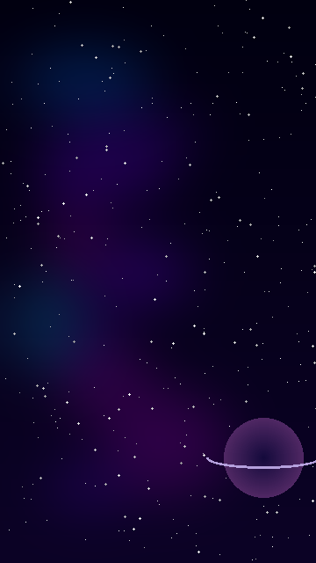

🚀 SPACE FLAPPY
GAME STORYBOARD

10 Levels · 3 Difficulty Tiers · Deep-Space Adventure
A visual & narrative guide to every level of Space Flappy

EASY Levels 1-3 | MEDIUM Levels 4-6 | HARD Levels 7-10
Speed 2.0 – 2.6× Gap 230 – 200 px | Speed 3.0 – 3.8× Gap 190 – 165 px | Speed 4.3 – 6.0× Gap 152 – 115 px

Document prepared June 2026 · Python + pygame · Pillow-generated art

LEVEL OVERVIEW

Level | Difficulty | Speed | Gap (px) | Spawn (s) | Clear Target
Level 1 | Easy | 2× | 230 px | 2.20 s | 10 pairs
Level 2 | Easy | 2.3× | 215 px | 2.10 s | 10 pairs
Level 3 | Easy | 2.6× | 200 px | 2.00 s | 10 pairs
Level 4 | Medium | 3× | 190 px | 1.80 s | 10 pairs
Level 5 | Medium | 3.4× | 178 px | 1.65 s | 10 pairs
Level 6 | Medium | 3.8× | 165 px | 1.50 s | 10 pairs
Level 7 | Hard | 4.3× | 152 px | 1.35 s | 10 pairs
Level 8 | Hard | 4.8× | 140 px | 1.20 s | 10 pairs
Level 9 | Hard | 5.4× | 128 px | 1.05 s | 10 pairs
Level 10 | Hard | 6× | 115 px | 0.90 s | 10 pairs

Each level requires the rocket to pass 10 asteroid pairs. Completing a level unlocks the next and saves progress to save_data.json. High scores are tracked per level.

LEVEL STORYBOARDS
Each panel shows: the scene layout, asteroid gap, rocket position, speed indicator, and narrative context.

Level 1 — Easy
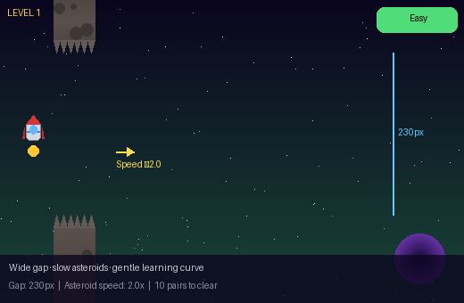 | LEVEL 1  [ EASY ]  Objective: Pass 10 asteroid pairs to complete the level.  Game Parameters:  - Gravity: 0.38 px/frame²  - Jump velocity: -6.2 px  - Spawn every 2.2 s  - Gap: 230 px  Speed: 2× base  Gap: 230 px (6 rocket-heights)  Spawn: every 2.20 s

Scene Description
The rocket launches into quiet deep space. Stars drift slowly past. Wide asteroid corridors give the pilot room to breathe and learn the controls.
Narrative
Cadet Zara fires the thrusters for the first time. The asteroid belt ahead looks manageable — wide passages, slow rocks. 'I've got this,' she whispers.
Pilot Tip ✦
Tap early and let gravity do the work. Short taps keep the rocket level.

Level 2 — Easy
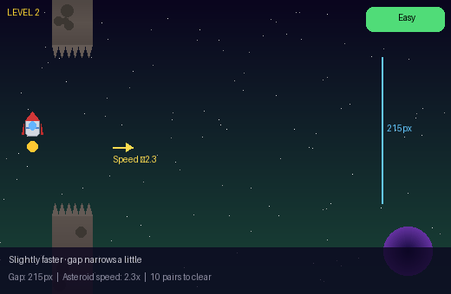 | LEVEL 2  [ EASY ]  Objective: Pass 10 asteroid pairs at increased speed.  Game Parameters:  - Speed: 2.3×  - Gap: 215 px  - Spawn every 2.1 s  Speed: 2.3× base  Gap: 215 px (5 rocket-heights)  Spawn: every 2.10 s

Scene Description
The asteroid density increases. Rocks begin to drift slightly closer together but the nebula still glows with calming blue light.
Narrative
Zara checks her instruments. 'Speed rising.' The gaps are still generous but she starts timing her jumps more carefully.
Pilot Tip ✦
Begin tapping a half-second earlier than you think you need to.

Level 3 — Easy
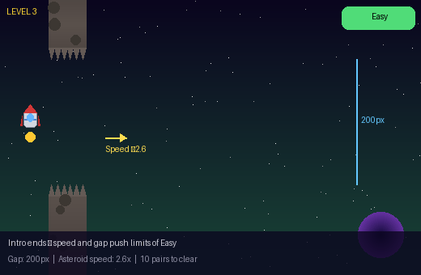 | LEVEL 3  [ EASY ]  Objective: Clear the final Easy level to unlock Medium.  Game Parameters:  - Speed: 2.6×  - Gap: 200 px  - Spawn every 2.0 s  Speed: 2.6× base  Gap: 200 px (5 rocket-heights)  Spawn: every 2.00 s

Scene Description
The outer belt ends. A ringed gas giant looms in the background. Asteroids move with more purpose — the Easy phase draws to a close.
Narrative
'Last of the easy runs.' Zara banks through a tighter passage. The gas giant's gravity pulls at the edges of her flight path.
Pilot Tip ✦
Consistent tapping rhythm is more reliable than reactive tapping.

Level 4 — Medium
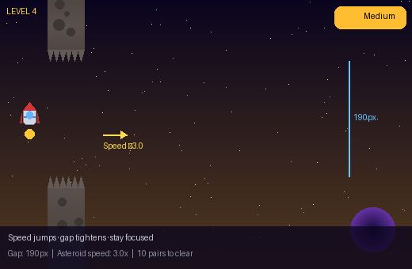 | LEVEL 4  [ MEDIUM ]  Objective: Navigate faster asteroids through medium gaps.  Game Parameters:  - Speed: 3.0×  - Gap: 190 px  - Spawn every 1.8 s  Speed: 3× base  Gap: 190 px (5 rocket-heights)  Spawn: every 1.80 s

Scene Description
The asteroid field thickens. A deep orange nebula replaces the blue — warning hues. Rocks accelerate past the cockpit window.
Narrative
Zara enters the medium sector. 'Shields up.' The rocks hit harder now. Every junction demands a deliberate choice.
Pilot Tip ✦
Don't panic-tap. One controlled jump is worth three frantic ones.

Level 5 — Medium
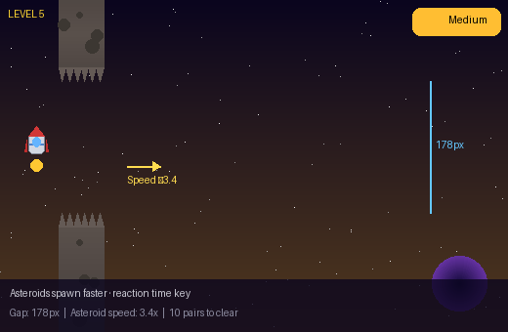 | LEVEL 5  [ MEDIUM ]  Objective: Pass 10 pairs as spawn rate accelerates.  Game Parameters:  - Speed: 3.4×  - Gap: 178 px  - Spawn every 1.65 s  Speed: 3.4× base  Gap: 178 px (4 rocket-heights)  Spawn: every 1.65 s

Scene Description
Asteroids spawn in rapid succession. The gap barely fits the rocket's wingspan. The purple nebula swirls overhead like a storm.
Narrative
Clusters of rocks cascade from both directions. 'Focus,' Zara tells herself, threading the rocket between jagged edges.
Pilot Tip ✦
Watch the next pair forming on the right while passing the current one.

Level 6 — Medium
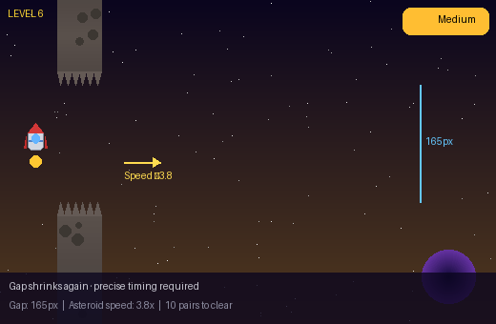 | LEVEL 6  [ MEDIUM ]  Objective: Complete the hardest Medium challenge to unlock Hard.  Game Parameters:  - Speed: 3.8×  - Gap: 165 px  - Spawn every 1.5 s  Speed: 3.8× base  Gap: 165 px (4 rocket-heights)  Spawn: every 1.50 s

Scene Description
The final medium level. Two asteroid clusters appear simultaneously on screen. The gap shrinks to a sliver against the dark void.
Narrative
'One more medium run.' The corridor ahead is the tightest yet. Zara exhales slowly and fires the thrusters in measured bursts.
Pilot Tip ✦
Your rocket is 40 px tall. Gap is 165 px — about 4 rocket heights. Use the middle third.

Level 7 — Hard
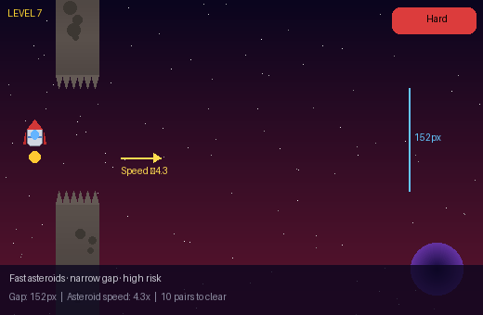 | LEVEL 7  [ HARD ]  Objective: Survive the first Hard tier — reaction time is everything.  Game Parameters:  - Speed: 4.3×  - Gap: 152 px  - Spawn every 1.35 s  Speed: 4.3× base  Gap: 152 px (4 rocket-heights)  Spawn: every 1.35 s

Scene Description
Welcome to Hard. The starfield blurs with velocity. Asteroids streak past in a near-continuous barrage. Red warning lights flash.
Narrative
Alarms sound in the cockpit. 'Hard sector engaged.' Rocks the size of buildings hurtle past. Zara's reflexes take over.
Pilot Tip ✦
Pre-position vertically before each gap — don't wait until the last moment.

Level 8 — Hard
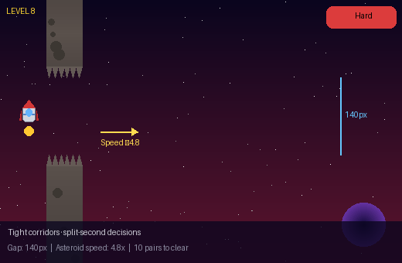 | LEVEL 8  [ HARD ]  Objective: Thread a near-constant stream of tight asteroid pairs.  Game Parameters:  - Speed: 4.8×  - Gap: 140 px  - Spawn every 1.2 s  Speed: 4.8× base  Gap: 140 px (4 rocket-heights)  Spawn: every 1.20 s

Scene Description
Asteroid walls close in. The corridor is barely wider than the rocket body. Particles from broken rocks shatter across the hull.
Narrative
Zara's hands are a blur on the controls. 'Gap is 140 pixels.' She can feel each near-miss vibrate through the hull plating.
Pilot Tip ✦
Micro-taps only. Any over-correction at this speed is fatal.

Level 9 — Hard
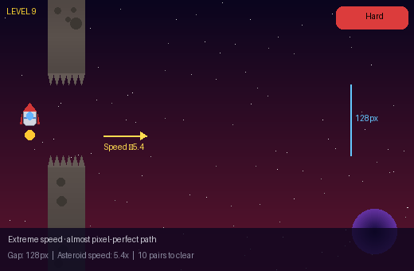 | LEVEL 9  [ HARD ]  Objective: Complete 10 pairs at near-maximum difficulty.  Game Parameters:  - Speed: 5.4×  - Gap: 128 px  - Spawn every 1.05 s  Speed: 5.4× base  Gap: 128 px (3 rocket-heights)  Spawn: every 1.05 s

Scene Description
Extreme velocity. Asteroids appear almost instantly on screen and are gone in a flash. The gap is a pixel-thin thread of survival.
Narrative
'128 pixels.' Less than four rocket heights. Zara enters a flow state — no thought, only reaction. The void blurs around her.
Pilot Tip ✦
You can hear the spawn timer. Use sound cues to anticipate the next pair.

Level 10 — Hard
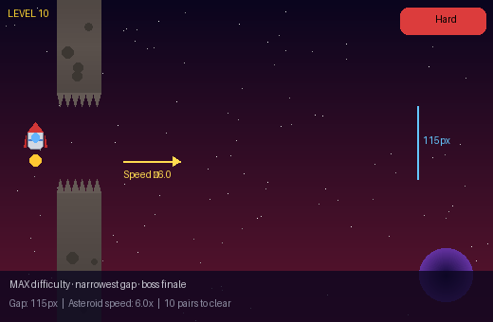 | LEVEL 10  [ HARD ]  Objective: Conquer all 10 pairs at maximum difficulty — you win the game!  Game Parameters:  - Speed: 6.0× (MAX)  - Gap: 115 px (MINIMUM)  - Spawn every 0.9 s (FASTEST)  - 🏆 Win condition: 10 pairs cleared  Speed: 6× base  Gap: 115 px (3 rocket-heights)  Spawn: every 0.90 s

Scene Description
FINAL LEVEL. Maximum speed. The narrowest gap. The asteroid belt reaches peak density. Only the best pilots survive to tell the tale.
Narrative
The final gauntlet. 'This is what I trained for.' Zara's rocket screams through the last asteroid belt at maximum thrust. Stars streak into lines. The gap is barely wider than the ship itself. One breath. One chance.
Pilot Tip ✦
Trust your muscle memory. You reached Level 10 — you already have what it takes.

DESIGN NOTES

Character: The player controls a procedurally generated rocket sprite (images/rocket.png) drawn with Pillow — silver fuselage, red nosecone, cockpit window, side fins, and engine flame.

Background: A deep-space starfield with a blurred nebula overlay and ringed gas planet, generated at 360×640px (images/background.png).

Obstacles: Asteroid columns with jagged tooth edges, randomised craters, and glow effects — replacing the original green pipes (images/asteroid_top.png, images/asteroid_bot.png).

Save system: Progress is written to save_data.json after every level clear, tracking max unlocked level and per-level high scores.

Code patterns: Custom exceptions (AssetLoadError, SaveDataError, LevelRangeError), type annotations, docstrings, NOTE markers, and try/except/finally throughout main.py.

Space Flappy · Storyboard Document · June 2026
Generated with Python 3 + Pillow + docx.js · 10 Levels · A4 Format

