**Link to repository:** <https://bitbucket.org/mabhinaya/team03_project/src/23763f9b32a2860b0cec129fcf0e4fb2609bb2a7?at=master>

**List of commits for P02:**

<https://bitbucket.org/mabhinaya/team03_project/commits/0e5192524c3dff64f49093628f1cb01b57ca4701?at=master> –Implemented External Login Feature

<https://bitbucket.org/mabhinaya/team03_project/commits/47f2cc62d8bb6fd29eb8bad4f508fc05c277aef8?at=master> –Modified Project Layout and Layout Partial

<https://bitbucket.org/mabhinaya/team03_project/commits/480f338c0004de2841a189720e19f096807a157b?at=master> –Changed the Existing Model structure and added New Models with New Fields.

<https://bitbucket.org/mabhinaya/team03_project/commits/4165cec6ece2a03d3a931f741f2aa6a4fd3cd0b1?at=master> – Completed Identity part and Modified Register page and redirected to Home Page – (Added users and assigned roles to the corresponding User)

**Contributions & Challenges:**

My Major contribution was Database Design as well as Authentication and Authorization.

After p01 brainstorming, we decided to remove separate entities based on profession and added a single entity FindTalents. I have faced challenges in linking older entities like actor, actress, cameraman, producer and others.

I faced challenges in adding external login feature, couldn’t figure it out how to use the secret Manager to store the Facebook Id and Facebook Secret generated, instead of reading from project configuration files and also to display name when use logged in instead of mail id in the Home Page.

**Screenshots:**

Home Page

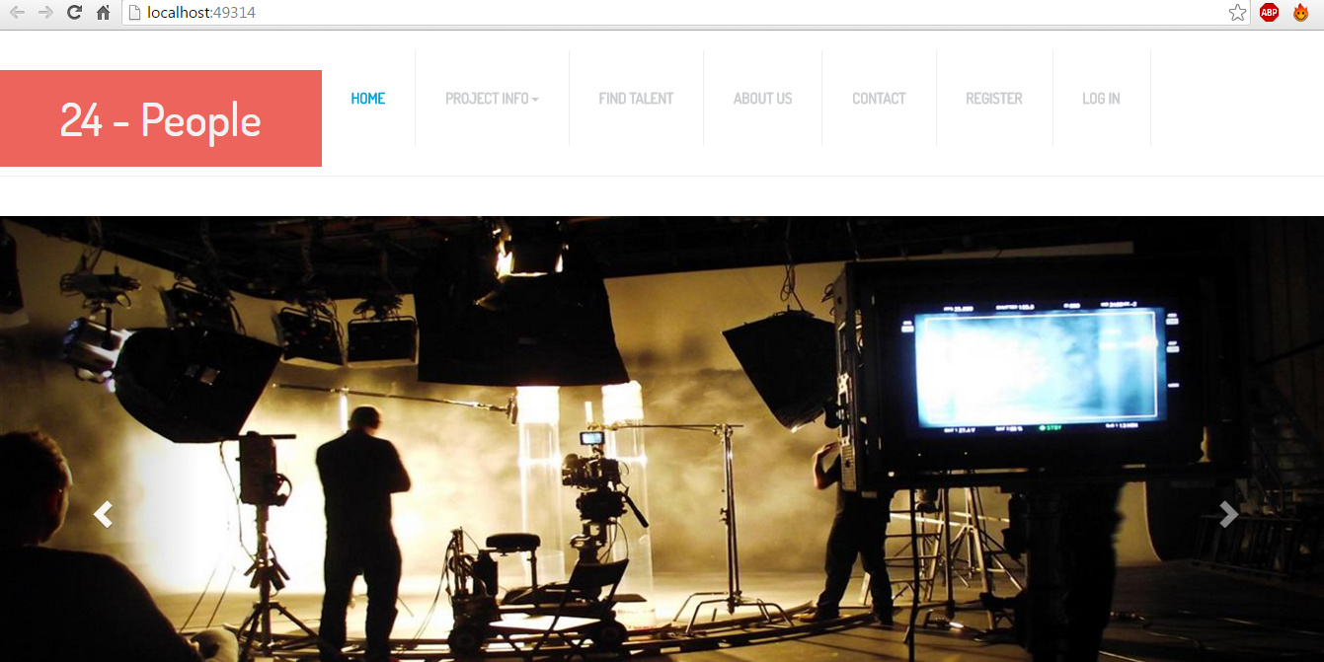

Login:

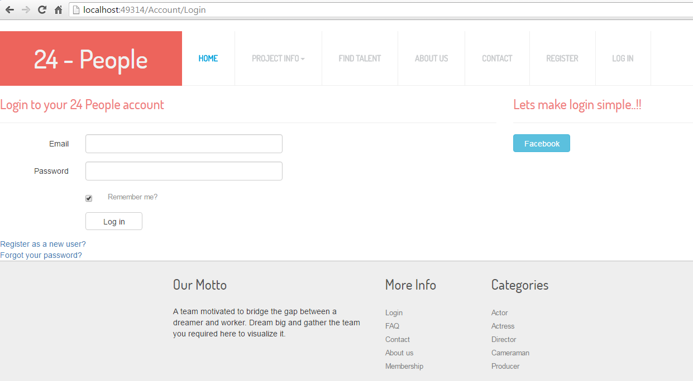

Register:

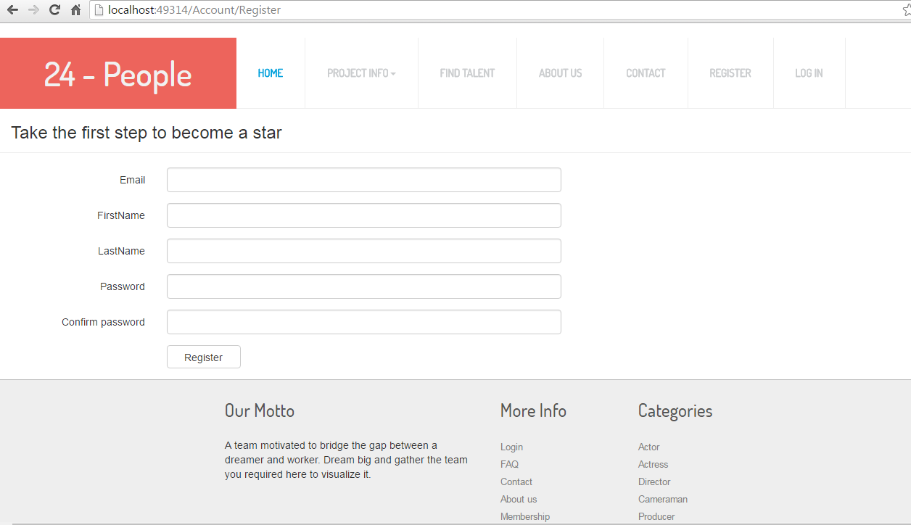

Find Talents: (User)

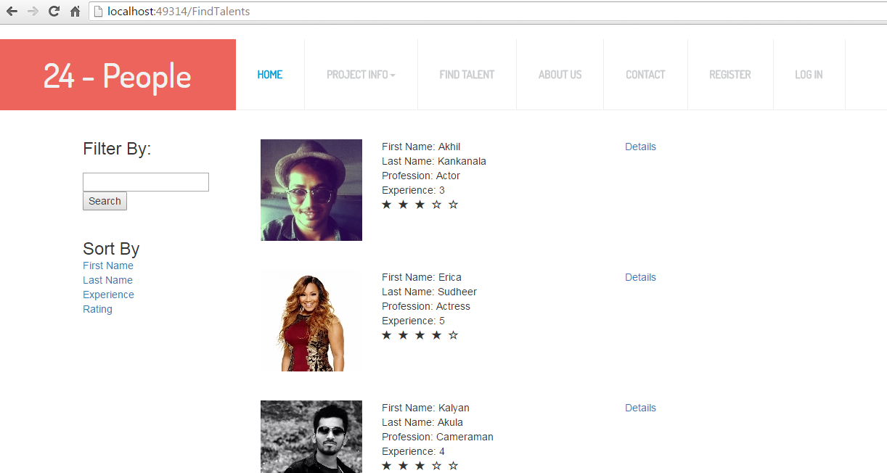

Find Talents: (Admin)

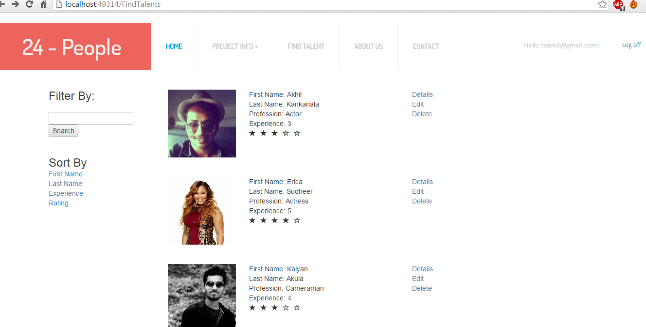

Modal Class: (Details)

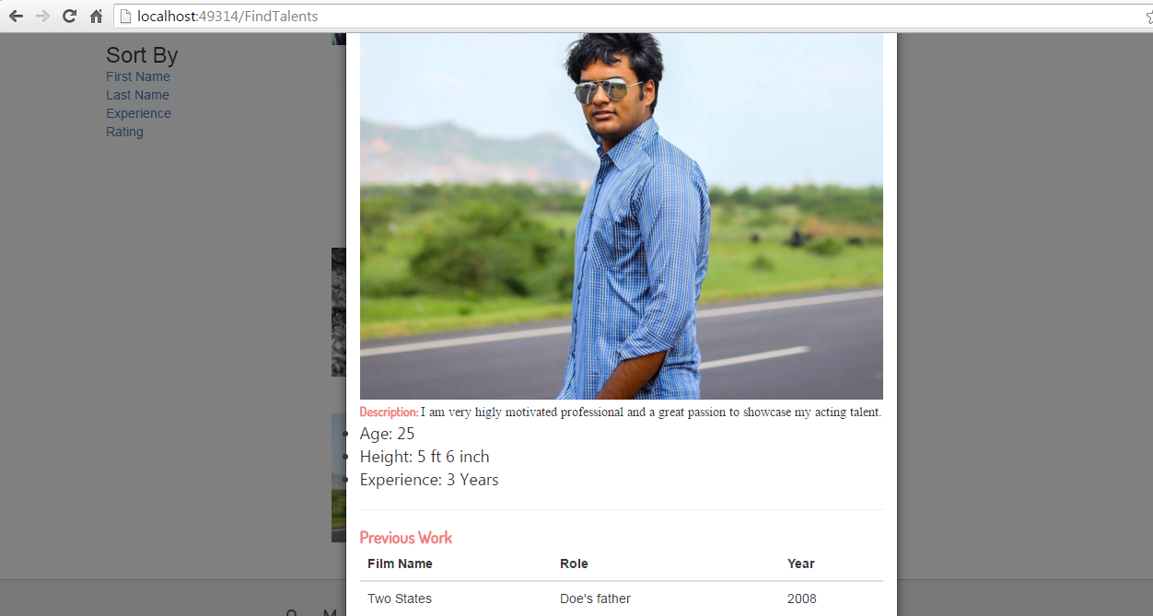

Milestones:

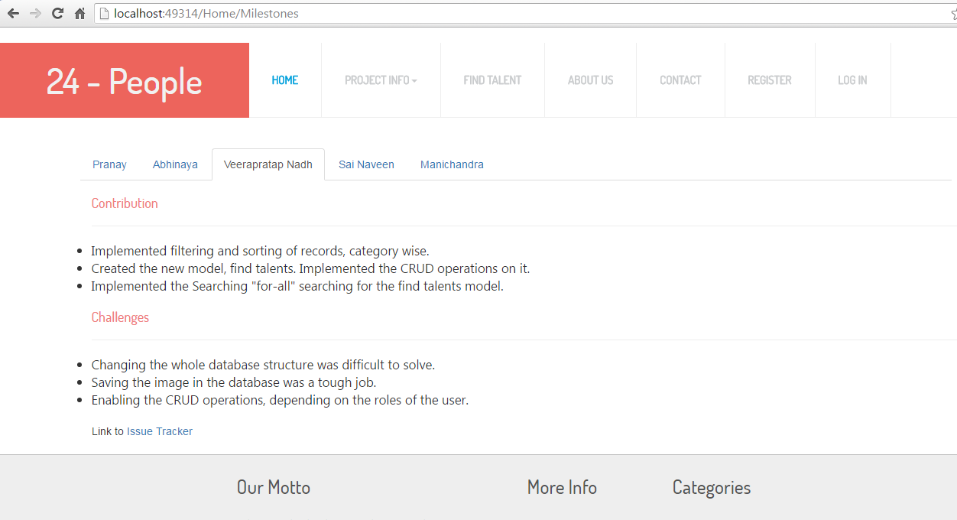

Goals:

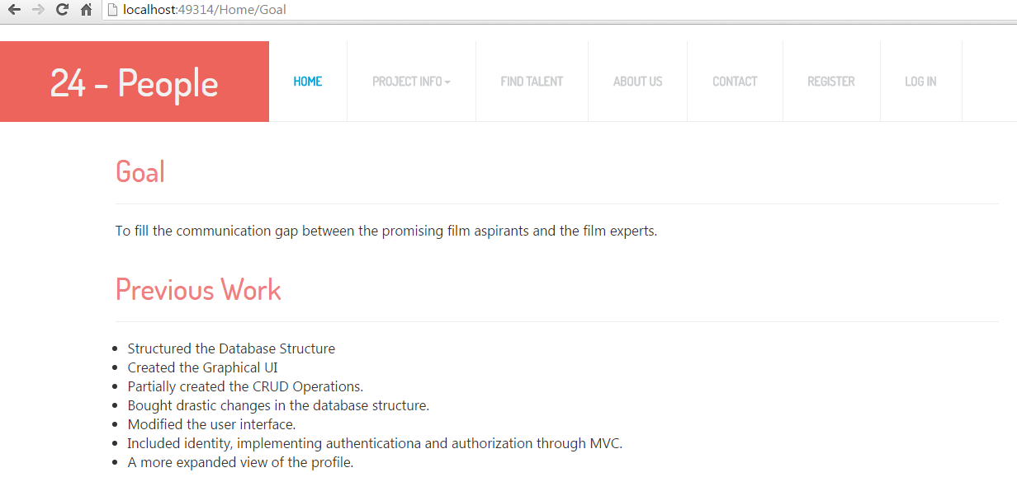

Future Work:

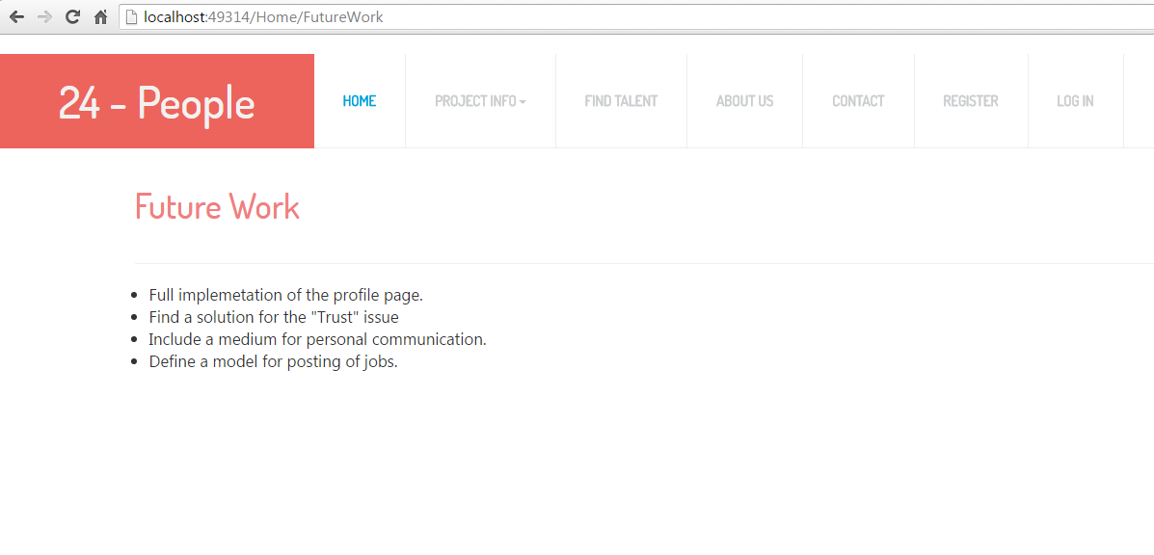

**Project Cost Estimate:**

Team 5 Members. Estimated work hours for each individual is 120 hours.

Total Cost: 5(team size) * 80(number of hours each worked) * 9 (hourly charge) = $3600

Our team believes that we have completed 70% of the project.