**Link to repository:**

<https://SaiNaveen92@bitbucket.org/mabhinaya/team03_project.git>

**List of team contributions:**

Manichandra Gampa :

* Project documentation and presentation.
* Cameraman entity creation and finding attributes.
* Created all views related to Cameraman.
* Version controlling (Git) understanding and solving conflicts.

Sai Naveen Mallampati:

* About Us and Contact Us pages.
* Actress entity creation and finding attributes.
* Created all views related to Actress.
* Version controlling (Git) understanding and solving conflicts.

Abhinaya Mogalipuva:

* Worked on Entity Relationship diagrams.
* Determining requirements.
* Producer entity creation and finding attributes.
* Created all views related to Producer.
* Database design and setting up relations between tables.
* Update records.
* Version controlling (Git) understanding and solving conflicts.

Putta Veerapratap Nadh:

* Worked on Profession page.
* Worked on views of all entities and data sorting.
* Actor entity creation and finding attributes.
* Created all views related to Actor.
* Version controlling (Git) understanding and solving conflicts.

Pranay Peddi:

* Worked on user interface design
* Worked on Index and _Layout pages
* Director entity creation and finding attributes.
* Created all views related to Director
* Testing the application and creating bugs.
* Update records
* Version controlling (Git) understanding and solving conflicts.

**Screenshots of the application:**

Home page:

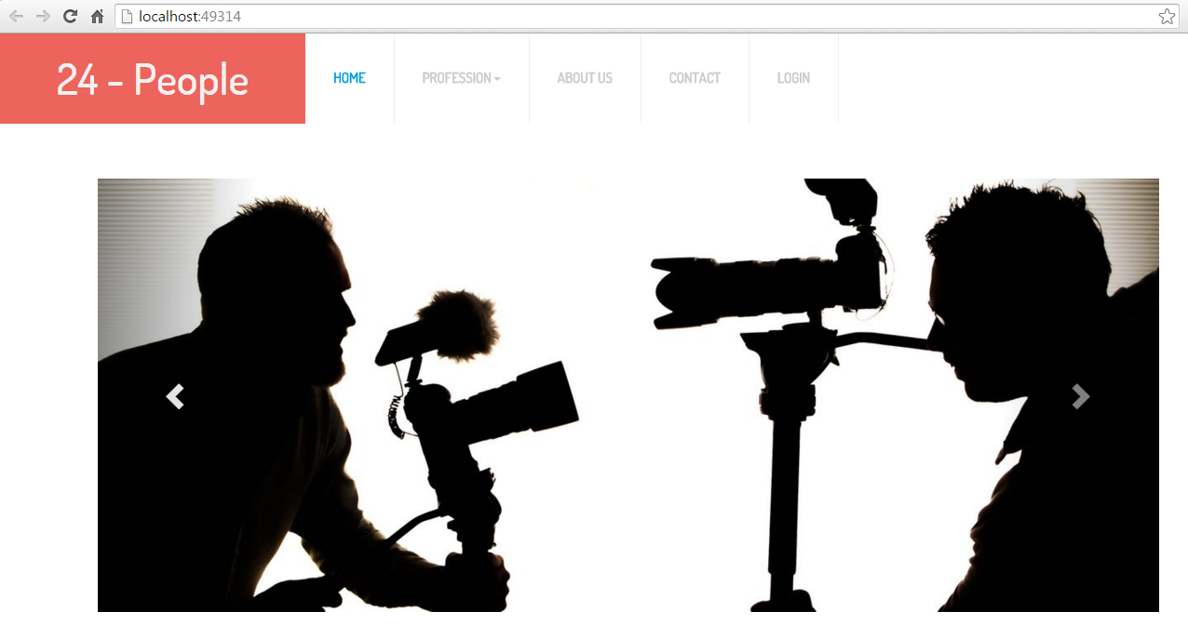

Actor Entity:

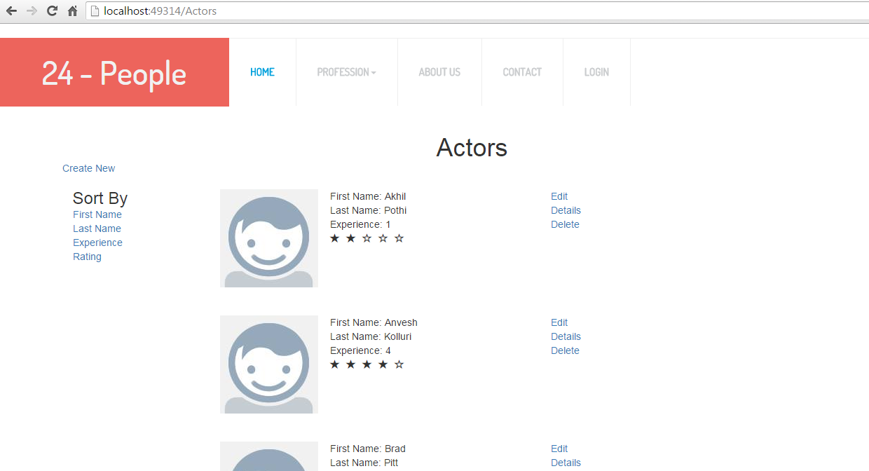

About Page:

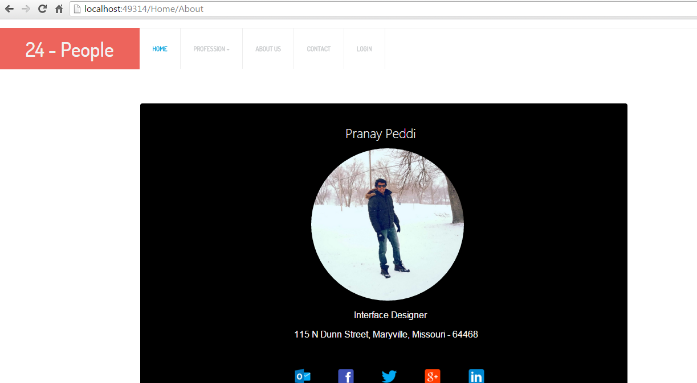

Contact:

