**Link to repository:** <https://ManichandraG@bitbucket.org/mabhinaya/team03_project.git>

**Commits:**

<https://bitbucket.org/mabhinaya/team03_project/commits/676e72e16f15879ebd531d552d0a9438b3528a7e>

Changed design of Home page.

[**https://bitbucket.org/mabhinaya/team03_project/commits/92168644e013b2ea9949d216650183e903a7ea54**](https://bitbucket.org/mabhinaya/team03_project/commits/92168644e013b2ea9949d216650183e903a7ea54)

Live chat with customers added.

**Contributions:**

1. Developed Home page and UI of the application.

2. Performed unit testing on each module.

3. Working on documentation along with Sai Naveen.

**Issues Assigned:**

[**https://bitbucket.org/mabhinaya/team03_project/issues/15/design-of-registration-page**](https://bitbucket.org/mabhinaya/team03_project/issues/15/design-of-registration-page)

[**https://bitbucket.org/mabhinaya/team03_project/issues/16/slides-preparation**](https://bitbucket.org/mabhinaya/team03_project/issues/16/slides-preparation)

**Screenshots:**

Home Page

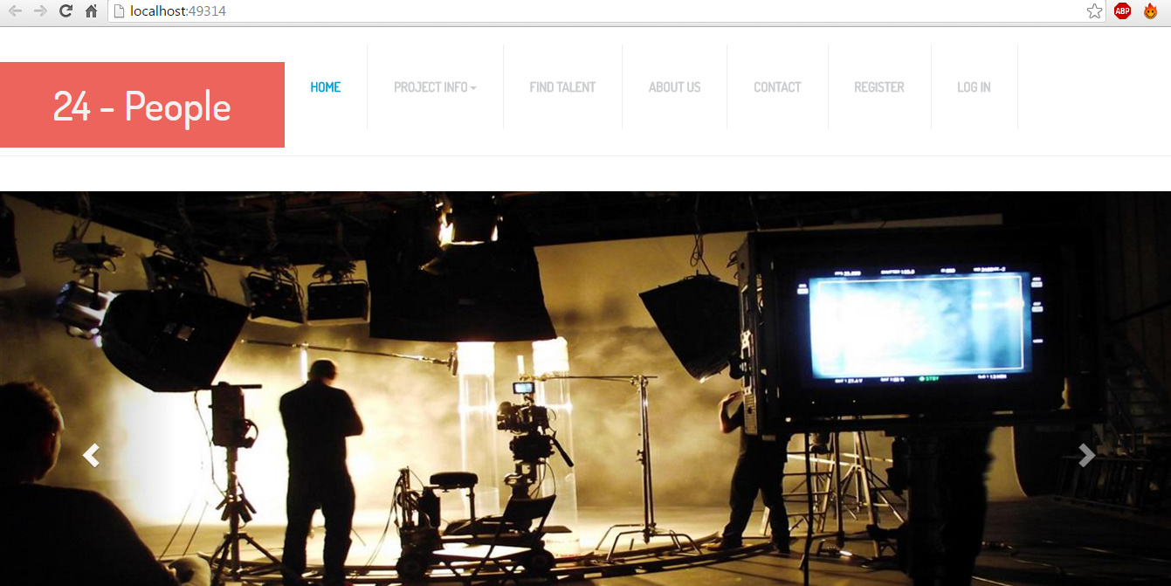

Login:

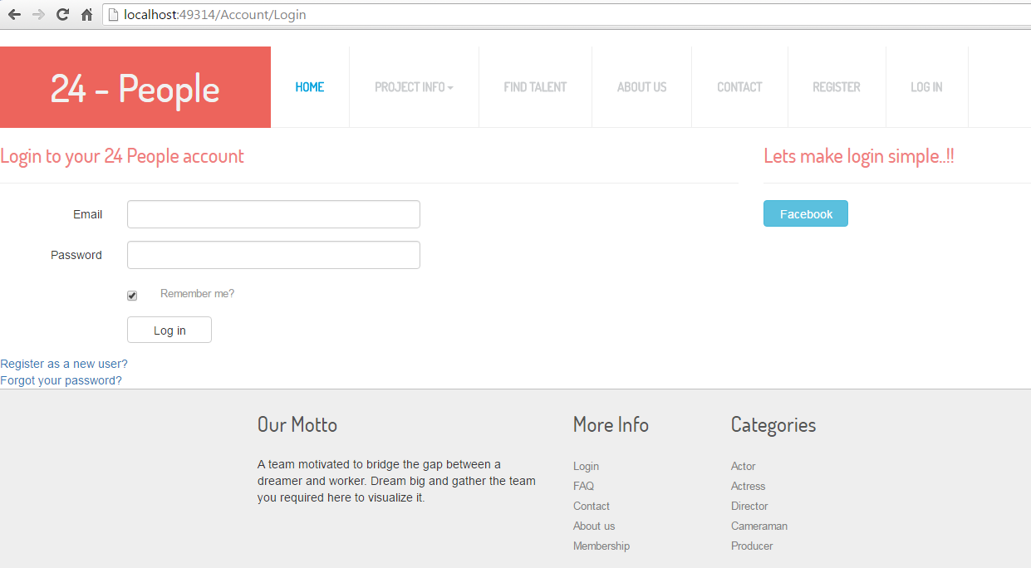

Register:

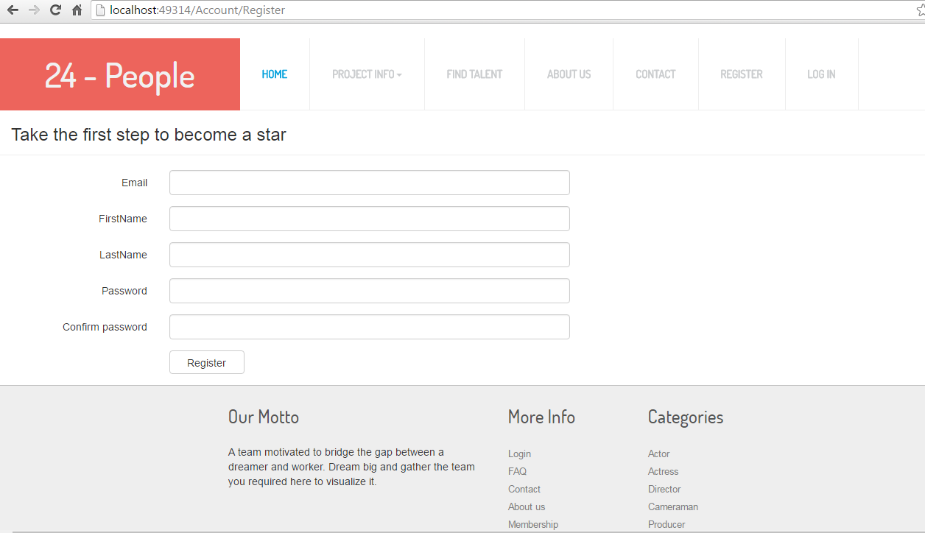

Find Talents: (User)

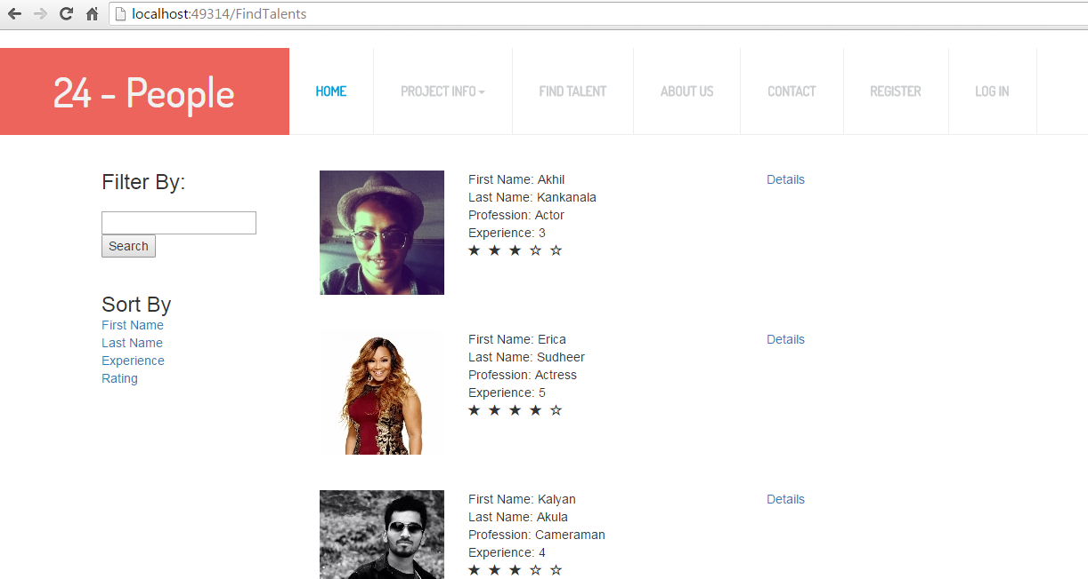

Find Talents: (Admin)

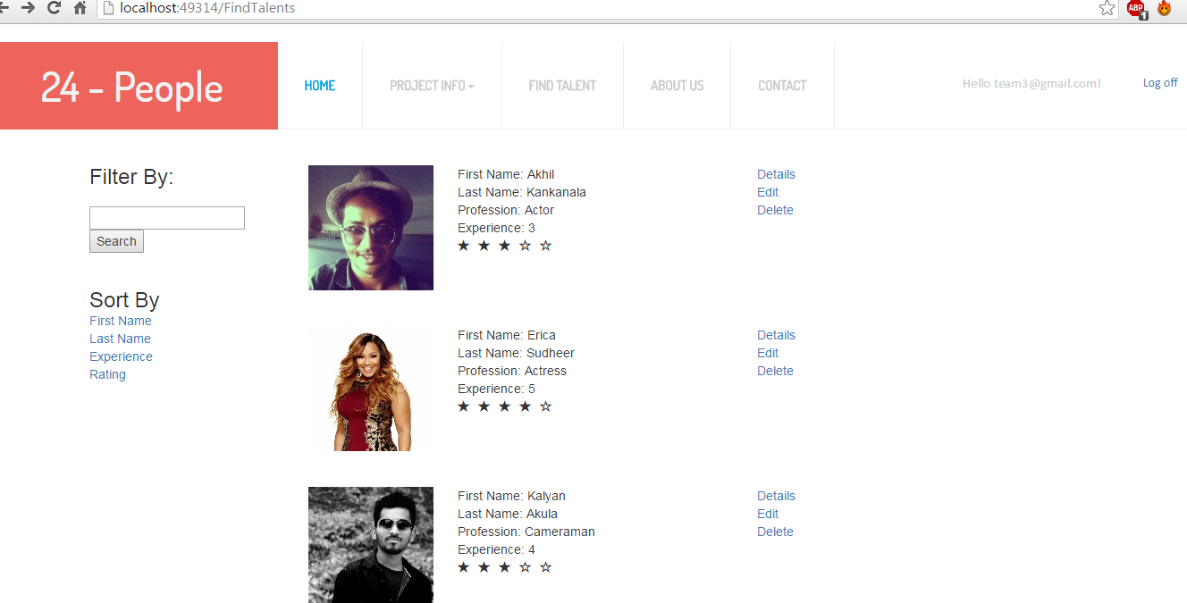

Modal Class: (Details)

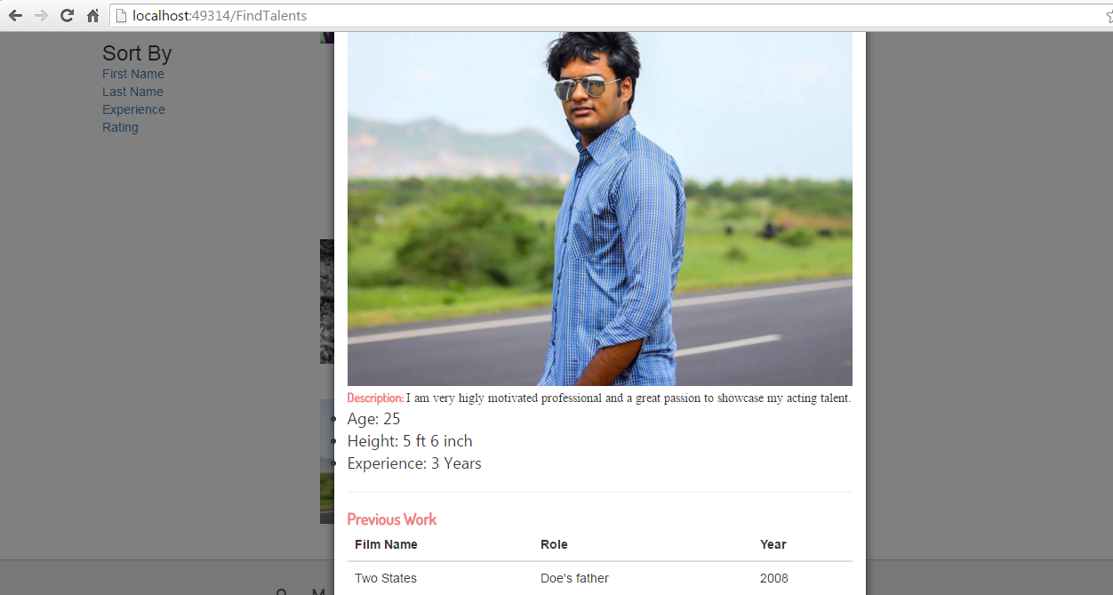

Milestones:

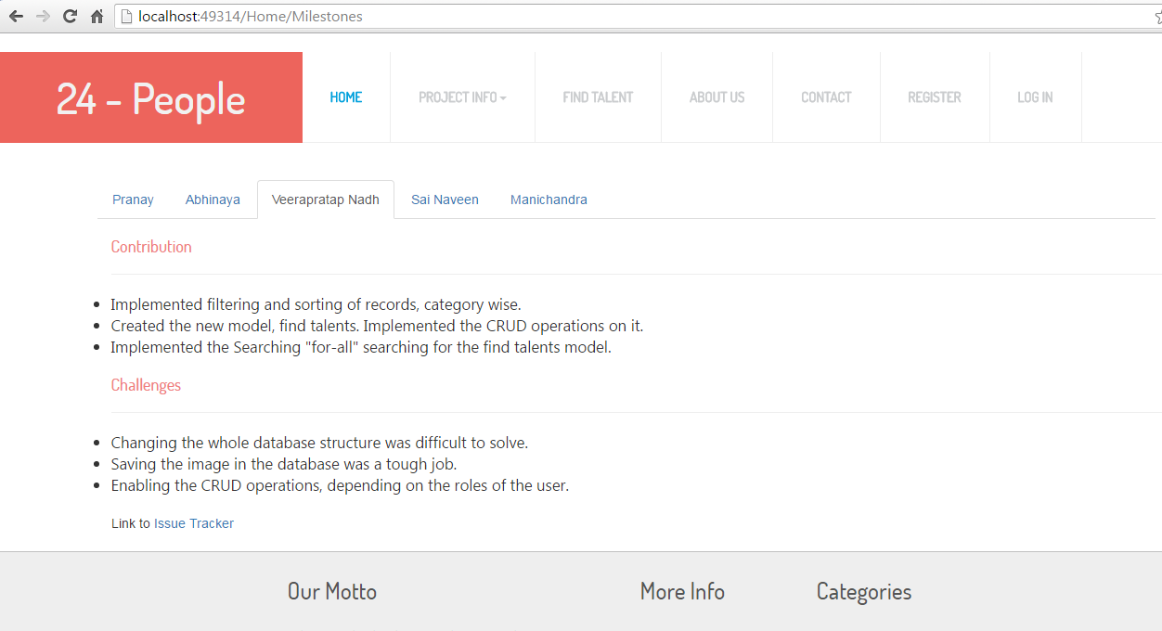

Goals:

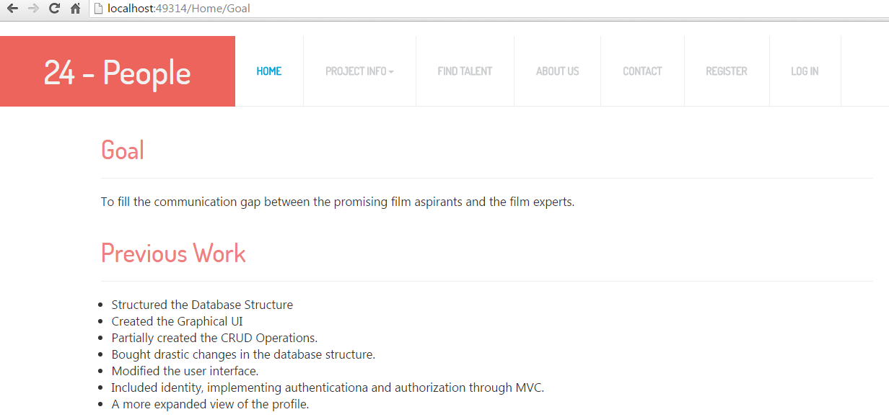

Future Work:

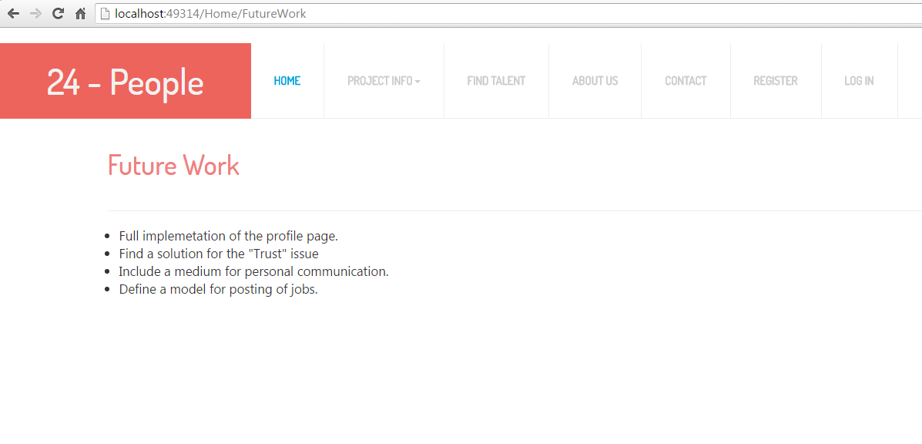

**Project Cost Estimate:**

Team 5 Members. Estimated work hours for each individual is 120 hours.

Total Cost: 5(team size) * 80(number of hours each worked) * 9 (hourly charge) = $3600

Our team believes that we have completed 70% of the project.