**Link to repository:** <https://SaiNaveen92@bitbucket.org/mabhinaya/team03_project.git>

**Commits:**

<https://bitbucket.org/mabhinaya/team03_project/commits/e91a5801c420899fe579ab9dae4eb2c42ad1e57d>

Designed Project Info Tab with contribution and challenges.

<https://bitbucket.org/mabhinaya/team03_project/commits/5e6df2a7fa9cef04b358253d9de49faf30dec70a>

Added Goal and Future Work Pages to Project Info Tab.

<https://bitbucket.org/mabhinaya/team03_project/commits/827a374a94cf024df397e02eaa5b599f88d259af>

Added Profession dropdown menu for P01.

**Contributions:**

1. Developed Contact Us page.

2. Developed Project Info Tab and added Goal, Future work, Milestones pages.

3. Performed unit testing on each module.

4. Working on documentation along with Mani Chandra.

**Challenges:**

1. Saving images on external server. I will work on this in future.

2. Planning to use image resizing API.

**Bug Fixes**

<https://bitbucket.org/mabhinaya/team03_project/commits/827a374a94cf024df397e02eaa5b599f88d259af>

Resolved memenu exception.

**Screenshots:**

Home Page

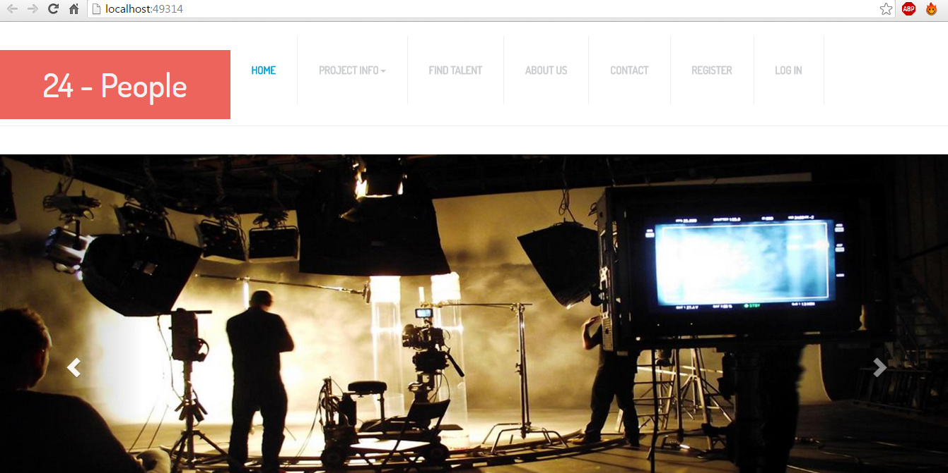

Login:

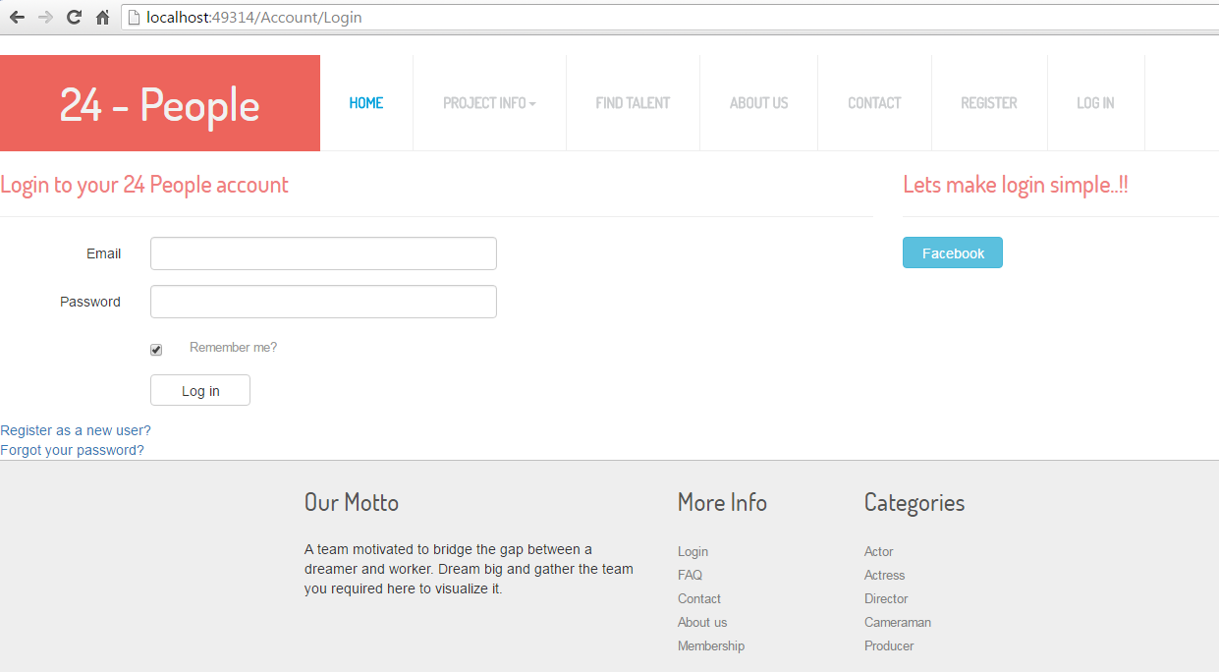

Register:

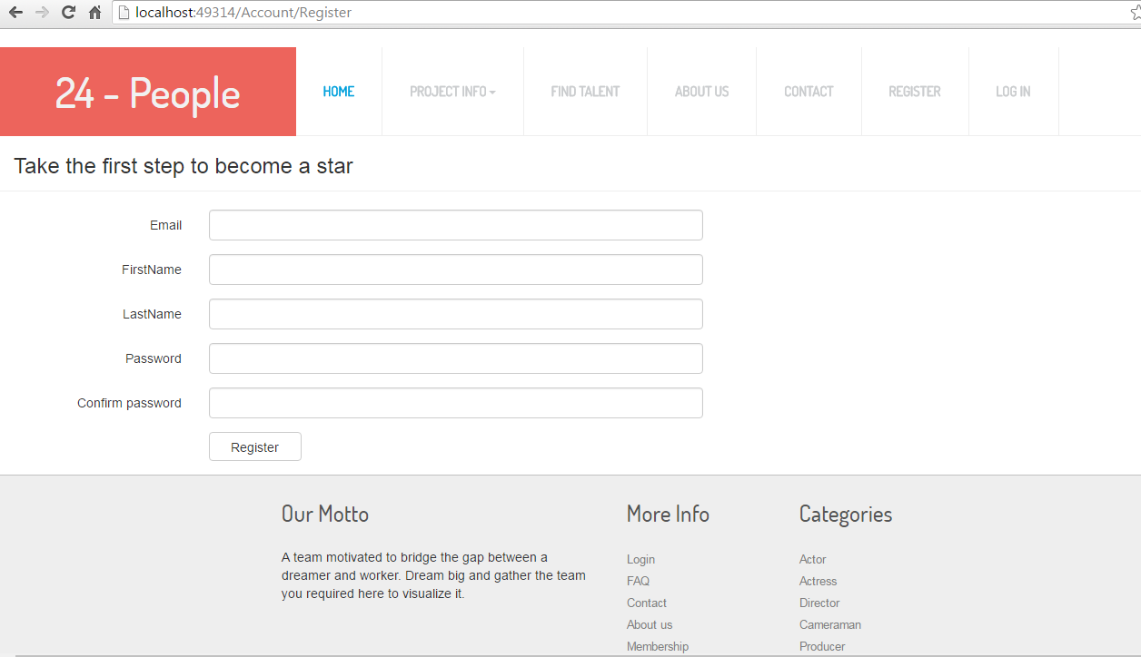

Find Talents: (User)

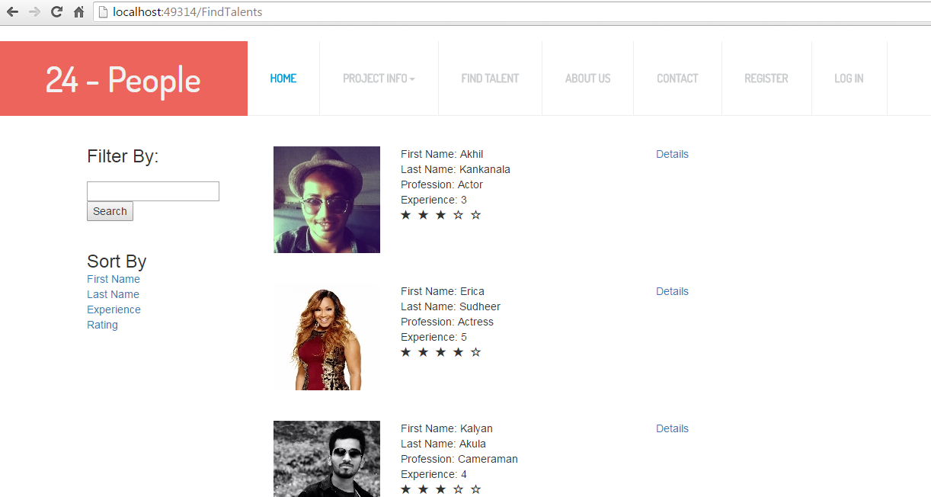

Find Talents: (Admin)

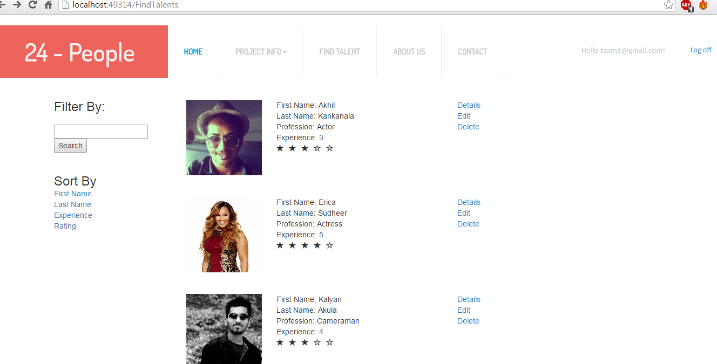

Modal Class: (Details)

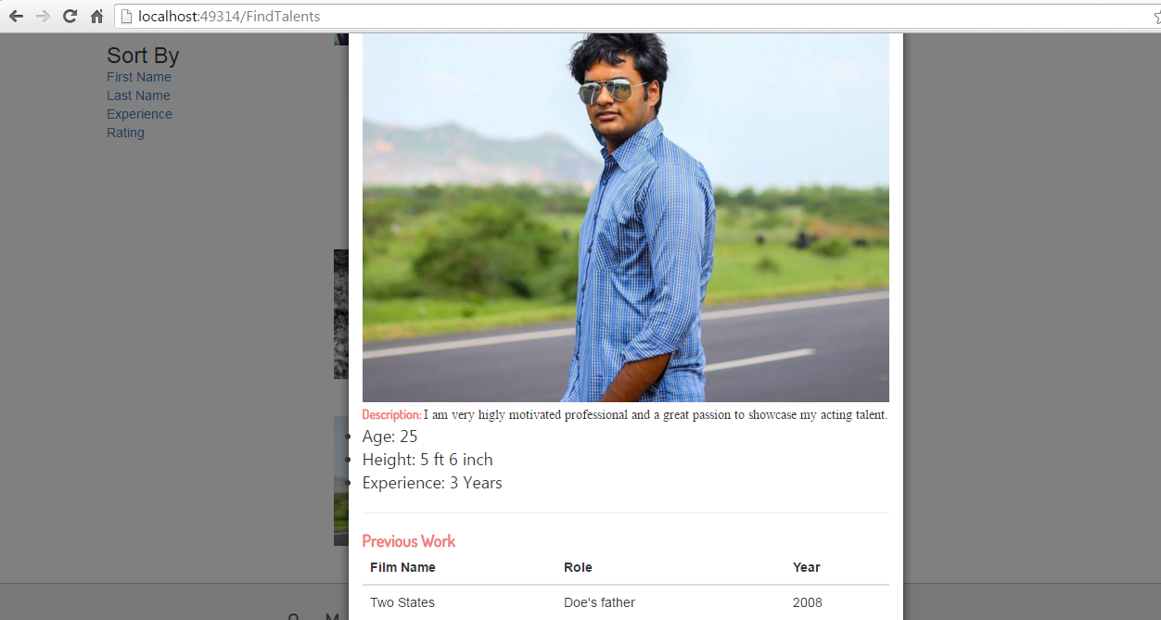

Milestones:

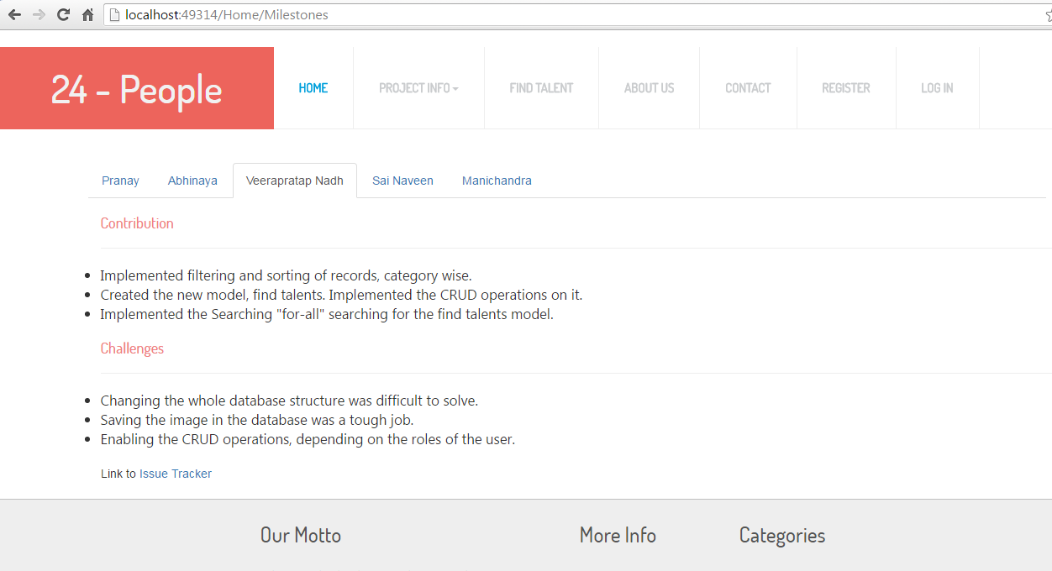

Goals:

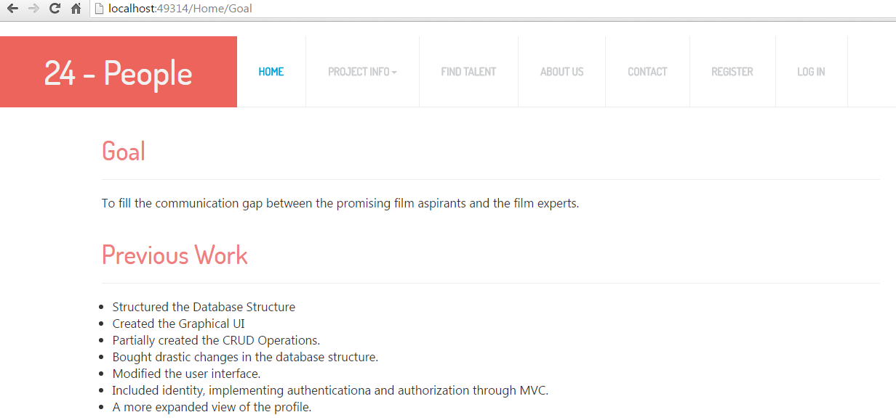

Future Work:

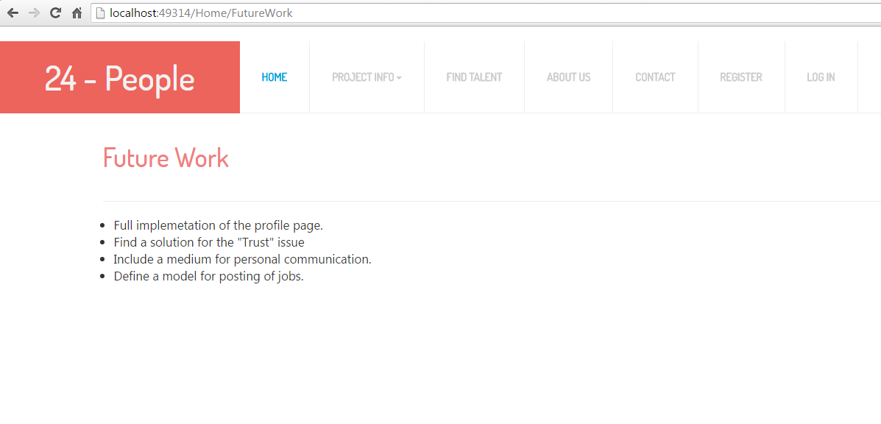

**Project Cost Estimate:**

Team 5 Members. Estimated work hours for each individual is 120 hours.

Total Cost: 5(team size) * 80(number of hours each worked) * 9 (hourly charge) = $3600

Our team believes that we have completed 70% of the project.