**Link to repository:** <https://pratapnadh@bitbucket.org/mabhinaya/team03_project.git>

**List of commits for P02:**

<https://bitbucket.org/mabhinaya/team03_project/commits/23b1bebd07a18aa3f930c864a9feb972d31918d1> - **Beta Commit**, final preparation for P02 presentation.

<https://bitbucket.org/mabhinaya/team03_project/commits/15cd2339a6132713577ebf0970d32acc0c20f3cd> - Added Bootstrap Modal class to Home page, trending actors.

<https://bitbucket.org/mabhinaya/team03_project/commits/1141b9b16f60d25e6b4093b49d0c3daf508279c1>

Worked on few bugs fixes with _layout, bootsrap.css and other pages.

<https://bitbucket.org/mabhinaya/team03_project/commits/17eb670122b312e3095d7d8e4e56ce2e7bc46afb>

Modified AccountController for admin privileges.

Also, modified the FindTalents index page to restrict user access on CRUD operations.

I faced challenges in restricting the user privileges with and without login privileges, as well as admin access privileges.

<https://bitbucket.org/mabhinaya/team03_project/commits/875420acf235b73dbc4f5fc815ac30ee84daf16c>

Added the Sorting and Filtering techniques on FindTalents page.

Sorting can be done based on First Name, Last Name, Experience and Rating.

Filtering can be done based on First Name, Last Name and Profession.

<https://bitbucket.org/mabhinaya/team03_project/commits/6502f515b42ac34e29e5837f601e4fb1ba14466f>

Added the resized profile images in FindTalents page.

I have faced challenges in resizing and cropping the image to fixed size. I tried implementing with Nuget tools like piczard package.

<https://bitbucket.org/mabhinaya/team03_project/commits/11a95f7c1219e7164b9d657501e00cf97030623d>

Created FindTalents entity.

After p01 brainstorming, we decided to remove separate entities based on profession and added a single entity FindTalents. I have faced challenges in linking older entities like actor, actress, cameraman, producer and others.

**Screenshots:**

Home Page

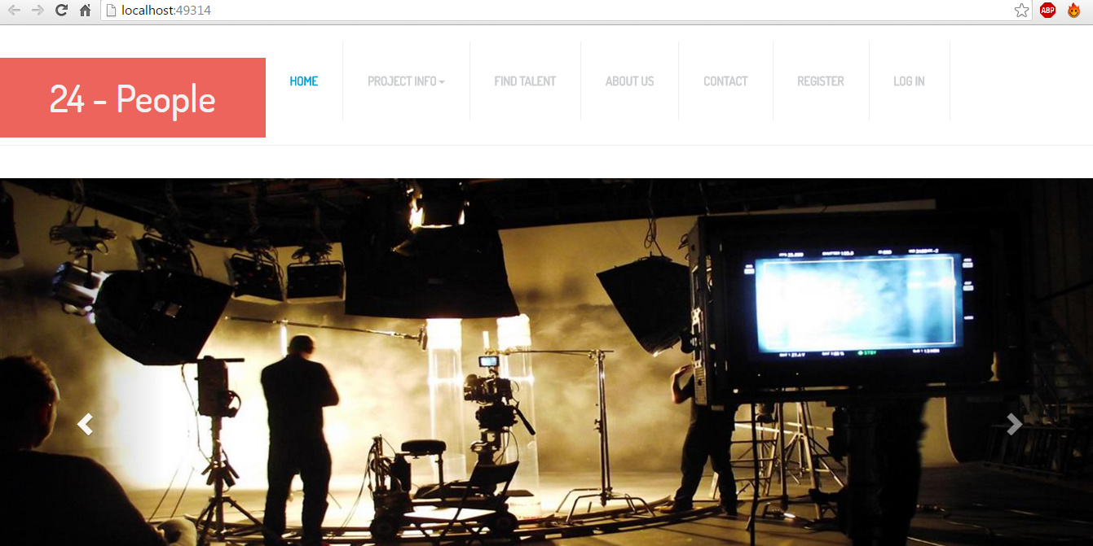

Login:

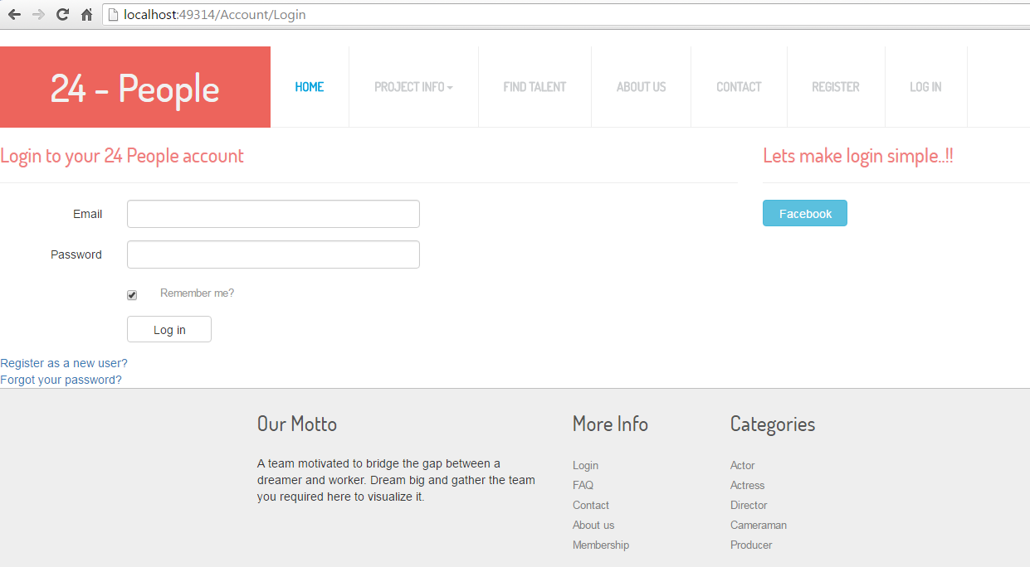

Register:

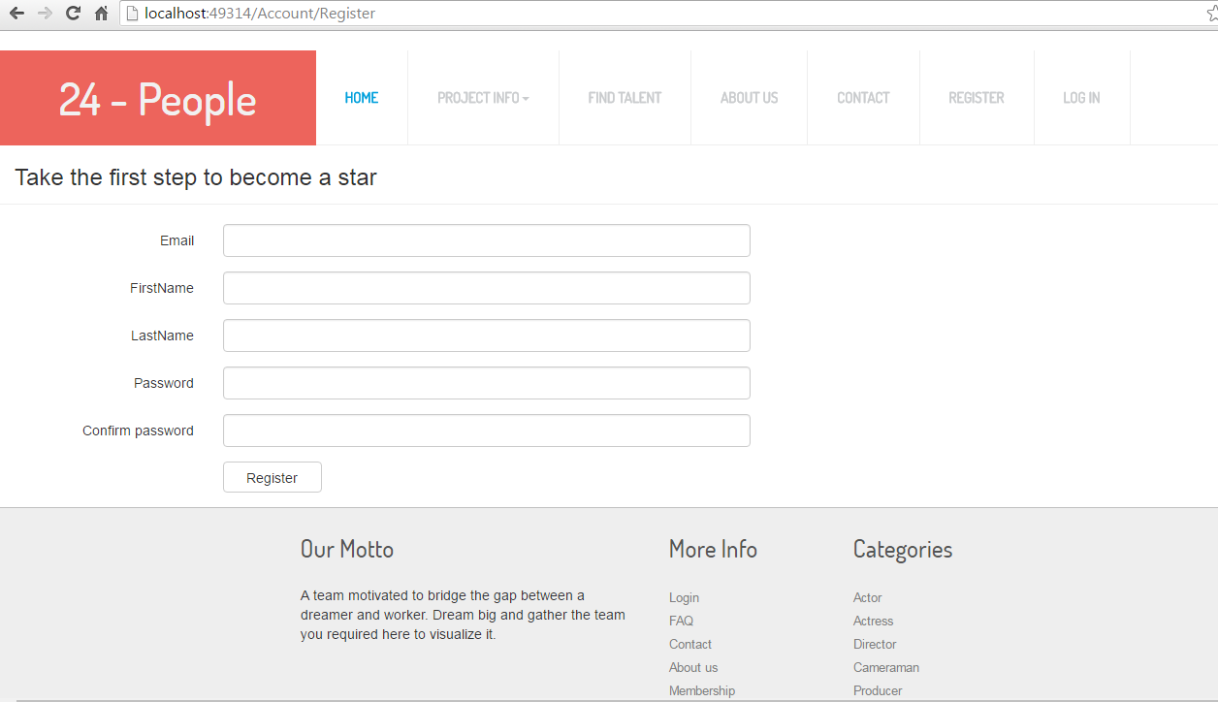

Find Talents: (User)

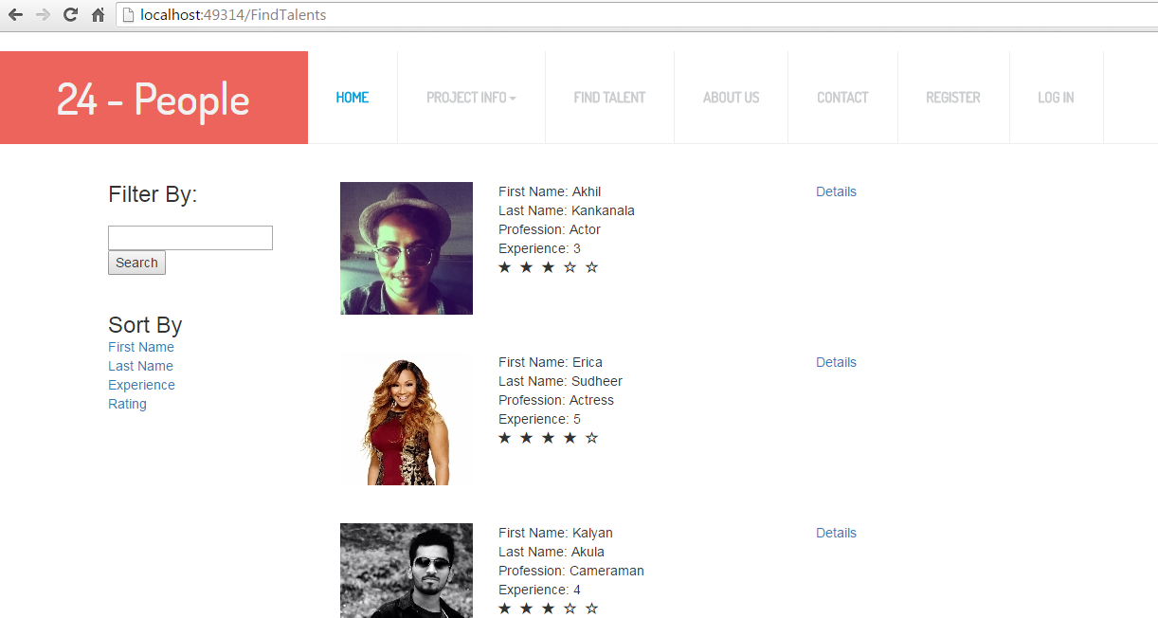

Find Talents: (Admin)

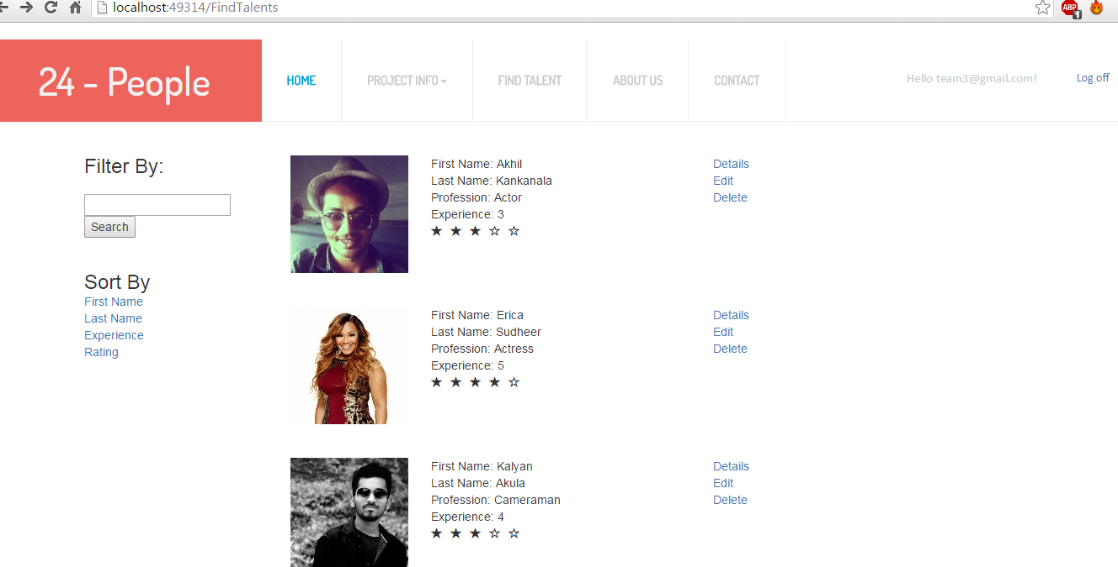

Modal Class: (Details)

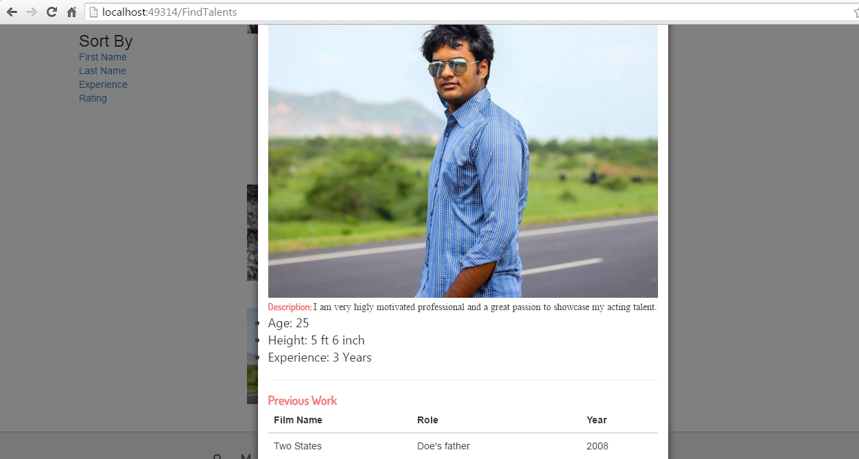

Milestones:

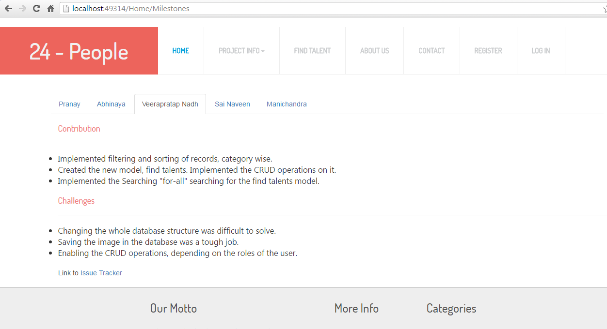

Goals:

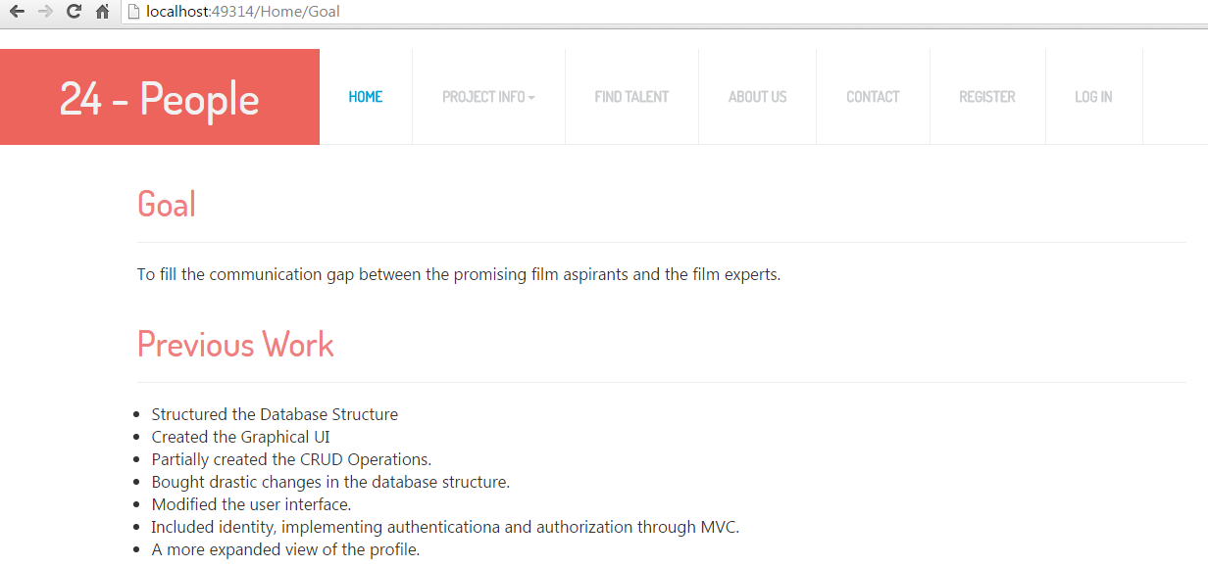

Future Work:

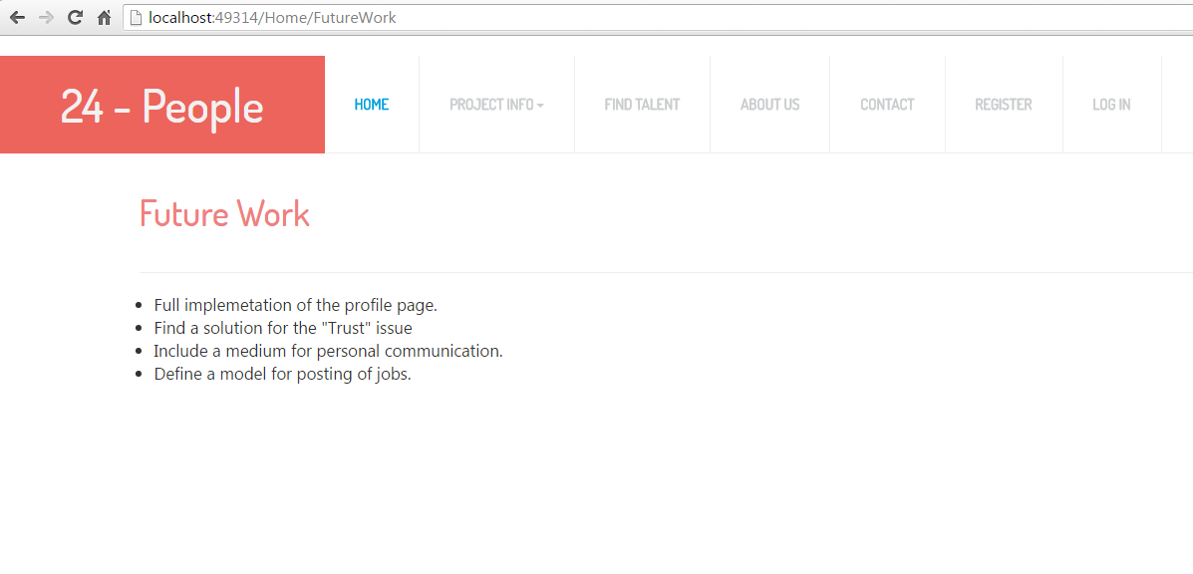

**Project Cost Estimate:**

Team 5 Members. Estimated work hours for each individual is 120 hours.

Total Cost: 5(team size) * 80(number of hours each worked) * 9 (hourly charge) = $3600

Our team believes that we have completed 70% of the project.