**Link to repository:** <https://pratapnadh@bitbucket.org/mabhinaya/team03_project.git>

**List of commits for P03:**

<https://bitbucket.org/mabhinaya/team03_project/commits/a5ff9af101a349960b7d0c62070f75234a9efd7a> - Added Director Model Test Cases.

<https://bitbucket.org/mabhinaya/team03_project/commits/c6a4eec635844f9325267b50edd7e1a38db74de0> - Added Actor Model Test Cases.

<https://bitbucket.org/mabhinaya/team03_project/commits/d39543ac98c944b108f352e9429ad8abc0968eff> - Worked on few bugs fixes with dropdown menu and other pages pointed by testing team.

<https://bitbucket.org/mabhinaya/team03_project/commits/05734c06c6caf4cd189b0421a5544aae60cd9d95> - Added Image resizing on FindTalents page

I faced challenges in identifying the unit tests and writing the test cases for different models.

**Screenshots:**

Home Page

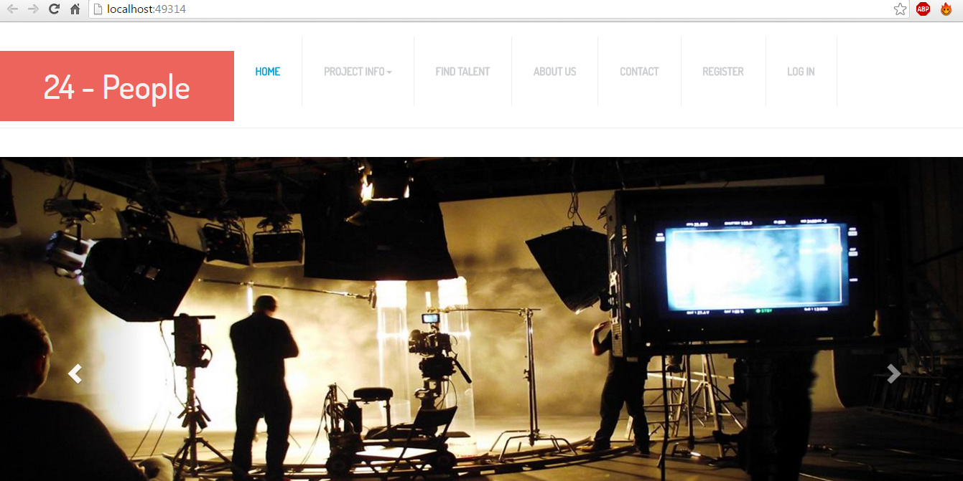

Find Talents: (User)

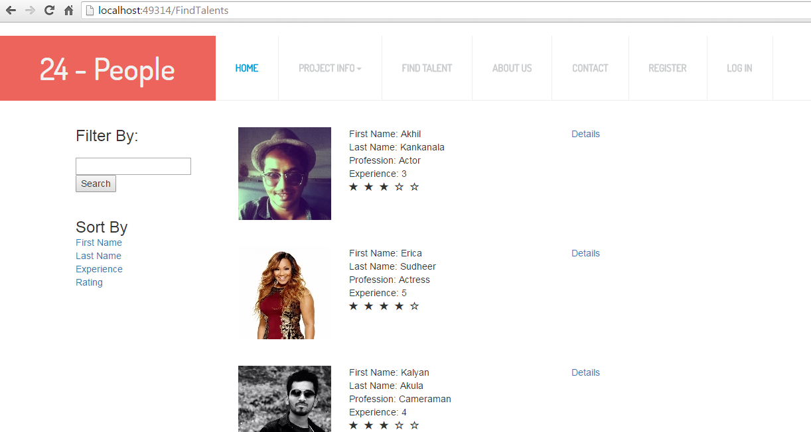

// GET: FindTalents

public IActionResult Index(string sortOrder, string searchString)

{

ViewBag.LastNameSortParm = String.IsNullOrEmpty(sortOrder) ? "lastname" : "";

ViewBag.FirstNameSortParm = String.IsNullOrEmpty(sortOrder) ? "firstname" : "";

ViewBag.ExperienceSortParm = String.IsNullOrEmpty(sortOrder) ? "experience" : "";

ViewBag.RatingSortParm = String.IsNullOrEmpty(sortOrder) ? "rating" : "";

var talentHunt = from s in _context.FindTalents.ToList()

select s;

if (!String.IsNullOrEmpty(searchString))

{

talentHunt = talentHunt.Where(s => s.LastName.Contains(searchString)

|| s.FirstName.Contains(searchString) || s.Profession.Contains(searchString));

}

switch (sortOrder)

{

case "firstname":

talentHunt = talentHunt.OrderByDescending(s => s.FirstName);

break;

case "lastname":

talentHunt = talentHunt.OrderBy(s => s.LastName);

break;

case "experience":

talentHunt = talentHunt.OrderBy(s => s.Experience);

break;

case "rating":

talentHunt = talentHunt.OrderBy(s => s.Rating);

break;

default:

talentHunt = talentHunt.OrderBy(s => s.FirstName);

break;

}

return View(talentHunt.ToList());

}

Find Talents: (Admin)

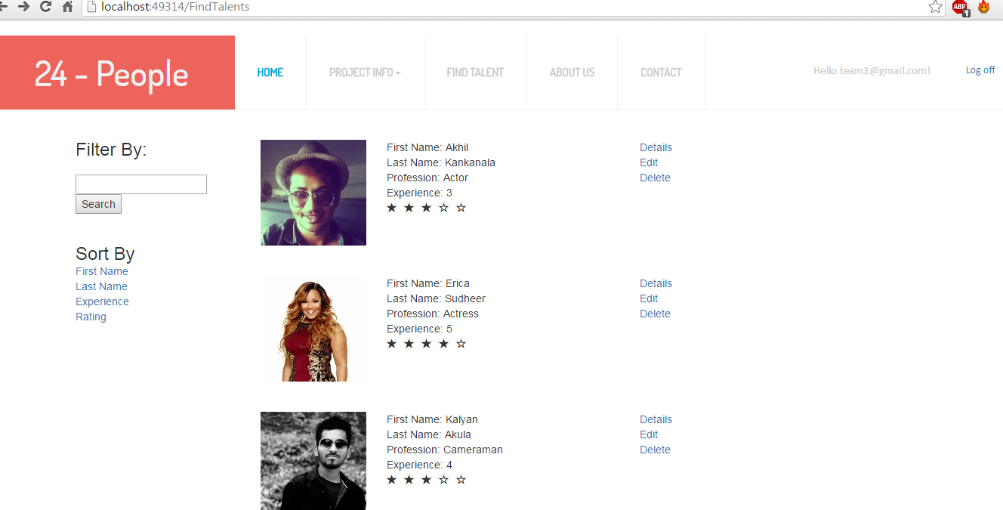

<a data-toggle="modal" data-target="#@item.FirstName">Details</a> <br />

@if (ViewContext.HttpContext.User.IsInRole("Admin"))

{

// Do something here

<**a** **asp-action**="Edit" **asp-route-id**="@item.FindTalentID">Edit</**a**><br />

<**a** **asp-action**="Delete" **asp-route-id**="@item.FindTalentID">Delete</**a**>

}

Modal Class: (Details)

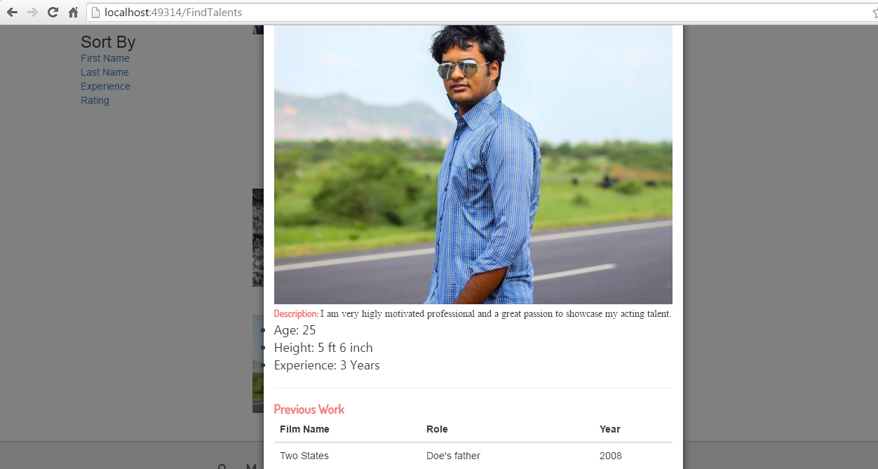

<div class="modal fade" id="Karthik" role="dialog">

<div class="modal-dialog">

<!-- Modal content-->

<div class="modal-content">

<div class="modal-header">

<button type="button" class="close" data-dismiss="modal">&times;</button>

<h4 class="modal-title">Karthik</h4>

</div>

<div class="modal-body">

<img class="img-responsive center-block" src="~/lib/bootstrap/dist/images/Melwin.jpg" alt="">

<div style="margin-top:3px; font-family:'Times New Roman', Times, serif;font-size:14px">

<b style="font-family:'Dosis-Medium';color:lightcoral">Description: </b> I am very higly motivated professional and a great passion to showcase my acting talent.

<ul>

<li style="font-family:'Segoe UI', Tahoma, Geneva, Verdana, sans-serif;font-size:large">Age: 22</li>

<li style="font-family:'Segoe UI', Tahoma, Geneva, Verdana, sans-serif;font-size:large">Height: 5 ft 7 inch</li>

<li style="font-family:'Segoe UI', Tahoma, Geneva, Verdana, sans-serif;font-size:large">Experience: 2 Years 6 Months</li>

</ul>

</div>

<hr />

<h4><b style="font-family:'Dosis-Medium';color:lightcoral">Previous Work</b></h4

<h4><b style="font-family:'Dosis-Medium';color:lightcoral">Videos</b></h4>

<iframe width="185" height="150" src="https://www.youtube.com/embed/eNunFc0w8Xg" frameborder="0" allowfullscreen></iframe>

<iframe width="185" height="150" src="https://www.youtube.com/embed/xzKfRT9D7xE" frameborder="0" allowfullscreen></iframe>

<iframe width="185" height="150" src="https://www.youtube.com/embed/LH_CbarjSJs" frameborder="0" allowfullscreen></iframe>

<div id="myProgress">

<div id="myBar"></div>

</div>

<br>

<button onclick="move()" style="font-family:'Dosis-Medium';color:lightcoral">Star Dust Rating</button>

<script>

**Review of Team:**

Firstly, I am very lucky to have this excellent team. If I had $800 and have to distribute among team members based on their contribution then

Pranay Peddi: $125 – For coming up with this beautiful idea of developing a website for Upcoming film professionals. He also greatly contributed in designing the UI of our application.

Abhinaya Mogalipuvvu: $125 – She contributed greatly in designing the database. As our application mainly depends on user previous works and contributions. All this information is greatly handled by her in the database.

Veerapratap Nadh Putta: $125 – I have greatly contributed in the coding part of the project. I had medium involvement in designing the UI of the project, documentation and testing. I have done the coding for entities, filtering, sorting and searching functionalities. I have also done admin authorization and display pages based on authorization level.

Sai Naveen Mallampati: $100 – He worked greatly in testing our project. At every phase of project presentation, we had smooth transition because of his hard work. He helped in coding the Our Goals, Milestones and figuring the reasonable future enhancements in our project.

Manichandra Gampa: $100 – He has worked so hard in fixing the layout issues and implanting chat into our application. His contributions like adding News feed to our websites has received great response from listeners.