Link to the repository:

<https://bitbucket.org/mabhinaya/team03_project>

Contributions:

* Defined the models for the project and took care of migrations.
* Implemented identity to achieve authentication and authorization.
* Added the external login feature.
* Implemented CRUD operations on models.

**Final Screen Shots:**

**Home Screen:**



Find Talents Page

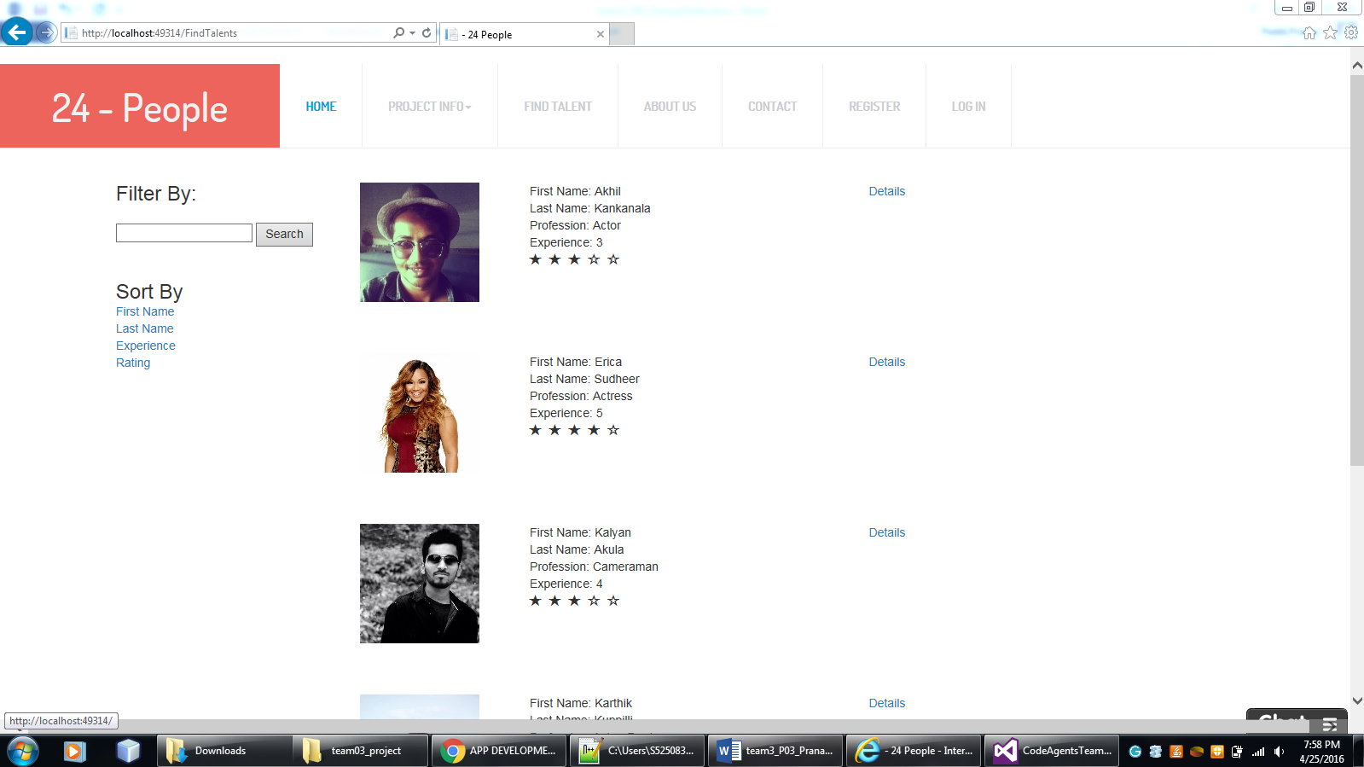

Deeper view of the profile:

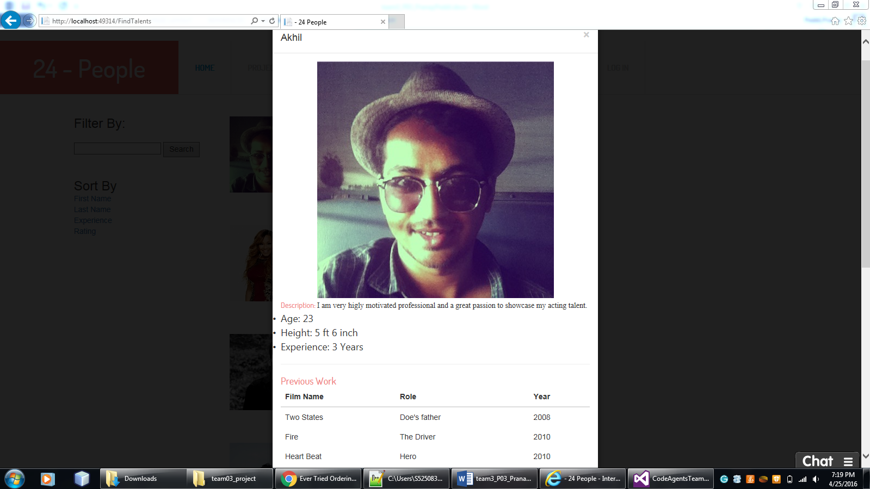

Trending Technicians:

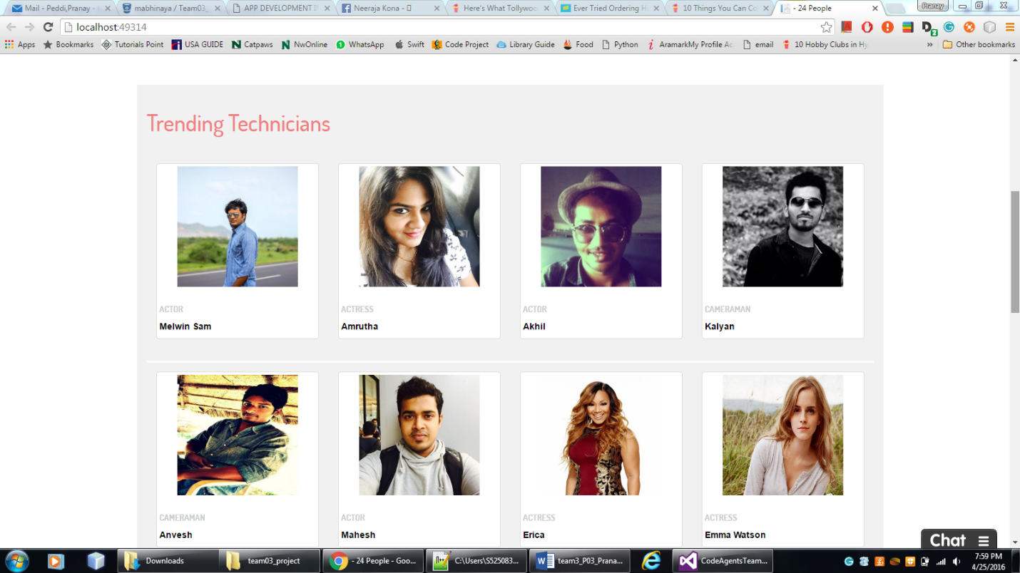

New Feed:

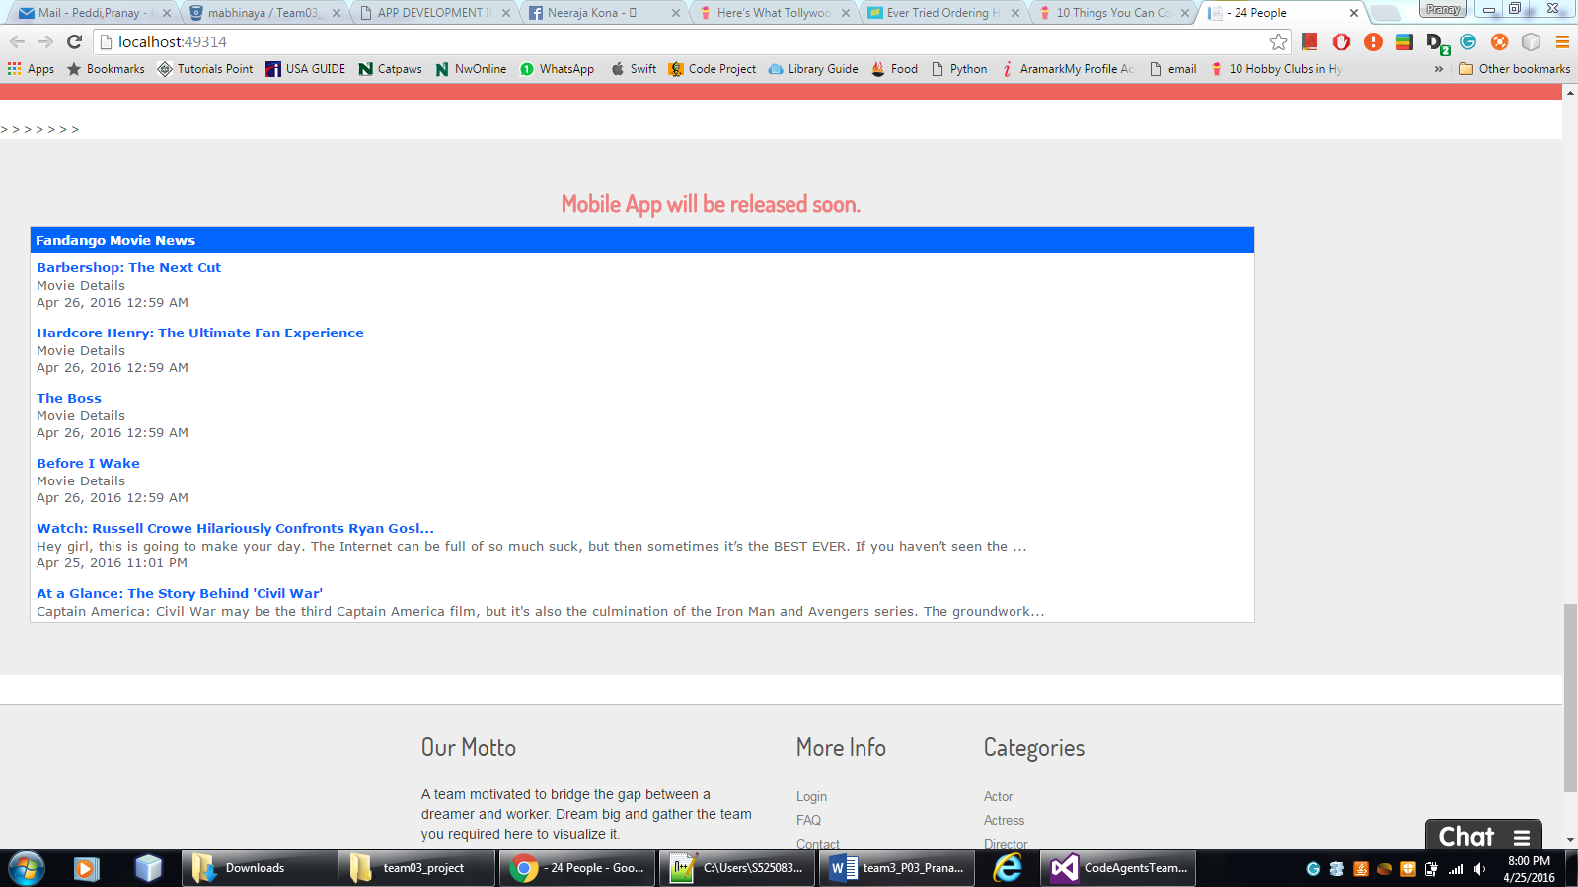

About Us:



Contact Us:

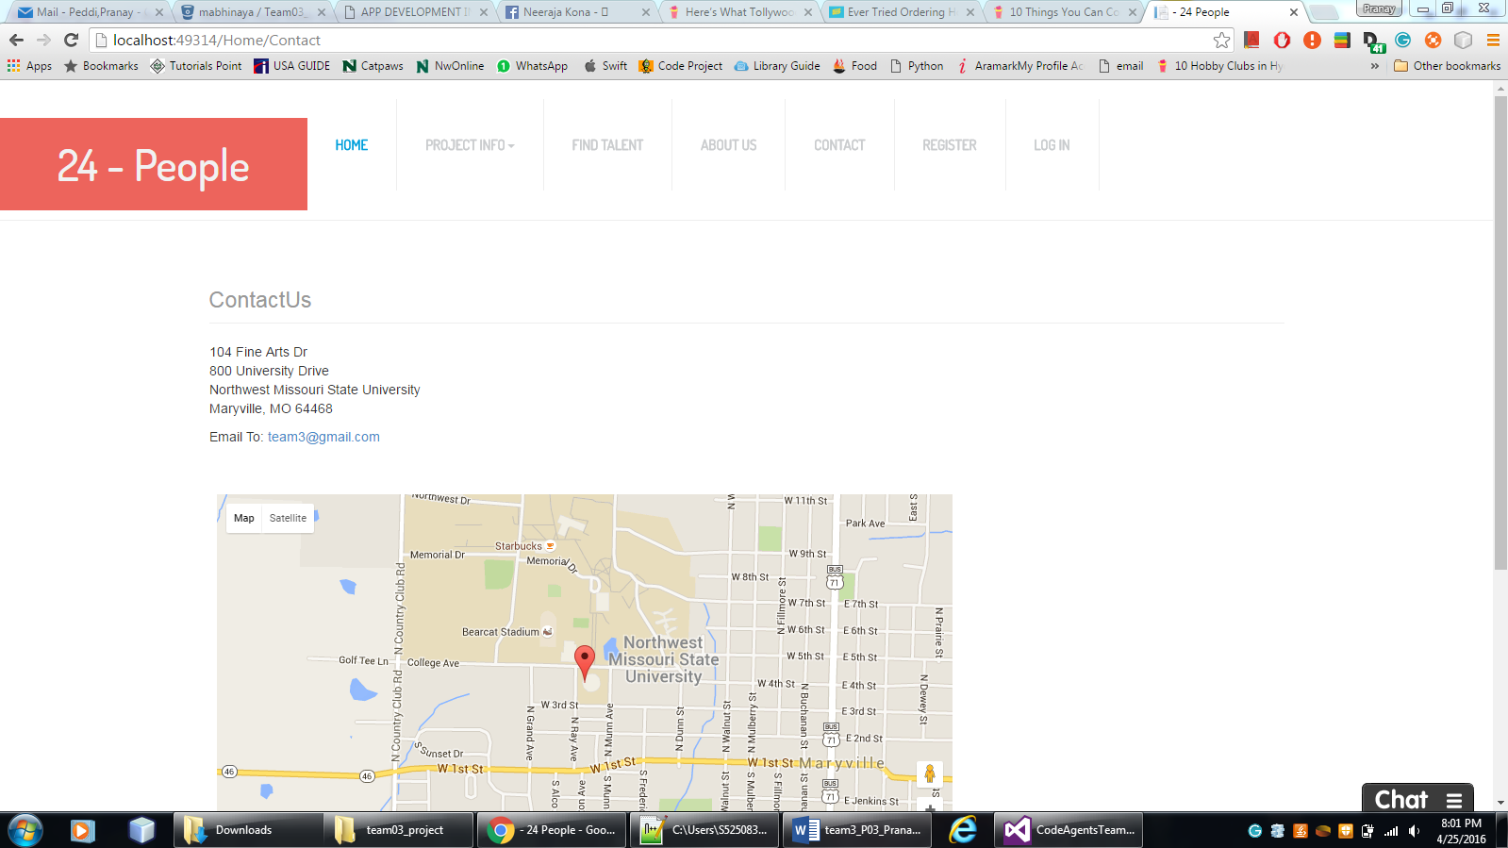

Challenges faced & bug fixes:

* Faced problems while implementing external login. But implemented later through the help of internet.
* Couldn't achieve identity in desired model, so have done it on Account controller
* Changing of database structure, made a tough job to create the CRUD operations

Team mates Review:

* Abhinaya: Did my job perfectly when given. But should maintain consistency.
* Veera Pratap: A highly knowledge coder and was helpful through out the project.
* Sai Naveen: Was very helpful throughout the documentation part and in bug fixes.
* Mani Chandra Gampa: Has contributed much through documentation and testing
* Pranay Peddi: Has contributed to interface design and project co ordination..

If I had 800$ in hand – I would distribute in the following way:

Abhinaya – 150

Veera Pratap – 200

Pranay Peddi – 200

Sai Naveen – 75

Mani Chandra Gampa - 75