Link to the repository:

<https://ManichandraG@bitbucket.org/mabhinaya/team03_project.git>

Contributions:

* Implemented Dynamically updated news Feed

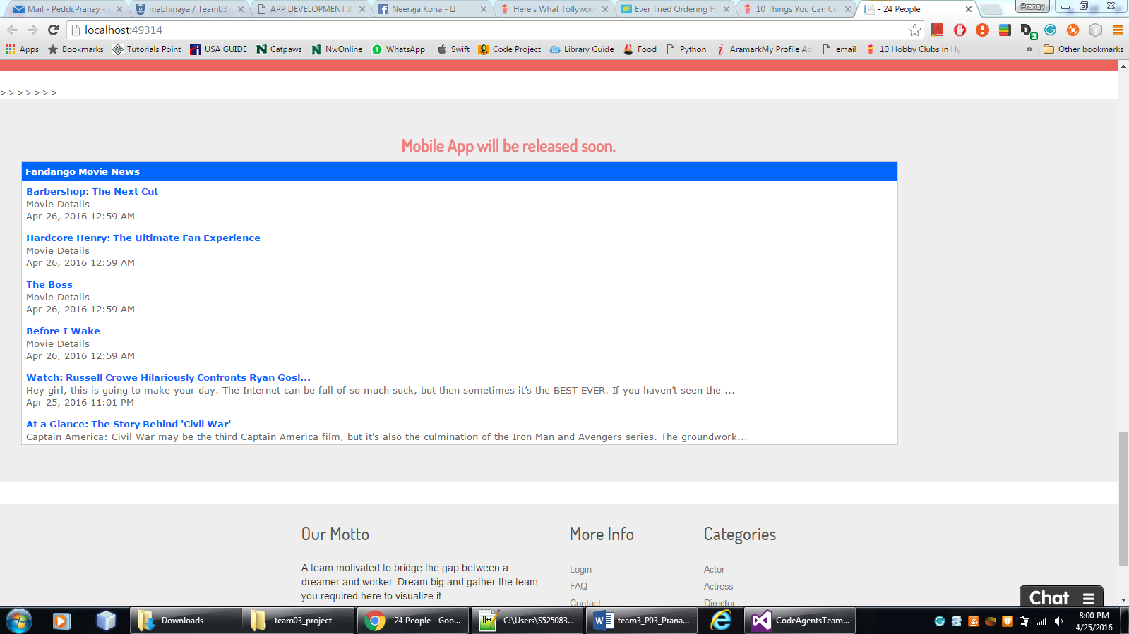

.

* Implemented Chat option with the customer

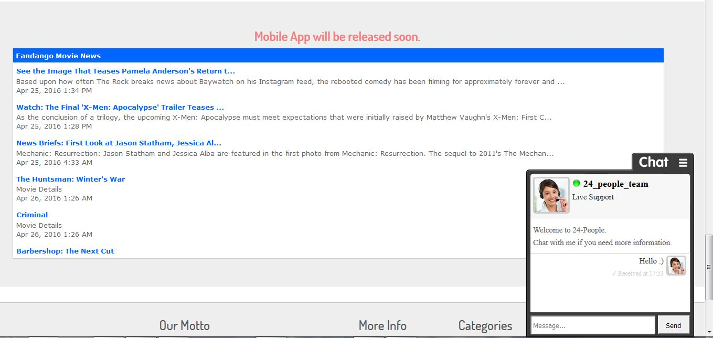

* Have done the Unit testing part.
* Have done the modals for expanding the views.
* Have done the designing part of the UI .

**Final Screen Shots:**

**Home Screen:**



Find Talents Page

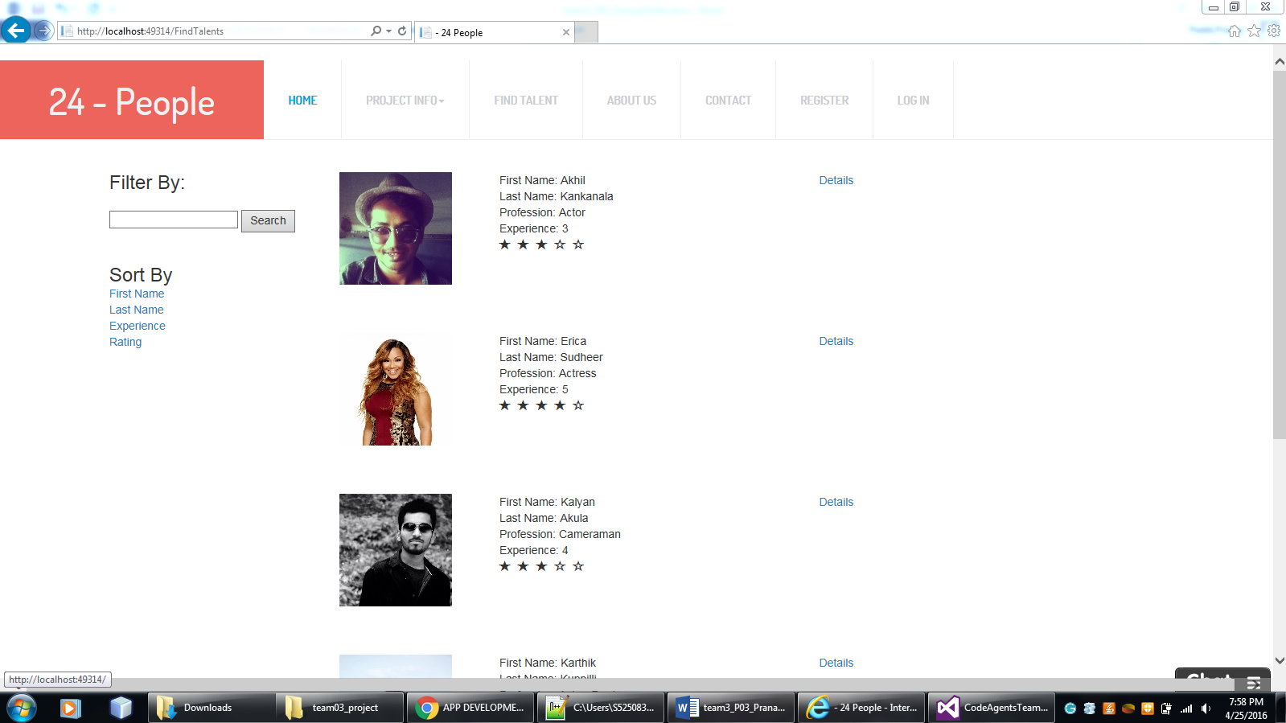

Deeper view of the profile:

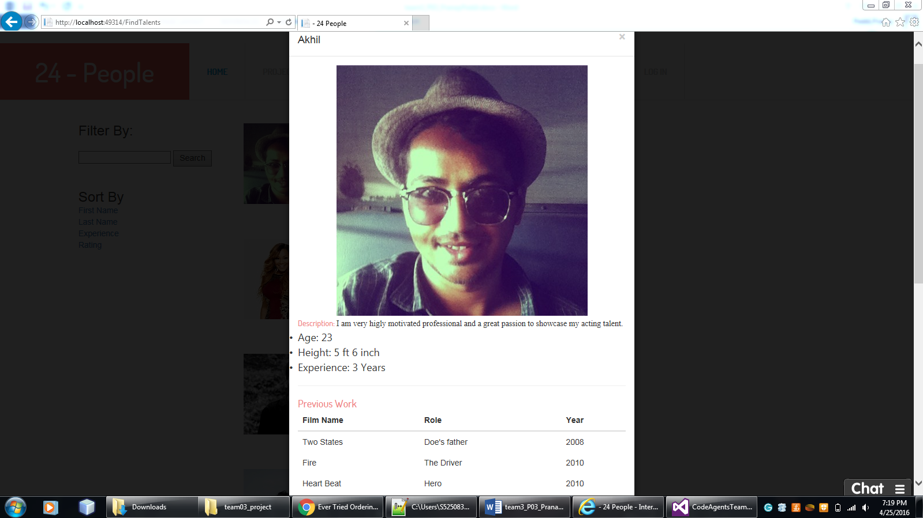

Trending Technicians:

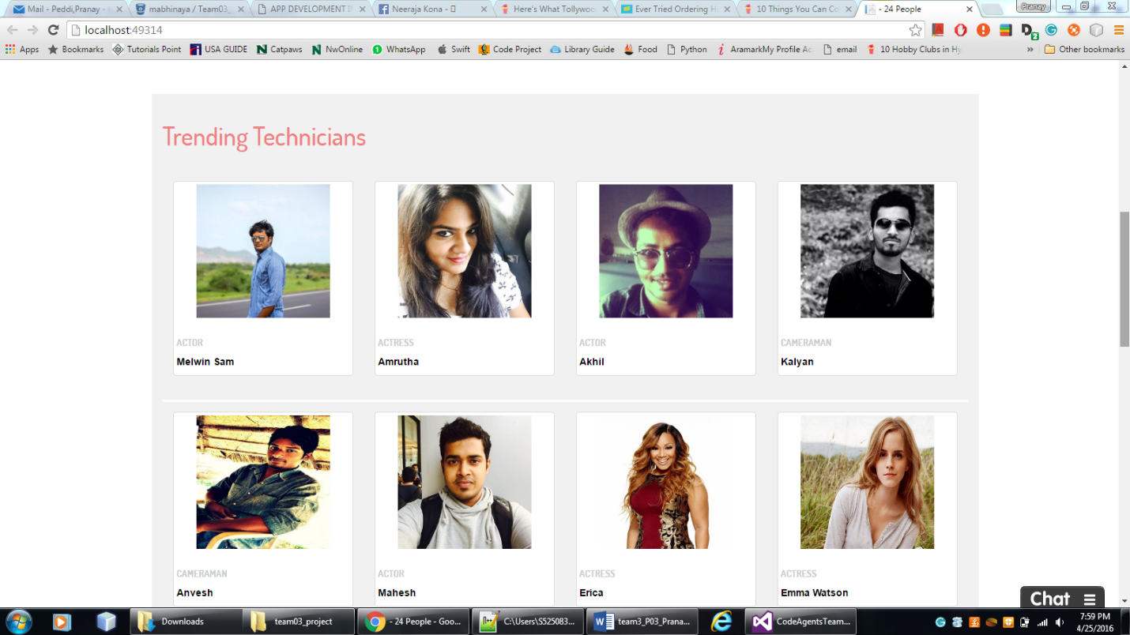

New Feed:



About Us:



Contact Us:

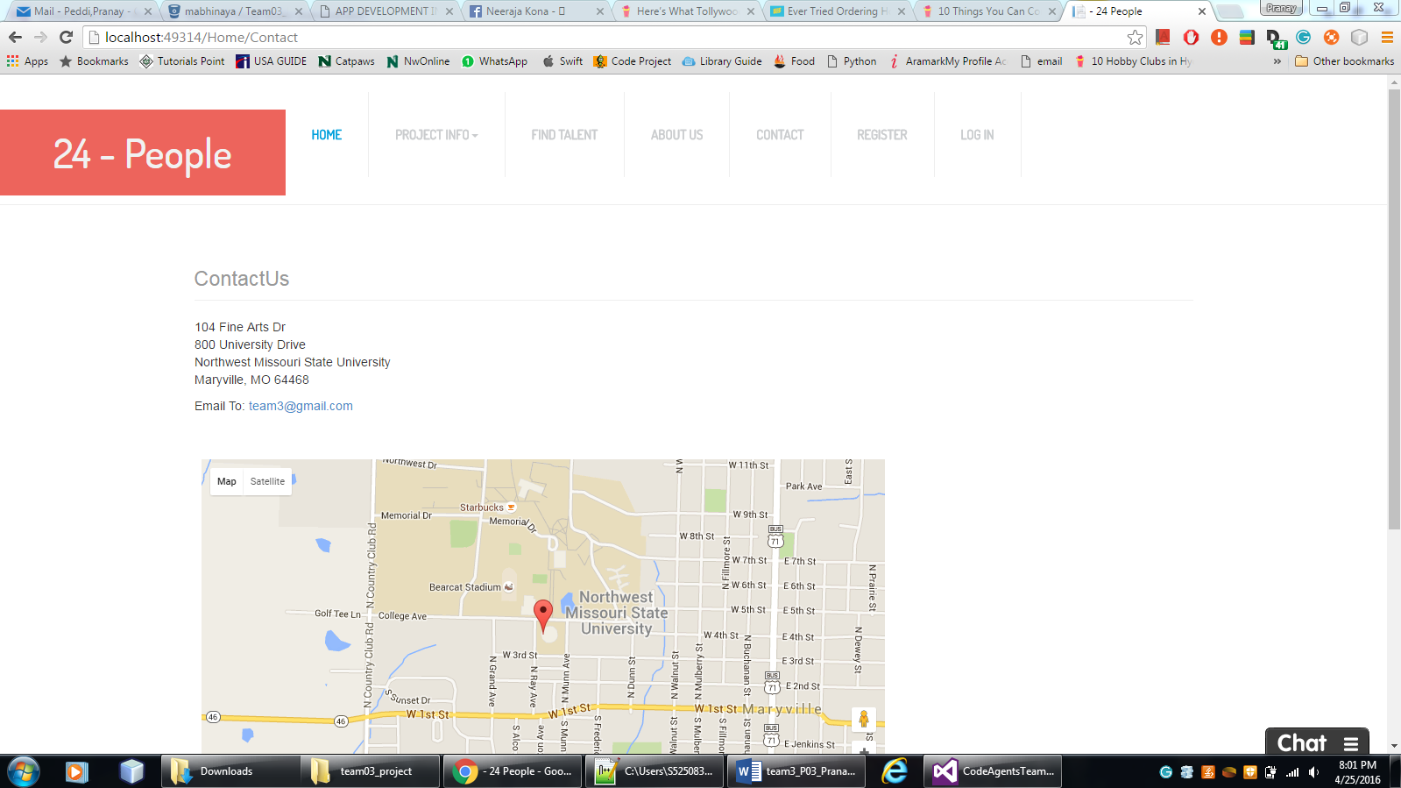

Challenges faced & bug fixes:

* While implementing the news feed, I have to search lot to find right APIs to embed the code to display in our website.
* Faced problems while implementing live chat with customers, there are less sources to implement live chat with customers to customers, so we decided to implement customer service.
* Faced some problems while working on Unit testing.

Team mates Review:

* Abhinaya:she done her part in implementing the database models in very well-mannered and integrated most of the project functionalities successfully.
* Veera Pratap: he is one of the backbone of the project and implemented most functionalities

Smartly.

* Sai Naveen: Very talented and gave cent percent hard work in doing his part.
* Mani Chandra Gampa: I contributed most of the work to turn the project into well featured application and also worked hard to implement those features.
* Pranay Peddi: He is very hard working person and took initiative in designing and developing the application and motivated all the teammates to design desired output.

If I had 800$ in hand – I would distribute 175 dollars each for abhinaya and veerapratap for their maximum effort and business logic implementation for the project. And 125 dollars for my contributions in interface design and implementing functionalities like news feed and chat applications. 125 dollars to Naveen for contributing testing and 200 to pranay for working hard for project completion and interface design.