Link to the repository:

<https://bitbucket.org/mabhinaya/team03_project>

Contributions:

* Designed the interface of for the project

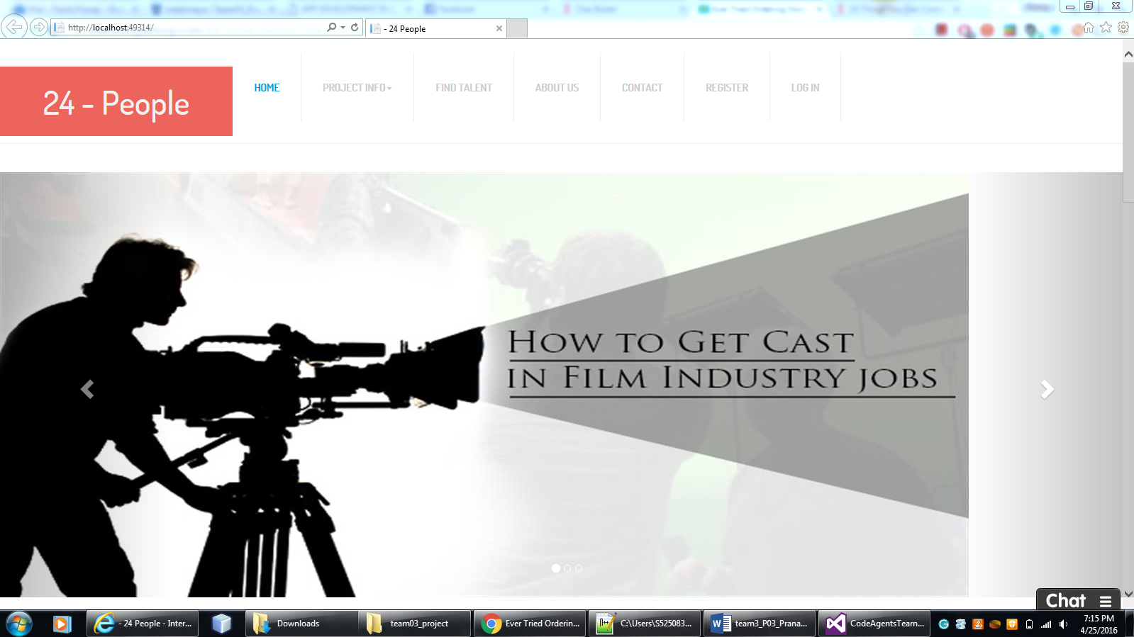

* Implemented the expanded view of the user profiles

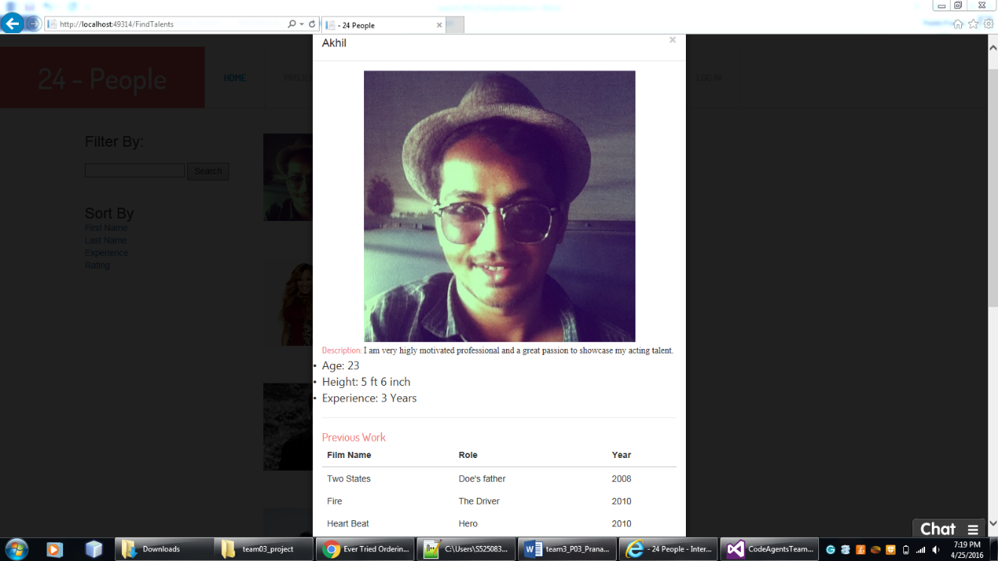

* Have done the requirement analysis for the project.
* Have done the model definition and migration for those models.
* Project co – ordination and organizing the project modules were my contributions.

**Final Screen Shots:**

**Home Screen:**



Find Talents Page

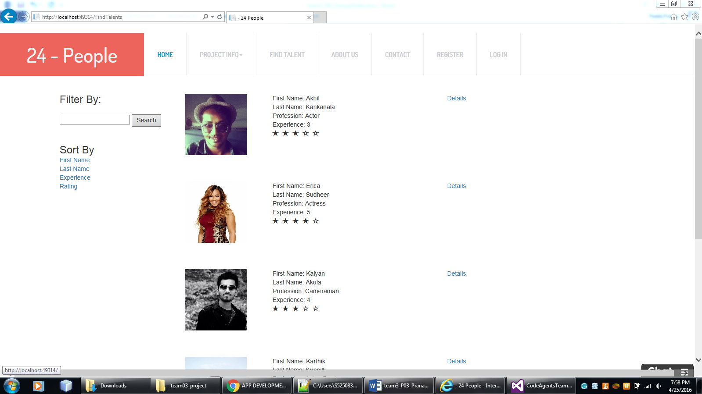

Deeper view of the profile:

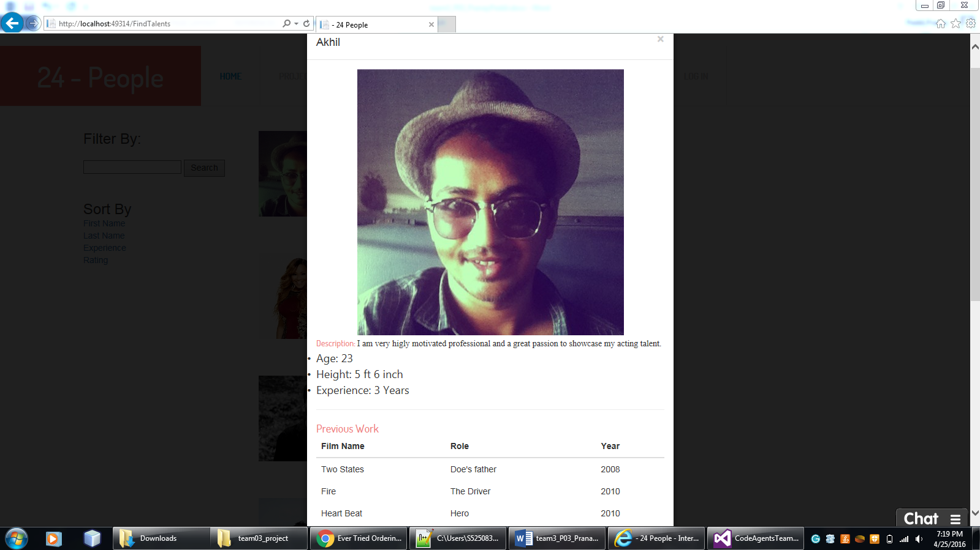

Trending Technicians:

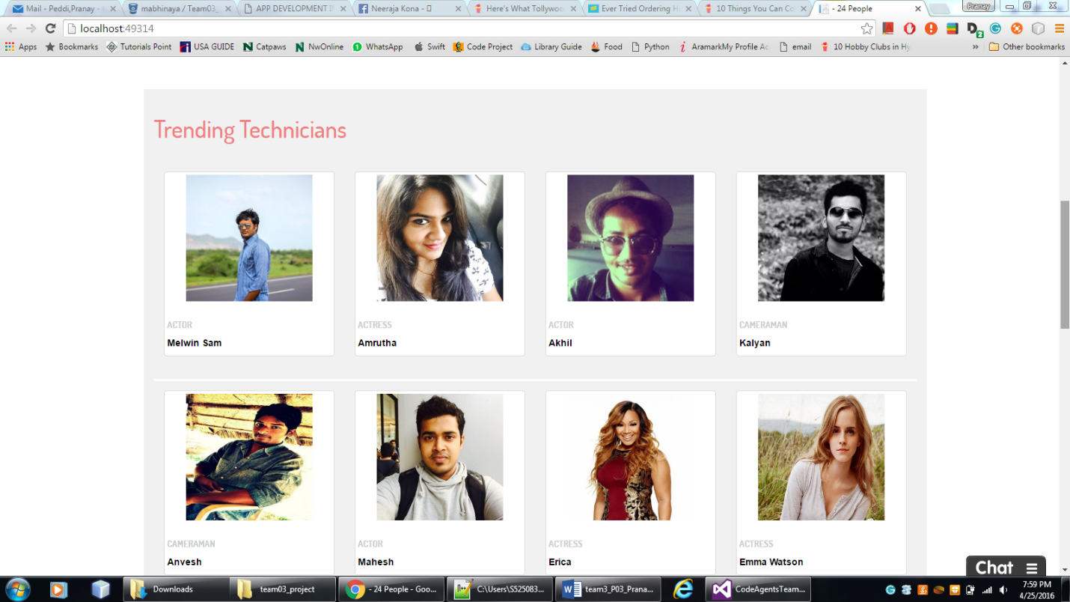

New Feed:

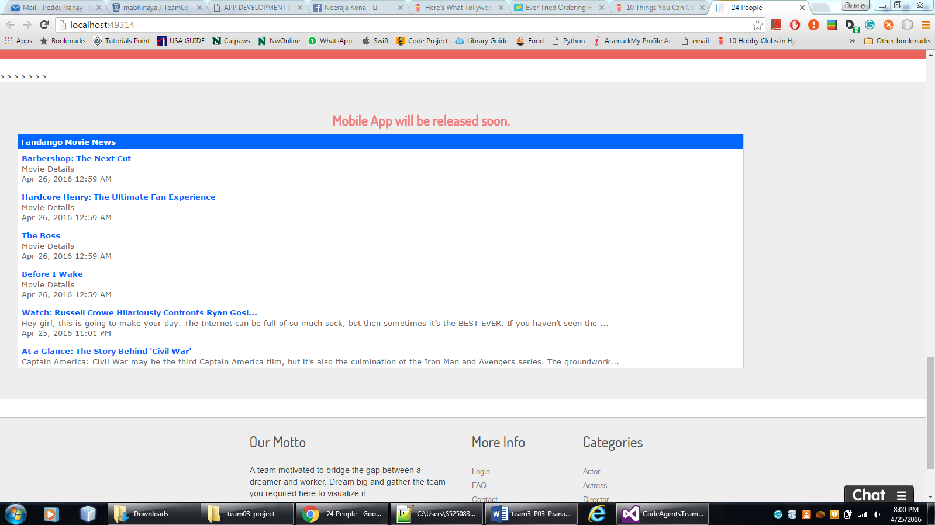

About Us:



Contact Us:

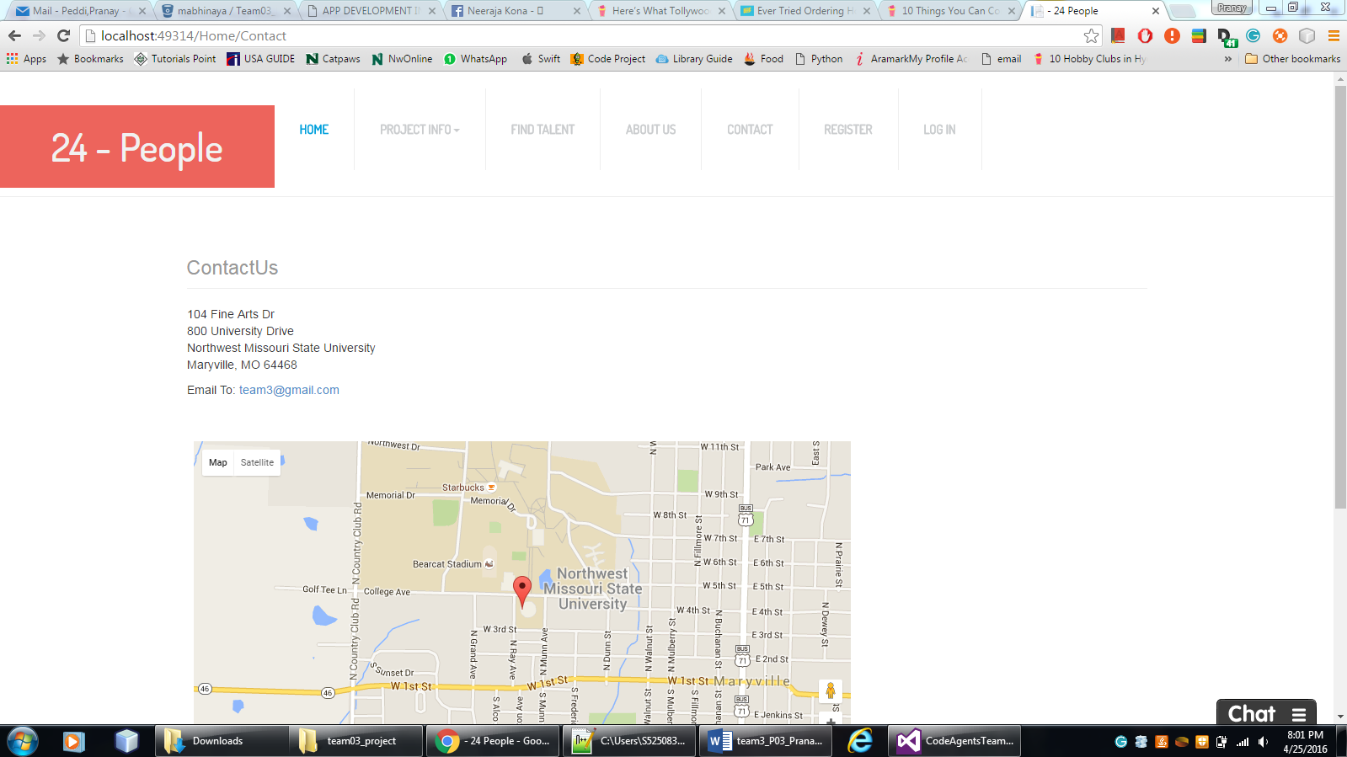

Challenges faced & bug fixes:

* Faced problems setting up carousel components.
* Couldn’t set up the bootstrap components at the starting, but finally succeeded after the assistance of my team mates
* Implementing the bootstrap models was tiresome, so integrated all those models into a modal to display the detailed profile view of the user.

Team mates Review:

* Abhinaya: Very helpful team mate and is always consistent.
* Veera Pratap: Knows his work and will surely complete his given task on time.
* Sai Naveen: Was always attentive in group meetings and has given solid contributions to the project
* Mani Chandra Gampa: Is a talented user interface designer. Took the role as a tester and has given his atmost effort to it.
* Pranay Peddi: I worked really hard for the project completion and the interface design. But should avoid procrastination.

If I had 800$ in hand – I would distribute 250 dollars each for abhinaya and veerapratap for their maximum effort and business logic implementation for the project. And 150 dollars for my contributions in interface design and project coordination and contribution. And 75 dollars each to Naveen and mani Chandra for their contribution in testing.