**Link to the repository:**

<https://SaiNaveen92@bitbucket.org/mabhinaya/team03_project.git>

**Contributions:**

1. Developed about us and Contact Us page.

2. Developed Project Info Tab and added Goal, Future work, Milestones pages.

3. Performed unit testing on each module.

4. Designed Actress Model and controller

**Final Screen Shots:**

**Home Screen:**

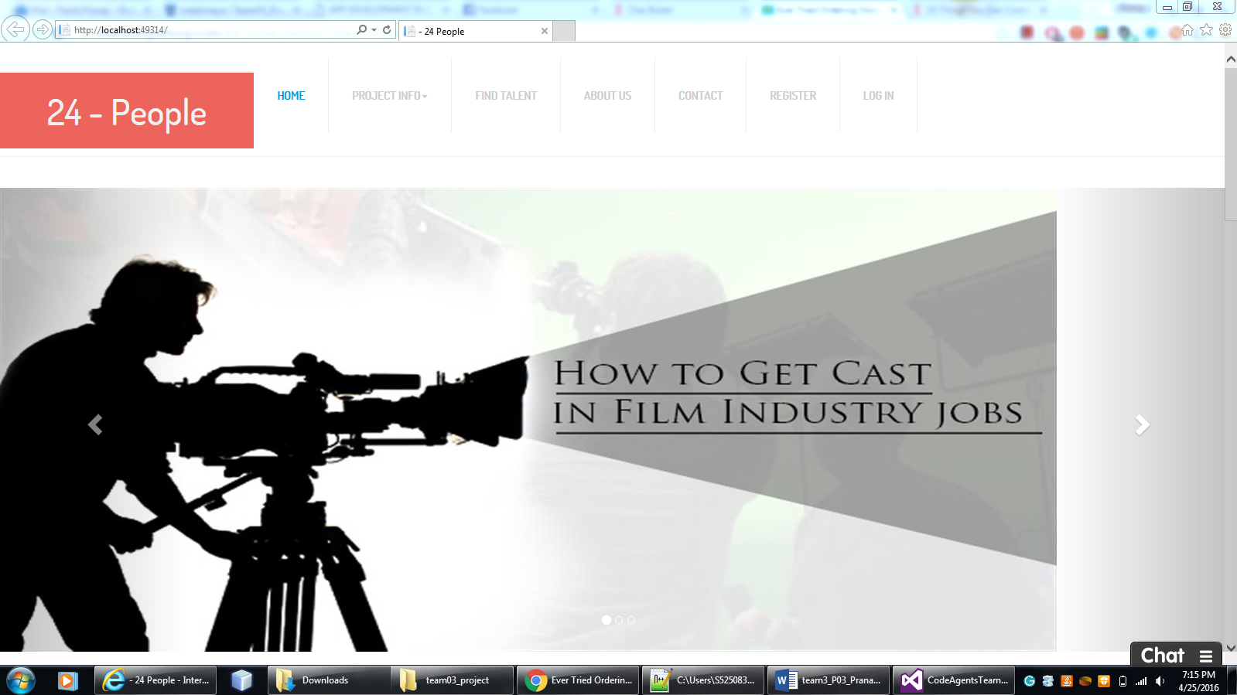

Find Talents Page

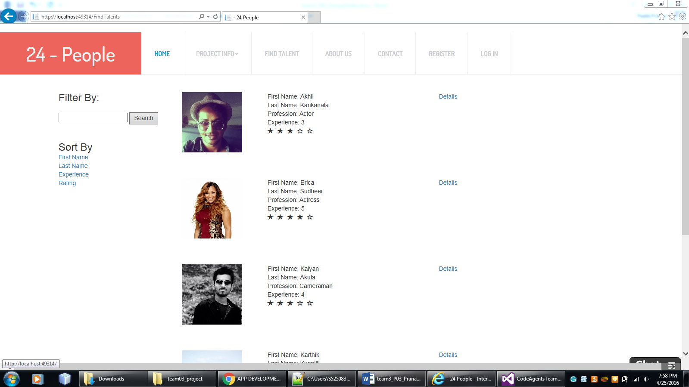

Deeper view of the profile:

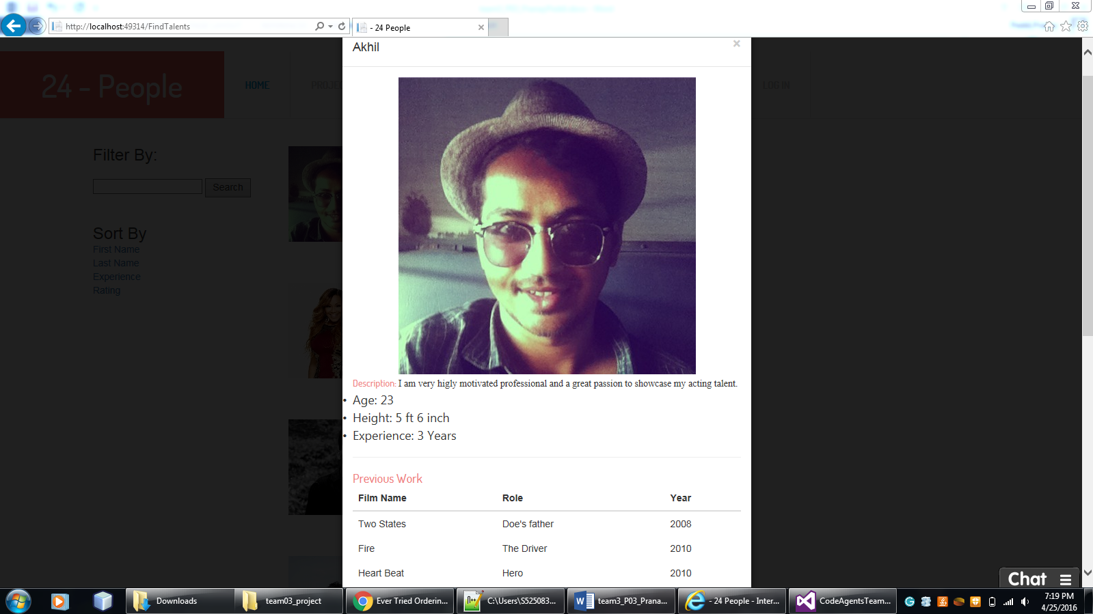

Trending Technicians:

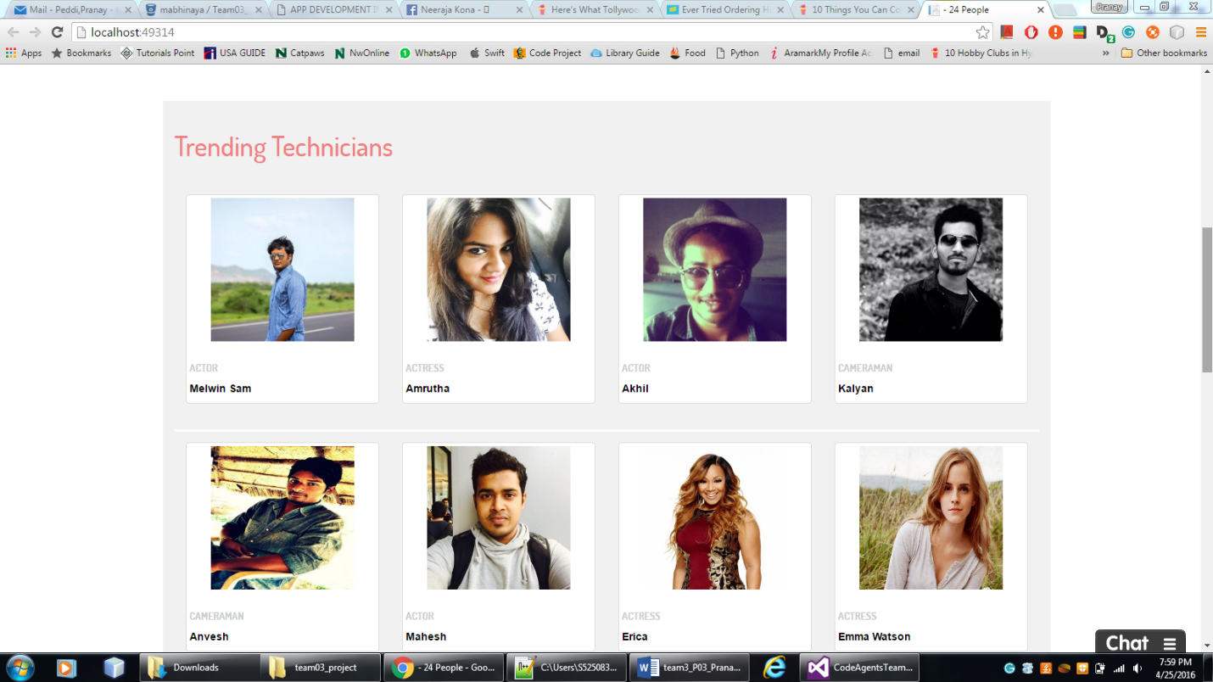

New Feed:

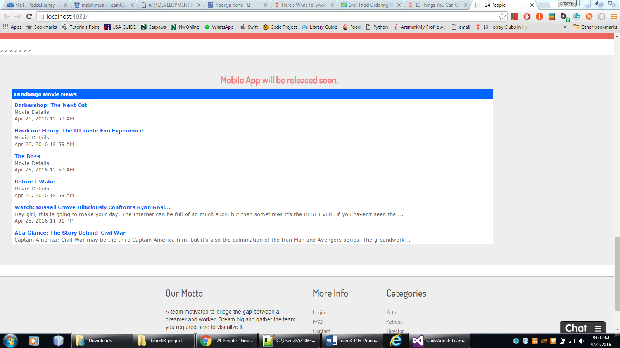

About Us:



Contact Us:

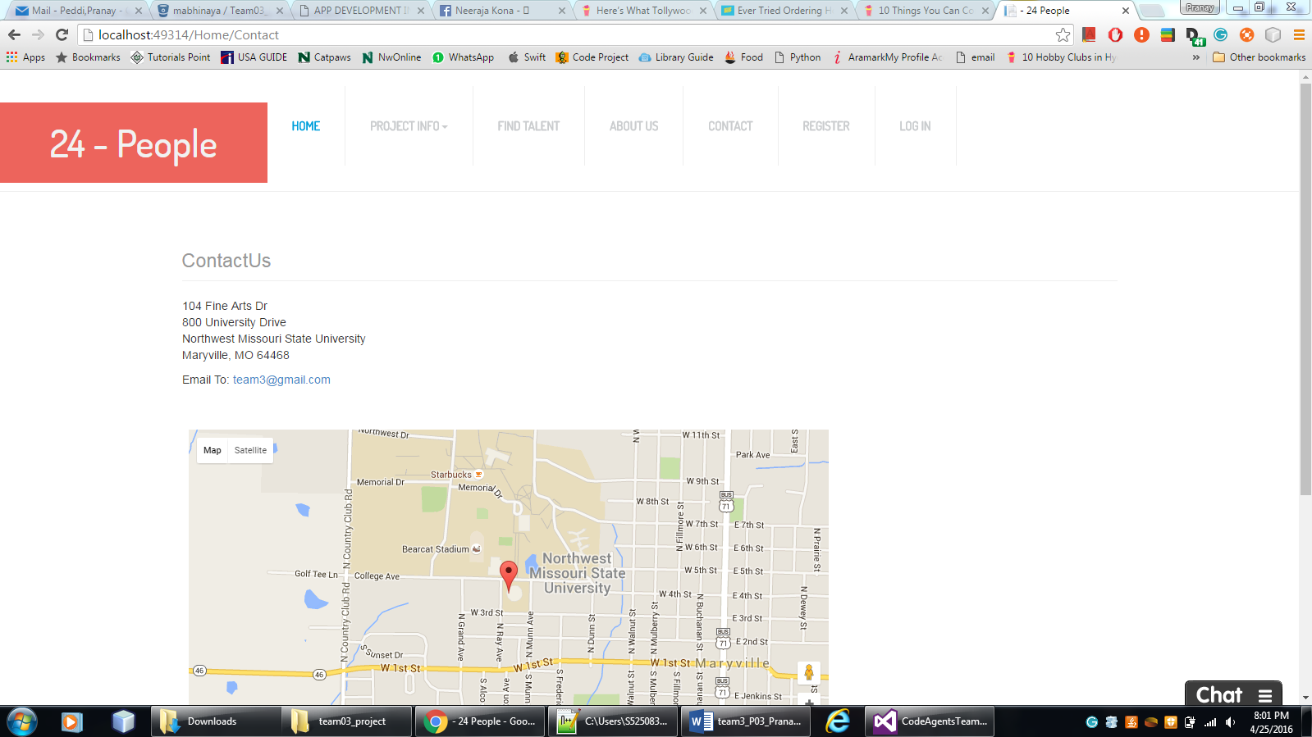

**Challenges faced & bug fixes:**

I have faced challenge regarding adding drop down menu of project info tab. It is not working, after I had added libraries and it is worked. I had tried for internationalization and not able to achieve it.

**Team mates Review:**

* Abhinaya: Did her job very nice. She works hard to complete the project.
* Veera Pratap: A good technical subject person we would contact him if any bug in project.
* Sai Naveen: I had kept good efforts in the team.
* Mani Chandra Gampa: Very nice and co-operative, complete the tasks in time.
* Pranay Peddi: He takes initiative in the team and motivates all the persons in the team.

If I had 800$ in hand – I would distribute in the following way:

Abhinaya – 200

Veera Pratap – 200

Pranay Peddi – 200

Sai Naveen – 100

Mani Chandra Gampa - 100