**Team 21 - BashGuardians - PartyGuardiOS**

**Client Name: Jacob Stansbury**

**Team member roles & responsibilities**

Spandana - S524987 - Primary Contact  
Pushpak - S525004 - Issues Management  
Vinod - S525117 - Communications and Documentation Management  
Yashwanth - S525056 - Quality and Testing Management  
Nandeesh - S525120 - Requirements Management  
Naveen - S525051 - Data Management  
Sanjeev - S525034 - Client Management

**What our team finished:**

1. **Requirement Discovery**

**Week1:**

* Worked on received prototype for both host/guard user and basic user screens.
* Link for Basic User prototypes: [https://projects.invisionapp.com/share/SB76VFTTR#/screens (Links to an external site.)](https://projects.invisionapp.com/share/SB76VFTTR#/screens)
* Link for Host/Guard User Prototypes: [https://projects.invisionapp.com/share/EN7YELSSH#/screens (Links to an external site.)](https://projects.invisionapp.com/share/EN7YELSSH#/screens)

**Week2:**

* We have grabbed the components required for our project such as Mac Book and iPad from the library.
* We need to acquire some more requirements such as application logo, label constraints and remaining design specifications from the client.

1. **Design Creation/Modification**

**Week1:**

* Completed UI Design for login and signup screens

**Week2:**

* Completed UI Design for App information page and Fraternity list screens

1. **Development of Application**

* Need to start developing the Login and Signup screens

1. **Client Interaction**

* Haven’t interacted with the client yet.
* Need to acquire application logo, label constraints and remaining design specifications from the client.

1. **Testing**

**Week1:**

* Didn’t received iPad and Mac Book.

**Week2:**

* Used iPad for testing the designed user interfaces for login, signup, app information and fraternity list screens.

1. **Documentation**

**Week1:**

* Saved a copy of M01, F01 and GDP-1 Project Manager Briefing in BitBucket.

**Week2:**

* Saved a copy of M02 in BitBucket.
* Provided a README file with the instructions of how to run the application.

**Screenshots of major artifacts for accomplishments:**

**1) Basic user login**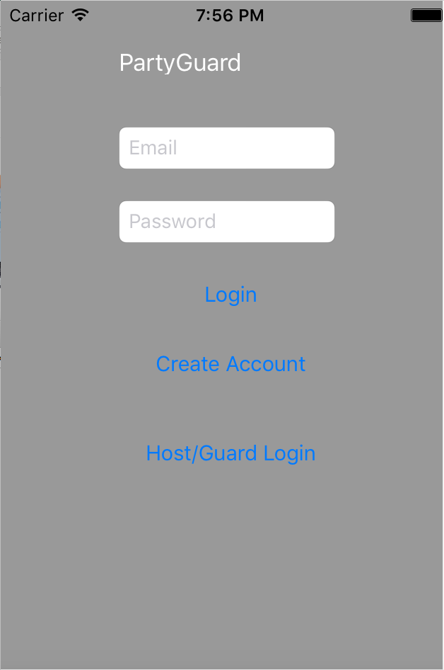

**2) Host/Guard user login:**

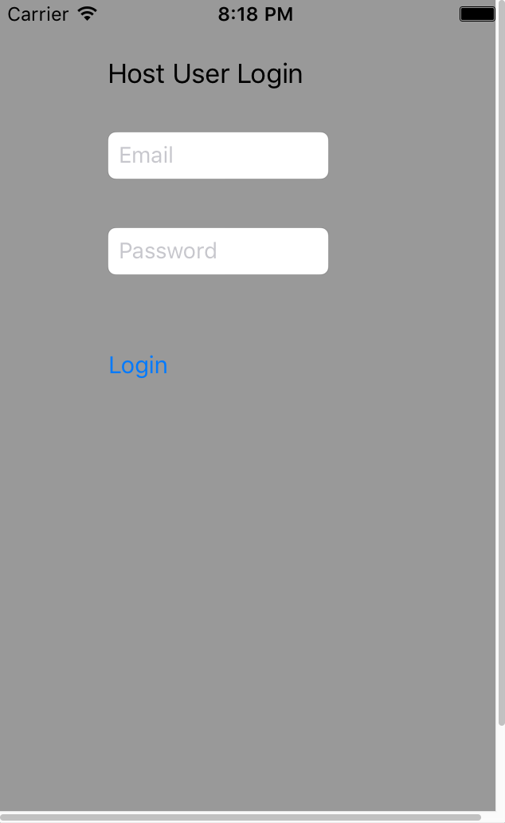

**3) Signup screen**

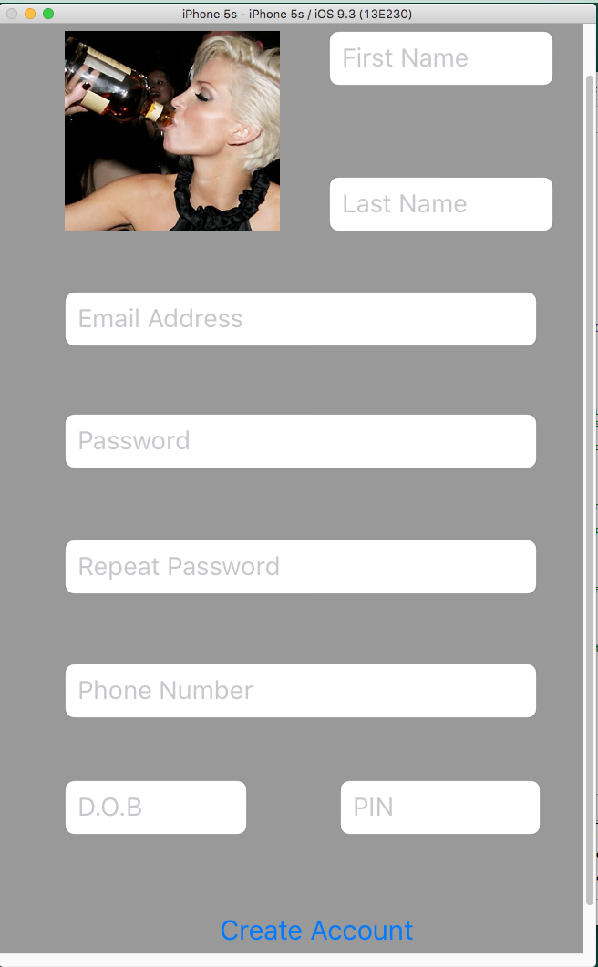

**4) App information screen**

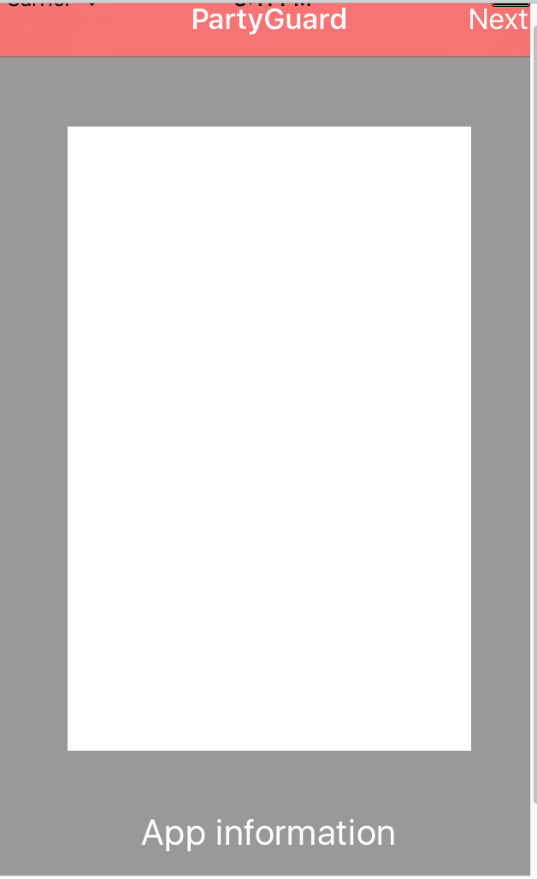

**5) Fraternity list screen**

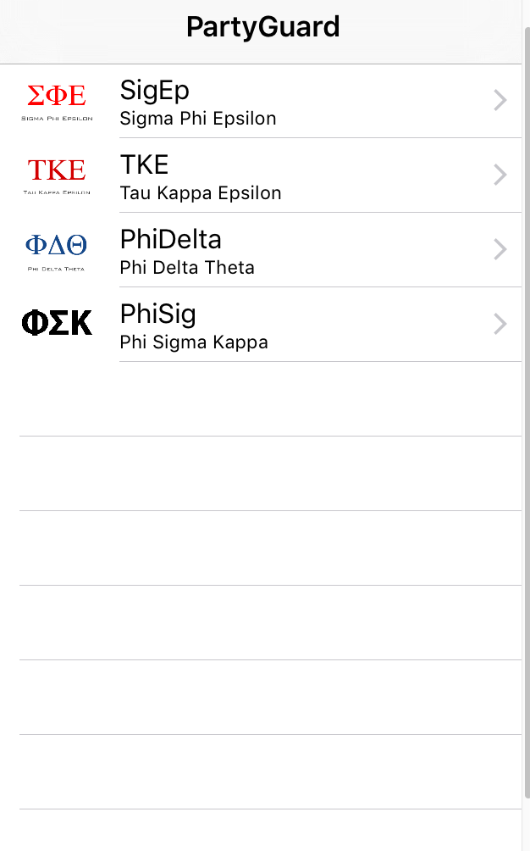

**Link for Repository:** [https://bitbucket.org/bashguardians/bashguardians (Links to an external site.)](https://bitbucket.org/bashguardians/bashguardians)

Person responsible:

Vinod, Nandeesh, Yashwanth and Pushpak – UI Design of login and signup screens

Sanjeev, Naveen and Spandana – UI Design of App information and Fraternity list screens

Team Bash Guardians – M01

Vinod and Nandeesh – F01

Sanjeev – GDP 1 Project Manager Briefing

Yashwanth and Sanjeev – GDP 1 Presentation

Team Bash Guardians – M02

**Work in progress:**

* Designing user interfaces for location, situation and alert screens
* Working on Workshop presentation

Person responsible:

Sanjeev and Naveen – Location, Situation and Menu screens (8 hours)

Vinod and Nandeesh – Host/Guard user screens (8 hours)

Yashwanth, Pushpak, and Spandana – Alert screens for both host/guard user and basic user (8 hours)

Team Bash Guardians - Workshop1 presentation (3 hours)

Sanjeev, Naveen, Spandana – Developing App information screen (4 hours)

Vinod, Nandeesh, Pushpak, Yashwanth – Developing login and signup screens (4 hours)

**Link for Trello Board:**[**https://trello.com/b/p8DPSe0J/partyguard-ios-bash-guardians (Links to an external site.)**](https://trello.com/b/p8DPSe0J/partyguard-ios-bash-guardians)