**PartyGuard iOS App**

User Manual

**Bash Guardians**

Vinod Reddy Somu

Sai Spandana Chava

Nandeesh Tankasala

Sai Naveen Mallampati

Naga Venkata Sanjeev Koneru

Yashwanth Teja Mangalapally

Sri Ram Pushpak Chowdary Godavarthi

Date: 11/20/2016

Prepared for

44-692 Graduate Directed Project-II

Instructor: Dr. Denise Case

Fall 2016

1. **Introduction**

An iOS application called “PartyGuard” that centers on women’s safety at parties developed for NWMSU students. Whenever a woman is assaulted she can report to the party admin and the fraternity head or police using this application. They can also report some problems such as inappropriate conduct, and assaults of any sort. The fraternity heads receive the reports and they will send the guards to the spot of the incident and help the woman. A timer is set to the “Emergency” button, if the trouble is not resolved within fifteen minutes after applying it, then an alert message would be sent to campus police.

The following are the main features of the application:

1. As our team is responsible for iOS application the app we build runs only on iOS.
2. This application allows all the members who are attending the party to register
3. This application maintains a database of all the members at the party.
4. Number of users registering: Though the number is precisely not mentioned, but the app can support a large number users at a time.
5. Emergency button - Allows a woman to report the police if she is assaulted at the party if her issue is not resolved in 15 minutes.
6. **Installation Instructions**

**Step 1:** Clone the project using Terminal from the BashGuardians Repository.

**Step 2:** Download and Install the Xcode from the Appstore.

**Step 3:** Open the project folder and open the PartyGuard.xcode file.

**Step 4:** Choose the device and run the application.

1. **Basic User**

Basic user is the woman who attends party organized by a fraternity house. She uses the application whenever she feels unsafe or assaulted by someone by reporting to the fraternity head and seek their help to resolve her issue.

**3.1 User Login**

* You will be redirected to the login page when she opens the app for the first time.
* You should provide username and password in the respective fields and click on Login.
* If you click on Register button, you will be redirected to registration page.
* You should be validated by the respective authentication server based on the credentials provided.
* If the login is successful, you should be redirected to “App Information” screen.
* If the you provided credentials are invalid, then an error should be thrown.

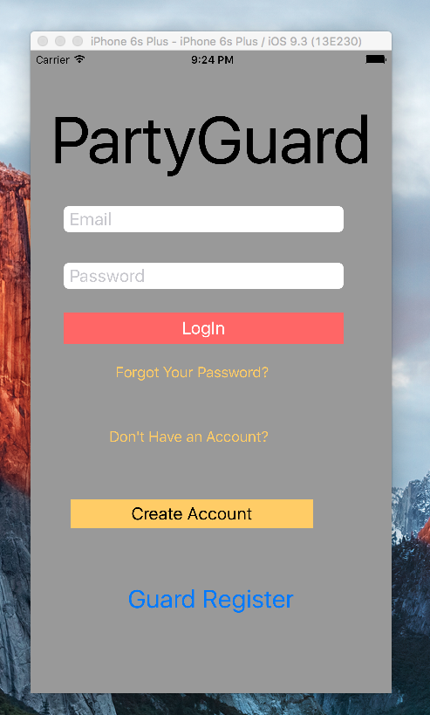

Fig 3.1: Basic User Login Screen

**3.2 Forgot Password**

* When you forget your password, you can reset the password by clicking on “Forgot Your Password?” button in the login screen.
* You will be redirected to another screen where you can reset your password by entering the email address that is used while registering for application.
* You will receive an email with a link to reset the password after entering your email address and click on “Submit”. You can reset your password through the link you got in email.

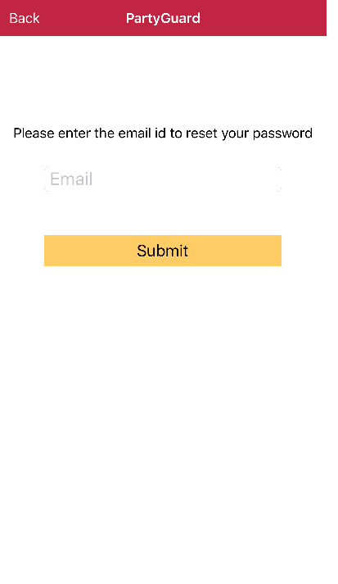

Fig 3.2: Forgot Password

**3.3 Registering user**

* You should be redirected to the registration page when you click on “Register” button in the login page.
* You should provide the following details to register as a new user

1. First Name
2. Last Name
3. Email Address
4. Password
5. Re-enter Password
6. Phone Number
7. Date of Birth (Optional)
8. Pin
9. University

* You can upload an image from the computer.
* Applications checks if the passwords match, if not an error will be thrown.
* New user details are added to the database.
* If registration is successful, you should be redirected to “Home” screen.

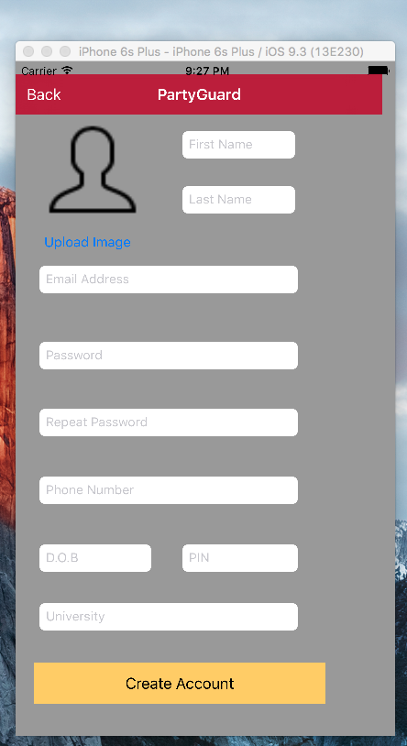

Fig 3.3: Registering new user

**3.4 Application Information**

* You will be redirected to “App Information” screen, when you login for the first time.
* You will be provided with a slider that contains images/ video that instructs you on how to use “PartyGuard” app.
* Images and Video links are shown on the page in a slider.
* This screen is not shown if the user is not logging in for the first time.
* You can view Images or Videos provided in this screen.

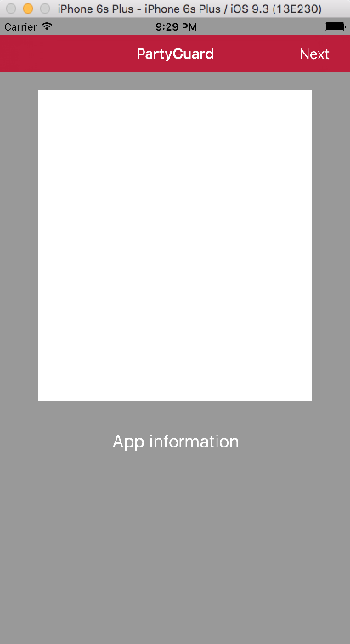

Fig 3.4: App Information Screen

**3.5 Fraternities Screen**

* The List of fraternities that are available in the user’s location are enabled for user to select.
* Fraternities list in the user’s location are fetched from the database.
* If the fraternity has not paid for the usage of this app, the fraternity option is not enabled in this screen.
* Fraternities list in the user’s location are fetched from the database. You can select a fraternity to report the issue.

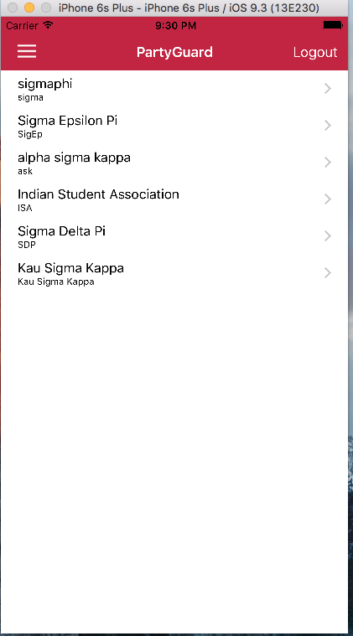

Fig 3.5: List of fraternities’ screen

**3.6 Basic User Menu Screen**

* You can navigate the application screens by side bar navigation.
* You can view the home screen by clicking home in side bar navigation.
* You can view details of your account like first name, last name and other details.
* You can view the previous request history that you made.
* You can change password by navigating into settings screen through side bar navigation.
* You can also change the location.
* You can navigate back to the login screen by clicking logout button.
* You can also view profile picture in side bar navigation.

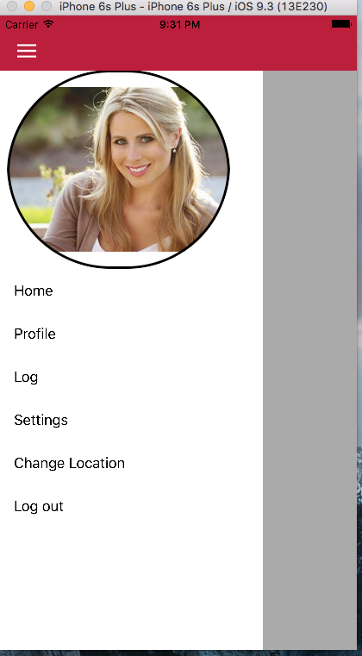

Fig 3.6: Basic User Menu Screen

**3.7 Profile Screen**

* You can view your account details by navigating into profile screen through side bar navigation.
* You can view the following details in account profile screen.

1. First Name
2. Last Name
3. University
4. Email Id
5. Phone number

* You will be provided with edit and logout options.
* You can change the account information through edit option.
* You can come out of account by clicking logout option.

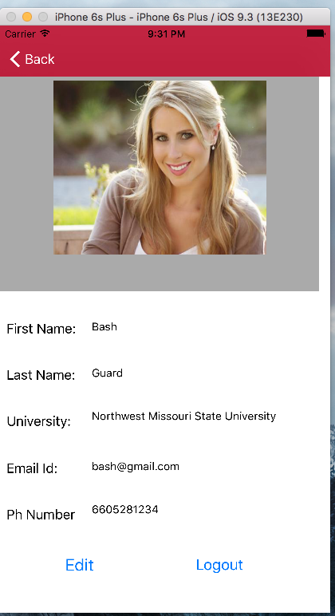

Fig 3.7: Basic User Profile Screen

**3.8 Edit Screen**

* You can edit account information by clicking edit in profile screen.
* You can edit the following details of account.

1. First Name
2. Last Name
3. University
4. Email Id
5. Phone Number

* You will be provided with update and logout buttons.
* You can commit detail changes by clicking update button.
* You can come out of account by clicking logout button.

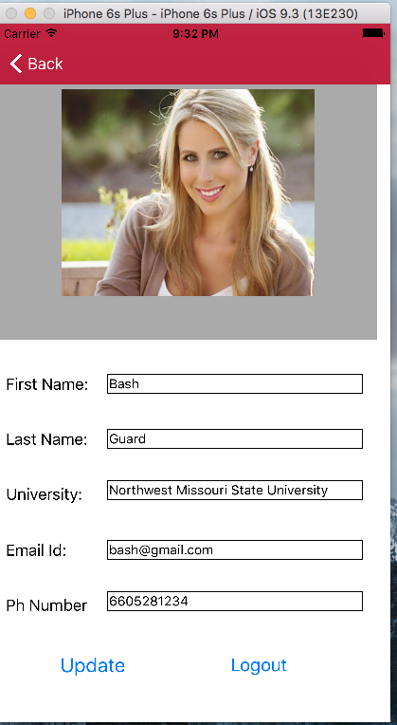

Fig 3.8: Edit Profile Screen

**3.9 Log Screen**

* You can view request history in log screen by clicking log option in side bar navigation.
* You can view the history of reports and type of the report and state of the incident happened.
* You are provided with back option to navigate to the home screen of account.

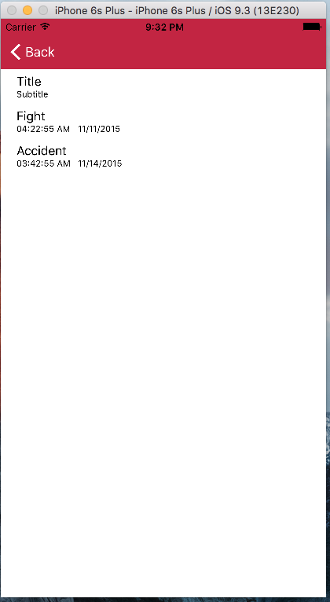

Fig 3.9: Alert Log Screen

**3.10 Settings Screen**

* You can edit your password by clicking on “Settings” option and select edit button.
* You can change the password by typing the old password once and create a new password.

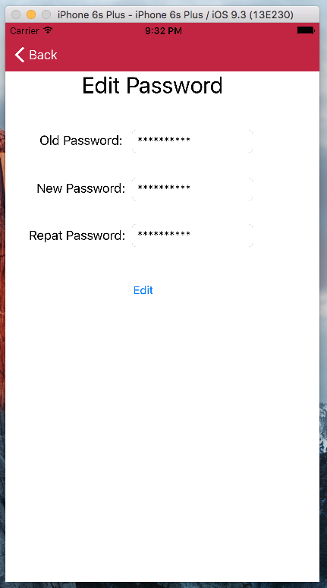

Fig 3.10: Settings Screen

**3.11 Incident Screen**

* After you select the fraternity house, you can select the incident.
* You can be more specific like accident, feeling unsafe, fight or describe any other incident.
* From the list of issues, select the type of issue you are facing in the party.

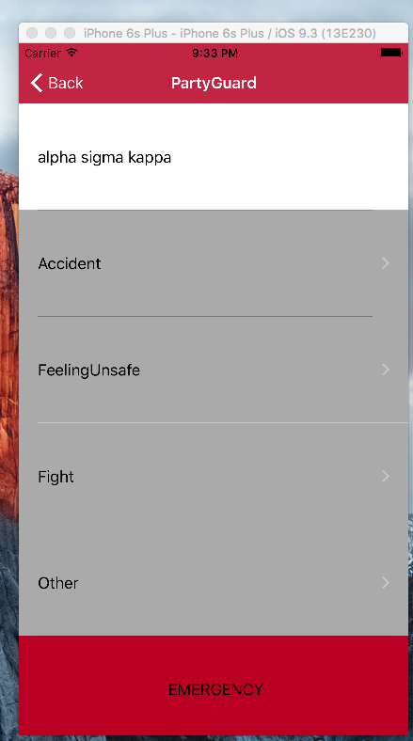

Fig 3.11: Type of Incident Screen

**3.12 Incident Location Screen**

* Select your exact location like upstairs, main floor, basement, deck etc. within the building.
* Let us say you have selected “upstairs” then that field gets highlighted.

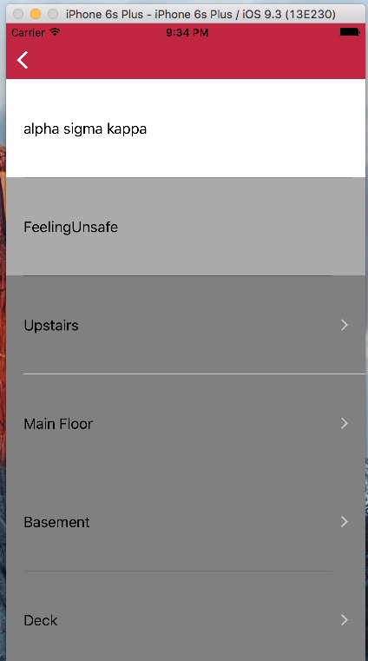

Fig 3.12: Incident Location Screen

**3.13 Alert Screen**

* After you select an incident, a confirmation box appears asking you to confirm the incident.
* You can also include a comment but it is not mandatory.
* You can select “accept” to confirm or cancel the incident reporting.

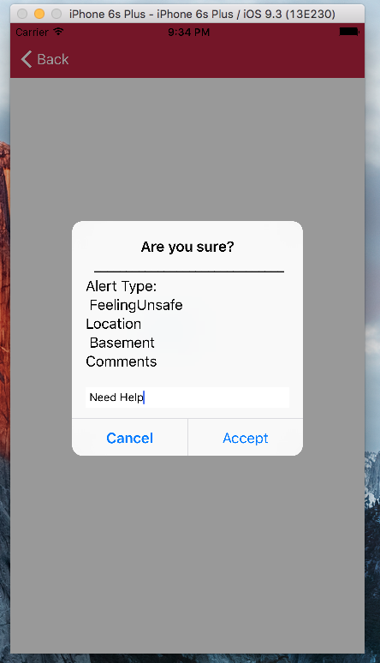

Fig 3.13: Alert Confirmation Screen

**3.14 Emergency button**

* When there is a delay in the coming of guards or in a case of life-threatening emergency, you can direct an SMS to university police.
* In the list of incidents screen you can see an “Emergency” button at the bottom of the screen.
* Tap on the “Emergency” button, so that a stop watch of 15 minutes will start.
* After 15 minutes, a SMS alert will be sent to the university police.
* They will come and solve the issue.



Fig 3.14: Emergency Button

1. **Host User**

Host user is the head of fraternity. Their duty is to assign guard users to rescue the basic user woman in danger.

**4.1 User Login**

* When you click on Host User on main screen of application, you will be redirected to host login screen.
* In this screen, you can log in as a Host user if you provide the valid username and password.
* Enter the username and correct password for successful login.
* If the username and password match you will be logged into the application.
* If you forget your password, you can click on “Forgot Your Password?” button.
* When you click on it, you will be redirected to another screen where it prompts for email address and click on the “Submit” button.
* You will receive an e-mail with a link to reset your password.

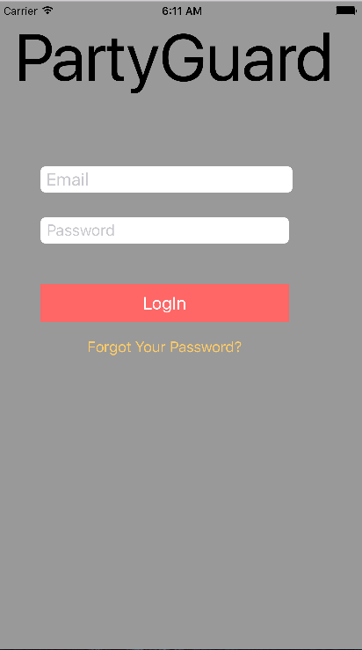

Fig 4.1: Host User Login Screen

* 1. **PG Team Screen**
* When you log in as a Host user, you will be able to see the list of guards available.
* You can check the guard profile by clicking on the “View” button beneath the profile image of guard.
* When you click on the view button, you will be able to see the profile which consists of an image and guard details.
* A green light appears if the guard is active.
* You can choose one or more guards based on the necessity.
* Guard user receive an alert when assigned.

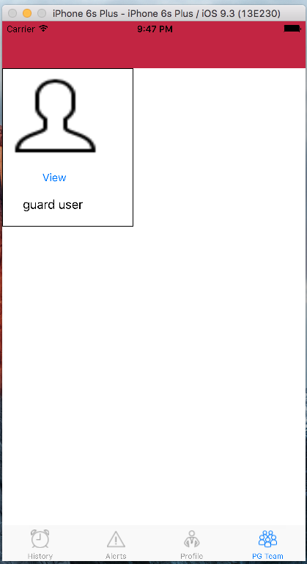

Fig 4.2: PG Team tab screen

* 1. **Alerts Tab Screen**
* On tapping the “Alert” tab at the bottom of the page, you will be directed to this screen.
* This tab shows all the list of incident that need to be resolved.
* You can view the details of basic user whom you need to rescue.
* When you click on the issue, you can get more details related to it.

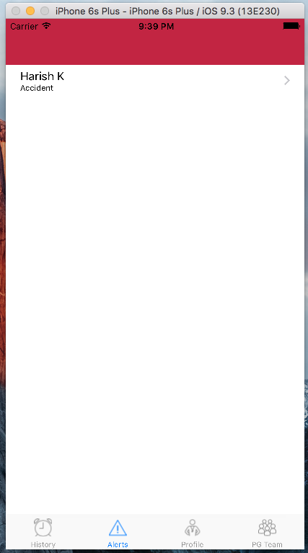

Fig 4.3 Host User Alerts Tab Screen

* 1. **History Tab Screen**
* On tapping the “History” tab at the bottom of the screen, you will be directed to this screen.
* When you tap on history tab, you can view a list of all the incidents that are resolved.
* When you click on the issue, you can get more details related to it.

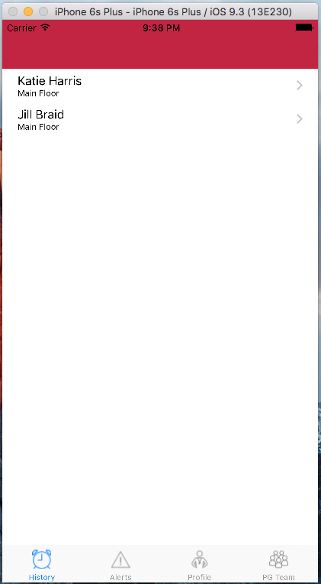

Fig 4.4: Host User History Tab Screen

* 1. **Host User Profile Screen**
* You can see your profile by clicking on “Profile” tab at the bottom of the screen.
* You can edit the profile or log out of the application.
* You can change the profile image by clicking on the image, or change the details.
* After you finish to edit the profile, click on “Update Profile” to save the changes made previously.
* You can also use logout button at the top-right corner to come out of the application.

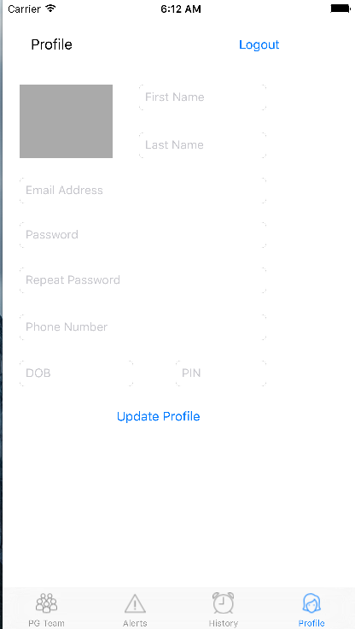

Fig 4.5: Host User Profile Screen

1. **Guard User**

**5.1 User Login**

* When you click on Guard User on main screen of application, you will be redirected to guard login screen.
* In this screen, you can log in as a Guard user, if you provide the valid username and password.
* Enter the username and correct password for successful login.
* If the username and password match you will be logged into the application.
* If you forget your password, you can click on “Forgot Your Password?” button.
* When you click on it, you will be redirected to another screen where it prompts for email address and click on the “Submit” button.
* You will receive an e-mail with a link to reset your password.



Fig 5.1: Guard User Login Screen

**5.2 Alerts Tab Screen**

* On tapping the “Alert” tab at the bottom of the page, you will be directed to this screen.
* This tab shows all the list of incident that need to be resolved.
* You can view the details of basic user whom you need to rescue.
* When you click on the issue, you can get more details related to it.

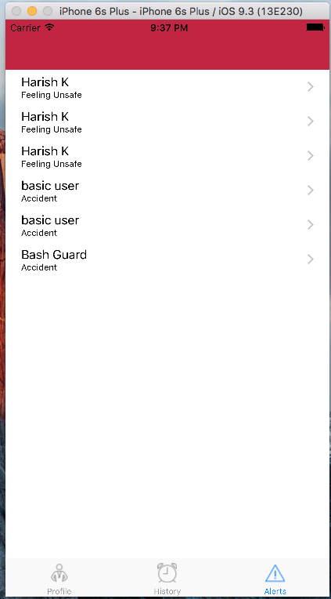

Fig 5.2: Guard User Alerts Tab Screen

* 1. **History Tab Screen**
* On tapping the “History” tab at the bottom of the screen, you will be directed to this screen.
* When you tap on history tab, you can view a list of all the incidents that are resolved.
* When you click on the issue, you can get more details related to it.

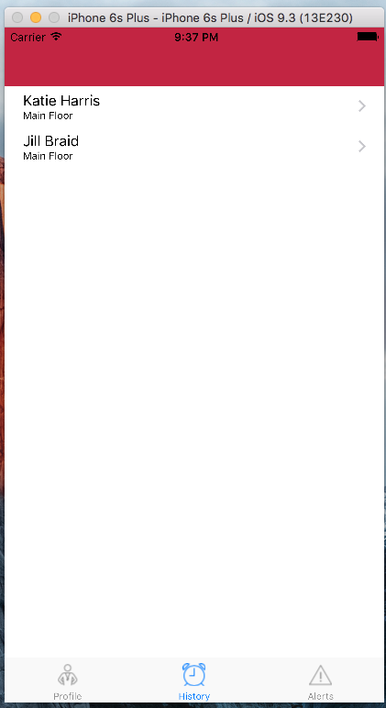

Fig 5.3 Guard User History Tab Screen

* 1. **Guard User Profile Screen**
* You can see your profile by clicking on “Profile” tab at the bottom of the screen.
* You can edit the profile or log out of the application.
* You can change the profile image by clicking on the image, or change the details.
* After you finish to edit the profile, click on “Update Profile” to save the changes made previously.
* You can also use logout button at the top-right corner to come out of the application.



Fig 5.4 : Guard User Profile Screen