***Detection of Drowsiness of driver’s***

***face Through IOT***

**ABSTRACT:** A real-time driver sleepiness detection system for driving safety is presented in this research. We have found a simple solution to detect the Drowsiness with the help of this project. We can reduce the number of accidents and spread awareness of driving adequate amount of rest. The driver's face is located from a color video shot in an automobile using computer vision techniques. Following that, face detection is performed to find the driver's eye areas, which are then used as templates for eye tracking in subsequent frames. Finally, the images from the tracked eye are used to identify drowsiness and create warning alarms. Face, eye, and sleepiness detection are the three steps of the proposed method. The purpose of image processing is to recognize the driver's face and then extract the image of the driver's eyes for sleepiness detection. The face detection algorithm starts with image frames that have been collected and then processes them. The CHT algorithm is then used to monitor the eyes of the discovered face. The eyes of the driver will be regarded closed if they are closed for a predetermined period of time, and an alarm will be activated to inform the driver. On a Raspberry Pi 4 Model, the proposed system was tested. The outcomes of the experiment appear to be quite positive and promising. On some test videos, the system could achieve more than 15 frames per second for face and eye tracking, with an average accuracy rate of 99.0 percent for eye placement and tracking. As a result, the proposed strategy can be inferred to be a low-cost and effective solution method for detecting driver drowsiness in real time.

**INTRODUCTION:**

When a person is fatigue due to prolonged driving will tend to sleep during driving which can cause accident, which in result will harm himself and possibly people around him. Drowsiness is generally difficult to detect or monitor. Drunk driving is a big issue in India. The dangers of drowsy driving, as well as the often-disastrous consequences, are alarming. The most dangerous type of driving is drowsy driving.

Drowsiness and driving are a deadly combo. And exhaustion This usually occurs when a driver loses control of his or her vehicle. If he has not gotten enough sleep, although it can also be caused by Medications, alcohol, or shift work may all be contributing factors.

However, the number of people drinking, and driving is on the rise. Every year, approximately 200 individuals are killed as a result of drinking and driving. It is not only the driver who suffers, but also his passengers and other passengers. In 2016, it was estimated that 100 footsloggers and 390 car passengers were critically hurt or killed by drunk drivers.

Drunk drivers killed or seriously injured 40 children in that year. When our bodies go to sleep, no one knows exactly what happens.

It's obvious that falling asleep while driving is dangerous, but it also impacts the driver's ability to drive safely. Drowsy driving caused 72,000 collisions, 44,000 injuries, and 800 deaths in 2013, according to the National Highway Traffic Safety Administration.

**EQUIPMENT’S:**

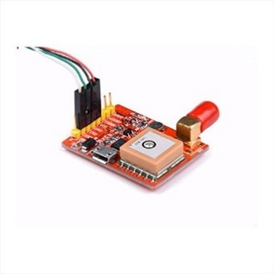**Hardware Components are**

* Raspberry pi 4
* Camera sensor
* Aux Cable
* 32 Gb Sd Card
* A picture containing text

  Description automatically generatedGPS
* LCD (Display Board)
* GSM Module
* Buzzer
* Vibration Sensor
* COMPIM

**Software Components are**

* proteus 8 professional
* VSPE
* Python – python 3.10
* Libraries like NumPy, Dlib, imutils, OpenCV, SciPy. Etc.

**LITRATURE\REVIEW:**

We found different ways to detect the drowsiness to prevent road accidents. We have researched and came to a conclusion that 91 out of 100% accidents are happening due to driver’s error, 5% from Surrounding factors and 4% due to vehicle’s technical problems. With the help of Artificial Intelligence, we are going to detect the driver’s drowsiness.

These are some ways to measure drowsiness Vehicle based, Physiological and Behavioral measures.

1. Vehicle based is mainly used in abroad countries it detects the lane of the vehicle and also steering wheel position, to determine driver’s weakness.
2. Physiological measure observes the physical condition in the driver’s body to detect the fatigue. It will observe the pulse rate and brain activities to prevent accident. With the help of beta and gamma waves they detect the drowsiness.
3. Behavioral measures is one of the best and easiest way to detect the drowsiness, it continuously detects the eye closure and eye blinking. We can do this method with the help of this project by simply placing a camera module in front of driver. This device continuously captures the driver’s eye position and further detects the drowsiness.

We are considering Behavioral measures in this project.

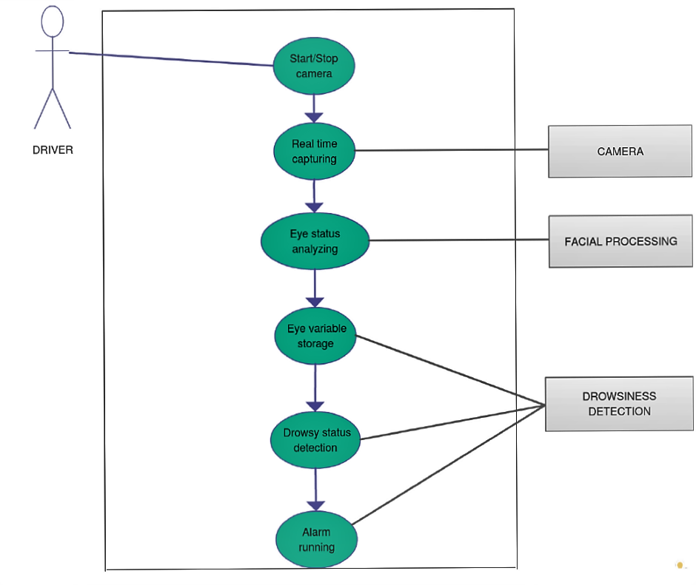

The main concept of this project is to utilize all the functioning sensors and devices we have chosen.

1. **LCD(LM016L)**

LCD stands for liquid crystal display, and it is a device that shows messages. We have connected the LCD to the Raspberry Pi and with the help of it the LCD can display a ‘Welcome’ message and also it will display a message when the driver is in Fatigue like ‘Sleep Alert’, ‘Drowsy Alert’, ‘Driver Active’ and ‘Accident Happened’. It is connected to all the components so that certain signals may be received, and messages can be displayed on the LCD Screen. It also supplies 5V power to other modules.

1. **GSM Module:**

‘Global System for Mobile Communications’, with the help of this device the owner can get a audio warning and a message (‘Accident Happened’) in case of any accident happened and it will active the buzzer in the device and also it sends the GPS location to the Owner and nearest police station.

1. A picture containing electronics, circuit

   Description automatically generated**Vibration Sensor:**

It is connected to the Raspberry Pi and the function of this sensor is to detect any jerk delivered to the car (in other words, it measures the frequency of vibration of the particular vehicle), emulating the occurrence of an accident in real time. The LCD's 5V port provides power to this device. The output generates and sends signals.

1. **Raspberry pi 4:**

It's a single-board computer that's built to operate Internet of Things (IoT) applications. It will also have an SD card for installing the operating system. The Raspberry Pi is quicker and has more RAM than Arduino board. We used it in our project because it allows us to Program and connect LCD, vibration sensors, and other devices using the Python computer language. We were using the Raspberry Pi 4 to develop a prototype for drowsy detection for vehicle drivers. The video of the driver is recorded and fed into a cascade classifier tool in our prototype. After the pictures have been detected, they are transmitted to a neural network which has been trained to determine the driver's level of fatigue. Our Raspberry Pi 4 prototype can be installed in a wide range of automobiles and can provide non-invasive warnings to drivers while maintaining a high level of accuracy. Due to its low cost and energy effectiveness, the Raspberry Pi 4 has the upper hand.

1. A picture containing electronics

   Description automatically generated**Buzzer:**

The use of buzzer is to give subsequent warning to the driver in certain interval of time after the detection of drowsiness which is interrelated to posture and eyes of driver on the road.

1. **Python:**

We have chosen the python as the programming language because it is one of the easiest languages to understand the logical codes and helpful for large scale projects. We have used ‘IDLE Python 3.10’ app to work on the code.

**METHEDOLOGY:**

We found different ways to detect the drowsiness to prevent road accidents. We have researched and came to a conclusion that 91 out of 100% accidents are happening due to driver’s error, 5% from Surrounding factors and 4% due to vehicle’s technical problems. With the help of Artificial Intelligence, we are going to detect the driver’s drowsiness.

Behavioral measures is one of the best and easiest way to detect the drowsiness, it continuously detects the eye closure and eye blinking. We can do this method with the help of this project by simply placing a camera module in front of driver. This device continuously captures the driver’s eye position and further detects the drowsiness.

Eye Detection:

The image or video will be captured from the camera which is placed on the dashboard of the car and the video will be converted into multiple frames. Then with the help of open cv and open cv Classifier (a rectangle is drawn around the face) then by using the feature face extraction we judge the position of the eye and then by comparing it from open cv and the eyes are detected.

We used facial landmarks to localize the areas of the face like Eyes, Eyebrows, Nose, Mouth, etc.

First the device will localize the image before detecting then we need to predict facial structures on the face then with the help of 68 landmark detector which is included in the Dlib library we can implement the data.

The x-y coordinates of regions that surrounds the region of the face.

Then the facial landmark detector which is pre-installed in the Dlib library is used to judge the 68 coordinates of the face. With the help of it, we can detect eyes.

2.Recognition of eye’s state:

This area is judged frame to frame and then the final decision is taken that the eye is covered by eyelids or not. There is also a different method which is matching the with the images of open and closed eye but there are many drawbacks to these features such as illumination, motion dynamics etc. that’s why we went with the simple approach to use an algorithm which detect the eye using facial landmark detector.

3.Eye state determination:

The decision for eye state is taken by the Euclidian distance if the distance is close to zero the eye is detected is closed and else it is detected as open. Frame by frame technique is used in this also and then the final decision is taken that whether the eye is open or covered by eyelids. There is also a different approach which used image of open and closed eye to detect.

4.Drowsiness detection:

It is the last step of the algorithm to determine the condition of the person. The duration of average blink is about 100-400 milli seconds. If a person is drowsy in that interval, and if the eye is closed for more than 15 seconds it is detected and the buzzer is triggered.

Fig 1.1 Fig 1.2 Fig 1.3

The python software and Dlib library helps us to detect the eye moments whereas the face is detected by a green box, now by using 68 Face Landmark the system will detect the eye moments. As show in fig 1.1 you can see the driver’s eye is open about 60% only, so it's showing sleeping state. And now you can see in fig 1.2 driver eye is about 70% open so it's showing drowsiness state. And at last condition we can clearly see from the fig 1.3 driver eyes are open more than 80% so it's showing active state.

When the driver is in sleeping and drowsiness state the alert will be generated by the raspberry pi using car speakers.

**CONCLUSION AND FUTURE WORK:**

**CONCLUSION:** The Raspberry Pi4 is the system's major component, which is used for continuous capture of facial landmarks that are localized using facial points and then analyzed. Likewise, it gathers images from the video, which are rapid enough to recognize a driver's face. The framework makes use of open-Source software known as the "open CV" picture handling libraries. The general architecture is made out of a Raspberry Pi and an open CV to make it an easy-to-tired location framework. The buzzer goes off if the driver becomes drowsy and closes his eyes for more than a few seconds. Even if an emergency arises, cops can locate him via GPS. As a result, the ratio of accidents drops. This equipment can tell a difference between normal eye blinks and fatigue, which prevents the driver from falling asleep behind the wheel. Even when drivers are wearing glasses or driving in low-light conditions, the device will work. During monitoring, the equipment may detect if the eyes are open or closed. The buzzer beeps to inform the driver when he/she is in the state of drowsy (when the eyes are closed for around 15 seconds). If the device detects the drowsiness of the driver’s face, it will quickly display a drowsy message on the LCD and alert the driver through the buzzer’s sound to avoid accidents.

**FUTURE SCOPE:** We are trying to add alcohol detector sensor for drunk drivers.

We are also trying to add a sensor to monitor the driver’s heart rate to prevent the accidents happen because of heart attack.

This model can be improved by using blink rate and state of the vehicle parameters.

Project Done by Group 4:

NIPUN RAJPUT

KETAN THAKUR

GODAVARTHI SAI NIKHIL

UTKARSH SINGH