MOVES DATA GENERTION USING AUTOMATION SCRIPT

Input Data Preparation
Step 1 :
Prepare Templates or default data from the MOVES manually.
Export all the excel sheets from i/p database based on the configurations required –

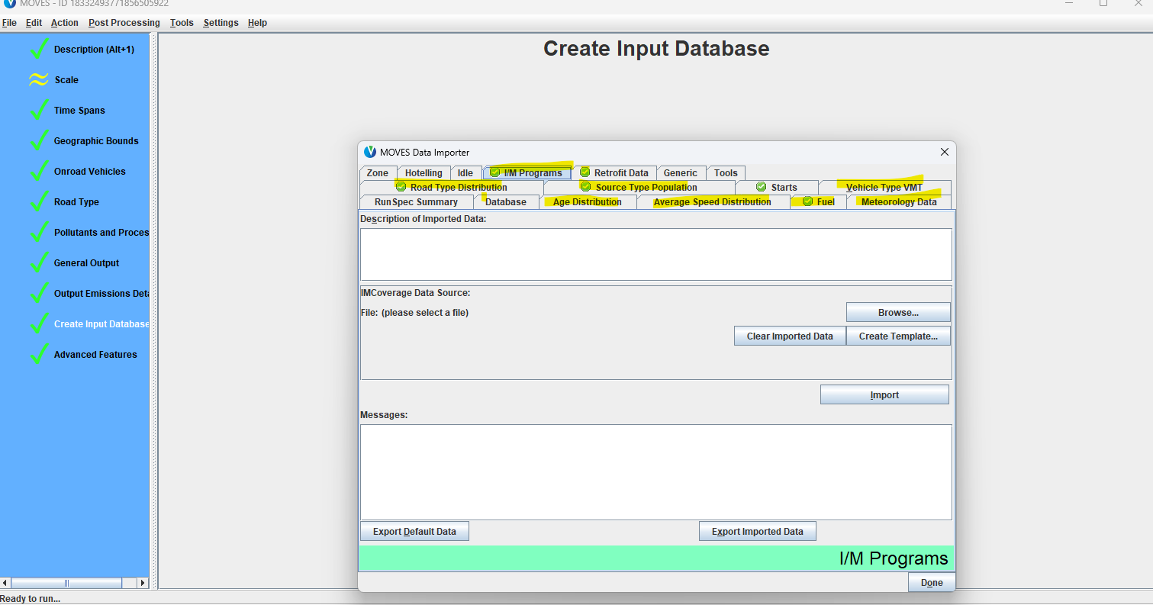
Step 2 :
Prepare importer.xml and county.xml from MOVES using county configuration
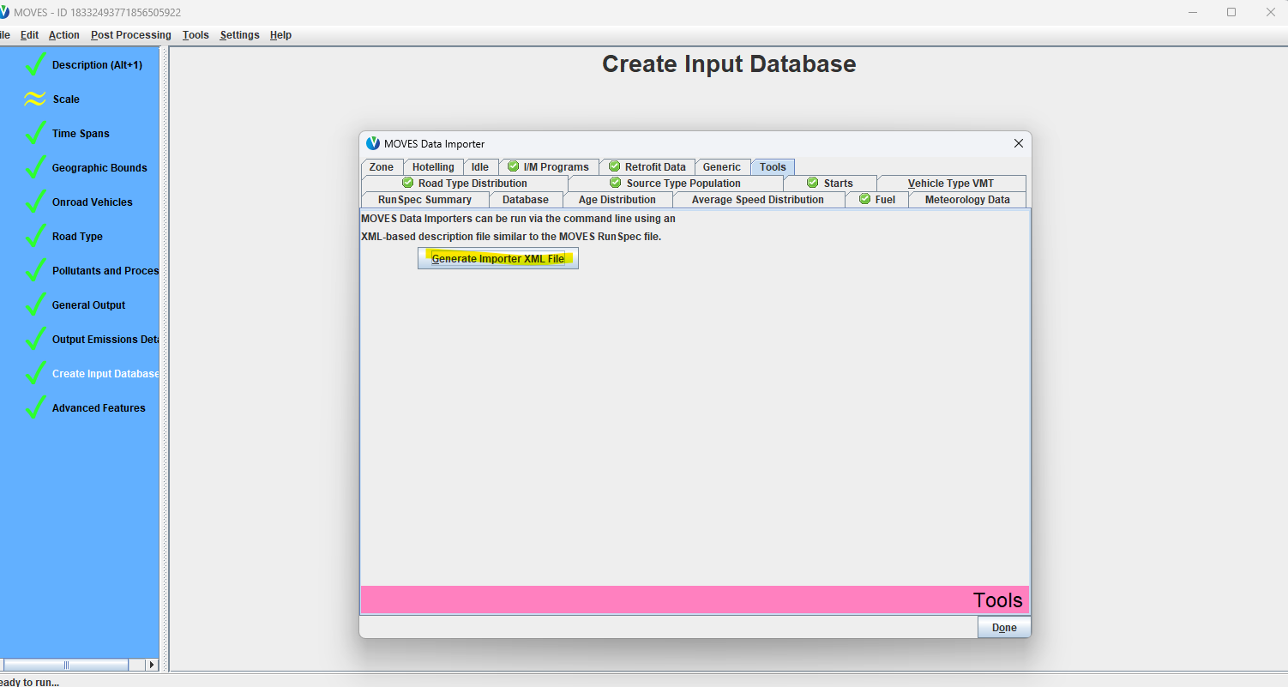

Step 3 :
Make sure you have all the files organized with the same naming conventions –
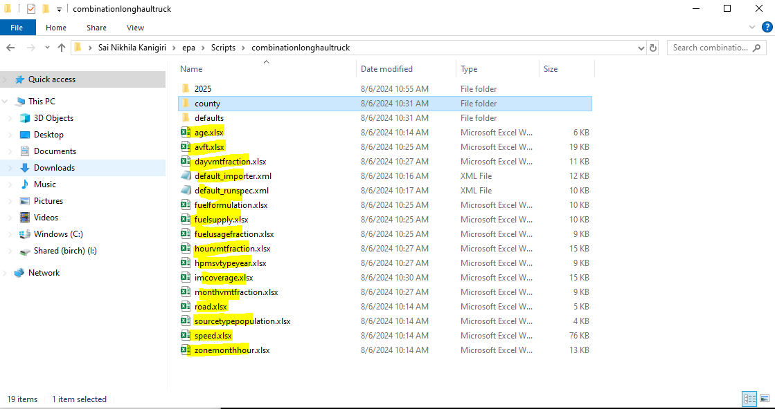
Step 4 :
Modify imcoverage.xlsx manually – source type, fuel type based on the vehicle
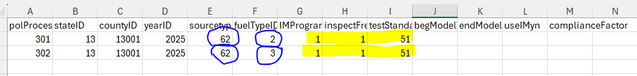

Make sure all these steps are performed for each vehicle type once
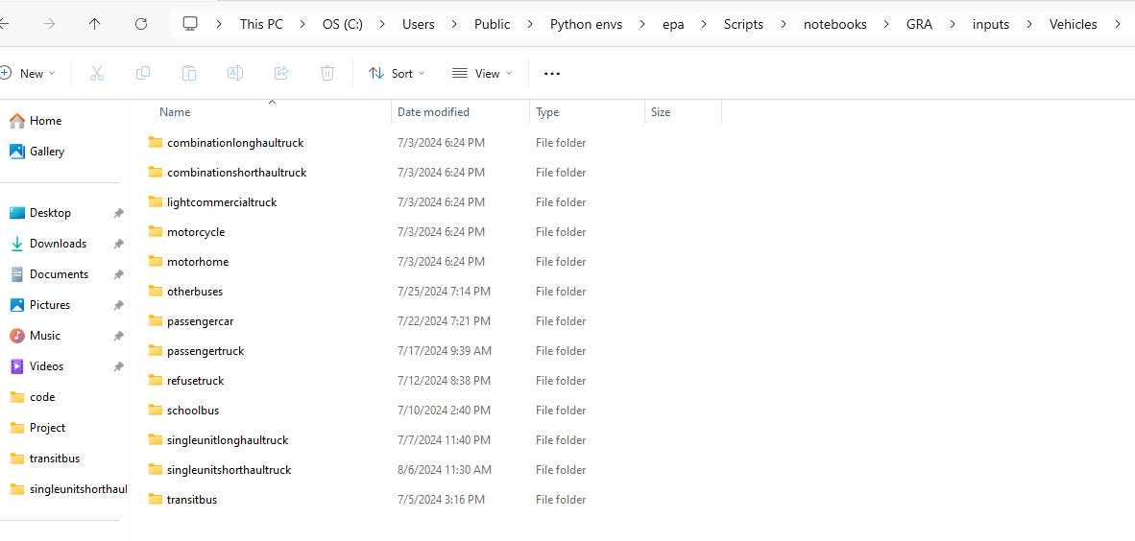

Generate Importer and Runspec Files
Pre installations – Jupyter Notebook – and all the packages to run the code like Streamlit,matplot,numpy etc..
1.Once the Templates are ready for each vehicle we need to run the python code
Generate_importer_runspec using command
“Streamlit run <filemname.py>”
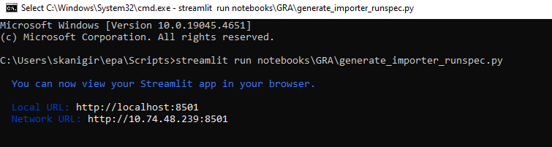
Once we run this application :
Expected UI
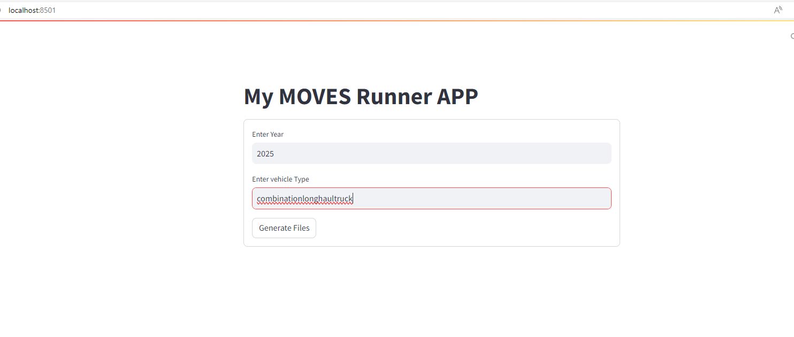
Please input the details on the UI- the year we wanted to generate the folders and also the vehicle type
Output- you will see a message in Ui saying the “Generating files completed”
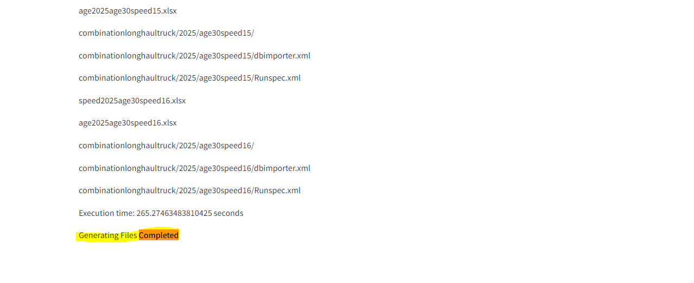
You can go and check in the folder if the files are generated – (by default the files are generated in location where the templates are created )
Make sure the vehiclename is same as folder name stored in templates

Templates folder :
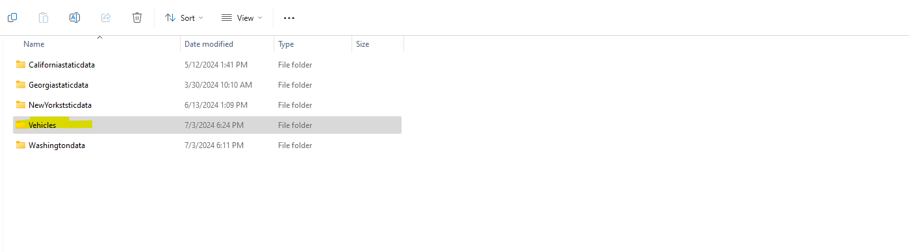
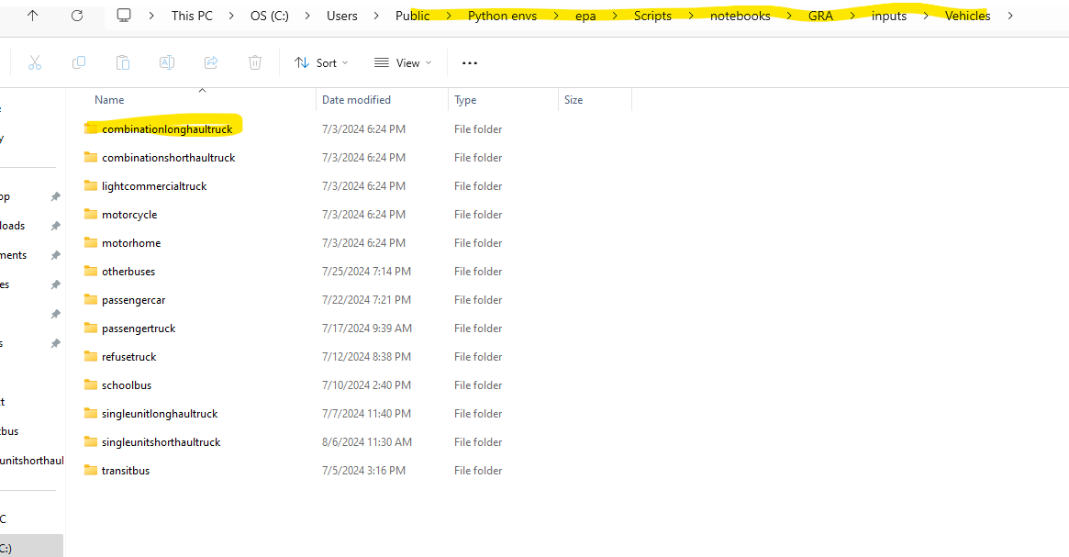
Generated importer and Runspec files :
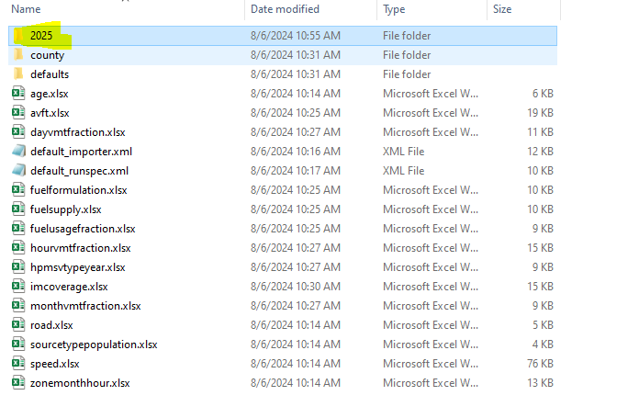
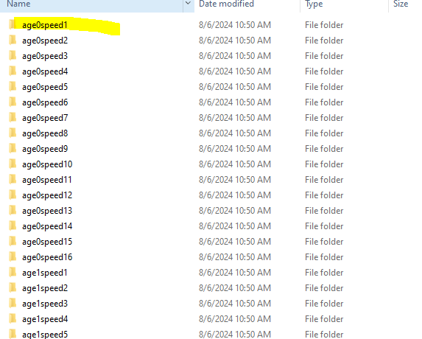
Note : If there is any error please check the folder paths and try again
By default the vehicle directory in path (make sure all the vehicles data templates are in that folder as shown above else we can also change the path in the code and run again)
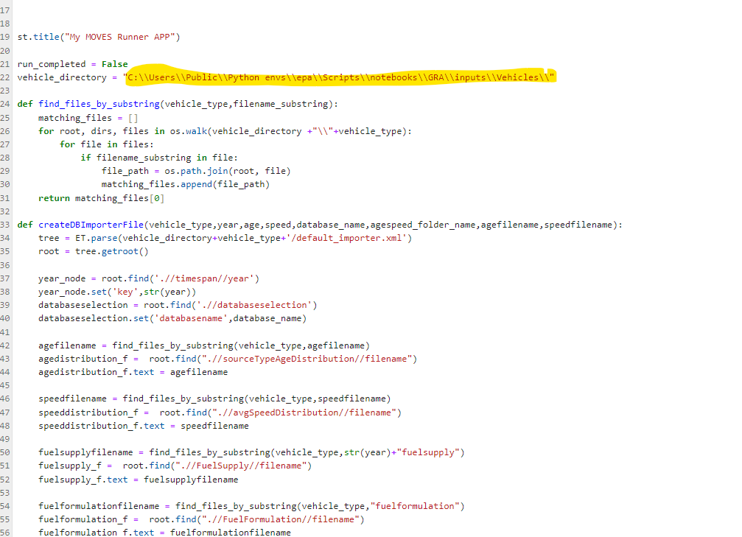

Running the generated importer and Runspec Files

Once the importer and runspec are created , we have to run them –
first importer and then the runspec - for this please run code “run_importer_runspec.py”
command used to run is “Streamlit run <filename.py>”
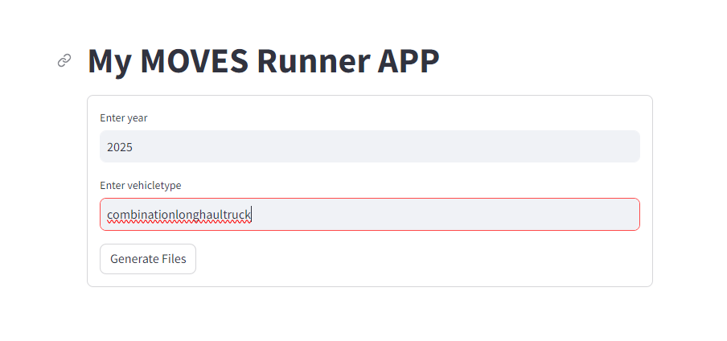
Provide the input data, an the importer and runspecs generated will be triggered sequentially
Note : Make sure the location of MOVES and script files are in place
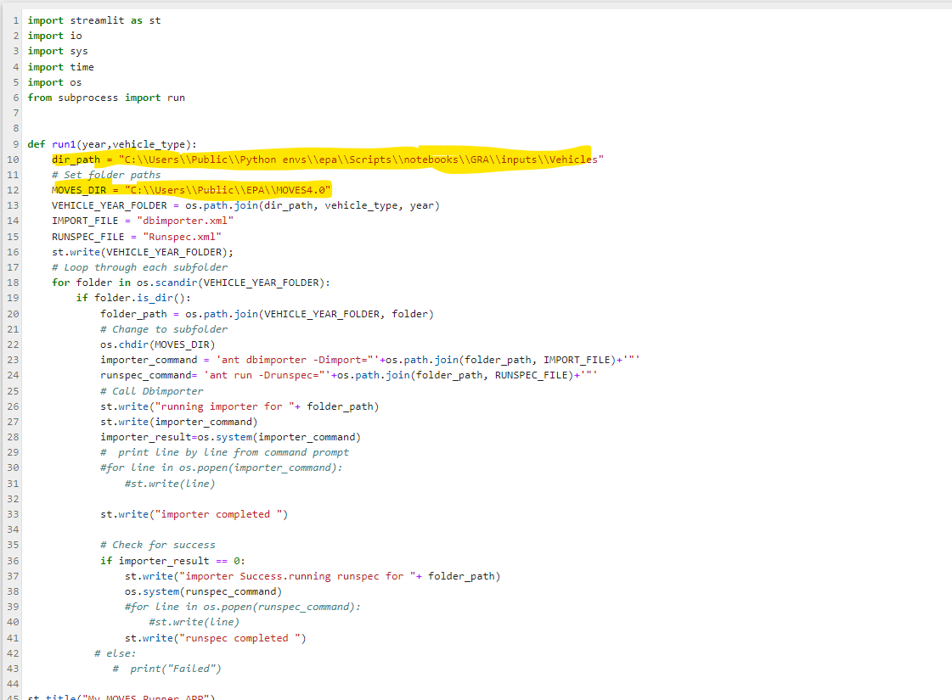

Output once the run_importer_runspec.py is triggered and completed run you will see all the generated i/p and o/p database in HeidSQL
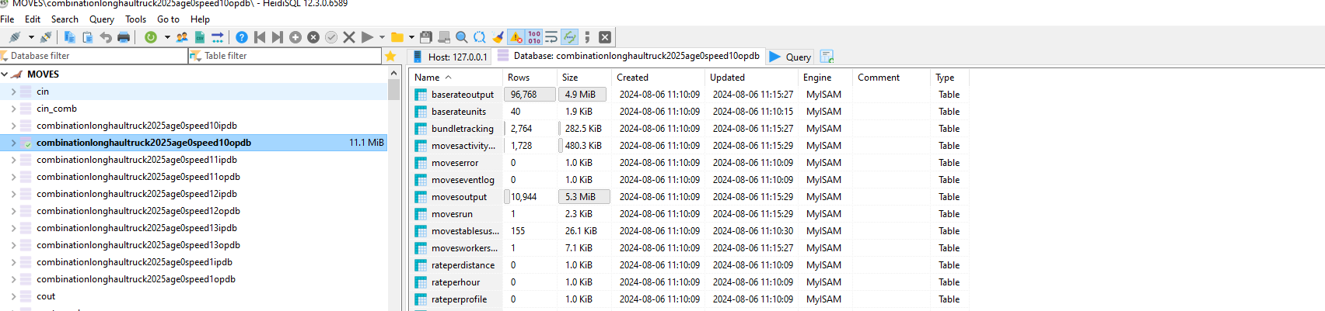

Process Output Data from Heid SQL :
Once the files are generated in sql i.e for all vehicles for all speeds and all ages we can export the data to excel using code “process_format_outputdb.ipynb”
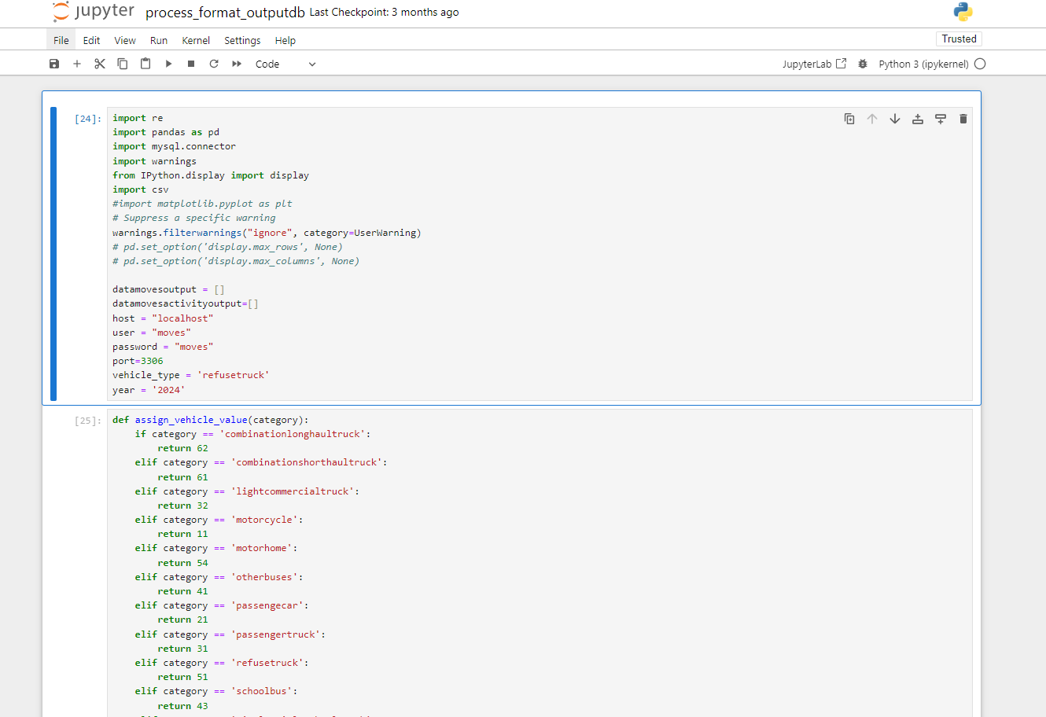

Once you run all the code expected result is an excel file with all the emission values
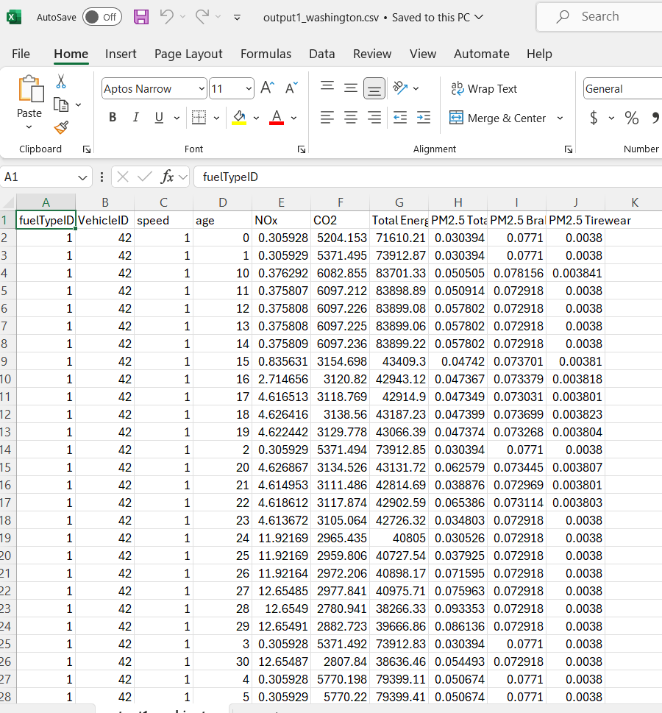

This file is processed and provided to ML model for estimation of emission

