**EMPLOYEE LEAVE MANAGEMENT SYSTEM SDP PROJECT – 39**

SECTION - 15 TEAM - 25

**PROJECT OUTLINE**

The Employee Leave Management System is a web-based application designed to streamline and automate the process of managing employee leave requests within an organization. It serves as a centralized platform where employees can submit leave requests, and managers or HR administrators can review, approve, or reject the requests. The system aims to ensure accurate leave tracking, improve leave planning, and enhance the overall efficiency of managing employee leave.

**INTRODUCTION**

1. Brief overview of the current leave management process

2. Enhance efficiency in handling employee leave requests

3. Improve accuracy in leave tracking.

4. Centralize leave management for better coordination

**SYSTEM ARCHITECTURE**

1. MERN Stack (MongoDB, Express.js, React.js, Node.js)
2. JavaScript for frontend and backend development
3. MongoDB for database Design

**MODULES & SUBMODULES**

1. Employee Module  
     
    - Employee Dashboard  
    - Leave request submission  
    - View own leave history and balance
2. Manager Module  
     
    - Receive and review leave requests  
    - Approve or reject leave requests  
    - View team's leave calendar
3. Administrator Module  
     
    - Comprehensive leave tracking and reporting  
    - Manage system settings and configurations
4. Authentication and Authorization  
     
    - Secure user login and registration

**SYSTEM WORKFLOW**

* Employee submits leave request
* Manager receives and reviews the request
* Manager approves/rejects the request
* System updates leave balances
* Notifications and alerts for all relevant stakeholders

**INTEGRATIONS AND FEATURES**

* Email integration
* Calendar integration
* Documentation upload
* Deadline reminder
* Reason selection

**FUTURE ENHANCEMENTS**

* Additional features based on user feedback
* Integration with other HR systems
* Mobile application development

**FIELD STUDY**

We conducted a field survey and also a virtual online form survey, we got many responses from various range of employees. we got to know about their leave management processes and their difficulties faced by using the system

**Difficulties faced by them**

1. User Interface Complexity
2. Communication Gaps
3. Privacy Concerns

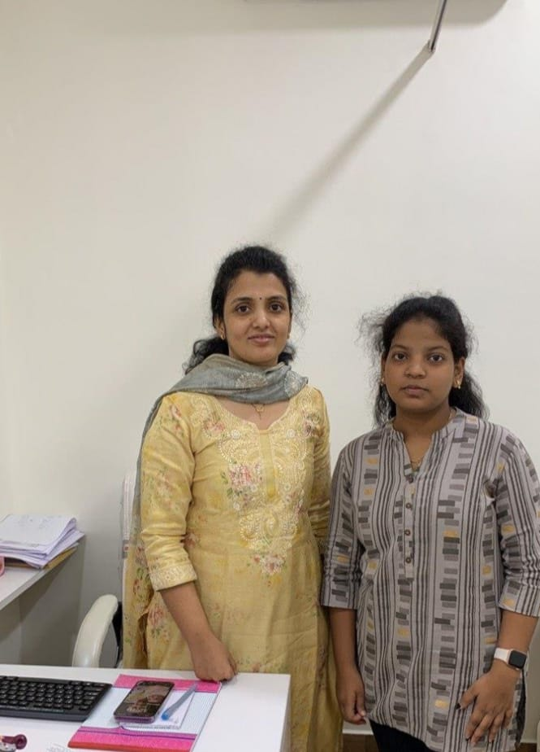 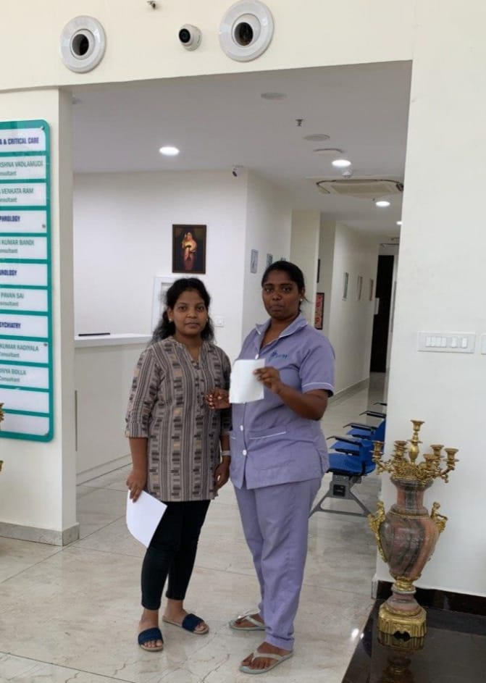

**PROTOTYPE**

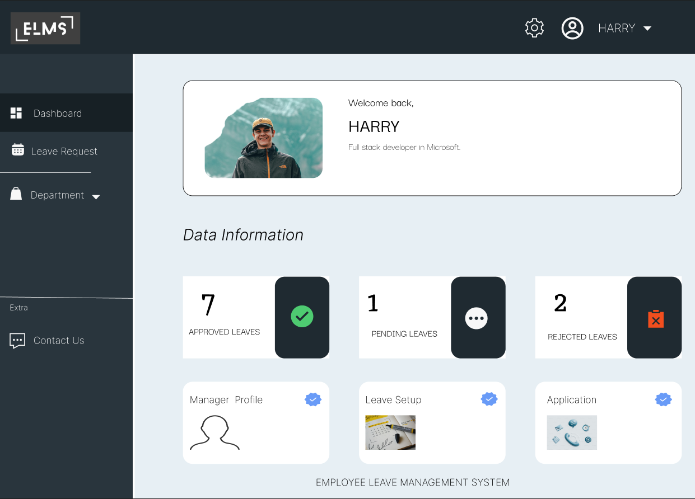 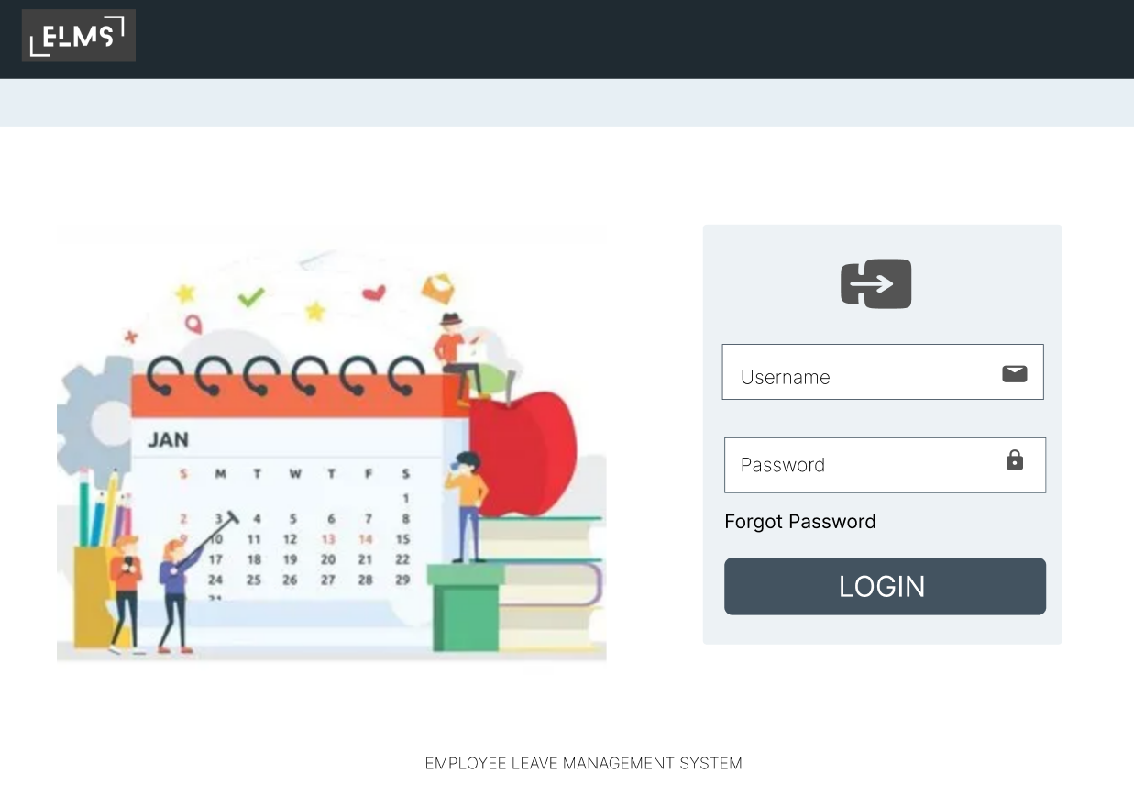

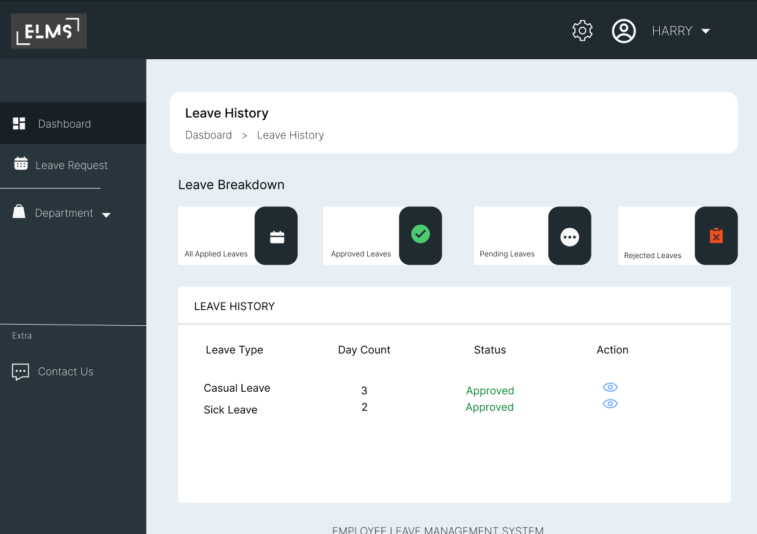 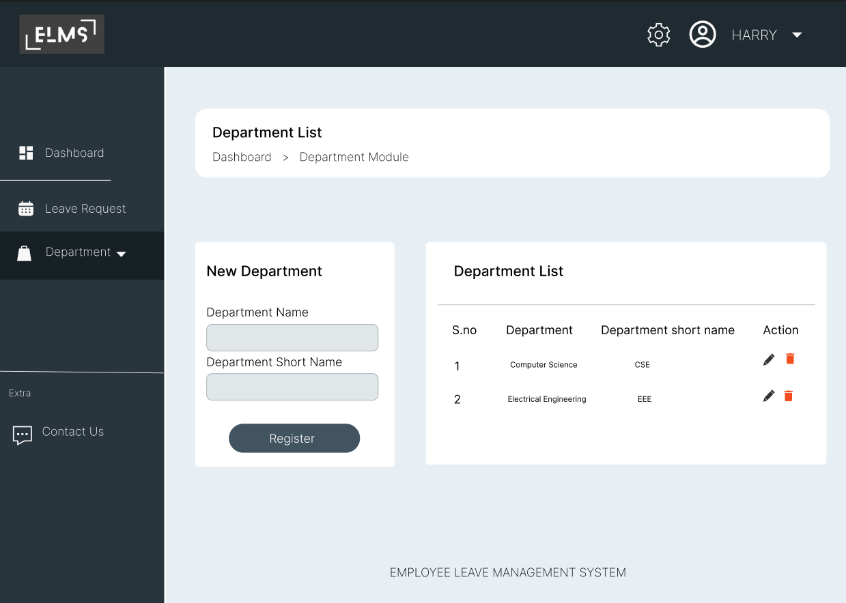

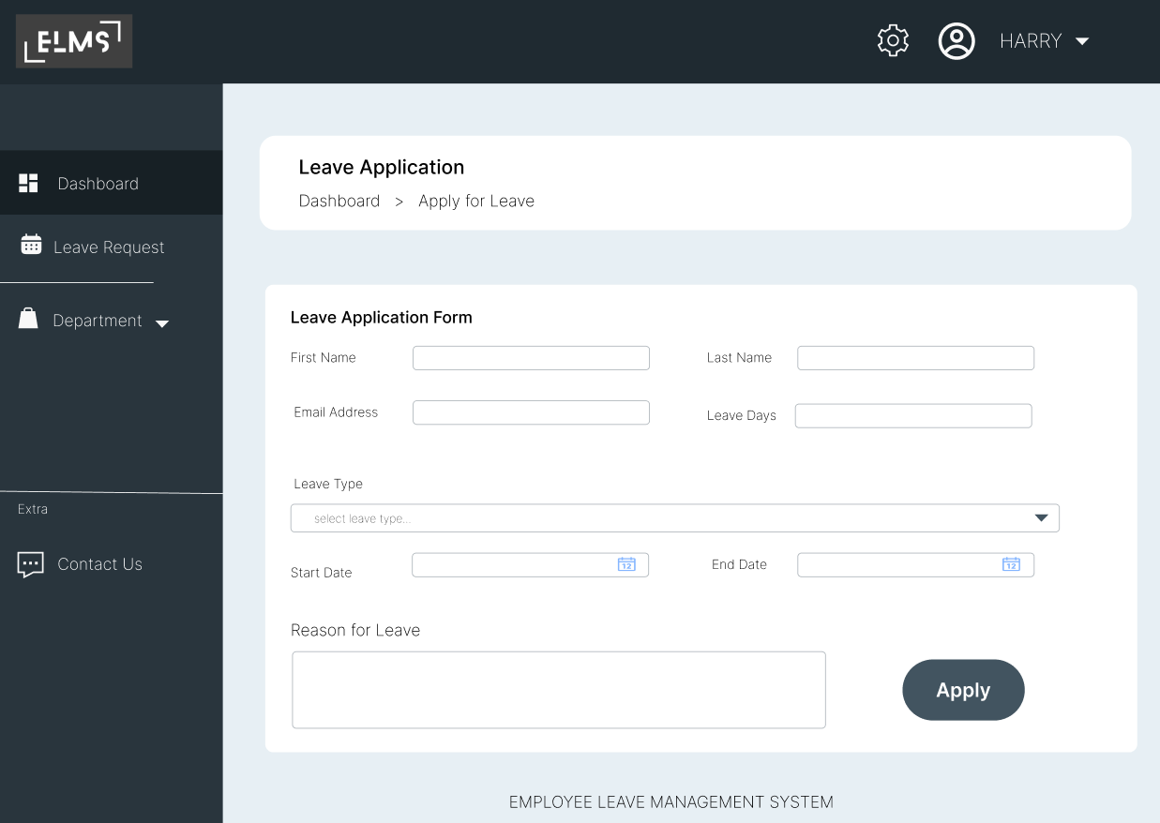 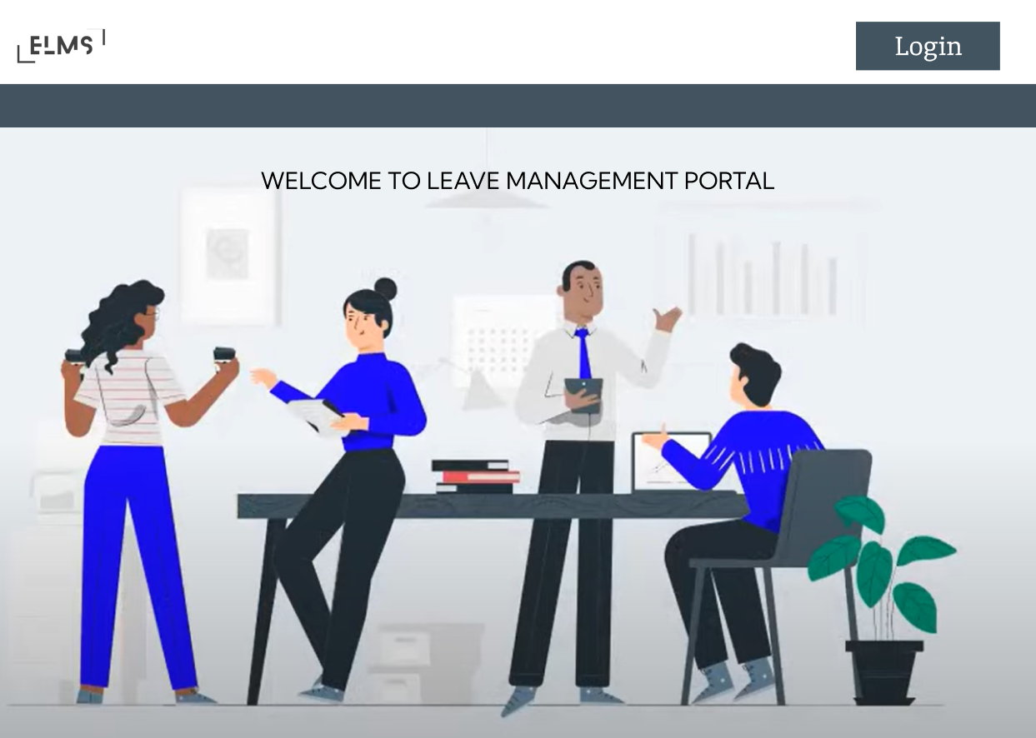

**TEAM ROLES**

**Pardhiv Sai - Full Stack Developer**

1. Overall technical leadership and decision-making.
2. Leads the development team in implementing features and functionalities.
3. Collaborates with other team members for seamless integration of frontend and backend components.
4. Authentication and Authorization

**Deepika - Frontend Developer**

1. Designs and implements the user interface based on UX/UI design.
2. Ensures a responsive and visually appealing frontend.
3. Using JavaScript for frontend design

**Bhargavi - Backend Developer**

1. Implements server-side logic using Node.js and Express.js.
2. Ensures efficient data storage, retrieval, and manipulation
3. Designs and manages interactions with the MongoDB database.