NeuroBot: An EEG-Based Deep Learning Pipeline for Movement- and Finger-Level Intention Decoding and Deployment
A Development Report, from Base Paper to Current Status
Veeravajhula Sai Phani Anirudh  B.Tech CSE student  Keshav Memorial College of Engineering  Koheda Road, Chintpalliguda(V), Ibrahimpatnam(M), R.R.Dist-501510, Telangana, India  saiphanianirudh@gmail.com  ORCID: 0009-0003-0562-3098 | Chaganti Sreevatsalya  B.Tech CSE student  Keshav Memorial College of Engineering  Koheda Road, Chintpalliguda(V), Ibrahimpatnam(M), R.R.Dist-501510, Telangana, India  sreevatsalyachaganti@gmail.com  ORCID: 0009-0007-8825-5348 | Ulindala Trinath  B.Tech CSE student  Keshav Memorial College of Engineering  Koheda Road, Chintpalliguda(V), Ibrahimpatnam(M), R.R.Dist-501510, Telangana, India  ulindalatrinath@gmail.com  ORCID: 0009-0008-6428-8927
Bashetty Sumukh  B.Tech CSE student  Keshav Memorial College of Engineering  Koheda Road, Chintpalliguda(V), Ibrahimpatnam(M), R.R.Dist-501510, Telangana, India  sumukhbashetty@gmail.com  ORCID: 0009-0006-1503-3448 | Majji Kiran  B.Tech CSE student  Keshav Memorial College of Engineering  Koheda Road, Chintpalliguda(V), Ibrahimpatnam(M), R.R.Dist-501510, Telangana, India  majjikiran8@gmail.com  ORCID: 0009-0005-5628-4086 | A. Shilpa Gupta  Faculty Mentor  Keshav Memorial College of Engineering  Koheda Road, Chintpalliguda(V), Ibrahimpatnam(M), R.R.Dist-501510, Telangana, India  a.shilpagupta@gmail.com

Abstract—This report describes NeuroBot, a self-trained EEG brain-computer interface pipeline: its motivation, methods, development history, deployment and results. Motivated by the real-time finger-level robotic hand control of Ding et al. [1], we first built two limb-level decoders (left fist, right fist or rest; both fists, both feet or rest) on the PhysioNet Motor Movement/Imagery Database [2], [3], using EEGNet [4] and the convolutional transformer TCFormer [5] (through Braindecode [6]) with a per-subject pretrain and fine-tune protocol. Over eleven iterations we found and fixed two leaks in our evaluation split, one from subject order and one from overlapping windows. On ten subjects with a trial-level split, TCFormer with cross-subject pretraining and three-seed averaging reaches group-mean majority-vote accuracies of 74.4% and 70.0% for Task A and 86.7% and 71.1% for Task B (executed and imagined movement; chance 33.3%). Compared with the same model trained without pretraining, the gain is significant only for Task B executed movement (+7.8 points, p = 0.003). A single-subject pilot on the finger dataset [7] reaches 79.9% for two fingers and 44.6% for three fingers on executed movement. The system is deployed as a software-only three-tier web service with no external API.
Index Terms—Electroencephalography (EEG), Brain-Computer Interface (BCI), Motor Imagery, Motor Execution, EEGNet, Transformer, TCFormer, Deep Learning, PhysioNet, Finger-Level Decoding, Deployment.

1. Introduction
Brain-computer interfaces (BCIs) translate neural activity directly into control signals, offering a communication and control pathway for individuals with motor impairment as well as novel human-computer interaction paradigms for the general population [8]. Invasive BCIs, which record from within or on the surface of the brain, offer high spatial precision but require surgery; noninvasive BCIs based on scalp EEG are accessible to a far wider population but have historically been limited to coarse control—whole-limb movement, binary choices, or slow spelling interfaces—because individual, closely spaced sources of neural activity are difficult to separate from scalp recordings. Executed and imagined movement modulate sensorimotor rhythms over the motor cortex (event-related desynchronization and synchronization) [9], [10], and it is this signal that motor-imagery BCIs learn to decode [11].
NeuroBot started as our attempt to rebuild such a decoding pipeline ourselves, from first principles and with models we trained, using no external API and no pretrained third-party service. We first checked the approach on limb-level motor tasks and only then turned to the finger-level task of the base paper. Fig. 1 shows the pipeline from raw EEG to the output served to the user.
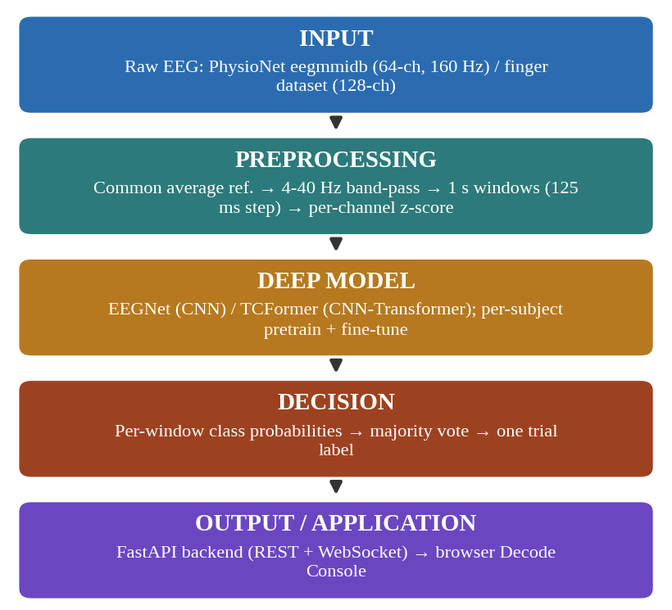
Fig. 1. End-to-end NeuroBot pipeline: input, preprocessing, deep model, decision, and application output.
The remainder of this report is organized as follows: Section 2 reviews related work; Section 3 states the problem and scope; Section 4 describes the datasets; Section 5 details the proposed methodology; Section 6 narrates the iterative development history; Section 7 summarizes results; Section 8 describes the software system and its deployment; Section 9 discusses limitations; Section 10 outlines future work; and Section 11 concludes.

1.1 The Base Paper
Ding, Udompanyawit, Zhang, and He [1] recorded 128-channel EEG (BioSemi ActiveTwo, 1024 Hz, international 10-20 placement) from 21 right-handed, experienced BCI users performing cued individual-finger movements—both physically executed (ME) and motor-imagined (MI)—across one offline and multiple online sessions per subject. A deep convolutional network (EEGNet [4]) was trained per subject with an online fine-tuning mechanism, decoding 1-second windows into finger-class predictions that drove a robotic hand in real time. In the offline sessions the four fingers of the right hand (thumb, index, middle and pinky) were each flexed and extended repeatedly, or imagined being so. The online tasks used thumb versus pinky (two fingers) and thumb, index and pinky (three fingers). The study reports online accuracies of 81.10% (executed) and 80.56% (imagined) for two fingers and 60.11% and 60.61% for three fingers, and identifies that fingers activating more distinct cortical regions (e.g., thumb versus pinky) are more separable than adjacent fingers.
The authors released both the dataset and their training code publicly, which this project consulted directly rather than inferring the methodology secondhand. The dataset (KiltHub/Figshare, DOI 10.1184/R1/29104040 [7]) totals approximately 502.77 GB across 21 subjects, structured as per-subject FieldTrip-style MATLAB files with associated event markers. The official code release (github.com/bfinl/Finger-BCI-Decoding) confirms the exact preprocessing used: 1-second analysis windows, downsampling from 1024 Hz to 100 Hz, a 4–40 Hz band-pass filter, and EEGNet hyperparameters of F1=8, D=2, F2=16, and a temporal kernel length of 32—values this project adopted for its own EEGNet configuration (Section 5.2). The official code validates only two- and three-class configurations; no four-finger configuration is present in the authors’ released pipeline.

2. Related Work
Classical and deep-learning decoders. Early motor-imagery BCIs relied on hand-engineered spectral-spatial features fed to linear or kernel classifiers; the field has since moved toward end-to-end deep learning, as surveyed in [12], [13]. Schirrmeister et al. showed that deep and shallow convolutional networks trained on raw EEG can match filter-bank common spatial patterns on movement decoding [14]. EEGNet [4] is a compact network built from a temporal convolution, a depthwise spatial convolution, and a separable convolution, and has become a standard baseline across BCI paradigms because of its small parameter count.
Attention-based decoders. The Transformer [15] models long-range dependencies through self-attention. EEG Conformer [16] places a self-attention module after a temporal-spatial convolution module so that global correlations among local temporal features can be captured. TCFormer [5] combines a multi-kernel convolutional front end, a Transformer encoder using grouped-query attention [17] and rotary position embeddings [18], and a temporal convolutional network (TCN) classification head [19].
Noninvasive robotic control. Edelman et al. demonstrated continuous, noninvasive EEG-based control of a robotic arm, using EEG source imaging to improve decoding [20]; Ding et al. [1] extend noninvasive control to the individual-finger level.
Training practice and tooling. Transformer-style training commonly pairs the Adam optimizer [21] with decoupled weight decay (AdamW) [22], a warm-up followed by cosine learning-rate decay [23], and label smoothing [24]. The implementation here uses PyTorch [25] and MNE-Python [26] for EEG handling, with the TCFormer implementation taken from Braindecode [6]. Relative to this literature, NeuroBot contributes (i) a per-subject hybrid pretrain/fine-tune protocol, a form of transfer learning [27], applied to a CNN and a CNN-Transformer, (ii) a documented diagnosis and correction of a self-attention token bottleneck when TCFormer is applied to short windows, and (iii) a software-only, API-free deployment of the trained models.

3. Problem Statement and Scope

3.1 Problem Statement
The goal is a self-trained pipeline that decodes movement intention from EEG, both for coarse limb-level tasks and for the finger-level task of the base paper, without an external API, a cloud inference service or a pretrained third-party model. If useful accuracy can be reached from raw EEG to a working software output, that is a small but reproducible step toward more accessible noninvasive assistive BCIs.

3.2 Scope
In scope:
- EEG preprocessing: common-average referencing, band-pass filtering, sliding-window segmentation, per-window normalization.
- Limb-level decoding on PhysioNet eegmmidb: left-fist/right-fist/rest (Task A) and both-fists/both-feet/rest (Task B).
- Finger-level decoding on the base paper’s released dataset: a single-subject pilot (subject S01) in the 2- and 3-finger configurations.
- Two model architectures—EEGNet (CNN) and TCFormer (CNN-Transformer hybrid)—compared head to head under the earlier window-level split (v7–v8); under the final trial-level split both TCFormer and EEGNet are evaluated on both tasks (v11).
- A per-subject hybrid pretrain/fine-tune training protocol developed for this project.
- A software backend (REST + WebSocket API) and a browser-based Decode Console, deployed as a web service on Render and also runnable on a laptop.
Out of scope:
- Physical robotic hardware or actuation—the system is deliberately software-only.
- Real-time, in-session closed-loop neurofeedback training of the kind used in the base paper’s online sessions.
- Clinical trials or evaluation on a patient population.
- Any call to an external large language model or third-party inference API.

4. Datasets

4.1 PhysioNet EEG Motor Movement/Imagery Database (eegmmidb)
The eegmmidb corpus [2], collected with the BCI2000 system [3], provides 64-channel EEG at 160 Hz from 109 subjects performing and imagining left/right fist movements and both-fists/both-feet movements, cued by on-screen prompts (T0 = rest; T1/T2 = the two movement classes for a given run). Five subjects (88, 92, 100, 104, 106) are excluded throughout this project because of a documented annotation-timing fault reported in prior BCI literature using this corpus.

4.2 Finger-Level Dataset
The base paper’s own dataset [7] provides 128-channel EEG across 21 subjects performing individual-finger ME and MI tasks, with an explicit real-time decoding log recorded alongside the raw EEG for each online session. This project evaluates the two configurations of the base paper’s validated pipeline—two-finger (thumb/pinky) and three-finger (thumb/index/pinky)—on one subject, S01, the only subject that could be downloaded (16.46 GB of the 502.77 GB corpus). The exploratory four-finger configuration (thumb/index/middle/pinky), which is not part of the authors’ validated pipeline, is not supported by the session-held-out protocol used here: the middle finger was recorded only in the offline session, so no later session can serve as a held-out test set. It was not attempted.

5. Proposed Methodology

5.1 Preprocessing
Each recording x with C channels and T samples is re-referenced to the common average (1), band-pass filtered to 4–40 Hz (FIR), and segmented into overlapping windows of W = 160 samples (1 s at 160 Hz) with a step of s = 20 samples (125 ms), matching the temporal resolution of the base paper’s released code. The number of windows per recording is given by (2).
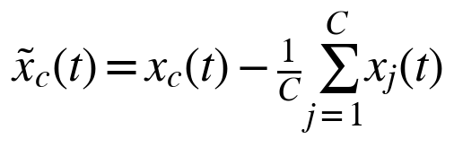 (1)
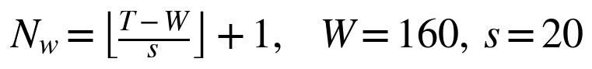 (2)
Each window is then independently z-score normalized per channel (3), where μ_{c} and σ_{c} are the mean and standard deviation of channel c within the window and ε is a small constant for numerical stability. Every window retains a trial identifier, enabling trial-level majority-vote evaluation (Section 5.4) in addition to raw per-window accuracy.
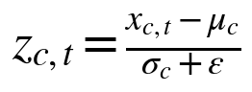 (3)

5.2 Model Architectures
EEGNet [4] is a compact convolutional network using depthwise and separable convolutions. Its hyperparameters were corrected during development to match the base paper’s values (F1=8, D=2, F2=16, temporal kernel length 32; Table I), which are also those of the official Finger-BCI-Decoding release.
TCFormer [5] is a temporal-convolutional Transformer combining a multi-kernel CNN front end, a grouped-query-attention Transformer encoder, and a TCN classification head, accessed through its maintained implementation in Braindecode [6]. The encoder applies scaled dot-product self-attention (4), with d_{k} the key dimension.
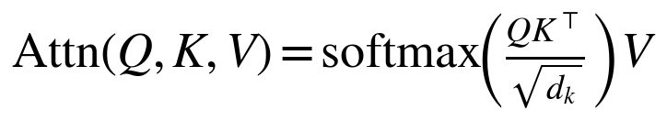 (4)
Direct inspection of the model’s internal tensor shapes on this project’s 160-sample (1 s) windows revealed that TCFormer’s published default pooling configuration collapses the self-attention sequence to only two temporal tokens—an artifact of its benchmarks having used substantially longer (4–4.5 s) windows. The token count is approximately given by (5), where P₁ and P₂ are the two pooling lengths.
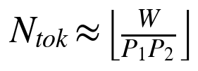 (5)
Reducing the pooling lengths to P₁=4 and P₂=2 restores twenty tokens at an identical parameter count (85,816), and was adopted as a targeted, empirically verified correction rather than a general hyperparameter search. The same relation predicts that a 2 s window (W=320) yields forty tokens, which motivates the window-length ablation in Section 6.
Table I
Key configuration values
Parameter | Value
Sampling rate / EEG channels (eegmmidb) | 160 Hz / 64
Band-pass filter | 4–40 Hz (FIR)
Window / step | 160 samples (1 s) / 20 samples (125 ms)
EEGNet F1 / D / F2 / kernel | 8 / 2 / 16 / 32
Fine-tune dropout (all models) | 0.65
TCFormer pooling (P₁, P₂) | 4, 2 (default gives 2 tokens)
TCFormer parameters | 85,816
Self-attention tokens | 20 (1 s) / 40 (2 s ablation)
Split (per mode, by whole trial) | first 60% of trials pretrain; remaining 40% split 20% fine-tune / 20% evaluation
Excluded subjects | 88, 92, 100, 104, 106

5.3 Hybrid Pretrain/Fine-Tune Protocol
A protocol was developed specifically for this project to address limited per-subject data. For each subject, let D_{ME} and D_{MI} be the windows from movement-execution and motor-imagery runs, and let K=3 be the number of classes. All training minimizes a class-weighted, label-smoothed cross-entropy (6), with smoothed targets and inverse-frequency class weights given by (7), where N_{k} is the number of training windows of class k and ε is the smoothing factor (ε=0 for EEGNet).
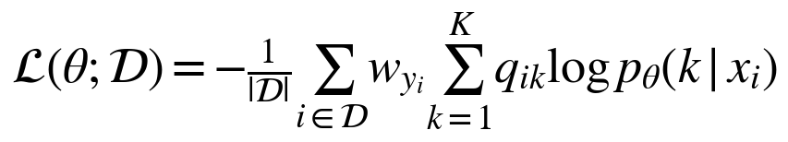 (6)
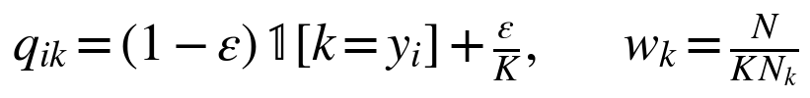 (7)
Stage 1 (pretraining). A single base model is pretrained on the pooled movement-execution and motor-imagery data (8), which preserves data volume.
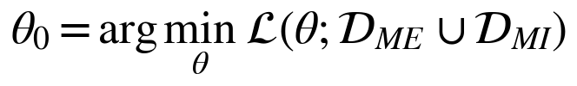 (8)
Stage 2 (fine-tuning). The base model is cloned and independently fine-tuned into two mode-specialist copies (9), one for ME and one for MI, each evaluated only on held-out data of its own mode. Within each mode’s block, trials are ordered chronologically and split by whole trial: the first 60% form the pretraining pool, and the remaining 40% are divided by stratified sampling into 20% fine-tuning and 20% held-out evaluation trials. Validation sets for early stopping are also drawn by trial (15% of the pretraining trials and 20% of the fine-tuning trials). The split is made per mode because a single global chronological split would place an entire mode in the evaluation set (Section 6, v5). Splitting by trial matters: consecutive windows overlap by 87.5%, so a window-level split lets near-duplicate windows of one trial appear in both fine-tuning and evaluation data (Section 6, v10).
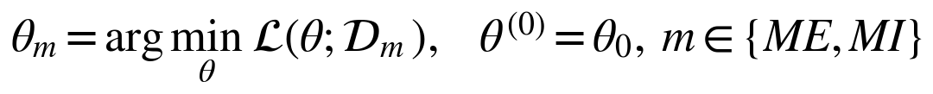 (9)
Optimization. EEGNet is trained with Adam [21] and ReduceLROnPlateau scheduling. TCFormer additionally uses AdamW (10) [22], where m̂_{t} and v̂_{t} are the bias-corrected first and second moment estimates and λ is the decoupled weight-decay coefficient, together with a linear-warmup/cosine-decay learning-rate schedule (11) over T steps with T_{w} warm-up steps [23] and label smoothing [24]—standard Transformer training practice not applied to EEGNet, whose tuning was left undisturbed. For TCFormer, η_{max} = 5×10⁻⁴ for pretraining and 3×10⁻⁴ for fine-tuning, η_{min} = 0, T_{w} is 10% of the total steps, λ = 10⁻², and ε = 0.1; the batch size is 16, and training runs for at most 250 (pretraining) and 100 (fine-tuning) epochs with early-stopping patience 25 and 18. EEGNet uses Adam with learning rates of 10⁻³ and 5×10⁻⁴, ReduceLROnPlateau (factor 0.5, patience 8), at most 150 and 60 epochs, and patience 20 and 12. During fine-tuning, dropout is set to 0.65 and only the last 50% (TCFormer) or 30% (EEGNet) of the parameters are updated. Training batches are augmented with Gaussian noise (σ = 0.05) and a random circular time shift of up to ±8 samples. Early stopping and learning-rate scheduling use validation trials held out from the training trials; the evaluation trials are never used for gradient updates or early stopping. Light augmentation (additive noise and time shift) is applied to training data only.
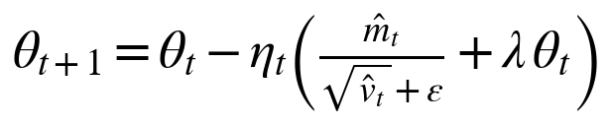 (10)
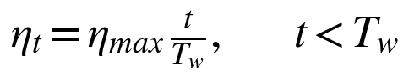 (11a)
(11b)

5.4 Evaluation Methodology
Two accuracy metrics are reported throughout. The raw per-window accuracy is (12), where ŷ_{i} and y_{i} are the predicted and true labels of window i.
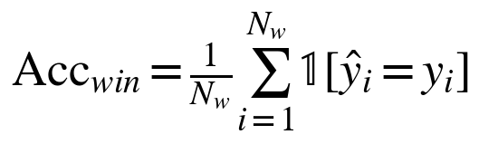 (12)
The trial-level majority-vote accuracy matches the base paper’s own primary metric: every window in the set W_{τ} belonging to trial τ casts a vote, and the trial’s predicted label is the majority class (13); the accuracy is the fraction of trials labelled correctly (14), where N_{τ} is the number of trials.
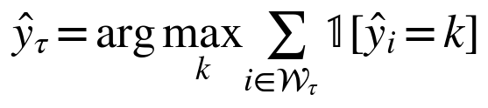 (13)
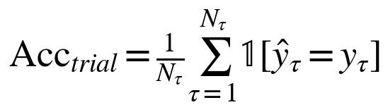 (14)
Because one model is trained per subject, results are reported as the group mean and standard deviation of per-subject accuracy A_{s} over S subjects (15). With K=3 classes, chance level is 1/K = 33.3%.
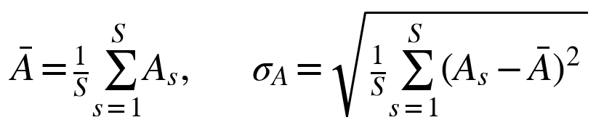 (15)

6. Development Timeline
The project’s methodology evolved through eleven iterations, several of which involved identifying and correcting genuine methodological errors rather than simple hyperparameter adjustment. This history is reported in full for transparency and reproducibility. Fig. 2 shows the three-tier software architecture that the models are deployed in, and Table II lists every iteration with its result.
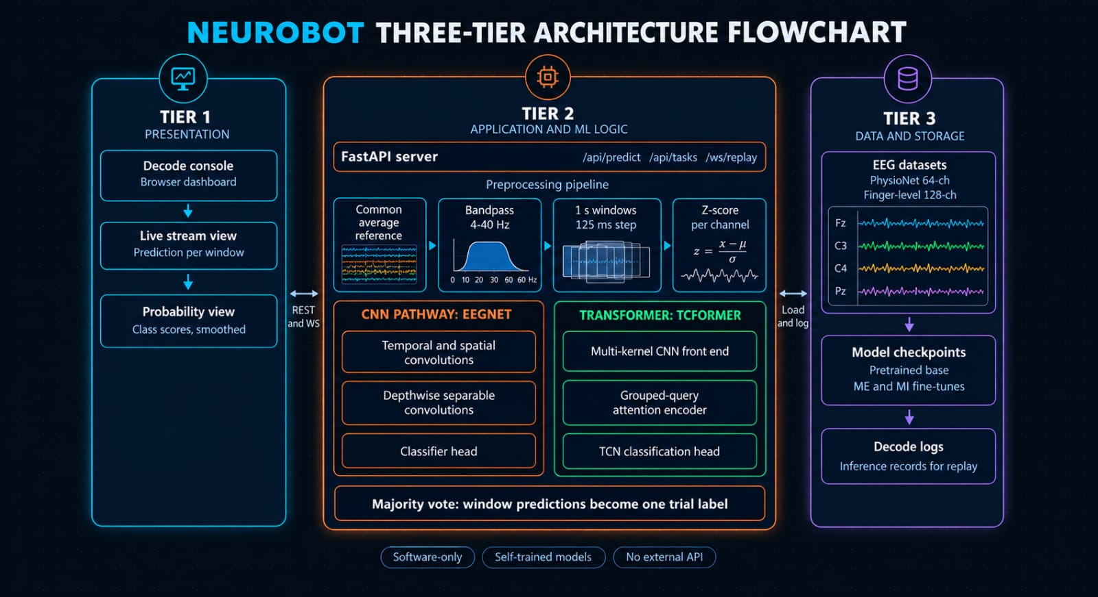
Fig. 2. NeuroBot three-tier architecture: presentation (Decode Console), application and ML logic (FastAPI server, preprocessing pipeline, EEGNet and TCFormer pathways, majority vote), and data and storage (EEG datasets, model checkpoints, decode logs). The system is software-only, uses self-trained models, and calls no external API.
Table II
Development timeline, v1 to v11
# | Change | Result
v1 | Single-subject EEGNet baseline (3-class left/rest/right). | 64.2% per-window accuracy (chance = 33%).
v2 | 10-subject pooled training; later found to leak subject identity across the train/test split (pooled subjects were split by raw index, so the model trained on early subjects and was evaluated on unseen later ones). | ~57% on both tasks—discarded once diagnosed as cross-subject transfer rather than genuine within-subject accuracy.
v3 | Per-subject methodology (one model per subject, matching the base paper); leakage bug fixed. | Task A 65.2%, Task B 68.9% (10-subject majority-vote means).
v4 | Fully separated ME and MI models (no pooling). | Task A 59.8% on average—a regression, diagnosed as data starvation (each mode loses half its training runs).
v5 | Hybrid pretrain (pooled) / fine-tune (per-mode) protocol introduced; within-mode 70/30 split fix. | Task A ME 74.1% / MI 66.3%; Task B ME 76.3% / MI 71.1%.
v6 | Ensemble of ME- and MI-specialist EEGNet models (same architecture). | Accuracy fell by 1.9–4.6 points in the original run and by 0.7–0.9 points in a later rerun—discarded as no improvement; diagnosed as averaging in an unreliable off-mode opinion.
v7 | TCFormer introduced via Braindecode, same hybrid protocol. | Beat EEGNet on all four task/mode conditions in a like-for-like re-run (+3.7 to +17.4 points); flagship best-subject exports of 81.4% / 86.4% per-window accuracy. Window-level split; not repeated under the trial-level split.
v8 | TCFormer pooling-bottleneck fix (2 → 20 tokens) plus AdamW, warm-up, cosine decay, and label smoothing. | Window-level split. Group means: Task A ME 75.2% / MI 65.2%; Task B ME 80.7% / MI 75.6%. Flagship fine-tune validation accuracy 86.8% (Task A) / 95.6% (Task B).
v9 | Window-length ablation (1 s → 2 s windows, 20 → 40 self-attention tokens at identical parameter count), TCFormer only, Task A, four subjects. A planned cross-architecture EEGNet+TCFormer ensemble was dropped when EEGNet runs were removed to cut training time from 5–7 h. | Inconclusive: 2 s windows changed executed-movement accuracy by −4.2 points and imagined-movement accuracy by +2.8 points, within run-to-run noise. Not scaled up.
v10 | Audit of the fine-tune/evaluation split: overlapping windows of one trial appeared on both sides of the window-level split. Replaced by a split by whole trial (60% / 20% / 20%) with larger evaluation sets (about 18 trials per subject and mode); TCFormer only. | Group means (10 subjects): Task A ME 65.6% / MI 60.0%; Task B ME 70.0% / MI 59.4%. An earlier independent run of the same code gave Task A 58.9% / 57.2% and Task B ME 76.1%.
v11 | Cross-subject pretraining (notebook v5): TCFormer and EEGNet each pretrained once on 30 other subjects (S011–S040), then trained per subject with three seeds averaged; EEGNet re-run under the trial-level split; automatic leakage checks; Tasks A and B. Baseline arm (notebook v6): TCFormer without pretraining, same trials and seeds. | Group means (10 subjects), Task A: TCFormer ME 74.4% / MI 70.0%; EEGNet 75.0% / 61.7%. Task B: TCFormer ME 86.7% / MI 71.1%; EEGNet 78.9% / 65.0%. Same-protocol baseline without pretraining: A ME 66.1% / MI 61.7%; B ME 78.9% / MI 71.1%. Gain +8.3 / +8.3 (not significant) on A; +7.8 (p = 0.003) / 0.0 on B.
Note: EEGNet figures (v1–v7) come from separate runs under earlier splits; EEGNet was re-run under the final trial-level split with cross-subject pretraining for both tasks (v11, Tables VI and VII). The like-for-like window-level comparison is in Table V.

We learned five things along the way. First, the v2 result of about 57% on both tasks looked too similar to be real, and that led us to the subject-order leak. After the fix, Task B (both fists or feet) again scored higher than Task A, as expected physiologically. Second, separating ME and MI completely (v4) lost more through data starvation than it gained through specialization, so we moved to the hybrid protocol. Third, the hybrid protocol exposed a second bug: the data were loaded as one block of ME followed by one block of MI, so a single chronological split left one mode without training data. We now split within each mode. Fourth, averaging in a specialist of the other mode (v6) made results worse, so the ME and MI models stay separate. Fifth, an audit showed that overlapping windows of the same trial ended up on both sides of the fine-tune/evaluation split. Splitting by whole trial lowered the executed-movement group means from 75.2% and 80.7% to 65.6% and 70.0% (Section 7). Leakage of this kind is common in deep-learning EEG studies [28], so accuracy should be checked for it before it is reported.

7. Results Summary
Table III reports the final trial-level evaluation of TCFormer on ten subjects: group-mean majority-vote accuracy with spread across subjects, using about 18 held-out trials per subject and mode. Task A is left-fist/right-fist/rest and Task B is both-fists/both-feet/rest. Fig. 3 plots the means against chance and the 85% target.
Table III
TCFormer, trial-level split: majority-vote accuracy (%), ten subjects
Task / mode | Mean | Std. | Min | Max | Subjects ≥ 85%
Task A – ME | 65.6 | 15.9 | 44.4 | 88.9 | 1
Task A – MI | 60.0 | 14.0 | 38.9 | 88.9 | 1
Task B – ME | 70.0 | 25.6 | 22.2 | 100.0 | 2
Task B – MI | 59.4 | 18.9 | 27.8 | 94.4 | 1

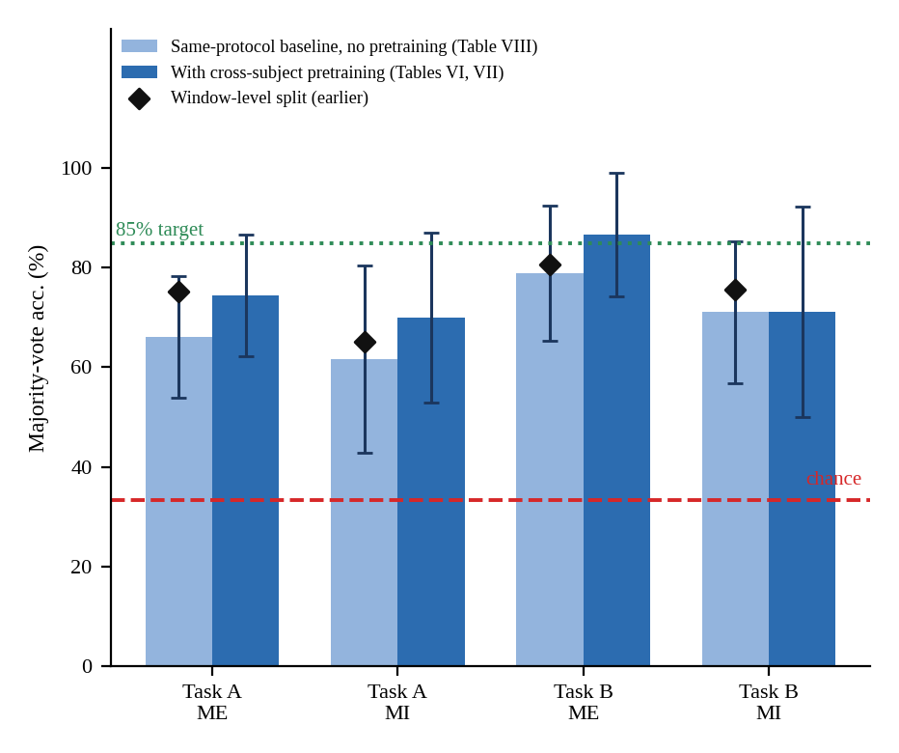
Fig. 3. Group-mean majority-vote accuracy (± std. across subjects) under the trial-level split: TCFormer without pretraining (light bars, three-seed average, Table VIII) and with cross-subject pretraining (dark bars, Tables VI and VII), with the earlier window-level-split means (diamonds), chance (33.3%), and the 85% target.
All four single-run group means (Table III) are well above the 33.3% chance level but below the 85% target. Subject variability dominates: Task B executed-movement accuracy ranges from 22.2% to 100%, and in each condition only one or two subjects reach 85%. Two subjects (S006 and S009) score below chance on Task B executed movement; with only 18 trials this is within sampling noise for a subject whose signal the model cannot use. Imagined movement is lower than executed movement in both tasks (by 5.6 and 10.6 points).
Table IV
Effect of splitting by trial: group-mean accuracy (%)
Task / mode | Window-level split | Trial-level split | Change
Task A – ME | 75.2 | 65.6 | −9.6
Task A – MI | 65.2 | 60.0 | −5.2
Task B – ME | 80.7 | 70.0 | −10.7
Task B – MI | 75.6 | 59.4 | −16.2
Table IV compares the earlier window-level split with the final trial-level split. The drop of 5–16 points is the expected effect of removing near-duplicate windows from the evaluation data. It is not a pure measurement of leakage, because the protocols also differ in split proportions (70/15/15 versus 60/20/20) and evaluation-set size, and each figure comes from a single run.
EEGNet versus TCFormer. The architecture comparison rests on two earlier head-to-head runs that used the window-level split (Table V; Section 6, v7–v8) and one run per task under the trial-level split with cross-subject pretraining (Tables VI and VII). TCFormer scored higher in all eight comparisons, by 3.7 to 17.4 points (mean 12.1), although EEGNet itself varied by up to 8.1 points between the two runs. Because both runs used the window-level split, this shows the relative ordering of the architectures under that protocol; it is not an estimate of the gap under the trial-level split. In the trial-level runs with cross-subject pretraining the gap is smaller and depends on task and mode: 8.3 points on imagined movement but none on executed movement for Task A, and 7.8 points on executed movement (significant) against 6.1 on imagined movement (not significant) for Task B (Tables VI and VII).
Table V
EEGNet versus TCFormer, window-level split: group-mean majority-vote accuracy (%), two independent runs
Task / mode | EEGNet run 1 | TCFormer run 1 | EEGNet run 2 | TCFormer run 2
Task A – ME | 68.5 | 72.2 | 60.4 | 76.7
Task A – MI | 58.9 | 68.5 | 57.0 | 69.3
Task B – ME | 68.5 | 80.7 | 70.7 | 81.5
Task B – MI | 57.8 | 75.2 | 61.1 | 75.9

Run-to-run variation. Training is not seeded for model initialization and batch order, while the data split is fixed. Two independent runs of the same trial-level code gave Task A means of 58.9% (ME) and 57.2% (MI) in the first run and 65.6% and 60.0% in the second, and a Task B executed-movement mean of 76.1% against 70.0%—differences of up to 6.7 points in group mean. For Task A executed movement the per-subject difference between runs has a standard deviation of 12.4 points (maximum 22.2) although the two runs correlate (r=0.71). Differences of a few points between conditions are therefore not interpretable from single runs.
Pilot: seed averaging and cross-subject pretraining. A pilot on Task A, subjects S001–S004, with two seeds and the same held-out trials, compared the trial-level recipe with a variant that first pretrains TCFormer on 20 other subjects (never an evaluated subject) before the per-subject stages. With the softmax outputs of the two seeds averaged, executed- and imagined-movement accuracy was 69.4% and 68.1% for the baseline and 75.0% and 75.0% with cross-subject pretraining, a paired gain of +5.6 and +6.9 points; three of the four subjects improved in each mode, and seed-to-seed variability was mixed. With four subjects and about 18 trials each, the paired standard errors are roughly 6 and 5 points, so this is suggestive rather than conclusive; the ten-subject Task A run below extends it.
Cross-subject pretraining on ten subjects (Task A). The pilot was extended to all ten subjects of Task A (Table VI). TCFormer and EEGNet were each pretrained once on 30 other subjects (S011–S040, every second window, never an evaluated subject) and then trained per subject with three seeds whose softmax outputs were averaged, on the same trial-level split (18 held-out trials per subject). TCFormer reached 74.4% (ME) and 70.0% (MI), EEGNet 75.0% and 61.7%, and the equal-weight average of the two 75.6% and 69.4%. Relative to the single-run baseline of Table III this is +8.8 and +10.0 points for TCFormer, but two single runs of the same code already differ by up to 6.7 points, so the effect of pretraining is measured against a same-protocol baseline in Table VIII (+8.3 points in both modes, not significant). Seed averaging is not the explanation: it moved group means by only 0.8–1.7 points (mean single-seed accuracy: TCFormer 75.2% and 69.1%, EEGNet 73.3% and 63.3%). On the pilot’s four subjects this run gave 68.1% (ME) and 81.9% (MI) against 75.0% and 75.0% in the pilot (30 versus 20 pretraining subjects, three versus two seeds), another reminder of the run-to-run spread. TCFormer exceeded EEGNet by 8.3 points on MI (paired t-test p = 0.048, Wilcoxon p = 0.078; better for 6, equal for 3 and worse for 1 of 10 subjects) and matched it on ME (−0.6 points, p = 0.88). The ensemble did not improve on TCFormer alone (+1.1 and −0.6 points). Three subjects (S005, S006, S009) are not above chance on MI by an exact binomial test (at least 10 of 18 trials are needed), whereas all ten are above chance on ME; per-subject ME and MI accuracies are uncorrelated in this task (r = 0.02, n = 10, so only a rough indication). Task B follows in Table VII.
Table VI
Task A, cross-subject pretraining, three-seed averaging: majority-vote accuracy (%), ten subjects
Model / mode | Mean | Std. | Min | Max | Subjects ≥ 85%
TCFormer ME | 74.4 | 12.2 | 55.6 | 94.4 | 2
TCFormer MI | 70.0 | 17.1 | 38.9 | 88.9 | 2
EEGNet ME | 75.0 | 13.9 | 50.0 | 94.4 | 3
EEGNet MI | 61.7 | 19.6 | 27.8 | 94.4 | 1
Ensemble ME | 75.6 | 13.0 | 50.0 | 94.4 | 3
Ensemble MI | 69.4 | 16.7 | 44.4 | 88.9 | 1
Cross-subject pretraining on ten subjects (Task B). The same recipe was run on Task B (Table VII). TCFormer reached 86.7% (ME) and 71.1% (MI), EEGNet 78.9% and 65.0%, and the equal-weight average of the two 88.9% and 70.0%. Relative to the single-run baselines of Table III (70.0% and 59.4%) this looks like +16.7 and +11.7 points for TCFormer, but the same-protocol baseline of Table VIII (78.9% and 71.1%) shows that the apparent gain was largely run-to-run variation: +7.8 points on ME and none on MI. The 95% confidence interval of the TCFormer executed-movement mean is ±9.4 points across the ten subjects, so a true mean below the 85% target is not excluded. All ten subjects are above chance on ME and eight of ten on MI. Seed averaging again changed group means by at most 0.6 points (mean single-seed accuracy: TCFormer 86.5% and 70.9%, EEGNet 78.3% and 65.0%). TCFormer exceeded EEGNet by 7.8 points on ME (paired t-test p = 0.010, Wilcoxon p = 0.016; better for 7 and equal for 3 of 10 subjects) and by 6.1 points on MI (p = 0.21, not significant). The ensemble was not reliably better than TCFormer alone (+2.2 points on ME, p = 0.27; −1.1 on MI). Per-subject ME and MI accuracies are moderately correlated in this task (r = 0.55, n = 10). Subjects S006 and S009 were at or below chance on MI in both tasks, although S009 reached 94.4% and 88.9% on ME, which points to an imagery-specific weakness rather than a generally poor responder.
Table VII
Task B, cross-subject pretraining, three-seed averaging: majority-vote accuracy (%), ten subjects
Model / mode | Mean | Std. | Min | Max | Subjects ≥ 85%
TCFormer ME | 86.7 | 12.5 | 61.1 | 100.0 | 7
TCFormer MI | 71.1 | 21.2 | 33.3 | 94.4 | 4
EEGNet ME | 78.9 | 12.9 | 61.1 | 100.0 | 3
EEGNet MI | 65.0 | 18.8 | 27.8 | 94.4 | 1
Ensemble ME | 88.9 | 12.9 | 55.6 | 100.0 | 8
Ensemble MI | 70.0 | 21.5 | 38.9 | 94.4 | 3
Same-protocol baseline (effect of cross-subject pretraining). To measure what cross-subject pretraining adds, we retrained TCFormer without it (notebook v6) on the same ten subjects, with the same code, the same three seeds and the same 18 held-out trials per subject and mode (the split is deterministic). We then compared the seed-averaged results subject by subject with the pretrained runs of Tables VI and VII (Table VIII). The two arms ran in separate sessions, so GPU nondeterminism cannot be ruled out. On Task B executed movement, pretraining raised accuracy from 78.9% to 86.7% (+7.8 points). It helped 9 of 10 subjects, tied for 1 and hurt none (paired t-test p = 0.003, Wilcoxon p = 0.004), and the result survives a Bonferroni correction for the four comparisons (threshold 0.0125). On Task A the group mean rose by 8.3 points in both modes, but individual differences ranged from −16.7 to +44.4 points and neither gain is significant with ten subjects (p = 0.12 and 0.11). On Task B imagined movement there was no gain (0.0 points, p = 1.0). The three-seed baseline sits 0.5 and 1.7 points above the single-run baselines of Table III on Task A, but 8.9 and 11.7 points above them on Task B. About half of the +16.7 points on executed movement and all of the +11.7 points on imagined movement seen against Table III were therefore run-to-run variation.
Seed averaging raised the baseline by 4.1–5.2 points but the pretrained models by at most 0.9 points (mean single-seed accuracy for Task A ME, A MI, B ME and B MI: baseline 61.9%, 56.5%, 74.4% and 67.0%; pretrained 75.2%, 69.1%, 86.5% and 70.9%). A single pretrained seed is therefore about as good as the three-seed average, while single baseline runs are lower and less stable. Against single seeds, pretraining gains 12.0–13.3 points on the first three conditions (paired p = 0.009–0.033) and 3.9 points on Task B imagined movement (p = 0.26).
Table VIII
Effect of cross-subject pretraining on TCFormer: three-seed majority-vote accuracy (%), mean ± std over ten subjects
Task / mode | No pretraining | Pretrained | Δ (pts) | Better / tie / worse | Paired t p
Task A – ME | 66.1 ± 12.3 | 74.4 ± 12.2 | +8.3 | 5 / 3 / 2 | 0.120
Task A – MI | 61.7 ± 18.8 | 70.0 ± 17.1 | +8.3 | 7 / 1 / 2 | 0.105
Task B – ME | 78.9 ± 13.6 | 86.7 ± 12.5 | +7.8 | 9 / 1 / 0 | 0.003
Task B – MI | 71.1 ± 14.2 | 71.1 ± 21.2 | 0.0 | 5 / 2 / 3 | 1.000
Best-case subjects. The models used by the software demo are the flagship models of S007 for Task A and S002 for Task B, trained with seed 0 and without cross-subject pretraining. On their 18 held-out trials, executed and imagined movement reach 83.3% (15 of 18) and 100% (18 of 18) for S007, with per-window accuracy of 72.4% and 77.8%, and 100% (18 of 18) and 88.9% (16 of 18) for S002, with per-window accuracy of 84.9% and 63.1%. The three Task A executed-movement errors were two rest trials and one left-fist trial, all labelled right fist; the two Task B imagined-movement errors were one both-feet trial labelled rest and one rest trial labelled both-fists. These are best-case, single-subject results chosen on the evaluation data, so they are optimistic, and they are not directly commensurable with the base paper’s group-level finger-decoding accuracies (two-finger 81.10% executed and 80.56% imagined; three-finger 60.11% and 60.61%) [1], since task granularity, subject selection, and evaluation protocol all differ.
Finger-level pilot (subject S01). The finger notebook was run on subject S01 of the base paper’s dataset [7] for two fingers (thumb versus pinky) and three fingers (thumb, index, pinky), with TCFormer and EEGNet and three seeds averaged. The split is chronological, by whole trial and by session: the model is pretrained on the subject’s own earlier sessions of both modes (no other subjects), fine-tuned on the first 30% of the trials of the last session, and evaluated on the remaining, later trials of that session (448 trials for two fingers, 336 for three; Table IX). For two fingers TCFormer reached 79.9% on executed movement (Wilson 95% interval [29], 76.0–83.4%) and 71.4% on imagined movement (67.1–75.4%), against 76.1% and 65.4% for EEGNet. The three TCFormer seeds agreed within 1.8 points on ME and 3.8 on MI, while the EEGNet seeds spread over 6.5 and 5.6 points. For three fingers TCFormer reached 44.6% (ME) and 43.2% (MI) and EEGNet 46.7% and 37.2%. All of these are above the 33.3% chance level except EEGNet on imagined movement (p = 0.075, exact binomial test). The equal-weight ensemble stayed within 2.1 points of the better single model and was ahead of it only for three-finger ME (+0.9).
Table IX
Finger-level pilot, subject S01: majority-vote accuracy (%), three seeds averaged, no cross-subject pretraining
Config. / mode | Trials | Chance | TCFormer | EEGNet | Ensemble
2-finger – ME | 448 | 50.0 | 79.9 | 76.1 | 78.8
2-finger – MI | 448 | 50.0 | 71.4 | 65.4 | 69.9
3-finger – ME | 336 | 33.3 | 44.6 | 46.7 | 47.6
3-finger – MI | 336 | 33.3 | 43.2 | 37.2 | 41.1
These results come from one subject, so they say nothing about differences between people. The intervals treat trials as independent although they come from one subject and a few sessions, so they are optimistic, and the architecture differences cannot be tested without per-trial predictions. Our two-finger executed-movement accuracy is close to the base paper’s 81.10% [1], and our imagined-movement accuracy is about 9 points below its 80.56%. Our three-finger accuracies are 15 to 17 points below its 60.11% and 60.61%. The base paper reports means over 21 subjects with online fine-tuning, so the comparison is only indicative.

8. Software System and Deployment

8.1 Architecture
The trained models are deployed as the three-tier application shown in Fig. 2. Tier 1 (presentation) is a browser-based Decode Console. It shows the decoded command for each window, the class probabilities and a three-dimensional bionic-limb model. Tier 2 (application and ML logic) is a FastAPI server. Its endpoints are /api/health, /api/models, /api/tasks, /api/predict, /api/replay/log/{task}, /ws/replay/{task}, /api/upload/edf and /api/upload/csv. It runs the preprocessing of Section 5.1 and one ONNX Runtime model per task and mode, and turns window predictions into a trial label by majority vote. The band-pass filter is stored as fixed taps identical to the MNE filter used in training (maximum difference 4×10⁻¹⁴ on test data), so the server sees the same input the models saw during training. Tier 3 (data and storage) holds the EEG data, the ONNX model files with a manifest that records each model’s task, mode, label order and held-out accuracy, and the replay logs. The tiers talk over REST and WebSocket.
Following a deliberate scope decision, the system is entirely software-based and runs as a web service on Render or locally on a laptop: no physical robotic hardware is targeted, and no call to any external LLM or third-party inference API exists anywhere in the pipeline. The server never invents output. When no model is loaded for a task and mode it answers with an error, ground truth is shown only when the data really contain it (the T0/T1/T2 annotations of an EDF file), and files that lack the 64 PhysioNet channels are rejected. The server is covered by 58 automated tests: 45 use small synthetic ONNX models and the stored replay logs, 10 run the four exported TCFormer models themselves (they load, give valid probabilities, and agree with the manifest and the replay logs), and 3 check the web page. A public instance is hosted at https://neurobot-nrnn.onrender.com/ on the free plan, so the first request after an idle period is slow.

8.2 Front End
Fig. 4 shows the Decode Console. For each window of a replayed or uploaded session it shows the decoded command with its confidence, the ground-truth label when there is one, and a match flag. It also drives a three-dimensional virtual bionic-limb model in the browser that moves the arms, the legs or both according to the decoded class. The limbs are a software visualization only, and no physical hardware is involved. Below the model the console shows a six-channel EEG window with playback controls, the softmax class probabilities and the task selector. Fig. 5 shows the other views: the Task B replay with the legs extended (a), a finger-kinematics test with manual sliders (b), the session analytics with a confusion matrix (c), and the Custom Data Lab for uploading EDF or CSV recordings or generating a synthetic session (d). The finger test is a manual demonstration. A separate finger view shows a close-up of the right hand and flexes the decoded finger (thumb, index or pinky); until a finger model is exported it plays a simulated sequence that is labelled as such and is not a result. The hand model has five articulated digits, but the finger-level dataset covers thumb, index, middle and pinky, and the deployed models decode whole-limb commands, so a decoded limb command curls the whole hand and not single fingers. Rows and colors are built from the label order of the loaded task, so the same interface serves both tasks.

8.3 Test Cases
Table X lists the checks made on the system. T1–T7, T9 and T10 belong to the automated suite (58 tests, all passing) and T8 was checked by hand in the front end. Most of the suite uses small synthetic ONNX models, so it tests the server logic. T9 and T10 check that the real exported files load and agree with their manifest and replay logs; they do not measure accuracy on new data.
Table X
Functional test cases
T1 | /api/health | Backend reports its status, the loaded models and any load errors | Pass
T2 | /api/tasks | Both tasks are listed with labels, models and replays | Pass
T3 | /api/replay/log/{task} | Stored replay log, with its provenance, returned for each task | Pass
T4 | /ws/replay/{task} | Per-window predictions stream over WebSocket | Pass
T5 | /api/predict | Probabilities sum to 1, label order follows the manifest, wrong shapes are rejected | Pass
T6 | /api/upload/* | Ground truth only from real annotations; files without 64 channels or over the size limit are rejected | Pass
T7 | Preprocessing | 4–40 Hz FIR output equals the MNE training filter | Pass
T8 | Decode Console | Rows and colors built from the loaded log’s label order (Task A and B) | Pass (manual)
T9 | Exported models | All four TCFormer ONNX models load; outputs are valid probabilities; ONNX matches PyTorch within 1e-5 | Pass
T10 | Replay logs | Label order and accuracy recomputed from each replay log match the manifest | Pass

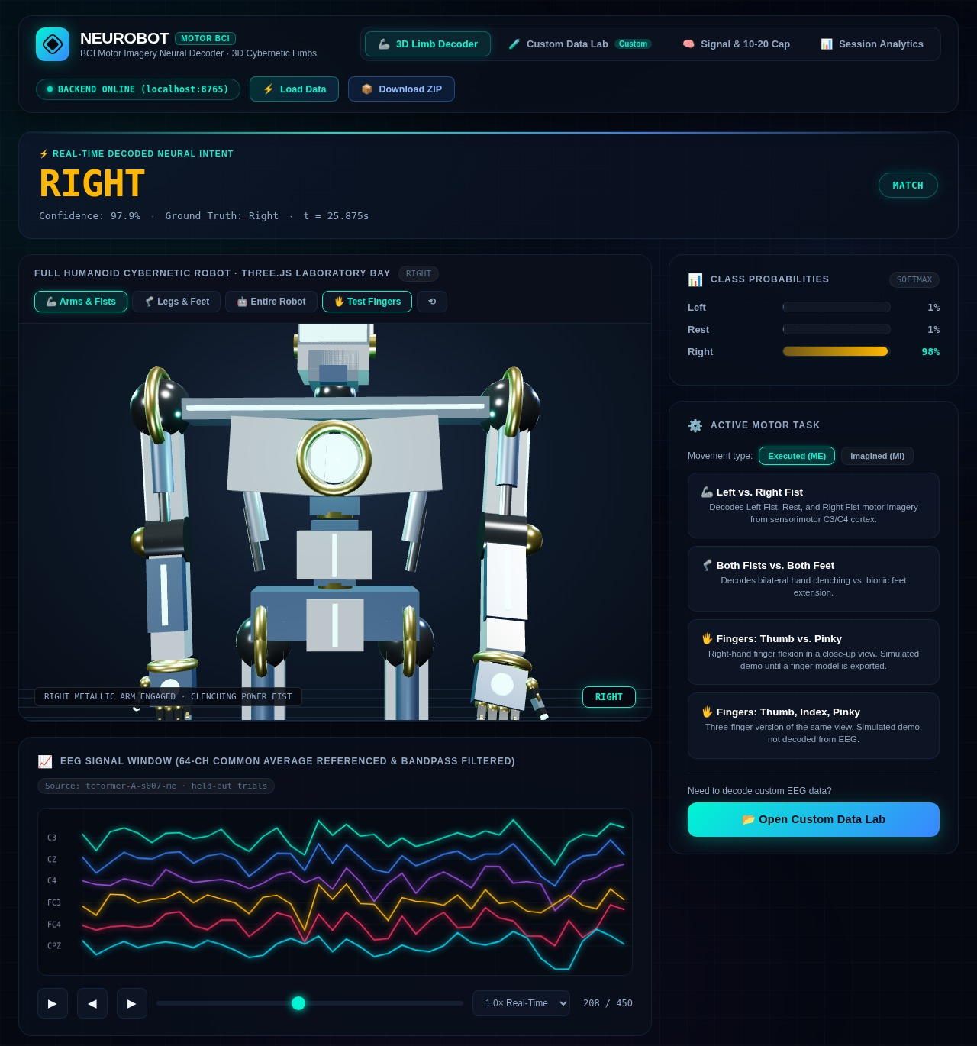
Fig. 4. Decode Console, 3D Limb Decoder view, replaying the held-out trials of the exported S007 executed-movement model (Task A) at one right-fist window: decoded command with confidence and a match flag against the ground-truth label, the humanoid model with the right arm and hand actuated, softmax class probabilities, the task selector, and the six-channel EEG window with playback controls.
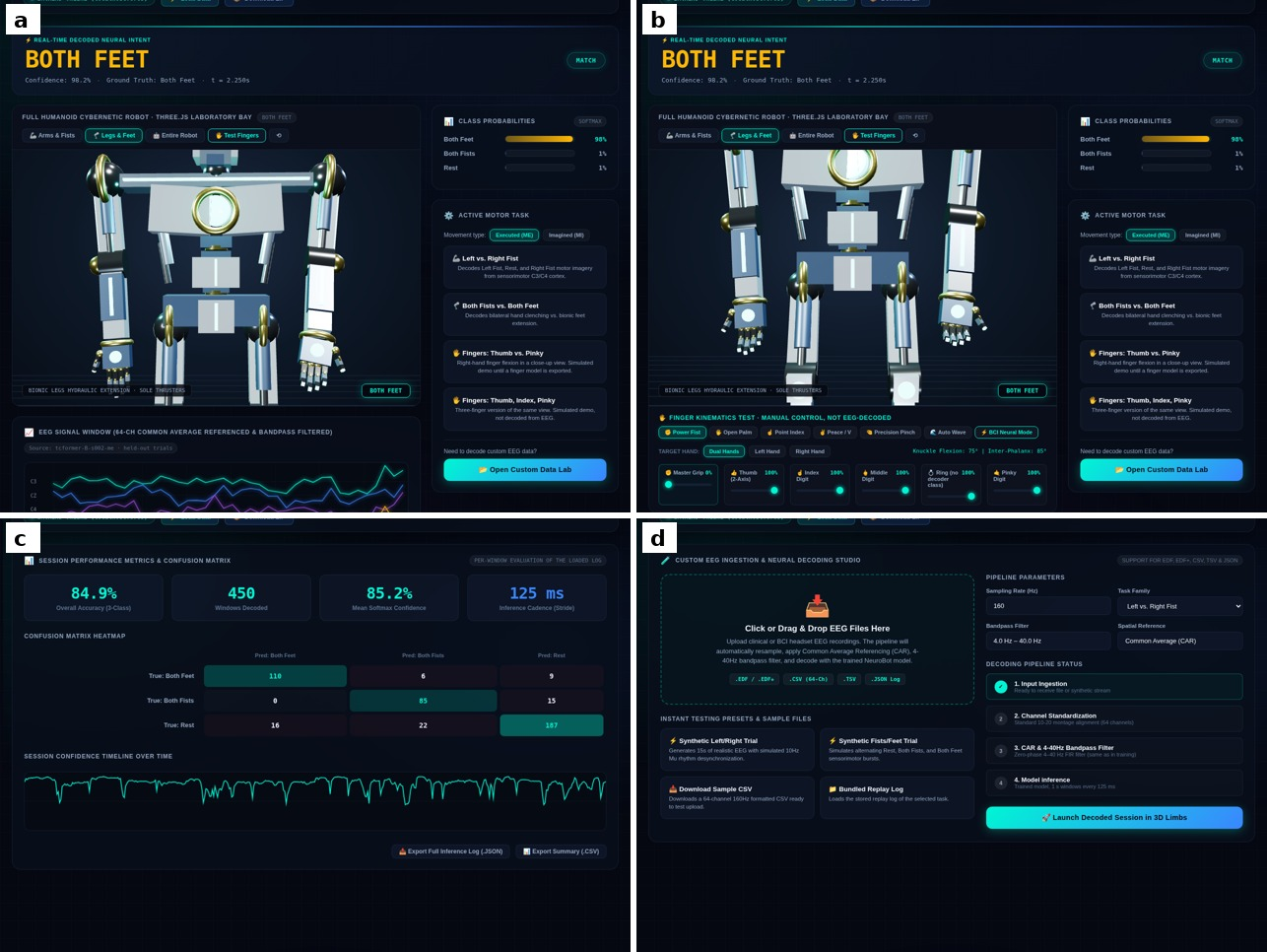
Fig. 5. Other views of the front end: (a) Task B replay with both feet decoded and the bionic legs extended; (b) finger-kinematics test with manual sliders, not driven by EEG (five digits are modelled; the finger dataset covers thumb, index, middle and pinky); (c) session analytics, per-window accuracy and confusion matrix of the loaded log; (d) Custom Data Lab for EDF/CSV upload and synthetic sessions.

9. Limitations
- Evaluation sets are small: about 18 trials per subject and mode, so per-subject accuracy moves in steps of about 5.6 points and individual values such as 100% rest on 18 trials.
- The trial-level results of Table III are single, unseeded runs: two runs of the same code differ by up to about 7 points in group mean (Section 7). The cross-subject comparison (Tables VI–VIII) averages three seeds in both arms, but each arm is one session per task, and the two arms ran in separate sessions.
- Subject-to-subject variability is large and persistent across every architecture and protocol tried; a small set of subjects (e.g., S002, S004, S007) outperformed the others in earlier runs, suggesting a physiological rather than methodological ceiling for weak responders. In the cross-subject runs, however, executed- and imagined-movement accuracies were uncorrelated across subjects in Task A (r = 0.02) and moderately correlated in Task B (r = 0.55; n = 10 each); only S006 and S009 were at or below chance on imagined movement in both tasks, while S009 reached 88.9–94.4% on executed movement, so the weakness may be specific to imagery.
- Motor imagery (MI) consistently underperforms movement execution (ME) in every configuration tested, consistent with the weaker, more variable cortical signal of imagined movement.
- Group-mean accuracy exceeds the project’s 85% target only for Task B executed movement (TCFormer 86.7%, 95% interval ±9.4 points, which includes values below 85%; the baseline without pretraining reached 78.9%). The other three conditions reach 70–74% with cross-subject pretraining, and imagined movement remains far from the target.
- The window-length ablation (v9) covered four subjects of Task A only and was inconclusive. Cross-subject pretraining is significant in only one of four conditions (Task B executed movement, +7.8 points, p = 0.003); on Task A its +8.3 points in both modes cannot be separated from zero with ten subjects of about 18 trials each (p = 0.12 and 0.11), and Task B imagined movement shows no gain (Section 7).
- The finger-level results come from a single subject (S01), so they give no estimate of between-subject variability, and their intervals (±3.7 points for two-finger executed movement) treat trials from one subject as independent. They were obtained offline, without the real-time, in-session closed-loop neurofeedback that the base paper documents as improving subject performance during acquisition, which may contribute to the three-finger accuracy (44.6% executed) lying below the base paper’s 60.11%.
- The exploratory four-finger configuration could not be evaluated under the session-held-out protocol, because the middle finger was recorded only in the offline session (Section 4.2).

10. Future Work
- Extend the finger-level track beyond subject S01 (more subjects, with cross-subject pretraining); a four-finger evaluation would need a different protocol, for example a held-out part of the offline session.
- Repeat the window-length ablation on more subjects (the four-subject pilot was inconclusive).
- Evaluate more subjects and held-out trials per condition so that the Task A pretraining gain (+8.3 points in both modes, Section 7) can be confirmed or excluded, and test whether per-run channel standardization or a sensorimotor channel subset helps the weakest subjects.
- Full redesign of the Decode Console user interface.
- Support multiple, flexible EEG input methods and data sources.
- Revisit guardrail and observability mechanisms (confidence thresholds, structured output validation, decode logging) appropriate to a software-only deployment.

11. Conclusion
NeuroBot shows that an EEG decoding pipeline can be built and trained entirely by ourselves, without an external API, and that it decodes coarse limb-level motor intention well above chance. With cross-subject pretraining the group-mean trial-level accuracy is 70–87% (chance 33%), and individual subjects reach 100%. Without pretraining, under the same protocol, it is 62–79%; the gain is significant only for Task B executed movement. A single-subject finger-level pilot reaches 79.9% for two fingers and 44.6% for three fingers on executed movement. The development history is as much a result as the final numbers: each iteration in Section 6 responded to a specific problem in the one before, and each architectural change, most notably the TCFormer pooling correction, was tested before we adopted it. The trained models are served by a software-only three-tier application. Future work will bring the same care to the finger-level task and to a more complete software product.

Acknowledgment
The authors used an AI assistant (Anthropic’s Claude) to help draft and edit text, write and review code, and format this report. The authors designed the experiments, ran all training on Kaggle, and checked the results, references and claims, and take full responsibility for the content.

References
[1] Y. Ding, C. Udompanyawit, Y. Zhang, and B. He, “EEG-based brain-computer interface enables real-time robotic hand control at individual finger level,” Nature Communications, vol. 16, p. 5401, 2025, doi: 10.1038/s41467-025-61064-x.
[2] A. L. Goldberger et al., “PhysioBank, PhysioToolkit, and PhysioNet: Components of a new research resource for complex physiologic signals,” Circulation, vol. 101, no. 23, pp. e215–e220, 2000.
[3] G. Schalk, D. J. McFarland, T. Hinterberger, N. Birbaumer, and J. R. Wolpaw, “BCI2000: A general-purpose brain-computer interface (BCI) system,” IEEE Trans. Biomed. Eng., vol. 51, no. 6, pp. 1034–1043, Jun. 2004, doi: 10.1109/TBME.2004.827072.
[4] V. J. Lawhern, A. J. Solon, N. R. Waytowich, S. M. Gordon, C. P. Hung, and B. J. Lance, “EEGNet: A compact convolutional neural network for EEG-based brain-computer interfaces,” J. Neural Eng., vol. 15, no. 5, p. 056013, 2018, doi: 10.1088/1741-2552/aace8c.
[5] H. Altaheri, F. Karray, and A.-H. Karimi, “Temporal convolutional transformer for EEG based motor imagery decoding,” Scientific Reports, vol. 15, 2025, doi: 10.1038/s41598-025-16219-7.
[6] B. Aristimunha et al., “Braindecode: Toolbox for decoding raw electrophysiological brain data with deep learning models,” Zenodo, 2025, doi: 10.5281/zenodo.17699192.
[7] Y. Ding, C. Udompanyawit, Y. Zhang, and B. He, “EEG-BCI dataset for real-time robotic hand control at individual finger level,” KiltHub, Carnegie Mellon University, 2025, doi: 10.1184/R1/29104040.
[8] J. R. Wolpaw, N. Birbaumer, D. J. McFarland, G. Pfurtscheller, and T. M. Vaughan, “Brain–computer interfaces for communication and control,” Clin. Neurophysiol., vol. 113, no. 6, pp. 767–791, 2002.
[9] G. Pfurtscheller and F. H. Lopes da Silva, “Event-related EEG/MEG synchronization and desynchronization: Basic principles,” Clin. Neurophysiol., vol. 110, no. 11, pp. 1842–1857, 1999.
[10] G. Pfurtscheller and C. Neuper, “Motor imagery and direct brain–computer communication,” Proc. IEEE, vol. 89, no. 7, pp. 1123–1134, Jul. 2001.
[11] F. Lotte et al., “A review of classification algorithms for EEG-based brain–computer interfaces: A 10 year update,” J. Neural Eng., vol. 15, no. 3, Art. no. 031005, 2018.
[12] Y. Roy, H. Banville, I. Albuquerque, A. Gramfort, T. H. Falk, and J. Faubert, “Deep learning-based electroencephalography analysis: A systematic review,” J. Neural Eng., vol. 16, no. 5, Art. no. 051001, 2019.
[13] A. Craik, Y. He, and J. L. Contreras-Vidal, “Deep learning for electroencephalogram (EEG) classification tasks: A review,” J. Neural Eng., vol. 16, no. 3, Art. no. 031001, 2019.
[14] R. T. Schirrmeister et al., “Deep learning with convolutional neural networks for EEG decoding and visualization,” Human Brain Mapping, vol. 38, no. 11, pp. 5391–5420, 2017.
[15] A. Vaswani et al., “Attention is all you need,” in Proc. Adv. Neural Inf. Process. Syst. (NeurIPS), vol. 30, 2017, pp. 5998–6008.
[16] Y. Song, Q. Zheng, B. Liu, and X. Gao, “EEG Conformer: Convolutional transformer for EEG decoding and visualization,” IEEE Trans. Neural Syst. Rehabil. Eng., vol. 31, pp. 710–719, 2023, doi: 10.1109/TNSRE.2022.3230250.
[17] J. Ainslie et al., “GQA: Training generalized multi-query transformer models from multi-head checkpoints,” arXiv:2305.13245, 2023.
[18] J. Su, M. Ahmed, Y. Lu, S. Pan, W. Bo, and Y. Liu, “RoFormer: Enhanced transformer with rotary position embedding,” Neurocomputing, vol. 568, Art. no. 127063, 2024.
[19] S. Bai, J. Z. Kolter, and V. Koltun, “An empirical evaluation of generic convolutional and recurrent networks for sequence modeling,” arXiv:1803.01271, 2018.
[20] B. J. Edelman et al., “Noninvasive neuroimaging enhances continuous neural tracking for robotic device control,” Sci. Robot., vol. 4, no. 31, Art. no. eaaw6844, 2019.
[21] D. P. Kingma and J. Ba, “Adam: A method for stochastic optimization,” in Proc. Int. Conf. Learn. Represent. (ICLR), 2015.
[22] I. Loshchilov and F. Hutter, “Decoupled weight decay regularization,” in Proc. Int. Conf. Learn. Represent. (ICLR), 2019.
[23] I. Loshchilov and F. Hutter, “SGDR: Stochastic gradient descent with warm restarts,” in Proc. Int. Conf. Learn. Represent. (ICLR), 2017.
[24] C. Szegedy, V. Vanhoucke, S. Ioffe, J. Shlens, and Z. Wojna, “Rethinking the Inception architecture for computer vision,” in Proc. IEEE Conf. Comput. Vis. Pattern Recognit. (CVPR), 2016, pp. 2818–2826.
[25] A. Paszke et al., “PyTorch: An imperative style, high-performance deep learning library,” in Proc. Adv. Neural Inf. Process. Syst. (NeurIPS), vol. 32, 2019, pp. 8024–8035.
[26] A. Gramfort et al., “MEG and EEG data analysis with MNE-Python,” Front. Neurosci., vol. 7, Art. no. 267, 2013.
[27] K. Zhang, G. Xu, X. Zheng, H. Li, S. Zhang, Y. Yu, and R. Liang, “Application of transfer learning in EEG decoding based on brain–computer interfaces: A review,” Sensors, vol. 20, no. 21, Art. no. 6321, 2020, doi: 10.3390/s20216321.
[28] G. Brookshire et al., “Data leakage in deep learning studies of translational EEG,” Front. Neurosci., vol. 18, Art. no. 1373515, 2024, doi: 10.3389/fnins.2024.1373515.
[29] E. B. Wilson, “Probable inference, the law of succession, and statistical inference,” J. Amer. Statist. Assoc., vol. 22, no. 158, pp. 209–212, 1927, doi: 10.1080/01621459.1927.10502953.

