**BrightEdge – Assessment**

* Disk Utilization Script

#!/bin/bash

threshold=20

result=0

while read -r line; do

mount_point=$(echo "$line" | awk '{print $6}')

usage=$(echo "$line" | awk '{print $5}' | sed 's/%//')

device=$(echo "$line" | awk '{print $1}')

if [ "$usage" -ge $((100 - threshold)) ]; then

result=1

fi

done < <(df -h | grep '^/dev')

if [ "$result" -eq 0 ]; then

echo "0"

else

echo "1"

fi

This script checks the all the disks and if the utilization is more than 80% then prints 1 and if less than 80% then prints 0

* Python script for disk utilization

import psutil

threshold = 20

alert = False

#print("disk partitions ",psutil.disk_partitions())

for part in psutil.disk_partitions():

#print(part)

usage = psutil.disk_usage(part.mountpoint)

#print("usage ",usage)

free_percentage = (usage.free / usage.total) * 100

used_percentage = 100 - free_percentage

if free_percentage < threshold:

alert = True

print("1")

if not alert:

print("0")

This script checks the all the disks and if the utilization is more than 80% then prints 1 and if less than 80% then prints 0

* Create user parameter in Zabbix
  + Edit /etc/zabbix/zabbix_agentd.conf and add userparameter

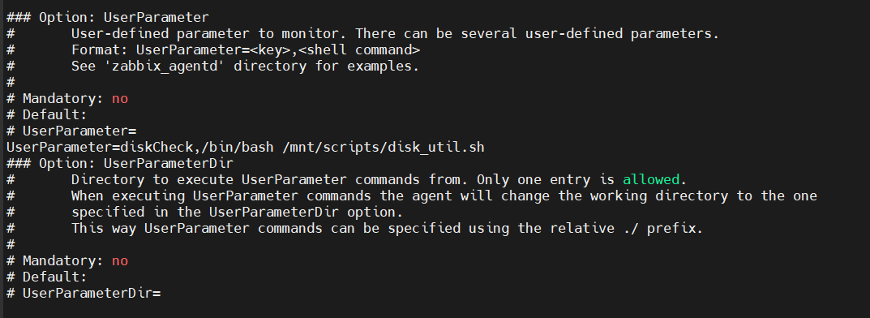

* + Restart the agent
    - systemctl restart Zabbix-agent
* Go to the Zabbix server and create an item

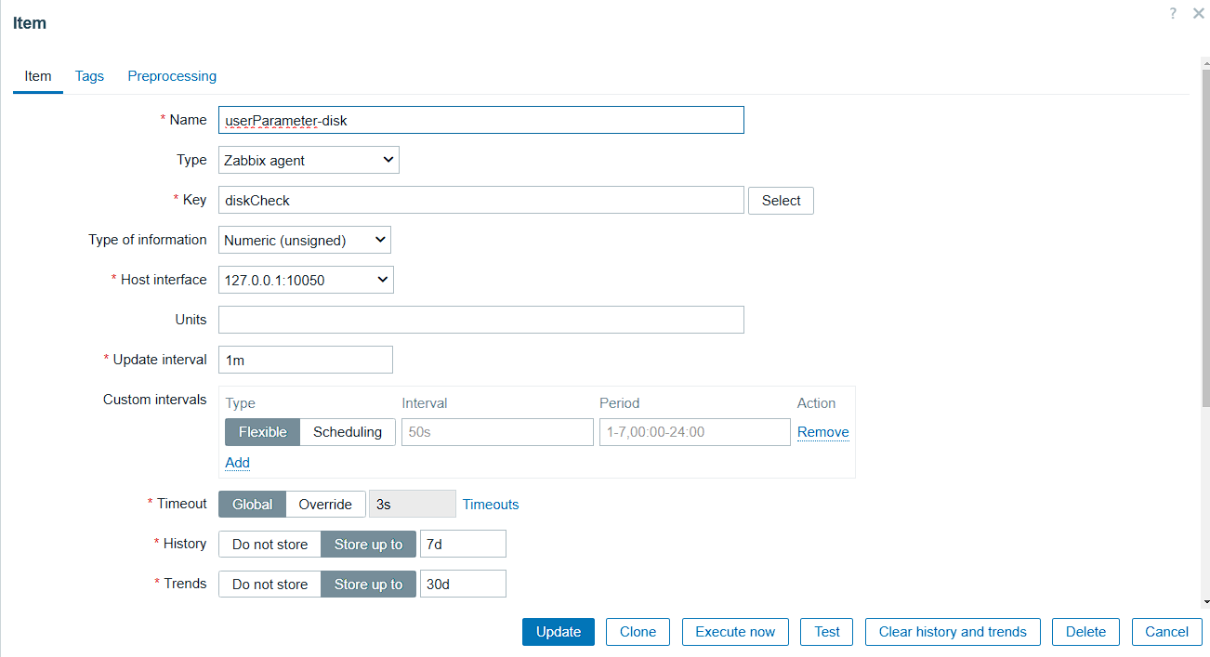

* You should be able to see in latest data the status and graphs

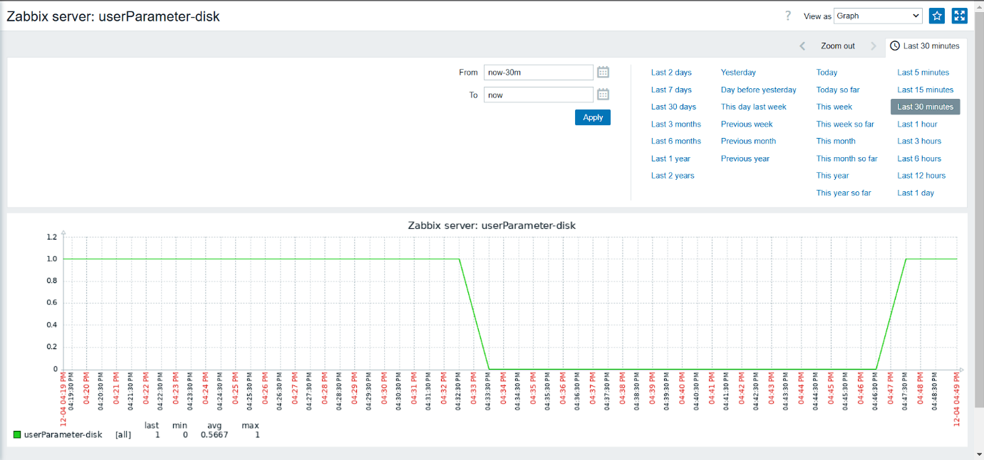

* Create Trigger

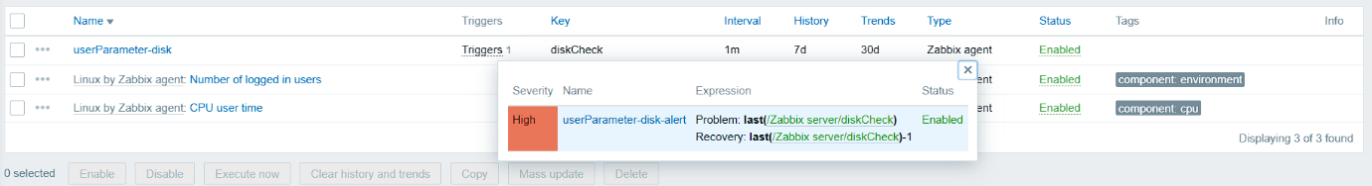

* Simulate high disk space

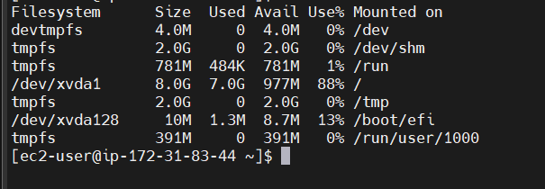

* It should trigger an alert

