Project Documentation
Calculating Family Expenses Using ServiceNow

1. INTRODUCTION

Project Overview
The Family Expense Management System is a centralized platform designed to simplify the process of tracking and analyzing household expenditures. Using ServiceNow, it enables families to record daily expenses, categorize them, generate summaries, and monitor budgets in real time.

Purpose
This project aims to replace manual tracking methods such as notebooks or spreadsheets with an automated system. It enhances transparency, provides real-time insights, and ensures that family members can collaboratively manage expenses for better financial decision-making.

2. IDEATION PHASE

Problem Statement
Families often face challenges in maintaining accurate expense records. Manual tracking leads to incomplete data, difficulty in consolidation, and lack of timely insights into overspending.

Empathy Map Canvas
- Who? Family members responsible for household finances.
- Think/Feel? Concerned about overspending, lack of clarity on where money goes.
- See? Scattered receipts, inconsistent tracking, no consolidated summary.
- Say/Do? “Where did our money go this month?” → rely on spreadsheets or paper notes.
- Hear? Complaints about high bills, difficulty managing budgets.
- Pain? No central system, no auto-summaries, manual errors.
- Gain? Organized digital expense log, real-time tracking, budget control.

Brainstorming
Options like Google Sheets or mobile apps were considered. ServiceNow was chosen because it provides structured workflows, automation, scalability, and easy integration with notifications and reporting.

3. REQUIREMENT ANALYSIS

Family Expense Journey Map
1. Family member logs in.
2. Submits daily expense (amount, date, details, member name).
3. System stores expense under the correct category.
4. Business Rule updates total expenses for the day.
5. Reports/summary available for analysis.

Solution Requirements
- Custom Catalog: Family Expenditure Services
- Categories: Daily Expenses, Monthly Expenses, Reports
- Custom Tables: u_family_expenses, u_daily_expenses
- Relationships: Link daily expenses to overall family expenses
- Workflows: Automatic updating of totals and details
- Notifications: Optional alerts for overspending or budget reminders

Data Flow Diagram

User → Service Portal → Form Submission → Workflow/Business Rule → Expense Tables
↓
Reports / Notifications → Family Members

Technology Stack
- Platform: ServiceNow
- Scripts: JavaScript (Glide APIs)
- Modules: Tables, Business Rules, Notifications, Relationships
- UI: Service Portal, Form Design

4. PROJECT DESIGN

Problem-Solution Fit
Manual expense tracking is error-prone and lacks automation. By implementing ServiceNow tables, business rules, and relationships, the system ensures accuracy, automation, and centralization.

Proposed Solution
- Catalog: Family Expenditure
- Tables: Family Expenses, Daily Expenses
- Relationships: Daily → Family Expenses
- Business Rules: Auto-update daily totals in Family Expenses
- Forms: User-friendly forms with mandatory fields and validations

Solution Architecture
- Frontend: Service Portal (expense submission forms)
- Logic Layer: Business Rules (auto-sum, validation)
- Backend: Custom tables (u_family_expenses, u_daily_expenses)
- Notifications: Email alerts (optional)
- Access Control: Roles for family members

5. PROJECT PLANNING & SCHEDULING
Key development steps:
1. Catalog Creation: Family Expenditure catalog.
2. Table Design: Family Expenses (summary), Daily Expenses (detailed).
3. Form Setup: Mandatory fields for date, amount, member name.
4. Auto-Numbering: Unique IDs for each record.
5. Relationships: Link daily records to overall family summary.
6. Business Rules: Auto-update total and details.
7. Portal Setup: User-friendly submission interface.
8. Testing: Check forms, rules, relationships.

6. IMPLEMENTATION WORKFLOW
This section explains in detail the process of setting up the Family Expense Management System in ServiceNow, from instance creation to configuring tables, forms, relationships, and automation rules.

Step 1: Setting Up ServiceNow Instance
1. Sign up for a developer account on the ServiceNow Developer site: https://developer.servicenow.com.
2. Log in and navigate to the Personal Developer Instance section.
3. Click Request Instance → fill required details → submit.
4. Once the instance is ready, credentials will be sent to your email.
5. Log in using the provided credentials.

Step 2: Create Update Set
- Navigate: All → Local Update Sets.
- Click New.
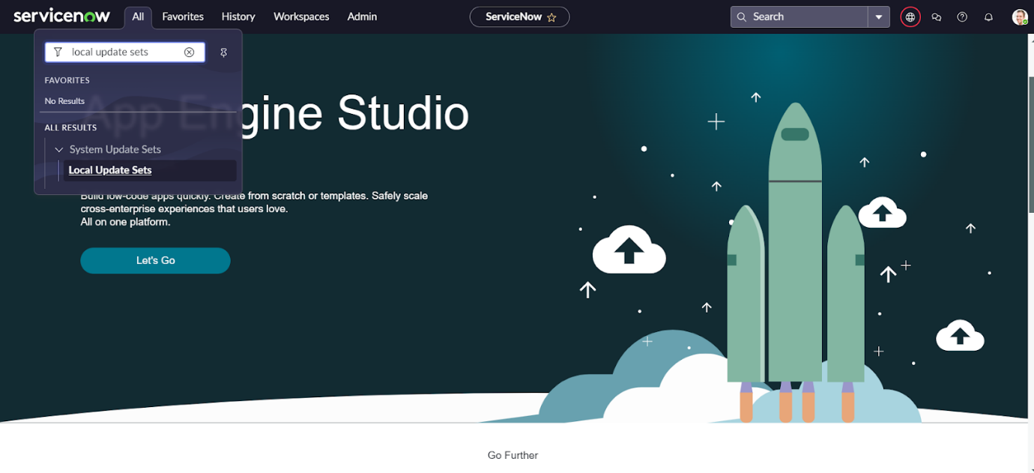
3. Enter details: Name: Family Expenses.
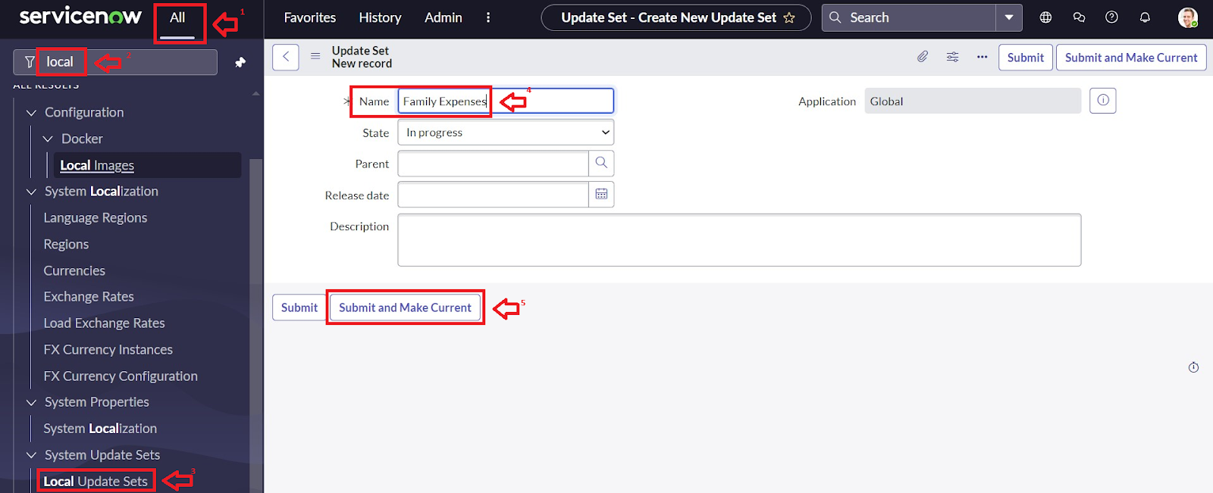
4. Submit and set it as Current.

Step 3: Create Family Expenses Table
- Navigate: All → Tables → New.
2. Enter details: Label: Family Expenses, Menu name: Family Expenditure.
3. Save the table.
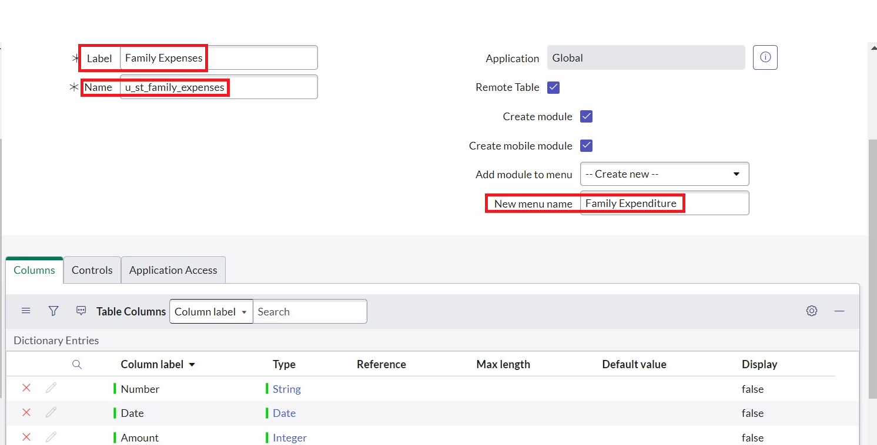
Add Columns (Fields):
- Number → String (set as Auto-number).
- Date → Date.
- Amount → Integer.
- Expense Details → String (Max length 800).
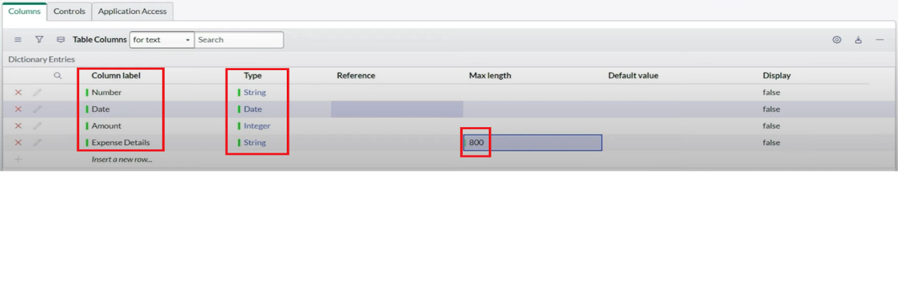
Configure Auto-Number for Number field:
1. Open the Number column → switch to Advanced view.
2. Select Dynamic default → Get Next Padded Number.
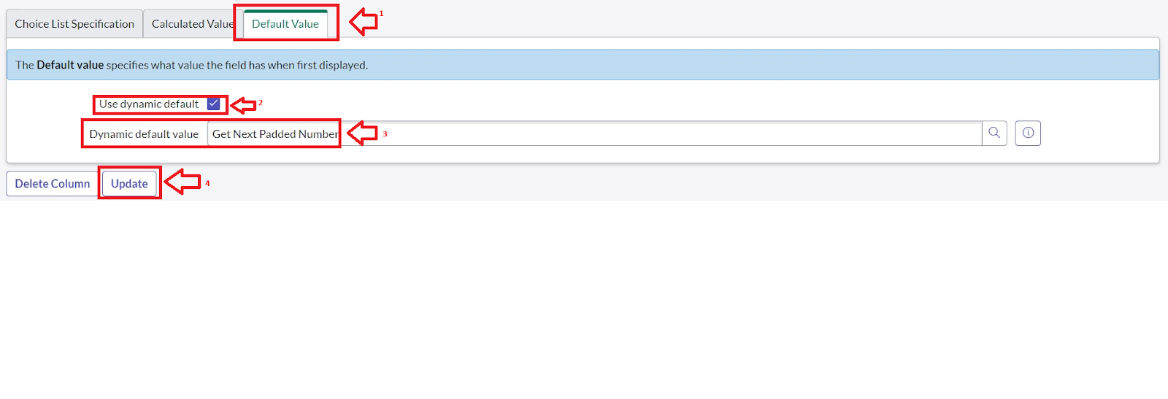
3. Navigate to All → Number Maintenance → New.
4. Configure: Table: Family Expenses, Prefix: MFE.
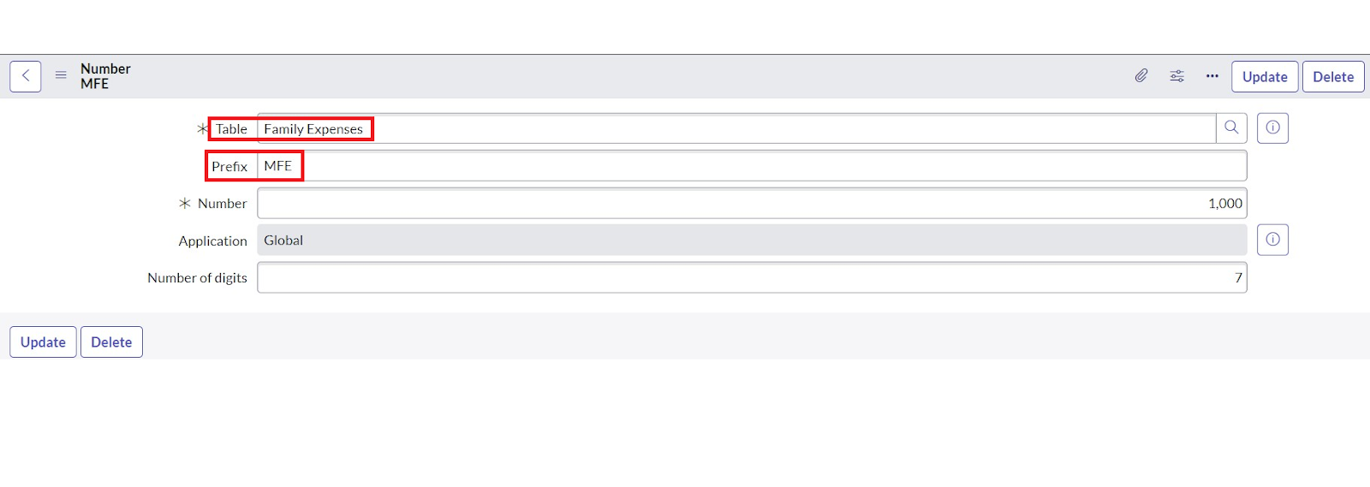
5. Submit.
Configure Form Layout:
1. Open Family Expenses table → click New.
2. Right-click header → Configure → Form Design.
3. Drag/drop fields as required.
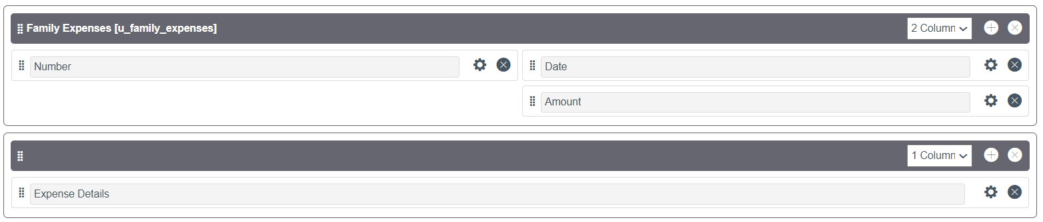
4. Set Number: Read-only; Date, Amount: Mandatory.
5. Save.

Step 4: Create Daily Expenses Table
- Navigate: All → Tables → New.
- Enter details: Label: Daily Expenses, Menu: Family Expenditure.
- Save the table.
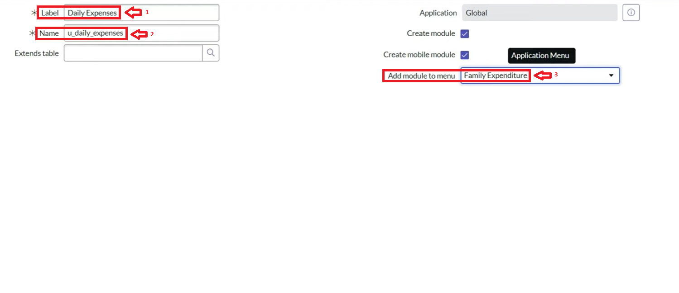

Add Columns (Fields):
- Number → String (Auto-number).
- Date → Date.
- Expense → Integer.
- Family Member Name → Reference.
- Comments → String (Max length 800).
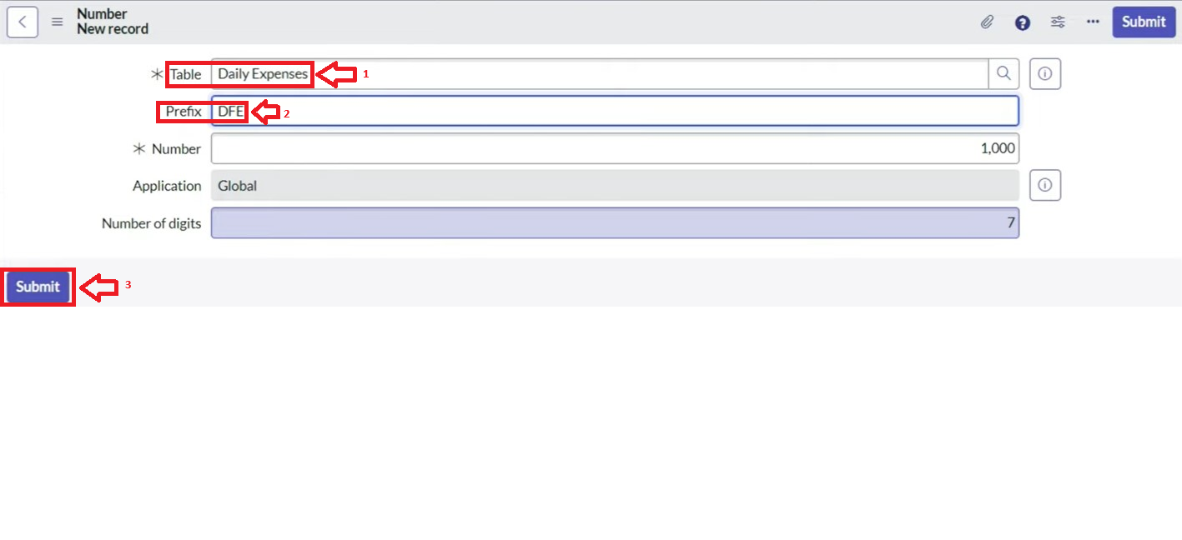
Configure Auto-Number for Number field (same as Family Expenses).
Configure Form Layout:
- Number: Read-only.
- Date, Family Member Name: Mandatory.
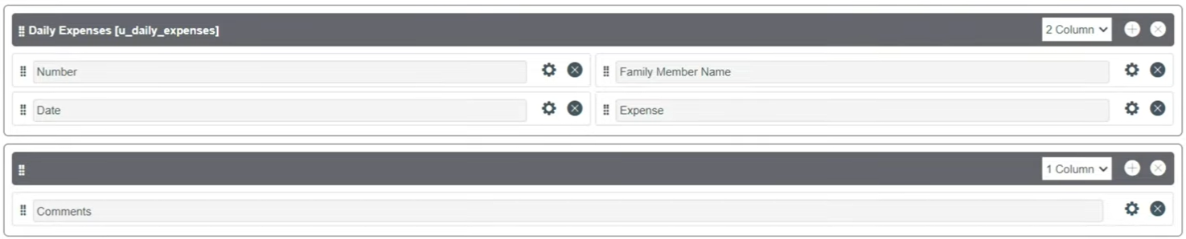

Step 5: Create Relationship Between Tables
1. Navigate: All → Relationships → New.
2. Configure: Name: Daily Expenses, Applies to Table: Family Expenses, Child Table: Daily Expenses.
3. Save.

Step 6: Configure Related List
- Open Family Expenses table → click New.
2. Right-click header → Configure → Related Lists.
3. Add Daily Expenses to the related list.
4. Save.
- 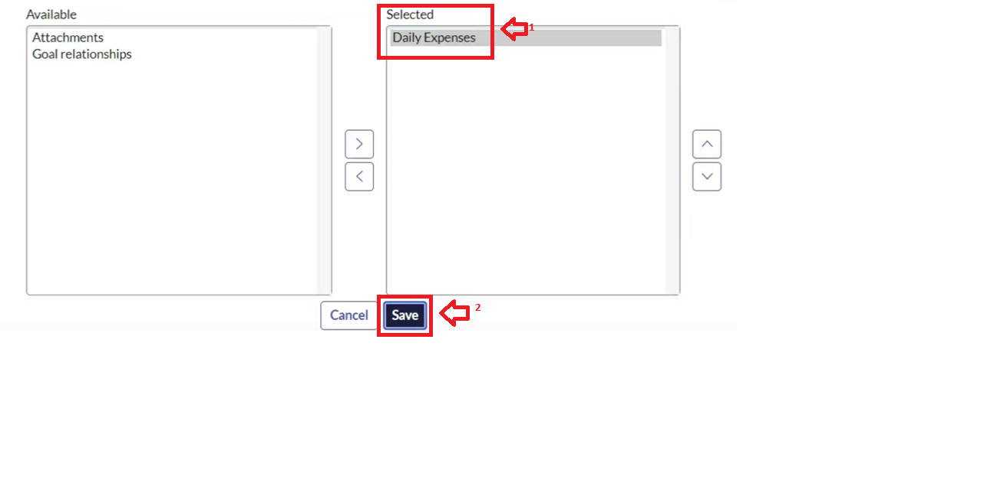

Step 7: Create Business Rule
- Navigate: All → System Definition → Business Rules → New.
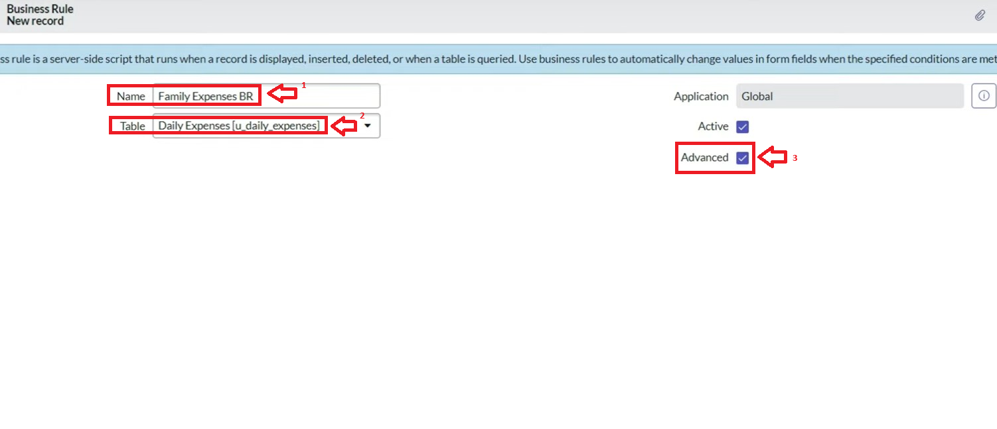
2. Configure: Name: Family Expenses BR, Table: Daily Expenses, When to run: Insert & Update, Check Advanced.
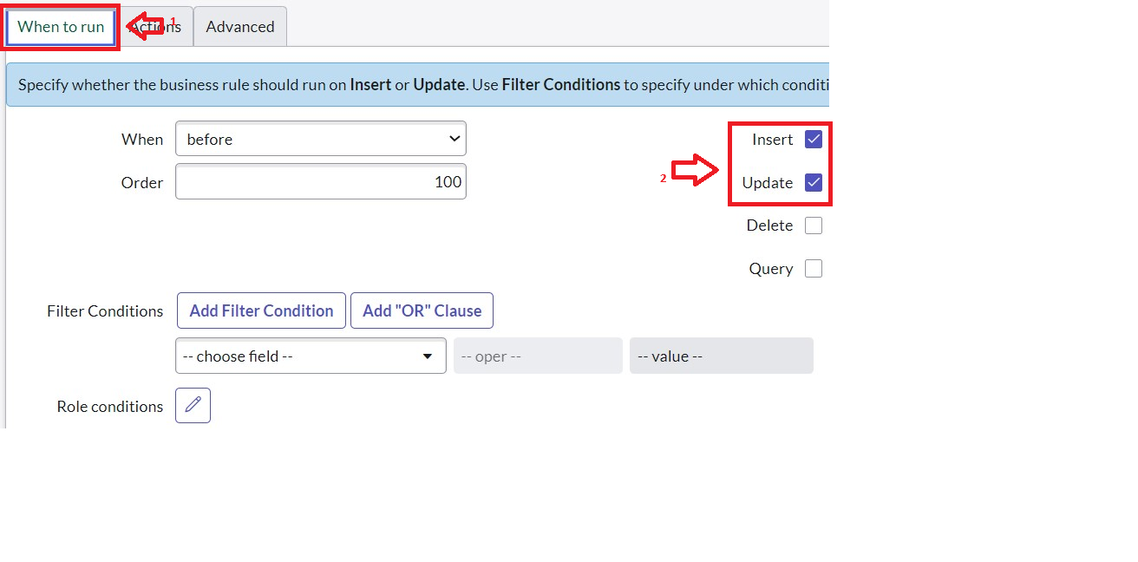

3. Add script:
function executeRule(current, previous /*null when async*/) {
var FamilyExpenses = new GlideRecord('u_family_expenses');
FamilyExpenses.addQuery('u_date', current.u_date);
FamilyExpenses.query();
if (FamilyExpenses.next()) {
FamilyExpenses.u_amount += current.u_expense;
FamilyExpenses.u_expense_details += " > " + current.u_comments + ": Rs." + current.u_expense + "/-";
FamilyExpenses.update();
} else {
var NewFamilyExpenses = new GlideRecord('u_family_expenses');
NewFamilyExpenses.u_date = current.u_date;
NewFamilyExpenses.u_amount = current.u_expense;
NewFamilyExpenses.u_expense_details = " > " + current.u_comments + ": Rs." + current.u_expense + "/-";
NewFamilyExpenses.insert();
}
})(current, previous);
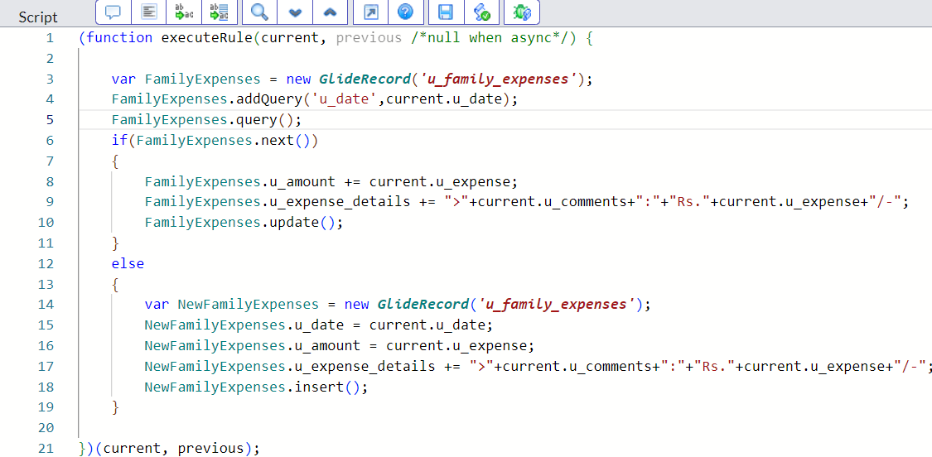

Step 8: Refine Relationship with Query
1. Navigate: All → Relationships → open Daily Expenses Relationship.
2. For Applies to table: Select Family Expenses.
3. In Query with, insert:
(function refineQuery(current, parent) {
current.addQuery('u_date', parent.u_date);
current.query();
})(current, parent);
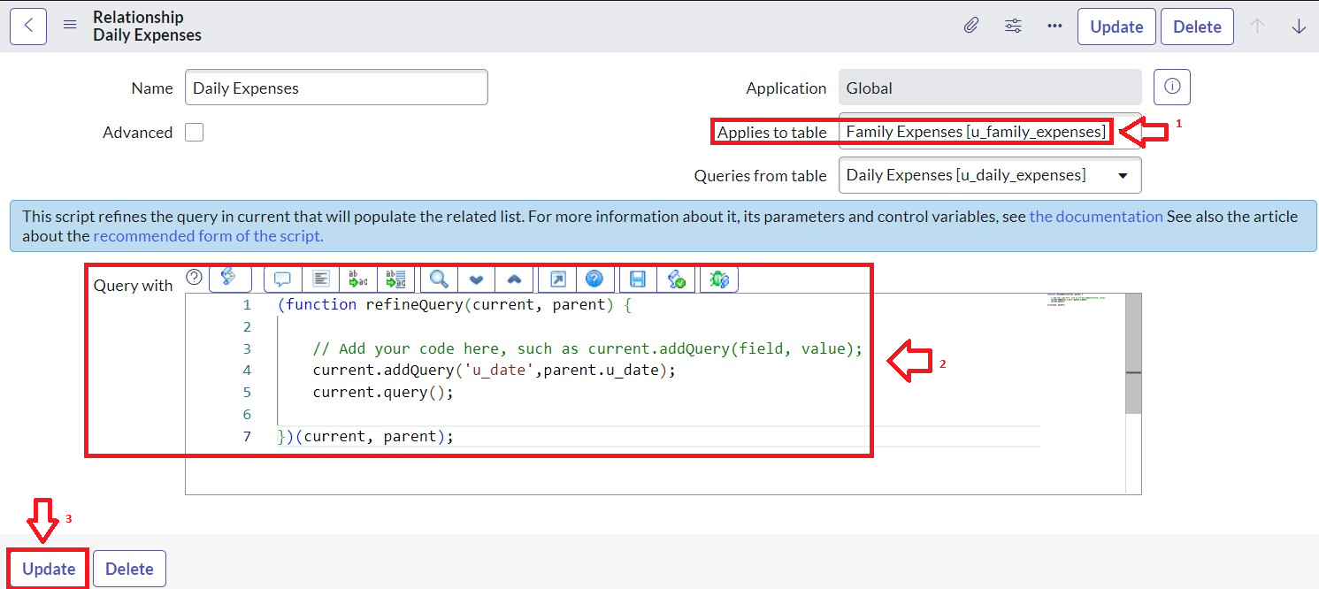

7. FUNCTIONAL AND PERFORMANCE TESTING
- Form Accuracy: Validates required fields.
- Business Rule Execution: Totals update correctly on new entries.
- Relationship Validation: Daily → Family Expenses linking works.
- Data Consistency: No duplicate or missing values.
- Performance: Quick updates, no delays in large datasets.

8. ADVANTAGES / DISADVANTAGES

Advantages
- Centralized expense management.
- Real-time daily-to-monthly tracking.
- Reduces manual errors.
- Scalable to add more categories (bills, savings, etc.).

Limitations
- Requires ServiceNow expertise for setup.
- Initial configuration can be time-consuming.
- Limited offline usage without ServiceNow access.

9. CONCLUSION
The Family Expense Management System built on ServiceNow provides an efficient and automated solution for tracking daily and monthly expenses. It eliminates manual tracking errors, enables transparency, and empowers families to monitor and manage finances collaboratively.

10. FUTURE SCOPE
- Budget Alerts: Notify when expenses exceed a set budget.
- Analytics Dashboard: Charts for expense distribution.
- Integration with Payment Systems: Auto-record online transactions.
- Mobile App Access: Simplify entry for all family members.
- Savings Tracker: Track surplus/deficit for financial planning.

