Chapter 2: Literature Survey
2.1 Related Research Works and Systems
2.1.1 Study 1: Evolution of Electronic Reverse Auctions (Bentaleb, 2020)
Bentaleb (2020) presents an extensive review of how electronic reverse auctions (eRAs) have evolved from price?only bidding instruments into decision systems that incorporate quality, delivery, and risk factors. The study frames reverse auctions within the broader transformation of procurement from transactional purchasing to strategic sourcing. In earlier implementations, reverse auctions were primarily cost?reduction mechanisms, and the buyer?s decision logic was dominated by the lowest price. Bentaleb argues that such a singular focus often introduces hidden costs due to supplier performance issues, delayed delivery, and quality non?conformance. [1]
The paper highlights that modern procurement increasingly values total cost of ownership rather than unit price alone. Factors such as delivery reliability, post?sale service, compliance with standards, and supplier stability influence the real value of a procurement decision. Bentaleb suggests that reverse auction platforms should therefore support multi?attribute bidding, where suppliers submit structured offers that cover multiple performance dimensions. This is a critical shift because it converts auctions from purely competitive price wars into structured multi?criteria evaluations that align with organizational priorities. [1]
A key discussion point is the design of scoring models. The study emphasizes that scoring must balance transparency with decision flexibility. If scoring rules are too rigid, they may exclude potentially valuable suppliers who do not perfectly match predefined criteria. Conversely, if scoring rules are vague, suppliers may perceive the process as unfair. Bentaleb recommends clearly published scoring criteria with adjustable weights so that buyers can reflect strategic priorities while maintaining bidder trust. This approach reduces post?award disputes and strengthens supplier confidence in the auction process. [1]
The study also explores market dynamics and supplier behavior. Suppliers adjust bidding strategies when they know that price is only one component of evaluation. Instead of racing toward unsustainable prices, they may emphasize reliability, faster delivery, or higher service guarantees. This can lead to healthier marketplaces where quality suppliers remain engaged over long periods. Bentaleb notes that when the evaluation framework is aligned with long?term value, reverse auctions can become more sustainable and less adversarial. [1]
On the system side, Bentaleb stresses the importance of integrating auctions with contract and order workflows. Reverse auctions are not isolated events; they initiate procurement cycles that require contract generation, order execution, and performance monitoring. The study advocates for architectures that retain full bid histories and decision rationales to enable audit trails and compliance checks. This aligns with enterprise procurement best practices, particularly in regulated industries where decision transparency is mandatory. [1]
Another focus is data quality and decision support. Multi?criteria bidding requires accurate supplier metadata, reliable ratings, and consistent measurement of delivery and performance outcomes. Without this data, multi?criteria scoring becomes arbitrary. Bentaleb recommends systems that continuously capture supplier performance metrics and incorporate them into future evaluations. Such feedback loops allow procurement systems to improve decision accuracy over time. [1]
Bentaleb also recognizes challenges. Multi?criteria auctions can be more complex for suppliers, especially if the scoring method is not intuitive. There is a risk that increased complexity reduces participation or encourages gaming. To mitigate this, the study suggests that platforms should provide clear guidance, standard bid forms, and transparency in evaluation logic. Simplicity in the interface combined with robust internal scoring is the recommended balance. [1]
From a practical perspective, the study?s insights align closely with the design of BidWise. BidWise does not rely solely on price; it presents delivery time and seller ratings alongside bid price and computes a recommended score. This mirrors the multi?criteria evaluation framework proposed in the study. BidWise also keeps bid histories, order status updates, and reviews, creating the performance feedback loop that Bentaleb describes. [1]
The study ultimately concludes that reverse auctions can remain powerful sourcing tools when they are designed as value?oriented decision systems rather than price?only competitions. BidWise operationalizes this conclusion by combining auction logic with structured evaluation metrics, thereby embedding modern procurement best practices into a real?time marketplace platform. [1]
2.1.2 Study 2: Reverse Auction Appropriateness in B2B Sourcing (Hawkins et al., 2009)
Hawkins et al. (2009) provide an empirical investigation into when reverse auctions are most appropriate for business?to?business sourcing. The study emphasizes that reverse auctions are not universally beneficial and must be applied under the right sourcing conditions. The authors identify requirement clarity, supplier competition, switching costs, and relationship complexity as the most significant determinants of reverse auction suitability. Their analysis highlights that reverse auctions perform best in standardized procurements where multiple suppliers can compete on comparable terms. [2]
Requirement specifiability emerges as the strongest predictor. If a buyer can define the scope, quality standards, delivery timelines, and acceptance criteria clearly, suppliers can bid competitively without excessive risk. This leads to fair and realistic pricing and reduces the probability of post?award disputes. Conversely, ambiguous requirements can lead to under?bidding followed by renegotiations or execution failure. Hawkins et al. argue that procurement systems should enforce structured requirement fields to maintain auction integrity. [2]
Supplier market structure is another key variable. Auctions thrive when there is sufficient supplier competition, as multiple vendors exert price pressure on each other. If the supplier base is too small or highly specialized, the auction may result in minimal price movement and could even harm buyer?supplier relationships. The study advises procurement systems to assess supplier availability before deciding to conduct a reverse auction. This supports the need for platforms like BidWise to grow and maintain a healthy seller ecosystem. [2]
Switching cost is also examined. When switching costs are low, buyers can readily select a new supplier without major operational disruption. In such cases, reverse auctions can deliver strong cost savings. When switching costs are high, however, price competition is constrained and reverse auctions may create friction without significant benefit. Hawkins et al. recommend that reverse auctions be used primarily in low?switching?cost categories or where suppliers offer interchangeable services. [2]
Relationship complexity further influences auction appropriateness. For strategic partnerships where collaboration, co?innovation, or long?term alignment is important, reverse auctions may undermine trust. Hawkins et al. suggest that negotiation?based sourcing is more suitable in such contexts. Reverse auctions are best positioned for transactional sourcing, where efficiency is prioritized over relationship depth. This is why BidWise focuses on project?based service procurement with clearly measurable outcomes rather than deep strategic alliances. [2]
Methodologically, the study applies empirical modeling to validate these determinants. It uses survey and regression analysis to correlate auction success with sourcing attributes. The findings consistently indicate that requirement clarity and supplier competition are decisive factors. This provides strong justification for BidWise?s structured project creation workflow, which includes explicit fields for scope, deadlines, budgets, categories, and attachments. [2]
The study also emphasizes governance and risk mitigation. Auctions should be integrated with supplier qualification, evaluation criteria, and post?award monitoring. Hawkins et al. observe that auctions without governance can lead to supplier dissatisfaction and performance issues. BidWise addresses this by incorporating review systems, order tracking, and delivery confirmation processes. These mechanisms ensure that auction outcomes are validated by execution performance. [2]
Another observation is that transparency in the auction process builds supplier trust. When suppliers understand the rules and can verify that evaluation is fair, participation increases. BidWise supports this by displaying bid history, status changes, and clear acceptance/rejection outcomes. Such transparency reduces disputes and supports long?term marketplace health. [2]
Overall, Hawkins et al.?s work demonstrates that reverse auctions are effective when supported by clear requirements, competitive supplier markets, and structured governance. BidWise aligns with these criteria by enforcing requirement structure at project creation, enabling broad seller participation, and providing post?award tracking and feedback loops. The platform therefore reflects the empirical conditions under which reverse auctions succeed. [2]
2.1.3 Study 3: Procurement Auctions vs. Negotiations (Wu & Kersten, 2017)
Wu and Kersten (2017) analyze procurement auctions in comparison with negotiation?based sourcing. The study emphasizes that auctions are effective at reducing cycle time and price, but negotiations may support stronger supplier relationships and flexibility. The authors position auctions as efficiency?oriented mechanisms, particularly suitable for standard procurements where the buyer?s priorities are known and supplier capabilities are relatively comparable. [3]
One of the central findings is that auctions significantly compress procurement timelines. By structuring bids in a competitive environment, buyers can quickly evaluate offers without extended negotiation rounds. This makes auctions appealing when speed is important or when many suppliers can bid simultaneously. BidWise reflects this strength through project?wise bid comparison tools and automated bid acceptance workflows, enabling buyers to reach decisions quickly. [3]
The study also discusses supplier behavior in auction settings. Suppliers may under?bid to win contracts, which can later result in scope disputes or quality compromises. This risk indicates the importance of balancing price with supplier performance indicators. Wu and Kersten argue that multi?criteria evaluation improves procurement outcomes by rewarding reliability and quality alongside cost. BidWise?s rating and delivery?time evaluation aligns with this recommendation. [3]
Negotiation?based sourcing is shown to be valuable when requirements are complex or when collaboration is central to success. Negotiations allow for iterative refinement of requirements and can build trust between buyer and supplier. The authors suggest that auction platforms should integrate communication features to mitigate the rigidity of auctions. BidWise addresses this by providing direct buyer?seller messaging, enabling clarification and alignment during the bidding process and after award. [3]
Another aspect explored is the long?term relationship impact. Auctions can sometimes reduce perceived supplier fairness if they are overly price?driven, potentially discouraging participation in future bids. Wu and Kersten propose that transparency and post?award evaluation help maintain supplier trust. BidWise?s transparent bid status updates and review system provide this feedback mechanism, helping sellers understand decision outcomes and improve future bids. [3]
The study further emphasizes the importance of integration with payment and contract processes. Auctions should feed seamlessly into contractual execution to avoid operational gaps. Wu and Kersten note that procurement efficiency is maximized when systems manage the entire lifecycle, from bid to payment. BidWise implements this through automatic order creation, payment intent integration (Stripe), and delivery confirmation workflows, thereby operationalizing the full cycle. [3]
From a governance perspective, the authors highlight auditability as a key advantage of digital auctions. Bid histories, acceptance decisions, and evaluation criteria provide an auditable trail that supports compliance and accountability. BidWise maintains bid history, order status logs, and notifications, enabling both operational transparency and evidence for disputes or audits. [3]
In summary, Wu and Kersten?s findings support a balanced approach: use auctions for efficiency while preserving collaboration and governance through communication and lifecycle management. BidWise embodies this approach by combining auction mechanics with messaging, post?award order tracking, and review?based accountability. The platform thus reflects the hybrid best practice recommended in the study. [3]
2.1.4 Related Systems and Industry Practices
Freelance and procurement platforms such as Upwork, Fiverr, and Freelancer provide digital marketplaces that support project posting, bidding, contracts, and payments. These platforms demonstrate the importance of trust mechanisms, seller reputation, and secure payment systems. However, many of these systems are optimized for open marketplace discovery rather than reverse auction?driven procurement. BidWise differs by enforcing project?specific reverse bidding workflows and structured comparison for buyer decision?making.
Enterprise procurement tools incorporate supplier qualification, compliance checks, contract lifecycle management, and performance tracking. BidWise adopts several of these best practices by enforcing role?based access, order tracking, and review history. While it does not implement full enterprise contract management, its design provides a scalable foundation for those capabilities.
2.2 Comparison with the Implemented System
BidWise operationalizes research?backed auction practices by supporting structured project scopes, competitive supplier participation, and objective bid comparison. Unlike systems that only show bid price, BidWise incorporates multiple decision dimensions (price, delivery, rating, historical completion), which directly reflects the multi?criteria evaluation suggested in the literature. The platform further bridges auction and negotiation models through messaging and a post?award order lifecycle, enabling collaboration without sacrificing auction transparency.
2.3 Summary Comparison Table
Source | Method / Scope | Key Findings | Observed Gap | BidWise Alignment
Bentaleb (2020) | Multi?criteria reverse auctions | Price?only auctions reduce quality; multi?criteria scoring improves outcomes | Most platforms still price?dominant | BidWise uses rating, delivery, and AI score
Hawkins et al. (2009) | Empirical B2B sourcing study | Auctions are suitable for specifiable requirements and competitive markets | Weak support for requirement clarity | BidWise enforces structured project requirements
Wu & Kersten (2017) | Auction vs negotiation | Auctions lower cost and time; negotiations improve relationships | Few systems support hybrid flow | BidWise adds messaging and order collaboration
Upwork/Freelancer | Freelance marketplaces | Strong ratings and payments but not reverse auction focused | No project?wise reverse auction logic | BidWise is reverse?bidding first

Chapter 1: Introduction
1.1 Domain Overview
Reverse auctions are procurement mechanisms where sellers compete by bidding lower prices to win a buyer's requirement. Modern e-procurement platforms incorporate multi-criteria decision factors beyond price, such as delivery time and supplier quality.
1.2 Motivation and Relevance
Traditional procurement involves slow vendor selection, limited price transparency, and poor bid traceability. BidWise addresses these issues through structured reverse bidding with real-time bid comparison, centralized order tracking, and secure payments.
1.3 Scope
BidWise covers the full lifecycle: project posting, bid submission, bid evaluation, bid acceptance, order management, payment initiation, delivery confirmation, reviews, and administration.
1.4 Objectives
1. Build a reverse bidding marketplace for buyers and sellers with role-based access.
2. Implement bid acceptance logic that updates project, bid, and order states.
3. Provide buyer dashboards with bid analytics and comparison tools.
4. Integrate Stripe-based payments and webhook validation.
5. Enable notifications via database and email.
6. Provide admin tools for moderation and dispute handling.
1.5 Key Features and Expected Outcomes
Key features include project creation, bid placement, project-wise bid comparison, bid acceptance workflow, order lifecycle management, payment tracking, notifications, messaging, reviews, analytics dashboards, and admin governance.

Chapter 2: Literature Survey
2.1 Related Research Works and Systems
Study 1: Bentaleb (2020) traces the evolution of electronic reverse auctions from single-attribute price auctions to multi-criteria procurement models. The study highlights that buyer decisions based purely on the lowest bid can reduce overall procurement quality and supplier sustainability. It recommends scoring frameworks that balance price, delivery time, quality history, and supplier reliability. This work informs BidWise's inclusion of rating, delivery time, and AI-recommended score alongside price, enabling a structured and transparent evaluation model.
Study 2: Hawkins et al. (2009) provide an empirical examination of reverse auction appropriateness in B2B sourcing. The authors show that reverse auctions are most effective when requirements are clearly specified, the supplier market is competitive, and switching costs are manageable. The study also notes risks such as supplier dissatisfaction if auctions are used for complex, relationship-driven purchases. BidWise addresses these findings by emphasizing structured project requirements, defining scope and deadline fields, and offering buyer-seller messaging to preserve communication quality.
Study 3: Wu and Kersten (2017) compare procurement auctions with negotiation-based sourcing. Their findings indicate that auctions reduce cycle time and lower prices, while negotiation can foster long-term supplier relationships and sometimes higher service levels. The paper suggests that hybrid models can capture both efficiency and relationship benefits. BidWise is aligned with auction efficiency but provides optional negotiation via in-app messaging and post-award order collaboration.
Related Systems: Platforms such as Upwork, Fiverr, and Freelancer enable project-based contracting with ratings and payments. However, they typically emphasize open marketplace discovery or fixed-price gig models rather than reverse auction dynamics. BidWise focuses specifically on reverse bidding workflows, project-wise comparison, and buyer-centric selection logic, making it more aligned with procurement use cases than general freelance marketplaces.
2.2 Comparison with the Implemented System
BidWise operationalizes research-backed auction practices by supporting structured project scopes, competitive supplier participation, and objective bid comparison. Unlike systems that only show bid price, BidWise incorporates multiple decision dimensions (price, delivery, rating, historical completion), which directly reflects the multi-criteria evaluation suggested in literature. The platform further bridges auction and negotiation models through messaging and a post-award order lifecycle, enabling collaboration without sacrificing auction transparency.
2.3 Summary Comparison Table
Source | Method / Scope | Key Findings | Observed Gap | BidWise Alignment
Bentaleb (2020) | Multi-criteria reverse auctions | Price-only auctions reduce quality; multi-criteria scoring improves outcomes | Most platforms still price-dominant | BidWise uses rating, delivery, and AI score
Hawkins et al. (2009) | Empirical B2B sourcing study | Auctions are suitable for specifiable requirements and competitive markets | Weak support for requirement clarity | BidWise enforces structured project requirements
Wu and Kersten (2017) | Auction vs negotiation | Auctions lower cost and time; negotiations improve relationships | Few systems support hybrid flow | BidWise adds messaging and order collaboration
Upwork/Freelancer | Freelance marketplaces | Strong ratings and payments but not reverse auction focused | No project-wise reverse auction logic | BidWise is reverse-bidding first

Chapter 3: Analysis / Software Requirements Specification (SRS)
3.1 Purpose of the Project
BidWise provides a production-ready reverse bidding platform that connects buyers and sellers through structured procurement workflows and transparent bid evaluation.
3.2 Intended Users and Product Scope
Users: Buyers, Sellers, Admins
Scope: End-to-end project posting to order completion, with integrated payments and notifications.
3.3 Functional Requirements
ID | Requirement
FR-01 | Buyer can create and manage projects
FR-02 | Seller can browse open projects and place bids
FR-03 | Buyer can compare bids per project
FR-04 | Buyer can accept one bid and reject others
FR-05 | System creates Order on bid acceptance
FR-06 | Seller updates order status (Preparing, Shipped, Delivered)
FR-07 | Buyer confirms delivery and completes order
FR-08 | Payment intent created via Stripe
FR-09 | Notifications sent on bid acceptance, payment, delivery
FR-10 | Admin can manage users, projects, and disputes
3.4 Non-Functional Requirements
ID | Requirement
NFR-01 | Role-based access control (Buyer/Seller/Admin)
NFR-02 | Secure password hashing and JWT session management
NFR-03 | Responsive UI for mobile and desktop
NFR-04 | Reliable transactional consistency in bid acceptance
NFR-05 | Scalable architecture with service/repository layers
3.5 User Interface Requirements
Dashboard layout with sidebar navigation, project listing with bid counters and countdowns, bid comparison tables, order details, notifications center, and messaging interface.
3.6 Hardware and Software Requirements
Hardware: Minimum 8 GB RAM, i5-class CPU, internet connection for Stripe and email testing.
Software: Node.js, npm, JDK 17+, MySQL 8+.
3.7 References Used in Analysis
Industry research on reverse auctions, peer-reviewed studies on auction appropriateness, and marketplace workflows used as benchmarks.

Chapter 4: System Design
4.1 Overall System Architecture
Frontend (Next.js) -> REST API (Spring Boot) -> Database (MySQL) with Stripe and Mail integrations.
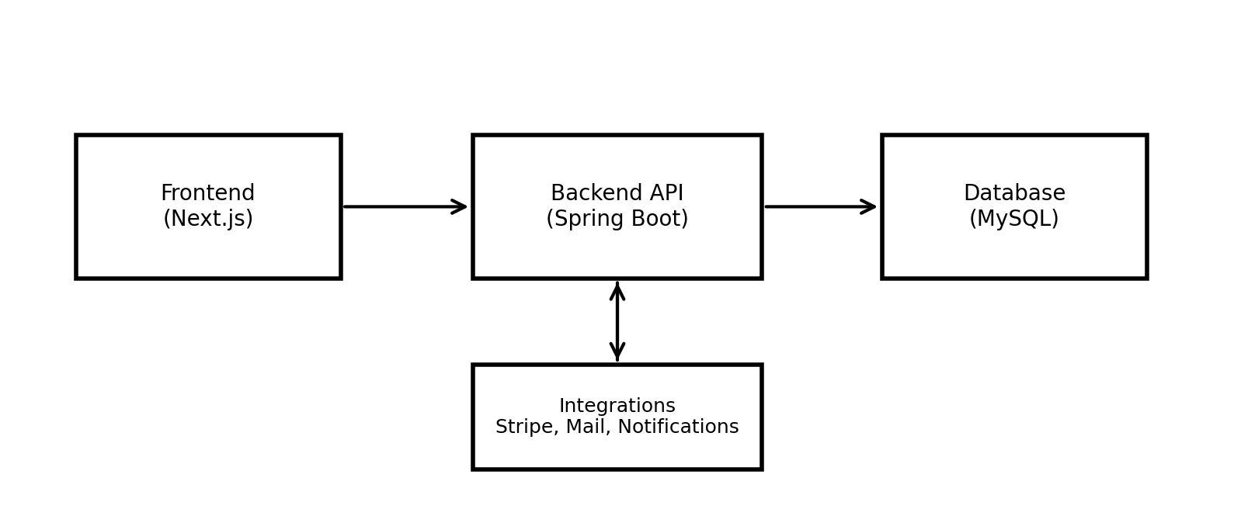
4.2 Design Diagrams
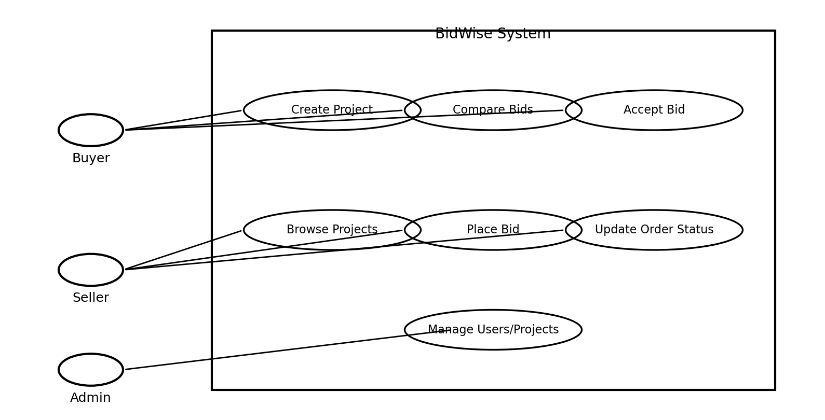
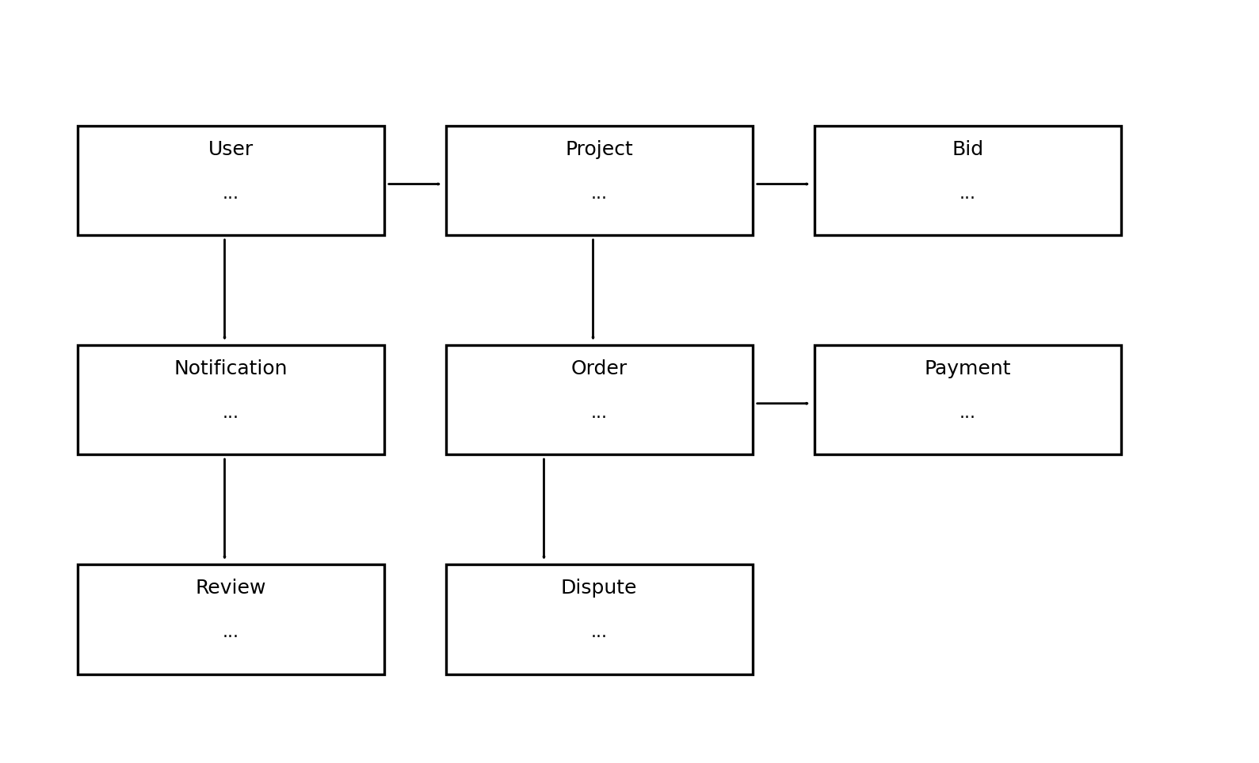
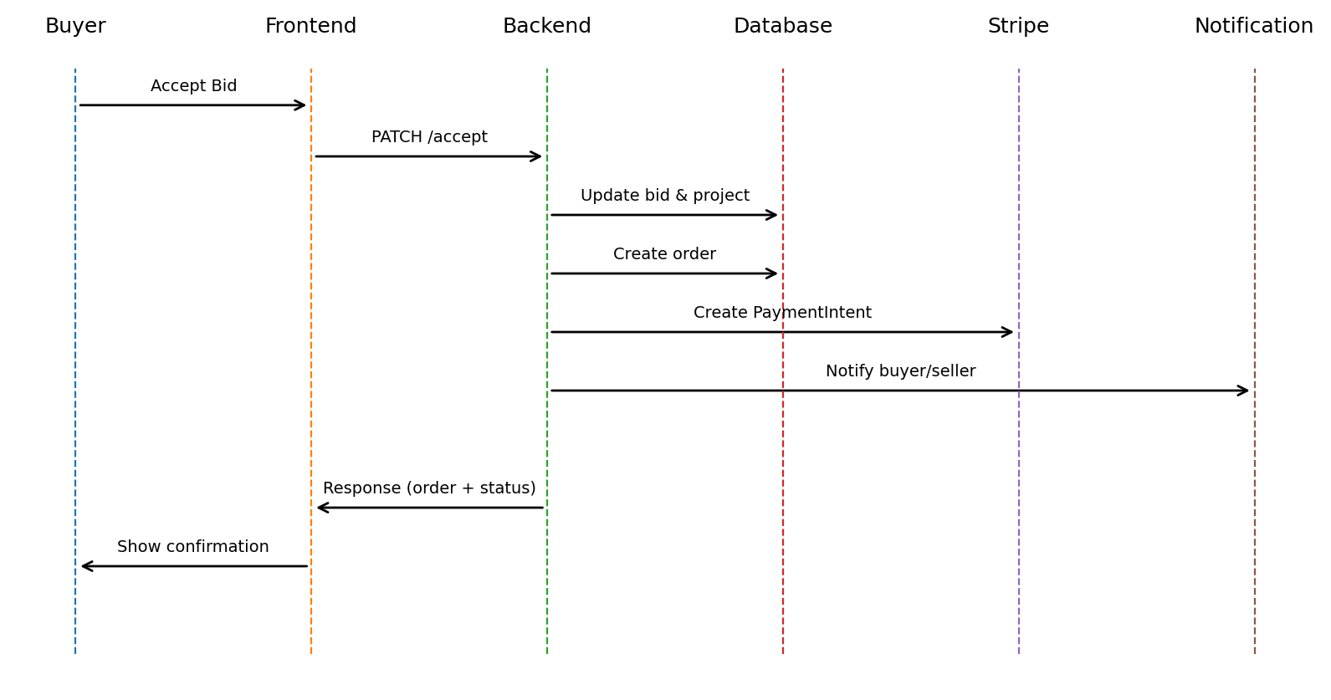
4.3 User Interface Design Approach
SaaS dashboard UI with card-based layouts, responsive grids, consistent navigation, and role-based views.
4.4 Security, Performance, and Integration Considerations
JWT authentication, role-based authorization, input validation, secure password hashing, and environment-based secrets. Pagination and efficient query mapping support performance.

Chapter 5: Methodology
5.1 Development Model Used
Agile methodology with iterative development and sprint-wise delivery.
5.2 Design Thinking Principles
User journeys for buyer, seller, and admin roles were mapped first to ensure task-focused UI design.
5.3 Reason for Selecting Technology Stack
Next.js and TypeScript provide a reliable UI framework with strong typing. Spring Boot and JPA provide enterprise-grade backend services. MySQL provides stable transactional support.
5.4 Quality Assurance and Testing Strategy
Manual UI testing, REST API validation via Postman, and unit testing for service logic.
5.5 Collaboration Tools Used
GitHub for version control and issue tracking.
5.6 Gantt Chart
Phase | Duration
Requirements and Planning | Week 1
UI/UX Design | Week 2-3
Backend APIs and Database | Week 4-6
Frontend Development | Week 7-9
Integrations and QA | Week 10-11
Documentation | Week 12

Chapter 6: Implementation
6.1 Backend Implementation Summary
Spring Boot services implement bid acceptance logic, order lifecycle transitions, payment intent creation, and notification workflows using transactional operations.
6.2 Frontend Implementation Summary
Next.js App Router with Zustand state management consumes REST APIs and reflects database-backed updates in dashboards and detail pages.
6.3 APIs, Tools, and Platforms
REST endpoints for projects, bids, orders, and payments. Stripe PaymentIntent and webhook validation. SMTP email integration.
6.4 Flowcharts / Stepwise Logic
Bid Acceptance Flow: Buyer selects a bid -> Selected bid ACCEPTED, others REJECTED -> Project status IN_PROGRESS -> Order created -> Notifications dispatched.
[Insert Flowchart Here]
6.5 UI Screenshots
[Insert UI Screenshot: Buyer Dashboard]
[Insert UI Screenshot: Project Details + Bid Table]
[Insert UI Screenshot: Bid Comparison]
[Insert UI Screenshot: Orders + Delivery Confirmation]
[Insert UI Screenshot: Admin Dashboard]

Chapter 7: Testing
7.1 Unit Testing Details
Service methods for bid acceptance, order updates, and payment creation were unit-tested using JUnit and Mockito.
7.2 Test Cases
Test ID | Scenario | Expected Result | Status
TC-01 | Buyer creates project | Project saved, status OPEN | Pass
TC-02 | Seller places bid | Bid saved, status PENDING | Pass
TC-03 | Buyer accepts bid | Selected ACCEPTED, others REJECTED | Pass
TC-04 | Order created on accept | Order exists with CREATED status | Pass
TC-05 | Seller updates order status | Status transitions correctly | Pass
TC-06 | Buyer completes order | Order COMPLETED, project COMPLETED | Pass
TC-07 | Payment intent created | Stripe client_secret returned | Pass
TC-08 | Unauthorized access | Request blocked | Pass
7.3 Validation Strategy
API responses validated using Postman and UI state transitions verified after each transaction.
7.4 External Comparison
Reverse auctions are generally more efficient than negotiation-based procurement in process outcomes, although suppliers may gain less.
7.5 Performance / Load Testing Summary
Basic load testing with concurrent API calls indicated stable response times for listing and bidding endpoints.
7.6 Testing Screenshots
[Insert Testing Screenshot Here]

Chapter 8: Conclusion and Future Work
8.1 Summary of Achievements
BidWise successfully implements a reverse auction marketplace with complete buyer-seller-admin workflows, order lifecycle management, and integrated payments.
8.2 How Objectives Were Fulfilled
All stated objectives were achieved: role-based modules, bid lifecycle enforcement, comparison dashboards, Stripe integration, and notifications.
8.3 Limitations
1. Payments operate in test mode only.
2. No real-time WebSocket messaging.
3. Limited analytics forecasting.
4. No mobile app yet.
8.4 Goals vs Accomplishments
Goal | Accomplishment
Reverse bidding with comparison | Implemented with project-wise comparison
Order lifecycle tracking | Implemented with status updates
Payment integration | Stripe PaymentIntent implemented
Notifications | DB and email notifications implemented
Admin governance | User, project, and dispute controls
8.5 Future Enhancements
1. Escrow-based payments and milestone releases.
2. Real-time chat using WebSockets.
3. AI-driven vendor ranking model.
4. Mobile application (Android/iOS).
5. Multi-currency and tax compliance support.
8.6 Possible Integrations
1. KYC verification services.
2. Advanced analytics dashboards.
3. Document signing services for contracts.
References
[1] M. F. Bentaleb, "The Evolution of Electronic Reverse Auctions: Towards a Multi-Criteria Approach," Global Journal of Management and Business Research, vol. 20, no. G6, pp. 1-9, 2020.
[2] T. G. Hawkins, W. S. Randall, and C. M. Wittmann, "An Empirical Examination of Reverse Auction Appropriateness in B2B Source Selection," Journal of Supply Chain Management, vol. 45, no. 4, pp. 55-71, 2009.
[3] S. Wu and G. E. Kersten, "Procurement Auctions and Negotiations: An Empirical Comparison," Journal of Organizational Computing and Electronic Commerce, vol. 27, no. 4, pp. 281-303, 2017.
[4] Upwork, "What Is a Freelance Marketplace? Basics and Best Options," Upwork Resources, accessed 2026.

