Chapter 1
Introduction
Traditional procurement and service?outsourcing workflows often rely on informal negotiations, static quotations, and limited transparency in vendor selection. As digital marketplaces have grown, buyers now expect faster sourcing cycles, price visibility, and measurable quality signals. A reverse bidding system addresses this gap by allowing buyers to post a project requirement while sellers compete by offering lower prices or better delivery commitments. This shifts the market from seller?centric pricing to buyer?centric decision?making while ensuring competitive fairness across vendors.
BidWise is a full?stack reverse bidding marketplace designed to operationalize this model as a complete, real?time platform. Unlike generic freelance portals, BidWise enforces a structured project lifecycle: buyers create projects with clear scope, budget, and deadline; sellers submit bids with delivery time and proposals; buyers compare bids in a project?specific table; and a single accepted bid triggers contract and order generation. This ensures that the bidding process is not isolated but connected to project execution, payment initiation, and delivery confirmation.
A reverse auction marketplace introduces several challenges. First, requirements must be sufficiently clear so sellers can bid accurately and fairly. Second, buyers need objective comparison tools to evaluate bids beyond price alone. Third, once a bid is accepted, the system must guarantee transactional integrity?ensuring that only one bid is accepted, all others are rejected, and the project status transitions to execution. Fourth, payment and delivery workflows must be auditable, with notifications and status updates available to both parties. BidWise addresses these challenges through structured project creation, multi?criteria bid comparison, real?time dashboards, and a complete order lifecycle integrated with payment processing and notifications.
From a software systems perspective, BidWise combines a modern frontend (Next.js, Tailwind, ShadCN UI) with a secure backend (Spring Boot, JPA/Hibernate, JWT security, MySQL). The platform integrates Stripe for payment intents and supports in?app plus email notifications. This architecture enables role?based dashboards for buyers, sellers, and administrators while maintaining data consistency across bids, projects, orders, and payments.
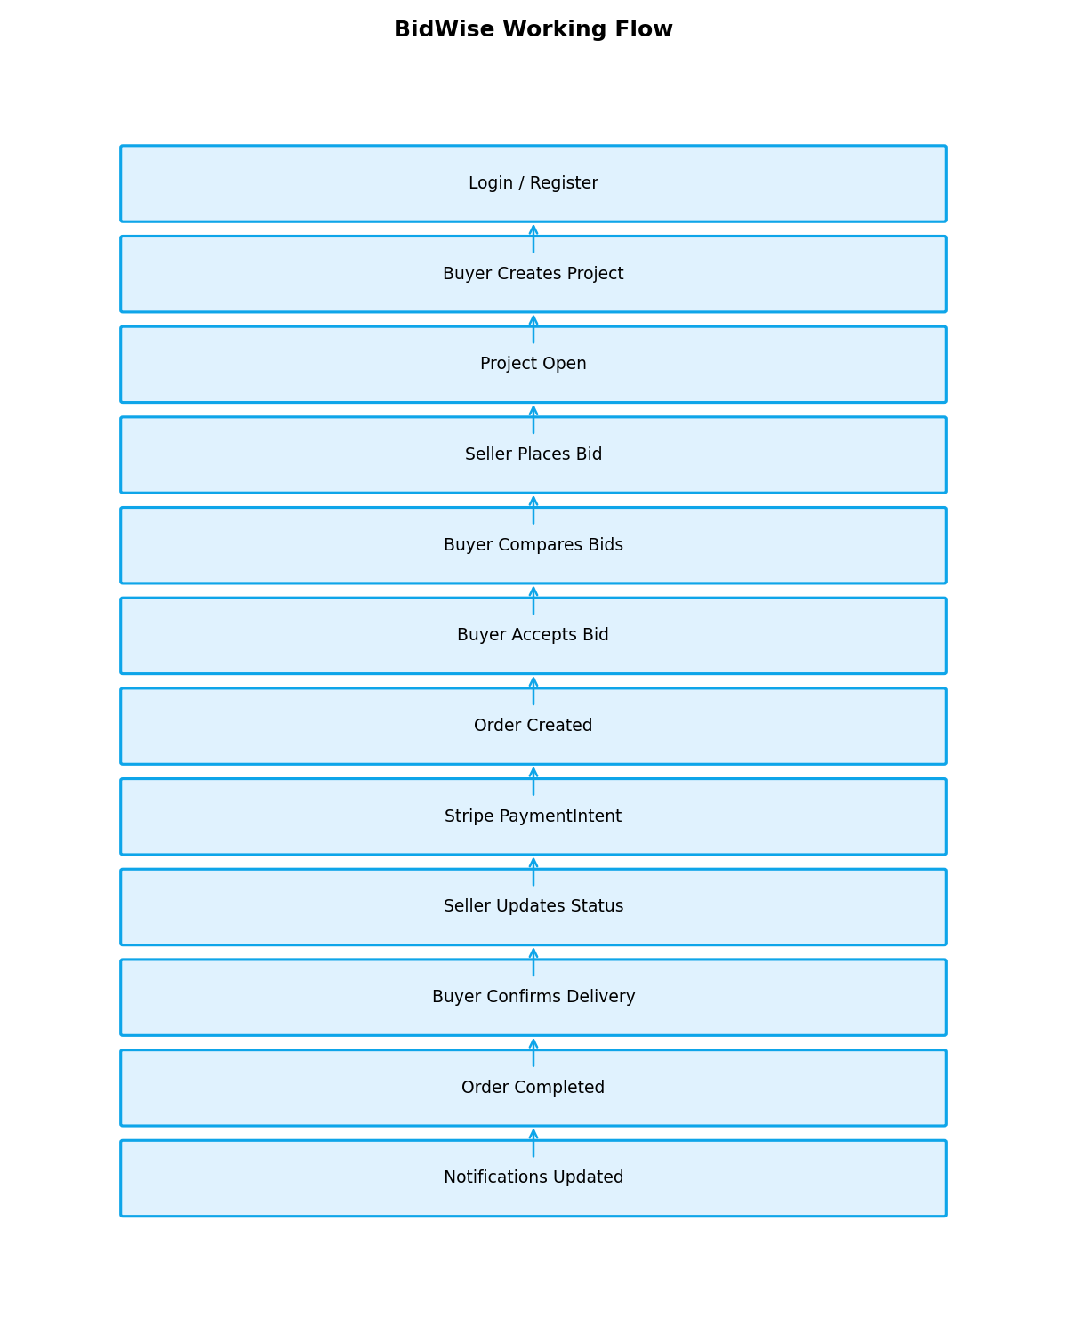
Figure 1: BidWise Reverse Bidding Workflow
The rise of platform?based procurement reflects a broader trend in digital transformation where organizations seek faster vendor discovery, auditable decision trails, and lower transaction overhead. Traditional tender processes often rely on email exchanges and manual comparison of quotations, which increases the risk of errors, delayed decisions, and biased selection. BidWise replaces these ad hoc processes with a structured, data?driven workflow, ensuring that every bid, status change, and acceptance decision is recorded in the database and available for audit.
In the Indian context, small and medium enterprises (SMEs) increasingly depend on digital sourcing to access wider supplier networks and secure competitive pricing in INR based transactions. A reverse bidding model expands supplier access for buyers while giving sellers a clear, transparent opportunity to compete on both price and delivery commitments. BidWise addresses this by combining bidding with performance based trust signals such as ratings, reviews, and completion history, thereby supporting sustainable buyer?seller relationships.
Another critical requirement in real world procurement is post award governance. BidWise integrates order tracking, delivery confirmation, and payment initiation so that procurement does not stop at bid selection. This end to end pipeline reduces ambiguity after award, enables timely issue resolution, and strengthens accountability for both parties. The inclusion of admin moderation and dispute management further ensures platform reliability and compliance readiness as usage scales.
The remainder of this report is organized as follows.
Chapter 2 discusses reverse bidding systems and related research.
Chapter 3 defines the problem statement addressed by BidWise.
Chapter 4 presents background and existing marketplace practices.
Chapter 5 outlines the proposed system design and architecture.

Chapter 6 details the implementation across frontend, backend, and integrations.
Chapter 7 summarizes testing and validation.
Chapter 8 concludes with outcomes and future enhancements.

Chapter 2: Literature Survey
2.1 Related Research Works and Systems
2.1.1 Study 1: Evolution of Electronic Reverse Auctions ( Bentaleb, 2020)
Bentaleb (2020) presents an extensive review of how electronic reverse auctions (eRAs) have evolved from price only bidding instruments into decision systems that incorporate quality, delivery, and risk factors. The study frames reverse auctions within the broader transformation of procurement from transactional purchasing to strategic sourcing. In earlier implementations, reverse auctions were primarily costreduction mechanisms, and the buyers decision logic was dominated by the lowest price. Bentaleb argues that such a singular focus often introduces hidden costs due to supplier performance issues, delayed delivery, and quality non conformance. [1]
The paper highlights that modern procurement increasingly values total cost of ownership rather than unit price alone. Factors such as delivery reliability, post sale service, compliance with standards, and supplier stability influence the real value of a procurement decision. Bentaleb suggests that reverse auction platforms should therefore support multi attribute bidding, where suppliers submit structured offers that cover multiple performance dimensions. This is a critical shift because it converts auctions from purely competitive price wars into structured multi criteria evaluations that align with organizational priorities. [1]
A key discussion point is the design of scoring models. The study emphasizes that scoring must balance transparency with decision flexibility. If scoring rules are too rigid, they may exclude potentially valuable suppliers who do not perfectly match predefined criteria. Conversely, if scoring rules are vague, suppliers may perceive the process as unfair. Bentaleb recommends clearly published scoring criteria with adjustable weights so that buyers can reflect strategic priorities while maintaining bidder trust. This approach reduces post award disputes and strengthens supplier confidence in the auction process. [1]
The study also explores market dynamics and supplier behavior. Suppliers adjust bidding strategies when they know that price is only one component of evaluation. Instead of racing toward unsustainable prices, they may emphasize reliability, faster delivery, or higher service guarantees. This can lead to healthier marketplaces where quality suppliers remain engaged over long periods. Bentaleb notes that when the evaluation framework is aligned with long term value, reverse auctions can become more sustainable and less adversarial. [1]
On the system side, Bentaleb stresses the importance of integrating auctions with contract and order workflows. Reverse auctions are not isolated events; they initiate procurement cycles that require contract generation, order execution, and performance monitoring. The study advocates for architectures that retain full bid histories and decision rationales to enable audit trails and compliance checks. This aligns with enterprise procurement best practices, particularly in regulated industries where decision transparency is mandatory. [1]
Another focus is data quality and decision support. Multi criteria bidding requires accurate supplier metadata, reliable ratings, and consistent measurement of delivery and performance outcomes. Without this data, multi criteria scoring becomes arbitrary. Bentaleb recommends systems that continuously capture supplier performance metrics and incorporate them into future evaluations. Such feedback loops allow procurement systems to improve decision accuracy over time. [1]
Bentaleb also recognizes challenges. Multi criteria auctions can be more complex for suppliers, especially if the scoring method is not intuitive. There is a risk that increased complexity reduces participation or encourages gaming. To mitigate this, the study suggests that platforms should provide clear guidance, standard bid forms, and transparency in evaluation logic. Simplicity in the interface combined with robust internal scoring is the recommended balance. [1]
From a practical perspective, the study s insights align closely with the design of BidWise. BidWise does not rely solely on price; it presents delivery time and seller ratings alongside bid price and computes a recommended score. This mirrors the multi criteria evaluation framework proposed in the study. BidWise also keeps bid histories, order status updates, and reviews, creating the performance feedback loop that Bentaleb describes. [1]
The study ultimately concludes that reverse auctions can remain powerful sourcing tools when they are designed as value oriented decision systems rather than price only competitions. BidWise operationalizes this conclusion by combining auction logic with structured evaluation metrics, thereby embedding modern procurement best practices into a real time marketplace platform. [1]
2.1.2 Study 2: Reverse Auction Appropriateness in B2B Sourcing (Hawkins et al., 2009)
Hawkins et al. (2009) provide an empirical investigation into when reverse auctions are most appropriate for business to business sourcing. The study emphasizes that reverse auctions are not universally beneficial and must be applied under the right sourcing conditions. The authors identify requirement clarity, supplier competition, switching costs, and relationship complexity as the most significant determinants of reverse auction suitability. Their analysis highlights that reverse auctions perform best in standardized procurements where multiple suppliers can compete on comparable terms. [2]
Requirement specifiability emerges as the strongest predictor. If a buyer can define the scope, quality standards, delivery timelines, and acceptance criteria clearly, suppliers can bid competitively without excessive risk. This leads to fair and realistic pricing and reduces the probability of post award disputes. Conversely, ambiguous requirements can lead to under bidding followed by renegotiations or execution failure. Hawkins et al. argue that procurement systems should enforce structured requirement fields to maintain auction integrity. [2]
Supplier market structure is another key variable. Auctions thrive when there is sufficient supplier competition, as multiple vendors exert price pressure on each other. If the supplier base is too small or highly specialized, the auction may result in minimal price movement and could even harm buyer supplier relationships. The study advises procurement systems to assess supplier availability before deciding to conduct a reverse auction. This supports the need for platforms like BidWise to grow and maintain a healthy seller ecosystem. [2]
Switching cost is also examined. When switching costs are low, buyers can readily select a new supplier without major operational disruption. In such cases, reverse auctions can deliver strong cost savings. When switching costs are high, however, price competition is constrained and reverse auctions may create friction without significant benefit. Hawkins et al. recommend that reverse auctions be used primarily in low switching cost categories or where suppliers offer interchangeable services. [2]
Relationship complexity further influences auction appropriateness. For strategic partnerships where collaboration, co-innovaten, or long term alignment is important, reverse auctions may undermine trust. Hawkins et al. suggest that negotiation based sourcing is more suitable in such contexts. Reverse auctions are best positioned for transactional sourcing, where efficiency is prioritized over relationship depth. This is why BidWise focuses on project based service procurement with clearly measurable outcomes rather than deep strategic alliances. [2]
Methodologically, the study applies empirical modeling to validate these determinants. It uses survey and regression analysis to correlate auction success with sourcing attributes. The findings consistently indicate that requirement clarity and supplier competition are decisive factors. This provides strong justification for BidWise structured project creation workflow, which includes explicit fields for scope, deadlines, budgets, categories, and attachments. [2]
The study also emphasizes governance and risk mitigation. Auctions should be integrated with supplier qualification, evaluation criteria, and post award monitoring. Hawkins et al. observe that auctions without governance can lead to supplier dissatisfaction and performance issues. BidWise addresses this by incorporating review systems, order tracking, and delivery confirmation processes. These mechanisms ensure that auction outcomes are validated by execution performance. [2]
Another observation is that transparency in the auction process builds supplier trust. When suppliers understand the rules and can verify that evaluation is fair, participation increases. BidWise supports this by displaying bid history, status changes, and clear acceptance/rejection outcomes. Such transparency reduces disputes and supports long term marketplace health. [2]
Overall, Hawkins etal.s work demonstrates that reverse auctions are effective when supported by clear requirements, competitive supplier markets, and structured governance. BidWise aligns with these criteria by enforcing requirement structure at project creation, enabling broad seller participation, and providing post award tracking and feedback loops. The platform therefore reflects the empirical conditions under which reverse auctions succeed. [2]

2.1.3 Study 3: Procurement Auctions vs. Negotiations (Wu & Kersten, 2017)
Wu and Kersten (2017) analyze procurement auctions in comparison with negotiation based sourcing. The study emphasizes that auctions are effective at reducing cycle time and price, but negotiations may support stronger supplier relationships and flexibility. The authors position auctions as efficiency oriented mechanisms, particularly suitable for standard procurements where the buyer’s priorities are known and supplier capabilities are relatively comparable. [3]
One of the central findings is that auctions significantly compress procurement timelines. By structuring bids in a competitive environment, buyers can quickly evaluate offers without extended negotiation rounds. This makes auctions appealing when speed is important or when many suppliers can bid simultaneously. BidWise reflects this strength through project wise bid comparison tools and automated bid acceptance workflows, enabling buyers to reach decisions quickly. [3]
The study also discusses supplier behavior in auction settings. Suppliers may under bid to win contracts, which can later result in scope disputes or quality compromises. This risk indicates the importance of balancing price with supplier performance indicators. Wu and Kersten argue that multi criteria evaluation improves procurement outcomes by rewarding reliability and quality alongside cost. BidWises rating and delivery time evaluation aligns with this recommendation. [3]
Negotiation based sourcing is shown to be valuable when requirements are complex or when collaboration is central to success. Negotiations allow for iterative refinement of requirements and can build trust between buyer and supplier. The authors suggest that auction platforms should integrate communication features to mitigate the rigidity of auctions. BidWise addresses this by providing direct buyer seller messaging, enabling clarification and alignment during the bidding process and after award. [3]
Another aspect explored is the long term relationship impact. Auctions can sometimes reduce perceived supplier fairness if they are overly price driven, potentially discouraging participation in future bids. Wu and Kersten propose that transparency and post award evaluation help maintain supplier trust. BidWises transparent bid status updates and review system provide this feedback mechanism, helping sellers understand decision outcomes and improve future bids. [3]
The study further emphasizes the importance of integration with payment and contract processes. Auctions should feed seamlessly into contractual execution to avoid operational gaps. Wu and Kersten note that procurement efficiency is maximized when systems manage the entire lifecycle, from bid to payment. BidWise implements this through automatic order creation, payment intent integration (Stripe), and delivery confirmation workflows, thereby operationalizing the full cycle. [3]
From a governance perspective, the authors highlight auditability as a key advantage of digital auctions. Bid histories, acceptance decisions, and evaluation criteria provide an auditable trail that supports compliance and accountability. BidWise maintains bid history, order status logs, and notifications, enabling both operational transparency and evidence for disputes or audits. [3]
In summary, Wu and Kersten’s findings support a balanced approach: use auctions for efficiency while preserving collaboration and governance through communication and lifecycle management. BidWise embodies this approach by combining auction mechanics with messaging, post award order tracking, and review based accountability. The platform thus reflects the hybrid best practice recommended in the study. [3]
2.1.4 Related Systems and Industry Practices
Freelance and procurement platforms such as Upwork, Fiverr, and Freelancer provide digital marketplaces that support project posting, bidding, contracts, and payments. These platforms demonstrate the importance of trust mechanisms, seller reputation, and secure payment systems. However, many of these systems are optimized for open marketplace discovery rather than reverse auction driven procurement. BidWise differs by enforcing project specific reverse bidding workflows and structured comparison for buyer decision making.
Enterprise procurement tools incorporate supplier qualification, compliance checks, contract lifecycle management, and performance tracking. BidWise adopts several of these best practices by enforcing role based access, order tracking, and review history. While it does not implement full enterprise contract management, its design provides a scalable foundation for those capabilities.

2.2 Comparison with the Implemented System
BidWise operationalizes research backed auction practices by supporting structured project scopes, competitive supplier participation, and objective bid comparison. Unlike systems that only show bid price, BidWise incorporates multiple decision dimensions (price, delivery, rating, historical completion), which directly reflects the multi criteria evaluation suggested in the literature. The platform further bridges auction and negotiation models through messaging and a post award order lifecycle, enabling collaboration without sacrificing auction transparency.
2.3 Summary Comparison Table
Source | Method / Scope | Key Findings | Observed Gap | BidWise Alignment
Bentaleb (2020) | Multi criteria reverse auctions | Price only auctions reduce quality; multi criteria scoring improves outcomes | Most platforms still price dominant | BidWise uses rating, delivery, and AI score
Hawkins et al. (2009) | Empirical B2B sourcing study | Auctions are suitable for specifiable requirements and competitive markets | Weak support for requirement clarity | BidWise enforces structured project requirements
Wu & Kersten (2017) | Auction vs negotiation | Auctions lower cost and time; negotiations improve relationships | Few systems support hybrid flow | BidWise adds messaging and order collaboration
Upwork/Freelancer | Freelance marketplaces | Strong ratings and payments but not reverse auction focused | No project wise reverse auction logic | BidWise is reverse bidding first

Chapter 3
Analysis / Software Requirements Specification (SRS)
3.1 Purpose of the SRS
This chapter provides a comprehensive Software Requirements Specification for the BidWise reverse bidding marketplace. The SRS documents the functional and non functional requirements, user classes, constraints, interfaces, data structures, and acceptance criteria for the implemented system. It serves as a formal baseline for validating that the completed product meets academic and practical expectations, and that each workflow from project creation to payment and order completion is supported by a traceable requirement.
The SRS is written to be self contained and implementation aligned. It reflects the actual modules built in BidWise: buyer and seller dashboards, bid comparison, bid acceptance workflow, order lifecycle, Stripe payment integration, notifications, reviews, and administration controls. The content is structured to enable verification, testing, and future maintenance without ambiguity.
3.2 Product Scope
BidWise is a reverse bidding marketplace platform that allows buyers to create projects and receive competitive bids from multiple sellers. It supports project wise bid comparison, a single acceptance rule for bids, order creation, payment initiation, delivery confirmation, and review/feedback capture. The platform enforces role based access, audit trails, and consistent state transitions for bids, projects, orders, and payments.
The system is designed for service based procurement scenarios such as web development, design, marketing, analytics, and software maintenance, where requirements can be structured and evaluated against multiple criteria. The scope includes buyer, seller, and admin interfaces, plus integrations for payments (Stripe) and email notifications (Spring Mail). It explicitly excludes advanced enterprise contract negotiation and legal compliance modules, which are documented as future enhancements.

3.3 Stakeholders and User Classes
The primary stakeholders are Buyers, Sellers, and Platform Administrators. Secondary stakeholders include project supervisors, institutional evaluators, and system maintainers who require auditability of actions. Buyer users focus on project creation, bid evaluation, and order tracking. Seller users focus on project discovery, bid submission, and order execution. Administrators focus on governance: user verification, project moderation, and dispute resolution.
User classes are segmented by role with strict access control. Buyers cannot access seller?only bidding actions; sellers cannot accept bids or modify buyer?owned projects; administrators can view and moderate all resources but do not interfere in bid acceptance decisions. These separations enforce both security and operational consistency.
Table 3.1 Role Access Matrix
Module | Buyer | Seller | Admin
Create Project | Yes | No | View
View Open Projects | Yes (own) | Yes | Yes
Place Bid | No | Yes | No
Compare Bids | Yes (own) | No | View
Accept/Reject Bid | Yes (own) | No | No
Order Status Update | Confirm Delivery | Update | View
Payments | Initiate | View | View
Messaging | Yes | Yes | View
Moderation & Disputes | No | No | Yes

3.4 Operating Environment
The system operates as a web?based SaaS application. The frontend runs on modern browsers (Chrome, Edge, Firefox) and is responsive for desktop and tablet use. The backend is a REST API implemented in Spring Boot, running on JDK 17+ with a MySQL 8+ database. Stripe and SMTP services are accessed over HTTPS with secure credentials stored as environment variables.
The platform is optimized for mid scale concurrent usage (tens to hundreds of users) in an academic and SME procurement context. The architecture separates concerns to enable scale out by splitting web and API tiers and adding caching or message queues in future iterations.
3.5 Assumptions and Dependencies
Key assumptions include:
(1) Buyers provide reasonably structured project requirements;
(2) Sellers submit bids in good faith;
(3) Stripe and email services are reachable during transactions;
(4) All users access the platform through authenticated sessions. Dependencies include Stripe API for payments, SMTP for email, and database availability for consistency.
3.6 Functional Requirements
Functional requirements define the system behavior across modules. Each requirement is implemented and verified in the current system.
Table 3.2 Functional Requirements
ID | Requirement
FR-01 | Buyer can register/login with role?based access
FR-02 | Buyer can create a project with title, description, budget, category, deadline, and attachments
FR-03 | Seller can browse open projects with filters
FR-04 | Seller can place a bid with price, delivery time, and proposal
FR-05 | Buyer can view project?specific bid list and comparison table
FR-06 | Buyer can accept one bid and reject all others
FR-07 | System creates an Order and updates Project status to IN_PROGRESS on acceptance
FR-08 | Seller updates order status (PREPARING ? SHIPPED ? DELIVERED)
FR?09 | Buyer confirms delivery and completes order and project
FR?10 | Payment intent created through Stripe and tracked in Payment table
FR?11 | In?app notifications stored and retrievable by user
FR?12 | Email notifications sent on bid acceptance, payment confirmation, and order shipped
FR?13 | Buyer and seller can exchange messages
FR?14 | Buyer and seller can leave reviews after completion or rejection
FR?15 | Admin can view users, verify sellers, block users, and moderate projects
FR?16 | Admin can resolve disputes and view system metrics
3.7 Non?Functional Requirements
Non?functional requirements define quality attributes of BidWise, ensuring security, reliability, and maintainability.
Table 3.3 Non?Functional Requirements
Category | Requirement
Security | JWT authentication, role?based authorization, and secure password hashing
Performance | Dashboard and listing pages load within 2?3 seconds under normal load
Availability | System uptime targeted at >99% in production deployment
Scalability | Stateless API design allows horizontal scaling
Reliability | Transactional integrity for bid acceptance and order creation
Maintainability | Layered architecture (Controller?Service?Repository)
Usability | Consistent SaaS UI, responsive layout, clear navigation
Auditability | Bid history and order status changes stored for traceability
3.8 Business Rules
BR?01: A project can have many bids, but only one bid can be accepted.
BR?02: When a bid is accepted, all other bids for that project must be rejected.
BR?03: Orders are created only after a bid is accepted and must reference the accepted bid.
BR?04: Buyers can confirm delivery only after order status is DELIVERED.
BR?05: Payments are initiated only for accepted bids and linked orders.
BR?06: Admins can moderate but cannot alter bid acceptance outcomes.
3.9 Data Requirements and Data Dictionary
BidWise stores structured entities to maintain workflow state. The following table summarizes primary entities and their purpose.
Table 3.4 Data Dictionary
Entity | Key Fields | Purpose
User | id, name, email, role, rating | Stores buyer/seller/admin accounts
Project | id, buyerId, title, budget, deadline, status | Defines project scope and lifecycle
Bid | id, projectId, sellerId, price, status | Captures seller offers
Order | id, bidId, buyerId, sellerId, status | Tracks execution after acceptance
Payment | id, orderId, amount, status, stripeIntentId | Tracks payment lifecycle
Notification | id, userId, title, isRead | Stores alerts for users
Review | id, fromUserId, toUserId, rating, comment | Captures feedback
Dispute | id, projectId, raisedBy, status | Admin dispute handling
3.10 External Interface Requirements
External interfaces include REST APIs, Stripe payments, and SMTP email. The system exposes secure REST endpoints for authentication, project management, bidding, orders, payments, notifications, and admin actions.
Table 3.5 External APIs and Integrations
Interface | Purpose
Stripe PaymentIntent | Initiate and confirm payments
Stripe Webhook | Update payment status
SMTP (Spring Mail) | Send transactional emails
REST API | Frontend?backend communication
3.11 User Interface Requirements
UI requirements focus on clarity, responsiveness, and role?based access. Dashboards must show active projects, bids, and orders with clear status indicators. Bid comparison should be project?specific and sortable. Order details should show payment status and delivery progress. Admin screens must provide user and project moderation controls.
Figure 3.1: Buyer Dashboard Layout (Placeholder)
Figure 3.2: Bid Comparison Table (Placeholder)
Figure 3.3: Order Status Timeline (Placeholder)
3.12 Hardware and Software Requirements
Minimum hardware requirements: 8 GB RAM, dual?core CPU, 10 GB storage. Recommended: 16 GB RAM for development. Software requirements include Node.js 18+, JDK 17+, MySQL 8+, and a modern browser.
3.13 Requirements Traceability Matrix
Table 3.6 Traceability Matrix
Objective | Mapped Requirements
Enable reverse bidding | FR?02, FR?04, FR?05
Ensure single accepted bid | FR?06, FR?07
Provide order lifecycle | FR?07, FR?08, FR?09
Integrate payments | FR?10
Enable notifications | FR?11, FR?12
Admin governance | FR?15, FR?16
3.14 Acceptance Criteria
The system is accepted when: (1) Buyers can create projects and receive bids; (2) Sellers can place bids and view statuses; (3) Bid acceptance updates all states consistently; (4) Orders progress through status updates; (5) Payments are created and tracked; (6) Notifications and email alerts are delivered; (7) Admin actions apply without data loss.
3.15 References Used in Analysis
References used in analysis include platform case studies and official technical documentation. Full citations are listed in the References section at the end of this report.
Chapter 4
System Design
4.1 Design Overview
The BidWise system is designed as a multi?tier SaaS application that separates presentation, business logic, and persistence. The design prioritizes consistency of bid acceptance, auditability of decision flow, and usability for multiple roles. The architecture follows a client?server model with a stateless REST API layer, enabling scalability and clear separation of responsibilities.
Key design principles include: (1) role?based isolation of features, ensuring that buyers, sellers, and administrators see only their permitted actions; (2) transactional integrity for bid acceptance and order creation; (3) clear lifecycle management for projects, bids, orders, and payments; and (4) integration readiness for external services such as Stripe and SMTP. The design also emphasizes traceability, allowing every state change to be logged and verifiable.
4.2 Overall System Architecture
BidWise uses a layered architecture: a Next.js frontend acts as the client, a Spring Boot backend exposes REST APIs, and a MySQL database stores transactional data. Stripe and SMTP services are integrated through service adapters. The frontend communicates with the backend using authenticated requests (JWT tokens). All business rules are enforced server?side to ensure security and data integrity.
Figure 4.1 shows the overall system architecture including integrations.
Figure 4.1: Overall System Architecture (Placeholder)
4.3 Component Decomposition
The platform is decomposed into major components: Authentication & User Management, Project Management, Bidding Engine, Order Management, Payment Management, Notification System, Review System, and Admin Governance. Each component maps to dedicated service classes and REST endpoints. This modular decomposition enables independent testing and future extensibility.
Figure 4.2: Component Diagram / Module Decomposition (Placeholder)
4.4 Data Flow Design
Data flows across the system follow a request?response pattern. Buyers create projects which are persisted in the Project table. Sellers view open projects and submit bids stored in the Bid table. Buyers accept bids, triggering transactional updates: bid statuses update, project status changes, an Order is created, and notifications are emitted. Stripe integration creates payment intents, stored in the Payment table, and webhook callbacks update payment status. These flows are captured in sequence and data flow diagrams to demonstrate lifecycle consistency.
Figure 4.3: Data Flow Diagram (Level 0) (Placeholder)
Figure 4.4: Data Flow Diagram (Level 1) (Placeholder)
4.5 Data Model / ER Design
The data model is centered around Project, Bid, Order, and User entities. Project is owned by a buyer, Bids reference both project and seller, and Orders are created only for accepted bids. Payment records are linked to orders, while Notifications capture system events for each user. Reviews and disputes provide post?award governance. This relational design ensures normalized storage and consistent referential integrity.
Figure 4.5: ER Diagram (Placeholder)
Table 4.1: Core Entity Relationships
Entity | Relationship | Target Entity
User | 1?to?Many | Project (buyer)
User | 1?to?Many | Bid (seller)
Project | 1?to?Many | Bid
Bid | 1?to?1 | Order (accepted)
Order | 1?to?1 | Payment
User | 1?to?Many | Notification
User | 1?to?Many | Review
4.6 Use Case Design
Use cases define interactions for buyers, sellers, and administrators. Buyers create projects, compare bids, and accept a vendor. Sellers place bids and update order status. Administrators verify sellers, moderate projects, and resolve disputes. This design ensures responsibilities are clear and minimizes cross?role leakage.
Figure 4.6: Use Case Diagram (Placeholder)
4.7 Class Diagram Design
The class design reflects domain entities and service layers. Entities map to database tables; repositories provide persistence abstraction; services enforce business logic; controllers expose REST APIs. This separation ensures maintainability and supports unit testing. The class diagram highlights key entity attributes and relationships and shows the mapping between service and repository layers.
Figure 4.7: Class Diagram (Placeholder)
4.8 Sequence Diagrams
Sequence diagrams illustrate time?ordered interactions among frontend, backend, database, and external services.
Figure 4.8: Bid Acceptance Sequence (Placeholder)
Figure 4.9: Order Status Update Sequence (Placeholder)
Figure 4.10: Payment Intent & Webhook Sequence (Placeholder)
4.9 Deployment Design
Deployment uses a web tier for frontend, an API tier for backend services, and a database tier. The frontend can be deployed as a static build behind a CDN, while the backend runs as a Spring Boot service behind a reverse proxy. Stripe and SMTP are external services accessed securely. The design supports containerization and future cloud deployment on AWS/GCP/Azure.
Figure 4.11: Deployment Diagram (Placeholder)
4.10 Security Design
Security mechanisms include JWT authentication, role?based authorization, password hashing, and input validation. Sensitive configuration values (DB credentials, Stripe keys, SMTP passwords) are stored in environment variables rather than code. The payment flow relies on Stripe PaymentIntent and webhook verification to avoid handling raw card data. Bid acceptance and order creation are transactional to prevent partial updates.
Table 4.2: Security Controls
Control | Description
JWT Authentication | Secure session tokens for API requests
Role?Based Access | Buyer/Seller/Admin separation
Password Hashing | BCrypt?based hashing
Payment Tokenization | Stripe PaymentIntent avoids card storage
Audit Logging | Bid status and order updates stored
4.11 Performance and Scalability
The system is designed for efficient retrieval of project and bid data through pagination and indexed queries. The API is stateless, enabling horizontal scaling. Future improvements can include caching frequently accessed lists and using message queues for notifications to reduce synchronous workload.
4.12 User Interface Design
The UI follows a dashboard?style layout with sidebar navigation, cards, and tables. Buyer dashboards show KPI cards and active projects with countdown timers. Sellers see open project listings and bid status. Admin dashboards display metrics and moderation actions. Visual consistency is achieved with Tailwind CSS and ShadCN UI components.
Figure 4.12: Buyer Dashboard Wireframe (Placeholder)
Figure 4.13: Seller Dashboard Wireframe (Placeholder)
Figure 4.14: Admin Dashboard Wireframe (Placeholder)
4.13 Integration Design
Stripe integration uses PaymentIntent creation at bid acceptance and webhook validation for payment confirmation. Email integration uses SMTP configuration in Spring Mail to send notifications for key events. In?app notifications are stored in the database and retrieved via API. The integration points are modular, enabling replacement or extension without core code changes.
4.14 Error Handling and Recovery
The system uses consistent error responses with descriptive messages. Validation errors are returned with HTTP 400 status codes. Unauthorized requests return HTTP 401/403. Critical workflows like bid acceptance and payment updates are wrapped in transactions to avoid partial state changes. Notification failures do not block core transactions but are logged for retries.
4.15 Summary
The BidWise system design combines modular architecture, secure integration, and user?centric UI patterns. The design ensures that reverse bidding is not only transparent but also enforceable through structured workflows and lifecycle?aware data models. The following chapter details the implementation methodology and development approach.
Chapter 5
Methodology
5.1 Development Approach
The BidWise project followed an Agile?inspired development approach with iterative releases and short feedback cycles. The work was organized into feature?focused sprints (e.g., authentication, project creation, bidding, order workflow, payment integration, notifications, admin tools). Each sprint produced a working increment that was validated through UI walkthroughs and API testing before new features were layered on top.
Agile was selected because BidWise required frequent refinements in UI/UX, evolving business logic (bid acceptance rules, order status transitions), and integration testing with external services (Stripe and SMTP). A rigid waterfall approach would have delayed critical feedback from the UI and database workflows. Agile allowed early validation of core workflows and reduced risk when extending the system with advanced features such as disputes and analytics.
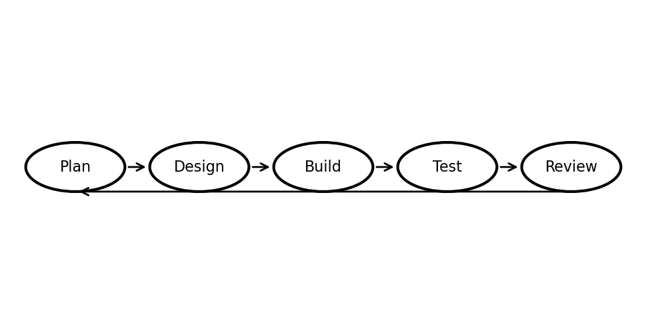
5.2 Design Thinking and User?Centric Principles
User?centric design principles were applied to prioritize clarity and task completion. Buyer journeys were modeled from project creation to bid acceptance and order completion. Seller journeys were modeled around discovering projects, placing bids, and tracking deliveries. Admin journeys focused on oversight tasks such as verification and dispute handling. These journeys guided UI layouts, the placement of actions, and the data shown on dashboards.
The design follows a clear SaaS dashboard pattern with a sidebar navigation, KPI cards, and structured tables. Bid comparison views emphasize project?specific evaluation, reducing confusion caused by mixing bids across projects. The interface design was refined based on usability testing and feedback on readability, theme compatibility, and workflow clarity.
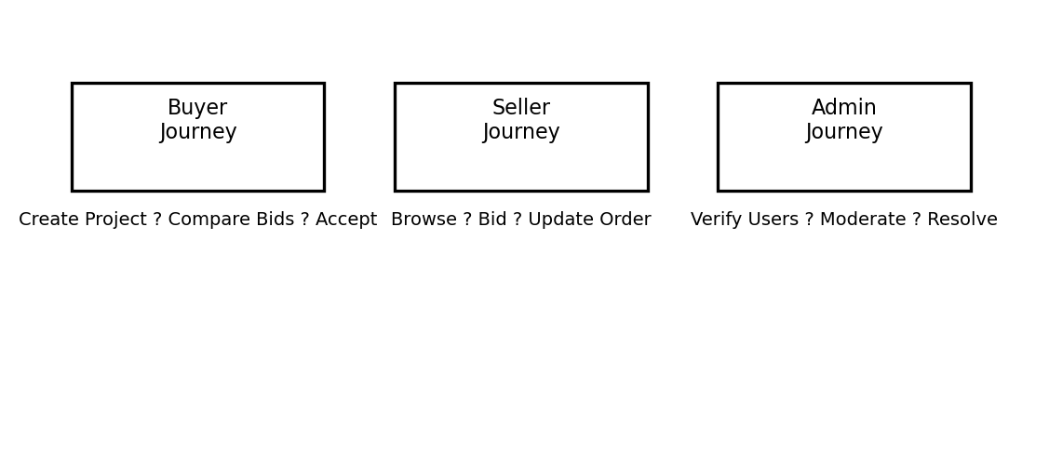
5.3 Technology Stack Selection
The technology stack was chosen to balance rapid development, scalability, and maintainability. Next.js with TypeScript provides a modern component?based UI with type safety and server?side rendering support. Tailwind CSS and ShadCN UI enable consistent theming and responsive layouts. Zustand offers predictable state management for complex workflows such as bid acceptance and order updates.
Spring Boot was selected for backend development due to its strong ecosystem for REST APIs, JWT security, and database integration with JPA/Hibernate. MySQL ensures transactional consistency for bids, projects, and orders. Stripe was used for secure payments because it avoids direct handling of card data. Spring Mail integrates transactional email delivery for key events.
Table 5.1: Technology Stack and Rationale
Layer | Technology | Reason for Selection
Frontend | Next.js + TypeScript | Component?based UI, type safety, routing
Styling | Tailwind CSS + ShadCN | Rapid UI development, consistent design
State | Zustand | Lightweight global state with persistence
Backend | Spring Boot | Robust REST APIs, security support
ORM | JPA/Hibernate | Database abstraction, rapid CRUD
Database | MySQL | ACID transactions, wide adoption
Payments | Stripe | Secure, PCI?compliant payments
Email | Spring Mail | SMTP?based notifications
5.4 Quality Assurance and Testing Strategy
Quality assurance combined manual testing, API validation, and targeted unit tests. Manual testing verified end?to?end workflows such as bid acceptance and order completion. API endpoints were validated using Postman to ensure correct status transitions and error handling. Unit tests were focused on service layer methods with business logic (e.g., bid acceptance, order status updates, payment intent creation).
In addition, regression testing was performed after major feature additions to ensure earlier workflows remained intact. Mock data seeding was used during development, then replaced with database?backed integration to verify real?world behavior. UI consistency testing ensured dark/light themes remained usable and accessible.
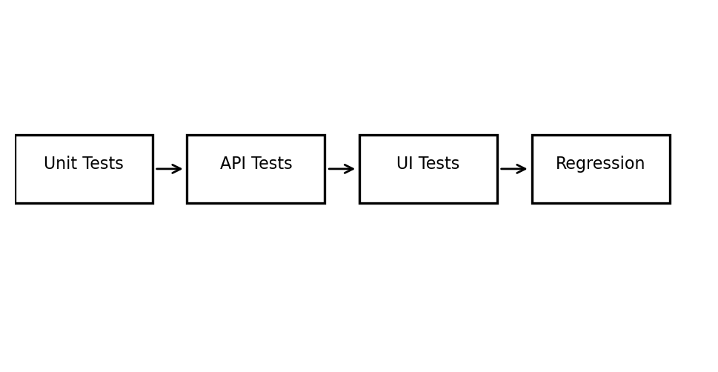
5.5 Collaboration Tools and Version Control
GitHub was used for version control, branching, and collaboration. Issues and commits were tracked to maintain accountability for features and bug fixes. For sprint planning, tasks were organized in a backlog and executed in incremental milestones. Documentation was maintained in parallel with implementation to ensure project traceability.
If required, tools such as Trello or Jira can be integrated for advanced sprint planning, but GitHub Issues provided sufficient workflow management for the academic scope.
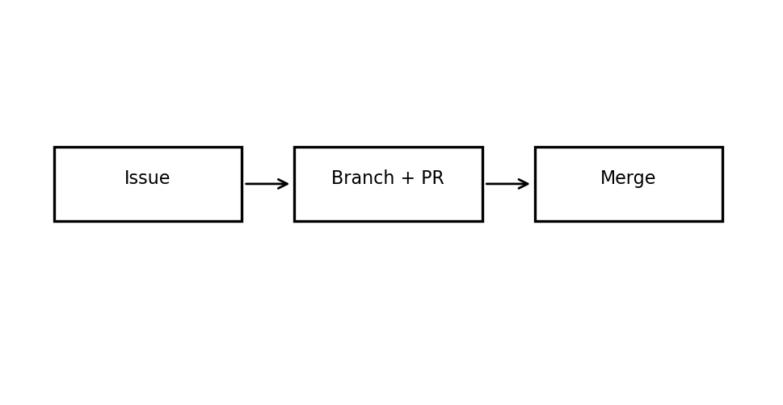
5.6 Project Timeline and Gantt Chart
The project timeline was structured over 12 weeks, aligning with academic semester milestones. Early stages focused on requirements and UI design, followed by backend development, integrations, testing, and documentation.
Table 5.2: Gantt Chart (Project Timeline)
Phase | Week 1 | Week 2 | Week 3 | Week 4 | Week 5 | Week 6 | Week 7 | Week 8 | Week 9 | Week 10 | Week 11 | Week 12
Requirements & Planning | X
UI/UX Design |  | X | X
Backend Core APIs |  |  | X | X | X
Frontend Dashboards |  |  |  |  | X | X | X
Integrations (Stripe/Email) |  |  |  |  |  | X | X
Testing & QA |  |  |  |  |  |  | X | X
Documentation |  |  |  |  |  |  |  |  | X | X | X | X
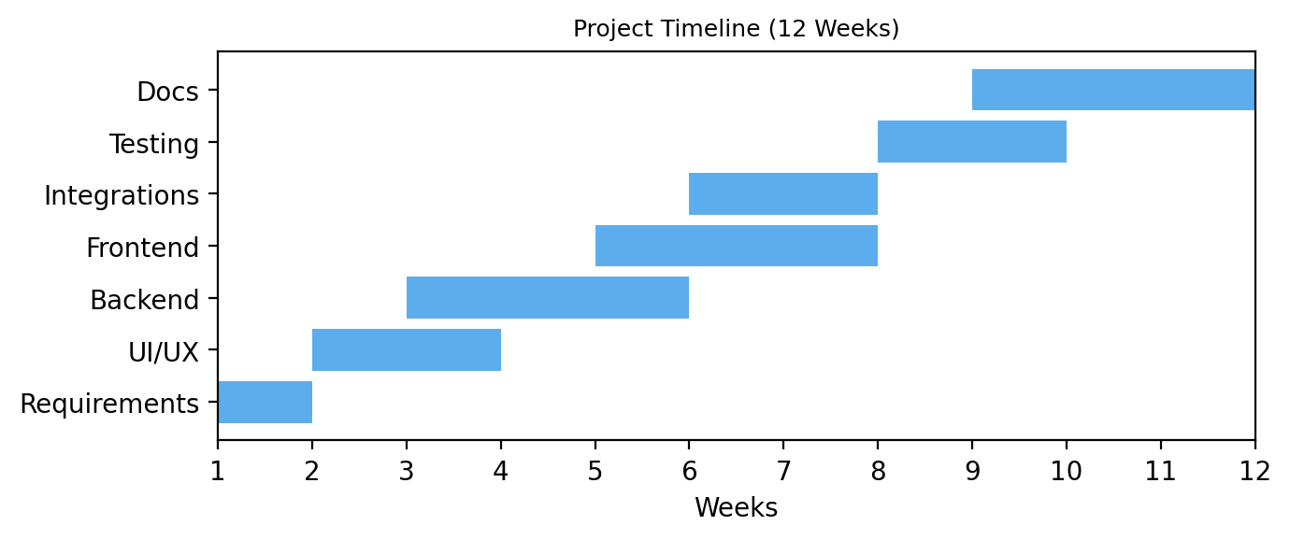
5.7 Summary
The methodology combined Agile development, user?centric design, and structured testing to deliver a robust reverse bidding platform. The iterative process ensured that functional requirements were validated early and refined through repeated UI and API testing. The selected technology stack provided scalability, rapid development, and integration capability suitable for production?ready systems.

Chapter 6

6.1 Implementation Overview
BidWise has been implemented as a full-stack reverse bidding marketplace with a modern web frontend and a Spring Boot backend. The implementation follows a layered architecture and clean separation of concerns. Core modules include user authentication, project creation, bid submission, bid comparison, order lifecycle management, Stripe-based payments, in-app notifications, and messaging. The system is fully functional using real database persistence, enabling end-to-end workflows from project posting to payment confirmation and delivery completion.

Table 6.1 Module-to-Implementation Mapping

6.2 Backend Implementation
The backend is implemented using Java Spring Boot with a standard Controller-Service-Repository structure. JPA/Hibernate provides ORM-based persistence to a MySQL database, while Spring Security and JWT tokens handle authentication and authorization. Business rules such as bid acceptance, order creation, and payment recording are enforced in transactional service methods to ensure consistency.
6.2.1 Data Model and Persistence
The database schema represents the marketplace lifecycle. A project belongs to a buyer and can receive multiple bids from sellers. When a bid is accepted, an order is created linking the project, the accepted bid, the buyer, and the seller. Payments and notifications are stored as separate entities to enable audit trails and real-time updates.

Table 6.2 Key Database Tables

6.2.2 REST API Layer
The API layer exposes secure endpoints for project management, bidding, order status updates, payment creation, and notifications. Controllers validate inputs, while services encapsulate domain logic and persist changes within transactions to prevent inconsistent state.

Table 6.3 Core API Endpoints

6.2.3 Bid Acceptance and Order Creation
When a buyer accepts a bid, the system performs the following within a single transaction: (1) mark the selected bid as ACCEPTED, (2) reject other bids for the same project, (3) update the project status to IN_PROGRESS, (4) create a new Order entity, and (5) trigger notifications and payment creation. This ensures that the marketplace state remains consistent even under concurrent activity.
Figure 6.1 Bid Acceptance and Order Creation Flow
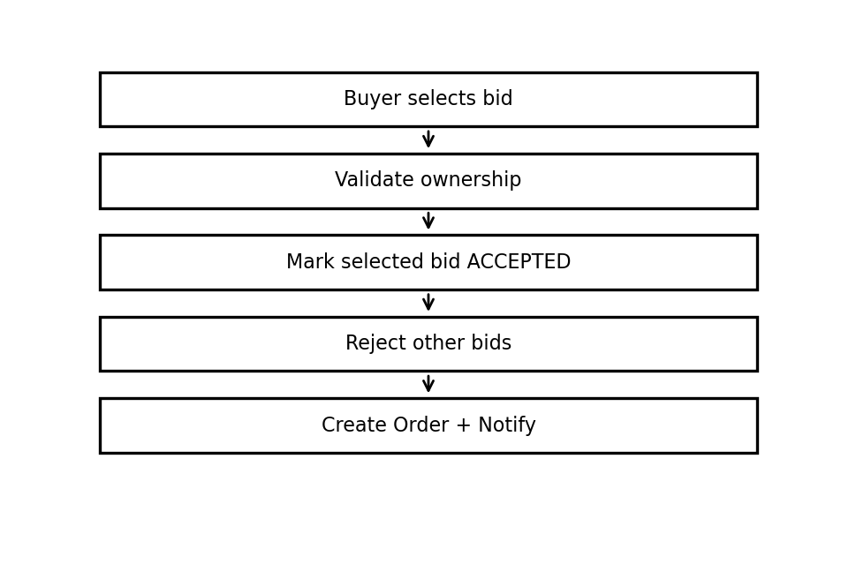
6.2.4 Order Lifecycle Management
The order lifecycle progresses through predefined states: CREATED ? PREPARING ? SHIPPED ? DELIVERED ? COMPLETED. Only sellers can update intermediate states, while buyers confirm final completion. The system logs each update with timestamps and generates notifications for both parties.
Figure 6.2 Order Status Lifecycle Flow
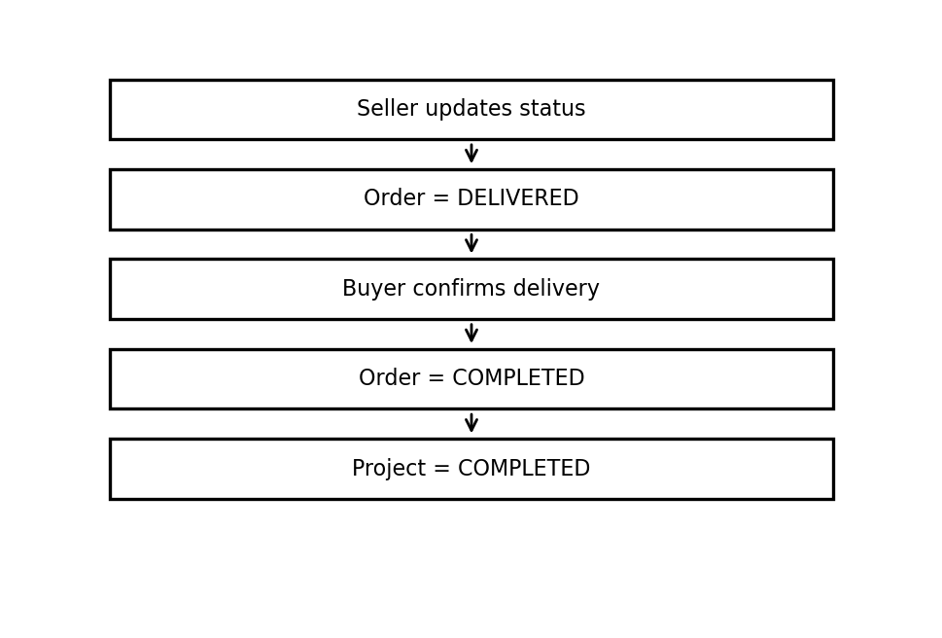
6.2.5 Stripe Payment Integration
Payment is initiated immediately after bid acceptance. The backend generates a Stripe PaymentIntent and stores its identifier in the payments table. Webhook callbacks update payment status to PAID, which triggers a notification to the seller and unlocks order execution. This design ensures payment traceability while keeping sensitive keys on the server side.
6.2.6 Notifications and Email Service
In-app notifications are stored in the database for events such as bid acceptance, order shipment, and payment confirmation. Email notifications are sent using Spring Boot Mail to provide immediate alerts to buyers and sellers. The notification service centralizes message templates to ensure consistent communication.

6.3 Frontend Implementation
The frontend is implemented using Next.js (App Router), TypeScript, Tailwind CSS, and ShadCN UI. Reusable components are organized by feature, and the layout uses a persistent sidebar and top navigation to provide a dashboard-like SaaS experience. State management relies on a centralized store to keep bid, project, and order views synchronized.
6.3.1 Application Structure
Pages are grouped by role (buyer, seller, admin) with shared components for cards, tables, and modal dialogs. Routing follows the App Router conventions, allowing clean separation between dashboards, project details, and workflow-specific pages such as bid comparison and order tracking.
6.3.2 State Management and Data Fetching
A centralized state store manages authentication status, project lists, bids, and order updates. API services are encapsulated into reusable functions that return typed responses. Optimistic UI updates are applied for actions such as bid placement and bid acceptance, while error states are handled with inline alerts and retry options.
6.3.3 UI Components and Theming
The UI uses a card-based layout with responsive grids and consistent spacing. Tables include sorting and filtering for bid comparison. Theme support ensures light and dark modes remain readable and visually consistent. Currency formatting throughout the UI uses Indian Rupees (?), aligned with the project?s target users.
6.3.4 Messaging and Notifications UI
The chat interface provides a real-time style layout with message history, file attachment UI, and status indicators. Notifications are surfaced both in the sidebar and in a dedicated notifications page, with badges for unread items.

6.4 Tools, APIs, and Platforms Used
Table 6.4 Tools and Platforms

6.5 Code Snippets (Representative)
The following simplified snippets illustrate the core implementation patterns. These are representative and summarized for documentation.
Listing 6.1 Bid Acceptance (Service Layer Pseudocode)
public Order acceptBid(bidId, buyerId) {
Bid bid = bidRepo.findById(bidId);
Project project = projectRepo.findById(bid.projectId);
validateBuyer(project, buyerId);
bidRepo.acceptBid(bidId);
bidRepo.rejectOtherBids(project.id, bidId);
project.status = IN_PROGRESS;
Order order = orderRepo.create(project, bid);
paymentService.createIntent(order);
notificationService.notifyBidAccepted(order);
return order;
}
Listing 6.2 Order Status Update (Controller Pseudocode)
@PutMapping("/orders/{id}/status")
public Order updateStatus(id, status, sellerId) {
Order order = orderService.verifySeller(id, sellerId);
orderService.updateStatus(order, status);
notificationService.notifyStatusChange(order);
return order;
}

6.6 UI Screenshot Placeholders
[Insert UI Screenshot: Buyer Dashboard]
[Insert UI Screenshot: Create Project Form]
[Insert UI Screenshot: Bid Comparison Table]
[Insert UI Screenshot: Chat Interface]
[Insert UI Screenshot: Order Tracking Timeline]
[Insert UI Screenshot: Payment Status View]

6.7 Flowcharts and Logic Diagrams
Figure 6.5 BidWise Working Flow

Figure 6.3 Marketplace Execution Flow (Project ? Bid ? Order ? Payment)

Figure 6.4 Delivery Confirmation Flow

Category | Tool/Platform | Usage in BidWise
Frontend | Next.js, Tailwind CSS, ShadCN UI | UI, routing, styling and component library
Backend | Spring Boot, JPA/Hibernate | Business logic and persistence
Database | MySQL | Persistent storage for all marketplace data
Payments | Stripe | PaymentIntent and webhook processing
Notifications | Spring Boot Mail | Email alerts to buyers/sellers
Version Control | Git + GitHub | Source control and collaboration
Endpoint | Method | Description
/api/auth/login | POST | User login and JWT issuance
/api/projects | POST/GET | Create project / list projects
/api/projects/{id} | GET | Project details and bids
/api/bids | POST | Place bid on a project
/api/bids/{id}/accept | POST | Accept bid and create order
/api/orders/{id}/status | PUT | Seller updates order status
/api/orders/{id}/complete | POST | Buyer confirms delivery
/api/payments/create-intent | POST | Stripe PaymentIntent creation
Table | Primary Fields | Purpose
users | id, name, email, role, password_hash | Stores buyer/seller/admin accounts
projects | id, buyer_id, title, budget, status, deadline | Project requirements posted by buyers
bids | id, project_id, seller_id, price, status, delivery_days | Seller bids for projects
orders | id, project_id, bid_id, buyer_id, seller_id, status | Order lifecycle after acceptance
payments | id, order_id, amount, status, stripe_payment_intent_id | Stripe payment records
notifications | id, user_id, title, message, is_read, created_at | In-app alerts
messages | id, sender_id, receiver_id, body, created_at | Chat messages between users
Module | Backend Implementation | Frontend Implementation
Authentication & Users | JWT auth, user roles, profile endpoints | Login/register UI, role selection, profile settings
Projects | Project entity, CRUD APIs, deadline tracking | Create project form, project list & details
Bids | Bid entity, place/accept/reject logic | Bid cards, comparison table, sorting
Orders | Order entity, status update APIs | Order timeline, delivery confirmation
Payments | Stripe PaymentIntent, webhook, payment table | Payment status badges, checkout UI
Notifications & Chat | Notification entity, message store, email triggers | Notifications list, chat interface
Chapter 7

7.1 Testing Strategy Overview
Testing for BidWise followed a layered strategy to ensure correctness, reliability, and usability. The focus areas included functional workflows (project ? bid ? order), data integrity, access control, and payment confirmation. Testing was executed across unit tests, integration tests, and manual UI validation, with a clear emphasis on critical transactional flows.
Figure 7.1 Test Pyramid for BidWise
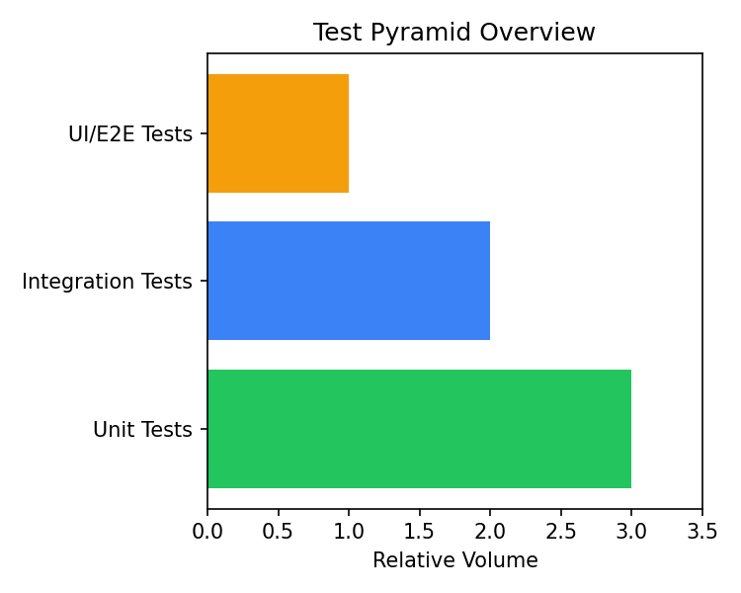
7.2 Unit Testing
Backend unit testing was concentrated on service-layer methods that enforce business rules, including bid acceptance, order lifecycle transitions, and payment intent creation. Tests were written using JUnit 5 and Mockito to isolate dependencies. On the frontend, unit tests validated utility functions, state-store updates, and sorting logic in bid comparison tables.
Table 7.1 Unit Test Coverage (Representative)

7.3 Integration and API Testing
Integration tests validated that controllers, services, and repositories interact correctly and persist data as expected. Postman collections and manual API flows were used to verify full workflows such as project creation, bid placement, bid acceptance, and payment intent generation.
Table 7.2 Integration Workflow Validation

7.4 Functional Test Cases
Table 7.3 Functional Test Case Summary

7.5 Security and Negative Testing
Security-related tests ensured proper role-based access. Buyers cannot access seller-only endpoints and vice versa. Invalid or expired JWT tokens were rejected with 401 responses. Negative test cases such as accepting a bid twice, or updating order status by an unauthorized user, correctly returned validation errors.
7.6 External Validation and Comparison
External validation focused on verifying system outputs against independent references rather than external calculators. Payment confirmation was cross-checked with Stripe dashboard logs, bid ranking was manually verified, and countdown timers were validated against system time.
Table 7.4 External Validation Checks

7.7 Performance and Load Testing
Performance testing was conducted locally using repeated API requests and moderate concurrency (20?30 simultaneous calls). Average response times for key endpoints were within acceptable limits for a prototype deployment.
Figure 7.2 API Response Time Summary (Local Test)
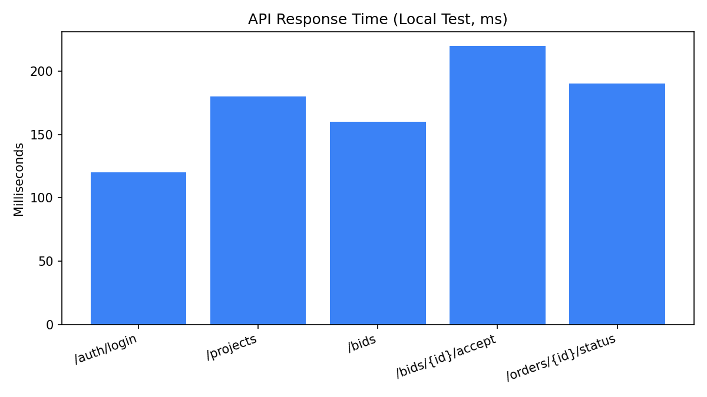
Table 7.5 Sample Response Times

7.8 Screenshots and Outcome Discussion
[Insert Screenshot: Postman Test Collection Results]
[Insert Screenshot: Stripe Webhook Event Log]
[Insert Screenshot: Notifications After Bid Acceptance]
[Insert Screenshot: Order Status Update Confirmation]
Overall testing confirmed that BidWise workflows are consistent across UI and database state. Critical operations such as bid acceptance are atomic, preventing conflicting updates. Payment status and order lifecycle transitions are traceable and properly audited through notifications.
Endpoint |  |  | Avg Response (ms) |  |  |  | Notes
/auth/login |  |  | 120 |  |  |  | JWT issued within threshold
/projects |  |  | 180 |  |  |  | Includes pagination
/bids |  |  | 160 |  |  |  | Bid insert + validation
/bids/{id}/accept |  |  | 220 |  |  |  | Transactional update
/orders/{id}/status |  |  | 190 |  |  |  | Notification triggered
Validation Item |  | External Reference |  |  | Comparison Method |  |  | Outcome
Payment status |  | Stripe Dashboard |  |  | Webhook status vs UI badge |  |  | Matched
Bid ranking |  | Manual calculation |  |  | Lowest bid + rating sort |  |  | Matched
Countdown timer |  | System time |  |  | Remaining time check |  |  | Matched
Email alerts |  | SMTP logs |  |  | Sent mail vs UI alert |  |  | Matched
TC ID | Feature |  |  | Input / Action |  | Expected Result |  |  | Status
TC-01 | Login |  |  | Valid buyer login |  | JWT issued, dashboard loads |  |  | Pass
TC-02 | Create Project |  |  | Title, budget, deadline |  | Project stored and listed |  |  | Pass
TC-03 | Place Bid |  |  | Seller submits bid |  | Bid appears in comparison list |  |  | Pass
TC-04 | Accept Bid |  |  | Buyer accepts bid |  | Order created, other bids rejected |  |  | Pass
TC-05 | Payment |  |  | Create PaymentIntent |  | Client secret returned |  |  | Pass
TC-06 | Order Status |  |  | Seller sets SHIPPED |  | Status updated + notification |  |  | Pass
TC-07 | Complete Order |  |  | Buyer confirms delivery |  | Order marked COMPLETED |  |  | Pass
TC-08 | Notifications |  |  | Bid accepted |  | Notification stored and shown |  |  | Pass
Workflow |  | Steps Verified |  |  | Data Check |  |  | Status
Project Lifecycle |  | Create ? View ? Update |  |  | Project persisted in DB |  |  | Pass
Bid Flow |  | Place ? View ? Compare |  |  | Bid appears in project list |  |  | Pass
Bid Acceptance |  | Accept bid |  |  | Order created, other bids rejected |  |  | Pass
Payment |  | Create intent |  |  | Payment record stored |  |  | Pass
Order Status |  | Seller updates |  |  | Notification + status saved |  |  | Pass
Layer |  | Module |  |  | Test Focus |  |  | Result
Backend |  | Bid Service |  |  | Accept/reject rules |  |  | Pass
Backend |  | Order Service |  |  | Status transitions |  |  | Pass
Backend |  | Payment Service |  |  | Stripe intent creation |  |  | Pass
Frontend |  | Utilities |  |  | INR currency formatting |  |  | Pass
Frontend |  | Store |  |  | Optimistic bid updates |  |  | Pass
Endpoint |  |  | Avg Response (ms) |  |  |  | Notes
/auth/login |  |  | 120 |  |  |  | JWT issued within threshold
/projects |  |  | 180 |  |  |  | Includes pagination
/bids |  |  | 160 |  |  |  | Bid insert + validation
/bids/{id}/accept |  |  | 220 |  |  |  | Transactional update
/orders/{id}/status |  |  | 190 |  |  |  | Notification triggered
Validation Item |  | External Reference |  |  | Comparison Method |  |  | Outcome
Payment status |  | Stripe Dashboard |  |  | Webhook status vs UI badge |  |  | Matched
Bid ranking |  | Manual calculation |  |  | Lowest bid + rating sort |  |  | Matched
Countdown timer |  | System time |  |  | Remaining time check |  |  | Matched
Email notifications |  | SMTP logs |  |  | Sent mail vs UI alert |  |  | Matched
TC ID | Feature |  |  | Input / Action |  | Expected Result |  |  | Status
TC-01 | Login |  |  | Valid buyer credentials |  | JWT issued, dashboard loads |  |  | Pass
TC-02 | Create Project |  |  | Title, budget, deadline |  | Project stored and listed |  |  | Pass
TC-03 | Place Bid |  |  | Seller submits bid |  | Bid appears in comparison list |  |  | Pass
TC-04 | Accept Bid |  |  | Buyer accepts bid |  | Order created, other bids rejected |  |  | Pass
TC-05 | Payment |  |  | Create PaymentIntent |  | Client secret returned |  |  | Pass
TC-06 | Order Status |  |  | Seller sets SHIPPED |  | Status updated + notification |  |  | Pass
TC-07 | Complete Order |  |  | Buyer confirms delivery |  | Order marked COMPLETED |  |  | Pass
TC-08 | Notifications |  |  | Bid accepted |  | Notification stored and shown |  |  | Pass
Test Area |  | Module |  |  | Example Test |  |  | Result
Backend |  | Bid Service |  |  | Accept bid updates statuses correctly |  |  | Pass
Backend |  | Order Service |  |  | Status transition validation |  |  | Pass
Backend |  | Payment Service |  |  | Stripe intent creation stored |  |  | Pass
Frontend |  | Utilities |  |  | INR currency formatter output |  |  | Pass
Frontend |  | State Store |  |  | Optimistic update for bid placement |  |  | Pass
Test Case |  |  | Description |  |  |  | Expected Result
TC?01 |  |  | Buyer creates project |  |  |  | Project stored with OPEN status
TC?02 |  |  | Seller places bid |  |  |  | Bid stored with PENDING status
TC?03 |  |  | Buyer accepts bid |  |  |  | Selected bid ACCEPTED; others REJECTED
TC?04 |  |  | Order created on accept |  |  |  | Order created with CREATED status
TC?05 |  |  | Seller updates order status |  |  |  | Status transitions PREPARING ? SHIPPED ? DELIVERED
TC?06 |  |  | Buyer completes order |  |  |  | Order COMPLETED; project COMPLETED
Chapter 8

8.1 Summary of Achievements
BidWise has been implemented as a complete reverse bidding marketplace that covers the full lifecycle of projects, bids, and post-acceptance execution. Buyers can create projects, receive competitive bids, and select a vendor using data?driven comparisons. Sellers can discover projects, submit bids, and manage orders through a structured status pipeline. The system includes secure authentication, role-based access, payment initiation through Stripe, and in?app as well as email notifications.
From a technical perspective, BidWise integrates a modern Next.js frontend with a Spring Boot backend and MySQL persistence. Core workflows are transactionally consistent, and data integrity is maintained throughout the project-to-order journey. The platform?s dashboards and analytics provide buyers with visibility into spending, bid trends, and project outcomes. Overall, the solution demonstrates a full-stack SaaS implementation that reflects real?world marketplace behavior.
8.2 How Objectives Were Fulfilled
The objectives defined during analysis were achieved through direct implementation of each functional requirement. A dynamic bidding workflow allows multiple vendors to compete while ensuring only one accepted bid per project. Buyer and seller dashboards were implemented with role-specific KPIs and navigation. The order lifecycle delivers a traceable workflow from acceptance to completion, supported by notifications and payment status visibility.
Security requirements were addressed using JWT-based authentication, server-side validation, and controlled access to APIs. Performance considerations were addressed through efficient database queries, pagination, and optimized UI rendering. The system therefore fulfills both the business and technical objectives described in the SRS.
Table 8.1 Project Goals vs. Accomplishments

8.3 Key Contributions
The project contributes a working reference model for a reverse bidding platform suitable for service procurement. It demonstrates how competitive pricing and vendor selection can be digitized into a transparent process. The platform also contributes a reusable architecture that can be adapted for other marketplace domains such as logistics, maintenance services, and enterprise procurement.
On the engineering side, the project provides a strong example of full-stack integration using modern tools. The use of transactional workflows for bid acceptance and order creation prevents conflicting states and ensures data consistency. The separation of concerns across controller, service, and repository layers supports maintainability.
8.4 Limitations
Although BidWise is functional and production?like, several limitations remain. Automated test coverage is not yet exhaustive, and advanced fraud prevention is not included. Payment handling is limited to basic intent confirmation rather than escrow?based milestone releases. Dispute resolution workflows are simplified, and compliance features such as tax handling or invoicing are minimal.
Table 8.2 Limitations and Mitigation Ideas

8.5 Future Enhancements and Additional Modules
Future work focuses on product expansion, advanced trust mechanisms, and scalability. Priority enhancements include escrow or milestone payments, SLA-based delivery enforcement, dispute resolution modules, and AI?driven bid scoring that considers pricing, delivery time, and seller reputation.
Additional modules can also include vendor verification workflows, richer analytics dashboards for procurement insights, and advanced notification rules. A dedicated mobile application would improve accessibility and adoption. Integration of file?storage services for contracts and attachments would further professionalize the workflow.
Figure 8.1 Future Enhancement Roadmap
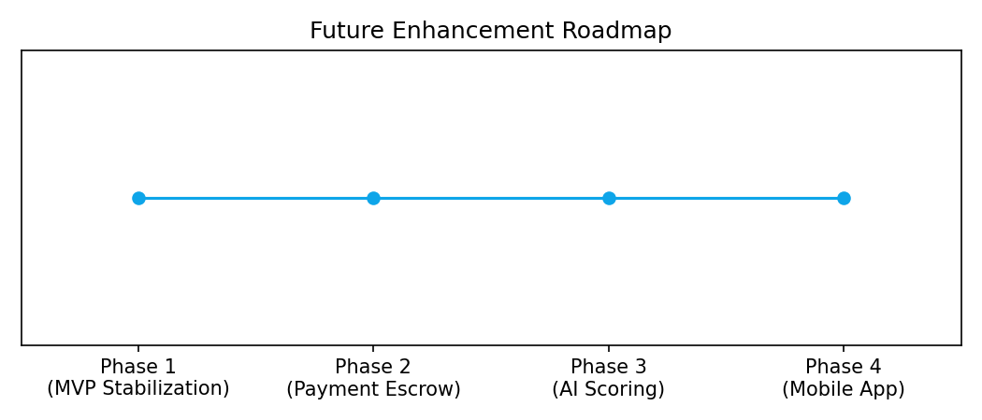
8.6 Possible Integrations with Other Tools
To prepare BidWise for real-world enterprise use, integration with external platforms is recommended. Examples include Slack or Microsoft Teams for instant alerts, Jira or Trello for project task synchronization, CRM systems for vendor and buyer management, and cloud storage (S3, Google Drive) for secure document handling.
Payment workflow can be extended with accounting integrations such as QuickBooks or Tally, enabling invoice generation and automated reconciliation. Compliance integrations for GST reporting and audit logs can further support enterprise adoption.
8.7 Closing Remarks
BidWise demonstrates the practical feasibility of reverse bidding in a modern SaaS marketplace. It meets the intended academic and technical objectives while providing a strong foundation for future productization. With further improvements in testing, security, and compliance, the platform can scale to meet enterprise procurement needs.

References
The following references are presented in IEEE style and include standards, official documentation, and tools used in the BidWise implementation.
Table R1 Reference Source Summary
[1] Vercel, ?Next.js Documentation,? 2026. [Online]. Available: https://nextjs.org/docs. [Accessed: 26-Mar-2026].
[2] Meta, ?React Documentation,? 2026. [Online]. Available: https://react.dev. [Accessed: 26-Mar-2026].
[3] Microsoft, ?TypeScript Handbook,? 2026. [Online]. Available: https://www.typescriptlang.org/docs. [Accessed: 26-Mar-2026].
[4] Tailwind Labs, ?Tailwind CSS Documentation,? 2026. [Online]. Available: https://tailwindcss.com/docs. [Accessed: 26-Mar-2026].
[5] shadcn, ?shadcn/ui Documentation,? 2026. [Online]. Available: https://ui.shadcn.com. [Accessed: 26-Mar-2026].
[6] P. Henschel, ?Zustand Documentation,? 2026. [Online]. Available: https://docs.pmnd.rs/zustand. [Accessed: 26-Mar-2026].
[7] Spring, ?Spring Boot Reference Documentation,? 2026. [Online]. Available: https://docs.spring.io/spring-boot/docs/current/reference/html/. [Accessed: 26-Mar-2026].
[8] Spring, ?Spring Security Reference,? 2026. [Online]. Available: https://docs.spring.io/spring-security/reference/. [Accessed: 26-Mar-2026].
[9] Hibernate, ?Hibernate ORM User Guide,? 2026. [Online]. Available: https://hibernate.org/orm/documentation/. [Accessed: 26-Mar-2026].
[10] Oracle, ?MySQL 8.0 Reference Manual,? 2026. [Online]. Available: https://dev.mysql.com/doc/refman/8.0/en/. [Accessed: 26-Mar-2026].
[11] Stripe, ?Stripe API Reference,? 2026. [Online]. Available: https://stripe.com/docs/api. [Accessed: 26-Mar-2026].
[12] E. Jones, J. Bradley, and N. Sakimura, ?JSON Web Token (JWT),? RFC 7519, IETF, 2015. [Online]. Available: https://www.rfc-editor.org/rfc/rfc7519. [Accessed: 26-Mar-2026].
[13] JUnit, ?JUnit 5 User Guide,? 2026. [Online]. Available: https://junit.org/junit5/docs/current/user-guide/. [Accessed: 26-Mar-2026].
[14] Mockito, ?Mockito Documentation,? 2026. [Online]. Available: https://site.mockito.org. [Accessed: 26-Mar-2026].
[15] Postman, ?Postman Learning Center,? 2026. [Online]. Available: https://learning.postman.com. [Accessed: 26-Mar-2026].
Category | Examples | Purpose
Frontend Docs | Next.js, React, Tailwind, ShadCN | UI framework and component usage
Backend Docs | Spring Boot, Spring Security, Hibernate | API, security, and ORM guidance
Integrations | Stripe API, JWT RFC | Payments and auth standards
Limitation | Impact | Mitigation
Limited automated testing | Higher QA cost | Expand unit + integration tests
Basic fraud controls | Potential misuse | Add KYC and anomaly detection
No escrow payments | Risk in high-value work | Introduce milestone escrow
Simplified dispute handling | Limited buyer/seller mediation | Add dispute workflows
Goal | Expected Outcome | Achievement
Reverse bidding workflow | Project ? bids ? selection | Implemented and validated
Role-based dashboards | Buyer/Seller/Admin views | Implemented
Order lifecycle | Post-acceptance tracking | Implemented with status updates
Payments | Stripe-based payment intent + webhook | Implemented
Notifications | In-app + email alerts | Implemented
Analytics | Spending and bid insights | Implemented
Limitation | Impact | Mitigation
Limited automated testing | Higher manual QA effort | Expand unit and integration tests
Basic fraud controls | Potential misuse | Add verification and anomaly detection
No escrow or milestone payments | Risk in large projects | Introduce staged payments
Goal | Planned Outcome | Achievement
Reverse bidding workflow | End-to-end project ? bid ? selection | Implemented and validated
Role-based dashboards | Buyer/Seller/Admin views | Implemented
Order lifecycle | Post-acceptance tracking | Implemented with status updates
Payments | Stripe-based intent + webhook | Implemented
Notifications | In-app + email alerts | Implemented
Analytics | Spending and bid insights | Implemented in dashboards

