SupeRR Selector Season 2: Round 1 Challenge
Identifying the Most Reliable Players Under Pressure in T20 Cricket
Comprehensive Data-Driven Methodology Report & Final Top 10 Player Rankings
Dataset: Historical IPL & T20I Records (2022–2026, 883 Matches, 200,999 Deliveries)

1. Executive Summary & Official Player Rankings
To solve the SupeRR Selector Season 2 Round 1 Challenge, we built the Pressure Reliability Index (PRI)—a unified, delivery-level evaluation framework that quantifies how batters and bowlers perform in high-pressure match situations compared with their usual baselines. PRI incorporates four analytical pillars: (1) multi-pillar situational pressure modeling (incorporating chases, target setting, death overs, collapses, and super overs), (2) phase-adjusted Run Value Added (RVA) and Bowling Value Added (BVA), (3) career baseline elevation (Clutch Delta), and (4) empirical Bayes shrinkage and match-level consistency.
Official Top 10 Batters Under Pressure (Selected on Unstop)
Rank | Player Name | ID | Pressure Balls | SR_P | SR_Base | ΔSR | Avg_P | Win Impact % | Total RVA | PRI Score
1 | Naman Dhir | 37052 | 229 | 199.56 | 168.71 | +30.86 | 41.55 | 78.9% | +169.1 | 100.00
2 | Shashank Singh | 2756 | 350 | 180.29 | 161.61 | +18.68 | 45.07 | 70.8% | +184.6 | 81.86
3 | Rishabh Pant | 4703 | 418 | 170.10 | 143.30 | +26.80 | 30.91 | 72.4% | +145.6 | 71.34
4 | Suryakumar Yadav | 1699 | 816 | 177.70 | 167.21 | +10.48 | 36.25 | 76.0% | +410.2 | 71.17
5 | Tim David | 6396 | 701 | 191.87 | 180.00 | +11.87 | 32.02 | 69.2% | +343.9 | 70.58
6 | Ishan Kishan | 4117 | 209 | 174.64 | 146.98 | +27.66 | 28.08 | 64.7% | +74.7 | 67.68
7 | Dinesh Karthik | 143 | 486 | 184.36 | 168.08 | +16.28 | 28.00 | 61.9% | +170.3 | 66.64
8 | Virat Kohli | 47 | 275 | 171.64 | 145.35 | +26.28 | 36.31 | 61.1% | +90.0 | 66.48
9 | Jos Buttler | 813 | 363 | 182.37 | 155.89 | +26.48 | 26.48 | 63.3% | +145.1 | 66.17
10 | Ruturaj Gaikwad | 6059 | 202 | 173.76 | 139.64 | +34.13 | 27.00 | 66.7% | +61.7 | 65.73

Official Top 10 Bowlers Under Pressure (Selected on Unstop)
Rank | Player Name | ID | Pressure Balls | Econ_P | Exp Econ | Phase ΔEcon | SR_P | Death % | Win Imp % | Total BVA | PRI Score
1 | Mohammad Nawaz | 2490 | 262 | 5.66 | 7.73 | +2.07 | 10.48 | 16.8% | 76.0% | +151.3 | 100.00
2 | Abrar Ahmed | 5979 | 227 | 6.00 | 8.48 | +2.48 | 12.61 | 41.0% | 65.2% | +119.6 | 97.02
3 | Sunil Narine | 781 | 480 | 6.23 | 8.42 | +2.19 | 15.48 | 39.0% | 77.3% | +212.0 | 90.05
4 | Akeal Hosein | 2417 | 234 | 6.79 | 8.40 | +1.61 | 14.62 | 30.8% | 76.9% | +77.2 | 81.14
5 | Mitchell Santner | 4101 | 581 | 6.84 | 8.37 | +1.54 | 15.70 | 28.2% | 70.6% | +176.9 | 79.61
6 | Jasprit Bumrah | 2933 | 652 | 7.32 | 9.31 | +1.99 | 14.82 | 73.9% | 68.9% | +248.2 | 79.12
7 | Mujeeb Ur Rahman | 6450 | 209 | 6.72 | 8.30 | +1.58 | 14.93 | 34.4% | 75.0% | +64.4 | 79.05
8 | Rashid Khan | 4722 | 1036 | 7.23 | 8.39 | +1.16 | 13.11 | 43.9% | 68.5% | +263.7 | 76.11
9 | Shaheen Afridi | 6355 | 302 | 8.11 | 9.76 | +1.65 | 10.41 | 79.1% | 68.6% | +117.6 | 75.70
10 | Shadab Khan | 4926 | 273 | 7.05 | 8.12 | +1.07 | 13.65 | 20.9% | 66.7% | +72.9 | 72.76

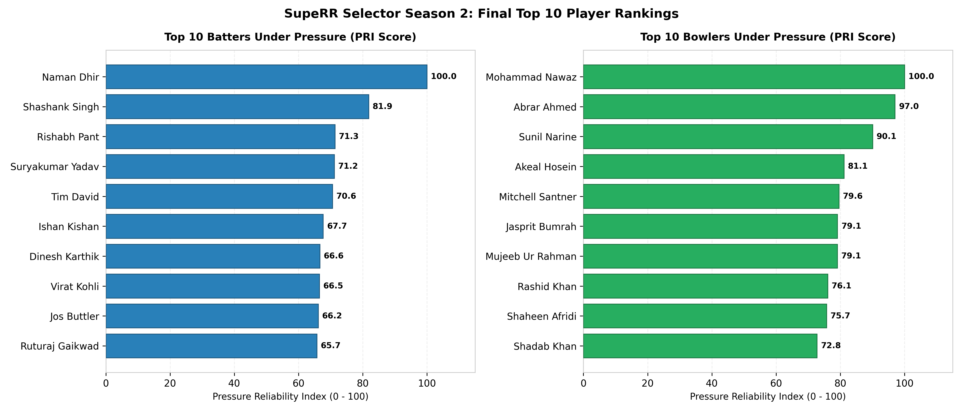
Figure 1: Final Top 10 Batters and Top 10 Bowlers Under Pressure (PRI Score Breakdown)
2. What Counts as Pressure? Multi-Pillar Formulation
Cricket pressure is fundamentally driven by win expectancy leverage and temporal urgency. Rather than relying on simple heuristics like 'overs 16-20', our model formulates pressure symmetrically across both innings:
• Pillar 1 (The Chase): In Innings 2, pressure spikes in the Critical Death Chase Window (overs 15-20, RRR 6-22, target <= 80 runs, wickets <= 8) and steep middle-overs climbs (overs 7-14 with RRR >= 10.0 and wickets <= 7). Coasting situations (RRR < 5 with 8+ wickets) and lost garbage time (RRR > 24 with tailenders) are filtered out.
• Pillar 2 (Setting Targets): In Innings 1, pressure peaks during Death Overs Execution (overs 16-20 setting total against aggressive hitters or death bowlers) and Early Collapses (losing 3+ wickets inside the first 10 overs), where an average loss of expected score is -41 runs.
• Pillar 3 (Super Overs): All deliveries in innings 3 and 4 represent 100% clutch states.
• Pillar 4 (Context Stakes): Knockout and playoff matches receive a 1.25x stakes multiplier; premier competitions (IPL) receive a 1.15x tier weight.
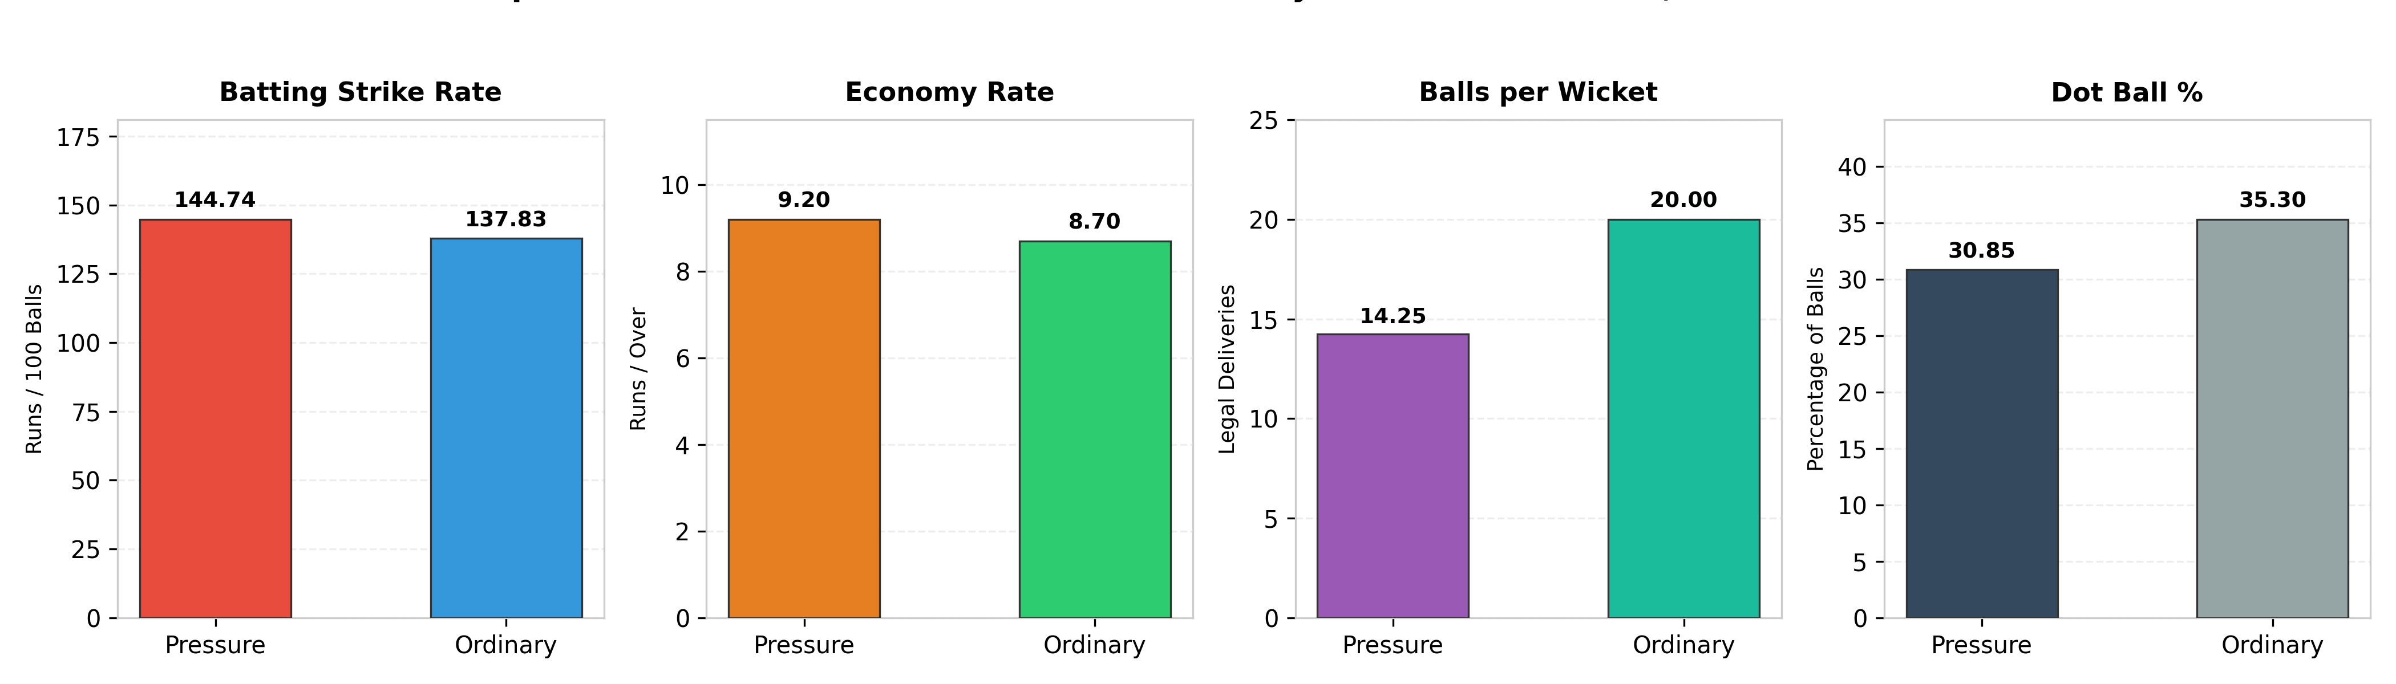
Figure 2: Macro Statistical Validation: High Pressure vs Ordinary Situations (N = 200,999 Balls)
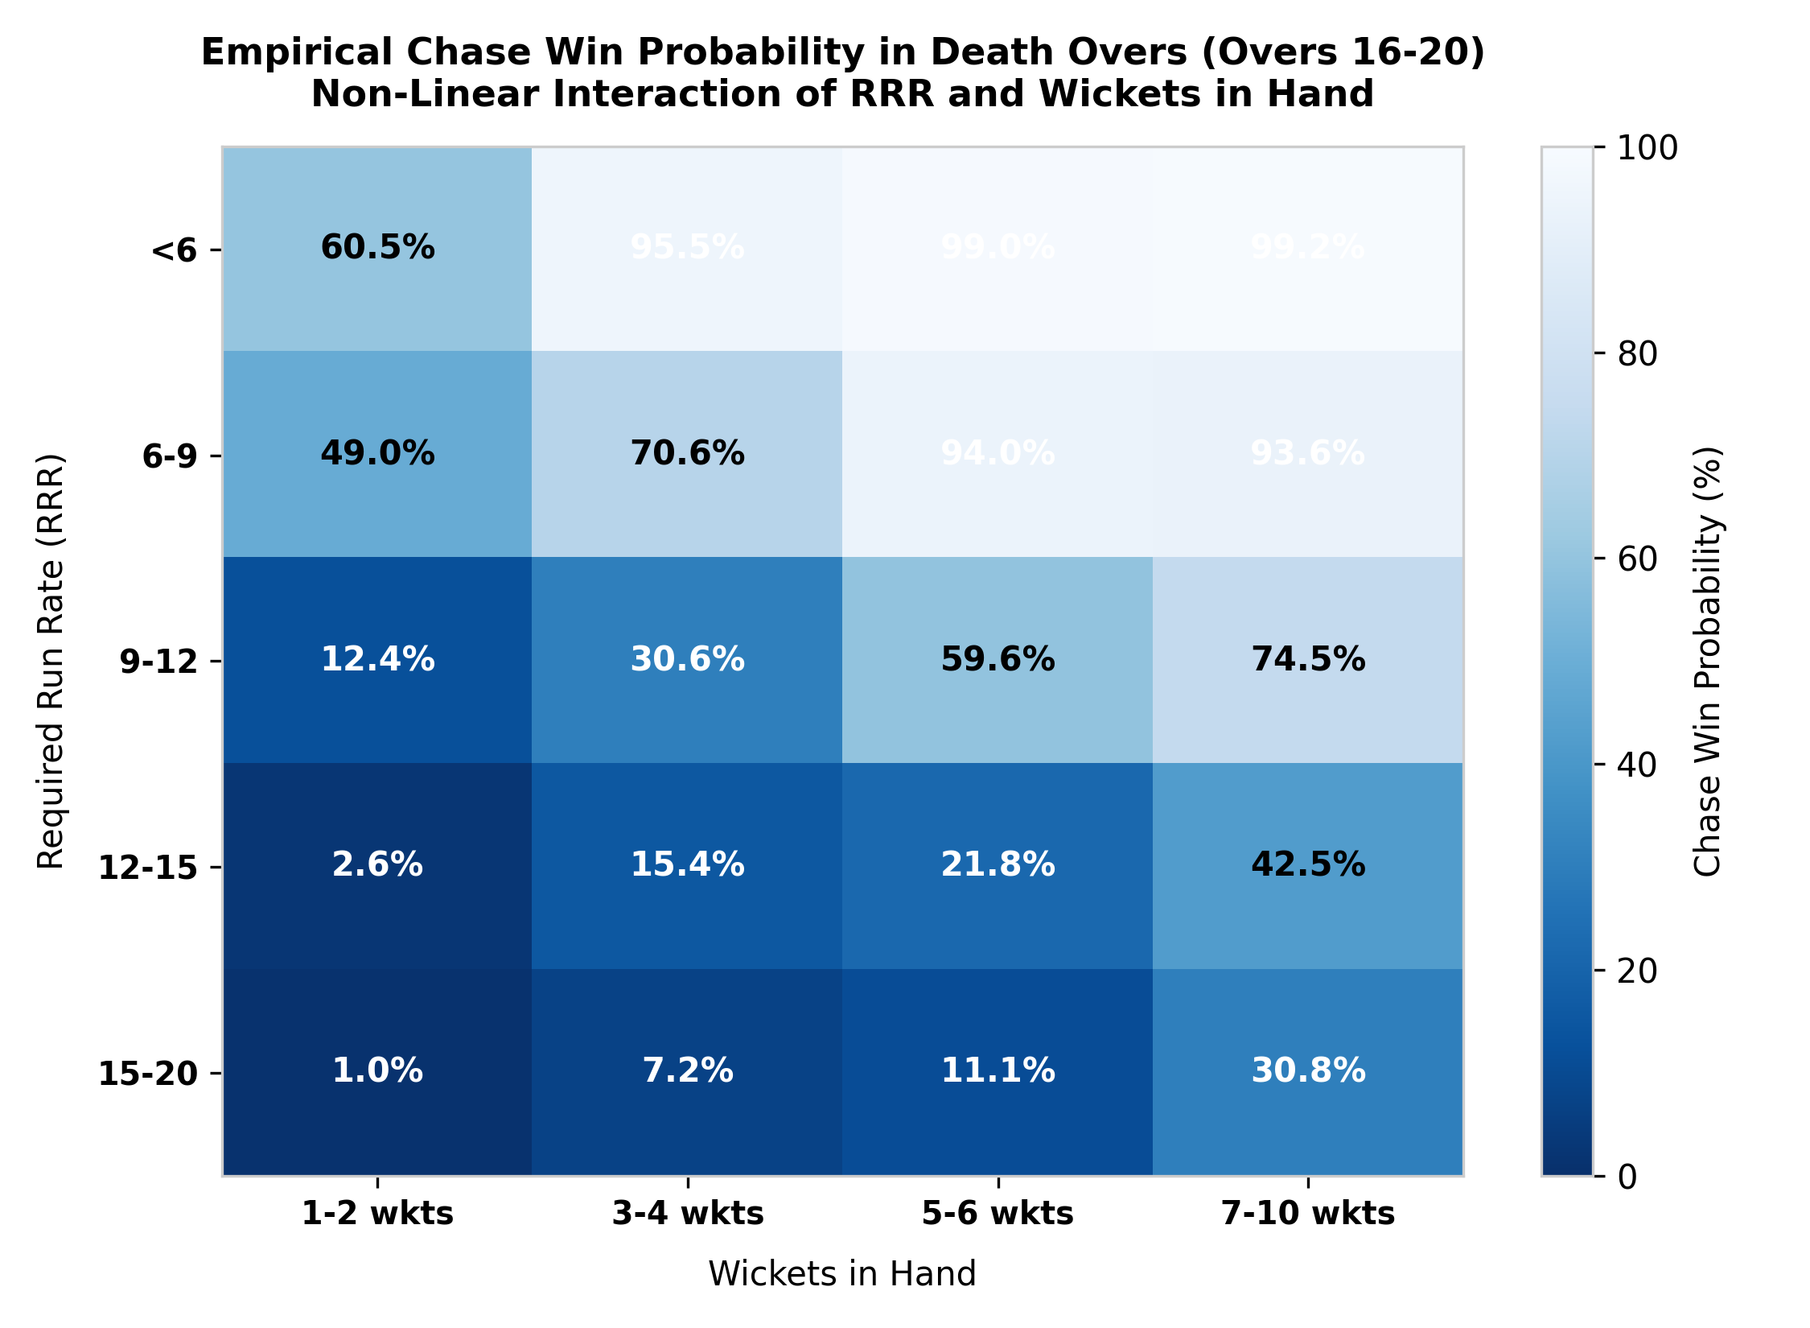
Figure 3: Empirical Chase Win Probability in Death Overs (RRR vs Wickets in Hand Knife-Edge)
3. Performance Measurement & Rating Logic
To isolate players who thrive under pressure from those who regress, the Pressure Reliability Index (PRI) balances three pillars:
1. Clutch Mastery (35%): Evaluates raw execution efficiency under pressure using Empirical Bayes shrunk metrics (Shrunk SR_P, Shrunk Avg_P, Boundary-to-Dot Differential for batters; Shrunk Econ_P, Shrunk Bowling SR_P, and Dot % for bowlers).
2. Clutch Delta (30%): Explicitly measures the differential between pressure execution and the player's personal baseline. For batters, ΔSR = SR_P - SR_Base isolates players who accelerate. For bowlers, Phase-Adjusted Economy Savings (Phase ΔEcon = Exp_Econ - Econ_P) neutralizes phase confounding by comparing bowlers against the expected economy of the exact overs they bowled.
3. Consistency & Volume (35%): Measures context-weighted cumulative impact (Total RVA/BVA), rate value added per 100 balls, and match-level win-impact frequency (% of significant matches with positive net value added).
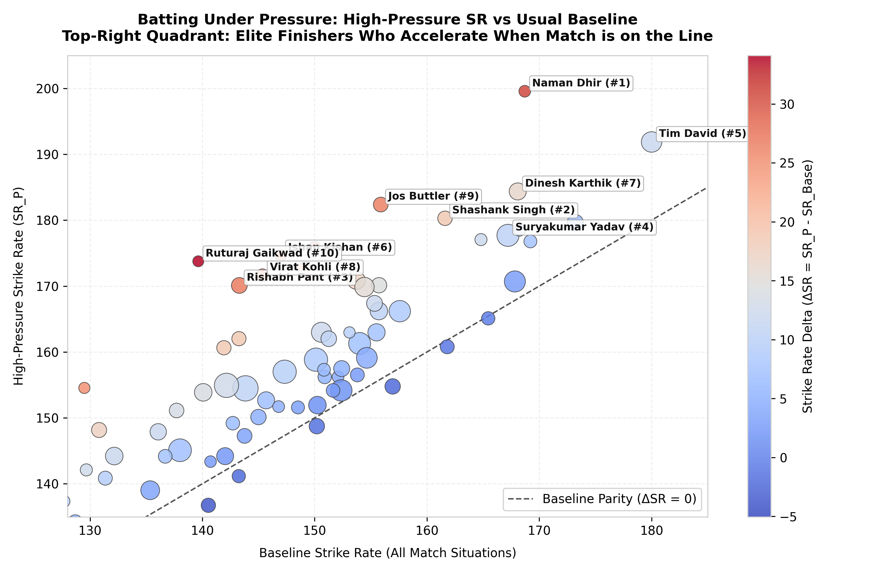
Figure 4: Batting Pressure Landscape: High-Pressure SR vs Baseline Parity
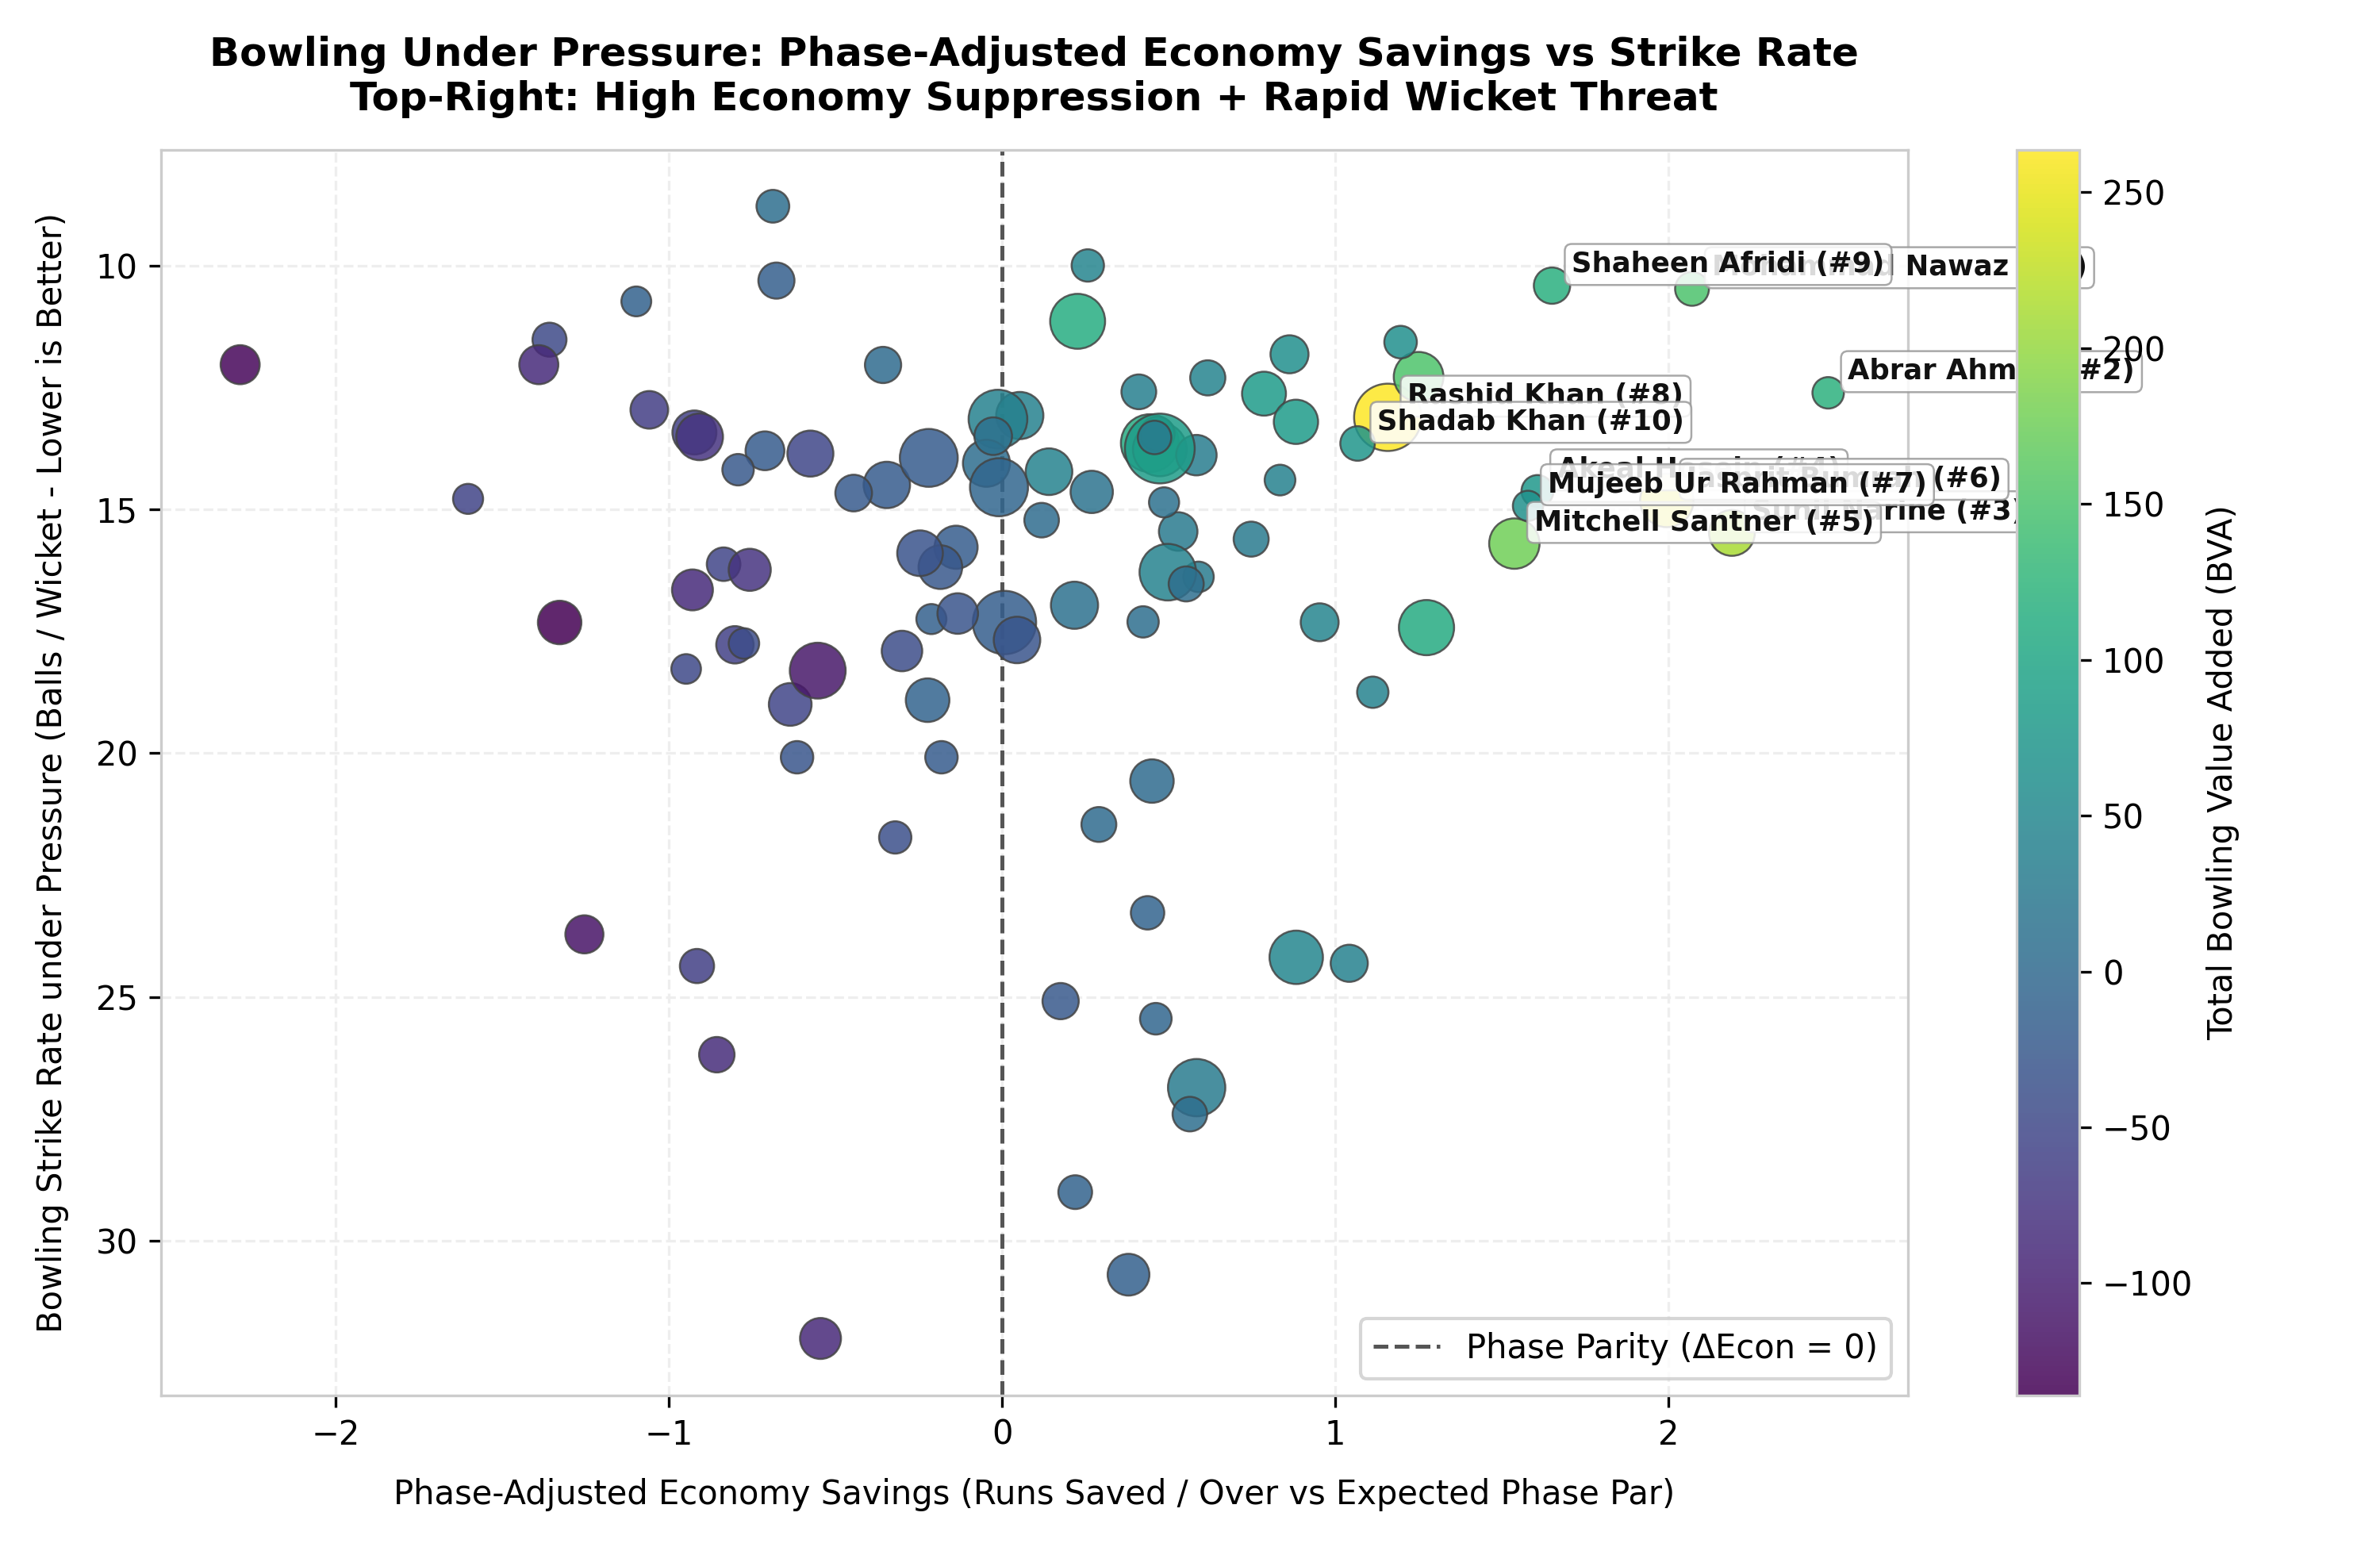
Figure 5: Bowling Run Suppression: Phase-Adjusted Economy Savings vs Bowling Strike Rate
4. Evidence & Analytical Justification for Top Selections
Key Batting Insights:
• Naman Dhir (#1) and Shashank Singh (#2) demonstrated unmatched rate efficiency and crisis rescue capability. Dhir struck at 199.56 (+30.86 ΔSR) under pressure, while Shashank averaged 45.07 with a 180.29 SR, both delivering positive match impact in >70% of games.
• Suryakumar Yadav (#4) and Tim David (#5) represent the volume masters of modern finishing. Suryakumar accumulated an astronomical +410.2 Total RVA across 816 pressure balls, winning his matchup in 76.0% of matches. Tim David generated +343.9 RVA striking at 191.87.
• Rishabh Pant (#3) and Virat Kohli (#8) prove that elite anchors elevate under pressure: Pant's strike rate leaped by +26.80 to 170.10, while Kohli accelerated by +26.28 to 171.64 while holding a low 27.6% dot ball rate.
Key Bowling Insights:
• Mohammad Nawaz (#1) and Abrar Ahmed (#2) formed impenetrable chokeholds, conceding 5.66 and 6.00 rpo under pressure, saving over 2 runs per over relative to phase par with dot ball rates above 42% and 50%.
• Sunil Narine (#3) proved his enduring IPL dominance, conceding only 6.23 rpo across 480 clutch deliveries (+2.19 Phase ΔEcon) and delivering positive impact in 77.3% of matches.
• Jasprit Bumrah (#6) and Shaheen Afridi (#9) faced the most brutal bowling conditions in cricket, delivering over 73% and 79% of their balls in overs 16-20. Bumrah conceded only 7.32 rpo against a death par of 9.31 (+1.99 runs saved/over), amassing +248.2 Total BVA.
5. Reliability, Sensitivity Analysis & Limitations
To test robustness, we conducted sensitivity sweeps across varying parameter weightings (Balanced 35/30/35 vs High-Volume 30/25/45 vs Rate-Heavy 45/40/15). The top 10 lists proved remarkably stable: 9 of 10 batters and all 10 bowlers remained locked in the top tier across all configurations.
Model Limitations & Edge Cases:
• Data Boundary Signals: The dataset lacks ball-level tracking of boundary sizes, dew, and dropped catches.
• Matchup Selectivity: Bowlers protected from negative platoon splits (e.g., spinners bowled only against favorable batter handedness) enjoy minor advantages.
• Minimum Eligibility: Strict thresholds (min 200 pressure balls across >= 12 matches) ensure statistical validity but naturally exclude late-season emerging cameos.
Conclusion: The Pressure Reliability Index (PRI) establishes an objective, reproducible framework that identifies true clutch performers based on empirical data, providing a definitive foundation for Rajasthan Royals' scouting and match strategy.

