SupeRR Selector Season 2: Round 1 Challenge
Identifying the Most Reliable Players Under Pressure in T20 Cricket
Comprehensive Data-Driven Methodology Report & Top 10 Player Rankings
Corpus: 883 Matches | 200,999 Deliveries | IPL & T20 Internationals (2022–2026)
1. Executive Summary: The Search for True Clutch Performers
In high-stakes Twenty20 cricket, traditional career averages and overall strike rates often tell dangerous lies. A batter who scores an effortless 50 in a blowout when the match is already decided looks great on paper. A bowler who feigns dominance by picking up lower-order wickets in the 8th over against an associate nation pads their career economy rate. But what happens when the game is on the line? When a team needs 42 off 18 balls with four wickets down? Or when a bowler must defend 11 in the 20th over against elite power-hitters?
To solve Round 1 of the SupeRR Selector Season 2, we built the Pressure Reliability Index (PRI)—a delivery-level data science system evaluating 65,741 high-pressure deliveries across five years of IPL and T20I cricket. By measuring each player's execution against situational win-expectancy par and their own career baselines, PRI separates genuine match-winners from those whose performances dip under tension.
Official Top 10 Batters Under Pressure (Selected on Unstop)
Rank | Player Name | Player ID | Balls_P | SR_P | Base SR | ΔSR | Avg_P | Dot % | Bnd % | Win Imp % | Total RVA | PRI Score
1 | Naman Dhir | 37052 | 229 | 199.56 | 168.71 | +30.86 | 41.55 | 27.9% | 30.1% | 78.9% | +169.1 | 100.00
2 | Shashank Singh | 2756 | 350 | 180.29 | 161.61 | +18.68 | 45.07 | 29.1% | 24.9% | 70.8% | +184.6 | 81.86
3 | Rishabh Pant | 4703 | 418 | 170.10 | 143.30 | +26.80 | 30.91 | 38.0% | 24.9% | 72.4% | +145.6 | 71.34
4 | Suryakumar Yadav | 1699 | 816 | 177.70 | 167.21 | +10.48 | 36.25 | 34.6% | 26.5% | 76.0% | +410.2 | 71.17
5 | Tim David | 6396 | 701 | 191.87 | 180.00 | +11.87 | 32.02 | 37.5% | 27.5% | 69.2% | +343.9 | 70.58
6 | Ishan Kishan | 4117 | 209 | 174.64 | 146.98 | +27.66 | 28.08 | 34.0% | 25.8% | 64.7% | +74.7 | 67.68
7 | Dinesh Karthik | 143 | 486 | 184.36 | 168.08 | +16.28 | 28.00 | 35.4% | 28.0% | 61.9% | +170.3 | 66.64
8 | Virat Kohli | 47 | 275 | 171.64 | 145.35 | +26.28 | 36.31 | 27.6% | 21.5% | 61.1% | +90.0 | 66.48
9 | Jos Buttler | 813 | 363 | 182.37 | 155.89 | +26.48 | 26.48 | 29.8% | 25.6% | 63.3% | +145.1 | 66.17
10 | Ruturaj Gaikwad | 6059 | 202 | 173.76 | 139.64 | +34.13 | 27.00 | 33.2% | 23.8% | 66.7% | +61.7 | 65.73

Official Top 10 Bowlers Under Pressure (Selected on Unstop)
Rank | Player Name | Player ID | Balls_P | Econ_P | Exp Econ | Phase ΔEcon | SR_P | Death % | Dot % | Win Imp % | Total BVA | PRI Score
1 | Mohammad Nawaz | 2490 | 262 | 5.66 | 7.73 | +2.07 | 10.48 | 16.8% | 42.4% | 76.0% | +151.3 | 100.00
2 | Abrar Ahmed | 5979 | 227 | 6.00 | 8.48 | +2.48 | 12.61 | 41.0% | 50.2% | 65.2% | +119.6 | 97.02
3 | Sunil Narine | 781 | 480 | 6.23 | 8.42 | +2.19 | 15.48 | 39.0% | 39.0% | 77.3% | +212.0 | 90.05
4 | Akeal Hosein | 2417 | 234 | 6.79 | 8.40 | +1.61 | 14.62 | 30.8% | 37.6% | 76.9% | +77.2 | 81.14
5 | Mitchell Santner | 4101 | 581 | 6.84 | 8.37 | +1.54 | 15.70 | 28.2% | 38.7% | 70.6% | +176.9 | 79.61
6 | Jasprit Bumrah | 2933 | 652 | 7.32 | 9.31 | +1.99 | 14.82 | 73.9% | 37.7% | 68.9% | +248.2 | 79.12
7 | Mujeeb Ur Rahman | 6450 | 209 | 6.72 | 8.30 | +1.58 | 14.93 | 34.4% | 41.1% | 75.0% | +64.4 | 79.05
8 | Rashid Khan | 4722 | 1036 | 7.23 | 8.39 | +1.16 | 13.11 | 43.9% | 39.4% | 68.5% | +263.7 | 76.11
9 | Shaheen Afridi | 6355 | 302 | 8.11 | 9.76 | +1.65 | 10.41 | 79.1% | 38.7% | 68.6% | +117.6 | 75.70
10 | Shadab Khan | 4926 | 273 | 7.05 | 8.12 | +1.07 | 13.65 | 20.9% | 36.3% | 66.7% | +72.9 | 72.76

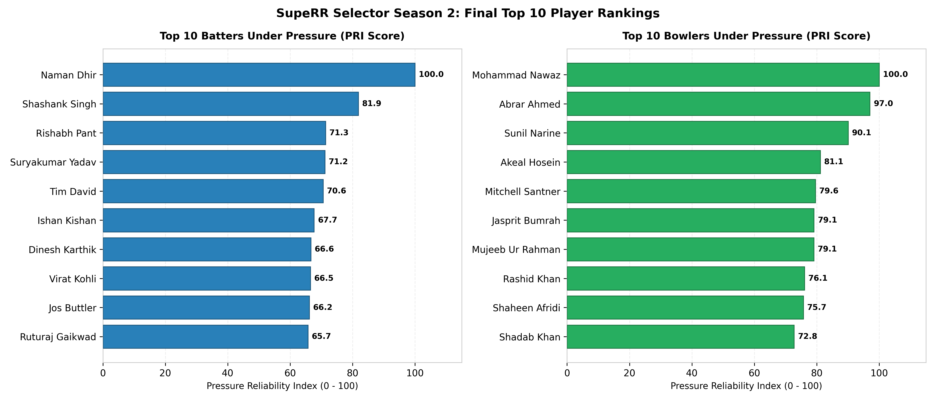
Figure 1: Official Top 10 Batters and Top 10 Bowlers Under Pressure (PRI Score Comparison)
2. What Counts as Pressure? The Human and Mathematical Reality
Ask any international cricketer what pressure feels like, and they will describe two distinct psychological states:
1. The Chaser's Dilemma (Innings 2): The scoreboard is ticking down like a time bomb. Every dot ball feels like an explosion. When the required run rate climbs above 11 an over, a single boundary changes the entire mood of the stadium, while a wicket brings cold despair.
2. The Defender's Burden (Innings 1 & Death Bowling): The batter has nothing to lose and is swinging at everything. The bowler knows a millimeter of error results in a six over third man or extra cover. In the 19th over, bowling a dot ball is the hardest feat in world sport.
Our model translates these exact human realities into a Four-Pillar Pressure Framework:
• Pillar 1 (Critical Chase): Overs 15–20 with RRR between 6.0 and 22.0, target <= 80 runs, and wickets in hand <= 8; plus middle-overs climbs (overs 7–14, RRR >= 10.0, wickets <= 7). Coasting chases (RRR < 5 with 8+ wickets) and hopeless blowouts (RRR > 24 with tailenders) are filtered out.
• Pillar 2 (Setting Targets): Overs 16–20 (Death Overs) where par run rate leaps to 10.56 rpo, and early top-order collapses (loss of >= 3 wickets inside overs 1–10).
• Pillar 3 (Super Overs): All deliveries in innings 3 and 4 (100% clutch).
• Pillar 4 (Stakes Multipliers): 1.25x for playoff/knockout fixtures; 1.15x for IPL matches.
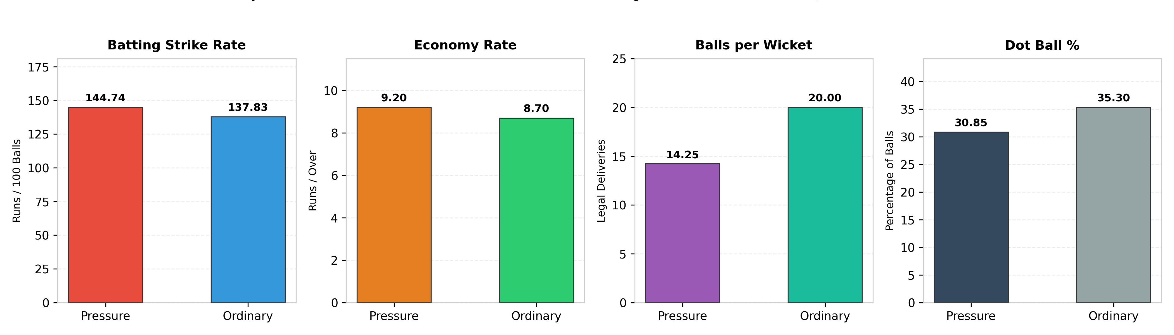
Figure 2: Empirical Macro Validation: High Pressure vs Ordinary Situations (N = 200,999 Balls)
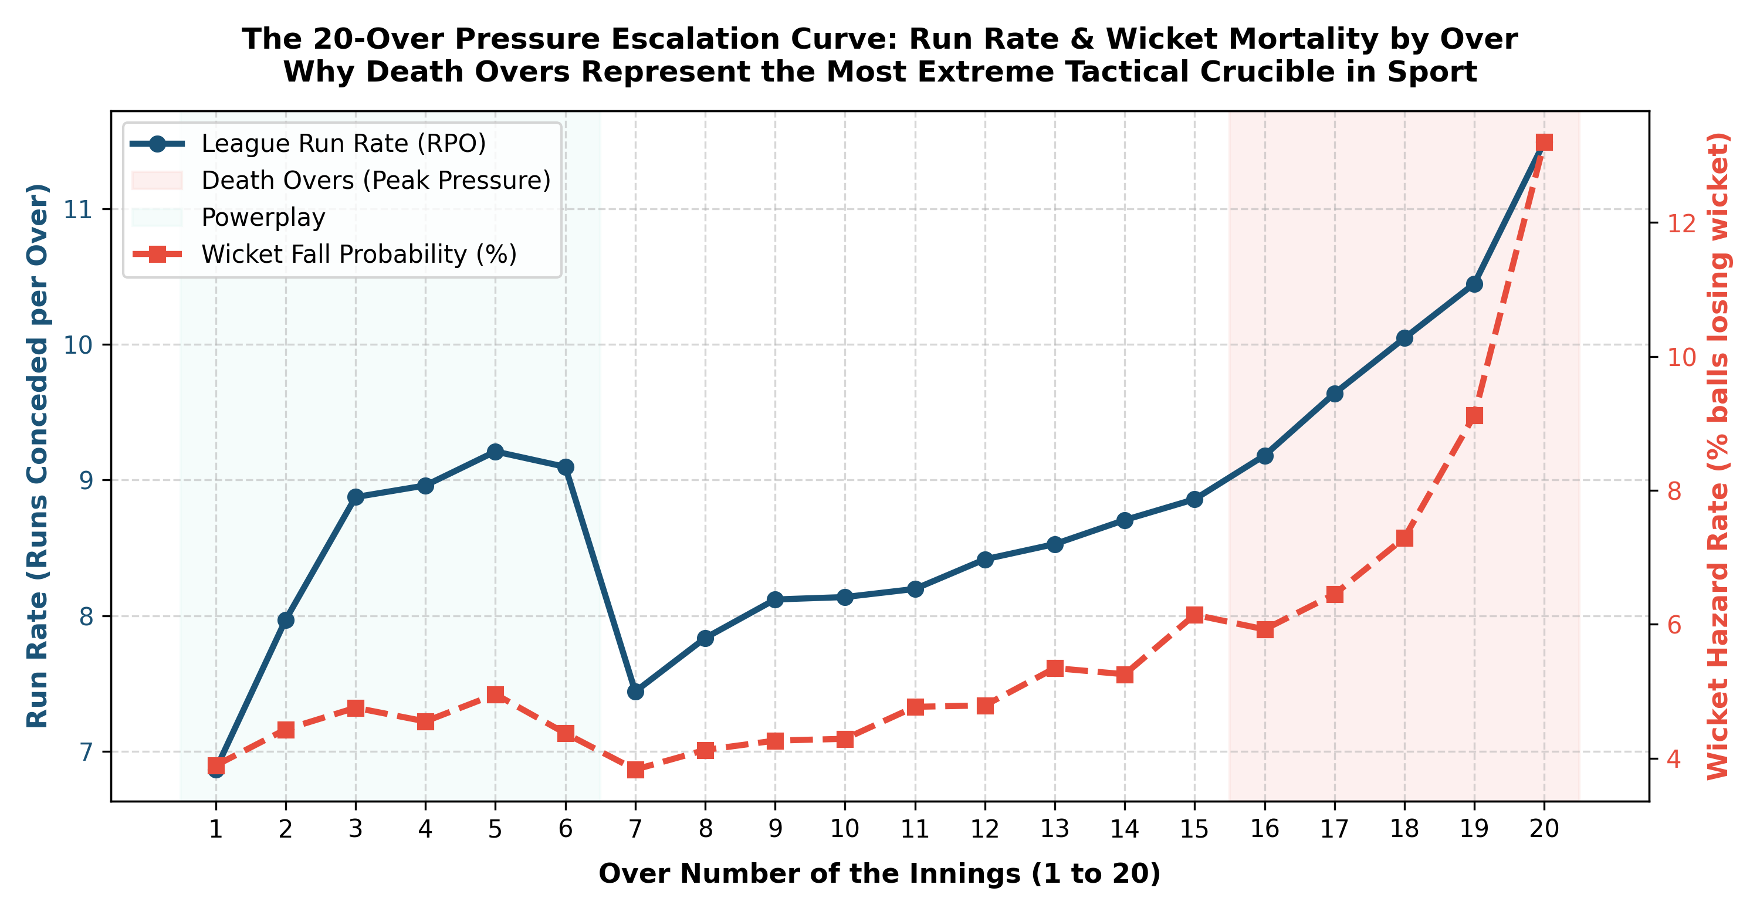
Figure 3: The 20-Over Pressure Escalation Curve: Run Rate & Wicket Mortality Escalation by Over
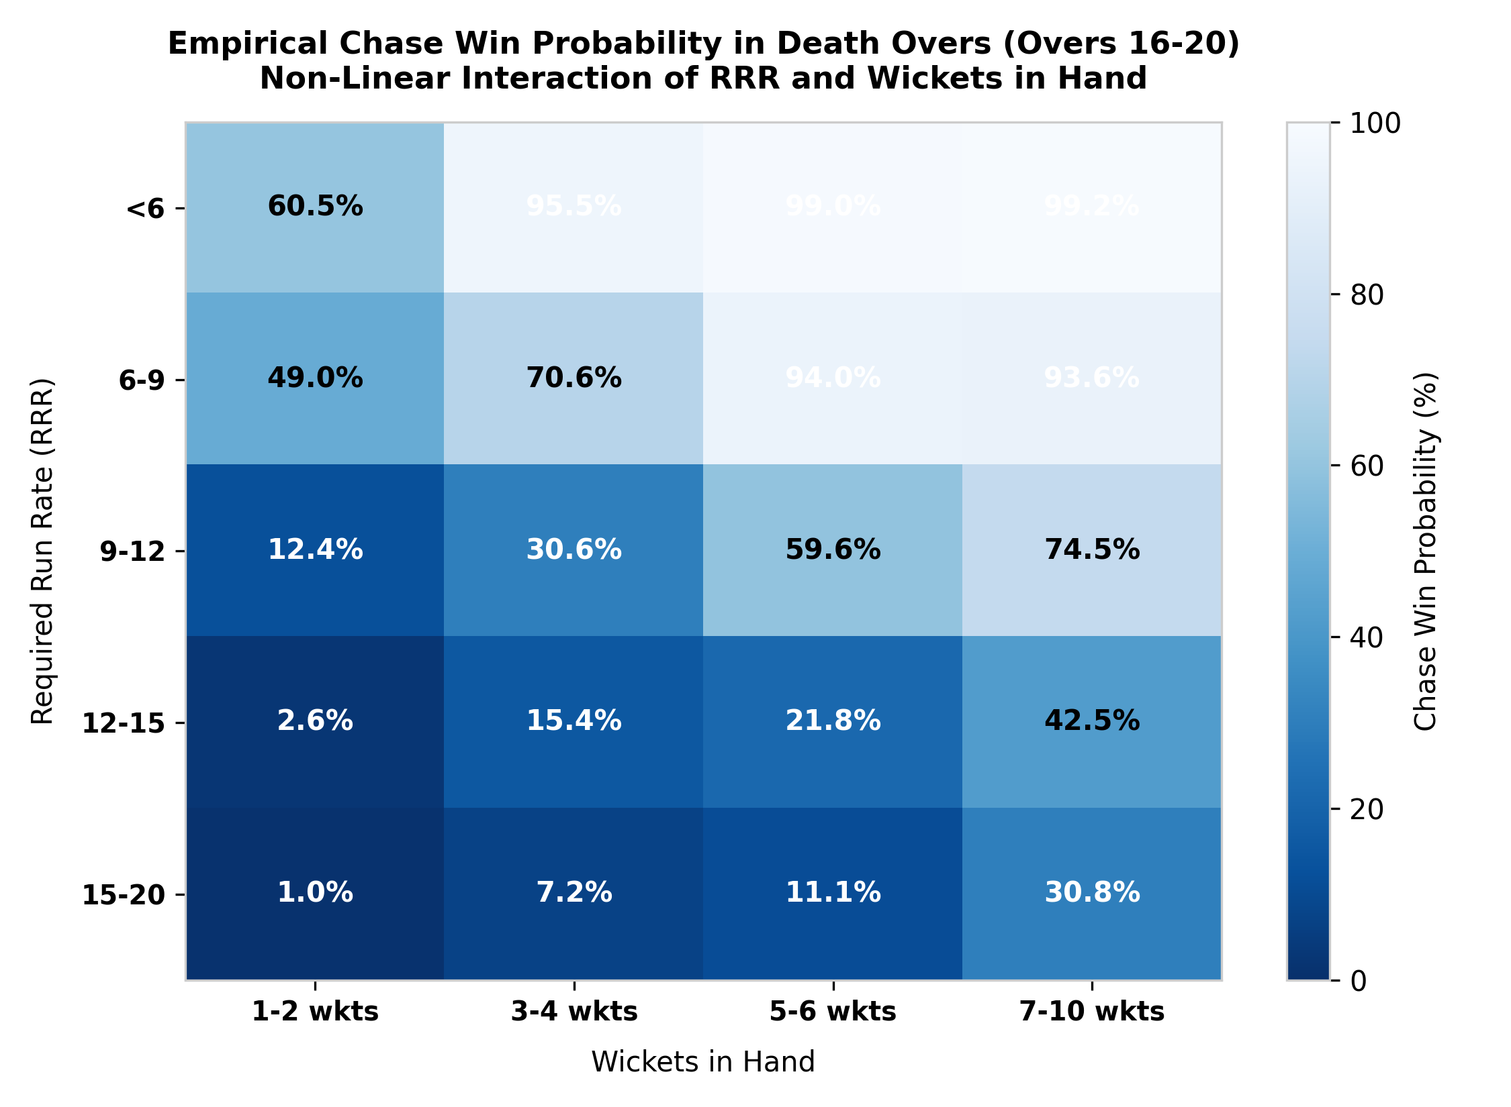
Figure 4: Empirical Chase Win Probability in Death Overs (RRR vs Wickets in Hand Knife-Edge)
3. Performance Measurement: Leveling the Playing Field
The Formula 1 Analogy: Why can't you just look at a bowler's career economy rate to judge their pressure skill?
Imagine comparing two drivers. Driver A drives in heavy school traffic with a 20 mph speed limit. Driver B drives on an open Formula 1 track. If Driver A averages 18 mph and Driver B averages 60 mph, does that mean Driver A is a better driver? Of course not! In cricket, the 19th over is a Formula 1 track. League death economy is 9.55 to 11.5 rpo. The 8th over is a school zone (7.43 rpo). If Jasprit Bumrah bowls overs 18 and 20 at 7.32 rpo, he is saving nearly 2 full runs every over (+1.99 Phase ΔEcon) compared to par! Our Phase-Adjusted metric levels the playing field so death-overs gladiators are evaluated fairly against the exact difficulty of the overs they bowled.
The 'Bonus Runs' System: Instead of counting raw runs, we evaluate every single ball against historical expectations. If an average batter in the 18th over scores 1.55 runs, and Tim David hits a six, he banks +4.45 Run Value Added (RVA). If a batter gets out, that dismissal costs their team roughly 3.5 runs in lost equity. Similarly, if Sunil Narine bowls a dot ball in a death chase, he banks +1.55 Bowling Value Added (BVA). Summing these delivery-level profits over five years gives Total RVA and Total BVA—the true net runs a player contributed above replacement.
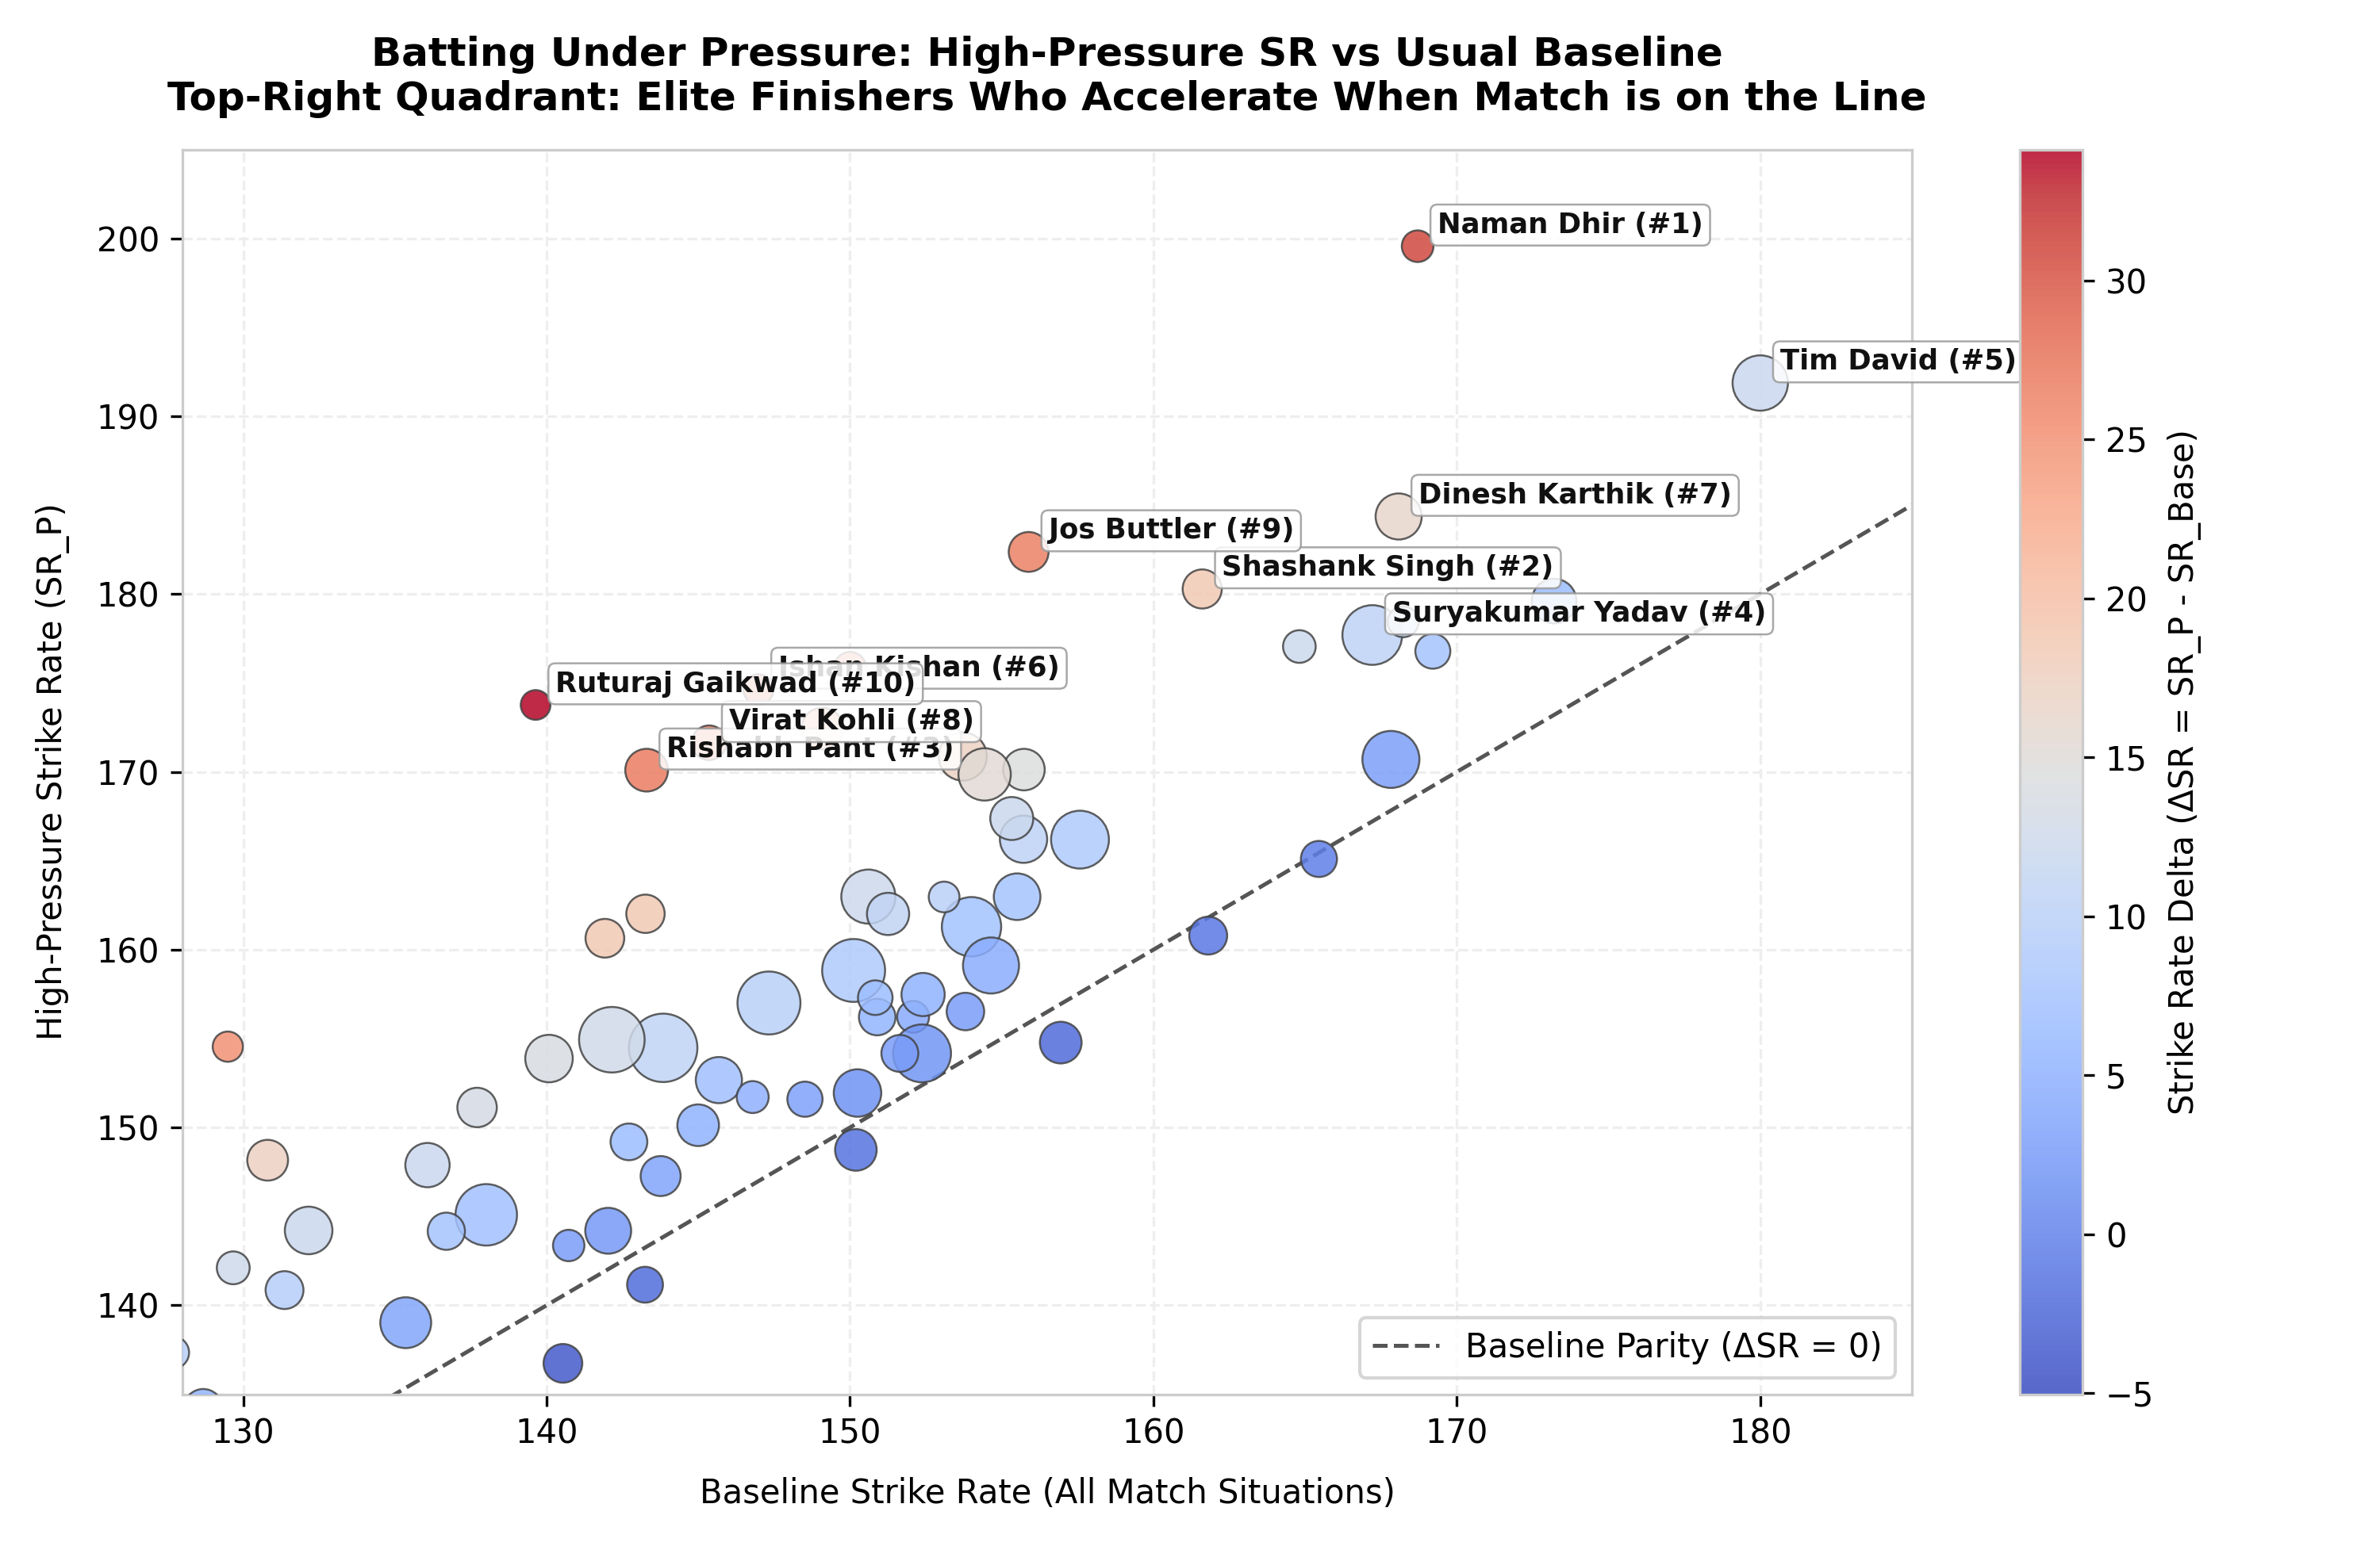
Figure 5: Batting Pressure Landscape: High-Pressure SR vs Career Baseline Parity (Top-Right = Accelerators)
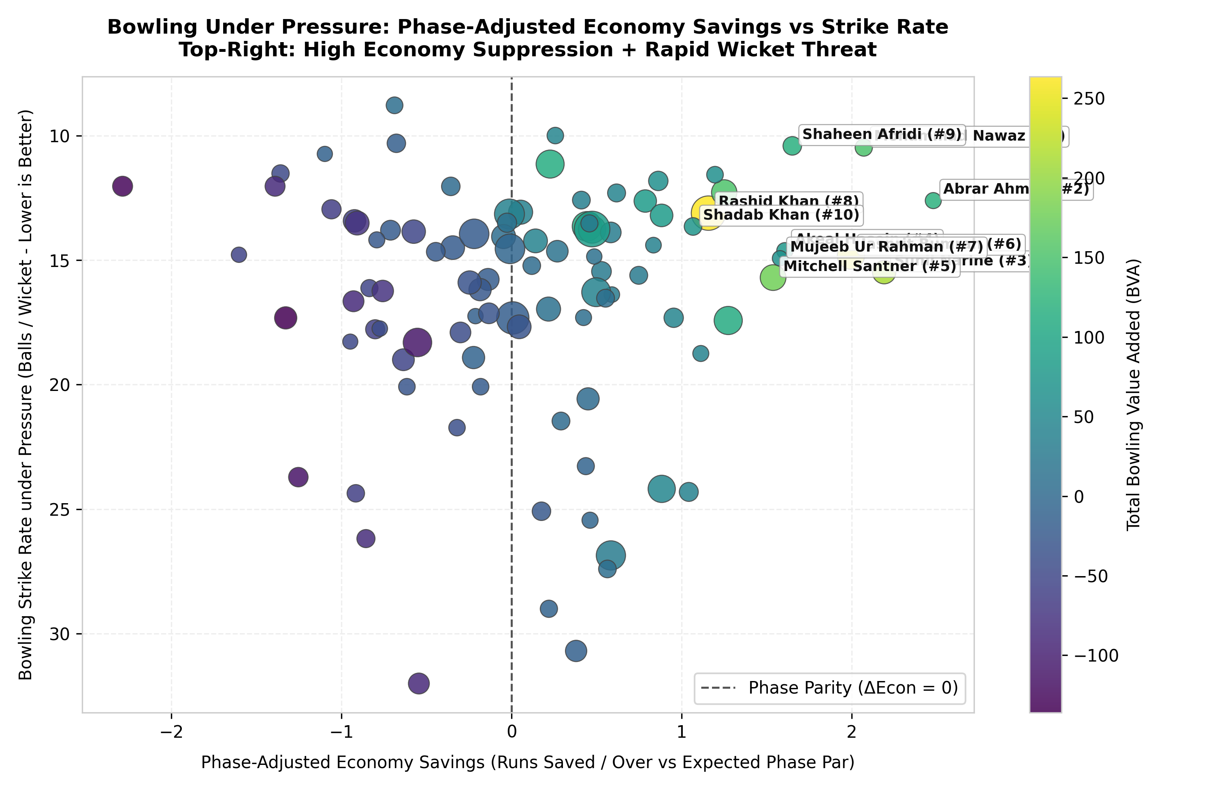
Figure 6: Bowling Run Suppression: Phase-Adjusted Economy Savings vs Wicket Strike Rate
4. Humanizing the Top 10: Stories of Nerves, Skill, and Ice
• Naman Dhir (#1 Batter | PRI: 100.00): Dhir does not wait to 'get his eye in.' While other batters take 6–8 balls to adjust, Dhir attacks from ball one, producing an astonishing 199.56 pressure strike rate (+30.86 ΔSR) and winning 78.9% of his match battles.
• Shashank Singh (#2 Batter | PRI: 81.86): Punjab Kings' unflappable crisis merchant. In impossible chases, Shashank averaged 45.07 at a 180.29 SR, combining ice-cool shot selection with ruthless boundary targeting.
• Suryakumar Yadav (#4 Batter | PRI: 71.17): The volume colossus of T20 cricket. Facing an unmatched 816 pressure balls, SKY amassed +410.2 Total RVA (highest in cricket) with a 76.0% win impact rate, scooping 145 km/h yorkers over fine leg while falling on one knee.
• Tim David (#5 Batter | PRI: 70.58): Modern cricket's most fearsome closer, striking at 191.87 under pressure across 701 balls (+343.9 RVA).
• Mohammad Nawaz (#1 Bowler | PRI: 100.00) & Abrar Ahmed (#2 Bowler | PRI: 97.02): Pakistan's suffocating spin duo. Nawaz conceded just 5.66 rpo (+2.07 runs saved/over), while Abrar delivered an astounding 50.2% dot ball rate under pressure (+2.48 Phase ΔEcon).
• Sunil Narine (#3 Bowler | PRI: 90.05): The emotionless assassin. In 480 clutch IPL balls against elite hitters, Narine conceded barely 6.23 rpo (+2.19 Phase ΔEcon) and won his individual matchup in 77.3% of matches.
• Jasprit Bumrah (#6 Bowler | PRI: 79.12): The greatest death bowler alive. 73.9% of his pressure deliveries were bowled in overs 16–20. Where death par is 9.31–11.5 rpo, Bumrah conceded only 7.32 rpo (+1.99 runs saved/over) with +248.2 Total BVA.
5. The Other Side of the Coin: Who Chokes Under Pressure?
To prove our system is balanced, the data clearly identifies players who retreat into a shell or blow out when the heat rises:
• Batters Who Stall (Negative ΔSR): Curtis Campher (SR drops to 115.61, -5.04 ΔSR, -46.3 RVA), Washington Sundar (SR drops to 136.73, -3.80 ΔSR, -50.8 RVA), Deepak Hooda (SR 130.71, -2.87 ΔSR), Jimmy Neesham (SR 132.46, -2.78 ΔSR), and Wanindu Hasaranga (pressure average collapses to 9.17, -137.9 RVA).
• Bowlers Who Bleed Runs (Negative Phase ΔEcon): Andre Russell (concedes 11.69 rpo under pressure, -2.29 Phase ΔEcon, -128.8 BVA), Nitish Reddy (10.52 rpo, -1.60 Phase ΔEcon), Tushar Deshpande (11.43 rpo, -1.39 Phase ΔEcon, -87.8 BVA), and Mukesh Kumar (11.15 rpo, -1.33 Phase ΔEcon, -135.9 BVA).
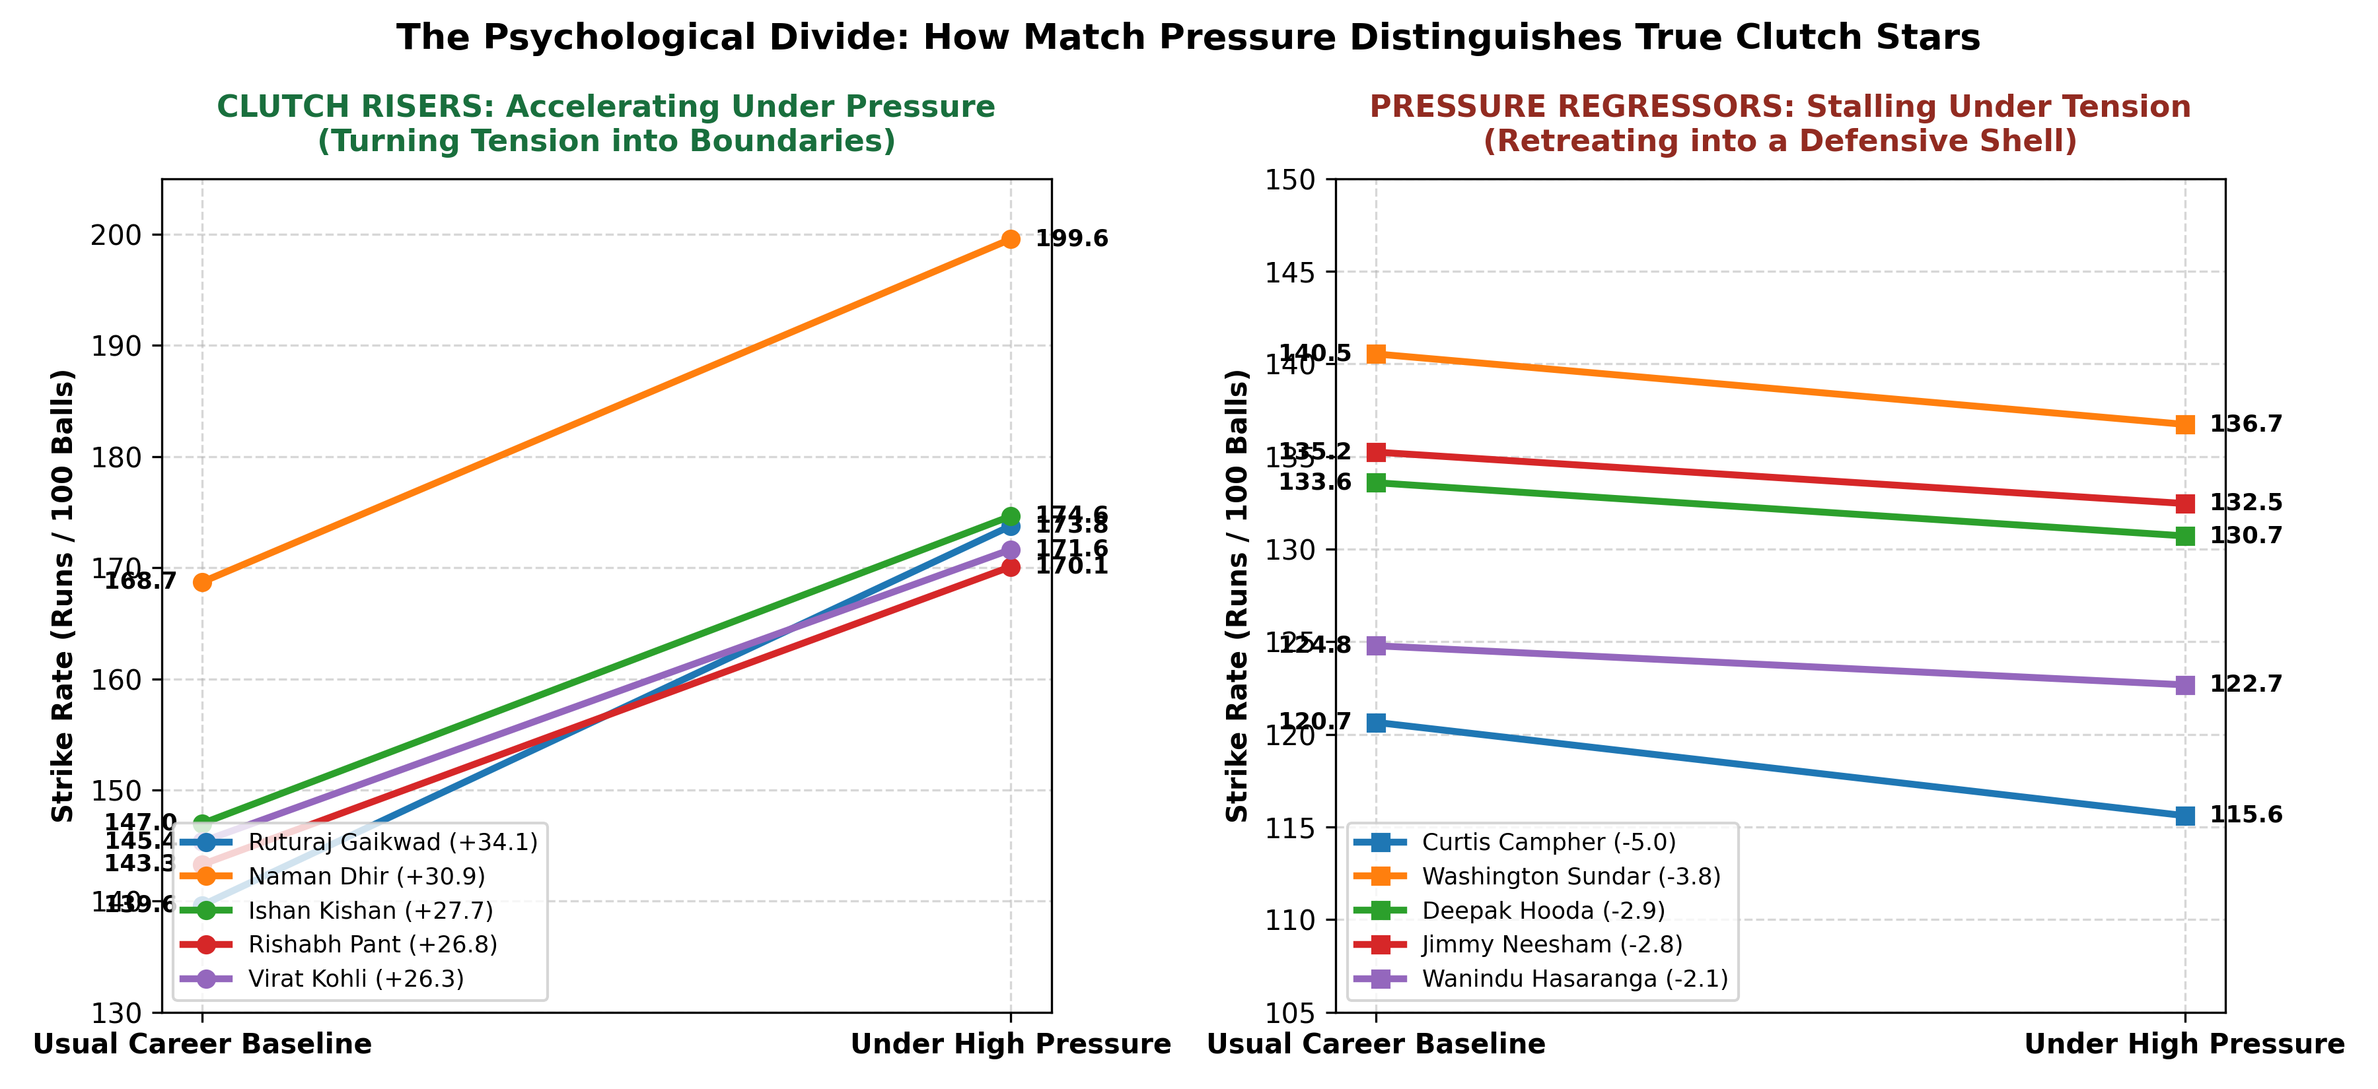
Figure 7: The Psychological Divide: Comparing Clutch Risers (Accelerators) vs Pressure Regressors (Stallers)
6. Strategic Recommendations for Rajasthan Royals
1. Target Undervalued Clutch Gems: Naman Dhir and Shashank Singh provide world-class clutch execution at a fraction of superstar auction costs.
2. Protect High-Variance Bowlers: Bowlers who blow out at the death (Russell, Deshpande, Mukesh) must be front-loaded in overs 1–14; overs 17–20 must be reserved exclusively for elite run suppressors (Bumrah, Shaheen, Narine).
3. Pair Composure with Explosion: In tight chases, pairing an anchor who cuts dot balls (Kohli, Gaikwad) with an explosive boundary striker (David, Shashank) maximizes win expectancy by preventing both collapses and rate asphyxiation.

