SMART RESUME SCREENER & CANDIDATE INTELLIGENCE PLATFORM
Comprehensive Technical Design, Architecture, AI Matching Engine & Deployment Report
Project Attribute | Details & References
Author / Lead Developer | Edupulapati Sai Praneeth
Contact Email | edupulapatisairpaneeth12345@gmail.com
Live Production Website | https://smart-resume-screener-frontend-c1ec.onrender.com
Live Backend API Endpoint | https://smart-resume-screener-backend-69ss.onrender.com
GitHub Source Repository | https://github.com/SaiPraneeth-E/Resume-Screening-Website
Tech Stack Overview | FastAPI (Python 3.10+), React 18, TypeScript, Tailwind CSS, PostgreSQL, Scikit-Learn
Documentation Version | 1.0.0 (Production Release)
Release Date | August 2026

[DOCUMENT PURPOSE] This document details the end-to-end technical specification, semantic resume parsing algorithms, candidate scoring workflows, and cloud deployment pipelines developed for the Smart Resume Screener application.

1. Executive Summary & Problem Statement
Recruiting and talent acquisition teams receive hundreds of resumes for every posted job description. Manual resume screening is notoriously labor-intensive, vulnerable to human fatigue and unconscious bias, and frequently slows down the hiring cycle. Traditional keyword-based Applicant Tracking Systems (ATS) often reject highly qualified candidates due to rigid string matching (e.g., failing to equate 'React.js' with 'React' or 'PostgreSQL' with 'Postgres').
Smart Resume Screener is an enterprise-grade AI-powered web platform created by Edupulapati Sai Praneeth to solve these exact challenges. The platform parses resumes in PDF and TXT formats, normalizes technical skills through an extensible taxonomy, and computes multidimensional match scores across seven distinct evaluation vectors. It delivers interactive analytics, customized interview questions, personalized outreach email drafts, and instant side-by-side candidate comparisons.

2. Key Features & Capabilities
- High-Precision Resume Parsing: Extracts structured text from complex multi-column PDF and TXT documents using PyMuPDF (fitz), identifying contact details, work experience, education, projects, skills, and certifications.
- Skill Taxonomy & Synonym Normalization: Maps over 200+ technology and tool aliases to standard taxonomy entries (e.g., 'NodeJS' -> 'Node.js', 'K8s' -> 'Kubernetes', 'ML' -> 'Machine Learning').
- 7-Factor Composite Scoring Engine: Evaluates candidate fit using weighted metrics: Skill Overlap (35%), Semantic Fit (25%), Work Experience (15%), Project Relevance (10%), Education (5%), Certifications (5%), and Keyword Density (5%).
- AI-Generated Strengths & Gaps Analysis: Highlights proven candidate qualifications alongside missing requirements and provides actionable suggestions for resume optimization.
- Automated Interview Kit Generation: Automatically synthesizes targeted technical, behavioral, and architectural interview questions tailored specifically to the candidate's documented experience and identified skill gaps.
- One-Click Recruiter Outreach Drafter: Generates professional email communication templates addressed to candidates with personalized praise of their specific projects and background.
- Side-by-Side Candidate Comparison Matrix: Enables recruiters to select multiple candidates and inspect their metrics, radar charts, and skill breakdowns in a unified comparative view.
- Visual Analytics & Executive Dashboard: Provides hiring managers with candidate score distribution curves, skill demand charts, shortlist metrics, and screening session history.

3. System Architecture & Technology Stack
The application is engineered with a decoupled client-server architecture ensuring high responsiveness, strict data validation, and modular extensibility.
Layer / Domain | Technologies Used | Key Architectural Responsibility
Frontend UI/UX | React 18, TypeScript, Vite, Tailwind CSS, Lucide Icons, Recharts | Cyberpunk-inspired dark theme, dynamic radar charts, responsive candidate matrices, and resume drag-and-drop.
Backend REST API | Python 3.10+, FastAPI, Uvicorn, Pydantic v2, Asyncio | High-performance asynchronous request handling, multipart upload parsing, CORS management, and RESTful routing.
Database Layer | SQLAlchemy 2.0 (Async), PostgreSQL (Production), SQLite (Dev) | Relational data persistence for jobs, candidate profiles, screening sessions, scores, and shortlists.
Document Parsing | PyMuPDF (fitz), Regex Pattern Matching | Stream extraction of text chunks, email/phone/link regex resolution, and section segmentation.
AI & Matcher Engine | Scikit-Learn (TF-IDF & Cosine Similarity), Sentence-Transformers, NumPy | Zero-OOM, sub-millisecond semantic document embedding and multi-vector compatibility scoring.
Deployment & Hosting | Render (Blueprint YAML), Docker, PostgreSQL Cloud DB, Vercel | Automated CI/CD git-backed builds, environment injection, and managed database provisioning.

4. Multi-Factor Scoring Engine
To prevent misleading scores caused by single-metric evaluations, the screening engine evaluates candidates across seven independent vectors. The overall candidate score S_total is calculated as follows:
S_total = (0.35 * S_skill) + (0.25 * S_semantic) + (0.15 * S_exp) + (0.10 * S_proj) + (0.05 * S_edu) + (0.05 * S_cert) + (0.05 * S_kw)
Evaluation Factor | Weight | Algorithm & Evaluation Methodology
Skill Match (S_skill) | 35% | Exact & normalized taxonomy matching. 75% weight on required skills ratio + 25% weight on preferred skills ratio.
Semantic Fit (S_semantic) | 25% | TF-IDF / SentenceTransformer Cosine similarity comparing full resume text against complete job responsibilities and brief.
Experience (S_exp) | 15% | Calculated from documented role count and job title alignment against target position level.
Projects (S_proj) | 10% | Portfolio project volume and intersection of project technologies with required technical competencies.
Education (S_edu) | 5% | Degree classification: Master's/Ph.D. (100%), Bachelor's/B.Tech (85%), Other/Diploma (70%).
Certifications (S_cert) | 5% | Presence of verified industry credentials (AWS, Azure, GCP, PMP, Kubernetes, etc.).
Keywords (S_kw) | 5% | Density of target job description keywords found within the body of the candidate's resume.

5. User Interface & Visual Walkthrough
The user interface incorporates high-contrast cyber-aesthetic design, smooth glassmorphism effects, vibrant status indicators, and rich data visualizations built with Tailwind CSS and Recharts.
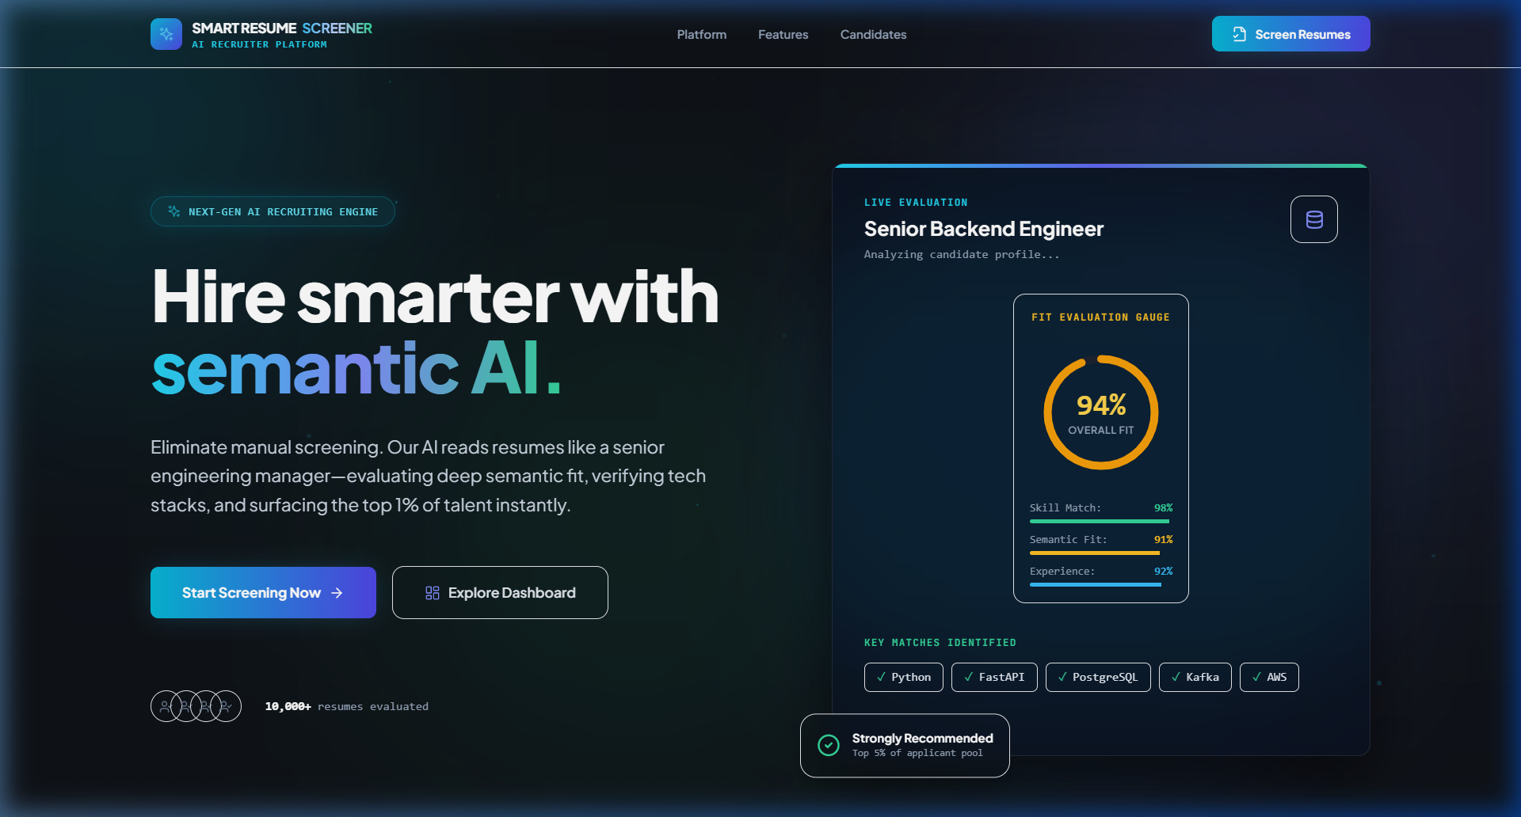
Figure 1: Smart Resume Screener Landing Page & Feature Showcase
Interactive landing page introducing recruiters to the AI engine, instant metrics, and workflow features.
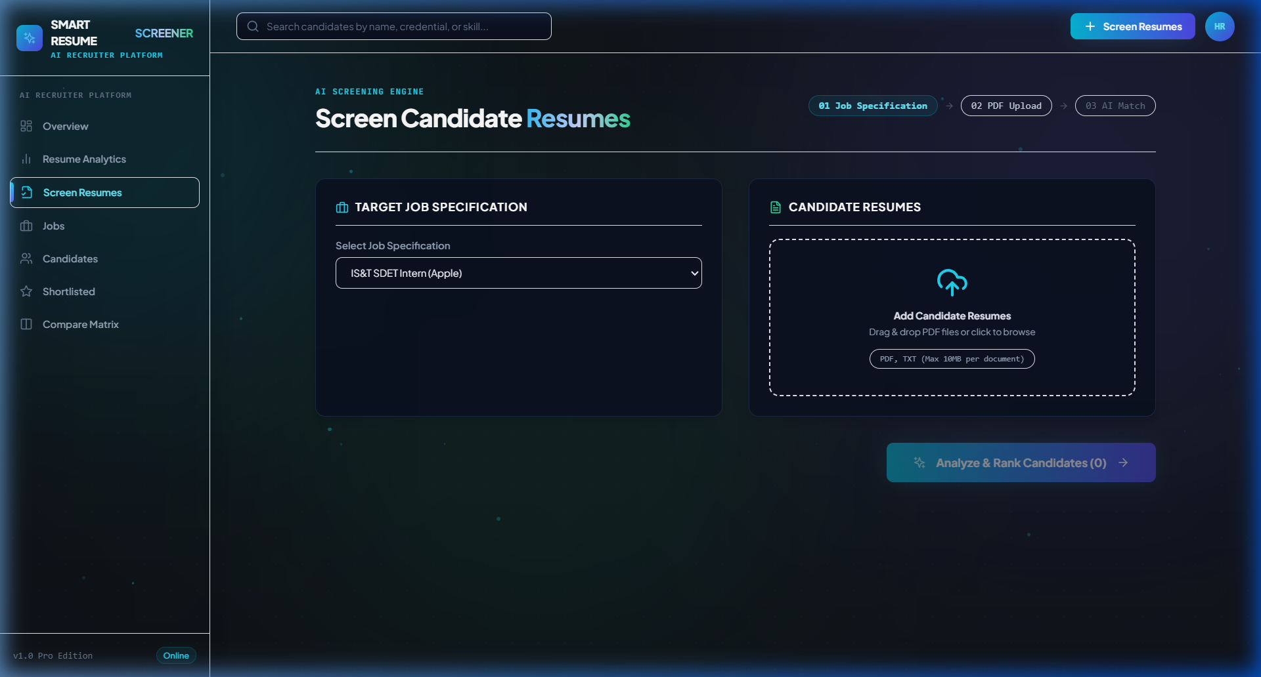
Figure 2: Resume Screening & Job Specification Input Console
Job brief editor and multi-file drag-and-drop upload zone for PDF and TXT resume batches.
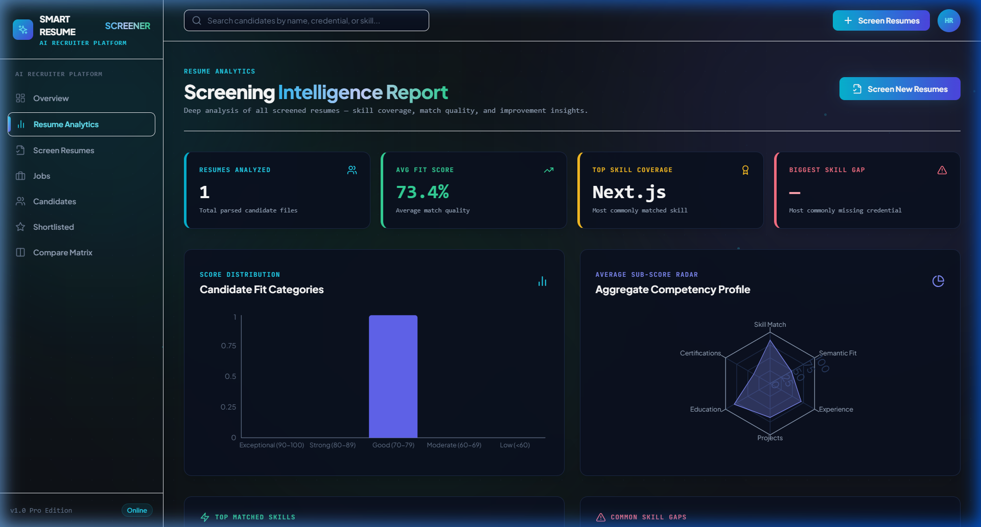
Figure 3: Analytics & Candidate Intelligence Dashboard
Comprehensive analytics dashboard displaying score distribution curves, top candidates, and candidate radar metrics.

6. REST API Endpoint Specification
HTTP Method | Endpoint Path | Functionality & Parameters
GET | /api/health | Health check endpoint verifying API status, version, and database connectivity.
POST | /api/screen | Multipart upload endpoint accepting resume files and job specifications. Returns ranked match reports.
GET | /api/jobs | Retrieves all saved job descriptions with title, department, and required skills.
POST | /api/jobs | Creates a new job description with structured skill requirements.
DELETE | /api/jobs/{id} | Deletes a specific job description by UUID.
GET | /api/candidates | Lists screened candidates with query filters: search, min_score, recommendation, shortlisted.
GET | /api/candidates/{id} | Returns detailed candidate profile, parsed experience/education, and match breakdown.
POST | /api/candidates/shortlist | Toggles shortlist bookmark status for a candidate.
POST | /api/candidates/compare | Accepts array of candidate IDs and generates comparative side-by-side matrices.
GET | /api/candidates/{id}/interview-questions | Generates custom interview questions based on candidate skill gaps.
GET | /api/candidates/{id}/outreach-email | Generates personalized recruiter outreach email text.
GET | /api/dashboard/stats | Aggregates total screened resumes, average score, shortlist count, and score tiers.
GET | /api/export/csv | Exports screened candidate rankings and scores to downloadable CSV.

7. Installation & Local Development Setup
Prerequisites: Python 3.10+, Node.js 18+, npm 9+.

Backend Configuration:
1. Open terminal and navigate to backend directory:
cd backend
2. Create and activate virtual environment:
python -m venv venv
venv\Scripts\activate # On Windows (or source venv/bin/activate on Linux/Mac)
3. Install Python dependencies:
pip install -r requirements.txt
4. Start the FastAPI development server:
uvicorn app.main:app --host 127.0.0.1 --port 8000 --reload

Frontend Configuration:
1. Open another terminal and navigate to frontend directory:
cd frontend
2. Install npm dependencies:
npm install
3. Launch the Vite development server:
npm run dev
4. Access the web application at http://localhost:5173

8. Production Cloud Deployment Guide
The project is production-ready and configured for continuous deployment using Render Blueprint infrastructure-as-code (render.yaml):
Service Component | Hosting Environment | Configuration & Live URL
Frontend (Static Site) | Render Static Web Service | https://smart-resume-screener-frontend-c1ec.onrender.com  Build: npm install && npm run build  Publish: ./dist
Backend (FastAPI) | Render Python Web Service | https://smart-resume-screener-backend-69ss.onrender.com  Runtime: Python 3.10+  Command: uvicorn app.main:app --host 0.0.0.0 --port $PORT
Database | Render Managed PostgreSQL | PostgreSQL database with asyncpg connection pooling & auto schema initialization.
Containerization | Docker & Docker Compose | docker-compose up --build -d launches frontend, backend, and PostgreSQL in isolated containers.

9. Conclusion & Project Sign-Off
Smart Resume Screener successfully bridges the gap between raw unstructured candidate resumes and actionable hiring intelligence. By leveraging semantic text similarity, multi-factor scoring algorithms, automated interview question generators, and an intuitive cyber-themed UI, the application drastically accelerates recruitment workflows while promoting consistent, fair, and evidence-based candidate evaluations.
[DEVELOPER CREDENTIALS & LINKS] Project Developer: Edupulapati Sai Praneeth
GitHub Profile: https://github.com/SaiPraneeth-E
Repository: https://github.com/SaiPraneeth-E/Resume-Screening-Website
Email Contact: edupulapatisairpaneeth12345@gmail.com
Live Application: https://smart-resume-screener-frontend-c1ec.onrender.com

