Microservices Proof of Execution
In this exercise, we created and configured two independent Spring Boot microservices for accounts and loans, running on port 8080 and 8081 respectively.

1. Account Microservice
Endpoint: http://localhost:8080/accounts/00987987973432
Sample Response: { "number": "00987987973432", "type": "savings", "balance": 234343 }
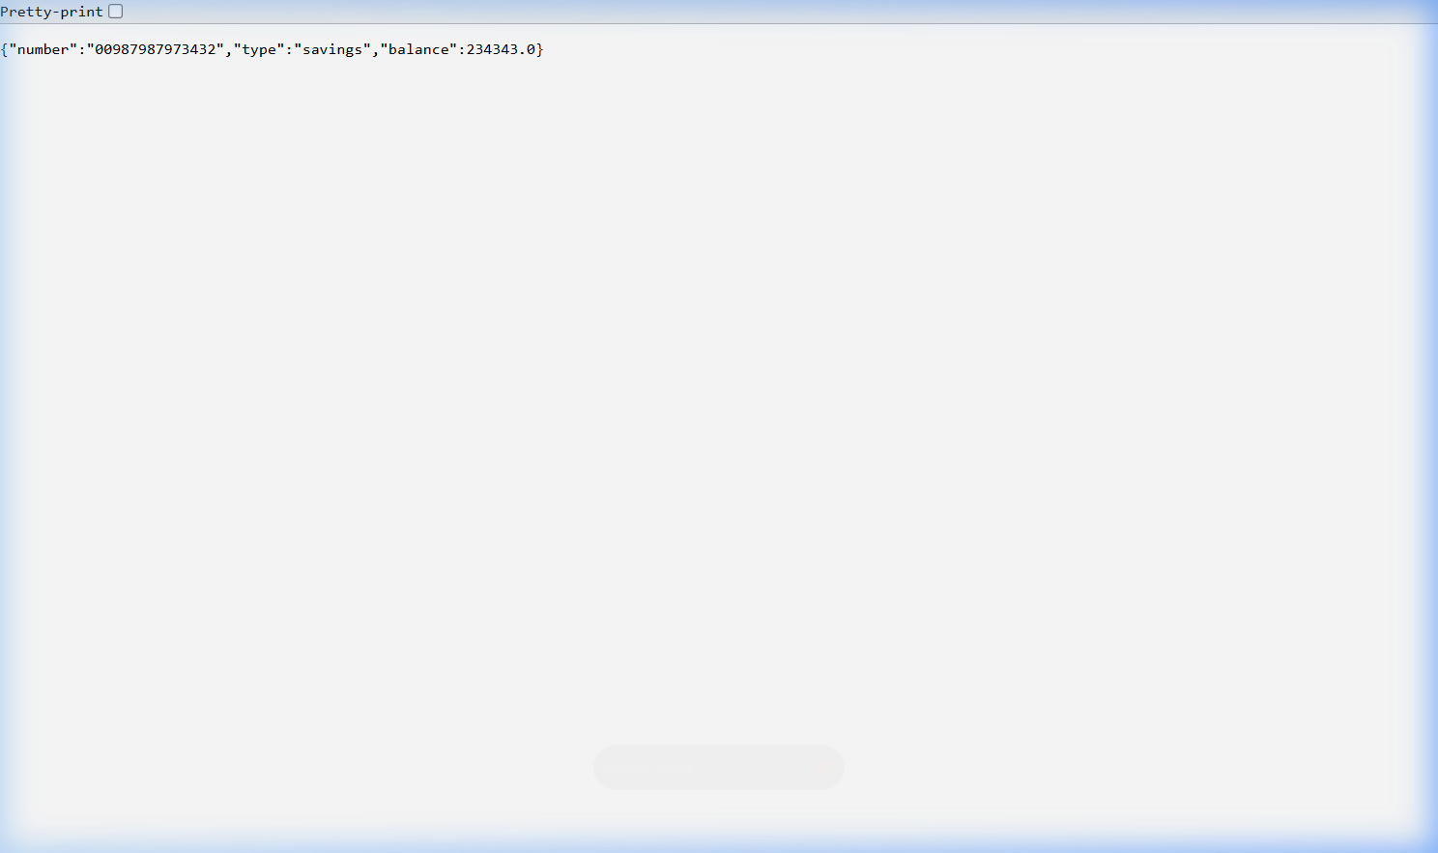
Figure 1: Account microservice execution output.

2. Loan Microservice
Endpoint: http://localhost:8081/loans/H00987987972342
Sample Response: { "number": "H00987987972342", "type": "car", "loan": 400000, "emi": 3258, "tenure": 18 }
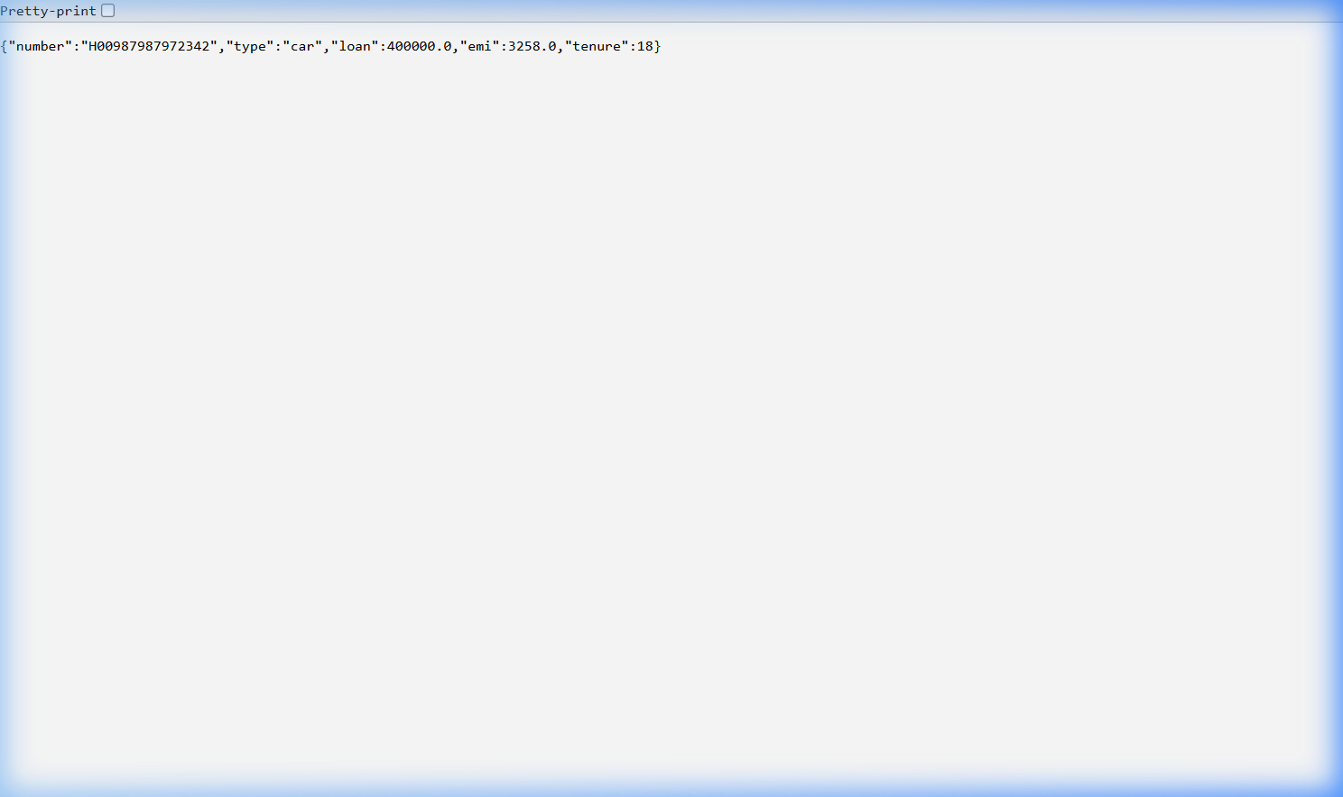
Figure 2: Loan microservice execution output on port 8081.

