Microservices Execution
In this exercise, we created and configured two independent Spring Boot microservices for accounts and loans, running on port 8080 and 8081 respectively.

1. Account Microservice
Endpoint: http://localhost:8080/accounts/00987987973432
Sample Response: { "number": "00987987973432", "type": "savings", "balance": 234343 }
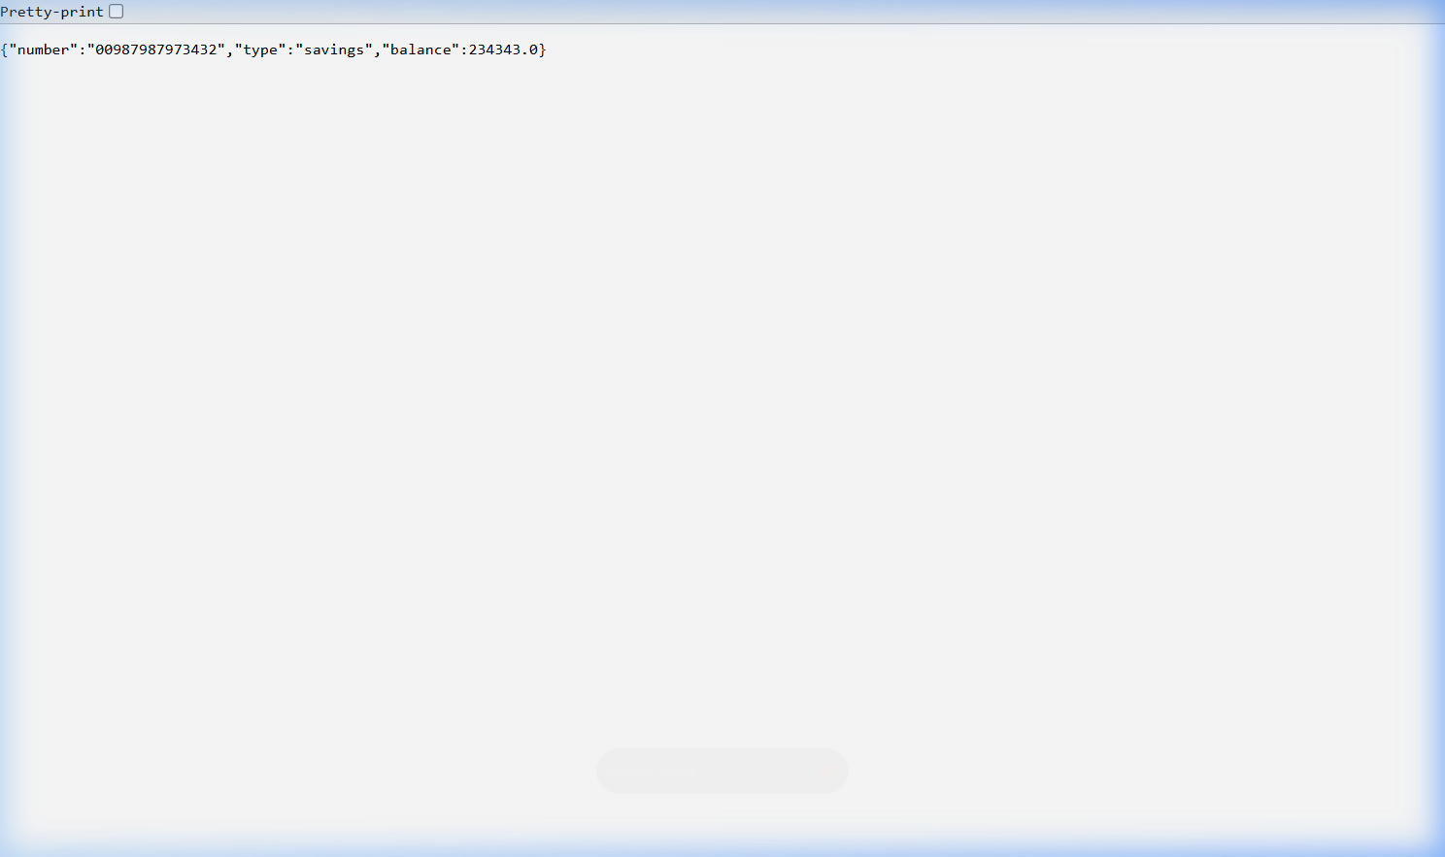

2. Loan Microservice
Endpoint: http://localhost:8081/loans/H00987987972342
Sample Response: { "number": "H00987987972342", "type": "car", "loan": 400000, "emi": 3258, "tenure": 18 }
