**Question 1:**

**Sort the list and find the min and max age**

I had used the sort() function which sorts the values in ascending order by default. For finding the minimum value min() is used. For finding the maximum value max() is used.

**Add the min age and the max age again to the list**

For adding to list I had used insert() which inserts the value in list at specified position and append() is used to append value at end of the list.

**Find the median age / average sum.**

I had used “statistics” module for getting the median value. This module is used to do mathematical operations on data like median and mean.

**Find the range of the ages (max minus min)**

For calculating range : max(value)-min(value)

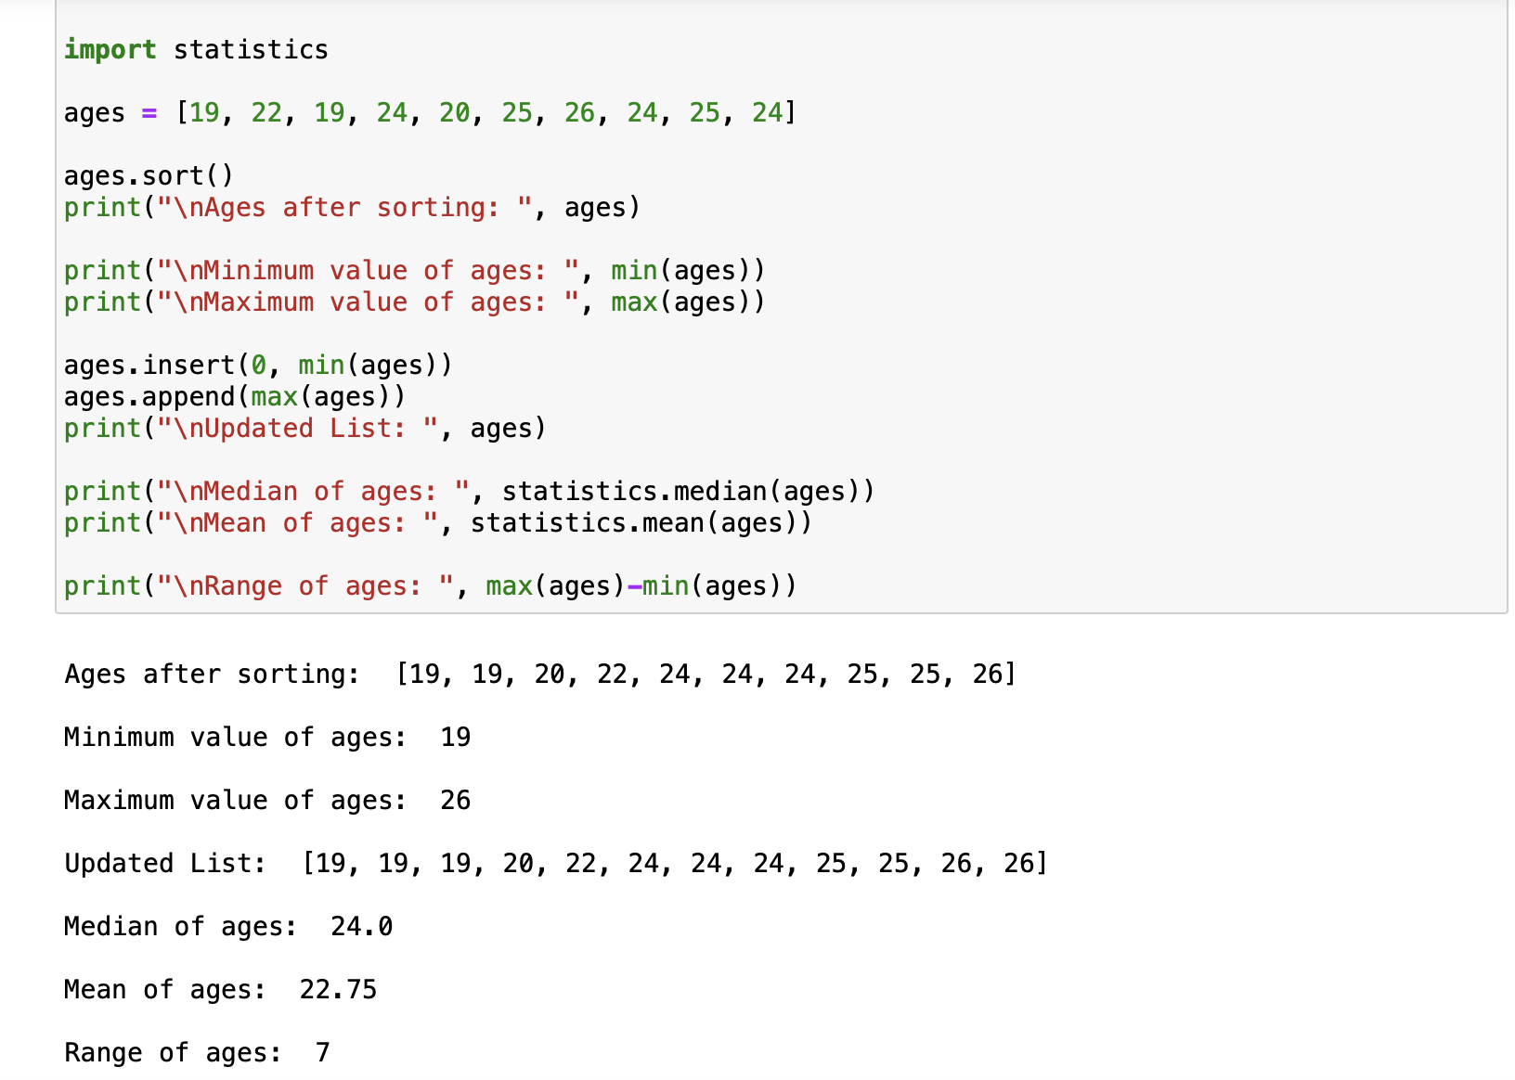

**Question 2:**

**Create an empty dictionary called dog**

Created a empty dictionary by using dict()

**Add name, color, breed, legs, age to the dog dictionary**

Updated the required values to the dictionary by using dog.update()

**Create a student dictionary and add first_name, last_name, gender, age, marital status, skills, country, city and address as keys for the dictionary**

Created a student dictionary by using dict() and and updated the values by using update().

**Get the length of the student dictionary.**

By using “len()” I got the length of dictionary.

**Get the value of skills and check the data type, it should be a list**

By using student_dict["skills"] I had acquired value of skills and by using type() we can get data type of list.

**Modify the skills values by adding one or two skills**

I had used extend() for adding values. It adds all the elements at end of list which is iterable.

**Get the dictionary keys as a list**

dict.keys() is used to get keys of list

**Get the dictionary values as a list**

dict.values() is used to get values of list

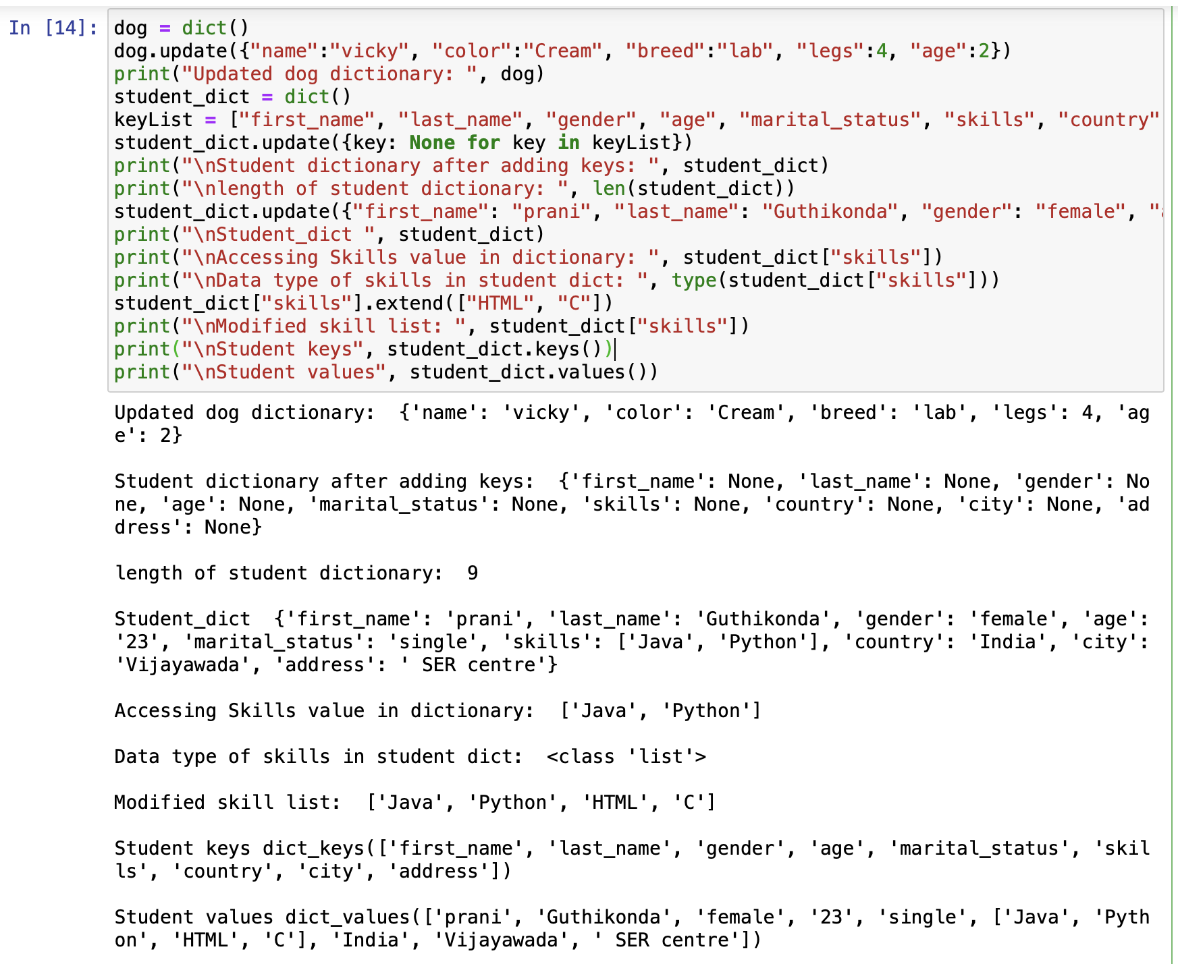

**Question 3:**

**Join brothers and sisters tuples and assign it to siblings. Modify the siblings tuple and add the name of your father and mother and assign it to family_members.**

I had used ‘+’ operator to join brothers and sisters and also had joined siblings and parents with same operator.

**How many siblings do you have?**

For counting the siblings I had used len().

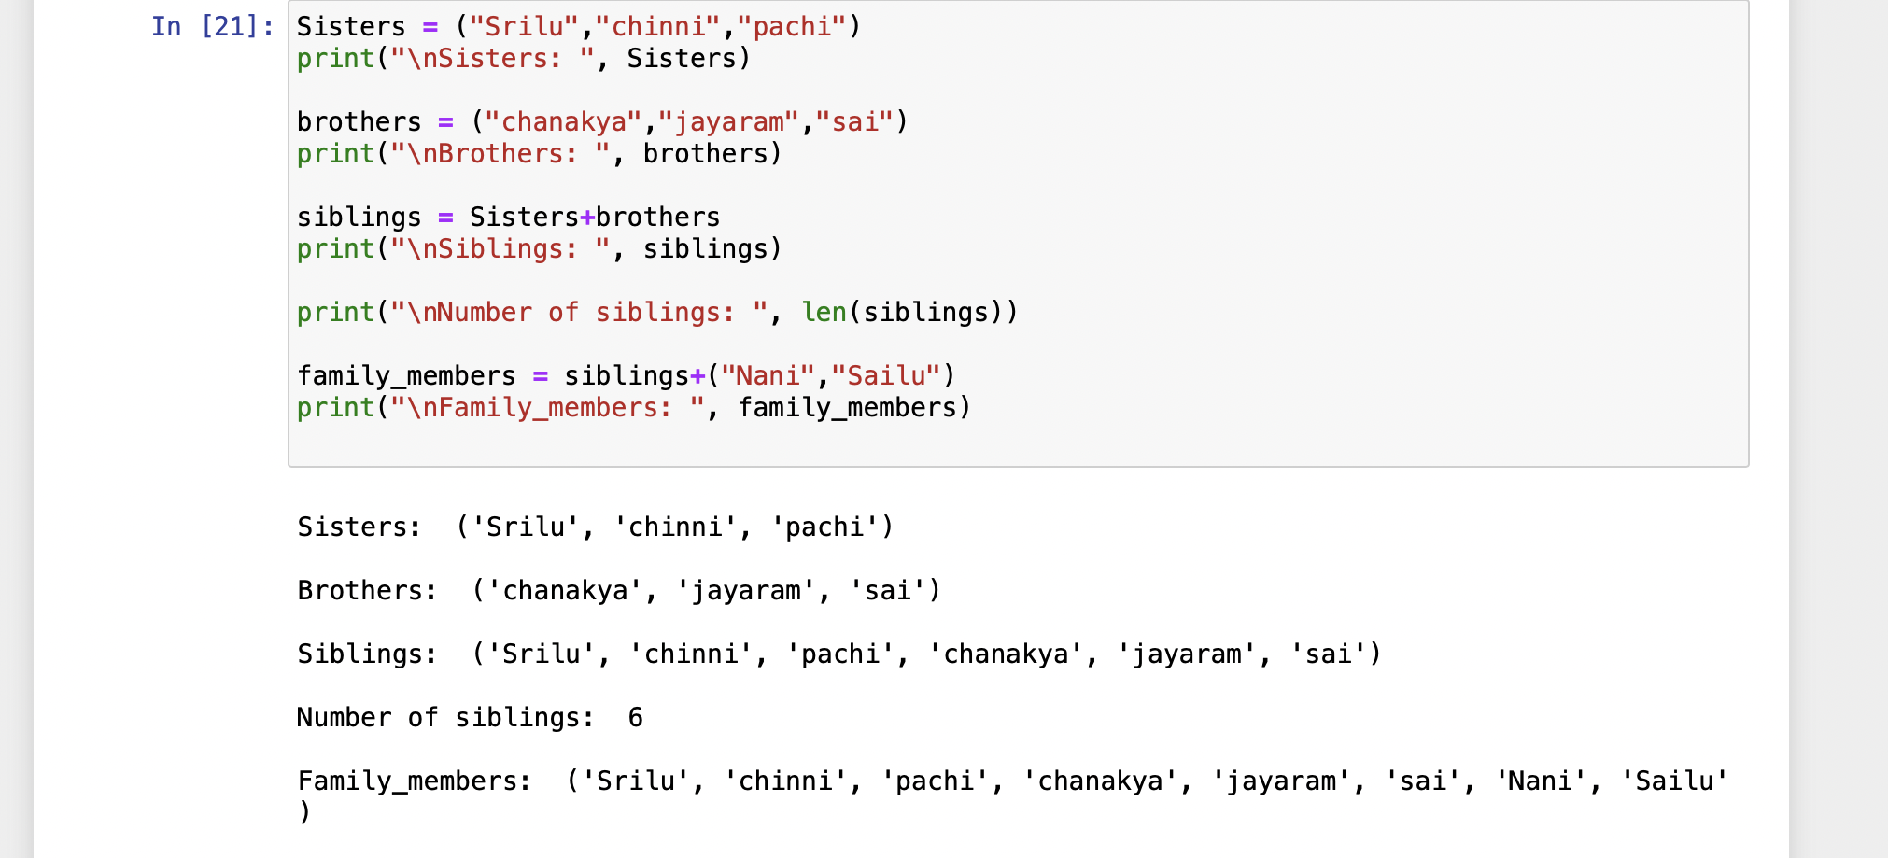

**Question 4:**

**Find the length of the set it_companies.**

By using len() I had calculated length of set.

**Add 'Twitter' to it_companies**

Add(elements) adds element into the set.

**Insert multiple IT companies at once to the set it_companies**

Update() is used to insert multiple companies at once.

**Remove one of the companies from the set it_companies**

Remove() is used to remove element from set.

**What is the difference between remove and discard?**

Remove(): throws error if the required item is not present in list.   
Discard(): Will not throw any error if item doesn't exist in list.

**Join A and B**

Union() is for joining two sets.

**Find A intersection B**

Intersection()

**Is A subset of B?**

issubset()

**Are A and B disjoint sets?**

isdisjoint()

**Delete the sets completely**

Clear() is used for deleting the sets.

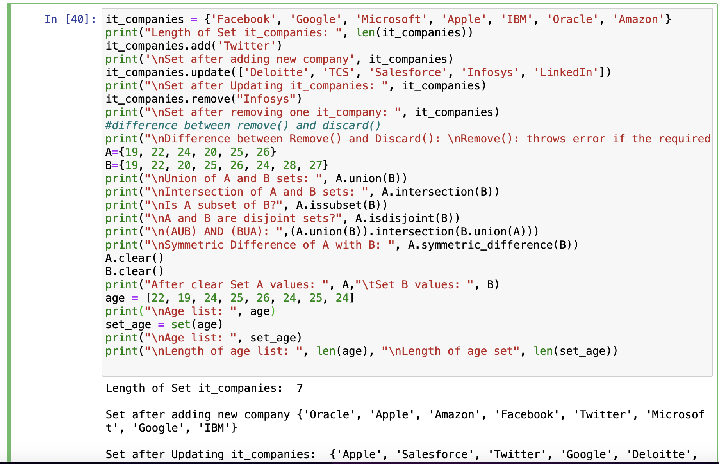

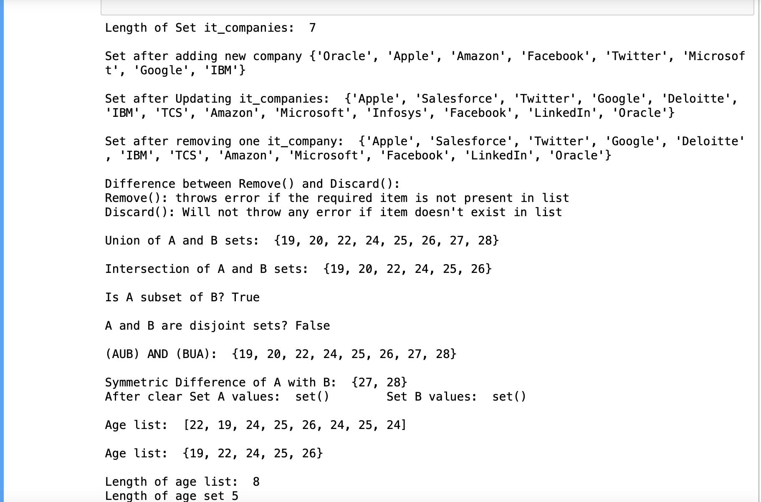

**Question 5:**

**Calculate the area of a circle**

Area of circle : pi * circle_radius **2

**Calculate the circumference of a circle**

Circumference of circle : 2 * pi * circle_radius

**Take radius as user input and calculate the area.**

Input() is used to take values from console.

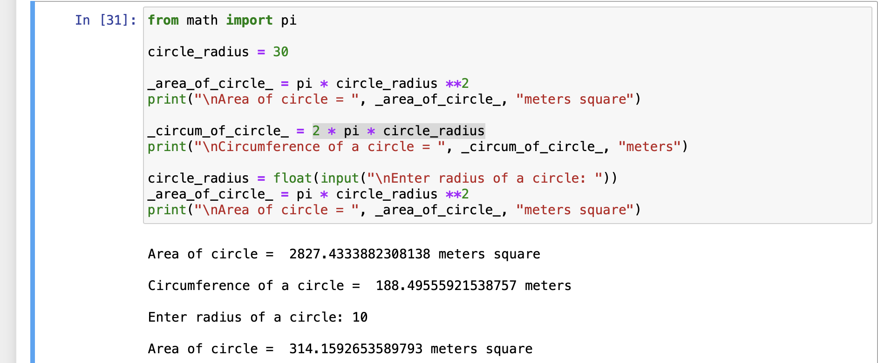

**Question 6:**

**How many unique words have been used in the sentence? Use the split methods and set to get the unique words.**

Split() method makes the string into words when ever there is a space

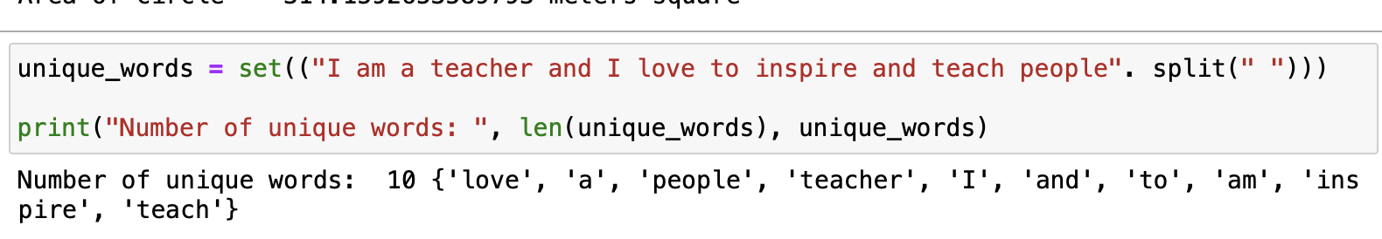

**Question 7:**

**Use a tab escape.**

“\t” is used for tab escape.

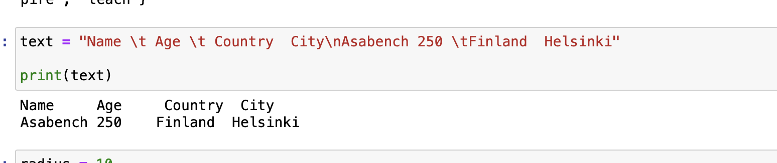

**Question 8:**

**Use the String formatted method to display.**

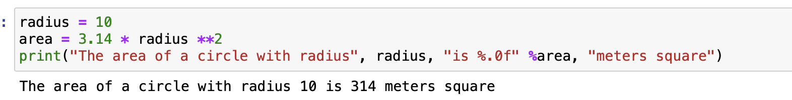

**Question 9:**

**Write a program, which reads weights (lbs.) of N students into a list and convert these weights to kilograms in a separate list using Loop. N: No of students (Read input from user)**

**Ex: L1: [150, 155, 145, 148] Output: [68.03, 70.3, 65.77, 67.13]**

**1lb = 0.453592**

