Assignment-3

Sai Prashanth Nagisetti

Student Id: 16337021

1.

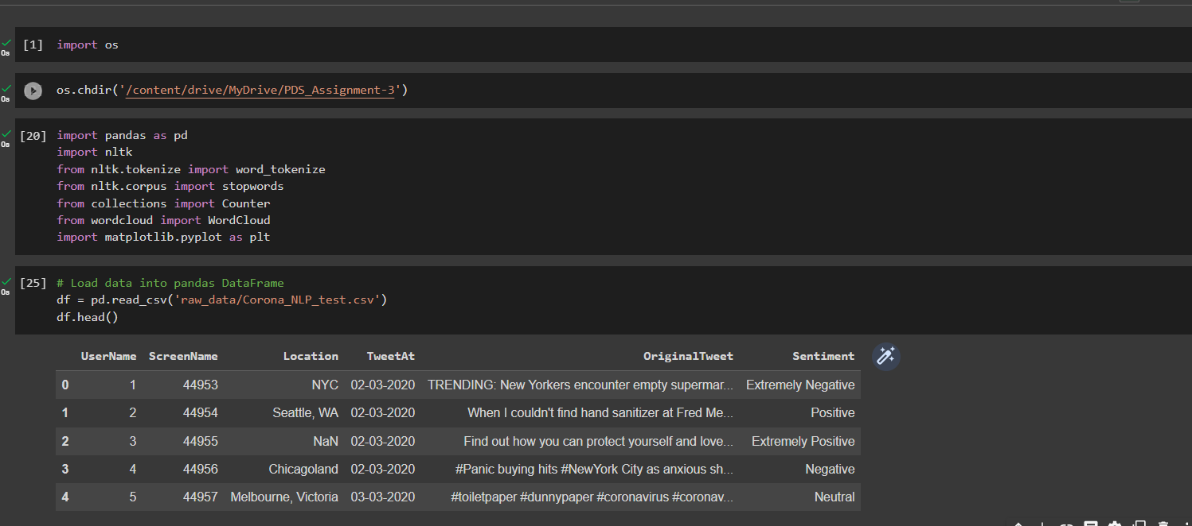

a) Convert the text corpus into tokens.

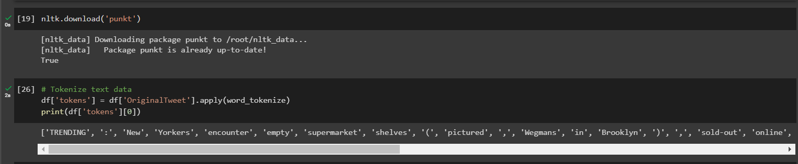

b) Perform stop word removal.

c) Count Word frequencies

d) Create word clouds.

