**1.Data input/collection**

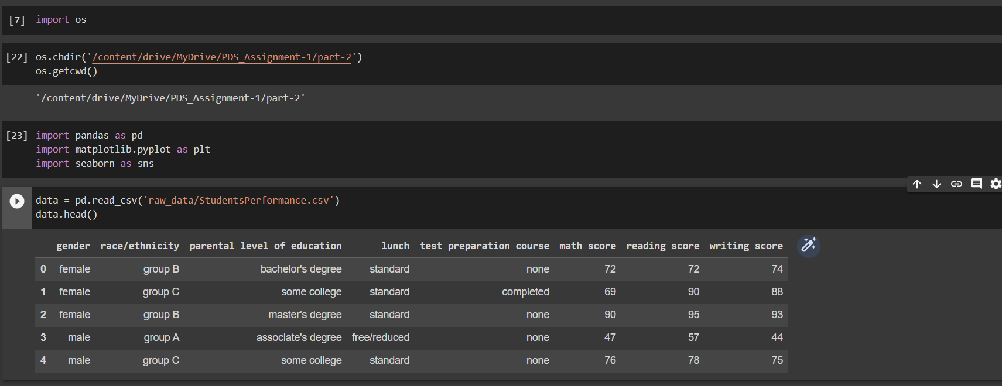

loaded the StudentsPerformance.csv file in a python environment using ***pandas*** library.

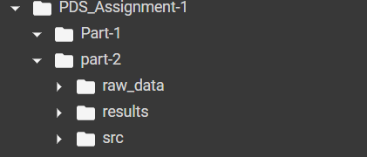

**2. Data processing**

Since the data doesn’t have any null values and data types are correct didn’t make any refinements to the data.

**3. Data analysis**

**a)**

This visualization shows the distribution of each of the predictors in the data set in the form of histogram.

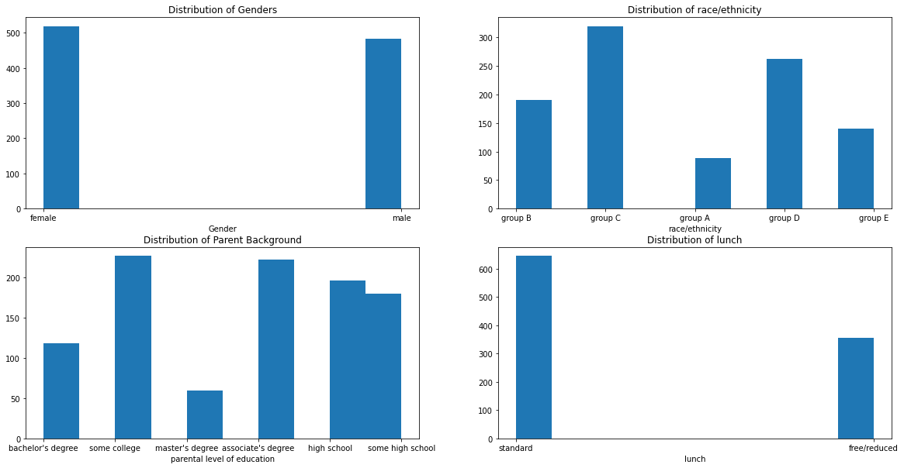

b)

c)

This bar chart used visualize the number of students who completed the test preparation course vs those who did not.

d)

This visualization can help identify whether there is a correlation between math scores and reading scores.

e)

This visualization shows box plots of different scores in the data set to give more insight on their distributions.

f)

This visualization can help identify whether there is a difference in test scores between students whose parents have different levels of education.

the folder structure looks like this after ***data analysis*** stage.