Transaction Microservice Documentation
1. Introduction
This document provides detailed documentation for the Transaction Microservice. This is a Flask-based microservice designed for managing financial transactions. It provides a RESTful API for creating and retrieving transactions, integrates with a database using SQLAlchemy, and is built to be scalable and observable.
The service is containerized using Docker and includes configurations for local deployment via Docker Compose and orchestration with Kubernetes (Minikube).
2. Features
- RESTful API: Endpoints for creating and retrieving transactions.
- Idempotency: Supports idempotent transaction creation via a correlation_id to prevent duplicate processing.
- Database Integration: Uses SQLAlchemy to interact with a SQLite database for local development.
- Containerization: Dockerfile for building a container image.
- Local Deployment: Includes a docker-compose.yaml for a simple local multi-service setup.
- Kubernetes Support: Provides Kubernetes manifests for deployment on a Minikube cluster.
- API Documentation: Automatically generates interactive OpenAPI (Swagger) documentation using Flasgger.
- Monitoring: Exposes Prometheus metrics for monitoring transaction volume, failures, and service latency.
- Structured Logging: Generates structured JSON logs for easier parsing and analysis.
3. Technology Stack
- Backend Framework: Flask
- Database ORM: Flask-SQLAlchemy
- API Documentation: Flasgger
- Metrics & Monitoring: Prometheus Flask Exporter
- Containerization: Docker
- Orchestration: Kubernetes
- Database: SQLite (default for local development)
4. Configuration
The microservice is configured using environment variables.
Variable | Description
FLASK_ENV | Sets the Flask environment.
SQLALCHEMY_DATABASE_URI | The connection string for the database.
ACCOUNTS_SERVICE_URL | The URL of the Accounts microservice, used to validate account status and balance.
NOTIFICATION_SERVICE_URL | The URL of the Notification microservice, used to send notifications after a transaction is processed.

5. API Endpoints
The API documentation is also available interactively via the Swagger UI by navigating to the root URL (/) of the running service.

5.1 Create Transaction
Creates a new transaction. For a 'transfer', this endpoint creates two transaction records (a withdrawal and a deposit). It supports idempotency via a correlation_id in the request body to prevent duplicate requests.
- Endpoint: POST /transactions
- Tags: Transactions
Request Body
json
Show full code block
{
"account_id": 1,
"counterparty_id": "2",
"amount": 100.50,
"txn_type": "transfer",
"reference": "Monthly rent",
"correlation_id": "uuid-for-idempotency-12345"
}
Property | Type | Required | Description
amount | number | Yes | The transaction amount.
txn_type | string | Yes | The type of transaction (e.g., 'deposit', 'withdrawal', 'transfer').
account_id | integer | No | The ID of the account initiating the transaction.
counterparty_id | string | No | The ID of the counterparty account (required for 'transfer' type).
reference | string | No | A client-provided reference for the transaction.
correlation_id | string | No | A unique ID for ensuring idempotency of the request.
Responses
- 201 Created: Transaction created successfully.
json
{
"message": "Transfer completed",
"withdrawal_txn_id": 1,
"deposit_txn_id": 2
}
- 400 Bad Request: Missing required fields, invalid amount, or other validation errors.
- 409 Conflict: A duplicate transaction was detected based on the correlation_id and request payload.
- 500 Internal Server Error: An unexpected error occurred on the server.
- 502 Bad Gateway: An error occurred while communicating with a downstream service (e.g., Accounts microservice).

5.2 Get All Transactions
Retrieves a list of all transactions in the system.
- Endpoint: GET /transactions
- Tags: Transactions
Responses
- 200 OK: A list of all transactions.
json
Show full code block
[
{
"txn_id": 1,
"account_id": 1,
"counterparty_id": "2",
"amount": -100.50,
"txn_type": "withdrawal",
"reference": "Monthly rent",
"created_dt": "2025-11-07T15:00:00Z",
"failure_status": null,
"correlation_id": "uuid-for-idempotency-12345"
}
]
- 500 Internal Server Error: An unexpected error occurred on the server.

5.3 Get Transaction by ID
Retrieves the details of a single transaction by its unique ID.
- Endpoint: GET /transactions/<txn_id>
- Tags: Transactions
Path Parameters
Name | Type | Required | Description
txn_id | integer | Yes | The unique ID of the transaction.
Responses
- 200 OK: The transaction details.
json
Show full code block
{
"txn_id": 1,
"account_id": 1,
"counterparty_id": "2",
"amount": -100.50,
"txn_type": "withdrawal",
"reference": "Monthly rent",
"created_dt": "2025-11-07T15:00:00Z",
"failure_status": null,
"correlation_id": "uuid-for-idempotency-12345"
}
- 404 Not Found: The transaction with the specified ID was not found.
- 500 Internal Server Error: An unexpected error occurred on the server.
6. Setup and Deployment
6.1 Local Development (Python)
- Create and activate a virtual environment:
bash
python -m venv venv
# On Windows
.\venv\Scripts\activate
# On macOS/Linux
source venv/bin/activate
- Install dependencies:
bash
pip install -r requirements.txt
- Run the application:
bash
flask run
6.2 Docker Compose
- Build and run the services defined in docker-compose.yaml:
bash
docker-compose up --build
- The service will be available at http://localhost:5000.
6.3 Kubernetes (Minikube)
- Ensure Minikube is running and your Docker CLI is configured to use Minikube's Docker daemon:
bash
eval $(minikube docker-env)
- Build the Docker image within Minikube's environment:
bash
docker build -t transaction-microservice:latest .
- Apply the Kubernetes manifests:
bash
kubectl apply -f k8s/
- Expose the service to access it locally:
bash
minikube service transaction-microservice
7. Monitoring
The service is instrumented with Prometheus metrics, available at the /metrics endpoint. Key custom metrics include:
- transactions_total: A counter for the total number of transactions, labeled by txn_type.
- failed_transfers_total: A counter for the total number of failed transfer transactions.
- balance_check_latency_ms: A histogram measuring the latency of calls to the Accounts microservice.

ER Diagram
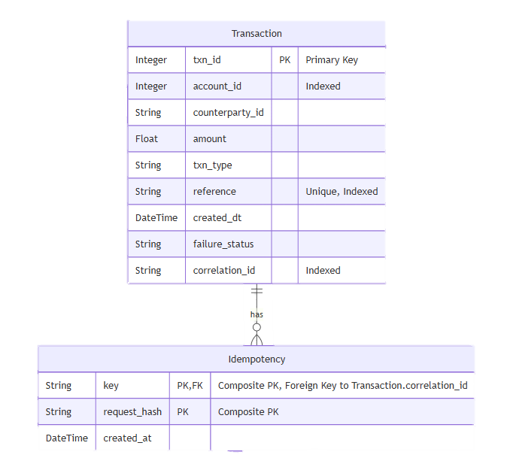

Context Map
