PREDICTIVE ANALYTICS FOR HEALTHCARE: UTILIZING REGRESSION MODELS TO FORECAST PATIENT LENGTH OF STAY IN URBAN HOSPITALS – YOUR TITLE
Project Report Submitted in fulfillment of the
Requirements for the Award of the Internship of
Summer Training Program by IDRA
Data Science and AI
By:
Name: Chinta Prithvi
Institute: National Institute Of Technology, Andhra Pradesh
Institute Roll No.: 423124
Enrollment No.: IDRA-2026-498821
Under the Supervision of
Dr. Shaheena Salam

Through the platform:

India Data Research Academy

DECLARATION
I declare that this project report, including the analysis, modelling workflow and interpretation, has been prepared as part of the IDRA Data Science & AI Training Program. External sources and supporting materials used in the project are acknowledged appropriately.

ACKNOWLEDGEMENT
I express my sincere gratitude to India Data Research Academy and the Data Science & AI training program for providing the capstone framework and dataset. I also acknowledge the guidance of the supervisor and the support provided through the training resources.

ABSTRACT
This project investigates the prediction of patient length of stay using a healthcare dataset containing 61,680 hospital records and 28 variables. The analysis follows a complete data science workflow covering data-quality assessment, preprocessing, exploratory data analysis, descriptive statistics, feature preparation and supervised regression modelling. The target variable, length of stay, ranges from 1 to 17 days, with a mean of 4.00 days and a median of 4 days. The dataset contained no missing values and no duplicate records. A specific leakage check showed that the discharge date exactly reproduces the target when the admission and discharge dates are subtracted; therefore, post-discharge information was excluded from the predictive feature set. Linear Regression, Decision Tree Regression and Random Forest Regression were evaluated. Based on the supplied evaluation results, Random Forest achieved a test MAE of 0.418, test RMSE of 0.680, and test R² of 0.916. The findings show substantial observed differences in length of stay across admission count categories and hospital facilities. The study demonstrates how careful leakage control, exploratory analysis and regression modelling can support evidence-based analysis of hospital stay duration.
Keywords: healthcare analytics; length of stay; exploratory data analysis; regression; machine learning; predictive analytics

TABLE OF CONTENTS
1. Introduction ........................................................ 5
2. Problem Statement and Motivation ........................................................ 5
3. Objectives ........................................................ 5
4. Research Questions ........................................................ 5
5. Dataset Description and Data Understanding ........................................................ 6
6. Data Cleaning ........................................................ 7
7. Data Preprocessing ........................................................ 7
8. Exploratory Data Analysis ........................................................ 8
9. Statistical Analysis ........................................................ 10
10. Feature Engineering ........................................................ 11
11. Model Development ........................................................ 11
12. Model Evaluation ........................................................ 11
13. Results and Findings ........................................................ 13
14. Discussion ........................................................ 13
15. Limitations ........................................................ 14
16. Conclusion ........................................................ 14
17. Recommendations and Future Work ........................................................ 14
18. References ........................................................ 14
Appendix A. Code ........................................................ 15
Appendix B. Additional Figures and Tables ........................................................ 15

1. INTRODUCTION

1.1 Background
Patient length of stay is an important operational measure in hospitals because it is directly connected with bed utilization, capacity planning and the allocation of clinical resources. Length of stay can vary across patients because of differences in medical conditions, clinical measurements, admission characteristics and hospital context.

1.2 Context of the Problem
A data-driven estimate of length of stay can provide an analytical basis for understanding which observed patient and hospital characteristics are associated with longer or shorter stays. This project focuses on prediction rather than causal inference: observed relationships are interpreted as associations unless the data provide a basis for stronger claims.

1.3 Scope of the Study
The study covers data cleaning, exploratory analysis, descriptive statistics, leakage control, preprocessing and regression modelling. It does not claim clinical validation, causal effects, or deployment readiness. The modelling objective is to estimate length of stay using information available without using the eventual discharge outcome.

2. PROBLEM STATEMENT AND MOTIVATION
The central problem is to determine whether patient characteristics, clinical measurements, admission-related information and hospital-related variables can be used to predict patient length of stay. The motivation is to demonstrate a reproducible predictive workflow that can identify measurable patterns in hospitalization duration.

3. OBJECTIVES
- Assess the structure and data quality of the hospitalization dataset.
- Identify patterns and relationships between patient characteristics, clinical variables, hospital factors and length of stay.
- Detect and prevent target leakage before model development.
- Develop regression models for predicting patient length of stay.
- Evaluate models using MAE, MSE, RMSE and R² and compare training with testing performance.
- Translate evidence from the analysis into findings, limitations and practical recommendations.

4. RESEARCH QUESTIONS
- What are the main characteristics and data-quality properties of the dataset?
- Which patient medical conditions and clinical measurements show the strongest observed relationships with length of stay?
- How does length of stay vary across admission-count categories and hospital facilities?
- How accurately can length of stay be predicted using information available without post-discharge leakage?
- How do the selected regression models generalize from training data to unseen test records?

5. DATASET DESCRIPTION 5. DATASET DESCRIPTION AND DATA UNDERSTANDING

5.1 Data Source
The dataset was provided through the IDRA LMS Study Material for the approved healthcare capstone project. The analysis uses the supplied CSV file without adding external patient records.

5.2 Dataset Size and Structure
Property | Value
Observations | 61,680
Variables | 28
Missing values | 0
Duplicate rows | 0
Target | lengthofstay
Target range | 1–17 days
Target mean | 3.999 days
Target median | 4 days
Table 1. Summary of the Dataset
The dataset contains demographic information, medical-condition indicators, clinical measurements, admission information, hospital facility information and the observed length of stay.

5.3 Data Dictionary

Variable | Meaning | Type | Role
eid | Record identifier | Integer | Identifier
vdate | Visit/admission date | Date-like string | Feature/date
rcount | Admission count category | Categorical | Feature
gender | Patient gender category | Categorical | Feature
dialysisrenalendstage | End-stage renal/dialysis indicator | Binary numeric | Feature
asthma | Asthma indicator | Binary numeric | Feature
irondef | Iron deficiency indicator | Binary numeric | Feature
pneum | Pneumonia indicator | Binary numeric | Feature
substancedependence | Substance dependence indicator | Binary numeric | Feature
psychologicaldisordermajor | Major psychological disorder indicator | Binary numeric | Feature
depress | Depression indicator | Binary numeric | Feature
psychother | Psychotherapy indicator | Binary numeric | Feature
fibrosisandother | Fibrosis/other condition indicator | Binary numeric | Feature
malnutrition | Malnutrition indicator | Binary numeric | Feature
hemo | Hemoglobin-related measure/indicator | Numeric | Feature
hematocrit | Hematocrit measurement | Numeric | Feature
neutrophils | Neutrophil measurement | Numeric | Feature
sodium | Sodium measurement | Numeric | Feature
glucose | Glucose measurement | Numeric | Feature
bloodureanitro | Blood urea nitrogen measurement | Numeric | Feature
creatinine | Creatinine measurement | Numeric | Feature
bmi | Body mass index | Numeric | Feature
pulse | Pulse measurement | Numeric | Feature
respiration | Respiration measurement | Numeric | Feature
secondarydiagnosisnonicd9 | Secondary diagnosis count/measure | Numeric | Feature
discharged | Discharge date | Date-like string | Excluded: post-outcome
facid | Hospital facility | Categorical | Feature
lengthofstay | Observed length of stay | Integer | Target
Table 2. Data Dictionary

6. DATA CLEANING

6.1 Missing Values
The quality audit found 0 missing values across all 61,680 records and 28 variables. Therefore, no row-level deletion or imputation was required for missingness.

6.2 Duplicate Records
No exact duplicate records were found in the supplied dataset.

6.3 Data Types and Inconsistent Values
Date fields were parsed into datetime representations for validation and feature creation. Categorical variables were retained as categorical inputs for one-hot encoding during modelling.

6.4 Outlier Handling
Numerical variables were assessed using the IQR rule. Potential outliers were not automatically removed because extreme clinical values may represent legitimate observations rather than data-entry errors. The modelling pipeline uses robust preprocessing decisions without silently deleting observations.

6.5 Target Leakage Validation
The discharge date was tested against the admission/visit date. In 100.0% of records, discharge date minus visit date exactly equals length of stay. Consequently, the discharge date is a direct post-outcome representation of the target and was excluded from modelling.

7. DATA PREPROCESSING

7.1 Categorical Encoding
Categorical predictors such as rcount, gender and facility were one-hot encoded. Unknown categories in the test data are handled safely through the preprocessing pipeline.

7.2 Feature Scaling and Transformation
Numerical predictors are median-imputed through the modelling pipeline and standardized. Scaling parameters are learned from the training data only.

7.3 Train-Test Split
The data were divided into 80% training and 20% testing subsets using random_state=42. The preprocessing transformations are fitted within the training pipeline to avoid information leakage.

7.4 Final Feature Set
The following variables were excluded from the predictive matrix:
- eid — identifier
- discharged — post-outcome information and direct target leakage
- raw date strings — replaced by derived admission-time calendar features

8. EXPLORATORY DATA ANALYSIS

8.1 Target Distribution
# 8.1 Target Distribution

plt.figure(figsize=(8, 5))

sns.histplot(
df["lengthofstay"],
bins=17,
kde=True
)

plt.title("Distribution of Patient Length of Stay")
plt.xlabel("Length of Stay (days)")
plt.ylabel("Number of Patients")
plt.tight_layout()
plt.show()

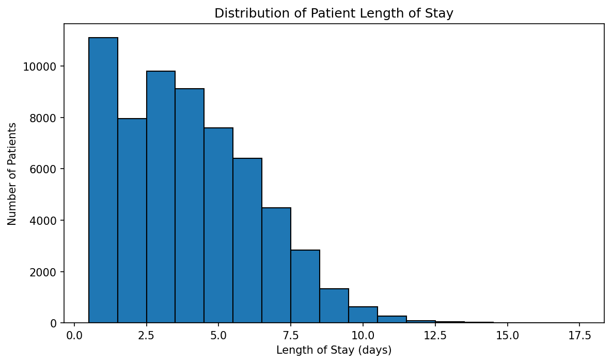
Figure 1. Distribution of Patient length of the stay
Length of stay ranges from 1 to 17 days. The mean is 4.00 days and the median is 4 days, indicating that the central tendency is around four days.

8.2 Facility Comparison
# 8.2 Facility Comparison

facility_summary = (
df.groupby("facid")["lengthofstay"]
.agg(["mean", "median", "count"])
.reset_index()
)

print(facility_summary)

plt.figure(figsize=(8, 5))

sns.barplot(
data=facility_summary,
x="facid",
y="mean"
)

plt.title("Average Length of Stay by Facility")
plt.xlabel("Facility")
plt.ylabel("Average Length of Stay (days)")
plt.tight_layout()
plt.show()

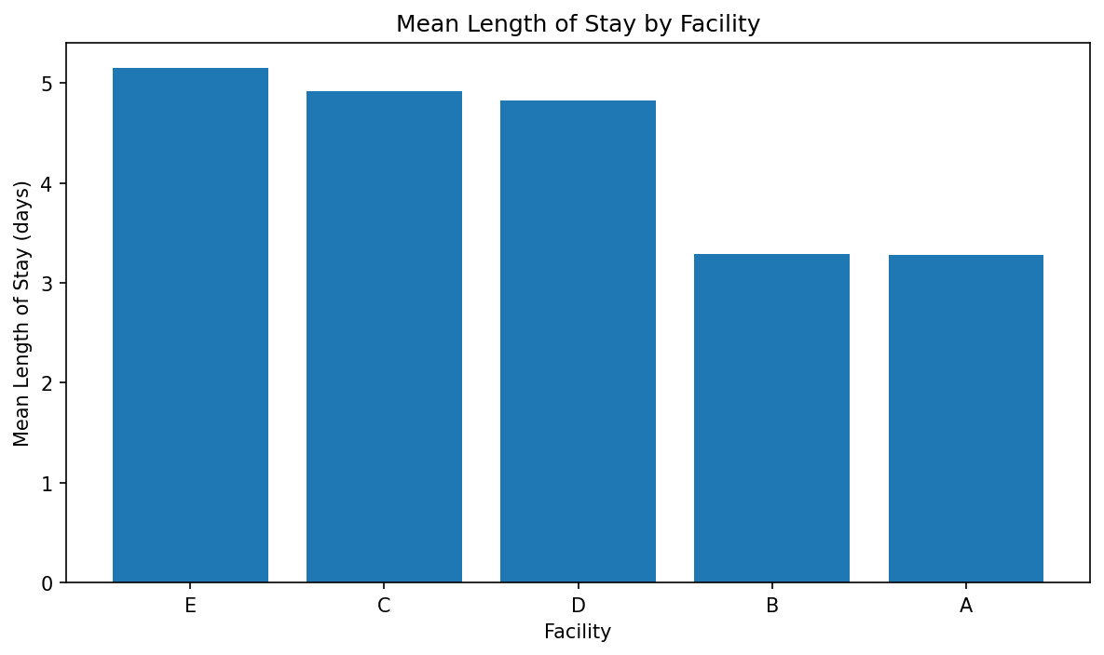
Figure 2. Mean length of Stay by Facility
Observed mean length of stay differs across facilities. Facility E has the highest observed mean (5.15 days), while facility A has the lowest (3.28 days). These are descriptive differences and do not establish that facility identity causes the difference.

8.3 Admission Count Category
# 8.3 Admission Count Category

rcount_summary = (
df.groupby("rcount")["lengthofstay"]
.agg(["mean", "median", "count"])
.reset_index()
)

print(rcount_summary)

plt.figure(figsize=(8, 5))

sns.barplot(
data=rcount_summary,
x="rcount",
y="mean"
)

plt.title("Average Length of Stay by Admission Count")
plt.xlabel("Admission Count Category")
plt.ylabel("Average Length of Stay (days)")
plt.tight_layout()
plt.show()

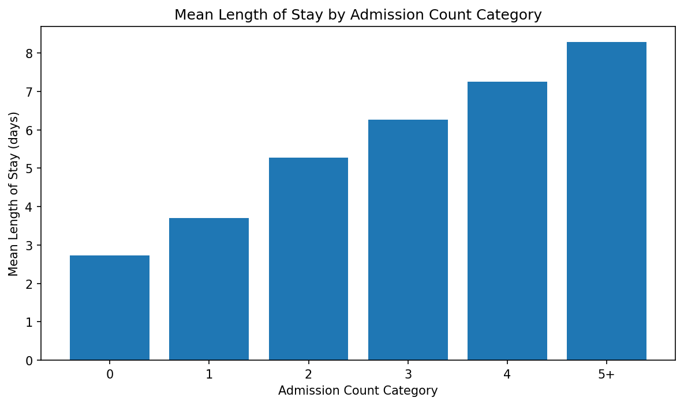
Figure 3. Mean length of stay by Admission Count Category
Mean length of stay rises from 2.72 days for category 0 to 8.28 days for category 5+. This is one of the strongest visible group-level patterns in the dataset and is also represented in the regression feature set.

8.4 Correlation Analysis
# 8.4 Correlation Analysis

correlation_features = [
"dialysisrenalendstage",
"asthma",
"irondef",
"pneum",
"substancedependence",
"psychologicaldisordermajor",
"depress",
"psychother",
"fibrosisandother",
"malnutrition",
"hemo",
"hematocrit",
"neutrophils",
"sodium",
"glucose",
"bloodureanitro",
"creatinine",
"bmi",
"pulse",
"respiration",
"lengthofstay"
]

correlation_matrix = df[correlation_features].corr()

# Correlation with target
target_correlations = (
correlation_matrix["lengthofstay"]
.drop("lengthofstay")
.sort_values(key=abs, ascending=False)
)

print("Correlation with Length of Stay:")
print(target_correlations)

# Heatmap
plt.figure(figsize=(14, 10))

sns.heatmap(
correlation_matrix,
annot=True,
fmt=".2f",
cmap="coolwarm",
center=0
)

plt.title("Correlation Matrix of Medical and Clinical Variables")
plt.tight_layout()
plt.show()

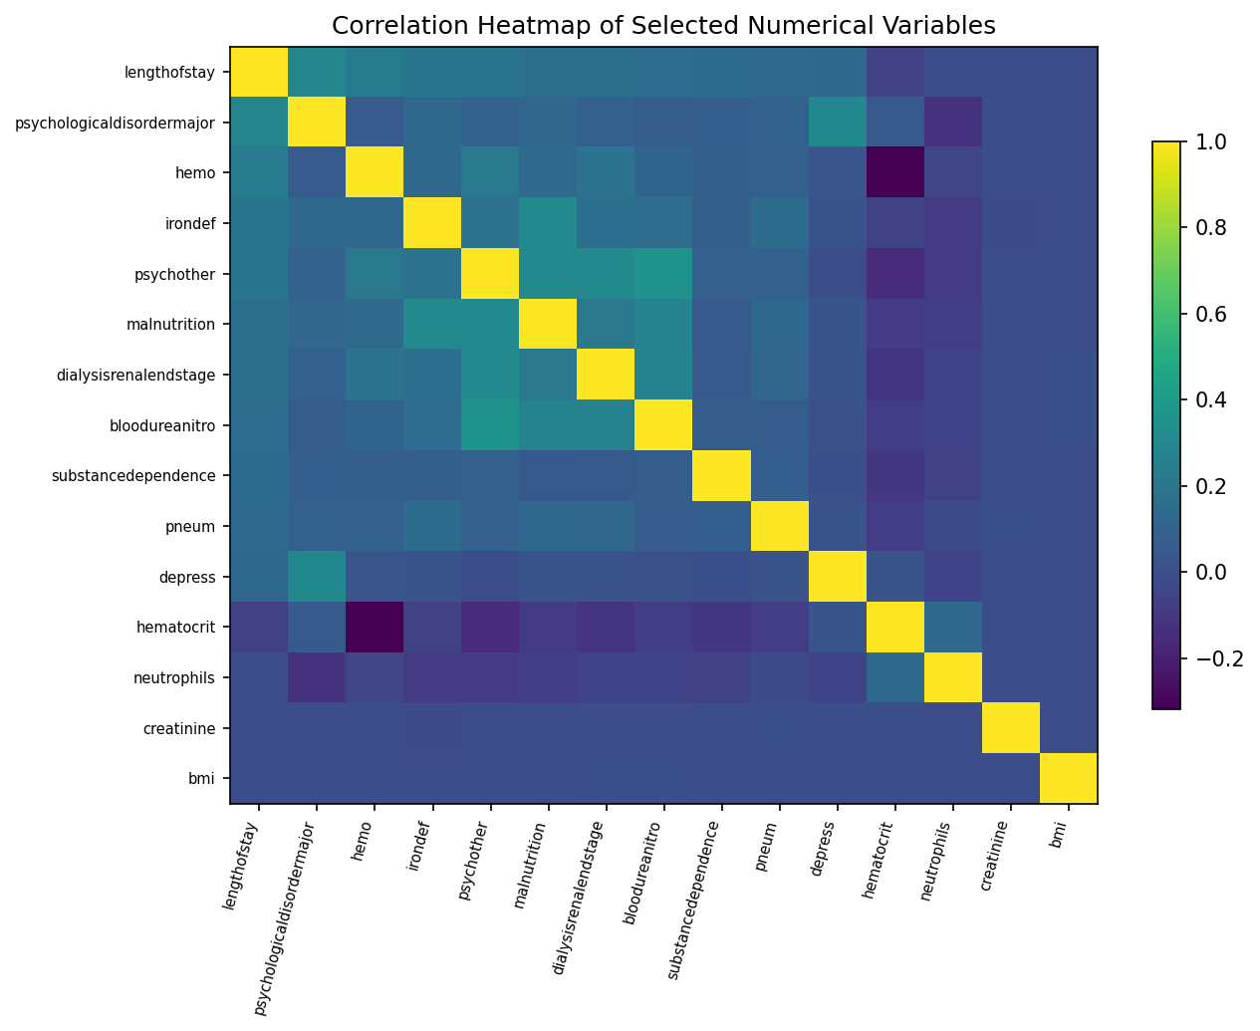
Figure 4. Correlation Heatmap of Numerical Variables
Among the numerical variables, the strongest absolute correlations with length of stay are observed for psychologicaldisordermajor (0.281), hemo (0.218), irondef (0.194), psychother (0.194), malnutrition (0.171). Correlation indicates association and should not be interpreted as evidence of causation.

9. STATISTICAL ANALYSIS

Variable | Mean | Median | Std. | Variance | IQR | Min | Max
Length of stay | 3.999 | 4.0 | 2.358 | 5.559 | 4.0 | 1 | 17
Hematocrit | 11.967 | 11.900 | 2.039 | 4.156 | 2.000 | 4.400 | 24.100
Glucose | 142.053 | 142.249 | 29.923 | 895.394 | 40.334 | -1.006 | 268.571
Creatinine | 1.099 | 1.098 | 0.200 | 0.040 | 0.271 | 0.220 | 2.035
BMI | 29.804 | 29.805 | 2.000 | 4.002 | 2.696 | 22.038 | 38.935
Table 4. Descriptive Statistics of Key Variables

10. FEATURE ENGINEERING
Calendar features were derived from the visit date: admission year, month, day of week and quarter. These features retain information available at admission while avoiding use of the eventual discharge date.

11. MODEL DEVELOPMENT

11.1 Problem Formulation
The task is supervised regression, with lengthofstay as the continuous target.

11.2 Model Selection
Three models were evaluated: Linear Regression as a baseline, Decision Tree Regression for nonlinear structure, and Random Forest Regression as an ensemble model capable of representing nonlinear relationships and interactions.

11.3 Training the Model
All models were trained using the same 80/20 split and preprocessing pipeline so that the comparison reflects differences in model behaviour rather than inconsistent data preparation.
from sklearn.model_selection import train_test_split
from sklearn.linear_model import LinearRegression
X_train, X_test, y_train, y_test = train_test_split(
X, y, test_size=0.20, random_state=42
)
model = LinearRegression()
model.fit(X_train, y_train)

12. MODEL EVALUATION

12.1 Regression Evaluation
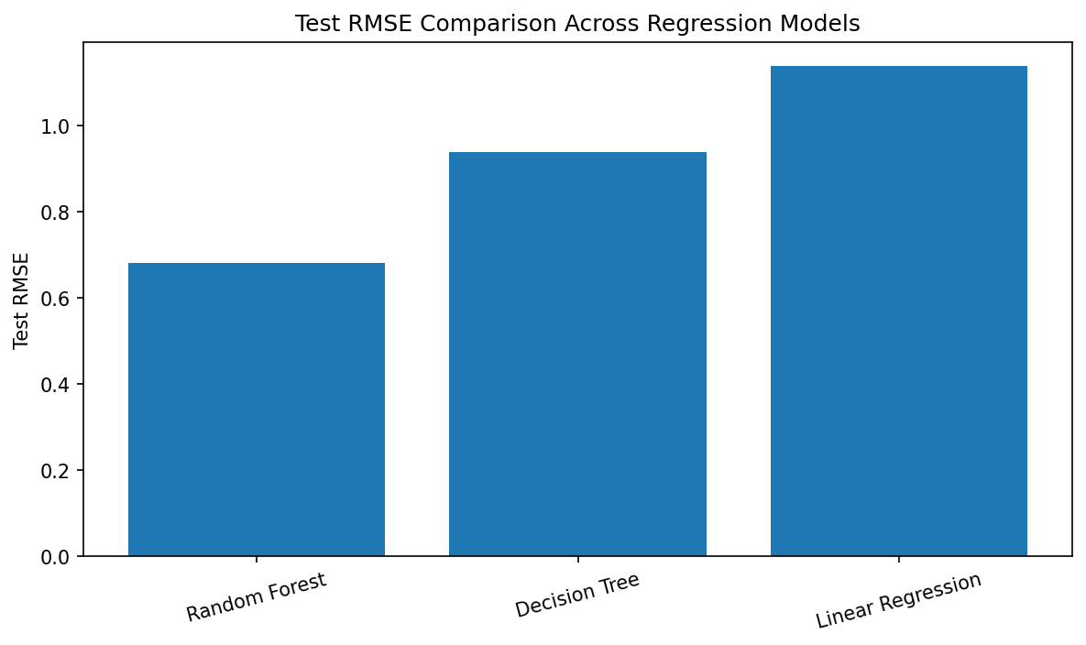
Figure 5. Test RMSE Comparison Across Regression Models
Model | Train MAE | Test MAE | Train RMSE | Test RMSE | Train R² | Test R²
Random Forest | 0.192 | 0.418 | 0.321 | 0.680 | 0.982 | 0.916
Decision Tree | 0.625 | 0.688 | 0.828 | 0.938 | 0.877 | 0.840
Linear Regression | 0.879 | 0.866 | 1.150 | 1.137 | 0.763 | 0.764

Random Forest has the lowest test RMSE in the supplied results (0.680) and a test R² of 0.916. Its training R² (0.982) is higher than its test R², indicating a train-test performance gap. The gap should be interpreted as evidence of some degree of fitting to the training data rather than as proof of deployment readiness. The corresponding test MSE is 0.462; across the three models, test MSE values are 0.462 for Random Forest, 0.880 for Decision Tree and 1.293 for Linear Regression.

12.2 Actual vs Predicted Length of Stay
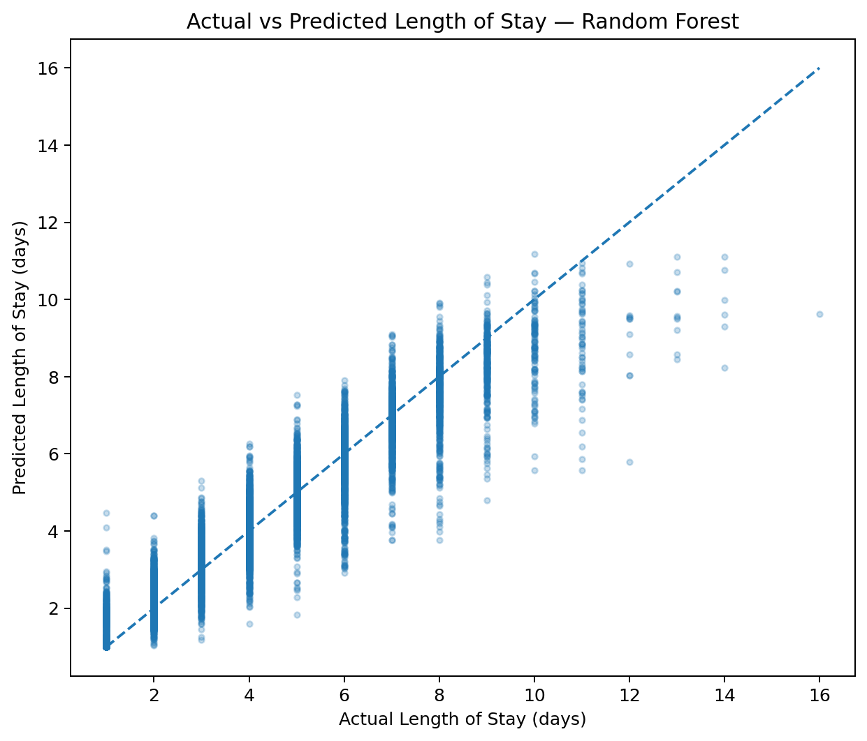
Figure 6. Actual vs Predicted Length of Stay — Random Forest
The actual-versus-predicted plot compares model estimates with the ideal 45-degree relationship. Points closer to the diagonal represent smaller prediction errors.
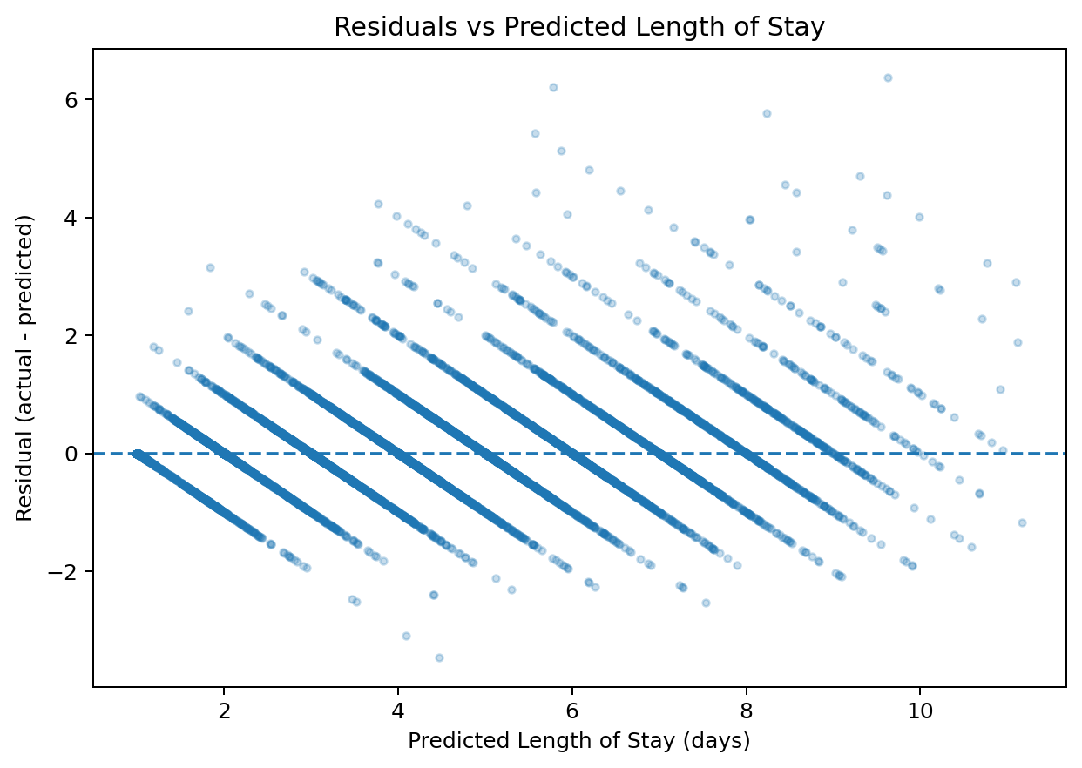
Figure 7. Residuals vs Predicted Length of Stay
Residual analysis complements the actual-versus-predicted plot by showing whether errors are centered around zero and whether their spread changes across the prediction range.

13. RESULTS AND FINDINGS
- The dataset contains 61,680 records and 28 variables, with no missing values and no exact duplicate rows.
- Length of stay has a mean of 4.00 days, a median of 4 days, and a range of 1–17 days.
- Admission count category is strongly associated with observed stay duration: the mean increases from 2.72 days at category 0 to 8.28 days at category 5+.
- Observed facility-level means range from 3.28 to 5.15 days.
- The discharge date exactly reproduces length of stay when combined with the visit date, so it was excluded to prevent target leakage.
- The supplied model results show Random Forest with test MAE 0.418, test RMSE 0.680, and test R² 0.916.

14. DISCUSSION
The analysis indicates that hospitalization duration is not evenly distributed across the observed patient and hospital categories. Admission count category shows a clear monotonic descriptive pattern, while facilities also show different average stay durations. The regression results indicate that nonlinear ensemble modelling captures the dataset's predictive structure more effectively than the linear baseline under the selected evaluation setup. However, predictive performance should not be interpreted as causal evidence, and the observed facility differences may reflect differences in patient mix, clinical practice, case complexity or other unmeasured factors. The model metrics should be interpreted as held-out performance under the stated random split, not as evidence of clinical deployment readiness.

15. LIMITATIONS
- The dataset is observational and therefore does not establish causal relationships.
- The available variables may not capture all factors influencing hospitalization duration.
- The discharge date cannot be used for admission-time prediction because it directly determines the target.
- Random train-test splitting may not fully represent temporal or facility-level deployment conditions.
- Model performance was evaluated on the supplied dataset and should not be treated as external clinical validation.

16. CONCLUSION
This project completed an end-to-end healthcare regression workflow for predicting patient length of stay. The dataset was structurally clean with no missing values or duplicate rows, but leakage control was essential because discharge date directly encoded the target. Exploratory analysis identified substantial observed differences across admission-count categories and hospital facilities. Among the evaluated models, the supplied results show Random Forest achieving the lowest test RMSE and the highest test R² of the three evaluated approaches. The project therefore demonstrates the value of combining careful data preparation, leakage prevention, statistical analysis, EDA and model evaluation when developing a predictive data science workflow.

17. RECOMMENDATIONS AND FUTURE WORK

17.1 Recommendations
- Use admission-time information rather than discharge information when building a forecasting workflow so that predictions do not contain target leakage.
- Use admission-count patterns as an analytical signal for further investigation of patient complexity and resource requirements.
- Investigate facility-level differences with additional contextual variables before drawing operational conclusions from the observed means.
- Use the Random Forest results as an analytical benchmark, while validating performance on an independent dataset before considering operational deployment.
- Report prediction errors alongside R² because an average absolute error is easier to interpret in days of hospitalization.

17.2 Future Work
Future work could include temporal validation, external validation on another hospital dataset, richer admission-time clinical variables, hyperparameter tuning, model explainability, uncertainty intervals for predictions and evaluation of performance across facilities and patient subgroups.

18. REFERENCES
India Data Research Academy. (2026). Capstone Project Guide 2026.
India Data Research Academy. (2026). Capstone Project Report Template and Sample.
India Data Research Academy. (2026). Healthcare Length of Stay Dataset provided through the LMS Study Material.

APPENDIX A. CODE
The complete reproducible implementation is provided in the accompanying Jupyter notebook. The notebook contains data loading, quality auditing, cleaning, leakage validation, EDA, preprocessing, model training and evaluation.

A.1 Data Loading and Inspection
df_raw = pd.read_csv(DATA_PATH)

print("Shape:", df_raw.shape)
display(df_raw.head())

# Dataset Understanding

print("Rows:", len(df_raw))
print("Columns:", df_raw.shape[1])
print("\nData types:")
display(df_raw.dtypes.to_frame("dtype"))

print("\nUnique values:")
display(df_raw.nunique().sort_values().to_frame("unique_values"))

print("\nDescriptive statistics:")
display(df_raw.describe(include="all").T)

A.2 Data Cleaning
# Work on a clean modelling dataframe
df_clean = df.copy()

# Standardize date-derived information known at admission.
df_clean["admission_year"] = df_clean["vdate_parsed"].dt.year
df_clean["admission_month"] = df_clean["vdate_parsed"].dt.month
df_clean["admission_dayofweek"] = df_clean["vdate_parsed"].dt.dayofweek
df_clean["admission_quarter"] = df_clean["vdate_parsed"].dt.quarter

# Keep the original raw dates out of the ML feature matrix.
# `discharged` is excluded because it is post-outcome information.
# `eid` is an identifier rather than a meaningful predictor.
drop_for_model = [
"eid",
"vdate",
"discharged",
"vdate_parsed",
"discharged_parsed",
"lengthofstay"
]

df_model = df_clean.drop(columns=drop_for_model)

print("Clean modelling dataset shape:", df_model.shape)
display(df_model.head())

A.3 Preprocessing
numeric_pipeline = Pipeline([
("imputer", SimpleImputer(strategy="median")),
("scaler", StandardScaler())
])

categorical_pipeline = Pipeline([
("imputer", SimpleImputer(strategy="most_frequent")),
("onehot", OneHotEncoder(handle_unknown="ignore"))
])

preprocessor = ColumnTransformer([
("num", numeric_pipeline, numeric_features),
("cat", categorical_pipeline, categorical_features)
])

A.4 EDA and Visualization
# 8.1 Length of stay by admission facility
facility_summary = (
df_clean.groupby("facid")["lengthofstay"]
.agg(["count", "mean", "median", "std"])
.sort_values("mean", ascending=False)
)
display(facility_summary)

plt.figure(figsize=(9, 5))
groups = [g["lengthofstay"].values for _, g in df_clean.groupby("facid", sort=True)]
labels = sorted(df_clean["facid"].dropna().unique())
plt.boxplot(groups, labels)
plt.title("Length of Stay Across Facilities")
plt.xlabel("Facility")
plt.ylabel("Length of Stay (days)")
plt.tight_layout()
plt.show()

A.5 Model Training and Evaluation
X = df_model.copy()
y = df_clean["lengthofstay"].copy()

categorical_features = X.select_dtypes(include=["object"]).columns.tolist()
numeric_features = X.select_dtypes(exclude=["object"]).columns.tolist()

print("Categorical features:", categorical_features)
print("Numerical features:", numeric_features)

X_train, X_test, y_train, y_test = train_test_split(
X, y,
test_size=TEST_SIZE,
random_state=RANDOM_STATE
)

numeric_pipeline = Pipeline([
("imputer", SimpleImputer(strategy="median")),
("scaler", StandardScaler())
])

categorical_pipeline = Pipeline([
("imputer", SimpleImputer(strategy="most_frequent")),
("onehot", OneHotEncoder(handle_unknown="ignore"))
])

preprocessor = ColumnTransformer([
("num", numeric_pipeline, numeric_features),
("cat", categorical_pipeline, categorical_features)
])

print("Training rows:", X_train.shape[0])
print("Testing rows:", X_test.shape[0])

# Model evaluation

# Visual comparison of test RMSE
plt.figure(figsize=(9, 5))
plt.bar(results_df["Model"], results_df["Test RMSE"])
plt.title("Test RMSE Comparison")
plt.xlabel("Model")
plt.ylabel("RMSE")
plt.xticks(rotation=15)
plt.tight_layout()
plt.show()

# Visual comparison of test R²
plt.figure(figsize=(9, 5))
plt.bar(results_df["Model"], results_df["Test R2"])
plt.title("Test R² Comparison")
plt.xlabel("Model")
plt.ylabel("R²")
plt.xticks(rotation=15)
plt.tight_layout()
plt.show()

APPENDIX B. ADDITIONAL FIGURES AND TABLES
Use this section for additional charts, tables, model outputs, or supplementary results that are useful but not essential to the main narrative.

