1. Make a function that takes two arguments ( A list of numbers and an integer ). This function should return pairs of numbers from the list that add up to the passed integer. Example. [1,2,3,4,5, 6] , 5

Ans - [1, 4], [2,3], [4, 6]

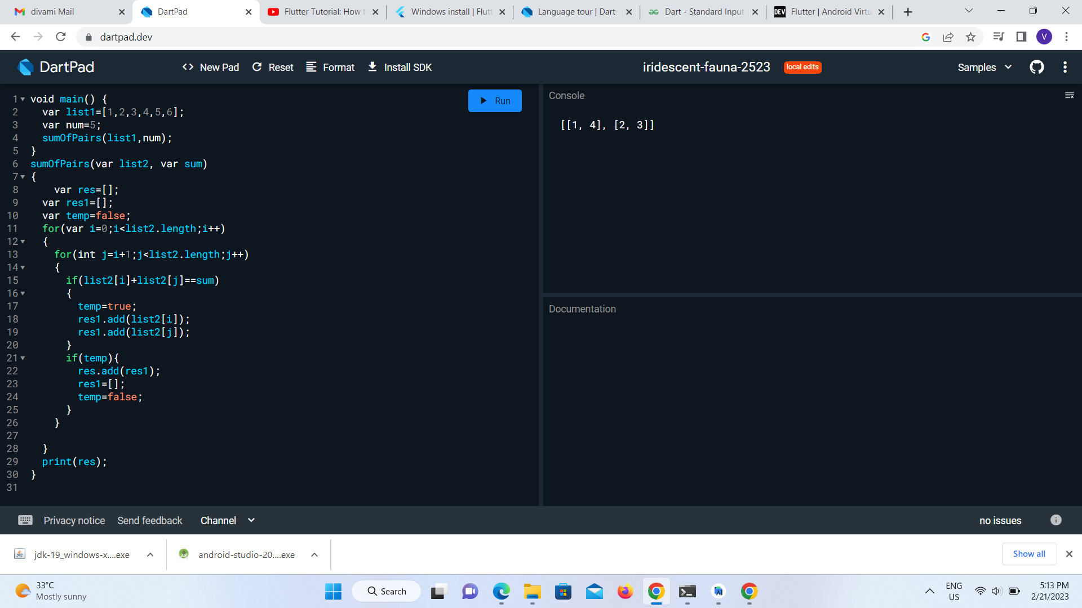

2. Given two strings A and B, find how many times string A was in string B and log how many times it was repeated and the position of the repeated string in B.

A=”in” B=’iqadninniwasinxvninnninwerfvniaqfin’

