**News at your desk**

AI chipmaker Nvidia launches tools for developers building humanoid robots



The company aims to address the need for vast amounts of data required to train robots by allowing developers to generate large amounts of synthetic data from a handful human tasks

Published - August 03, 2024 03:20 pm IST

[The Hindu Bureau](https://www.thehindu.com/profile/author/The-Hindu-Bureau-14355/)

Nvidia has announced a new suite of services and tools at Siggraph 2024 to speed up development of humanoid robots. The AI chipmaker has made its tools available to developers and software makers for training and building advanced humanoid robots.

The company introduced the new Nvidia NIM microservices and frameworks for robot simulation and learning as well as the Nvidia OSMO for running multi-stage robotics workloads and a remote-control workflow that helps developers train robots with small amounts of data

IRCTC plugs critical data breach on insurance portal

A cybersecurity analyst had flagged vulnerability that gave access to travel details of passengers and also option to change nominee in travel insurance



Updated - August 05, 2024 09:51 am IST

Published - August 04, 2024 10:22 pm IST - Chennai

The Indian Railway Catering and Tourism Corporation (IRCTC) has addressed a critical vulnerability on its insurance portal that previously allowed unauthorised access to passengers’ travel details and enabled changes to nominee information in the insurance policy.

Cybersecurity researcher Nilabh Rajpoot of Noida discovered the bug after booking train tickets on the IRCTC website and opting for travel insurance. He received a link via SMS that, upon entering the PNR and registered mobile number, opened the travel insurance policy provided by United India Insurance Co Ltd. The link included an option to update nominee details.

CERT-IN says Apple iPhone, VisionPro headset, Mac, iPad, and Apple Watch have ‘multiple vulnerabilities’ in software



Those with Apple devices should check to see that they have the latest version of the software provided by the company, to keep their products secure

Updated - August 05, 2024 11:12 am IST

Published - August 05, 2024 10:59 am IST

[The Hindu Bureau](https://www.thehindu.com/profile/author/The-Hindu-Bureau-14355/)

The Indian Computer Emergency Response Team, or CERT-IN, has flagged multiple vulnerabilities in Apple software products and given them a severity rating of ‘High’ in an advisory dated August 2.

“Multiple vulnerabilities have been reported in Apple products which could allow an attacker to access sensitive information, execute arbitrary code, bypass security restrictions, cause denial of service (DOS) and perform spoofing attacks on the targeted system,” said CERT-IN in the advisor

'Game changer' AI detects hidden heart attack risk



Katharine Da Costa

BBC News, Oxford

The artificial intelligence (AI) model detects inflammation in the heart that does not show up on CT scans, which involve a combination of X-rays and computer technology.

A pilot project, supported by NHS England, is running at five hospital trusts in Oxford, Milton Keynes, Leicester, Liverpool and Wolverhampton.

A decision on its use within the NHS is expected within months.

Its developer, Oxford University spinout company Caristo Diagnostics, said it was already working to adapt the technology to prevent strokes and diabetes.

Zoom launches AI-powered Docs feature to help workplace collaboration



The video-calling platform intends to compete with Google and Microsoft which have already introduced a host of AI features in their workplace collaboration tools

Published - August 06, 2024 12:34 pm IST

[The Hindu Bureau](https://www.thehindu.com/profile/author/The-Hindu-Bureau-14355/)

Zoom has launched a new feature so users can now generate a document with AI and create shareable files based on their meetings, while also being able to use Generative AI to write and edit them. As a part of Zoom Docs, users can also prompt the AI Companion to organise meeting transcripts, create tables, make checklists, as well as track processes and tasks assigned in the meeting.

The features were first announced by the company at their annual Zoomtopia event last year to help people collaborate easier online.

Google loses massive antitrust case over its search dominance



Google almost certainly will appeal the decision in a process that ultimately may land in the U..S. Supreme Court

Updated - August 06, 2024 06:43 am IST

Published - August 06, 2024 02:26 am IST - WASHINGTON

A judge on Monday ruled that [Google's ubiquitous search engine has been illegally exploiting its dominance](https://www.thehindu.com/sci-tech/technology/judge-says-trial-required-to-decide-government-antitrust-case-over-googles-advertising-tech/article68292326.ece) to squash competition and stifle innovation in a seismic decision that could shake up the internet and hobble one of the world's best-known companies.

The highly anticipated decision issued by U.S. District Judge Amit Mehta comes nearly a year after the start of a trial pitting the U.S. Justice Department against Google in the country's biggest antitrust showdown in a quarter century.

Microsoft hits back at Delta after the airline said last month’s CrowdStrike outage cost it $500 million

Microsoft is joining cybersecurity firm CrowdStrike in fighting back against criticism from Delta Air Lines

Updated - August 07, 2024 09:42 am IST

Published - August 07, 2024 09:24 am IST

Microsoft is joining cybersecurity software firm CrowdStrike in fighting back against Delta Air Lines, which blames the companies for [causing several thousand cancelled flights following a technology outage last month.](https://www.thehindu.com/sci-tech/technology/crowdstrike-rejects-delta-air-lines-claims-over-flight-woes-due-to-microsoft-global-it-outage/article68487067.ece)

A lawyer for Microsoft said Tuesday that Delta's key IT system is probably serviced by other technology companies, not Microsoft Windows.

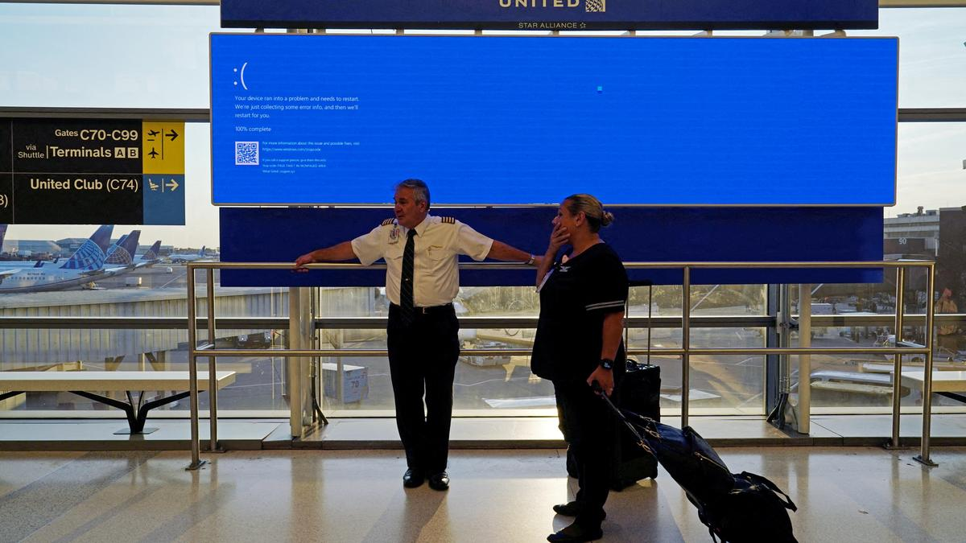

Samsung’s 8-layer HBM3E chips cleared Nvidia’s tests for use in its artificial intelligence processors

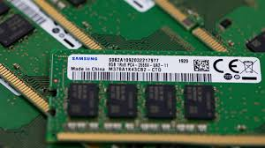

Published - August 07, 2024 05:00 pm IST - SINGAPORE

Reuters

A version of Samsung Electronics' fifth-generation high bandwidth memory (HBM) chips, or [HBM3E, has passed Nvidia's tests](https://www.thehindu.com/sci-tech/technology/samsung-hbm-chips-failing-nvidia-tests-due-heat-power-consumption-woes-sources-say/article68210145.ece) for use in its artificial intelligence (AI) processors, three sources briefed on the results said.

The qualification clears a major hurdle for the world's biggest memory chipmaker which has been struggling to catch up with local rival SK Hynix in the race to supply the advanced memory chips capable of handling generative AI work.

Intel shareholders sue chipmaker after job, dividend cuts cause stock plunge



Intel also posted a $1.61 billion second-quarter net loss, as revenue fell 1% to $12.83 billion

Published - August 08, 2024 09:20 am IST

Intel was sued on Wednesday by shareholders who said the Silicon Valley chipmaker fraudulently concealed problems that led it to post weak results, slash jobs and suspend its dividend, and caused its market value to sink more than $32 billion in a single day.

The proposed class action against Intel, Chief Executive Patrick Gelsinger and Chief Financial Officer David Zinsner was filed in San Francisco federal court.

Reuters

YouTube Shorts achieves trillion views in India, touches 11k creators with 10 lakh subscribers



YouTube also shared about the opportunities for advertisers and marketers

Updated - August 07, 2024 08:44 pm IST

Published - August 07, 2024 08:00 pm IST

[The Hindu Bureau](https://www.thehindu.com/profile/author/The-Hindu-Bureau-14355/)

[YouTube Shorts has achieved trillions of views within four years of its launch](https://www.thehindu.com/sci-tech/technology/youtube-creators-can-soon-run-ads-during-livestreams-through-a-picture-in-picture-feature/article68495802.ece)and has emerged as the preferred platform by Indians to consume content, said Neal Mohan, YouTube CEO, at Brandcast event in New Delhi on Wednesday (August 7, 2024).

He informed that YouTube Shorts has more than 11,000 Indian creators with over a million subscribers, a 50% increase year-over-year.

How are hackers using AI and HDMI cables to steal your passwords



Threat actors are using AI to decode electromagnetic signals emitted by HDMI cables to steal passwords.

Updated - August 08, 2024 01:58 pm IST

Published - August 08, 2024 01:55 pm IST

[The Hindu Bureau](https://www.thehindu.com/profile/author/The-Hindu-Bureau-14355/)

Since its launch for users, the [impact of AI and deep learning algorithms on security](https://www.thehindu.com/sci-tech/technology/how-ai-shaped-cybersecurity-landscape-2023/article67657577.ece) has been a topic of discussion amongst cybersecurity researchers. The fears were not unfounded; researchers have discovered a new way used by hackers to steal sensitive information, including passwords.

The method involves using AI to decode electromagnetic frequencies emitted from HDMI cables and reconstruct what is displayed on the screen.

Chatbot at Paris Olympics 2024 | Intel’s AthleteGPT handles queries from athletes



Intel’s processors will also power 8K resolution live streaming experiences, providing fans with low-latency, high-definition streaming across the 32 sporting events

Published - July 22, 2024 10:15 am IST

[The Hindu Bureau](https://www.thehindu.com/profile/author/The-Hindu-Bureau-14355/)

Intel has developed a chatbot in collaboration with the International Olympic Committee (IOC). Titled AthleteGPT, the platform will answer queries from [athletes across the world and help them navigate the venue and comply with rules easily.](https://www.thehindu.com/life-and-style/fashion/uniforms-are-getting-weaved-as-olympics-arrives-to-capital-of-fashion/article68425102.ece)

Powered by Intel Gaudi accelerators and Xeon processors, the chatbot is a Retrieval Augmented Generation or RAG-

based solution to deliver “on-demand information” to athletes during the 2024 Paris Olympics.

CrowdStrike fallout | Why did your home Windows PC survive the Microsoft outage?

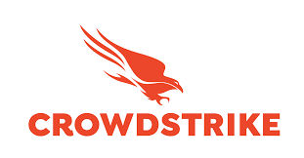

The CrowdStrike-Microsoft outage that disrupted flight operations globally, flashing the Blue Screen of Death (BSOD) on several enterprise Windows PCs last week, did not affect Windows computers used at home

Updated - July 24, 2024 11:31 am IST

Published - July 22, 2024 11:40 am IST

[The Hindu Bureau](https://www.thehindu.com/profile/author/The-Hindu-Bureau-14355/)

The CrowdStrike-Microsoft outage that disrupted flight operations globally, [flashing the Blue Screen of Death (BSOD) on several enterprise Windows PCs](https://www.thehindu.com/sci-tech/technology/issue-resolved-flight-schedule-being-followed-now-mos-mohol-on-microsoft-outage/article68425074.ece) last week, did not affect Windows computers used at home. Why didn’t the outage disrupt home PCs? That’s because CrowdStrike’s Falcon solution was deployed only at companies that buy the cybersecurity firm’s licenses in a sizeable chunk.

CrowdStrike revealed that the global IT outage that impacted transport, finance, and medical industries around the world was caused by a sensor configuration update for Windows gone wrong

A sensor configuration update for Microsoft Windows systems that went wrong was the cause of what is now being identified as possibly the largest IT outage in history.

The IT outage on July 19 started when the CrowdStrike software update triggered a logic error. This led to a system crash and caused the ‘blue screen of death’ that many saw on their affected devices.

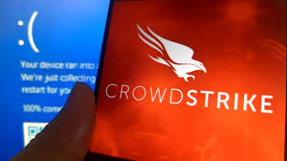

CrowdStrike rejects Delta Air Lines claims over flight woes due to Microsoft global IT outage

Published - August 05, 2024 10:16 am IST - WASHINGTON

Reuters

CrowdStrike on Sunday rejected a claim by Delta Air Lines that it should be blamed for flight disruptions following a July 19 global outage sparked by a faulty update, and suggested it had minimal potential liability.

Delta CEO Ed Bastian said [last week the outage had cost the U.S. airline $500 million and that it planned to take legal action](https://www.thehindu.com/sci-tech/technology/delta-air-lines-seek-compensation-over-cyber-outage-report/article68462951.ece) to get compensation from the cybersecurity firm.