Crack Segmentation for KEYSTONE
Report sections for Workstream A (Data) and Workstream C (Measurement and Integration)
2 October 2026. Every number below comes from a run on the shared code (crack-seg v5) and the Workstream B checkpoints in crack-runs-20261001T074007Z.

Main findings
- The converter silently dropped 237 of DeepCrack's 537 images. It is fixed, and all results here use the full 537 pairs (386 train, 66 validation, 85 test).
- Cracks are 3.537% of pixels. Predicting no crack anywhere scores 0.9657 pixel accuracy on the test split with an IoU of zero, so pixel accuracy is not used as a headline metric.
- The best model (focal Tversky loss) reaches a test IoU of 0.6506. The top three losses are within 0.007 IoU of each other from one training run each, so they cannot be ranked.
- On real model output, crack width is not accurate to the 1 px that the synthetic calibration suggests. Median error is 1.0 px for mean width and 2.0 px for maximum width, and thin cracks read about 1 px too wide.
- On masonry the model's IoU falls from 0.6506 to 0.4553, mostly through lost precision. In the worst inspected case it marked every mortar joint of a brick wall as a crack.

Part A. Data

A.1 Dataset
The project uses DeepCrack (Liu et al., 2019), taken from github.com/yhlleo/DeepCrack. It has 537 photographs of cracked road and concrete surfaces, each with a hand-drawn pixel mask. The repository has no formal licence file; its README restricts use to non-commercial research and education, which covers this project.
All 537 images are one of two sizes: 490 are 544 x 384 pixels (landscape) and 47 are 384 x 544 (portrait). DeepCrack ships its own train and test folders (300 and 237 images). These were pooled and re-split, as described in A.5.

A.2 Conversion, and a data-loss bug
scripts/prepare_data.py --layout deepcrack --clean converts the raw folders into data/processed/images and data/processed/masks: lossless PNG, masks strictly 0 or 255, files named 0000 to 0536. Images are not resized at this stage.
The original converter numbered the train folder and the test folder separately, both starting at 0000. The 237 test images therefore overwrote the first 237 train images. The script still printed "537 pairs written" while only 300 files existed on disk. Workstream B caught it on Colab when scripts/inspect_data.py counted 300 pairs, and it was found independently while testing the converter for Workstream A. The fix continues the numbering across folders, and the script now stops with an error if the number of files on disk differs from the number it reports.

A.3 Class imbalance
Measured over all 537 masks by scripts/inspect_data.py:
Quantity | Value
Crack pixels, whole dataset | 3.537%
Crack pixels per image, median | 2.802%
Crack pixels per image, minimum to maximum | 0.262% to 19.935%
Images with no crack | 0
Suggested positive class weight (background / crack) | 27.3
Pixel accuracy of predicting no crack anywhere (test split) | 0.9657
Table A1. Class balance of the converted DeepCrack data.
prepare_data.py prints its own estimate (2.913% and a weight of 33.3), but it samples only the first 300 masks. The figures above cover all 537 and are the ones to cite. Training computes its class weight from the training split alone, so the test split does not influence it.

A.4 Quality control
scripts/inspect_data.py checks for the failures that quietly ruin a segmentation dataset: an implausible crack fraction, empty masks, masks that are almost entirely crack (inverted labels), masks whose size differs from their image, and non-binary masks. On the converted data it reported 537 pairs and its final verdict, "DATASET LOOKS USABLE", which it prints only when no check fails.
The script also writes a contact sheet of images with their masks overlaid in red (Figure A1). It was inspected by eye: the red sits on the dark crack lines in every tile.
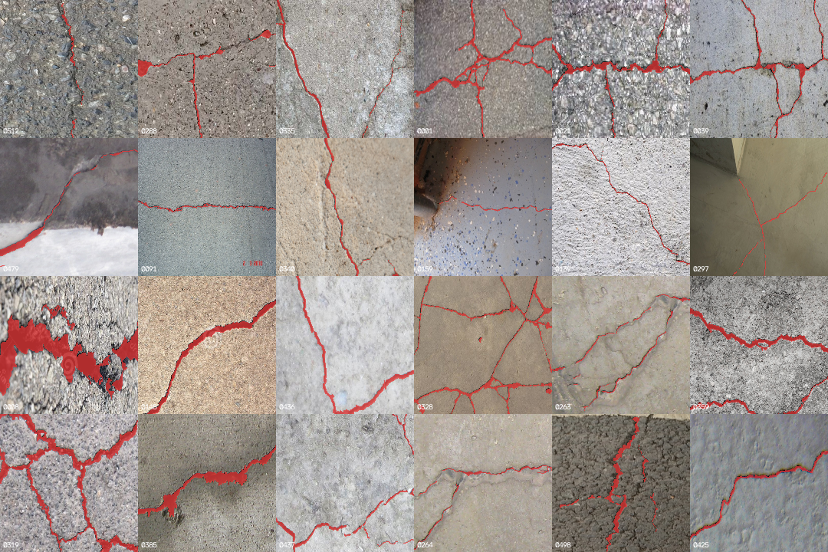
Figure A1. Contact sheet from inspect_data.py: 24 DeepCrack images with their ground-truth masks overlaid in red.
python tests/contracts_test.py --only A passes 6 of 6 checks on this data, which is what guarantees Workstreams B and C can consume it without shape or range mismatches.

A.5 Splits
Images are assigned to train, validation and test by hashing the filename, with 15% each for validation and test. The split is never shuffled. An image therefore lands in the same split on every run and on every machine, and adding images later cannot move an existing image from train to test.
The 537 filenames give 386 train, 66 validation and 85 test images. This was confirmed on two machines: the laptop used for Workstreams A and C and the Colab runtime used for B produce the same counts, and the B checkpoints reproduce B's reported test scores exactly on the laptop (section C.2).

A.6 Augmentation survival study
Question. Can augmentation erase a thin crack from the image while its mask still marks it? If so, the model is trained to call plain wall a crack.
The self-test in src/data/transforms.py reports "crack survived 12/12 draws", but it uses a 3 px crack and only checks that the mask still has crack pixels. It cannot see a crack that has faded out of the image.
Method. scripts/aug_survival_experiment.py draws synthetic cracks 1, 2 and 3 px wide, at random angles, on a textured 544 x 384 background (the size of 91% of DeepCrack). It applies each of the project's real pipelines, and each augmentation on its own, 100 times per width. A draw counts as faded when the crack keeps less than half of its original contrast against the wall 2 to 3 px either side of it, while the mask still marks it.
Test | 1 px | 2 px | 3 px
Training pipeline, light | 93% (0.24) | 10% (0.71) | 5% (0.80)
Training pipeline, medium (used for training) | 90% (0.35) | 13% (0.69) | 2% (0.81)
Training pipeline, heavy | 95% (0.29) | 15% (0.68) | 5% (0.80)
Evaluation pipeline (resize to 320 x 320) | 97% (0.35) | 0% (0.75) | 0% (0.85)
RandomResizedCrop, scale 0.5 to 1 | 91% (0.44) | 0% (0.80) | 0% (0.88)
Resize to 320 x 320 | 98% (0.34) | 0% (0.75) | 0% (0.85)
GaussianBlur, kernel 3 to 5 | 96% (0.27) | 11% (0.61) | 0% (0.80)
MotionBlur, kernel 5 | 67% (0.34) | 5% (0.79) | 1% (0.88)
Flip and 90 degree rotation | 0% (1.00) | 0% (1.00) | 0% (1.00)
Brightness and contrast | 0% (1.04) | 0% (0.99) | 0% (1.00)
Gamma | 0% (1.00) | 0% (1.00) | 0% (1.00)
Gaussian noise | 0% (0.85) | 0% (0.84) | 0% (0.87)
Elastic transform, medium / heavy | 0% (0.76) / 0% (0.70) | 0% (0.92) / 0% (0.91) | 0% (0.95) / 0% (0.94)
Grid distortion, heavy | 0% (0.67) | 0% (0.90) | 0% (0.94)
Candidate: crop at native size, no blur | 2% (0.95) | 1% (0.95) | 0% (1.00)
Table A2. Share of draws in which the crack faded, by crack width. Median contrast ratio in brackets (1.00 means as dark as before). 100 draws per cell.
Findings.
- A 1 px crack fades in 90% to 95% of training draws at every augmentation strength, and in 97% of evaluation draws. The strength setting makes no difference, because the cause is present in all of them.
- Two operations are responsible: any resize to 320 x 320 (91% to 98%) and blur (96% for Gaussian, 67% for motion). Flips, brightness, gamma, noise, elastic and grid distortion fade nothing.
- Cracks 2 px wide fade in 10% to 15% of training draws, and 3 px cracks in 5% or fewer.
- Cropping at native resolution and dropping blur removes the problem: 2% or less at every width.
How much this matters for DeepCrack. Very little. DeepCrack's cracks are mostly wide: the median crack on the test split is 5.92 px, and only 17 of 85 test images have a mean width under 3 px (section C.5). Two independent results agree. Workstream B's ablation at 512 px scored 0.6342 IoU against 0.6355 at 320 px with the same loss, and a perfect model working at 320 x 320 would still measure width within 1 px on 99% of test images (section C.5).
Version measured. Table A2 was measured with src/data/transforms.py as shipped in the shared code (crack-seg v5), where blur is applied with probability 0.25. A re-run with that probability lowered to 0.10 gave 94%, 85% and 90% for 1 px cracks in the light, medium and heavy training pipelines and 97% in evaluation, against 94%, 86%, 92% and 97% at 0.25 in the same run. Lowering the blur probability does not remove the fade, because the resize is in every pipeline. Workstream B should confirm which version the checkpoints were trained with.
Proposed recommendation, pending Workstream B's decision to retrain or to record this as a limitation. Keep the medium pipeline for the DeepCrack results reported here. For hairline cracks, which are the ones that matter on heritage masonry, train on native-resolution crops and remove blur. That needs retraining and has not been done.
Limits of this study. The cracks are synthetic, straight, and a fixed 60 grey levels darker than the wall. Real cracks vary in contrast. The augmentation library draws its own random numbers, so individual percentages move by a few points between runs; the pattern does not.

A.7 Domain note
DeepCrack is road and concrete. KEYSTONE's target is masonry, where mortar joints are dark, linear and high-contrast, like cracks. Section C.6 measures what that costs.

Part C. Measurement and integration

C.1 Metrics and protocol
src/metrics.py reports IoU, Dice, precision and recall, computed per image and then averaged, so a few heavily cracked images cannot dominate. Pixel accuracy is printed only next to the do-nothing baseline: predicting no crack anywhere scores 0.9657 pixel accuracy on the test split with IoU, precision and recall all zero.
The decision threshold is tuned on the 66 validation images, then applied once to the 85 test images. Tuning on test and reporting test would be leakage. src/evaluate.py writes the chosen threshold into the checkpoint so that prediction and the KEYSTONE interface use it automatically.

C.2 Reproducing Workstream B's results
Before any change to the evaluation code, B's checkpoints were re-evaluated on a second machine (a CPU laptop, with the data converted independently). Focal Tversky gave IoU 0.6493 and Dice loss gave 0.6440, identical to B's table to four decimals. BCE+Dice, focal and BCE, evaluated after the change described in C.3, kept their thresholds and also match B's original figures exactly. This confirms that the data, the split and the code path are the same on both machines.

C.3 Threshold analysis
The original sweep tested thresholds from 0.05 to 0.95. For the focal Tversky model, validation IoU was still rising at the last step:
Threshold | 0.05 | 0.25 | 0.50 | 0.75 | 0.90 | 0.95
Validation IoU | 0.6257 | 0.6504 | 0.6583 | 0.6642 | 0.6697 | 0.6717
Precision | 0.6594 | 0.7008 | 0.7185 | 0.7352 | 0.7557 | 0.7696
Recall | 0.9280 | 0.9064 | 0.8947 | 0.8816 | 0.8648 | 0.8497
Table C1. Focal Tversky model, validation split (66 images), original sweep. IoU rises at every step.
Three of the six losses had selected exactly 0.95, the edge of the grid. The grid was extended to 0.99, and for the Tversky model, whose validation IoU was still rising at 0.99 (0.6642 at 0.98, 0.6663 at 0.99), to 0.999. evaluate.py now warns when the selected threshold sits on the edge of the grid. The threshold is still chosen on validation only.
Loss | Test IoU | Dice | Precision | Recall | Threshold | Before the fix
Focal Tversky | 0.6506 | 0.7711 | 0.7365 | 0.8507 | 0.96 | 0.6493 at 0.95
Tversky | 0.6484 | 0.7703 | 0.7303 | 0.8456 | 0.996 | 0.6369 at 0.95
Dice | 0.6440 | 0.7636 | 0.7310 | 0.8366 | 0.90 | unchanged
BCE + Dice | 0.6355 | 0.7552 | 0.7180 | 0.8363 | 0.95 | unchanged
Focal | 0.6318 | 0.7489 | 0.7244 | 0.8058 | 0.55 | unchanged
BCE | 0.6012 | 0.7173 | 0.7042 | 0.7813 | 0.40 | unchanged
Table C2. Final test results (85 images), thresholds tuned on validation. Models trained by Workstream B.
What the table supports.
- The top three losses are within 0.0066 IoU of each other, from one training run each on 85 test images. That is not enough to rank them. Plain BCE is 0.049 IoU below the best.
- The overlap-based losses need thresholds between 0.90 and 0.996. They output high confidence on a band of pixels around each crack, which agrees with the over-wide masks measured in C.5. BCE and focal loss sit near the conventional 0.5.
- The Tversky model's threshold of 0.996 means its outputs are pushed very close to 1. A cut-off that extreme is fragile on new images. Focal Tversky, at 0.96, is the model used for the rest of this section.
- Extending the grid changed two results by 0.0013 and 0.0115 IoU. The conclusion did not change.

C.4 Width calibration on synthetic masks
A crack's width is measured by thinning the mask to a one-pixel centreline, taking the distance from each centreline pixel to the nearest background pixel, and converting that to a width. python keystone/interface.py checks this against bands of known width:
True width (px) | 1 | 2 | 3 | 4 | 5 | 6 | 7 | 8 | 9
Measured (px) | 1 | 1 | 3 | 3 | 5 | 5 | 7 | 7 | 9
Table C3. Odd widths are exact. Even widths read 1 px low, because the centreline falls on one of the two middle pixels.
Every width therefore carries up to 1 px of quantisation error. A band widened from 3 px to 7 px is reported as +4.00 px, which is +2.00 mm at 0.5 mm per pixel. Because each of two measurements can be off by a pixel, a change of less than about 2 px cannot be claimed. At 0.5 mm per pixel that is about 1 mm of widening.
This test measures hand-made masks. It never runs the model, so it gives the best case. Section C.5 measures the real case.

C.5 Measurement error on real model output
scripts/measure_vs_gt.py measures each of the 85 test images three ways: from the ground-truth mask, from the focal Tversky model's mask (threshold 0.96), and from the ground truth passed through the model's 320 x 320 input grid and back. The third is what a perfect model at this input size would produce, so it separates error caused by the resize from error caused by the network. All values are in pixels of the original image.
Ground-truth mean crack width on the test split has a median of 5.92 px and ranges from 1.15 to 38.87 px. 17 images are thin (under 3 px) and 68 are wider.
Quantity | Median signed error | Median absolute error | Within 1 px | Median relative error
All images (n = 85)
Mean width | +0.36 px | 0.98 px | 51% | 18%
95th percentile width | 0.00 px | 1.86 px | 36% | 16%
Maximum width | 0.00 px | 2.00 px | 27% | 14%
Total length | -14 px | 75 px |  | 10%
Number of cracks | 0 | 1 |  | 30%
Thin cracks (n = 17)
Mean width | +0.97 px | 0.97 px | 53% | 48%
95th percentile width | +1.53 px | 1.53 px | 47% | 40%
Maximum width | +1.53 px | 2.94 px | 6% | 44%
Total length | -58 px | 70 px |  | 12%
Number of cracks | 0 | 3 |  | 55%
Wider cracks (n = 68)
Mean width | +0.10 px | 1.00 px | 50% | 16%
95th percentile width | 0.00 px | 1.88 px | 34% | 15%
Maximum width | -0.13 px | 2.00 px | 32% | 12%
Total length | -11 px | 77.5 px |  | 9%
Number of cracks | 0 | 1 |  | 27%
Table C4. Model against ground truth. Positive signed error means the model reads too wide or too long.
Perfect model at 320 x 320 | Median absolute error, thin | Within 1 px, thin | Median absolute error, wider | Within 1 px, wider
Mean width | 0.07 px | 100% | 0.10 px | 99%
95th percentile width | 0.00 px | 94% | 0.03 px | 97%
Maximum width | 0.00 px | 94% | 0.00 px | 100%
Total length | 5 px (1%) |  | 11.5 px (2%)
Table C5. The resize alone costs almost nothing on DeepCrack. The error in Table C4 comes from the network.
Findings.
- The 1 px figure from the synthetic calibration does not hold on real output. Across all 85 images the median error is 0.98 px for mean width and 2.00 px for maximum width, and 51% of images are within 1 px on mean width.
- Maximum width is the least reliable quantity: within 1 px on 27% of images overall, and on 6% of thin-crack images. It is set by a single pixel, often at a junction or a blob.
- Thin cracks read about 1 px too wide, which is close to half their true width. The model also finds less of their length (58 px short at the median, about 12%), and the crack count is off by 3 at the median because a single crack is returned in pieces.
- Wider cracks have almost no width bias (+0.10 px).
- Raising the threshold from 0.95 to 0.96 changed the thin-crack width bias only from +1.05 to +0.97 px. The over-width is a property of the model, not of the threshold.
DeepCrack photographs carry no scale reference. Any millimetre value printed by src.predict --mm-per-px on this dataset is the pixel value multiplied by the number supplied, not a physical measurement.

C.6 Failure cases
On DeepCrack. Wide, high-contrast cracks are segmented well. Thin cracks are traced but broken by small gaps, so one crack is returned as several pieces (Figure C1).
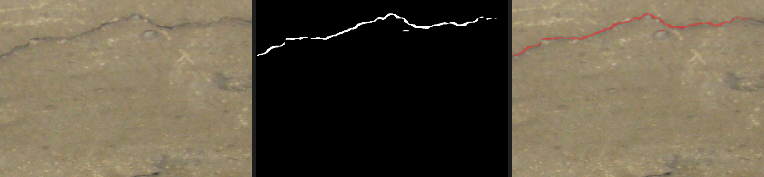
Figure C1. Test image 0476. Left: photograph. Middle: predicted mask. Right: overlay. One thin crack, returned with gaps and stray fragments.
On masonry. The same checkpoint, with its DeepCrack-tuned threshold of 0.96 and no re-tuning, was scored on the masonry crack set of Dais et al. (2021): 240 photographs of 224 x 224 pixels, each with a mask, 4.211% crack pixels. scripts/eval_external.py scores it exactly as evaluate.py scores DeepCrack.
 | DeepCrack test (85) | Masonry (240) | Change
IoU | 0.6506 | 0.4553 | -0.195
Dice | 0.7711 | 0.5875 | -0.184
Precision | 0.7365 | 0.5452 | -0.191
Recall | 0.8507 | 0.7698 | -0.081
Table C6. The domain gap. Most of the loss is precision: the model still finds the cracks but marks many pixels that are not crack.
Pixel accuracy on masonry is 0.9606. With 4.2% crack pixels, predicting no crack anywhere would score about 0.958, so on masonry the model barely beats doing nothing by that measure.
Image | IoU | Precision | Recall | Reading
a_40_0 | 0.071 | 0.071 | 0.983 | Crack found; about 13 times as many false pixels
a_17_3 | 0.060 | 0.062 | 0.729 | Same pattern
a_143_0 | 0.053 | 0.054 | 0.676 | Same pattern
c_30_139 | 0.057 | 0.918 | 0.057 | Opposite: only 6% of the crack marked
a_31_92 | 0.000 | 0.000 | 0.000 | Nothing marked overlaps the crack
Table C7. Five of the eight lowest-scoring masonry images. a_40_0 and c_30_139 were inspected by eye (Figures C2 and C3).
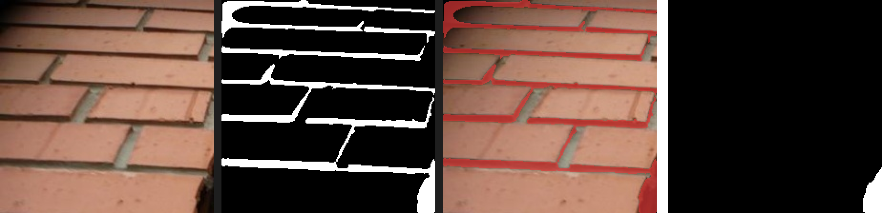
Figure C2. Masonry image a_40_0. Left to right: photograph, predicted mask, overlay, ground truth. Every mortar joint is marked as crack; the only real crack is the small region at the bottom-right corner.
In a_40_0 the model found the real crack (recall 0.983) and also marked every mortar joint in the wall (precision 0.071). This is the failure the project plan predicted. The other low-precision, high-recall images are consistent with it but were not inspected.
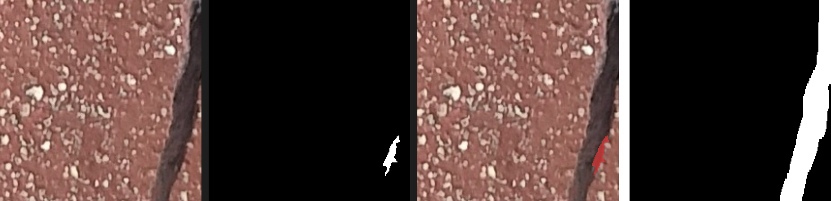
Figure C3. Masonry image c_30_139. Left to right: photograph, predicted mask, overlay, ground truth. A wide, dark crack down the right edge; the model marked one small patch of it.
c_30_139 fails the opposite way. The crack is wide and clearly visible, 9.8% of the image. The model marked 6% of it (recall 0.057), and what it marked was correct (precision 0.918). Why it stopped there was not investigated.

C.7 What this means for KEYSTONE
These are recommendations from Workstream C. The first one changes the alert rule in the shared KEYSTONE adapter, so it is pending approval by the team that owns the alert decision. Until it is approved, keystone/interface.py and the README example are unchanged.
- Proposed, pending approval: alert on mean width, not maximum width. The example in the README alerts on d_max_width > 1.0. Maximum width is within 1 px of the truth on 27% of images, against 51% for mean width, and its median error is twice as large.
- Set alert thresholds above the measured error, not just above the 1 px quantisation floor. Each capture's mean width is typically off by about 1 px, and a comparison uses two captures.
- Do not rely on crack count. One thin crack is often returned as several pieces.
- Expect a constant over-width of about 1 px on hairline cracks. Some of it cancels when two captures of the same crack are compared, but this has not been measured.
- KEYSTONE must still supply the scale in millimetres per pixel and two registered captures. compare_captures rejects masks of different sizes but cannot detect a misalignment of a few pixels.
- The model is not ready for masonry as trained. The 240 labelled masonry images make fine-tuning possible without hand-labelling; this has not been done.

C.8 Code changes made in Workstream C
- src/predict.py: --compare-to crashed on a colour-conversion constant that does not exist in OpenCV. Fixed.
- src/metrics.py and src/evaluate.py: threshold grid extended beyond 0.95, a --thresholds option added, and a warning when the chosen threshold is on the edge of the grid.
- scripts/measure_vs_gt.py and scripts/eval_external.py added. Both only read from src/ and keystone/.
src/contracts.py and the tests were not changed. All 22 contract checks pass.

C.9 What this analysis does not show
- Each loss was trained once. Differences of a few thousandths of IoU are within what a different random seed could produce.
- The measurement errors are for one model on DeepCrack. They are in pixels; no real-world scale was available.
- Every masonry image contains a crack, so the rate of false alarms on crack-free walls could not be measured. The masonry set is brick, in small patches, not the stone of heritage monuments.
- The comparison of two captures taken months apart was tested only on synthetic masks.

References
Liu, Y., Yao, J., Lu, X., Xie, R., Li, L. (2019). DeepCrack: A deep hierarchical feature learning architecture for crack segmentation. Neurocomputing, 338, 139-153. Data: github.com/yhlleo/DeepCrack.
Dais, D., Bal, İ. E., Smyrou, E., Sarhosis, V. (2021). Automatic crack classification and segmentation on masonry surfaces using convolutional neural networks and transfer learning. Automation in Construction, 125, 103606. https://doi.org/10.1016/j.autcon.2021.103606. Data: github.com/dimitrisdais/crack_detection_CNN_masonry (GPL-3.0).

Appendix. Commands that produced these numbers
Result | Command
Table A1, section A.4 | python scripts/inspect_data.py --root data/processed --sheet data/contact_sheet.png
Table A2 | python scripts/aug_survival_experiment.py
Tables C1, C2 | python -m src.evaluate --checkpoint runs/<loss>/best.pt --data-root data/processed then python scripts/collect_results.py
Table C3 | python keystone/interface.py
Tables C4, C5 | python scripts/measure_vs_gt.py --checkpoint runs/loss_focal_tversky/best.pt
Tables C6, C7 | python scripts/eval_external.py --checkpoint runs/loss_focal_tversky/best.pt --images <images> --masks <masks> --name masonry
Figures C1, C2 | python -m src.predict --checkpoint runs/loss_focal_tversky/best.pt --input <folder> --outdir predictions/<name>

