


Onsite IT Advisors
12600 Deerfield Parkway, Suite 100
Alpharetta, GA 30004
govt@onsiteitadvisors.com | www.onsiteitadvisors.com
(770) 940-3445

Vol 1 Mission Capabilities- FDIC DMS – Onsite IT Advisors LLC

January 2,2026

Table of Contents
1. Understanding of FDIC DMS Mission 3
2. Technical Approach 3
2.1 DMS Support Model Overview 3
2.2 CDMA Platform Support (Azure Data & Analytics) 4
2.3 AlphaRex Modernization (AI / NLP) 5
2.4 Enterprise AI Operations 5
2.5 Agile Delivery and DevOps 5
2.6 Technical Risk Management 6
3. Management Approach 6
3.1 Program Governance and Oversight 6
3.2 Staffing and Role Alignment 6
3.3 Work Management and Delivery Approach 7
3.4 Communication and Coordination 7
3.5 Risk and Issue Management 7
3.6 Continuity and Surge Support 8
4. Technical Capabilities Security, Governance, and Compliance 8
4.1 Security-by-Design Approach 8
4.2 Governance and Enterprise Alignment 8
4.3 Risk Management Framework (RMF) and Compliance Support 8
4.4 Monitoring, Logging, and Incident Response 9
4.5 DevOps, Configuration Management, and Audit Readiness 9
4.6 Privacy and Data Protection 9
5. Risk Management 9
5.1 Privacy and Data Protection 9
5.2 Technical and Operational Risks 10
5.3 Security and Compliance Risks 10
5.4 Staffing and Continuity Risks 10
5.5 Schedule and Dependency Risks 10
6. Key Personnel 11
6.1 Key Personnel Mapping Table 11

Understanding of FDIC DMS Mission
The Federal Deposit Insurance Corporation’s Division of Management Services (DMS) plays a critical role in enabling secure, reliable, and scalable data and analytics capabilities that support the FDIC’s mission to maintain stability and public confidence in the nation’s financial system. As FDIC continues to modernize its enterprise data and analytics platforms, DMS must simultaneously support ongoing operations, legacy system modernization, and the adoption of advanced analytics and artificial intelligence technologies without disruption to mission-critical services.

The FDIC’s data environment is inherently complex, requiring support for multiple concurrent initiatives across cloud-native analytics platforms, artificial intelligence solutions, and enterprise data operations. These initiatives demand not only technical expertise, but also disciplined governance, security compliance, and close coordination with FDIC stakeholders and partner contractors.

Onsite IT Advisors understand that success under this requirement is defined by the ability to operate as a trusted extension of FDIC’s Chief Data Office and DMS teams. Our approach emphasizes stable operations, incremental modernization, and secure adoption of advanced analytics and AI capabilities. We are prepared to support FDIC’s CDMA platform, AlphaRex modernization efforts, and enterprise AI operations through a delivery model that integrates architecture, engineering, security, and operational support across Azure-based environments.

Our proposed approach is designed to reduce operational risk, accelerate value delivery, and ensure alignment with FDIC governance, security, and enterprise architecture standards. By applying proven enterprise delivery practices, disciplined Agile execution, and strong security oversight, Onsite IT Advisors will enable FDIC to modernize its data and analytics ecosystem while maintaining the reliability and compliance expected of a federal financial regulatory agency.

Technical Approach

DMS Support Model Overview
Onsite IT Advisors will support the FDIC Division of Management Services (DMS) through a delivery model designed to manage multiple concurrent initiatives while maintaining operational stability, security compliance, and alignment with FDIC enterprise standards. Our approach recognizes that DMS must balance ongoing platform operations, legacy system modernization, and the adoption of advanced analytics and artificial intelligence capabilities without disrupting mission-critical services.

We apply a multi-initiative support model that enables FDIC to prioritize work dynamically across the CDMA platform, AlphaRex modernization, and enterprise AI operations. Work intake, prioritization, and execution are coordinated closely with FDIC stakeholders to ensure transparency, responsiveness, and alignment with mission objectives. This model allows FDIC to scale effort across initiatives while maintaining clear ownership, accountability, and delivery discipline.

Onsite IT Advisors integrates directly with FDIC teams and partner contractors, operating as a trusted extension of the FDIC Chief Data Office and DMS organizations. We emphasize proactive communication, disciplined change management, and continuous risk monitoring to ensure smooth coordination across technical, security, and governance domains.

CDMA Platform Support (Azure Data & Analytics)
Onsite IT Advisors will provide comprehensive support for FDIC’s Cloud Data Management and Analytics (CDMA) platform, leveraging proven experience in Azure-based data architectures and enterprise analytics operations. Our approach supports the full data lifecycle—from ingestion and transformation through analytics, visualization, and operational support—while embedding governance and security controls throughout.

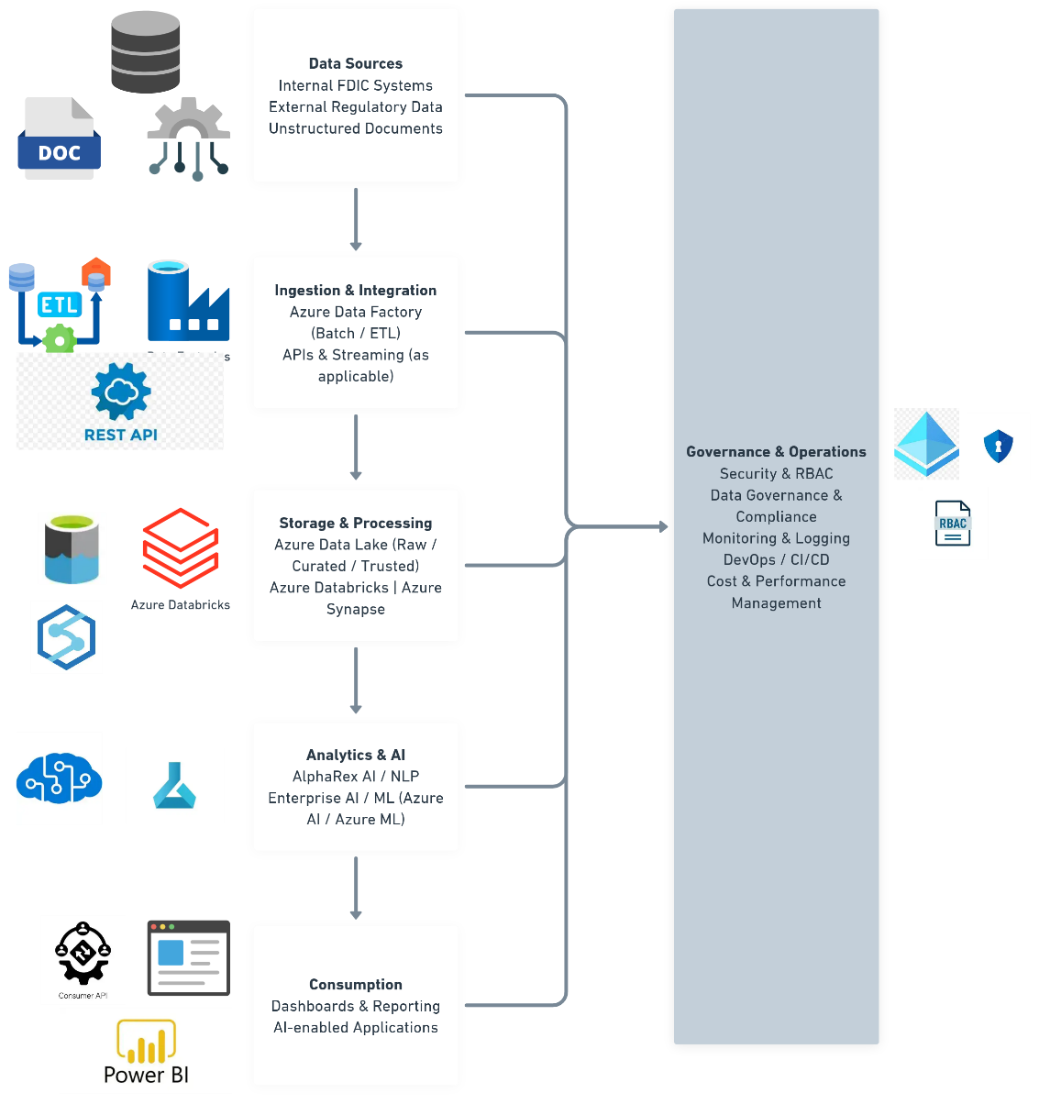
Figure 1: High Level Architecture Diagram
- Data Ingestion and Processing: We support structured, semi-structured, and unstructured data ingestion using Azure Data Factory and related Azure integration services. Data pipelines are designed to ensure reliability, scalability, and traceability, enabling FDIC to process data from multiple internal and external sources while maintaining data quality and lineage.
- Analytics and Lakehouse Architecture: We support Azure Databricks, Azure Synapse Analytics, and Azure Data Lake environments to enable scalable analytics and reporting capabilities. Our approach aligns with modern lakehouse architecture that allows FDIC to perform advanced analytics while maintaining centralized governance and access controls.
- Operational Support and Optimization: Onsite IT Advisors provide ongoing operational support for CDMA environments, including performance monitoring, incident response, and cost optimization. We apply infrastructure-as-code practices using Terraform and leverage Git-based workflows to ensure consistency, repeatability, and auditability across environments.
- Security and Governance Integration: Security and governance are embedded into all CDMA activities. We align with FDIC enterprise architecture standards, access control requirements, and data governance policies to ensure that analytics capabilities remain compliant with federal security expectations.

AlphaRex Modernization (AI / NLP)
Onsite IT Advisors will support FDIC’s AlphaRex modernization by enabling the secure and reliable transition of legacy analytics and artificial intelligence capabilities to modern, cloud-based platforms. Our approach emphasizes continuity of operations while introducing scalable, maintainable, and explainable AI solutions.

We support Python-based AI and natural language processing (NLP) solutions that operate on unstructured and semi-structured data sources. Modernization activities include refactoring legacy workflows, migrating processing pipelines to Azure-based environments, and implementing cloud-native services to improve performance and maintainability.

Our approach ensures that AlphaRex capabilities are integrated into FDIC’s broader data and analytics ecosystem, enabling reuse of shared services, centralized monitoring, and consistent governance. Throughout modernization efforts, we maintain close coordination with FDIC stakeholders to ensure functional parity, controlled transitions, and minimal operational disruption.

Enterprise AI Operations
Onsite IT Advisors treats artificial intelligence as an enterprise capability rather than a standalone development effort. Our approach supports the full AI lifecycle, including development, deployment, monitoring, and operational support, with a strong emphasis on governance, security, and reliability.

We support role-based access control, usage monitoring, and operational oversight to ensure AI services are used appropriately and transparently. AI solutions are monitored for performance, availability, and reliability, with defined processes for incident response and issue resolution.

Our approach emphasizes responsible and explainable AI practices, ensuring that models and analytics outputs are understandable, auditable, and aligned with FDIC governance expectations. This allows FDIC to adopt advanced AI capabilities while maintaining public trust and regulatory accountability.

Agile Delivery and DevOps
Onsite IT Advisors employs a disciplined Agile delivery model aligned with FDIC governance and oversight requirements. Work is executed through iterative sprints, with clearly defined backlogs, acceptance criteria, and deliverables. Agile ceremonies and artifacts provide transparency into progress, risks, and dependencies.

DevOps practices are integrated across development and operations to enable continuous integration, automated testing, and controlled deployments. CI/CD pipelines are designed to support secure, repeatable releases while maintaining alignment with change management and security review processes.

Quality is enforced through automated testing, peer reviews, and structured validation processes. This approach ensures that enhancements and fixes are delivered efficiently without compromising stability or compliance.

Technical Risk Management
Onsite IT Advisors proactively identifies and manages technical risks associated with enterprise data platforms and AI solutions. Risks related to system availability, data quality, security, and integration are continuously monitored and addressed through defined mitigation strategies.

Our risk management approach emphasizes early identification, clear escalation paths, and close collaboration with FDIC stakeholders. By addressing risks proactively, we reduce the likelihood of disruptions and ensure consistent delivery of mission-critical capabilities.

Management Approach

Program Governance and Oversight
Onsite IT Advisors will manage this effort through a structured program governance model designed to ensure transparency, accountability, and alignment with FDIC priorities. Governance is established to support concurrent initiatives across CDMA platform operations, AlphaRex modernization, and enterprise AI services while maintaining operational stability and compliance.

A designated Program Manager will serve as the primary point of contact for FDIC DMS leadership and will be responsible for overall delivery, coordination, and performance management. Governance activities include regular status reporting, risk and issue tracking, and alignment with FDIC change management and approval processes. This approach ensures that FDIC stakeholders maintain continuous visibility into progress, priorities, and emerging risks.

Program governance is structured to integrate seamlessly with FDIC’s existing oversight frameworks, enabling effective collaboration with internal teams and partner contractors without duplicating processes or introducing unnecessary administrative overhead.

Staffing and Role Alignment
Onsite IT Advisors will staff this effort with qualified personnel aligned to the technical and operational needs of FDIC DMS initiatives. Roles are assigned based on functional responsibility, technical expertise, and federal delivery experience to ensure continuity and accountability.

Key roles include program management, solution architecture, data engineering, AI and analytics support, DevOps, and quality assurance. Each role has clearly defined responsibilities and escalation paths to ensure timely issue resolution and consistent delivery. Staffing plans are designed to support both steady-state operations and surge requirements as FDIC priorities evolve.

Personnel are cross-trained where appropriate to reduce dependency on single individuals and to ensure continuity of operations in the event of staff transitions. This approach minimizes delivery risk while maintaining flexibility to respond to changing mission needs.

Work Management and Delivery Approach
Onsite IT Advisors employs a disciplined Agile delivery approach tailored to federal governance environments. Work is planned and executed in iterative cycles, with defined backlogs, priorities, and acceptance criteria established in collaboration with FDIC stakeholders.

Agile ceremonies and artifacts provide transparency into progress, dependencies, and risks while maintaining alignment with FDIC reporting and oversight expectations. Deliverables are reviewed regularly to ensure quality, technical accuracy, and compliance with FDIC standards.

This approach enables incremental value delivery while allowing FDIC to adjust priorities as mission requirements evolve, without introducing unnecessary disruption or rework.

Communication and Coordination
Effective communication is central to successful program execution. Onsite IT Advisors will maintain structured communication channels to ensure timely coordination with FDIC DMS leadership, technical teams, and partner contractors.

Regular meetings, written status reports, and ad hoc coordination sessions are used to address progress, risks, and upcoming activities. Communication protocols are designed to support decision-making while minimizing administrative burden on FDIC personnel.

All communications are conducted in accordance with FDIC information security and data handling requirements to ensure protection of sensitive information.

Risk and Issue Management
Onsite IT Advisors applies a proactive risk management approach to identify, assess, and mitigate potential risks throughout the program lifecycle. Risks related to staffing, technical complexity, security compliance, and schedule are monitored continuously and addressed through defined mitigation strategies.

Issues are escalated promptly through established governance channels to ensure timely resolution and minimal impact on mission-critical operations. This disciplined approach reduces uncertainty and supports predictable, reliable delivery.

Continuity and Surge Support
Onsite IT Advisors is committed to maintaining continuity of operations across all supported initiatives. Knowledge transfer, documentation, and cross-training practices ensure that services remain stable and resilient over time.
Surge support can be provided as needed to address priority initiatives, emerging requirements, or unforeseen operational demands. This flexibility allows FDIC to respond effectively to changing mission needs without compromising service quality or compliance.

Technical Capabilities Security, Governance, and Compliance

Security-by-Design Approach
Onsite IT Advisors applies a security-by-design approach across all activities supporting FDIC DMS initiatives. Security considerations are embedded into solution architecture, development, deployment, and operations to ensure that confidentiality, integrity, and availability requirements are consistently met.

Security controls are implemented in alignment with FDIC policies and federal standards, with particular emphasis on access control, data protection, monitoring, and incident response. Role-based access control (RBAC) is enforced to ensure that users and services have only the permissions required to perform their authorized functions.

This approach ensures that security is not treated as a standalone activity, but as an integral component of all data, analytics, and AI operations.

Governance and Enterprise Alignment
Onsite IT Advisors align all technical activities with FDIC enterprise architecture, data governance, and operational standards. Governance processes are designed to support consistency, traceability, and accountability across CDMA platform operations, AlphaRex modernization, and enterprise AI services.

Data governance practices include support for data classification, lineage, and metadata management to ensure transparency and appropriate use of data assets. Architectural decisions and technical implementations are documented and reviewed to maintain alignment with FDIC governance expectations and to support long-term sustainability.

This governance-focused approach enables FDIC to maintain control over enterprise data and analytics capabilities while continuing to modernize and adopt advanced technologies.

Risk Management Framework (RMF) and Compliance Support
Onsite IT Advisors supports FDIC compliance obligations through disciplined adherence to the Risk Management Framework (RMF) and related federal security requirements. We assist with the documentation, implementation, and validation of security controls required to support Authority to Operate (ATO) processes and ongoing compliance activities.

Security artifacts, including system documentation, control evidence, and remediation plans, are maintained to support audits, assessments, and continuous monitoring activities. Findings and risks are tracked and addressed through defined mitigation and remediation processes, including Plan of Action and Milestones (POA&M) management where applicable.

This approach ensures that security compliance activities are proactive, auditable, and aligned with FDIC operational timelines.

Monitoring, Logging, and Incident Response
Onsite IT Advisors implement monitoring and logging practices to provide visibility into system performance, security events, and operational health. Monitoring activities support early detection of anomalies, potential security incidents, and performance degradation.

Defined incident response procedures are followed to ensure timely identification, escalation, and resolution of issues in coordination with FDIC stakeholders. This disciplined approach minimizes operational impact and supports FDIC’s commitment to system reliability and security.

DevOps, Configuration Management, and Audit Readiness
DevOps practices are implemented to support controlled, repeatable, and auditable changes across environments. Configuration management, version control, and automated testing are used to maintain consistency and reduce the risk of unintended changes.

All changes are executed in alignment with FDIC change management and approval processes. Documentation and evidence are maintained to support audit readiness and compliance verification, ensuring that FDIC can demonstrate control over system changes and operational activities.

Privacy and Data Protection
Onsite IT Advisors is committed to protecting sensitive and regulated data throughout its lifecycle. Data protection measures include encryption, access controls, and handling procedures aligned with FDIC privacy and security requirements.

Privacy considerations are incorporated into system design and operational processes to ensure appropriate handling of sensitive information and to support FDIC’s regulatory responsibilities.

Risk Management

Risk Management Approach
Onsite IT Advisors applies a proactive and structured risk management approach throughout the lifecycle of FDIC DMS support activities. Risks are identified early, assessed for potential impact, and actively managed to reduce the likelihood of disruption to mission-critical operations.

Risk management activities are integrated into program governance, delivery planning, and operational execution. This ensures that technical, security, staffing, and schedule risks are continuously monitored and addressed in coordination with FDIC stakeholders.

Technical and Operational Risks
Technical risks associated with enterprise data platforms and AI solutions include system performance, integration complexity, and data quality challenges. Onsite IT Advisors mitigates these risks through disciplined architecture practices, incremental delivery, and continuous validation of system behavior.

Operational risks, including system availability and change coordination, are managed through defined processes for release management, monitoring, and incident response. These controls ensure that enhancements and maintenance activities do not adversely impact ongoing FDIC operations.

Security and Compliance Risks
Security and compliance risks are addressed through alignment with FDIC security policies and federal standards, including the Risk Management Framework (RMF). Continuous monitoring, access control enforcement, and audit-ready documentation reduce the likelihood of security incidents and compliance findings.

Potential risks identified through assessments or audits are tracked and mitigated through structured remediation processes, including Plan of Action and Milestones (POA&M) management when applicable.

Staffing and Continuity Risks
Staffing risks, including personnel availability and knowledge continuity, are mitigated through cross-training, documentation, and knowledge transfer practices. Onsite IT Advisors ensures that critical functions are not dependent on single individuals and that transitions are managed without service disruption.

Surge support can be applied to address changing priorities, emergent requirements, or unexpected workload increases, providing FDIC with flexibility while maintaining delivery stability.

Schedule and Dependency Risks
Schedule and dependency risks are managed through transparent planning, dependency tracking, and regular coordination with FDIC stakeholders and partner contractors. This approach enables early identification of potential delays and timely adjustments to delivery plans.

By maintaining open communication and structured escalation paths, Onsite IT Advisors minimize schedule risk while supporting FDIC’s evolving mission needs.

Key Personnel
Onsite IT Advisors proposes a team of experienced professionals with demonstrated expertise in enterprise data platforms, cloud analytics, artificial intelligence, and federal program delivery. Key personnel are selected based on their direct relevance to the FDIC DMS mission, experience supporting complex data and analytics environments, and ability to operate effectively within regulated federal environments.

Each key role is aligned to specific responsibilities within the proposed Technical and Management Approaches, ensuring accountability, continuity, and low delivery risk. Personnel possess experience supporting cloud-native platforms, AI-enabled analytics, and secure enterprise operations, with an emphasis on collaboration, governance, and operational stability.

Key Personnel Mapping Table
Proposed Role | Name | Responsibility | Relevant Experience
Program Manager | Parimal Kulkarni | Overall program delivery, stakeholder coordination, governance and risk management | Federal programs, enterprise delivery
Solution Architect | Marcus McMahan | CDMA Architecture, Azure design, and technical oversight | Azure data platforms analytics
Data Engineer | Bradley Ford | Data ingestion, ETL development, Azure Databrincks, and Azure Synapse | Cloud data engineering
AI/Analytics Lead | Ezekiel Oladipupo | AI/ML analytics, NLP solutions, enterprise AI operations | AI/ML, analytics platforms
DevOps/Platform Engineer | Antone Silvia | CI/CD, monitoring, environment stability | DevOps, Cloud Ops
Security and Compliance Officer | Natasha Mills | Security compliance oversight, policy alignment, RMF support, audit readiness. | Federal compliance, governance, risk management
QA/Validation Lead | Joseph Caintic | Quality assurance, validation, and release support | Testing validation

Table 1: Key Personnel Mapping Table

