NETWORK SCANNING
AND TRAFFIC ANALYSIS
USING NMAP AND WIRESHARK
Practical Cyber Security Project Report

Project Type | Hands-on network scanning and traffic analysis
Tools Used | Nmap 7.993 and Wireshark
Operating System | Windows
Scan Target | Localhost (127.0.0.1)
Prepared as practical learning documentation

1. Introduction
Network scanning and traffic analysis are common activities in cybersecurity. Network scanning helps identify hosts, open ports, and services. Traffic analysis helps examine packets exchanged during network communication. In this project, Nmap was used to scan the local computer, and Wireshark was used to capture and inspect traffic generated during normal web browsing.

2. Project Objectives
- Perform a TCP port scan against the local computer.
- Identify open and closed ports reported by Nmap.
- Use Nmap service detection to identify services on open ports.
- Capture network traffic from the laptop's Wi-Fi connection using Wireshark.
- Apply the DNS display filter to inspect DNS packets.
- Save scan output, packet captures, and screenshots as project evidence.

3. Tools and Environment
Tool / Environment | Purpose | Details
Nmap | Network scanning and service detection | Version 7.993
Wireshark | Packet capture and traffic inspection | Used on the laptop's Wi-Fi interface
Windows | Operating system under test | Local machine scan
Command Prompt | Run Nmap commands | Windows command line

4. Practical Activities

4.1 Wireshark Packet Capture
Wireshark was opened and the Wi-Fi interface was selected for live capture. After packets began appearing, normal web browsing was performed to generate traffic from the laptop. The capture was stopped and saved in PCAPNG format.
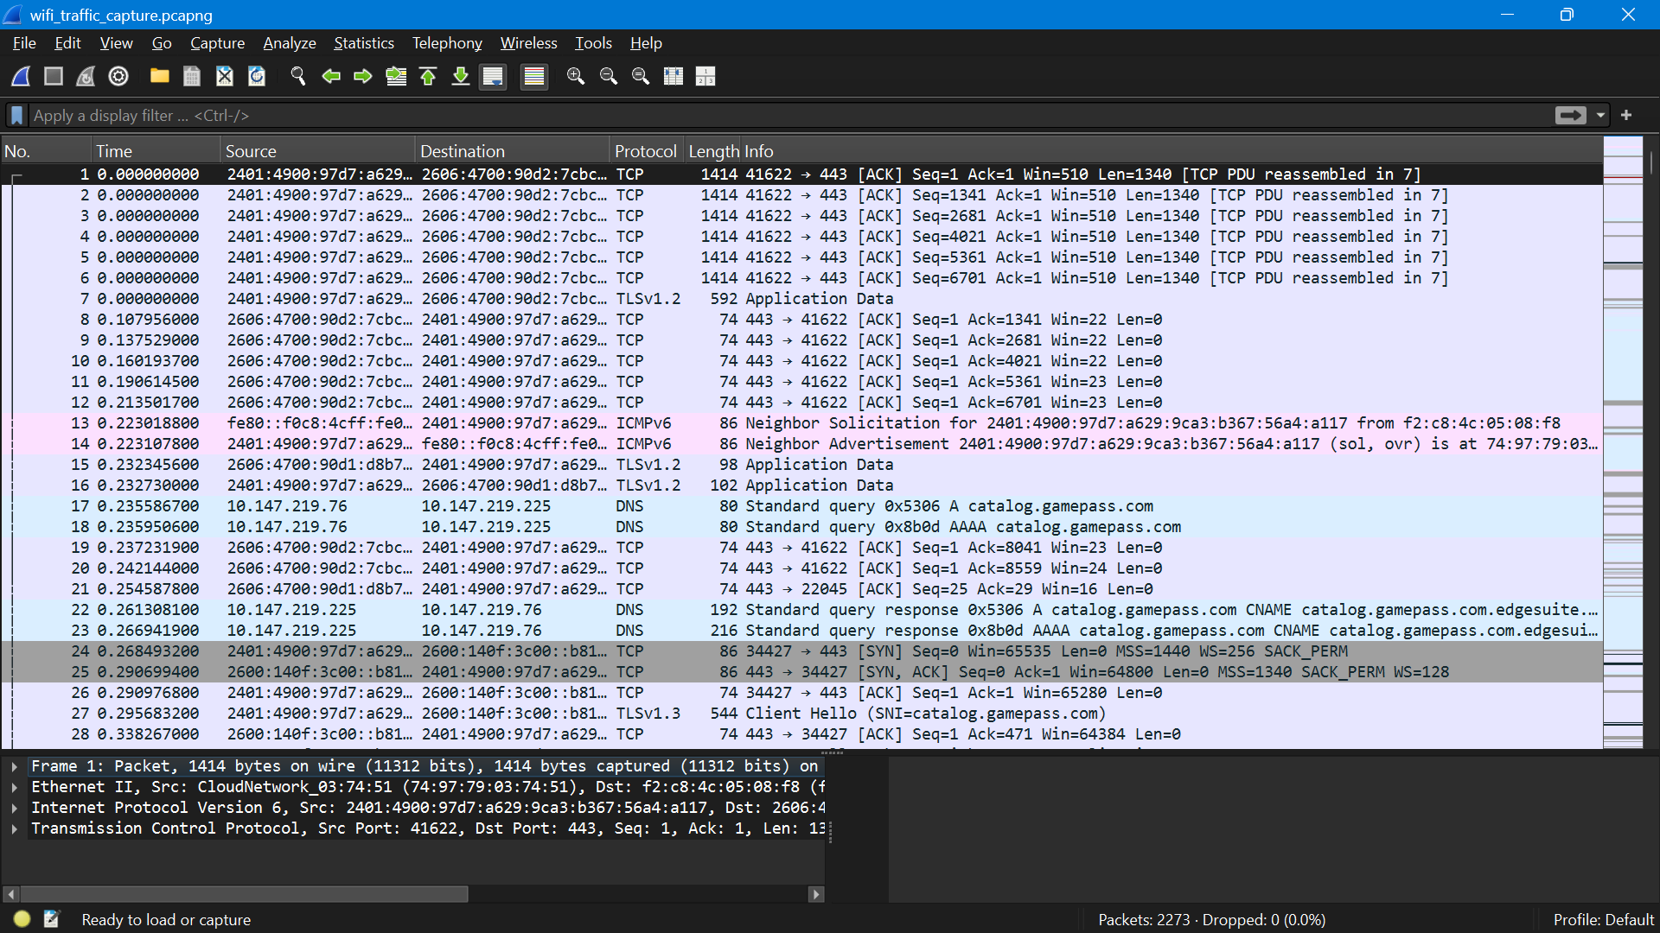
Figure 1. Wireshark packet capture showing network traffic.
Capture file: wifi_traffic_capture.pcapng
A general packet-list screenshot was saved as wireshark_packet_capture.png.

4.2 DNS Traffic Analysis
The Wireshark display filter dns was applied to focus the packet list on DNS traffic. A screenshot of the filtered packet list was saved as dns_traffic_analysis.png. The screenshot and capture file are the evidence for this activity; individual DNS queries or responses should only be described if they are visible in the saved capture.
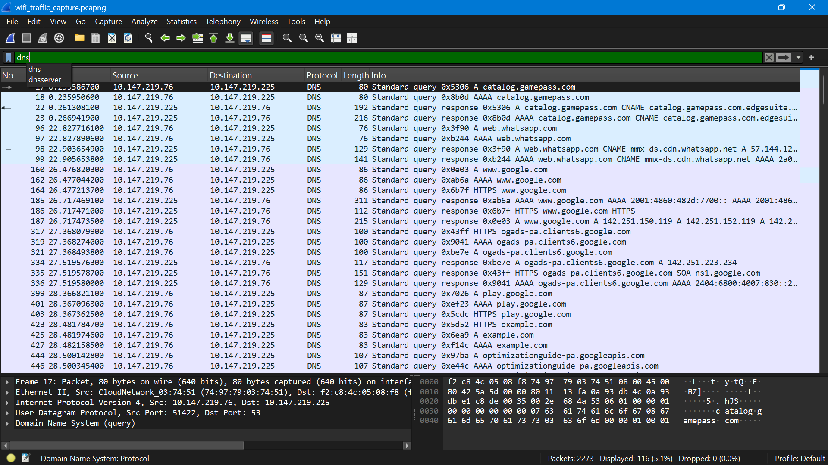
Figure 2. DNS packets displayed using the dns filter.

4.3 Basic Nmap Port Scan
Command executed: nmap 127.0.0.1
The target was localhost (127.0.0.1), which refers to the same computer on which the command was run. Nmap reported that the host was up, found two open TCP ports, and reported 998 closed TCP ports in its default scan.
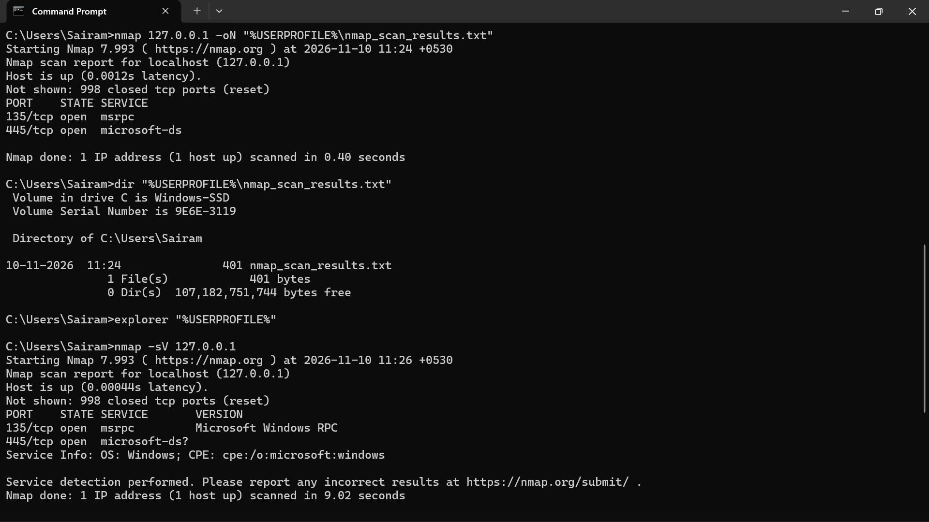
Figure 3. Nmap basic port scan results for localhost.

4.4 Nmap Service Detection
Command executed: nmap -sV 127.0.0.1
The -sV option asks Nmap to probe open ports to identify the services running on them. The scan identified Microsoft Windows RPC on port 135. On port 445, Nmap reported microsoft-ds?; the question mark indicates that the service identification was uncertain. Nmap also reported Windows as the operating system family in the service information.
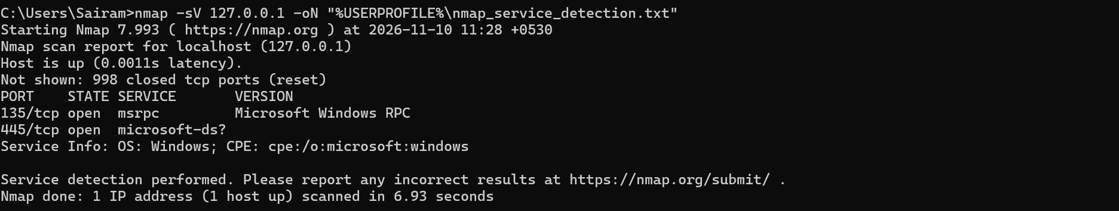
Figure 4. Nmap service detection results for localhost.

5. Nmap Results
Basic scan target: localhost (127.0.0.1). Host status: Up.
Port | State | Service | Observed identification
135/tcp | Open | msrpc | Microsoft Windows RPC
445/tcp | Open | microsoft-ds? | Service label uncertain; associated with SMB / Microsoft-DS
The basic scan reported 998 closed TCP ports (reset). The service-detection scan completed successfully but did not provide an exact service version for port 445.

6. Security Observations
- An open port indicates that a service is accepting connections on that port; it does not by itself prove that the system is vulnerable.
- Port 135 is used by Microsoft Windows RPC-related services.
- Port 445 is commonly associated with SMB file and printer sharing on Windows systems.
- Services should be kept updated and configured according to need. Unneeded network sharing should be disabled, and firewall rules should limit access to trusted networks.
- The scan was limited to localhost. It does not assess other devices or the security of the entire network.

7. Evidence and Project Files
Place the following files in the corresponding project folders:
Folder | Expected evidence files
Nmap_Scan_Results/ | nmap_scan_results.txt; nmap_service_detection.txt
Wireshark_Captures/ | wifi_traffic_capture.pcapng
Screenshots/ | wireshark_packet_capture.png; dns_traffic_analysis.png; nmap_localhost_scan.png; nmap_service_detection.png
Before submitting or publishing the project, confirm that each listed evidence file exists and that screenshots show the user's actual results. Do not include private traffic, credentials, or other people's data.

8. Conclusion
This practical project provided hands-on experience with Nmap port scanning and service detection, along with Wireshark packet capture and DNS filtering. The work demonstrated how to collect basic network evidence, interpret open-port results, and document observations. Further work could include reviewing firewall settings and comparing scans before and after a controlled configuration change on the local system.

9. Scope and Authorization
All Nmap scanning described in this report was performed against the local computer (127.0.0.1). Traffic capture was performed on the user's own laptop. Any future scanning or packet analysis should be limited to systems and networks owned by the user or for which explicit permission has been granted.

