AI Content Generator - Project Documentation
Name : Sai Ravi Charan Neerumalla
Email : sairavicharan.n@gmail.com
Reaidy Acc Id : 69252ec49f2b6ea2c1104631
College Name : Parul University

TASK OF Web Developer
Reaidy.io:
Build an AI-Powered Content Generator Web Application Using an AI API Key (OpenAI, Gemini, or HuggingFace)
Project Name : Content Gen AI – An AI Powered Content Generator

1. Project Overview
This is a web application that helps users create different types of written content using artificial intelligence. Users can select what kind of content they need (like a social media post or an email), describe their topic, and the application generates relevant text for them.
The application has two main parts: - A landing page that explains what the tool does - A generator page where users actually create content
The tool supports four content types: 1. Social Media Captions - Short posts with hashtags for platforms like Instagram or Twitter 2. Blog Ideas - Article titles and outlines for blog writers 3. Product Descriptions - Marketing text for selling products 4. Email Templates - Professional email drafts for business communication

2. Tech Stack
Component | Technology | Why I Used It
Framework | Next.js 14 | Allows both frontend and API routes in one project. No need for a separate backend server.
Frontend | React.js | Component-based structure makes the UI easy to build and maintain.
Styling | Tailwind CSS | Fast to write and keeps styles consistent across the app.
AI Model | Google Gemini API | Free tier available, good quality text generation, simple to integrate.
Icons | Lucide React | Clean, lightweight icon library.
Markdown | react-markdown | Renders AI responses with proper formatting (headings, lists, bold text).
Why Next.js instead of plain React?
The project requirements said not to expose the API key in frontend code. Next.js solves this problem with API Routes - these are server-side functions that run on the server, not in the browser. The API key stays hidden on the server, and the frontend only talks to our own /api/generate endpoint.

3. Screenshots of UI

Landing Page - Hero Section
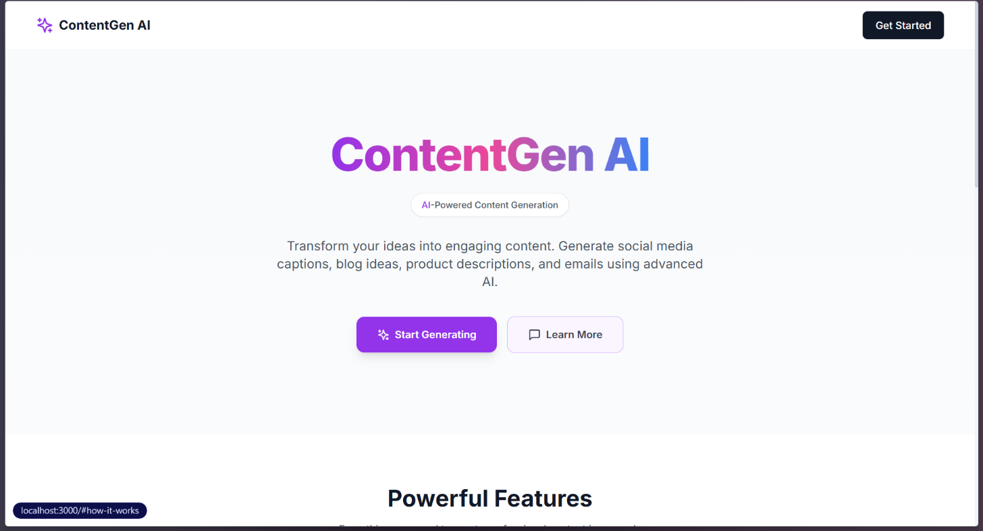

Landing Page - Features Section
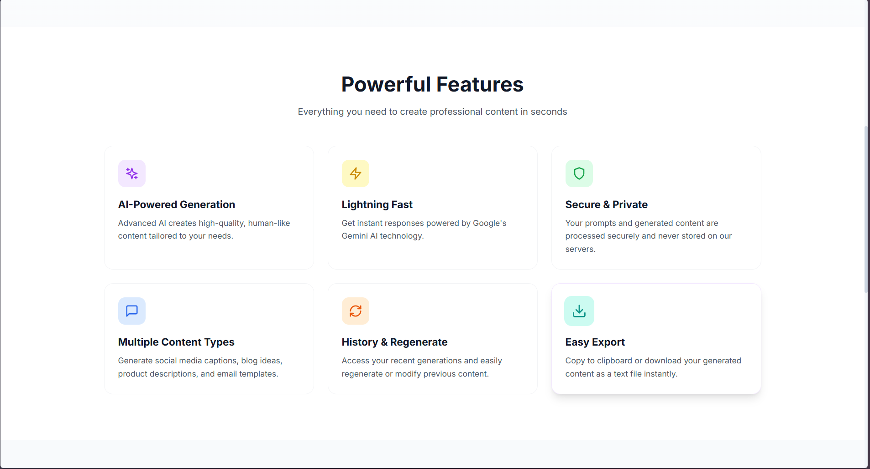

Shows : six feature cards with icons - Each card explains one capability of the tool

Landing Page - How It Works
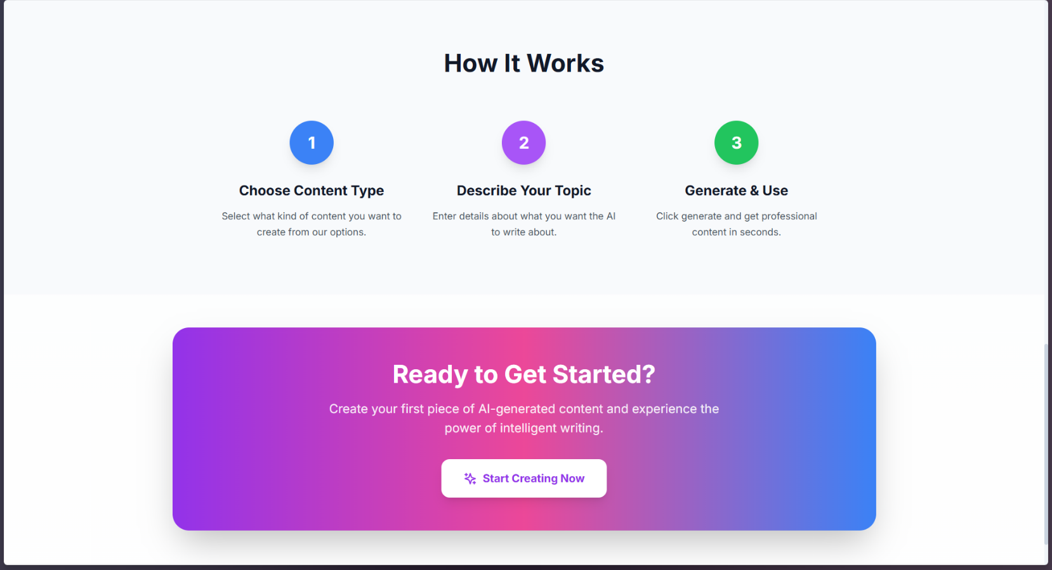
Three numbered steps explaining the process - Simple visual guide for new users

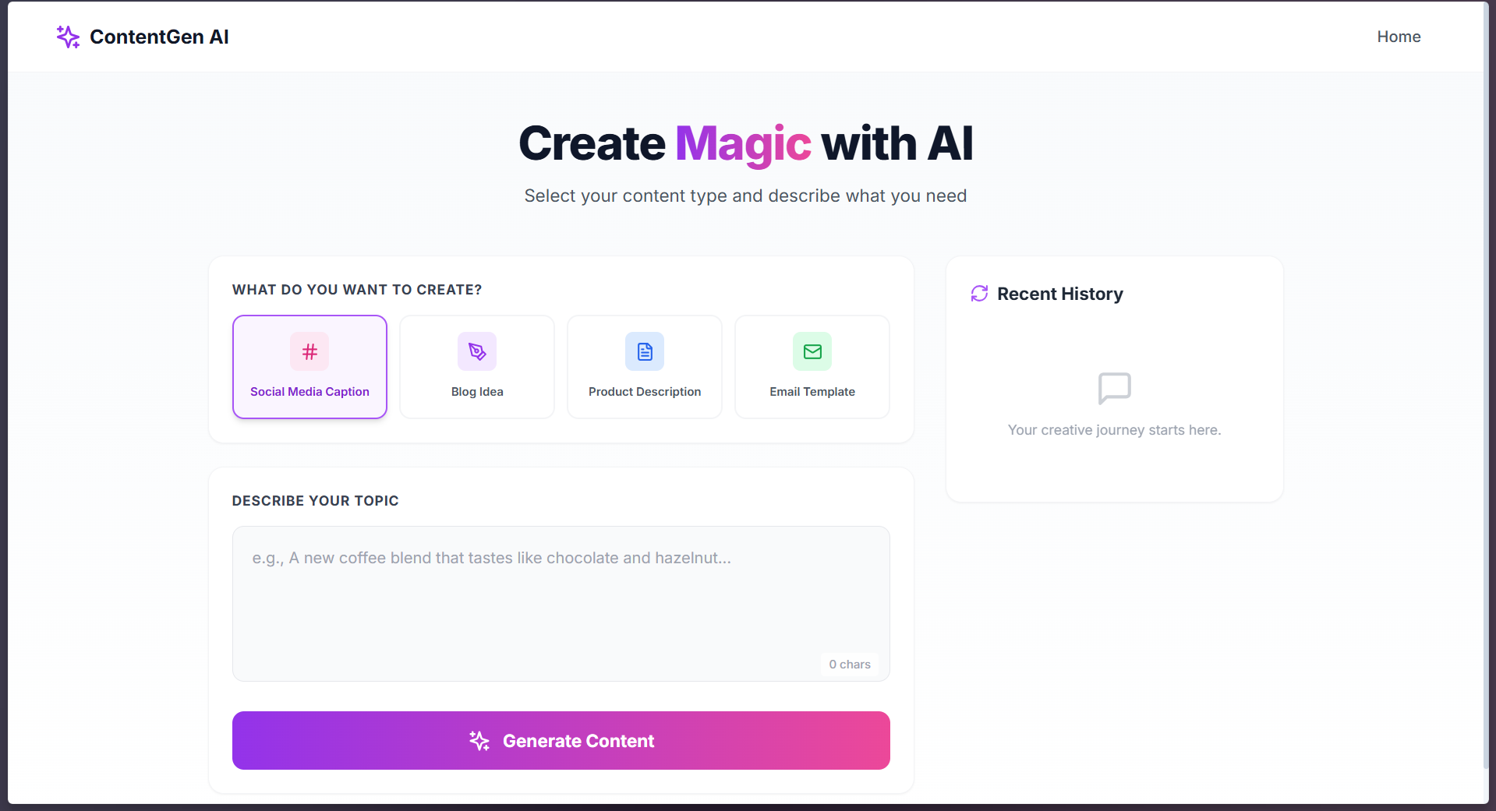
Landing Page - Call to Action Banner

Generator Page - Content Type Selection
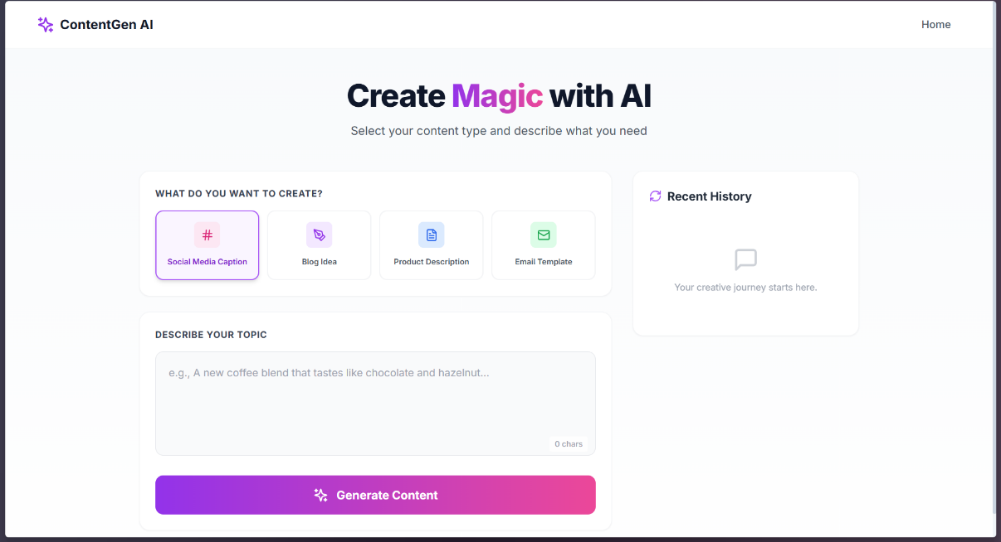
Four clickable cards with icons - Selected type is highlighted with purple border

Generator Page - Input and Generate

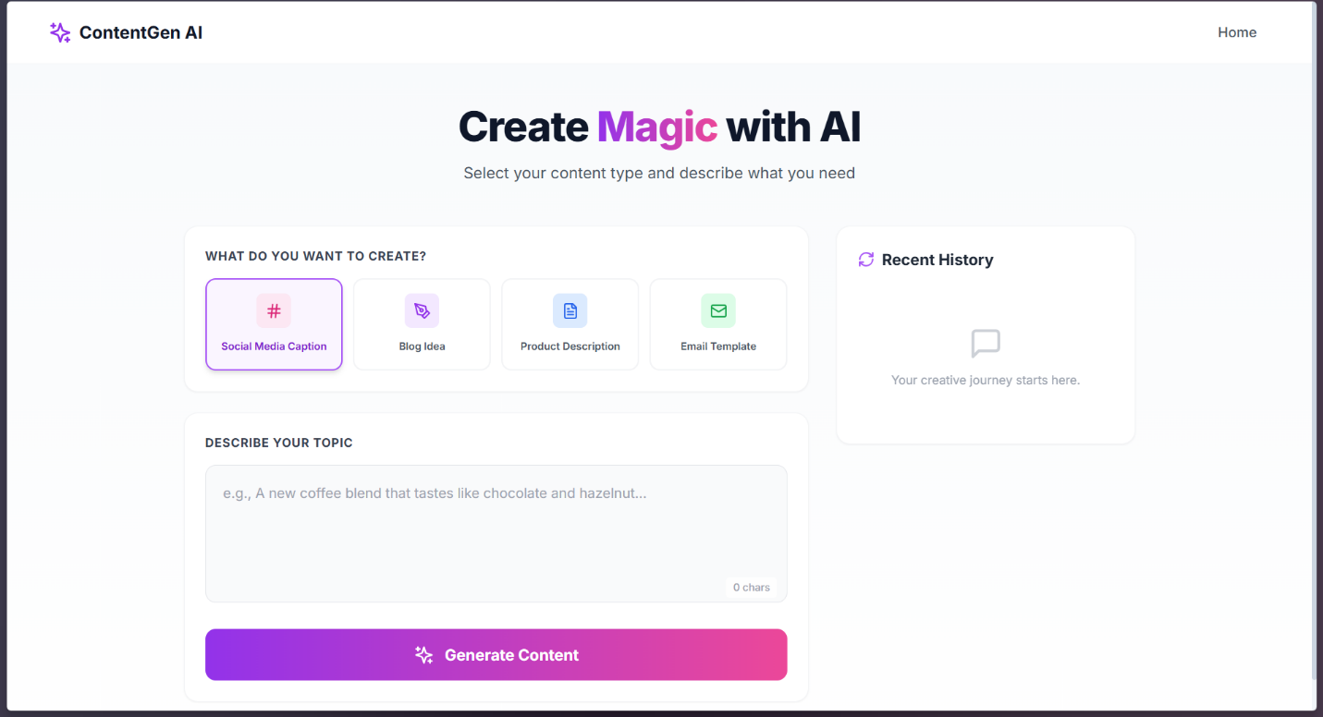
Text area for describing the topic - Character counter in bottom right - Purple gradient “Generate Content” button

Generator Page - Generated Output

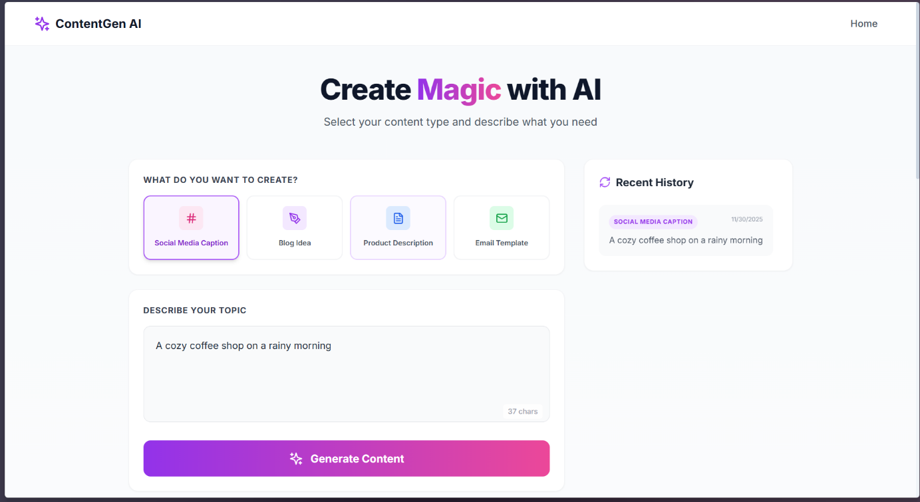
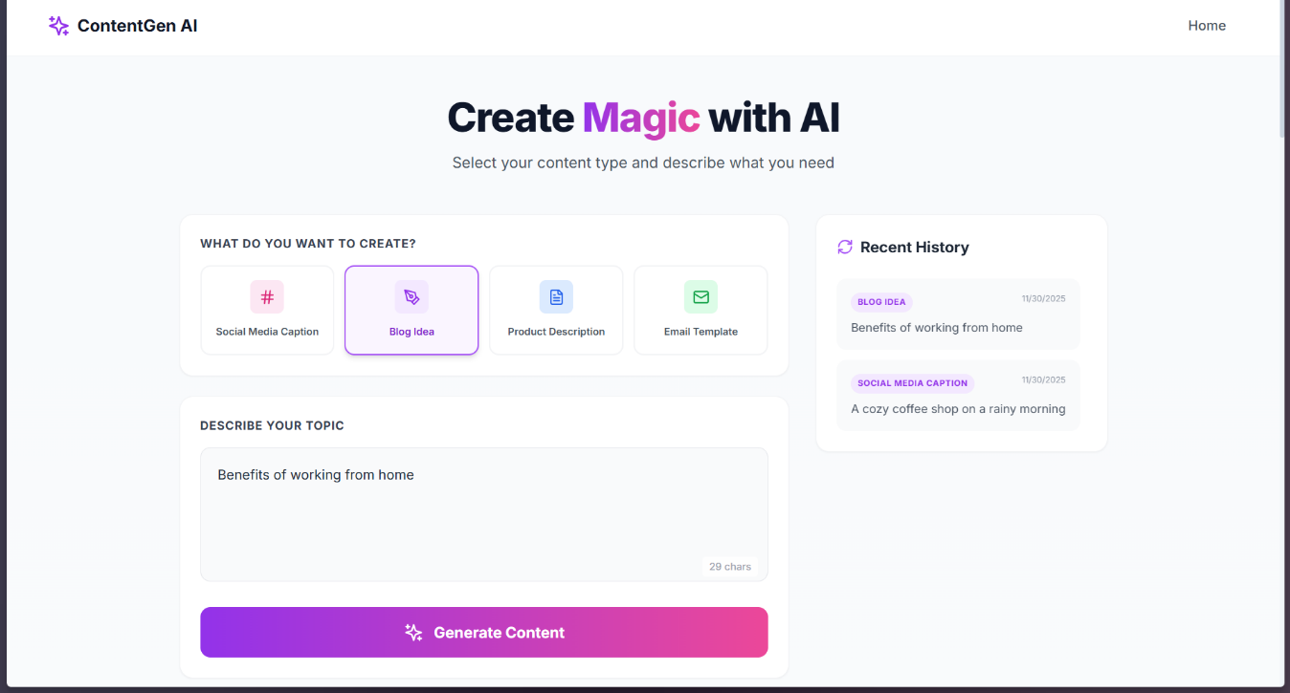

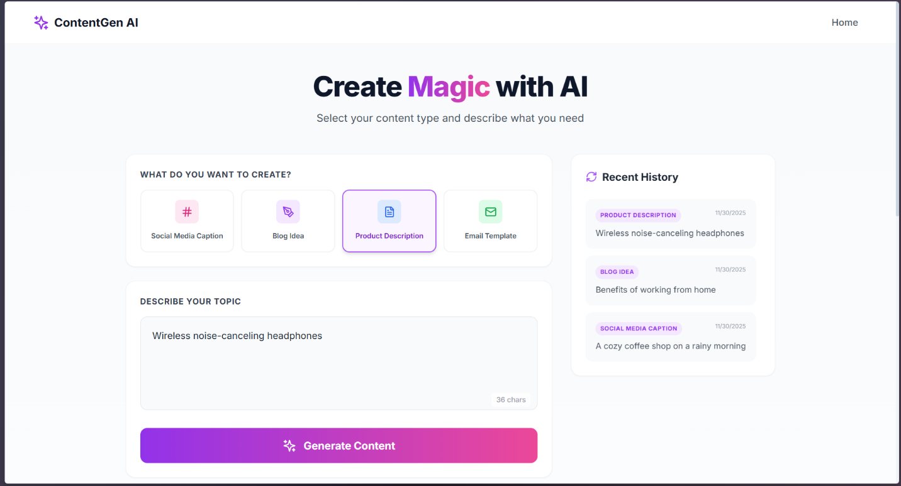

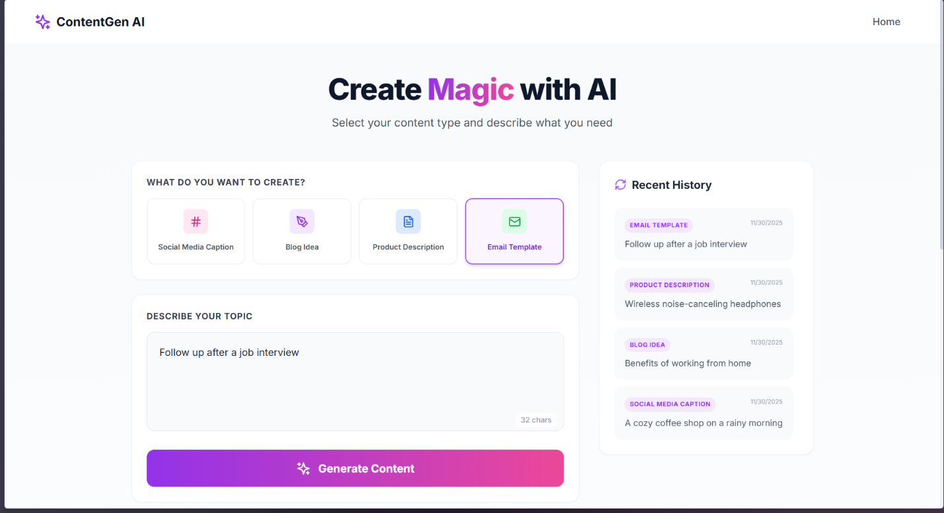

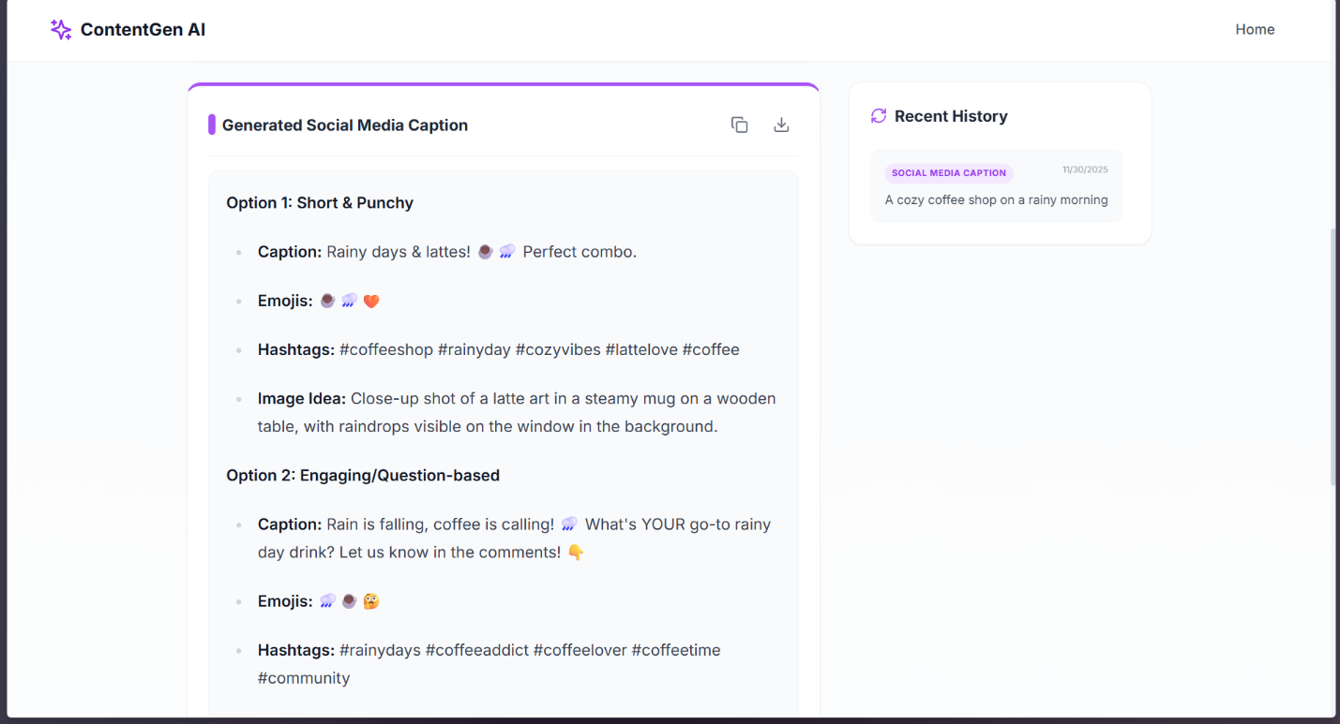
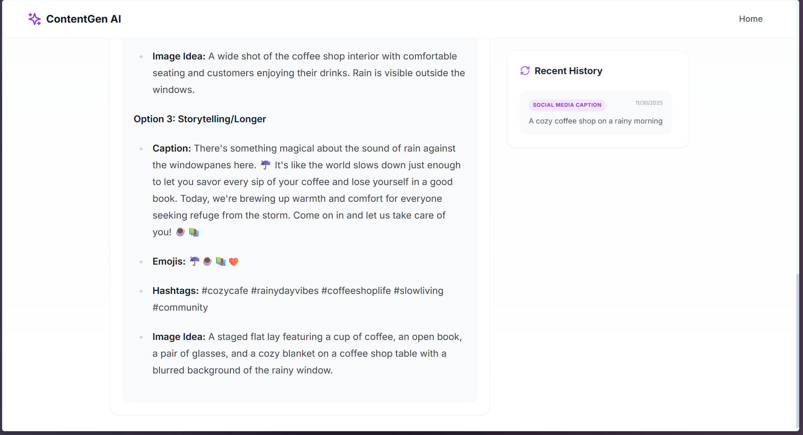
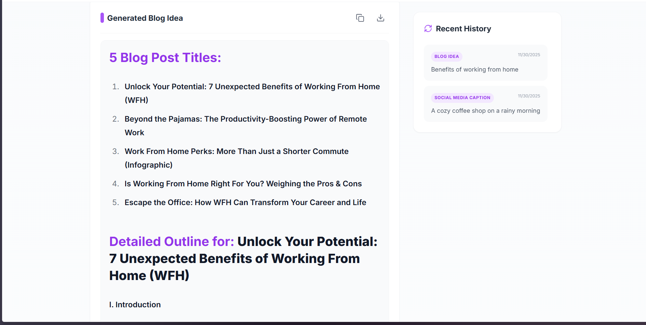
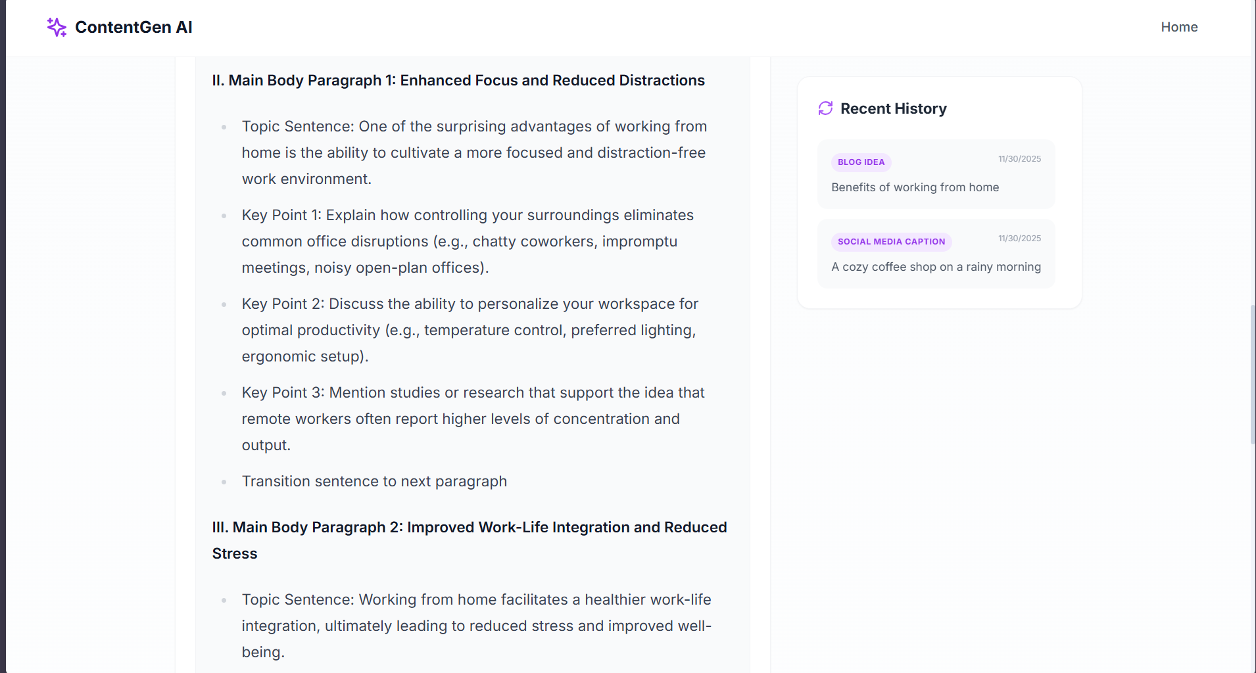
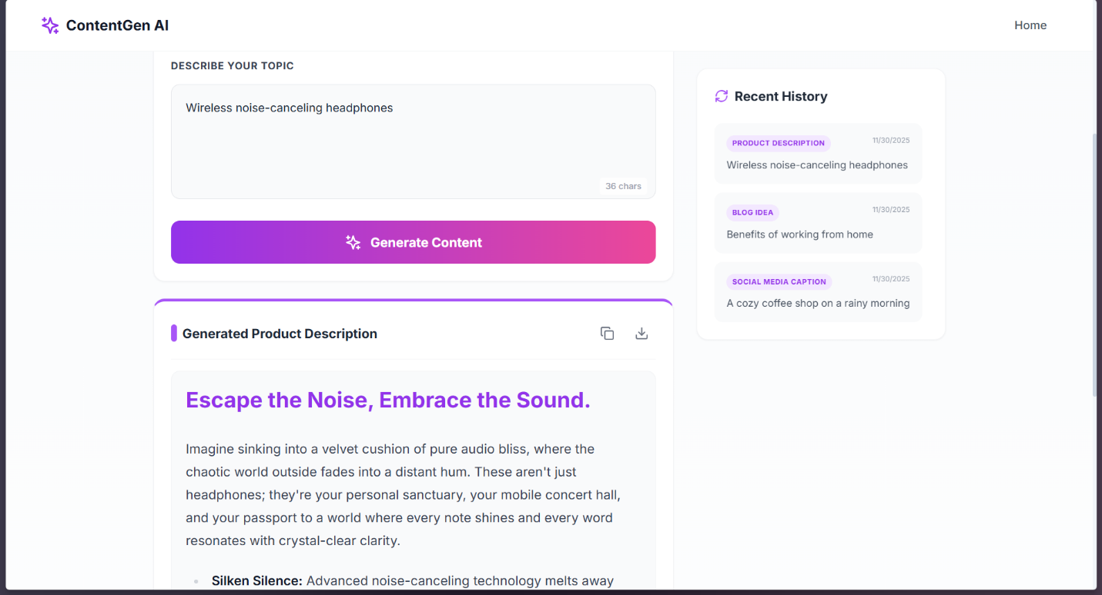
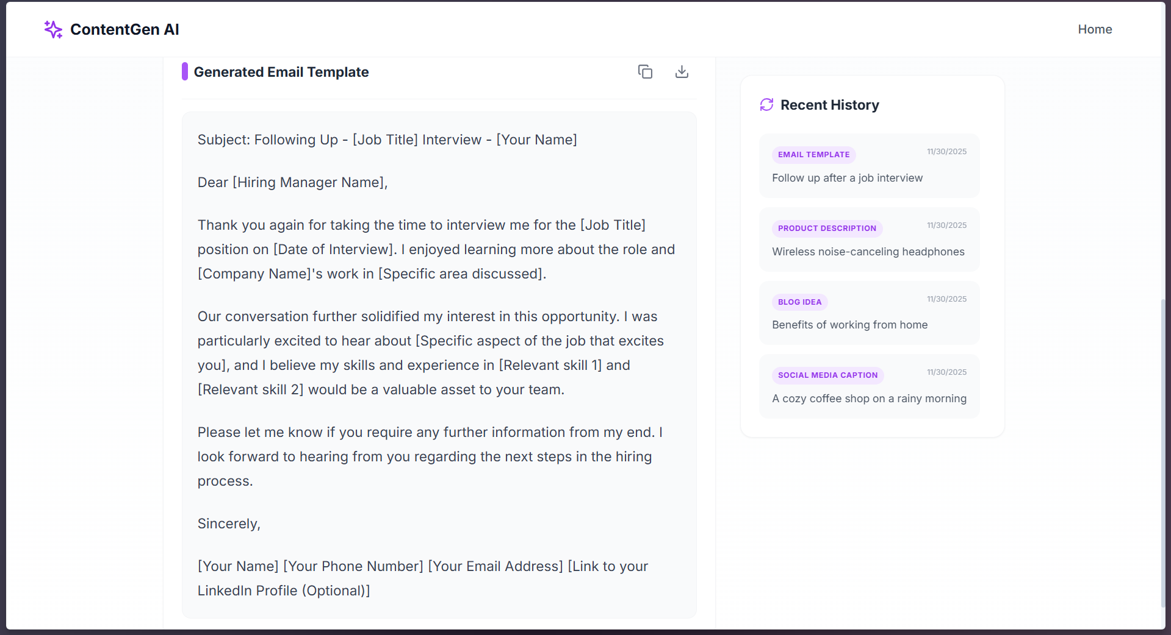

Result displayed with proper formatting - Copy and Download buttons in the header - Markdown rendered correctly (headings, bullet points)

Generator Page - History Sidebar
Shows recent generations - Click any item to reload that result

4. API Call Explanation

How the flow works:
User clicks "Generate"
↓
Frontend sends POST request to /api/generate
↓
Next.js API Route receives the request (server-side)
↓
API Route reads GEMINI_API_KEY from environment variables
↓
API Route sends request to Google Gemini API
↓
Gemini returns generated text
↓
API Route sends response back to frontend
↓
Frontend displays the result

Why this approach?
The API key never reaches the browser. If someone inspects the network requests in their browser, they will only see calls to /api/generate - our own endpoint. The actual Gemini API call happens on the server where the key is stored securely in environment variables.

Request structure sent to Gemini:
{
contents: [
{
parts: [
{
text: "You are a social media expert. Write a catchy caption for: [user's topic]"
}
]
}
]
}
The system adds specific instructions based on the content type selected. For example, if the user selects “Email Template”, the prompt starts with instructions to write a professional email with subject line, greeting, body, and closing.

5. Code Snippets

Frontend - Making the API Call (app/page.js)
const handleGenerate = async () => {
// Check if user entered something
if (!prompt.trim()) {
setError('Please enter a prompt.');
return;
}
setLoading(true);
setError('');
setGeneratedContent('');
try {
// Call our own API route, not Gemini directly
const response = await fetch('/api/generate', {
method: 'POST',
headers: {
'Content-Type': 'application/json',
},
body: JSON.stringify({ prompt, type: contentType }),
});
const data = await response.json();
// Check if something went wrong
if (!response.ok) {
throw new Error(data.error || 'Something went wrong');
}
// Show the result
setGeneratedContent(data.result);
// Save to history
const newEntry = {
id: Date.now(),
type: contentType,
prompt: prompt,
result: data.result,
date: new Date().toLocaleDateString()
};
setHistory([newEntry, ...history].slice(0, 10));
} catch (err) {
setError(err.message || "Failed to connect to the server.");
} finally {
setLoading(false);
}
};

Backend - API Route (pages/api/generate.js)
export default async function handler(req, res) {
// Only allow POST requests
if (req.method !== 'POST') {
return res.status(405).json({ error: 'Method not allowed' });
}
try {
const { prompt, type } = req.body;
// Validate input
if (!prompt || !type) {
return res.status(400).json({ error: 'Prompt and Content Type are required.' });
}
// Get API key from environment (never exposed to browser)
const apiKey = process.env.GEMINI_API_KEY;
if (!apiKey) {
return res.status(500).json({ error: 'Server configuration error.' });
}
// Build specific instructions based on content type
let systemInstruction = "";
switch (type) {
case "Social Media Caption":
systemInstruction = "You are a social media expert. Generate 3 caption options with emojis and hashtags.";
break;
case "Blog Idea":
systemInstruction = "You are a content strategist. Generate 5 blog titles and an outline for one.";
break;
case "Product Description":
systemInstruction = "You are a copywriter. Write a compelling product description with features.";
break;
case "Email Template":
systemInstruction = "You are a business writer. Write a professional email with subject and body.";
break;
}
const finalPrompt = `${systemInstruction}\n\nTopic: ${prompt}`;
// Call Gemini API
const response = await fetch(
`https://generativelanguage.googleapis.com/v1beta/models/gemini-2.0-flash:generateContent?key=${apiKey}`,
{
method: 'POST',
headers: { 'Content-Type': 'application/json' },
body: JSON.stringify({
contents: [{ parts: [{ text: finalPrompt }] }]
})
}
);
if (!response.ok) {
const errorData = await response.json();
return res.status(response.status).json({
error: errorData?.error?.message || 'AI provider error.'
});
}
const data = await response.json();
const generatedText = data.candidates?.[0]?.content?.parts?.[0]?.text;
if (!generatedText) {
return res.status(500).json({ error: 'No content generated.' });
}
return res.status(200).json({ result: generatedText });
} catch (error) {
return res.status(500).json({ error: 'Internal Server Error' });
}
}

Displaying Formatted Output
import ReactMarkdown from 'react-markdown';
// In the component:
<div className="prose prose-lg max-w-none">
<ReactMarkdown>
{generatedContent}
</ReactMarkdown>
</div>
This renders markdown syntax (like ## Heading or **bold**) as actual formatted HTML instead of showing the raw characters.

6. Project Links
- GitHub Repository: https://github.com/SaiRaviCharan/AI-Content-Generator

- Live Demo: https://ai-content-generator-six-weld.vercel.app/

7. Challenges and Solutions

Challenge 1: API Key Security
Problem: The requirements said not to expose the API key in frontend code. But in a pure React app, any code runs in the browser where users can see it.
Solution: Used Next.js API Routes. These run on the server, not the browser. The frontend calls /api/generate (our own endpoint), and that endpoint calls Gemini with the secret key. The key is stored in .env.local which is never sent to the browser.

Challenge 2: Finding the Right AI Model
Problem: The Gemini API returned errors saying “model not found” for gemini-pro and gemini-1.5-flash.
Solution: Created a script to list all available models for my API key. Found that gemini-2.0-flash was available and working. Used that instead.
// Script to check available models
const response = await fetch(
`https://generativelanguage.googleapis.com/v1beta/models?key=${apiKey}`
);
const data = await response.json();
console.log(data.models.map(m => m.name));

Challenge 3: 404 Errors on API Route
Problem: The frontend kept getting 404 errors when calling /api/generate, even though the file existed.
Solution: Moved the API route from app/api/generate/route.js (App Router style) to pages/api/generate.js (Pages Router style). The Pages Router approach is more stable for API routes in Next.js 14.

Challenge 4: Markdown Not Rendering
Problem: The AI returns text with markdown formatting like ## Title and * bullet point, but it was displaying as plain text with those characters visible.
Solution: Installed react-markdown library and wrapped the output in a <ReactMarkdown> component. Also added @tailwindcss/typography for automatic prose styling.

Challenge 5: Making Content Type-Specific
Problem: The AI was giving generic responses regardless of what content type was selected.
Solution: Added specific system instructions for each content type in the API route. For example, when “Email Template” is selected, the prompt includes: “Write a professional email with Subject Line, Salutation, Body, and Closing.”

8. Features Checklist
Requirement | Status | Notes
Select Content Type | Done | Four types with icon cards
Input Prompt Field | Done | Textarea with character counter
Generate Button | Done | Shows loading state while processing
AI API Call | Done | Uses Gemini 2.0 Flash
Display AI Output | Done | Rendered with markdown formatting
Loading State | Done | Spinner and “Creating Magic…” text
Error Handling | Done | Shows specific error messages
API Key Security | Done | Stored in .env.local, used via API route
Responsive Design | Done | Works on mobile and desktop
Copy to Clipboard | Done | Button in output section
Download as Text | Done | Downloads .txt file
History | Done | Stored in localStorage, shows last 10

9. How to Run Locally
- Clone the repository
- Run npm install
- Create .env.local file with your Gemini API key:
- GEMINI_API_KEY=your_key_here
- Run npm run dev
- Open http://localhost:3000

10. File Structure
Content Generator/
├── app/
│ ├── globals.css # Global styles
│ ├── layout.js # Root layout with metadata
│ └── page.js # Main UI component (landing + generator)
├── pages/
│ └── api/
│ └── generate.js # API route that calls Gemini
├── .env.local # API key (not committed to git)
├── .gitignore # Ignores node_modules, .env.local, .next
├── package.json # Dependencies and scripts
├── tailwind.config.js # Tailwind CSS configuration
└── README.md # Setup instructions

Document prepared for project submission.

