23CSE111

OBJECT ORIENTED PROGRAMMING

LAB REPORT



Department of Computer Science Engineering

Amrita School of Computing

Amrita Vishwa Vidyapeetham, Amaravati Campus

Name: B.SAI RISHITHA

Roll: AV.SC.U4CSE24016

Branch: CSE

Section: A

Verified by:

WEEK-1

Task-1: How to download and install JAVA software.

Task-2: Write a java program to print the message welcome to java programming.

Task-3: Write a java program that print name, roll.no and section of a student.

Task-1: How to download and install JAVA software.

AIM: To download and install JAVA software.

**Procedure:**

**Step 1: Download JDK**

Go to the official [Oracle website](https://www.oracle.com/java/technologies/downloads/#jdk22-windows) to download the JDK.

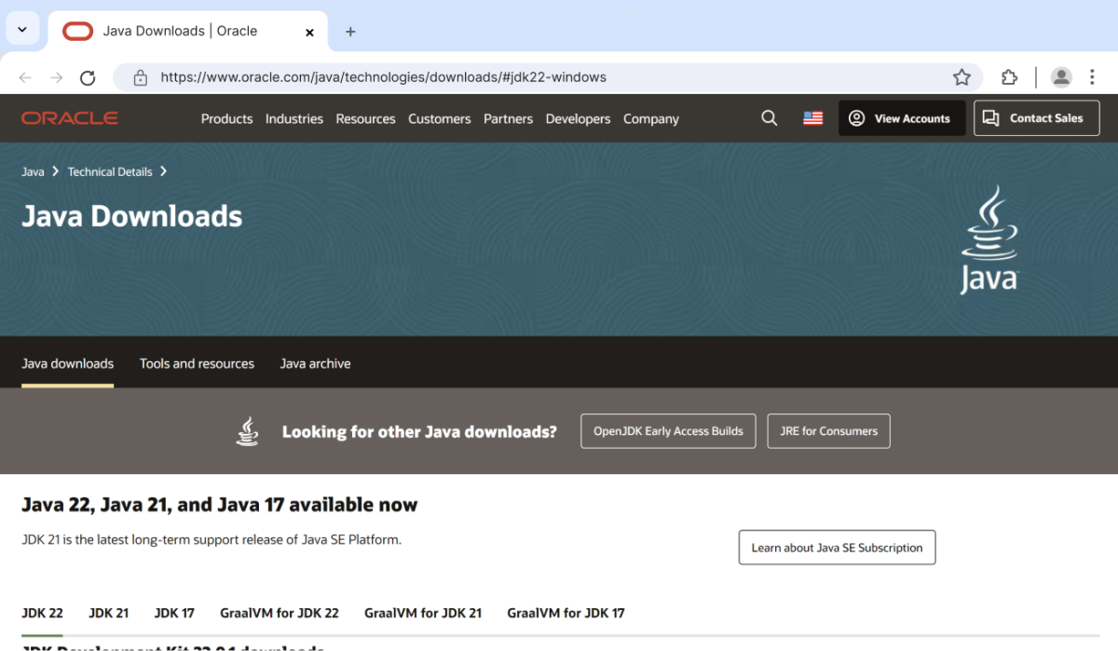

Download Java on Windows

Choose **x64 MSI Installer** on the windows tab and click on download link.

**Step 2: Run the Installer**

Now, go to your **downloads** folder and run the installer you just downloaded. You will be prompted to the screen

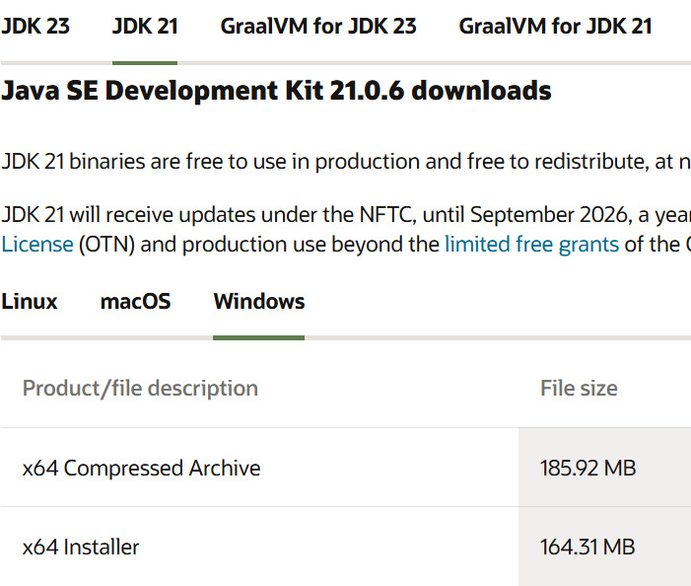

Run JDK Installer on Windows

Simply click **Next** to proceed.

**Step 3: Configure Environment Variables**

After installation, you will need to tell your system where to find Java. This is done by setting environment variables.

**Locate JDK Path**: Navigate through your file explorer to reach the JDK installation directory. Normally, it is located at

C:\Program Files\Java\jdk-21\bin

Copy this path.

**Access Environment Variables**: Search **environment variable** on the terminal. In system properties, click on environment variables. You will be prompted to the screen below.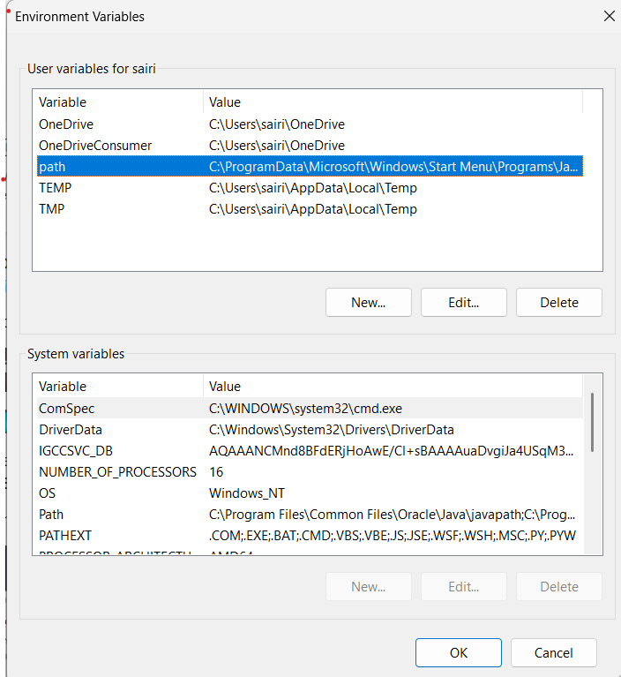

Java Setup Environment Variable

**Update the Path Variable:**

Find the **Path** variable in the System variables section and click on **Edit**. Then, click **New** and paste your JDK bin path (i.e. C:\Program Files\Java\jdk-21\bin).

Finally, click **Ok** to close each window.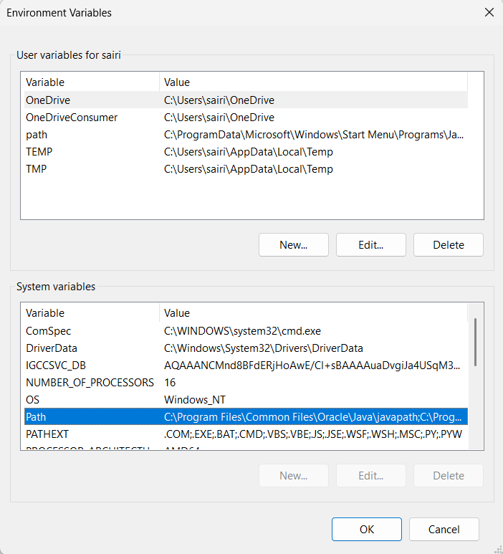

**Set javapath Variable:**

Back in the environment variables window, under the system variables section, click **New** to create a new variable.

Now, name the variable **javapath** and set its value to the path of the JDK folder directory (i.e.C:\Program Files\Java\jdk-21).

Set javapath Variable

Close all the dialogues with the **Ok** button.

**Step 4: Verify your Installation**

After the installation, you can verify whether Java is installed by using the following command in the command prompt.

java --version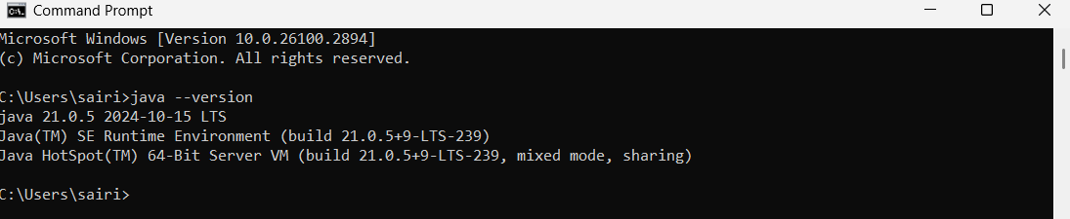

Verify Java Installation

If Java is installed successfully, it will print the version information; otherwise, it will produce an error message indicating that the command is not recognized.

Task-2: Write a java program to print the message welcome to java programming.

**AIM:** To write a Java Program to print the message “Welcome to Java programming”.

**CODE:**

    //java program that prints a welcome message

   //Define a class named Example1

      class Example1{

                   public static void main(String[]args){

                   //print "welcome to java programming"

                                System.out.println("Welcome to java programming");

       }

}

**OUTPUT:**

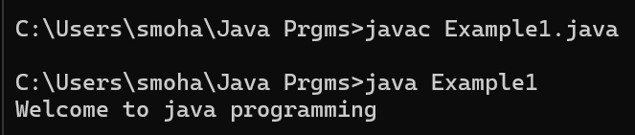

Task-3: Write a java program that print name, roll.no and section of a student.

**AIM:** To Write a java program that prints Name, Roll no and Section of a student

**CODE:**

  //java program that prints a Details of student

//Define a class named Example2

class Example2{

       public static void main(String[]args){

       //print Name, Roll no and Section of student

              System.out.println("Name:Mohana Maheswari");

              System.out.println("Section: CSE-A");

              System.out.println("Roll No : 24314");

       }

}

**OUTPUT:**

