**WEEK 1**

**Task-1**

**Aim**: How to download and install JAVA software.

Procedure:

STEP 1: Go to browser and search for java download

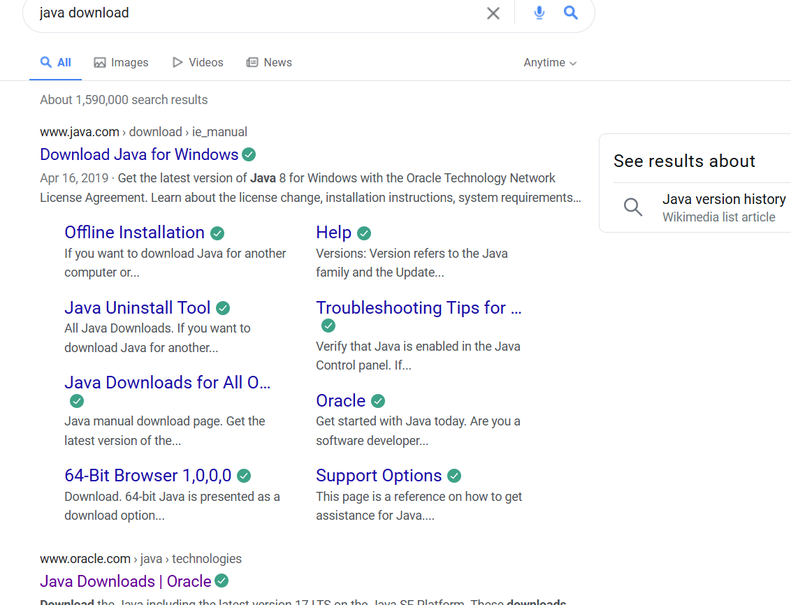

Step2: Open website link with oracle

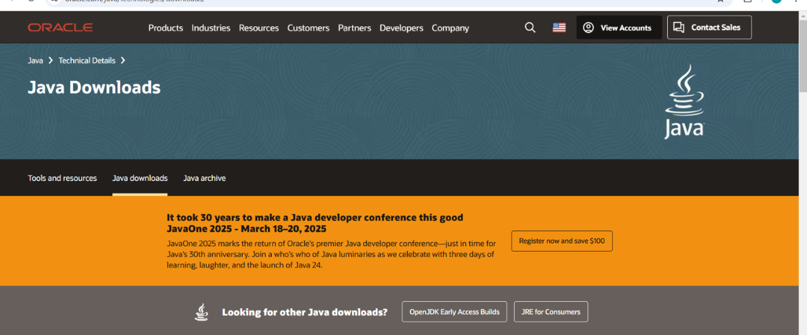

Step3: Click on JDK 21 and click on windows

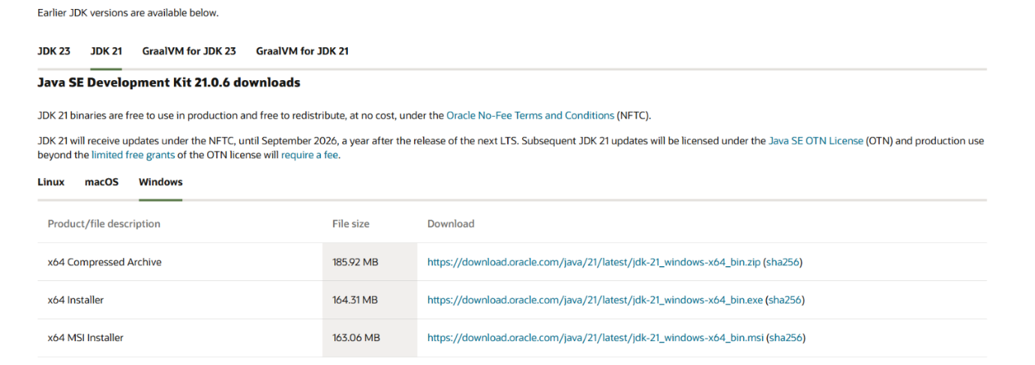

Step4: After that click on x64 installer

Step5: The download starts

Step6: After downloading the next step installation starts

Step7: After installation we need to set a path

Step8: Go to “c” drive in c drive we must the program files

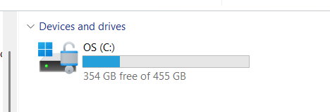

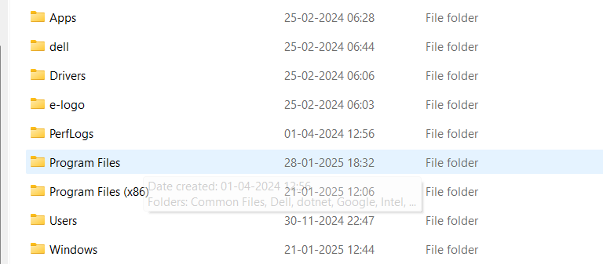

Step 9: Double click on the program files and double click on the java

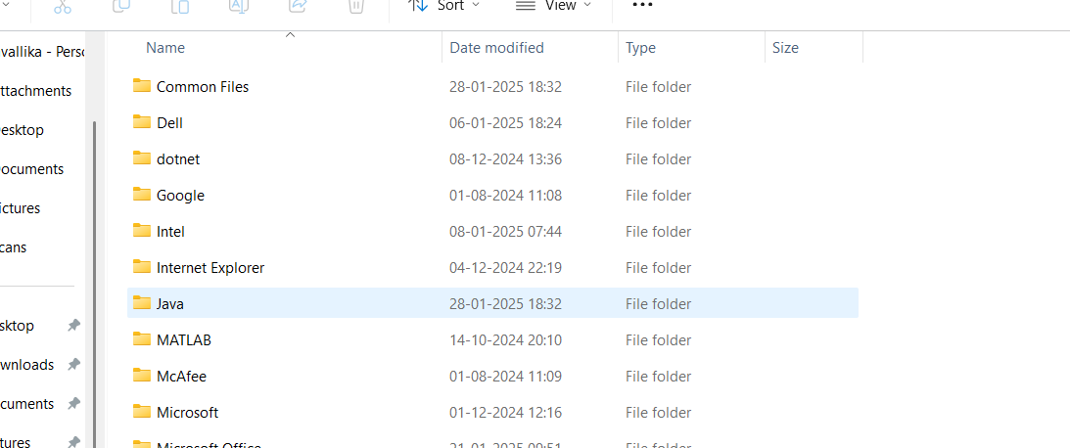

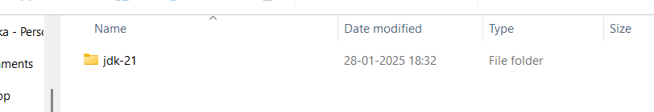

 Step 10: Click on JDK-21 and select bin

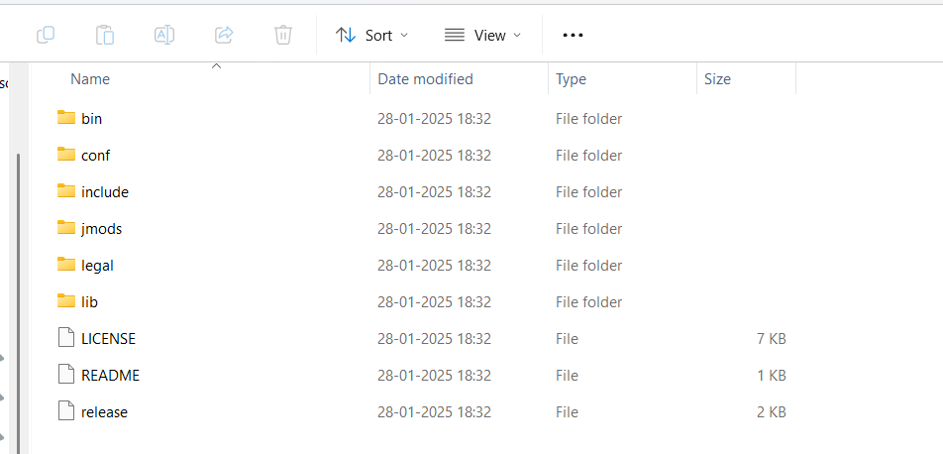

Step11: Copy the link and paste the environment

Step12: Select the system variables and select the path

STEP13: After selecting the path we need select new one need to paste the link

Step14: After pasting the link we need to click the ok and the apply

Step15: In this way the downloading and installation of java takes place

Step16: After installation go to command prompt and type javac –version

Step17: In command prompt we get the version which we download.

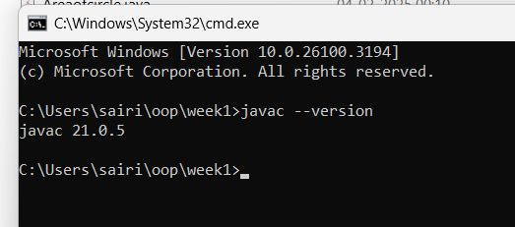

**Task-2**

**Aim:** Write the java program to print the message “welcome to java programming “

Code:

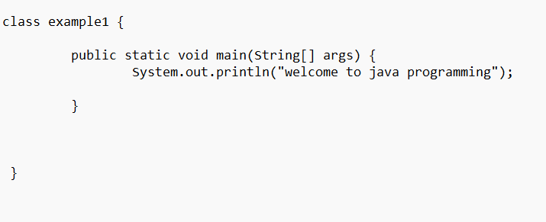

Output:

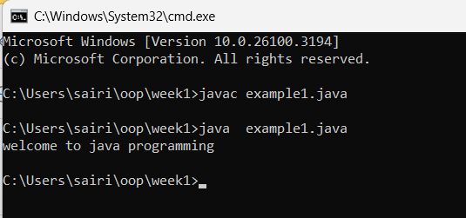

**Task-3:**

**Aim**: write the java program to print the message “Name, class, roll.no, section”.

Code:

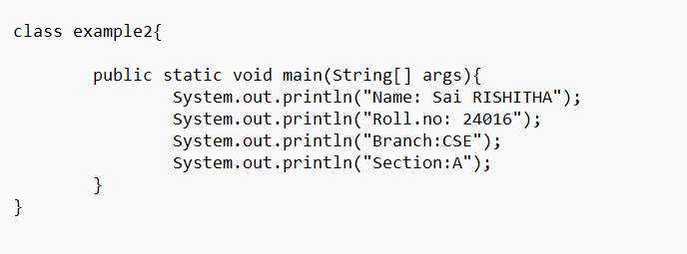

Output:

