**Week-2**

**Task-1**

**Aim:** write a java program to calculate the area of the rectangle

Input code:

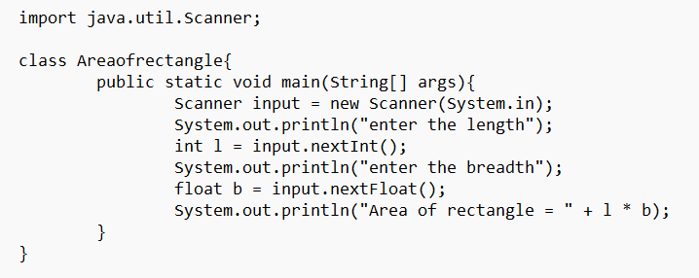

Output:

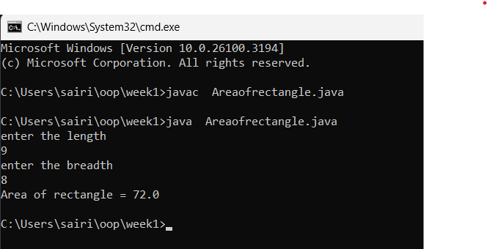

ERROR:

|  |  |  |
| --- | --- | --- |
| SI.NO | Error message | Error rectification |
| 1. | Error: file not found | “rectangle” |
| 2 | Error: incorrect formula | Rewrite formula |

**Task-2:**

**Aim:** write a java program to convert temperature from Celsius to Fahrenheit.

Input Code:

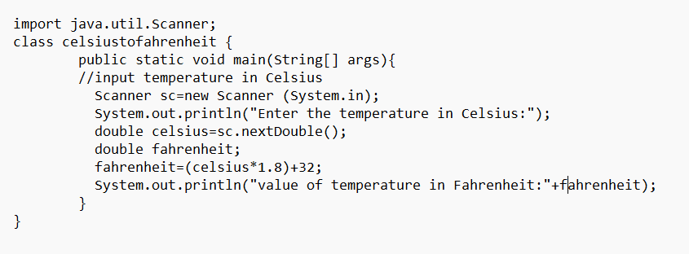

Output:

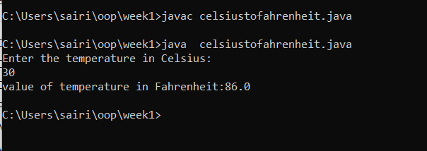

Error

|  |  |  |
| --- | --- | --- |
| SI.NO | Error message | Error rectification |
| 1 | Error: expected | Inserted; |
| 2 | Error: scanner input” capital letter case sensitive” | “Scanner input” |

**Task-3**

**Aim:** write a java program to calculate the simple interest

Code:

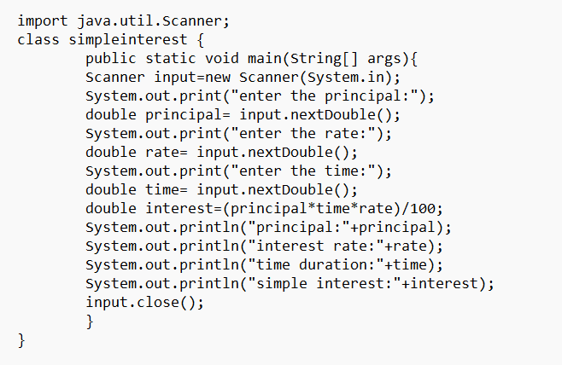

Output:

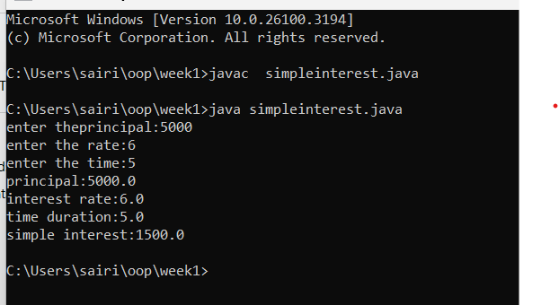

Error

|  |  |  |
| --- | --- | --- |
| SI.NO | Error message | Error rectification |
| 1 | Error: input nextInt[]”parenthesis” | “input nextInt()” |
| 2 | Error: ”Scanner object not closed” | Placed paranthesis[] |

**Task-4**

**Aim:** Write a java program largest of three number using ternary operator .

Input code:

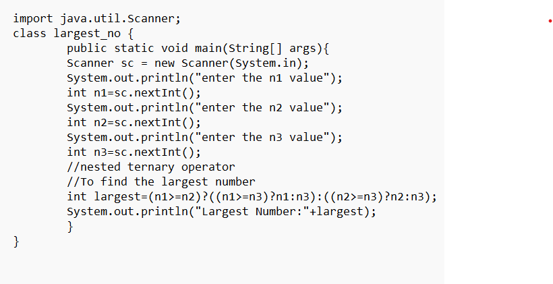

Output:

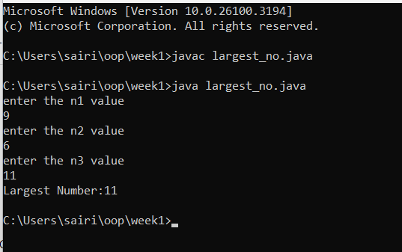

Error

|  |  |  |
| --- | --- | --- |
| SI.NO | Error message | Error rectification |
| 1 | Error: ”variable i not   declared properly” | Declared inside the loop |
| 2 | Error: ”access modifier for class” | Public class simple |

**Task-5**

**Aim:** Write a java program to find the factorial of number.

Input code:

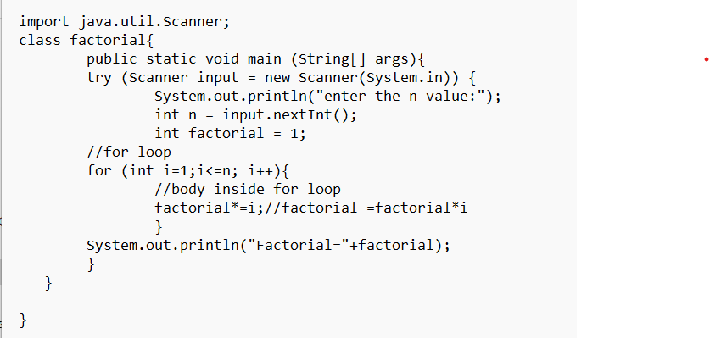

Output:

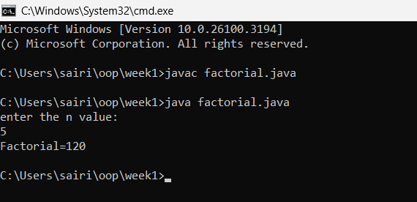

Error

|  |  |  |
| --- | --- | --- |
| SI.NO | Error message | Error rectification |
| 1 | Error: ’file not found’ fact | ‘fact’ |
| 2 | Error: expected”;” | Inserting’;’ |