Week-3

**Task-1**

**Aim:** Create the java program with the following instruction

1)create a class with name car

2)create four attributes name, car_color, car_brand, fueltype, mileage

3)create three methods named Start(), Stop(), Services()

4)create three objects name car1,car2,car3

5)create a constructor which should print “welcome to car garage.”

Input Code:

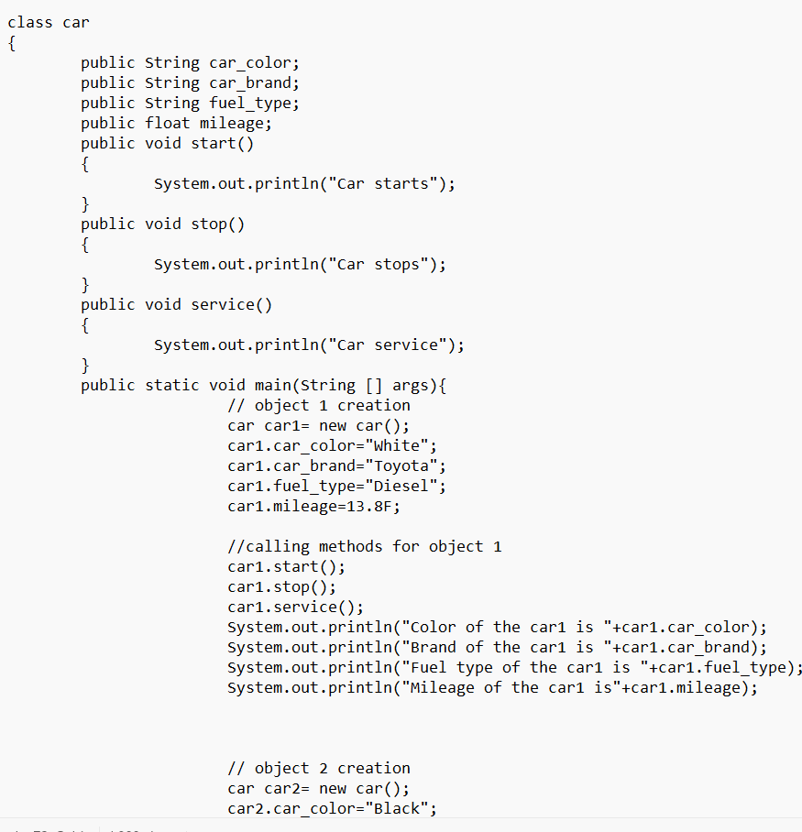

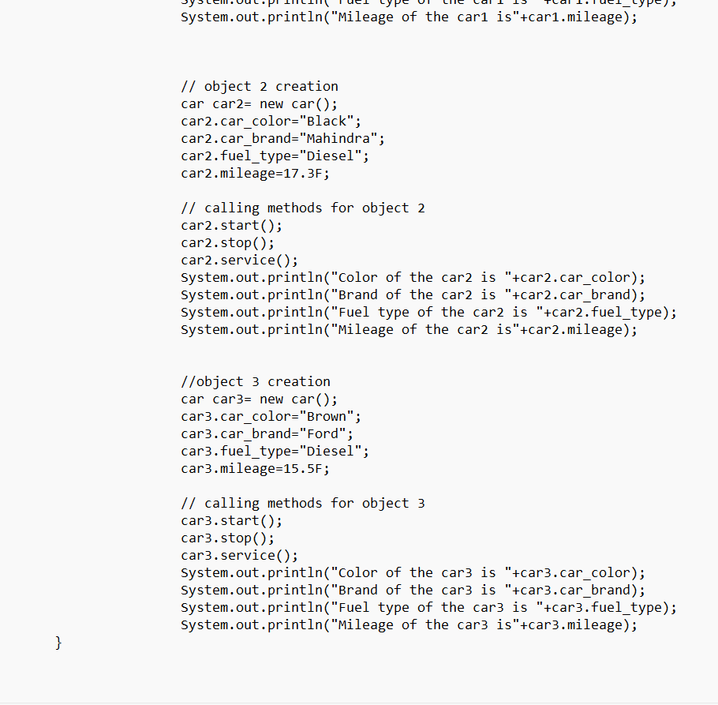

Output:

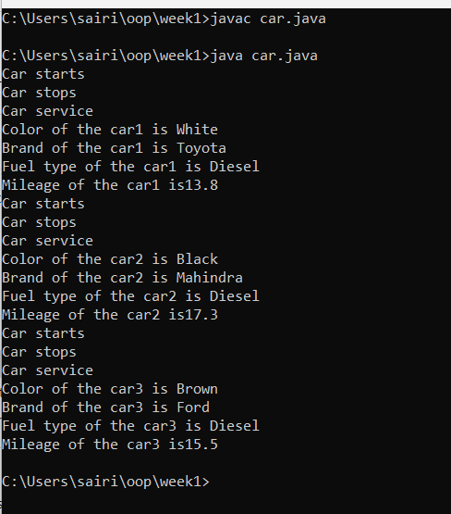

**Task-2**

**Aim:** Write a java program to create a class named BankAccount with two methods deposit and withdraw:

1)In deposit method whenever an amount is deposited it has to be updated with current amount.

2)In withdraw method whenever an amount is being withdraw it has to be less then the current amount else print insufficient funds.

Input Code:

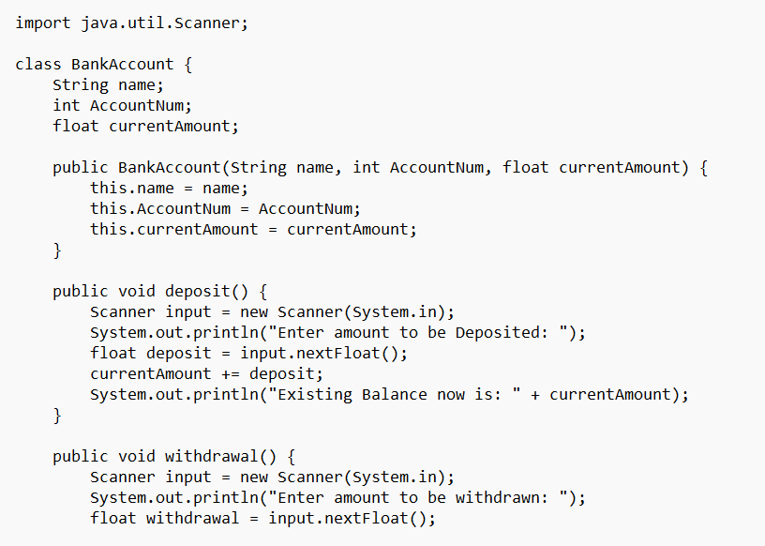

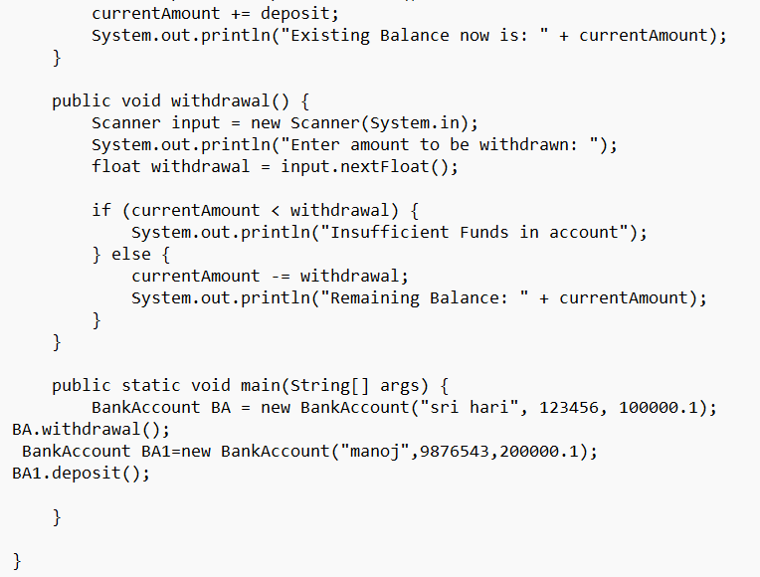

Output: